
Cairo University
CS213: Object Oriented Programming
Assignment 2
Cairo University, Faculty of Computing and AI

TA: Dalia Maher

Name | ID & FUNCTIONS
عبدالاله احمد محمد | 20230826>>> 2 | 6| 4 | 5|12 | 20230826@stud.fci-cu.edu.eg
محمد أحمد عبداالله محمد | 20220985>> 1 | 3 | 7 | 9| 11 | 2022098@stud.fci-cu.edu.eg

1

Class Diagram

AudioPlayerApp
Attributes | mainWindow : std::unique_ptr<MainWindow>
Methods | getApplicationName() : juce::String  getApplicationVersion() : juce::String  initialise(args : juce::String)  shutdown()

MainWindow (inner class)
Attributes | Inherited from juce::DocumentWindow
Methods | MainWindow(name : juce::String)  closeButtonPressed()

MainComponent
Attributes | playerGUI1 : PlayerGUI  playerGUI2 : PlayerGUI  mixerSource : juce::MixerAudioSource
Methods | MainComponent()  ~MainComponent()  prepareToPlay(int, double)  getNextAudioBlock(AudioSourceChannelInfo)  releaseResources()  paint(juce::Graphics&)  resized()

PlayerGUI
Attributes | playerAudio : PlayerAudio  loadButton, playPauseButton, stopButton, loopButton : juce::TextButton  muteButton, jumpBack10sButton, jumpForward10sButton : juce::TextButton  volumeSlider, positionSlider, speedSlider : juce::Slider  titleLabel, timeLabel, fileNameLabel : juce::Label  volumeLabel, positionLabel, speedLabel : juce::Label  fileChooser : std::unique_ptr<juce::FileChooser>
Methods | PlayerGUI()  ~PlayerGUI()  resized()  paint(juce::Graphics&)  prepareToPlay(int, double)  getNextAudioBlock(AudioSourceChannelInfo)  releaseResources()  buttonClicked(juce::Button*)  sliderValueChanged(juce::Slider*)  timerCallback()  updateUI()  formatTime(double) : juce::String  getAudioSource() : PlayerAudio*

PlayerAudio
Attributes | formatManager : juce::AudioFormatManager  readerSource : std::unique_ptr<juce::AudioFormatReaderSource>  transportSource : juce::AudioTransportSource  resamplingSource : juce::ResamplingAudioSource  isMute : bool  previousVolume : float  looping : bool  currentFileName : juce::String  waitingForLoop : bool  loopCheckPosition : double
Methods | PlayerAudio()  ~PlayerAudio()  prepareToPlay(int, double)  getNextAudioBlock(AudioSourceChannelInfo)  releaseResources()  loadFile(juce::File) : bool  play()  pause()  stop()  setGain(float)  setPosition(double)  getPosition() : double  getLength() : double  toggleMute()  setLooping(bool)  jumpForward(double)  jumpBackward(double)  setSpeed(double)  getOutputSource() : juce::AudioSource*

Class Relationships
- AudioPlayerApp → MainWindow : Composition (owns main window)
- MainWindow → MainComponent : Composition (contains the main UI)
- MainComponent → PlayerGUI : Composition (contains two PlayerGUIs)
- MainComponent → MixerAudioSource : Association (mixes both audio outputs)
- PlayerGUI → PlayerAudio : Composition (GUI controls its PlayerAudio)
- PlayerAudio → JUCE classes : Aggregation (uses JUCE audio modules)

Use of “A PIE” OOP Principles
- Abstraction: Simplifies complex audio logic through clear classes like PlayerAudio and PlayerGUI.
- Polymorphism: Uses common interfaces (., AudioSource) to handle different audio objects flexibly.
- Inheritance: Extends JUCE classes (Component, DocumentWindow) to build the app structure.
- Encapsulation: Protects data by keeping variables private and exposing only needed methods.
Link of the video : https://drive.google.com/drive/folders/1lvU0TqDc7wSOv3behyc_6guE_O8lIe2j?usp=drive_link
Screenshots :

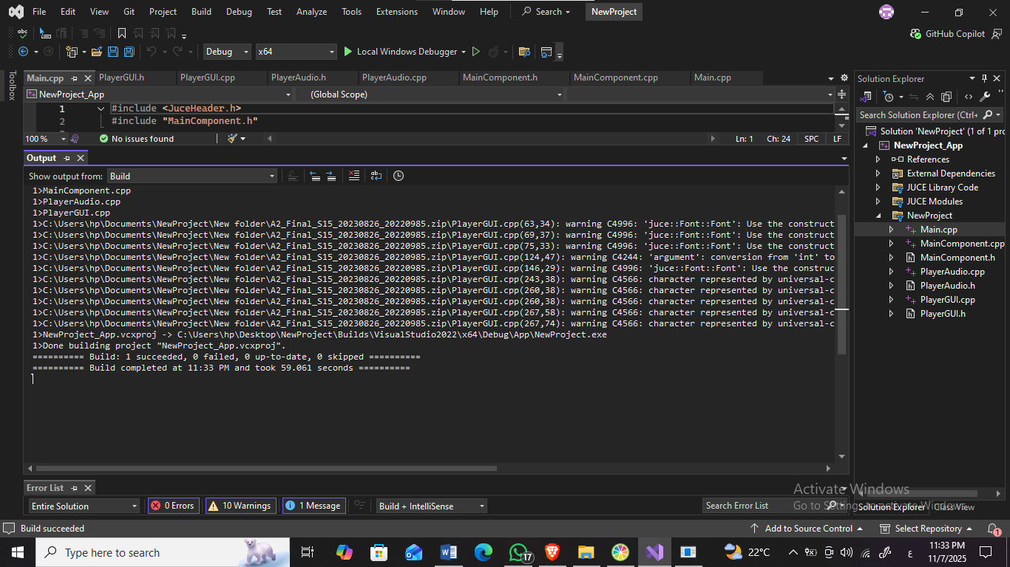

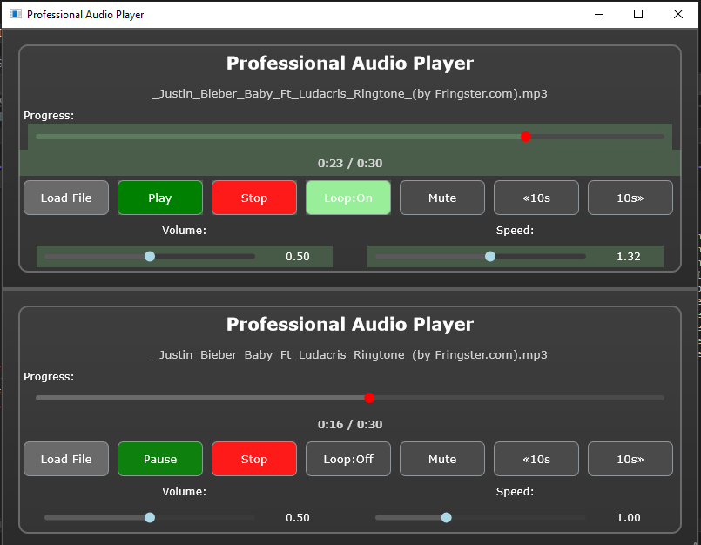
github
