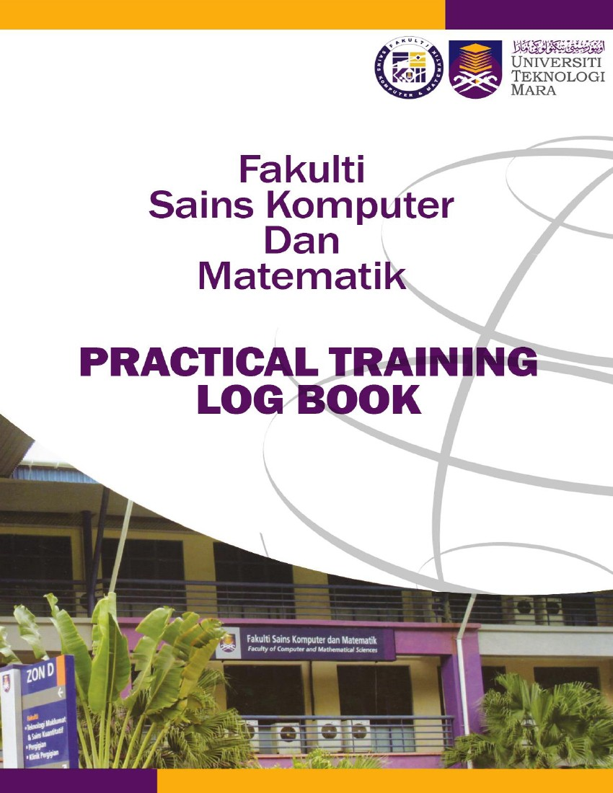


Instructions
This logbook is for you to provide a history of your industrial training and to act as a daily and/or weekly record by the work on which you are engaged.
Student’s responsibilities for keeping logbook up-to-date
Once you start your industrial training, you should consistently consult with your supervisor at the organization or supervisor-in-charge.
It is your responsibility to make the main entries of the logbook and keep it up to date. Entries
must be regularly (weekly) initialled by your Supervisor. You must ensure that:

1. Student’s name: SYAZA SHAHIRAH BINTI AZIZAN
1. It is available at your place of work during your industrial training.
2. All entries, except sketches, are made in ink, either handwritten or typed.
3. Entries are made within a week of the work to which they refer.
4. The logbook is handed to your Academic Supervisor upon his/her visit and submitted later be
handed to the Coordinator of Industrial Training when you return to UiTM for grading.
5. The logbook contributes 10% towards your final assessment.
Recording
The log book should contain the following information.
1. A neat concise description of each of your training location and the work on which you are
engaged.
2. Relevant sketches, data, flowcharts and diagrams.
3. References to textbooks, standards and other technical information related to the work
being under taken.
4. Constructive comments on the work being undertaken and your considered opinion as to
its value as training.
5. The logbook is to be written in ENGLISH.
2. UiTM Student No: 2023189465
3. Programme Course: CDCS253

4. Address during Industrial Training: Level 9, Bangunan Yayasan Sarawak, Jalan Masjid, 93000 Kuching, Sarawak.
5. Name of Organization: Sarawak Multimedia Authority (SMA)
6. Address of Organization: Level 5, Bangunan Yayasan Sarawak, Jalan Masjid, 93000 Kuching, Sarawak.
7. Name of Supervisor in-charge: TS. DR. SUHAILA BINTI JAAFAR
8. Name of Academic Supervisor:
9. Duration of training:
From: 10 MARCH 2025 to 13 JUNE 2025
FOR OFFICE USE ONLY
10. Remarks: (Coordinator of Industrial Training)
________________________________________________________________________
________________________________________________________________________
________________________________________________________________________
________________________________________________________________________
________________________________________________________________________
________________________________________________________________________

DATE | NATURE OF WORK DONE | SUPERVISOR’S REMARKS/  SIGNATURE
10 March 2025 | - Attended an Office Tour to explore the workplace and meet the team.  - Introduced to colleagues and had a briefing session with Cik Siti Zuraidha binti Salim (HR) about the company.  - Given Task 1: Develop External Training Application Form Web Based System  - Given Task 2: Create New Poster Template on Canva (Farewell and Announcement)
11 March 2025 | - Assigned to give meeting minutes, to be signed for approval by Ts. Dr. Suhaila binti Jaffar.  - Learned how to create DSign [ Digital Signing ].  - Continued working on Task 2 until completion.
12 March 2025 | - Worked on the poster and system before presenting progress.  - Presented Poster Template and System Progress to Puan Sophia binti Dris and Cik Siti Zuraidha binti Salim (Administrative Officers).  - Received corrections and made necessary fixes.  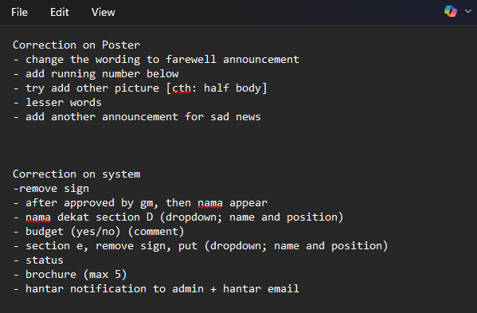
13 March 2025 | - Added GCR (Gantian Cuti Rehat) Form to the system.  - Worked on the form design and workflow.

14 March 2025 | - Continued working on the system development, focusing on GCR form and workflow improvements.
15 March 2025 | Weekend | -
16 March 2025 | Weekend | -
17 March 2025 | - Added Training Evaluation Form - V2 to the system.  - Fixed bugs and database issues.
18 March 2025 | 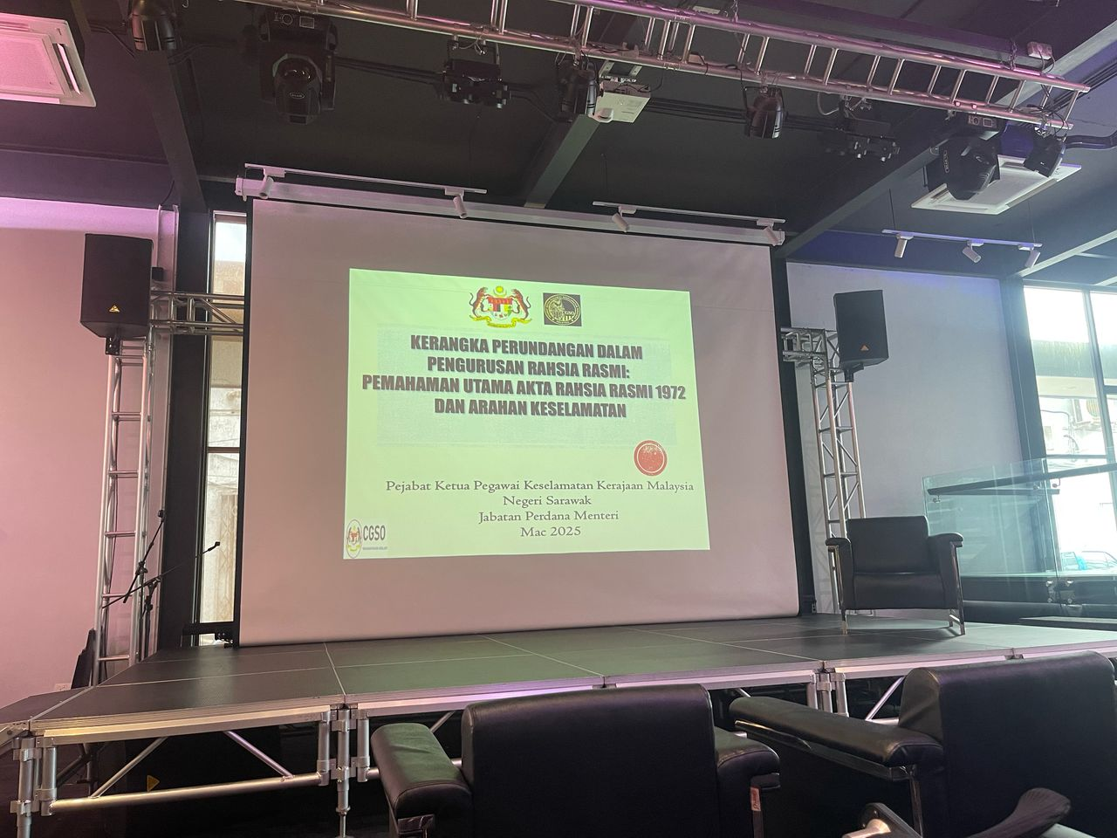  - Attended a sharing session on Kerangka Perundangan Dalam Pengurusan Rahsia Rasmi: Pemahaman Utama Akta Rahsia Rasmi 1972 dan Arahan Keselamatan by Azizol Rahman bin Yon (Pengarah Keselamatan Kerajaan) at CHIC Sarawak Multimedia Computing.  - Continued working on the system workflow and fixing bugs.

19 March 2025 | - Fixed bugs and improved workflow.  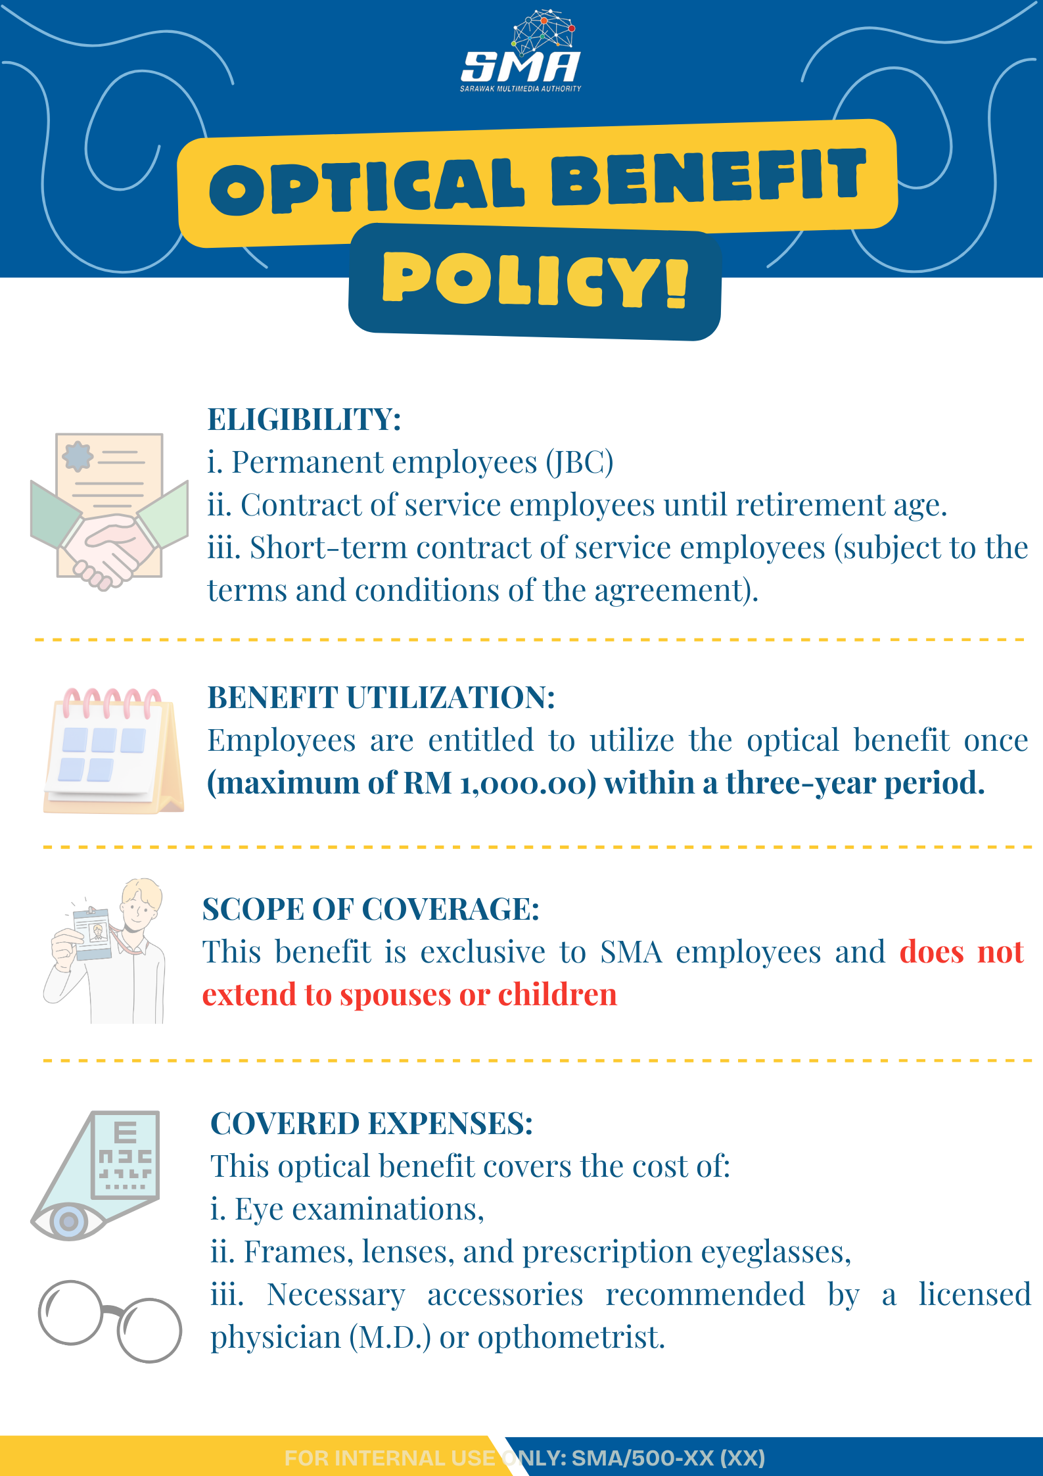  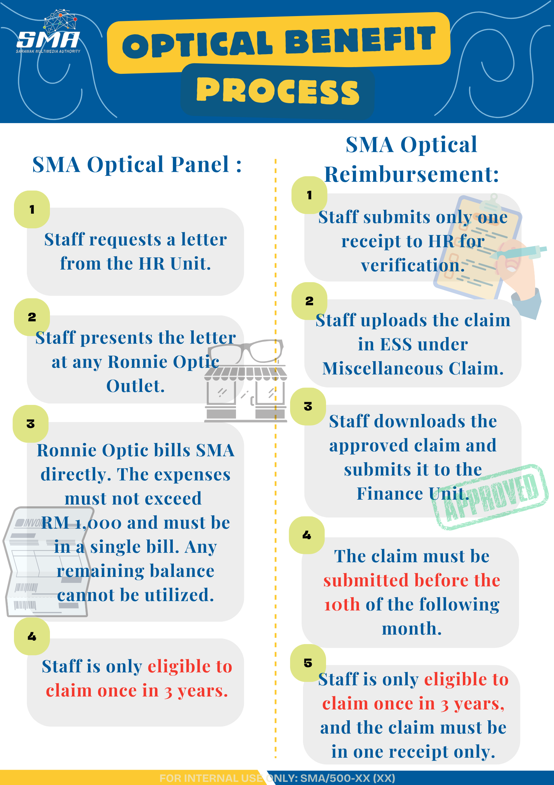  - Do infographics for Optical Benefit Policy.
20 March 2025 | - Continued working on the form system.  - Designed infographics for the announcement meeting minutes.  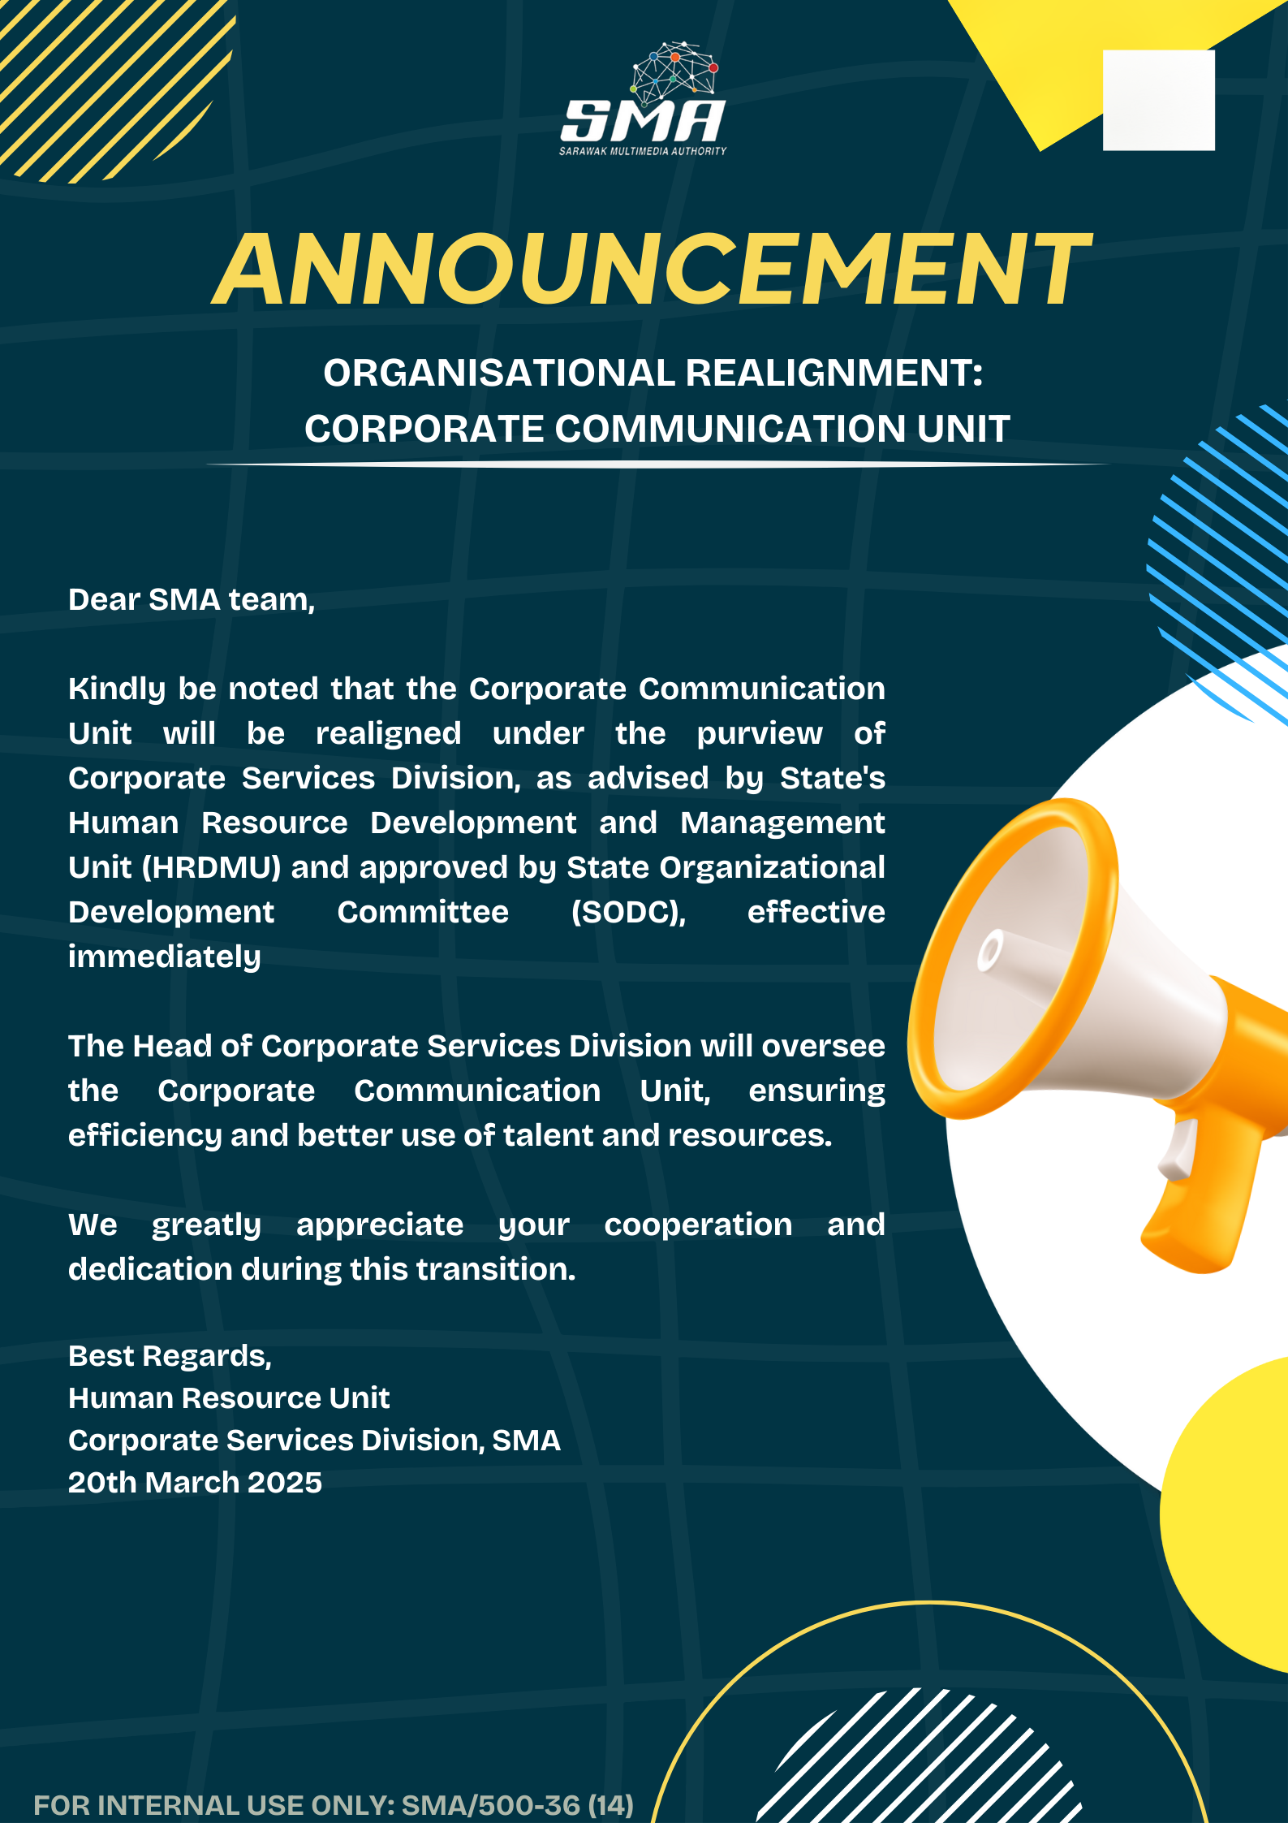
21 March 2025 | - Assisted the HR team in setting up the event, including rearranging chairs, capturing event photos, and ensuring all attendees scanned the attendance QR code.  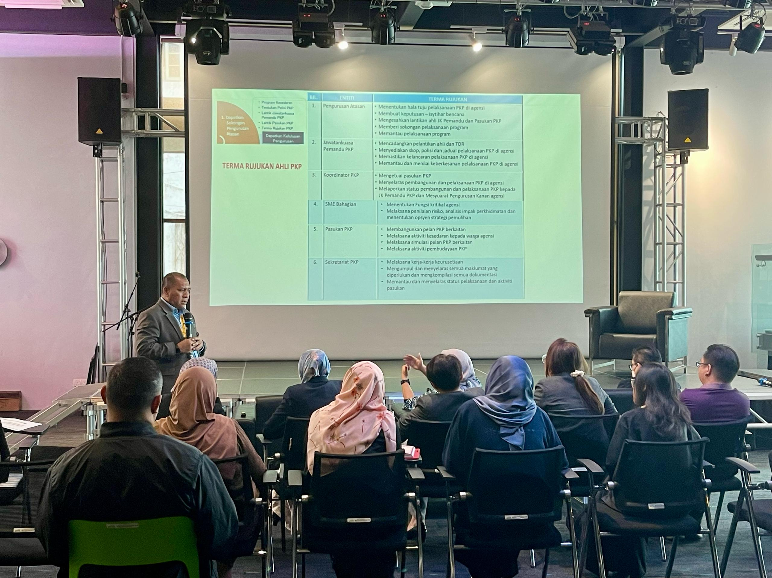  - Continued working on the system, focusing on fixing bugs.
22 March 2025 | Weekend | -
23 March 2025 | Weekend | -

24 March 2025 | - Continued working on the system, fixing bugs and improving the workflow. Resolved issues with data not fetching properly.
25 March 2025 | - Fixing bugs and resolving flow issues as multiple users and approvals are required for two different forms, causing the process to become mixed up.  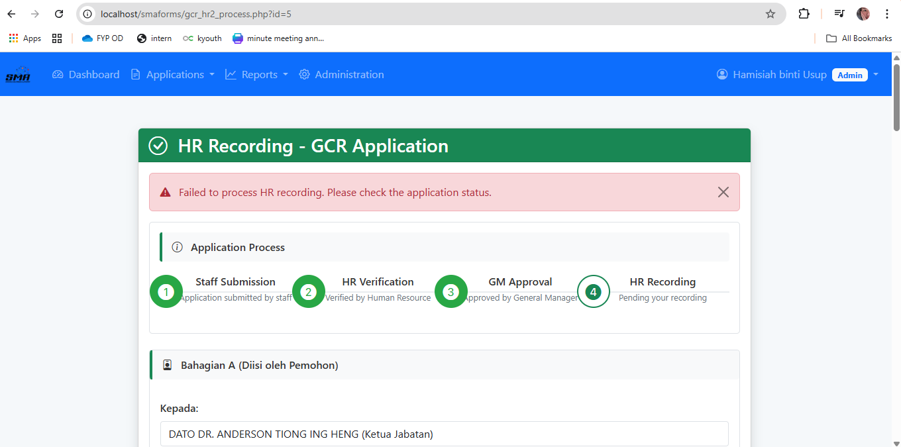
26 March 2025 | - Fixing fetch data problem.  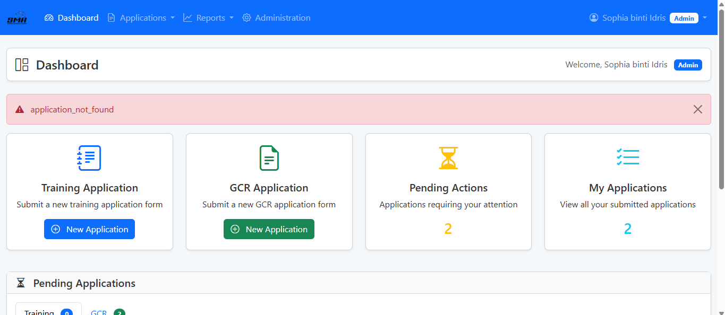  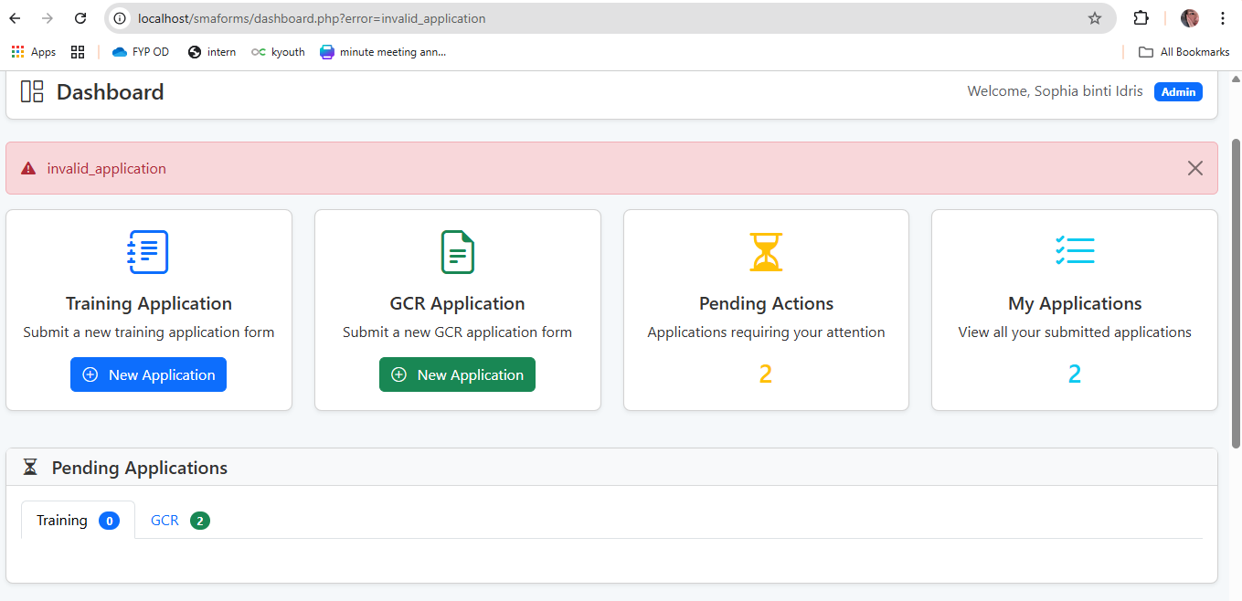
27 March 2025
28 March 2025
29 March 2025 | Weekend | -
30 March 2025 | Weekend | -
31 March 2025 | Public Holiday for Raya | -
1  April 2025 | Public Holiday for Raya | -
2  April 2025 | Unpaid Leave for Raya | -
3  April 2025 | Unpaid Leave for Raya | -
4
April 2025
5  April 2025 | Weekend | -
6  April 2025 | Weekend | -
7
April 2025
8
April

