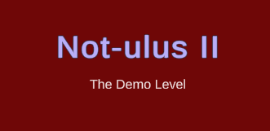

Not-ulus II – Closing Kit
V1.0.0
Written by: Cass Mepham
Point of contact: Cass Mepham (st20233132@outlook.cardiffmet.ac.uk / 07752 546695)
Date of publishing: 10th Jan, 2024
Table of Contents
Not-ulus II – Closing Kit 1
Instructions: 2
Repository: 2
https://github.com/20233132/CIS5014 2
Credits: 2
Issue List: 2
References 2

Instructions:
To play the game, open the unity executable. Past this, the instrustions are displayed on the main page. Once in the game, the escape key will allow you to exit.

Repository:

https://github.com/20233132/CIS5014

Credits:
Made by Cass Mepham,
using SFX taken from the Filmcow Royalty Free Sound Effect Library (FilmCow, 2023),
Created for a university project as a clone of Populous II, made by Bullfrog Entertainment

Issue List:
As a model demo, the game does not need to include all the features a full game of this type would have. However, one glaring issue is with model detail – the buildings in the game could have had more details directly built into the models (the game only uses around 12% of the poly limit given). In a continuation of this project, it may be worth allowing more leniency on polygon usage.

References
- FilmCow (2023) Filmcow Royalty Free Sound Effect Library. Available at: https://filmcow.itch.io/filmcow-sfx Accessed at: 13/12/2023

