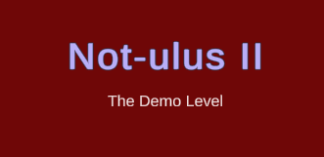

Not-ulus II – Technical Design Document
V1.0.0
Written by: Cass Mepham
Point of contact: Cass Mepham (st20233132@outlook.cardiffmet.ac.uk / 07752 546695)
Date of publishing: 10th Jan, 2024

Table of Contents
Not-ulus II – Technical Design Document 1
Development Requirements: 2
Asset Specifications: 2
File Naming Convention: 2
Level / World Details: 3
Development Plan 4
Asset References 4

Development Requirements:
- Development — Unity Version 2022.3.9f1, Visual Studio 2019
- Game Engine— Unity Version 2022.3.9f1
- 2D/3D Software — 3DS Max, Unity Version 2022.3.9f1, GIMP 2.10.36
- Project Management — Github
- Source Control — Github
- Sound Software — Audacity

Asset Specifications:
The game uses .WAV files for audio files, .PNG files for textures, and .FBX files to import models.

File Naming Convention:
The files in game are laid out using capitalisation for each word, and full caps for upgraded versions of other models. The code uses a convention of capitalising all words in a name except the first

Level / World Details:
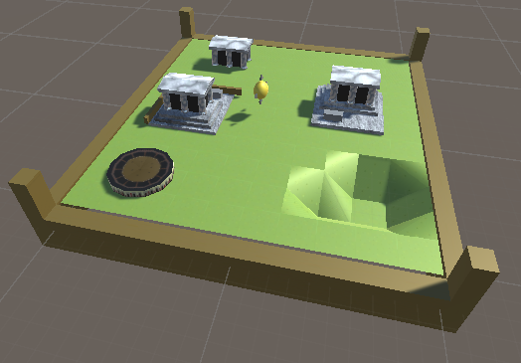
This is the demo Level, incorporating all of the used models and textures. In the bottom right, an example of the types of terrain that will be available in the final game is present

Development Plan
Milestones | Date | Deliverable
Pre-Production End | 10/01/24 | TDD  Demo level
Terrain Movement Function | 24/01/24 | Ability to lift and sink terrain. Ability to select terrain highlighted. Ability to create buildings
Character and Skills | 05/02/24 | Character Creator  Skill Tree  Passive abilities
Alpha | 20/02/24 | First Level,  Active Abilities,  Sound
Beta | 15/03/24 | Ten Levels,  Balancing,  Bug fixing from Alpha.
Final | 30/03/24 | Bug fixing from Beta.

Asset References
- FilmCow (2023) Filmcow Royalty Free Sound Effect Library. Available at: https://filmcow.itch.io/filmcow-sfx Accessed at: 13/12/2023

