

# CCT College Dublin Continuous Assessment

|  |  |  |  |
| --- | --- | --- | --- |
| Programme Title: | BSc (Hons) in Computing and IT Y4 | | |
| Cohort: | Y4 | | |
| Module Title(s): | Artificial Intelligence | | |
| Assignment Type: | Individual | Weighting(s): | 40% (AI) |
| Assignment Title: | AI_Lv8_CA2_v8 | | |
| Lecturer(s): | David McQuaid | | |
| Issue Date: | 16/10/2023 | | |
| Submission  Deadline Date: | 17/11/2023 | | |
| Late Submission Penalty: | Late submissions will be accepted up to 5 calendar days after the deadline. All late submissions are subject to a penalty of 10% of the mark awarded.  Submissions received more than 5 calendar days after the deadline above will not be accepted and a mark of 0% will be awarded. | | |
| Method of Submission: | Moodle | | |
| Instructions for Submission: | Assessment must be submitted before 11.55pm 17/11/2023 as a Jupyter Notebook file and a CSV file containing your Dataset   * The Jupyter Notebook File Must be saved as “YourName_AI_CA2.ipynb” | | |
| Feedback Method: | Results released on Moodle | | |
| Feedback Date: | 2 weeks after final submission Inc PMC | | |

Learning Outcomes:

Please note this is not the assessment task. The task to be completed is detailed on the next page. This CA will assess student attainment of the following minimum intended learning outcomes:

# Artificial Intelligence

MLO 2 - Distinguish the different agents and environments of current Artificial Intelligence, being aware of consideration to perception / action and potential changes to environment.

(Linked to PLO 2 (Stage 4 SLO 2))

MLO 3 - Understand the differences and challenges involved in developing different levels of

Artificial Intelligence

(Linked to PLO 3 (Stage 4 SLO 3))

MLO 4 - Identify and apply an appropriate problem-solving strategy in relation to search, non-classical search, Adversarial Search, Constraint Satisfaction Problem. (Linked to PLO 5 (Stage 4 SLO 5))

Attainment of the learning outcomes is the minimum requirement to achieve a Pass mark (40%). Higher marks are awarded where there is evidence of achievement beyond this, in accordance with QQI Assessment and Standards, Revised 2013, and summarised in the following table:

|  |  |  |
| --- | --- | --- |
| Percentage Range | CCT  Performance  Description | QQI Description of Attainment |
| Level 6, 7 & 8 awards |
| 90% + | Exceptional | Achievement includes that required for a Pass and in most respects is significantly and consistently beyond this |
| 80 – 89% | Outstanding |
| 70 – 79% | Excellent |
| 60 – 69% | Very Good | Achievement includes that required for a Pass and in many respects is significantly beyond this |
| 50 – 59% | Good | Achievement includes that required for a Pass and in some respects is significantly beyond this |
| 40 – 49% | Acceptable | Attains all the minimum intended programme learning outcomes |
| 35 – 39% | Fail | Nearly (but not quite) attains the relevant minimum intended learning outcomes |
| 0 – 34% | Fail | Does not attain some or all of the minimum intended learning outcomes |

Please review the CCT Grade Descriptor available on the module Moodle page for a detailed description of the standard of work required for each grade band.

The grading system in CCT is the QQI percentage grading system and is in common use in higher education institutions in Ireland. The pass mark and thresholds for different grade bands may be different from what you have experience of in the higher education system in other countries. CCT grades must be considered in the context of the grading system in Irish higher education and not assumed to represent the same standard the percentage grade reflects when awarded in an international context.

# Assessment Task

Students are advised to review and adhere to the submission requirements documented after the assessment task.

# Questions

1. A puzzle has multiple ways of reaching the end solution. Fig. 1 shows a graph that represents all possible routes to the solution. The starting point of the game is represented by A, the solution is represented by S. The other points in the graph are possible intermediary stages.

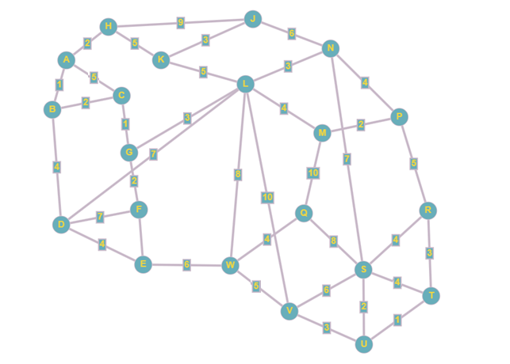

Fig. 1

* 1. The graph in Fig. 1 is a visualisation of the problem.
     1. Identify the differences between a graph and a tree. [0-5]
     2. Explain in detail how the graph is an abstraction of the problem. [0-5]
     3. Identify the advantages of using a visualisation such as the one shown in Fig. 1. [0-5]
  2. Demonstrate how Dijkstra’s algorithm would find the shortest path to the solution in Fig.1 through diagrams and written explanation of each stage. [0-25]

1. The creator of the puzzle has been told that the A* algorithm is more efficient at finding the shortest path because it uses heuristics. Compare the performance of Dijkstra’s algorithm and the A* search algorithm, referring to heuristics, to find the shortest path to the problem by implementing both algorithms programmatically and comparing the solutions generated in Mark-down. Refer to the complexity of the algorithms and **compare the actual time** it takes for the solutions to be processed. [0-60]

## Note

* All written work MUST be completed in Jupyter Notebook Markdown (please review “Jupyter Notebook Tutorial” Notes in Moodle if you are unsure of this).
* All data wrangling, analysis, and visualizations must be generated using python.
* All Code must be included in code blocks (As normal). No other upload will be accepted.
* All written work MUST be detailed in your Jupyter Markdown (NOT in code comments).

**Submissions that are suspected of plagiarism and/or inclusion of AI (CHATGBT, BARD etc…) Generated content will be referred to the college authorities.**

**Note ALL Students are required to use Git for any Assignments that they are working on.**

This means that ALL changes must be committed to Git during your assignment. (Not just a single commit at the end!) This is to allow you to display your incremental progress throughout the assessments, give you practice for your capstone/thesis, allows you to create an online portfolio that can be used to showcase your work and to ensure that there are no problems with final uploads (as all your work will be available on GitHub). It is expected that there will be a minimum of 10 commits (with many of you making very many more).

**You may Only use your CCT email for your git account, private/work email-based accounts will not be accepted. You must also include your lecturer's CCT email as a collaborator on your account.**

**Students are advised to review and adhere to the submission requirements documented after the assessment task.**

### Submission Requirements

All assessment submissions must meet the minimum requirements listed below. Failure to do so may have implications for the mark awarded.

All assessment submissions must:

* Be submitted before 11.55pm 17/11/2023 as a Jupyter Notebook file.
* The Jupyter Notebook File Must be saved as “YourName_DV_CA2.ipynb”
* Be submitted by the deadline date specified or be subject to late submission penalties
* Be submitted via Moodle upload
* Use Harvard Referencing when citing third party material
* Be the student’s own work.
* Include the CCT assessment cover page.

### Additional Information

* Lecturers are not required to review draft assessment submissions.
* In accordance with CCT policy, feedback to learners may be provided in written, audio or video format and can be provided as individual learner feedback, small group feedback or whole class feedback.
* Results and feedback will only be issued when assessments have been marked and moderated / reviewed by a second examiner.
* Additional feedback may be requested at the next class, Additional feedback may be provided as individual, small group or whole class feedback. Lecturers are not obliged to respond to email requests for additional feedback where this is not the specified process or to respond to further requests for feedback following the additional feedback.
* Following receipt of feedback, where a student believes there has been an error in the marks or feedback received, they should avail of the recheck and review process and should not attempt to get a revised mark / feedback by directly approaching the lecturer. Lecturers are not authorised to amend published marks outside of the recheck and review process or the Board of Examiners process.
* Students are advised that disagreement with an academic judgement is not grounds for review.
* For additional support with academic writing and referencing students are advised to contact the CCT Library Service or access the CCT Learning Space.
* For additional support with subject matter content students are advised to contact the CCT Student Mentoring Academy
* For additional support with IT subject content, students are advised to access the CCT Support Hub.