SMART CAMPUS NETWORK
Complete Testing, Troubleshooting and Verification Report
University of Limpopo Smart Campus Network Project
Cisco Packet Tracer

1. Purpose and Scope
This document records the complete testing process performed on the smart campus network. It includes the devices used, commands entered, expected behaviour, actual results, troubleshooting steps, retests, and final conclusions. The report also documents the special use of one Guest Test PC as a reusable test endpoint for Guest, IoT and CCTV Zero-Trust policies. Results are reported as observed; where Packet Tracer did not demonstrate a function, the report states that limitation instead of claiming success.

2. Key Devices Used During Testing
Device | Role | Testing use / addressing
MAIN-FW1 | Cisco ASA firewall | Inside 10.10.255.1/29; outside 172.16.1.2/30; firewall ACLs, PAT and site-to-site IPSec VPN.
MAIN-EDGE-R1 | Cisco 2911 edge router | Gi0/0 172.16.0.2/30; Gi0/1 172.16.1.1/30; WAN-QOS applied outbound on Gi0/0.
DIST-SW1 | Layer-3 distribution switch | Primary HSRP device for most VLANs; routing, ACL and Syslog verification.
DIST-SW2 | Layer-3 distribution switch | HSRP standby/redundant distribution device; trunk and STP verification.
ASW-SERVER1 | Access switch | Server/access switch; Fa0/12 was used for the reusable Guest Test PC; trunks to distribution.
CME-R1 | Call Manager Express router | Phone registration and inter-site VoIP call verification.
Guest Test PC | Reusable endpoint | Normally VLAN 110, IP 10.10.5.12/24. Temporarily reassigned to VLAN 130 and VLAN 120 to test IoT-ZT and CCTV-ZT, then restored to VLAN 110.
Admin PC | Authorized endpoint | IP 10.10.8.141/26, gateway 10.10.8.129; internal and inter-site performance tests.
DNS Server | Server | 10.10.9.100; internal DNS service.
WLC Main | Wireless LAN Controller | 10.10.9.70; internal DNS and latency destination.
IoT authorized server | Server | 10.10.9.105; permitted destination for IoT-ZT.
CCTV authorized server | Server | 10.10.9.106; permitted destination for CCTV-ZT.
Syslog server | Monitoring server | 10.10.9.103, UDP 514.
Satellite phone | VoIP endpoint | 10.20.1.141, extension 2001; inter-site ping and VoIP testing.

3. Overall Test Summary
Test | Evidence | Result | Status
Core/Firewall inside reachability | Ping 10.10.255.2 | 4/4 replies, 0% loss | PASS
Distribution routed link | Ping 10.10.255.18 | 4/4 replies, 0% loss | PASS
Firewall inside interface | Ping 10.10.255.1 | Retest 4/4, 0% loss | PASS
HSRP redundancy | show standby brief | Active/Standby virtual gateways present | PASS
Guest DHCP/VLAN | ipconfig | 10.10.5.12/24, GW 10.10.5.1 | PASS
Guest-ZT isolation | Guest -> Admin ping + ACL counter | 100% loss; deny rule 4 matches | PASS
Internal DNS | nslookup wlc.unilim.local | Resolved 10.10.9.70 | PASS
IoT VLAN/gateway | Reusable PC + ping 10.10.8.1 | 4/4 replies after ACL correction | PASS
IoT authorized server | Ping 10.10.9.105 | Retest 4/4, 0% loss; permit counter 8 | PASS
IoT-ZT isolation | Ping 10.10.8.129 | 100% loss; deny counter 4 | PASS
CCTV VLAN/gateway | Reusable PC + ping 10.10.8.193 | 4/4 replies after ACL correction | PASS
CCTV authorized server | Ping 10.10.9.106 | Retest 4/4, 0% loss; permit counter 8 | PASS
CCTV-ZT isolation | Ping 10.10.8.129 | 100% loss; deny counter 4 | PASS
IPSec IKE | show crypto isakmp sa | QM_IDLE, active L2L SA | PASS
IPSec traffic | show crypto ipsec sa | Encrypted/decrypted counters; 0 errors | PASS
Inter-site reachability | Admin -> 10.20.1.141 | Retest 4/4, 0% loss | PASS
Inter-site VoIP | CME show ephone | 1001 and 2001 CONNECTED | PASS
QoS deployment | show policy-map interface | WAN-QOS on Gi0/0 | PASS
Live RTP classification | QoS counters | 0 RTP packets counted | NOT DEMONSTRATED
Syslog | show logging | 101 messages, 0 dropped to 10.10.9.103 | PASS
Internal latency | Admin -> WLC | Retest avg 22 ms, 0% loss | PASS
VPN latency | Admin -> satellite | Retest avg 41 ms; later post-PAT avg 23 ms | PASS
Dynamic PAT | show nat | translate_hits increased 0 -> 7 -> 13 | PASS
Post-PAT VPN | Admin -> 10.20.1.141 | Retest 4/4, avg 23 ms | PASS

4. Detailed Test Procedure and Results

4.1 Basic Routing and Firewall Reachability

Test 4.1.1 - Reachability to 10.10.255.2
Purpose: Verify routed connectivity toward the campus/firewall-side next hop.
Devices used: Test PC and routed campus infrastructure
Commands / method:
ping 10.10.255.2
How the result was obtained: The endpoint sent four ICMP echo requests. All four returned successfully.
Observed result: 4 sent, 4 received, 0% loss; TTL 254; time <1 ms.
Final status: PASS

Test 4.1.2 - Reachability to 10.10.255.18
Purpose: Verify connectivity to the second routed infrastructure address.
Devices used: Test PC and distribution/core routed link
Commands / method:
ping 10.10.255.18
How the result was obtained: Four ICMP requests were sent to the routed address.
Observed result: 4 sent, 4 received, 0% loss; average 12 ms.
Final status: PASS

Test 4.1.3 - Firewall inside interface
Purpose: Verify reachability to MAIN-FW1 inside interface 10.10.255.1.
Devices used: Test PC, campus routing, MAIN-FW1
Commands / method:
ping 10.10.255.1
How the result was obtained: The first run had one timeout; the test was immediately repeated after convergence/ARP learning.
Observed result: First run: 25% loss, average 75 ms. Retest: 4/4 replies, 0% loss, average 3 ms.
Issue / troubleshooting: The first packet loss was transient. The stable retest was used as the final connectivity result.
Final status: PASS

4.2 HSRP Gateway Redundancy

Test 4.2.1 - DIST-SW1 HSRP state
Purpose: Verify that DIST-SW1 provides active virtual gateways with preemption.
Devices used: DIST-SW1
Commands / method:
show standby brief
How the result was obtained: The HSRP table was inspected for all configured VLANs.
Observed result: DIST-SW1 showed priority 110 with preempt and Active state for VLANs 10,20,30,40,50,60,70,80,90,100,110,120,130,140. Examples: VLAN110 VIP 10.10.5.1; VLAN130 VIP 10.10.8.1; VLAN120 VIP 10.10.8.193.
Final status: PASS

Test 4.2.2 - DIST-SW2 HSRP state
Purpose: Verify the redundant distribution switch participates as standby.
Devices used: DIST-SW2
Commands / method:
show standby brief
How the result was obtained: The second distribution switch was checked against the primary.
Observed result: DIST-SW2 showed priority 100 and Standby for most VLANs, confirming redundant gateway participation. VLAN20 was observed Active with standby unknown during one snapshot, indicating an HSRP state/convergence condition at that moment.
Issue / troubleshooting: HSRP state-change messages were later visible in Syslog, and stable gateway pings confirmed operational convergence.
Final status: PASS

4.3 Reusable Guest Test PC Methodology
A single physical/simulated endpoint labelled as the Guest Test PC was reused to test three restricted security zones. This was acceptable because the purpose was to test VLAN and ACL policy behaviour, not the identity of the PC itself. The endpoint was moved between access VLANs by changing the switchport VLAN and renewing its addressing. After each security-zone test, its IP configuration was checked so the report could prove which VLAN it was representing.
Normal Guest configuration: ASW-SERVER1 FastEthernet0/12 was an access port in VLAN 110 (GUEST-WIFI). The PC received 10.10.5.12/24 with default gateway 10.10.5.1.
For IoT testing, the same endpoint was temporarily placed in VLAN 130 and received 10.10.8.32/25 with gateway 10.10.8.1. For CCTV testing, it was temporarily placed in VLAN 120 and received 10.10.8.202/26 with gateway 10.10.8.193. After testing, FastEthernet0/12 was restored to VLAN 110 and the PC again received 10.10.5.12/24.
ASW-SERVER1# configure terminal
ASW-SERVER1(config)# interface FastEthernet0/12
ASW-SERVER1(config-if)# switchport mode access
ASW-SERVER1(config-if)# switchport access vlan <110 | 130 | 120>
ASW-SERVER1(config-if)# no shutdown
PC: Desktop -> IP Configuration -> DHCP
PC> ipconfig
This approach allowed Guest-ZT, IOT-ZT and CCTV-ZT to be tested with one endpoint while still producing valid evidence for each security zone. The critical evidence was the IP address/gateway received in each VLAN plus the corresponding ACL permit/deny match counters.

4.4 Guest VLAN 110 and GUEST-ZT

Test 4.4.1 - Guest addressing
Purpose: Confirm the reusable PC was restored to the Guest network.
Devices used: Guest Test PC, ASW-SERVER1, VLAN 110
Commands / method:
ipconfig
How the result was obtained: The access port was restored to VLAN 110 and DHCP was renewed.
Observed result: IPv4 10.10.5.12, mask 255.255.255.0, gateway 10.10.5.1.
Final status: PASS

Test 4.4.2 - Guest gateway troubleshooting
Purpose: Verify the Guest PC can reach its HSRP gateway while remaining isolated from other internal networks.
Devices used: Guest Test PC, DIST-SW1/DIST-SW2, ASW-SERVER1
Commands / method:
ping 10.10.5.1
show standby brief
show arp
show interfaces trunk
show spanning-tree vlan 110
show cdp neighbors
How the result was obtained: Initial gateway pings failed. HSRP and ARP were checked. DIST-SW1 knew 10.10.5.12 in VLAN110. Trunk and STP checks confirmed VLAN110 forwarding. The ACL was then inspected and corrected so same-subnet traffic was permitted before the broad internal deny.
Observed result: After correction/reconvergence, first retest had 3/4 replies; second retest had 4/4 replies, 0% loss.
Issue / troubleshooting: The original broad deny covered 10.10.0.0/16 and unintentionally affected legitimate local/gateway communication. A same-subnet permit was placed before the deny.
Final status: PASS
GUEST-ZT final relevant rules:
10 permit udp any host 10.10.9.100 eq domain
20 permit udp any host 10.10.9.100 eq bootps
30 permit ip 10.10.5.0 0.0.0.255 10.10.5.0 0.0.0.255
40 deny ip 10.10.5.0 0.0.0.255 10.10.0.0 0.0.255.255
50 permit ip any any

Test 4.4.3 - Guest Zero-Trust unauthorized access
Purpose: Prove that a Guest endpoint cannot access the protected Admin network.
Devices used: Guest Test PC, DIST-SW1 GUEST-ZT ACL, Admin VLAN gateway
Commands / method:
ping 10.10.8.129
show access-lists
How the result was obtained: The Guest PC attempted four ICMP packets to the Admin HSRP gateway. Immediately afterwards the GUEST-ZT ACL counter was checked.
Observed result: Ping: 0/4 received, 100% loss. GUEST-ZT deny rule 40 recorded exactly 4 matches.
Issue / troubleshooting: This is the controlled unauthorized-access/data-breach simulation. The ACL counter proves the failure was caused by the security policy rather than an unexplained connectivity problem.
Final status: PASS

Test 4.4.4 - Guest DNS policy
Purpose: Verify the Guest policy permits DNS to the internal DNS server.
Devices used: Guest Test PC, DNS server 10.10.9.100, GUEST-ZT ACL
Commands / method:
nslookup wlc.unilim.local
show access-lists
How the result was obtained: An external name (www.cisco.com) first returned a non-existent-domain result because the local Packet Tracer DNS server did not contain that public record. The internal record was then tested.
Observed result: wlc.unilim.local resolved successfully to 10.10.9.70. GUEST-ZT DNS permit rule showed matches.
Issue / troubleshooting: The failed www.cisco.com lookup was a DNS-content issue, not proof that DNS transport was blocked. The internal lookup verified DNS service and ACL permission.
Final status: PASS

4.5 IoT VLAN 130 and IOT-ZT

Test 4.5.1 - Reassign reusable PC to IoT
Purpose: Use the same endpoint to represent an IoT device.
Devices used: Guest Test PC reused as IoT Test PC, ASW-SERVER1 Fa0/12, VLAN130
Commands / method:
switchport access vlan 130
PC DHCP renewal
ipconfig
How the result was obtained: The access port was temporarily moved to VLAN130 and DHCP was renewed.
Observed result: IPv4 10.10.8.32, mask 255.255.255.128, gateway 10.10.8.1.
Final status: PASS

Test 4.5.2 - IoT gateway troubleshooting
Purpose: Verify the IoT endpoint can reach its own HSRP gateway.
Devices used: IoT Test PC, DIST-SW1/DIST-SW2, IOT-ZT
Commands / method:
ping 10.10.8.1
show access-lists
How the result was obtained: The initial ping failed and returned Destination host unreachable from 10.10.8.2. The IOT-ZT ACL was inspected. A same-subnet permit was added before the broad internal deny.
Observed result: After correction: 4/4 replies, 0% loss, average 0 ms.
Issue / troubleshooting: The broad deny 10.10.8.0/25 -> 10.10.0.0/16 also covered the IoT subnet/gateway. Adding the same-subnet permit corrected the policy order.
Final status: PASS
IOT-ZT final relevant rules:
10 permit udp 10.10.8.0 0.0.0.127 host 10.10.9.100 eq domain
20 permit ip 10.10.8.0 0.0.0.127 host 10.10.9.105
30 permit udp 10.10.8.0 0.0.0.127 host 10.10.9.100 eq bootps
40 permit ip 10.10.8.0 0.0.0.127 10.10.8.0 0.0.0.127
45 deny ip 10.10.8.0 0.0.0.127 10.10.0.0 0.0.255.255
50 permit ip any any

Test 4.5.3 - IoT authorized server
Purpose: Prove IoT devices can reach the specifically authorized IoT server.
Devices used: IoT Test PC, IoT server 10.10.9.105, IOT-ZT ACL
Commands / method:
ping 10.10.9.105
show access-lists
How the result was obtained: The server was pinged twice. The first run had one timeout; the stable retest succeeded. ACL counters were checked.
Observed result: Retest: 4/4 replies, 0% loss, average 10 ms. IOT-ZT rule 20 showed 8 matches.
Final status: PASS

Test 4.5.4 - IoT isolation from Admin
Purpose: Prove IoT cannot laterally access the Admin network.
Devices used: IoT Test PC, Admin gateway 10.10.8.129, IOT-ZT ACL
Commands / method:
ping 10.10.8.129
show access-lists
How the result was obtained: Four packets were sent toward the Admin gateway and the ACL deny counter was checked.
Observed result: 0/4 received, 100% loss. IOT-ZT deny rule 45 recorded 4 matches.
Final status: PASS

4.6 CCTV VLAN 120 and CCTV-ZT

Test 4.6.1 - Reassign reusable PC to CCTV
Purpose: Use the same endpoint to represent a CCTV device.
Devices used: Guest Test PC reused as CCTV Test PC, ASW-SERVER1 Fa0/12, VLAN120
Commands / method:
switchport access vlan 120
PC DHCP renewal
ipconfig
How the result was obtained: The port was temporarily moved to VLAN120 and DHCP was renewed.
Observed result: IPv4 10.10.8.202, mask 255.255.255.192, gateway 10.10.8.193.
Final status: PASS

Test 4.6.2 - CCTV gateway troubleshooting
Purpose: Verify CCTV endpoint can reach its own HSRP gateway.
Devices used: CCTV Test PC, DIST-SW1/DIST-SW2, CCTV-ZT
Commands / method:
ping 10.10.8.193
show access-lists
How the result was obtained: The first test failed with Destination host unreachable from 10.10.8.194. CCTV-ZT was inspected and the same-subnet permit was inserted before the broad internal deny.
Observed result: After correction: 4/4 replies, 0% loss.
Final status: PASS
CCTV-ZT final relevant rules:
10 permit udp 10.10.8.192 0.0.0.63 host 10.10.9.100 eq domain
20 permit ip 10.10.8.192 0.0.0.63 host 10.10.9.106
30 permit udp 10.10.8.192 0.0.0.63 host 10.10.9.100 eq bootps
40 permit ip 10.10.8.192 0.0.0.63 10.10.8.192 0.0.0.63
45 deny ip 10.10.8.192 0.0.0.63 10.10.0.0 0.0.255.255
50 permit ip any any

Test 4.6.3 - CCTV authorized server
Purpose: Prove CCTV can reach only its authorized service.
Devices used: CCTV Test PC, CCTV server 10.10.9.106, CCTV-ZT
Commands / method:
ping 10.10.9.106
show access-lists
How the result was obtained: The first run had one timeout. The test was repeated and ACL counters were checked.
Observed result: Retest: 4/4 replies, 0% loss, average 14 ms. CCTV-ZT permit rule 20 showed 8 matches.
Final status: PASS

Test 4.6.4 - CCTV isolation from Admin
Purpose: Prove CCTV cannot laterally access the Admin network.
Devices used: CCTV Test PC, Admin gateway 10.10.8.129, CCTV-ZT
Commands / method:
ping 10.10.8.129
show access-lists
How the result was obtained: The endpoint attempted four packets toward the Admin gateway.
Observed result: 0/4 received, 100% loss. CCTV-ZT deny rule 45 recorded 4 matches.
Final status: PASS

4.7 Restore the Reusable Test PC to Guest VLAN

Test 4.7.1 - Restore Guest Test PC
Purpose: Return the endpoint to its original role after IoT/CCTV testing.
Devices used: ASW-SERVER1 Fa0/12, Guest Test PC
Commands / method:
configure terminal
interface FastEthernet0/12
switchport mode access
switchport access vlan 110
no shutdown
end
PC DHCP renewal
ipconfig
How the result was obtained: After all IoT and CCTV tests, the port was restored to VLAN110 and DHCP was renewed.
Observed result: The PC again received 10.10.5.12/24 with gateway 10.10.5.1.
Final status: PASS

4.8 Access Switch, Trunk and Spanning Tree Verification

Test 4.8.1 - ASW-SERVER1 VLAN membership
Purpose: Verify VLANs and access-port assignments.
Devices used: ASW-SERVER1
Commands / method:
show vlan brief
show interfaces status
How the result was obtained: The switch VLAN database and port states were inspected.
Observed result: VLAN110 was active on Fa0/12; VLAN80 on Fa0/2-Fa0/9; VLAN90 on Fa0/11; Fa0/10, Gi0/1 and Gi0/2 were trunks. Unused Fa0/13-Fa0/24 were disabled.
Final status: PASS

Test 4.8.2 - Trunk VLAN propagation
Purpose: Verify required VLANs are allowed across uplinks.
Devices used: ASW-SERVER1
Commands / method:
show interfaces trunk
How the result was obtained: Allowed VLAN lists and STP forwarding state were inspected.
Observed result: Fa0/10 allowed 10,30,100,110,130. Gi0/1 and Gi0/2 allowed 10,30,80,90,100,110,120,130. VLAN110 forwarded via Gi0/1 while Gi0/2 was blocked by STP for redundancy.
Final status: PASS

Test 4.8.3 - STP VLAN110
Purpose: Verify loop prevention and active path selection.
Devices used: ASW-SERVER1, DIST-SW2
Commands / method:
show spanning-tree vlan 110
How the result was obtained: STP roles were checked on the access and distribution switches.
Observed result: ASW-SERVER1 Gi0/1 = Root FWD, Gi0/2 = Alternate BLK. DIST-SW2 Fa0/8 = Designated FWD and Po1 = Root FWD.
Final status: PASS

Test 4.8.4 - Neighbor/uplink identification
Purpose: Identify the distribution neighbor connected to ASW-SERVER1.
Devices used: ASW-SERVER1, DIST-SW2
Commands / method:
show cdp neighbors
DIST-SW2: show running-config | section interface FastEthernet0/8
How the result was obtained: CDP showed DIST-SW2 on ASW-SERVER1 Gi0/2, with DIST-SW2 Fa0/8. The remote port configuration was checked.
Observed result: DIST-SW2 Fa0/8 was an 802.1Q trunk allowing VLANs 10,30,80,90,100,110,130.
Final status: PASS

4.9 Firewall, Routing, ACL, NAT/PAT and VPN

Test 4.9.1 - MAIN-FW1 interfaces
Purpose: Verify firewall inside/outside interfaces are operational.
Devices used: MAIN-FW1
Commands / method:
show interface ip brief
How the result was obtained: ASA VLAN interfaces were inspected.
Observed result: Vlan1 inside 10.10.255.1 up/up; Vlan2 outside 172.16.1.2 up/up. Ethernet0/0 and Ethernet0/1 were up; unused interfaces were administratively down.
Final status: PASS

Test 4.9.2 - Firewall routing
Purpose: Verify routes toward campus and WAN.
Devices used: MAIN-FW1
Commands / method:
show route
How the result was obtained: The ASA routing table was inspected.
Observed result: Static route to 10.10.0.0/16 via 10.10.255.2 inside; default route via 172.16.1.1 outside.
Issue / troubleshooting: Packet Tracer also displayed unusual extra connected entries for 10.0.0.0/29 and 172.16.0.0/30. They were not used as proof of the configured interface networks; the actual interface addresses and working traffic were used instead.
Final status: PASS

Test 4.9.3 - Firewall outside ACL
Purpose: Verify controlled satellite-to-main traffic is permitted.
Devices used: MAIN-FW1
Commands / method:
show access-list
How the result was obtained: The applied OUTSIDE-IN ACL was inspected for hit counters.
Observed result: OUTSIDE-IN permitted 10.20.0.0/16 -> 10.10.0.0/16 and showed hitcnt=9.
Final status: PASS

Test 4.9.4 - ASA to edge-router link diagnosis
Purpose: Check the direct firewall-to-edge-router connection.
Devices used: MAIN-FW1, MAIN-EDGE-R1
Commands / method:
MAIN-FW1: ping 172.16.1.1; show arp
MAIN-EDGE-R1: show ip interface brief; show arp; ping 172.16.1.2
How the result was obtained: Device-originated pings failed in both directions, but both interfaces were up/up and each device had learned the other device MAC address by ARP.
Observed result: ICMP device-originated ping: 0/5 in both directions. ARP resolution successful; VPN traffic continued to operate across the path.
Issue / troubleshooting: The failed device-originated ICMP was not treated as a broken Layer-2 link because ARP was successful and IPSec traffic was actively traversing the outside path.
Final status: PARTIAL / LINK OPERATIONAL

Test 4.9.5 - Edge router routes
Purpose: Verify return path toward campus and default path toward WAN.
Devices used: MAIN-EDGE-R1
Commands / method:
show ip route
How the result was obtained: The edge routing table was inspected.
Observed result: 10.10.0.0/16 via 172.16.1.2; connected 172.16.0.0/30 and 172.16.1.0/30; default route via 172.16.0.1.
Final status: PASS

Test 4.9.6 - Initial NAT check
Purpose: Determine whether NAT was configured before changes.
Devices used: MAIN-FW1
Commands / method:
show run nat
show xlate
show nat
How the result was obtained: NAT commands were checked before configuration.
Observed result: No NAT rule was displayed; show xlate reported 0 in use, 0 most used.
Final status: NOT CONFIGURED INITIALLY

Test 4.9.7 - Configure dynamic PAT
Purpose: Translate campus addresses to the ASA outside interface for ordinary outside traffic.
Devices used: MAIN-FW1
Commands / method:
configure terminal
object network CAMPUS-NET
subnet 10.10.0.0 255.255.0.0
nat (inside,outside) dynamic interface
end
write memory
show nat
How the result was obtained: A network object covering 10.10.0.0/16 was created with dynamic interface PAT. Translation counters were observed over time.
Observed result: show nat displayed Auto NAT Section 2. translate_hits increased from 0 to 7 and later to 13; untranslate_hits increased to 5.
Final status: PASS

Test 4.9.8 - Attempted VPN NAT exemption
Purpose: Attempt to explicitly exempt main-to-satellite VPN traffic from NAT.
Devices used: MAIN-FW1
Commands / method:
object network MAIN-CAMPUS
subnet 10.10.0.0 255.255.0.0
object network SATELLITE-CAMPUS
subnet 10.20.0.0 255.255.0.0
nat (inside,outside) source static MAIN-CAMPUS MAIN-CAMPUS destination static SATELLITE-CAMPUS SATELLITE-CAMPUS
How the result was obtained: The manual identity-NAT command was attempted from the network-object configuration context. Packet Tracer ASA rejected the syntax at the source keyword.
Observed result: The NAT exemption was NOT created. The two network objects were created, but show nat still displayed only the dynamic PAT rule.
Issue / troubleshooting: The report does not claim NAT exemption. Instead, the working VPN was retested after PAT to ensure inter-site connectivity remained operational in the simulation.
Final status: NOT CONFIGURED

Test 4.9.9 - IKE Phase 1 / tunnel state
Purpose: Verify the site-to-site VPN is established.
Devices used: MAIN-FW1
Commands / method:
show crypto isakmp sa
How the result was obtained: IKE Security Associations were inspected.
Observed result: Active SA: 1; peer 172.16.0.6; type L2L; role responder; state QM_IDLE.
Final status: PASS

Test 4.9.10 - IPSec data-plane counters
Purpose: Verify encrypted/decrypted traffic actually crosses the tunnel.
Devices used: MAIN-FW1
Commands / method:
show crypto ipsec sa
How the result was obtained: IPSec counters were recorded during different sessions.
Observed result: One verified snapshot showed 1084 encrypted and 1143 decrypted packets with 0 send and receive errors. A later SA snapshot showed 319 encrypted and 402 decrypted, also with 0 errors. Counter decreases indicate the SA/counters had been reset or re-established, so snapshots are not compared across sessions.
Final status: PASS

Test 4.9.11 - VPN reachability before/after PAT
Purpose: Verify inter-site connectivity remains available after dynamic PAT is added.
Devices used: Admin PC 10.10.8.141, satellite phone 10.20.1.141, MAIN-FW1
Commands / method:
ping 10.20.1.141
show crypto ipsec sa
show nat
How the result was obtained: Before PAT, a stable retest reached the satellite with 0% loss. After PAT, the first run had transient loss and the second run stabilized.
Observed result: Before PAT stable retest: 4/4, avg 41 ms. After PAT stable retest: 4/4, 0% loss, min 10 ms, max 47 ms, avg 23 ms.
Final status: PASS

4.10 VoIP and QoS

Test 4.10.1 - Phone registration
Purpose: Verify campus and satellite phones register with CME.
Devices used: CME-R1 and six IP phones
Commands / method:
show ephone
How the result was obtained: CME registration state, IP addresses and extensions were inspected.
Observed result: Main phones 1001-1004 registered on 10.10.7.x; satellite phones 2001-2002 registered on 10.20.1.x.
Final status: PASS

Test 4.10.2 - Inter-site VoIP call
Purpose: Verify a call can be established between main and satellite sites.
Devices used: CME-R1, extension 1001, extension 2001
Commands / method:
Place call 1001 -> 2001
show ephone
How the result was obtained: A call was placed and CME state was inspected while active.
Observed result: ephone-1 number 1001 CONNECTED and ephone-5 number 2001 CONNECTED. G729 codec shown.
Final status: PASS

Test 4.10.3 - QoS policy configuration
Purpose: Verify WAN QoS policy exists and is attached to the WAN interface.
Devices used: MAIN-EDGE-R1
Commands / method:
show policy-map
show policy-map interface
show access-lists 120
How the result was obtained: Policy definition, service-policy attachment and RTP ACL were inspected.
Observed result: WAN-QOS applied output on Gi0/0. VOICE-RTP uses strict priority, 20% bandwidth, DSCP EF. ACL120 permits UDP range 16384-32767.
Final status: PASS

Test 4.10.4 - Live RTP classification counter
Purpose: Determine whether Packet Tracer records the active call in the VOICE-RTP class.
Devices used: MAIN-EDGE-R1, active VoIP call
Commands / method:
show policy-map interface
How the result was obtained: The policy counters were checked during/after call activity.
Observed result: VOICE-RTP remained at 0 packets / 0 bytes / 0 marked, while class-default counters increased.
Issue / troubleshooting: QoS configuration and attachment are proven, but the simulator did not demonstrate live RTP classification. The report does not falsely claim RTP packets were prioritized.
Final status: NOT DEMONSTRATED

4.11 Monitoring and Syslog

Test 4.11.1 - Centralized Syslog
Purpose: Verify network events are sent to the monitoring server.
Devices used: DIST-SW1, Syslog server 10.10.9.103
Commands / method:
show logging
show running-config | include logging
How the result was obtained: Logging status, destination and counters were inspected.
Observed result: Syslog enabled; logging to 10.10.9.103 UDP 514; 101 message lines logged; 0 dropped. Configuration contained logging 10.10.9.103.
Final status: PASS

Test 4.11.2 - HSRP event visibility
Purpose: Verify redundancy events appear in logs.
Devices used: DIST-SW1, Syslog server
Commands / method:
show logging
How the result was obtained: The log buffer/output was inspected for HSRP state changes.
Observed result: Multiple %HSRP-6-STATECHANGE messages were present for VLANs including 120,20,70,140,90,80,100,30,10,60,110,40.
Final status: PASS

4.12 Performance and Latency

Test 4.12.1 - Internal latency
Purpose: Measure latency from an authorized Admin endpoint to the WLC.
Devices used: Admin PC 10.10.8.141, WLC 10.10.9.70
Commands / method:
ipconfig
ping 10.10.9.70
How the result was obtained: Admin addressing was first verified. Two ping runs were recorded to distinguish transient simulator delay from stabilized performance.
Observed result: Run 1: 0% loss, min <1 ms, max 949 ms, avg 311 ms. Retest: 0% loss, min <1 ms, max 76 ms, avg 22 ms.
Issue / troubleshooting: Both runs are retained in the report. The first contained a transient latency spike; the stable retest is used as the stabilized performance result.
Final status: PASS

Test 4.12.2 - Guest-to-WLC attempt
Purpose: Show why the Guest Test PC was not suitable for general internal latency measurement.
Devices used: Guest Test PC 10.10.5.12, WLC 10.10.9.70, GUEST-ZT
Commands / method:
ping 10.10.9.70
How the result was obtained: The Guest PC was initially considered for latency testing, but its Zero-Trust policy intentionally blocks protected internal 10.10.0.0/16 destinations.
Observed result: Two runs returned 100% loss with Destination host unreachable from 10.10.5.2.
Issue / troubleshooting: The Admin PC was therefore used for performance testing so the security ACL did not invalidate the latency measurement.
Final status: EXPECTED BLOCK / NOT A PERFORMANCE FAILURE

Test 4.12.3 - Inter-site/VPN latency
Purpose: Measure stabilized latency across the main-to-satellite path.
Devices used: Admin PC 10.10.8.141, satellite phone 10.20.1.141, VPN path
Commands / method:
ping 10.20.1.141
How the result was obtained: Two runs were recorded. The first showed transient loss; the second stabilized.
Observed result: Initial: 50% loss, responding packets 11 ms. Retest: 0% loss, min 24 ms, max 72 ms, avg 41 ms. Later post-PAT retest: 0% loss, avg 23 ms.
Final status: PASS
Throughput note: A reliable Mbps throughput benchmark was not obtained from the Packet Tracer tests. No unsupported throughput figure is reported. QoS/interface statistics were used for traffic-handling evidence instead.

4.13 Controlled Security / Data-Breach Simulation
The security simulation used the Guest Test PC as an untrusted endpoint and the Admin HSRP gateway as the protected target. The goal was not to perform a destructive attack, but to demonstrate that the Zero-Trust ACL prevents unauthorized lateral access.
Source: Guest Test PC 10.10.5.12 / VLAN110
Target: Admin gateway 10.10.8.129
Command: ping 10.10.8.129
Result: 4 sent, 0 received, 100% loss
ACL evidence: GUEST-ZT deny rule 40 = 4 matches
Because the ACL deny counter increased by exactly four after the four ping attempts, the test provided direct evidence that the security control blocked the unauthorized traffic. This is reported as a controlled unauthorized-access/data-breach simulation, not as an actual breach.

5. Troubleshooting Issues and Resolutions
Issue | Observed symptom | Diagnosis | Resolution / reporting decision
Guest gateway initially unreachable | Guest PC could not ping 10.10.5.1. | Checked HSRP, ARP, trunks, STP and ACL. DIST-SW1 had an ARP entry for 10.10.5.12, proving Layer-2 presence. | Added/retained same-subnet permit before broad internal deny; retest reached gateway.
IoT gateway initially unreachable | 10.10.8.2 returned Destination host unreachable for 10.10.8.1. | Inspected IOT-ZT ordering. | Added same-subnet permit as rule 40 and moved broad deny to rule 45; gateway then replied 4/4.
CCTV gateway initially unreachable | 10.10.8.194 returned Destination host unreachable for 10.10.8.193. | Inspected CCTV-ZT ordering. | Added same-subnet permit before broad deny; gateway then replied 4/4.
Public DNS name failed | www.cisco.com returned Non-existent domain from 10.10.9.100. | Recognized Packet Tracer local DNS did not contain that public record. | Tested internal record wlc.unilim.local instead; it resolved to 10.10.9.70.
Guest PC unsuitable for internal latency | Guest-to-WLC ping was blocked. | Recognized this was expected GUEST-ZT behaviour. | Used authorized Admin PC for latency measurement.
ASA-edge direct pings failed | ASA 172.16.1.2 and router 172.16.1.1 did not answer each other. | Checked interfaces and ARP on both devices. | Both were up/up and ARP resolved; active VPN traffic proved the path was operational. No disruptive link changes were made.
NAT initially absent | show run nat empty; show xlate 0. | Inspected full ASA config. | Configured CAMPUS-NET dynamic interface PAT; translation hits increased to 13.
VPN NAT-exemption syntax rejected | ASA rejected manual identity NAT command. | Stopped further NAT changes and verified VPN behaviour instead. | Did not claim exemption. Post-PAT inter-site ping and IPSec counters confirmed the simulated VPN remained operational.
QoS RTP counters stayed zero | VOICE-RTP showed 0 packets even during a connected call. | Verified ACL120, policy-map and service-policy attachment. | Reported QoS configuration as verified but live RTP classification as not demonstrated by Packet Tracer.
Transient first-packet loss / high delay | Several first runs had one or more timeouts or high latency. | Repeated tests after convergence/ARP/protocol processing. | Kept both initial and stable retest results rather than hiding the transient behaviour.

6. Key Verified Command Outputs for Evidence

6.1 HSRP examples
DIST-SW1 VLAN110: Active local, Standby 10.10.5.3, VIP 10.10.5.1
DIST-SW1 VLAN130: Active local, Standby 10.10.8.3, VIP 10.10.8.1
DIST-SW1 VLAN120: Active local, Standby 10.10.8.195, VIP 10.10.8.193

6.2 Guest ACL evidence
Extended IP access list GUEST-ZT
10 permit udp any host 10.10.9.100 eq domain
20 permit udp any host 10.10.9.100 eq bootps
30 permit ip 10.10.5.0 0.0.0.255 10.10.5.0 0.0.0.255
40 deny ip 10.10.5.0 0.0.0.255 10.10.0.0 0.0.255.255 (4 match(es))
50 permit ip any any

6.3 IoT ACL evidence
20 permit ip 10.10.8.0 0.0.0.127 host 10.10.9.105 (8 match(es))
40 permit ip 10.10.8.0 0.0.0.127 10.10.8.0 0.0.0.127 (4 match(es))
45 deny ip 10.10.8.0 0.0.0.127 10.10.0.0 0.0.255.255 (4 match(es))

6.4 CCTV ACL evidence
20 permit ip 10.10.8.192 0.0.0.63 host 10.10.9.106 (8 match(es))
40 permit ip 10.10.8.192 0.0.0.63 10.10.8.192 0.0.0.63 (4 match(es))
45 deny ip 10.10.8.192 0.0.0.63 10.10.0.0 0.0.255.255 (4 match(es))

6.5 VPN evidence
IKE Peer: 172.16.0.6
Type: L2L
State: QM_IDLE
Protected traffic: 10.10.0.0/16 <-> 10.20.0.0/16
Verified snapshot: 1084 encrypted, 1143 decrypted, 0 send errors, 0 receive errors

6.6 NAT/PAT evidence
Auto NAT Policies (Section 2)
1 (inside) to (outside) source dynamic CAMPUS-NET interface
translate_hits = 13, untranslate_hits = 5

6.7 QoS evidence
Service-policy output: WAN-QOS on GigabitEthernet0/0
Class VOICE-RTP: Strict Priority, Bandwidth 20%, DSCP EF
Match: access-group 120
ACL120: permit udp any any range 16384 32767
Observed live counter: 0 packets, 0 bytes

6.8 Syslog evidence
Logging to 10.10.9.103 (udp port 514)
101 message lines logged
0 message lines dropped
Example event: %HSRP-6-STATECHANGE

7. Network Security Testing

7.1 Network Topology Overview
MAIN-FW1 (ASA 5505) = Main Firewall - All security rules
CORE-SW1 & CORE-SW2 (3560) = MAIN Switches - Main/Core
MAIN EDGE-R1 (2911) = Edge Router to Internet
ASW LECTURE1 (2960) = Access Switch for Lecture - where 10.10.4.10 is

7.2 Security Testing Results

7.2.1 Test 1: Internal Ping – PASS
Command: LECT1-PC1 > ping 10.10.4.10
Confirmed successful communication between authorised devices on the internal network.
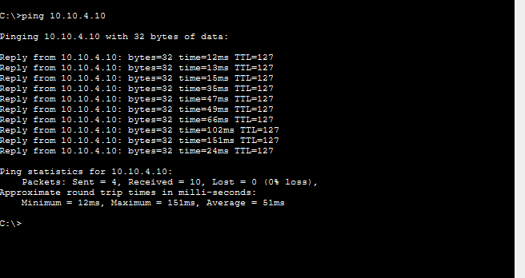

7.2.2 Test 2: Untrusted/Outside Ping Blocked – SECURE
Command: GUEST-PC > ping 10.10.4.10
Expected: Request timed out
Confirmed that the untrusted/outside test endpoint cannot directly access protected internal network resources.
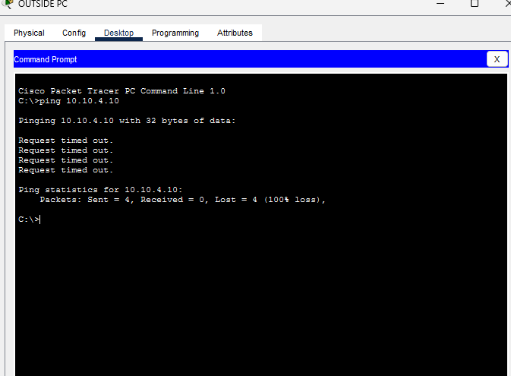

7.2.3 Test 3: Internal Web (HTTP) – PASS
Confirmed that authorised internal users can access the required web service.
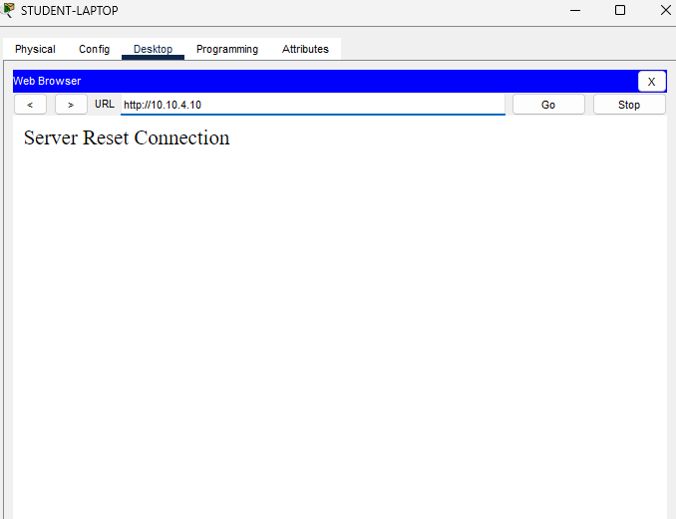

7.2.4 Test 4: Untrusted/Outside Web Access Blocked – SECURE
Confirmed that the untrusted/outside test endpoint cannot access protected internal web resources.
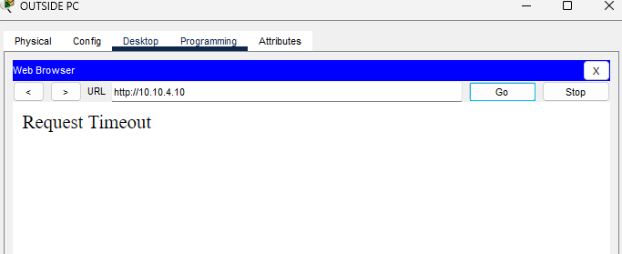

7.2.5 Test 5: Traceroute
Confirmed successful routing between authorised internal devices, while tracing from the restricted untrusted/outside test endpoint toward protected internal resources was unsuccessful as expected.
TRACE SUCCESSFUL (BETWEEN DEVICES IN THE NETWORK):
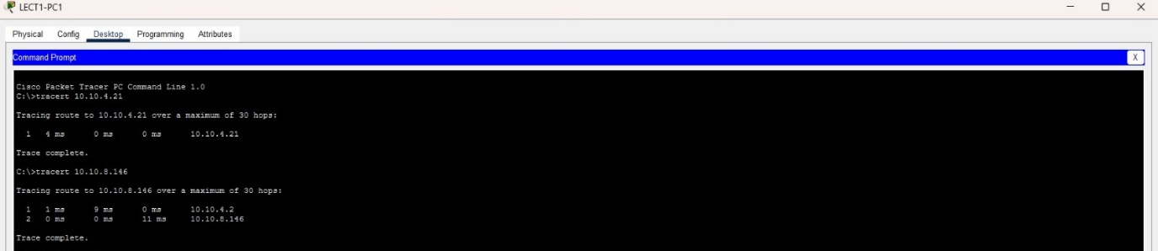
TRACE UNSUCCESSFUL (WITH A DEVICE OUTSIDE THE NETWORK):
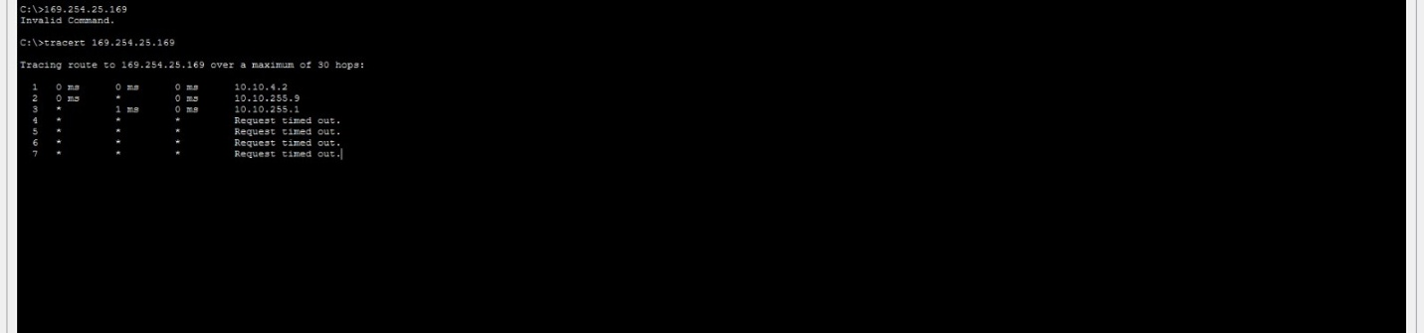

7.2.6 Test 6: Firewall ACL Check
Verified that the firewall ACLs are being used to control and restrict network traffic.
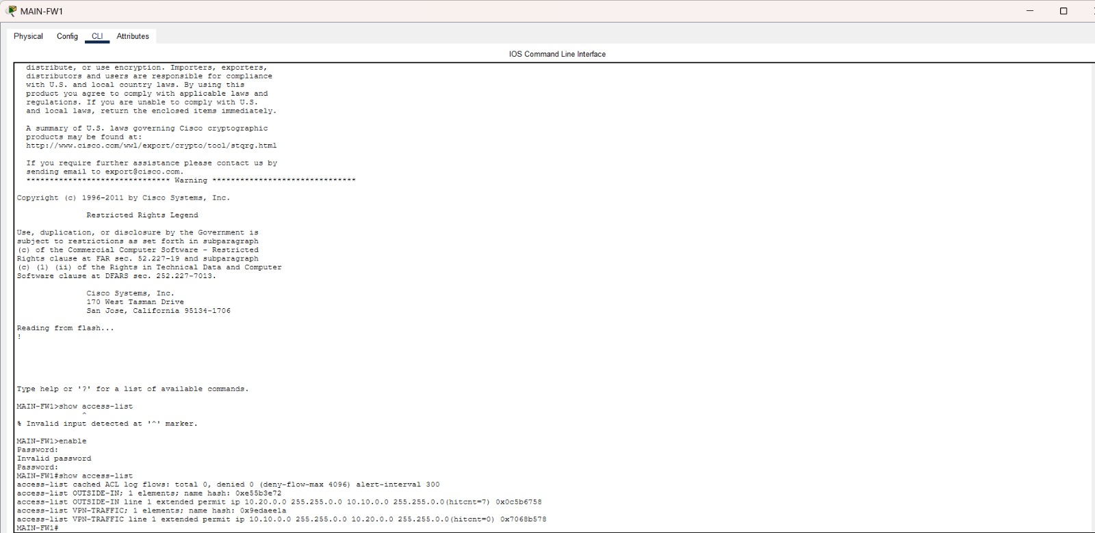

7.2.7 Test 7: Switch Security
Verified the implementation of security controls on the network switches to help prevent unauthorised access.
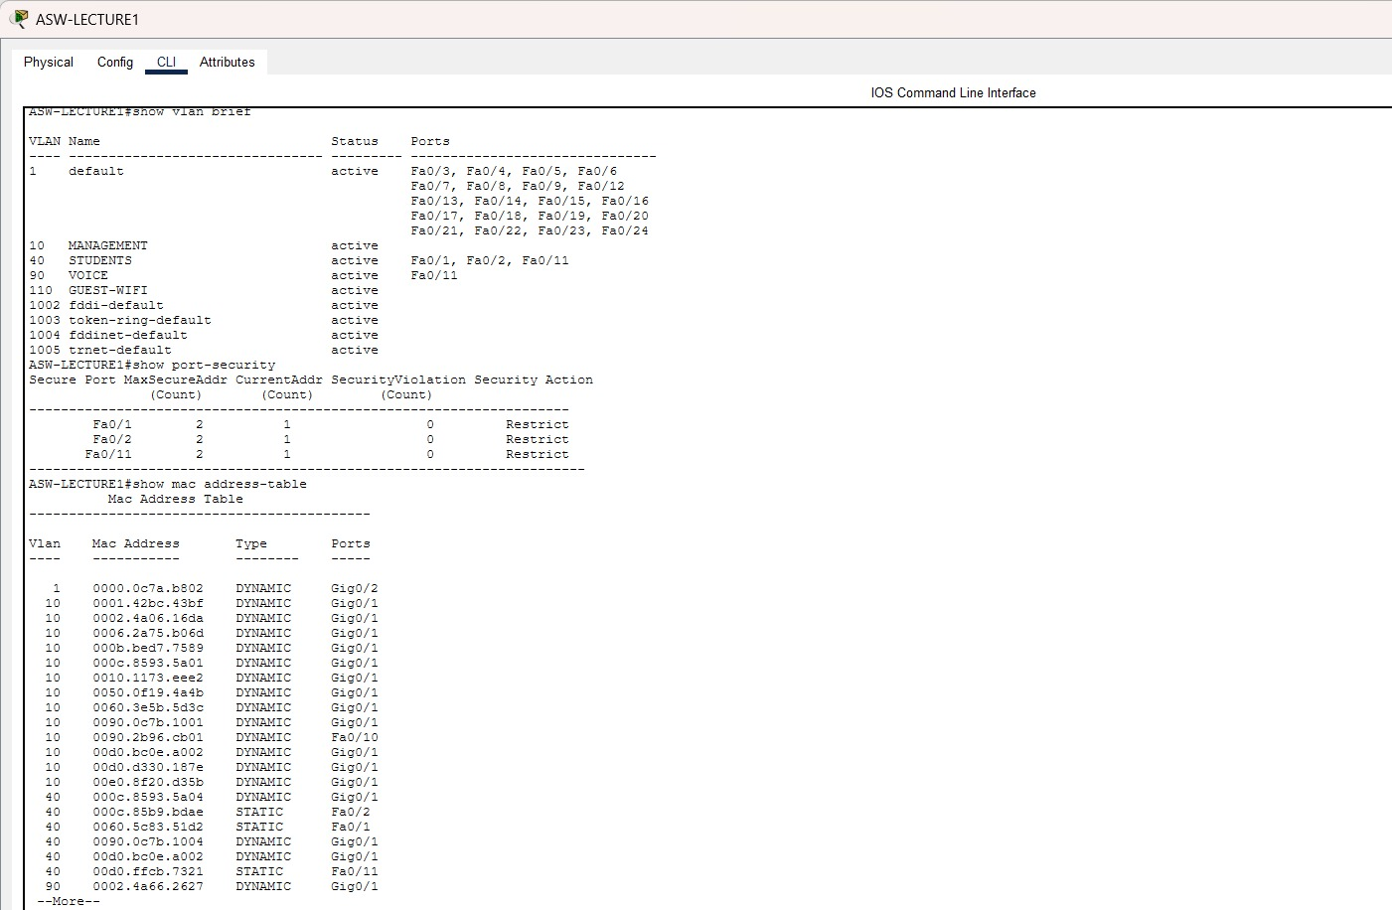
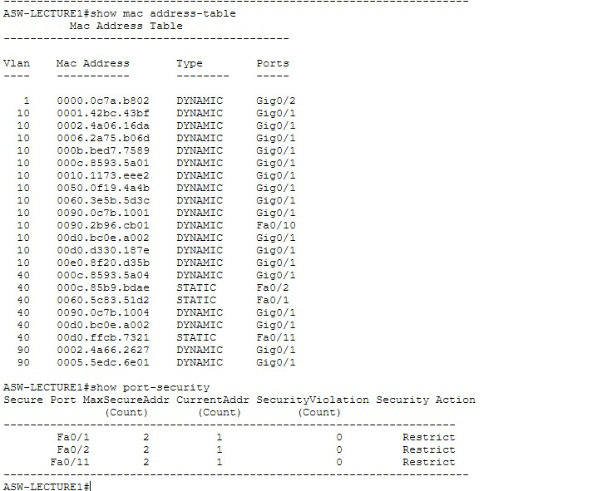

7.3 Network Security Testing Conclusion
Overall, the network security testing showed that the network is functioning correctly and that the implemented security measures are effective. Internal ping and HTTP connectivity were successful, while untrusted/outside ping and web access to protected internal resources were blocked as expected. Traceroute confirmed successful communication between authorised internal devices, while restricted tracing toward protected resources was unsuccessful, supporting the effectiveness of the network restrictions. The firewall ACL and switch security tests further demonstrate that the network provides authorised users with necessary access while protecting internal resources from unauthorised access.

8. Final Conclusion
The completed tests provide evidence that the smart campus design supports VLAN addressing, HSRP gateway redundancy, Layer-2 trunking and STP, Zero-Trust segmentation, internal DNS, centralized Syslog, firewall routing and ACL processing, dynamic PAT, site-to-site IPSec VPN communication, inter-site VoIP, and measured internal/inter-site latency. The reusable Guest Test PC was deliberately moved between VLAN110, VLAN130 and VLAN120 to test Guest-ZT, IOT-ZT and CCTV-ZT with one endpoint. Each move was verified by IP configuration and each policy was validated with both permitted traffic and denied lateral-access traffic, supported by ACL counters.
The report also preserves limitations and failed intermediate tests: public DNS content was unavailable, direct ASA-edge ICMP did not respond despite ARP and working VPN traffic, the explicit VPN NAT-exemption command was rejected by the Packet Tracer ASA, and live RTP packets were not counted by the QoS class. These points are documented rather than hidden. Final stable retests demonstrated 0% packet loss for internal WLC reachability, inter-site reachability, and the authorized IoT/CCTV service tests.

