BIRLA INSTITUTE OF TECHNOLOGY AND SCIENCE, PILANI
STUDY PROJECT · PHASE 3
Explainable Machine Learning Framework for
Battery Health Assessment and Dynamic
Backup‑Time Prediction
IMPLEMENTATION AND VALIDATION · REVISION 2 FINAL SUBMISSION
Verified package: 5,593 records · 3 real public datasets · 2,532 held-out predictions
22 graphs · 8 persisted models · 20 automated tests executed

Prepared by | Student ID
Dhruv Purohit | 2023EB03173
Himanshu Kadia | 2023EB03114
Nitin Kumar | 2023EB03248

Project Supervisor: Mr. Vamsi Bandi
B.Sc. Computer Science · BCSZC241T · Team Axiom AI (Team ID 19)
Prepared 20 August 2026

Evidence statement and declaration
What this report proves
The submitted software executes an end-to-end, leakage-aware workflow for capacity/SOH estimation, formula and machine-learning backup-time comparison, explainability, persistence, rule-based guidance, and dashboard reporting. Quantitative evidence is reported separately for the controlled CSGB benchmark and real public laboratory data from NASA PCoE, CALCE, and TRI/Matr.io.

What this report does not claim
The results are not field validation, deployment certification, a certified battery-management system, or safety authority. TRI expands real laboratory evidence across 94 aged cells and eight constant-current rates, but it is not dynamic field telemetry. The Oxford adapter is fixture-tested; no Oxford quantitative result is claimed because its official MAT file was not processed.

Student declaration
We declare that this Phase‑3 submission presents the implemented project evidence available in the accompanying ZIP. Metrics, figures, models, aligned predictions, and test evidence are reproducible from the included code and processed inputs. Public source ownership and licensing remain with their respective providers; raw public archives are not redistributed.
Name | Student ID | Signature | Date
Dhruv Purohit | 2023EB03173
Himanshu Kadia | 2023EB03114
Nitin Kumar | 2023EB03248

Contents
1. Executive summary
2. Phase continuity, objectives and scope
3. Implemented system architecture
4. Dataset provenance and evidence domains
5. Data preparation and leakage-safe evaluation
6. Modelling, formula baseline and metrics
7. Quantitative validation results
8. Explainability and model interpretation
9. Decision support and Streamlit dashboard
10. Verification, persistence and performance
11. Discussion, limitations and residual risks
12. Deliverables, execution procedure and output inventory
13. Conclusion and future work
References
Appendix A – Metric definitions
Appendix B – Graph and file inventory

Abbreviations
Term | Meaning | Term | Meaning
Ah | Ampere-hour | MAE | Mean Absolute Error
SOH | State of Health | RMSE | Root Mean Squared Error
M4 | Formula baseline | MAPE | Mean Absolute Percentage Error
M5 | Capacity/SOH model | R² | Coefficient of determination
M6 | Backup-time ML model | SHAP | SHapley Additive exPlanations
LOBO | Leave-one-battery-out | CSGB | Controlled Synthetic Golden Benchmark

1. Executive summary
Phase 3 implements and validates the framework proposed in Phase 1 and designed in Phase 2. Revision 2 expands the real experimental evidence with the official TRI/Matr.io 94-cell multi-rate validation dataset. The final package contains a modular Python pipeline (M1–M10), prepared evaluation data, aligned record-level predictions, regression and classification metrics, global/local Shapley explanations, eight persisted models, twenty-two comparison figures, a Streamlit interface, and automated verification evidence.
Dataset | Evidence | Rows | Train / holdout | M5 MAE (Ah) | M6 MAE (min) | Group overlap
CSGB | controlled synthetic | 720 | 540 / 180 | 0.056 | 1.519 | 0
NASA | real experimental | 579 | 298 / 281 | 0.074 | 2.826 | 0
CALCE | real experimental | 3,544 | 1,665 / 1,879 | 0.029 | 1.721 | 0
TRI | real experimental | 750 | 558 / 192 | 0.122 | 34.638 | 0

- 5,593 validated cycle-level records were used: 720 CSGB controlled records and 4,873 real laboratory records from NASA, CALCE, and TRI.
- All four evaluations used battery-group holdouts with zero development/holdout battery overlap.
- The M5 capacity model achieved MAE 0.0560 Ah on CSGB, 0.0737 Ah on NASA, 0.0287 Ah on CALCE, and 0.1222 Ah on TRI.
- The M6 runtime model achieved MAE 1.519, 2.826, 1.721, and 34.638 minutes respectively; TRI's long low-rate tests make absolute-minute errors larger, so MAPE and rate-stratified results are also reported.
- The transparent M4 operational formula was stronger by aggregate MAE on NASA, CALCE, and TRI, while M6 was stronger on the varied-load CSGB benchmark. On TRI, M6 nevertheless achieved lower aggregate MAPE and lower MAE at five of eight rate levels. These mixed results are retained rather than selectively reported.
- Eight models reloaded within a 1×10⁻⁹-minute numerical tolerance. Global and local Shapley outputs passed for every evaluated domain; the supplied execution used the documented deterministic fallback because the optional SHAP package was unavailable in the build runtime.
- The complete validation suite executed 20 automated tests: 19 passed and one Streamlit AppTest was explicitly skipped because Streamlit was unavailable in the build runtime. Dashboard backend, input guards, syntax, outputs, and the full analytical pipeline passed; the pinned requirements enable the AppTest on a fully installed environment.
Principal finding
A nonlinear model is not automatically superior. M6 reduced runtime MAE by 82.66% versus M4 on varied-load CSGB. M4 had lower aggregate MAE on NASA, CALCE, and TRI; however, TRI M6 had lower MAPE (3.34% versus 3.56%) and lower MAE at five of eight discharge rates. Protocol diversity and deployment-domain data matter more than model complexity alone.

2. Phase continuity, objectives and scope

2.1 Continuity from Phases 1 and 2
Phase | Role | Evidence carried forward
Phase 1 | Problem and research definition | Title, integrated health/runtime objective, public-data commitment, explainability, formula benchmark, non-safety boundary.
Phase 2 | Design and controlled proof of concept | M1–M10 contracts, common schema, leakage-safe workflows, CSGB benchmark, record alignment, comparison graphs and test design.
Phase 3 | Implementation and validation | NASA/CALCE/TRI processing, grouped real-data evaluation, global/local Shapley attribution, persistence, dashboard, automated tests, and submission artefacts.

2.2 Implemented objectives
- Import source-adapted battery data and validate it against the common schema.
- Estimate remaining capacity and calculate SOH without using capacity-derived target leakage as an input.
- Calculate a transparent load-aware formula baseline and separately predict backup time using Random Forest regression.
- Compare M4 and M6 on identical held-out record IDs using MAE, RMSE, MAPE, bias and R².
- Provide built-in importance, permutation importance and SHAP global/local explanations.
- Persist models and verify reload/inference consistency.
- Expose validation, predictions, caveats, plots and downloads in Streamlit.
- Map model outputs to configurable, non-safety-critical guidance through M9.

2.3 Scope boundary
Included | Excluded / not claimed
Cycle-level lithium-ion laboratory data; capacity/SOH; discharge backup time; formula-versus-ML comparison; explainability; dashboard prototype; reproducible exports. | Cell balancing, SOC control, electrochemical diagnosis, safety interlocks, certification, production deployment, field-load validation, warranty decisions, or expert maintenance authority.

3. Implemented system architecture
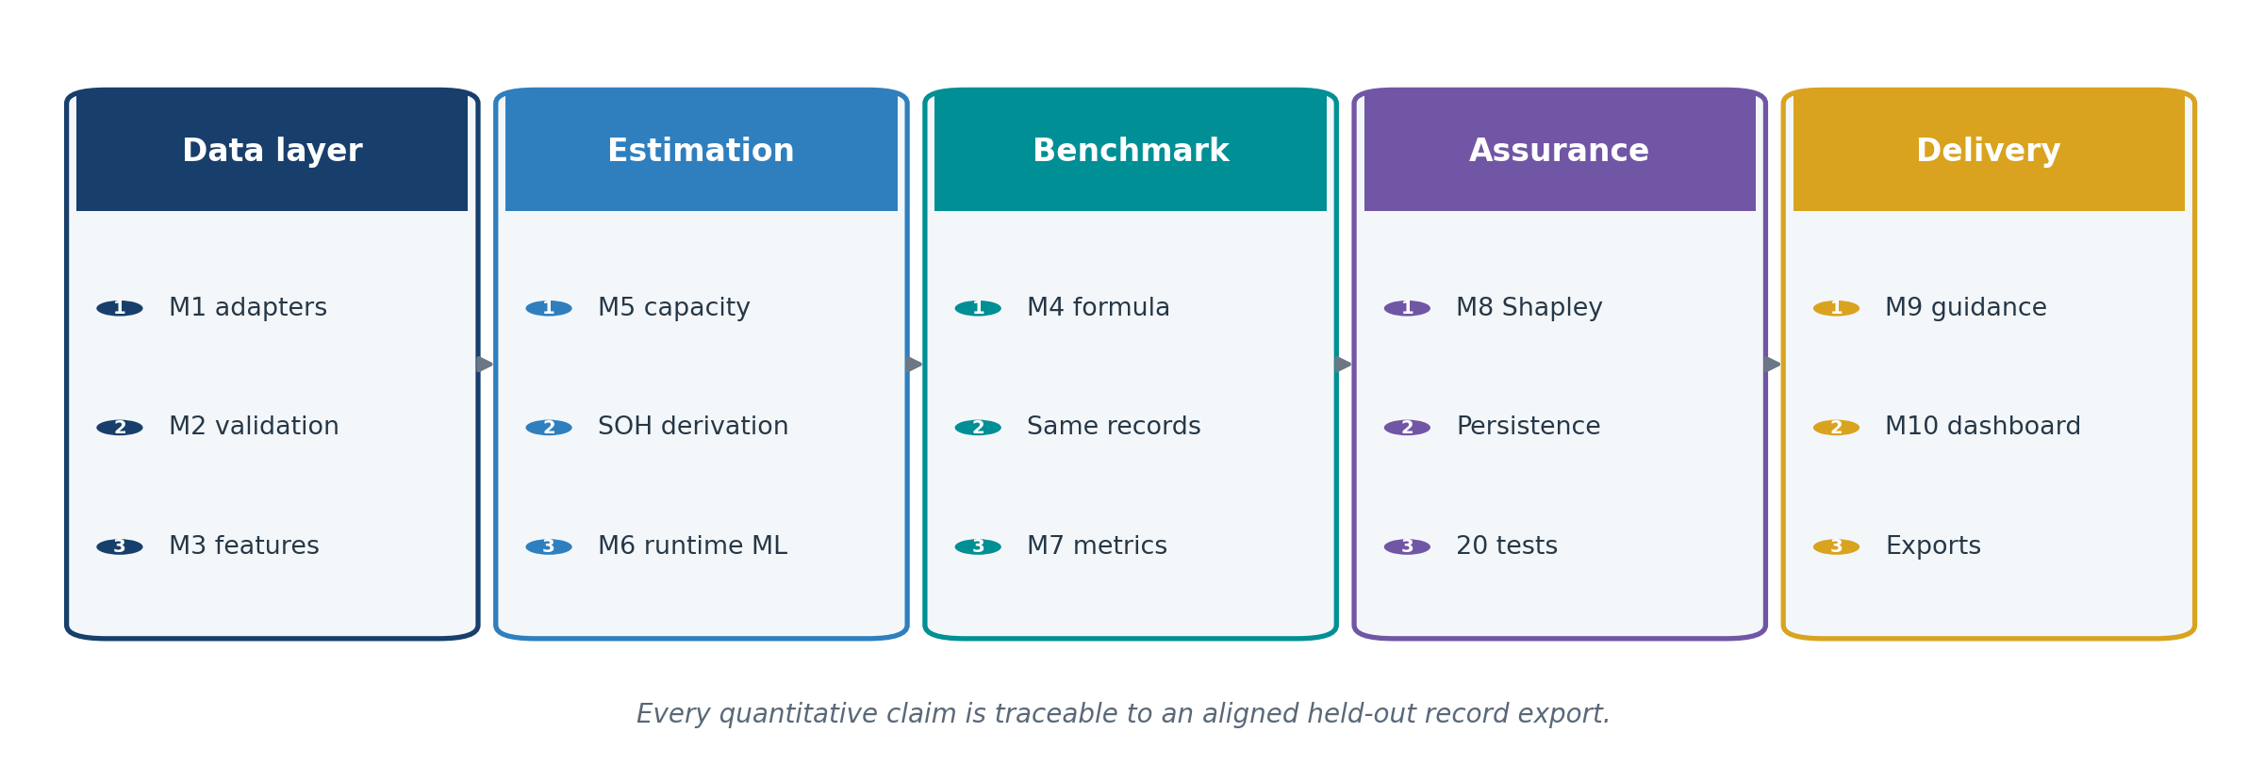
Figure 1. Implemented Phase‑3 architecture and assurance flow.

3.1 Module responsibilities
Module | Implemented responsibility | Primary output
M1 | Load common-schema inputs and source-adapted records. | Standardized cycle table
M2 | Check schema, types, duplicates, nulls and physical ranges. | Clean table + quality report
M3 | Create cycle, thermal, current, voltage, load and resistance features. | Leakage-safe feature matrices
M4 | Calculate reference and operational formula runtime. | Formula runtime estimates
M5 | Fit capacity Random Forest and derive SOH. | Predicted capacity + SOH
M6 | Fit a separate dynamic backup-time Random Forest. | ML runtime estimate
M7 | Align targets/predictions and calculate errors/residuals. | Metrics + comparisons
M8 | Generate built-in, permutation and SHAP explanations. | Global/local attribution
M9 | Apply configurable, secondary guidance rules. | Health class + recommendation
M10 | Present validation, estimates, plots, caveats and downloads. | Streamlit interface + exports

3.2 Record-level traceability
Every held-out prediction export retains dataset, record_id, battery_id, cycle_count, actual targets, M4 formula outputs, M5 capacity/SOH outputs, M6 runtime output, residuals, M9 labels and recommendations. This is the implemented bridge from module output to each graph and aggregate metric.

4. Dataset provenance and evidence domains

4.1 Evidence classification
Dataset | Nature | Batteries | Usable rows | Phase‑3 use | Status
CSGB v1.0 | Controlled synthetic benchmark | 12 | 720 | Continuity, known-answer and varied-load software benchmark | Evaluated
NASA PCoE B0005/06/07/18 | Real public laboratory | 4 | 579 | Capacity/SOH and runtime held-out validation | Evaluated
CALCE CS2_35/36/37/38 | Real public laboratory | 4 | 3,544 | Capacity/SOH and runtime held-out validation | Evaluated
TRI ResVal multi-rate | Real public laboratory | 94 | 750 | Cross-cell capacity/SOH and rate-dependent runtime validation | Evaluated
Oxford Battery Degradation Dataset 1 | Real public laboratory | 8 in source | — | Native MAT adapter contract and fixture | Adapter only

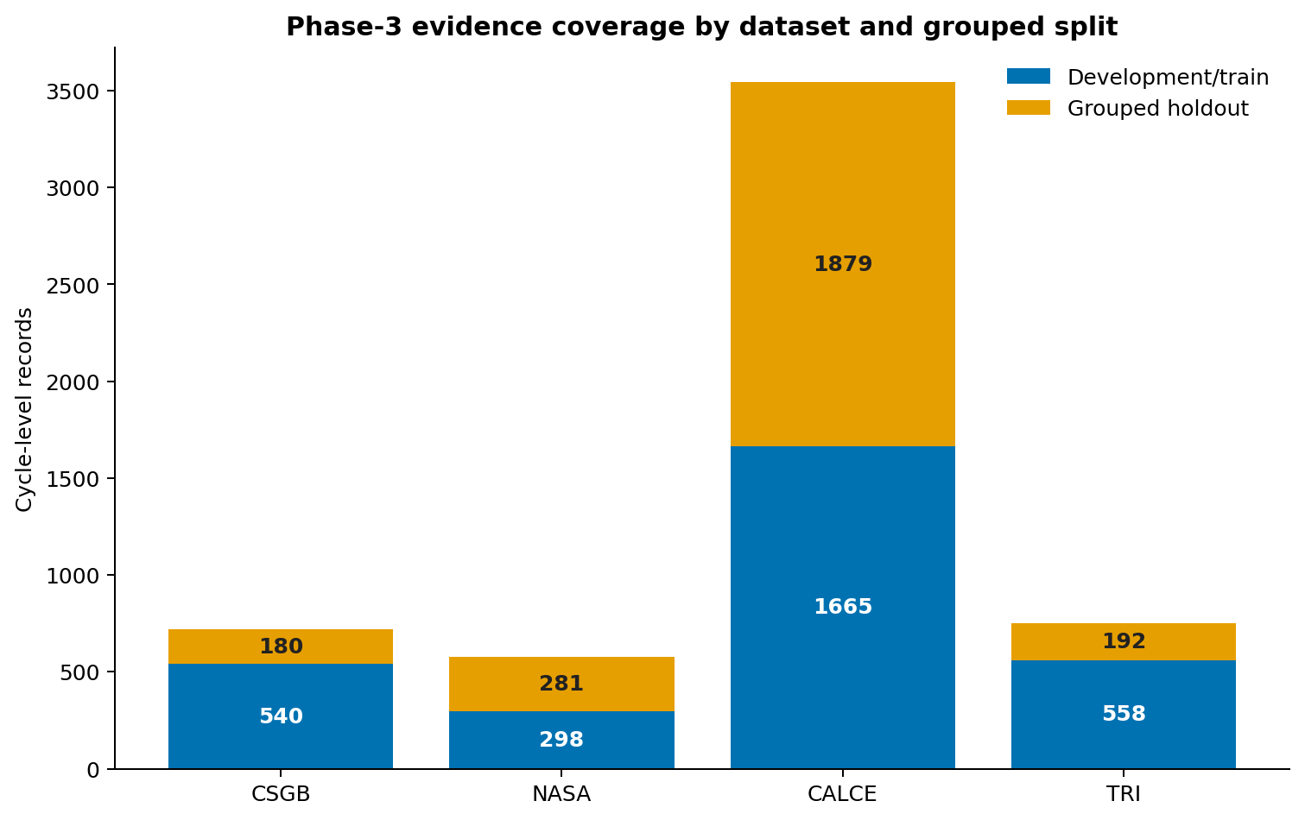 | 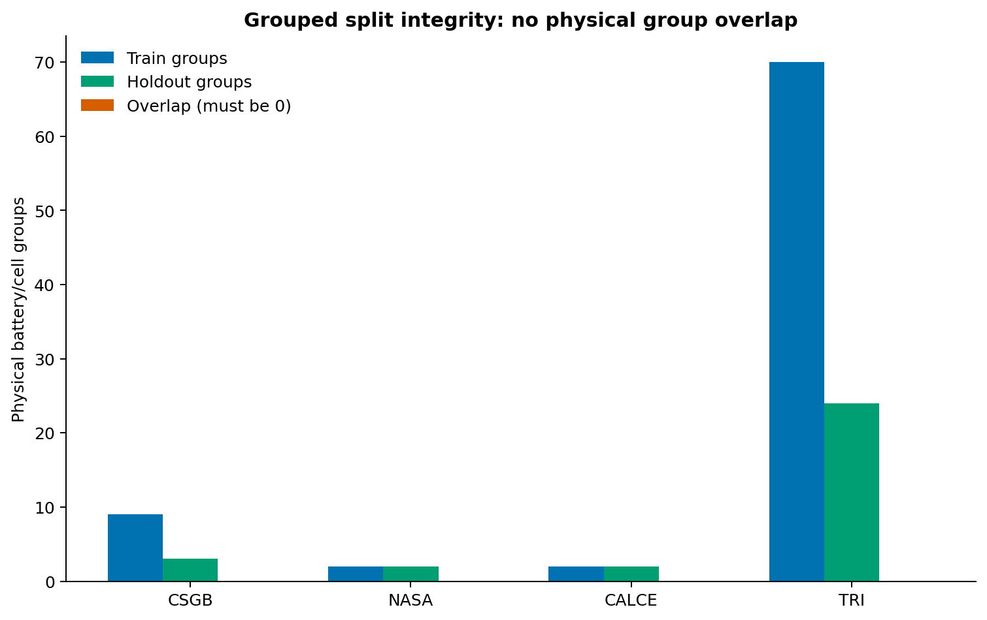
Figure 2. Record coverage by domain and split. | Figure 3. Battery-group split integrity.

4.2 Source processing and provenance
- NASA: official PCoE MAT files were processed into discharge-cycle summaries. Capacity and runtime use measured discharge data; the most recent preceding impedance observation supplies Re+Rct where available.
- CALCE: official CS2 Excel workbooks were processed into discharge-cycle summaries. Capacity is derived from the change in cumulative discharge capacity; runtime comes from elapsed discharge time; resistance is an explicitly labelled voltage-sag proxy.
- TRI: the official ResValData Maccor archive was streamed directly and converted to 750 rate-characterization discharge summaries from 94 aged 4.84 Ah Panasonic 21700 cells. Capacity, energy, representative load power, and time to the 2.7 V cutoff are derived from observed samples.
- CSGB and Oxford: the Phase-2 CSGB workbook is retained unchanged for controlled continuity checks. Oxford Cell*/cyc*/C1dc parsing is fixture-tested, but no Oxford metric is claimed because the official MAT file was not processed.

4.3 TRI extraction rules and limitations
The TRI ResVal subset contains eight constant-current characterization conditions: C/80, C/40, 0.05 A, C/10, C/7, C/5, 1C, and 2C. The adapter selects the first complete discharge to 2.7 V at each rate. Ninety-three cells supply all eight records; cell 0000ED supplies six low-rate records and no usable 1C/2C record, consistent with the authors' released processing code. No replacement records are fabricated.
The raw files do not contain measured temperature or prior aging-cycle count. The common-schema adapter therefore uses a declared constant 25 °C placeholder and a zero cycle-count sentinel; both are excluded from physical interpretation. TRI expands the number of real cells and the discharge-rate range, but it remains controlled laboratory evidence rather than field telemetry.
Raw-data distribution
The final ZIP includes compact processed cycle summaries, quality metadata, and provenance hashes. Large raw public archives are not redistributed. NASA, CALCE, and TRI preparation scripts support authorized local reproduction from official source files; TRI's 250,042,781-byte archive is represented by its SHA-256 digest and derived 750-row summary.

5. Data preparation and leakage-safe evaluation

5.1 Common schema
Category | Fields used
Identity/provenance | record_id, battery_id, source_dataset, cycle_count
Operating conditions | temperature_c, discharge_current_a, avg_voltage_v, min_voltage_v, load_power_w
Battery condition | internal_resistance_ohm, rated_capacity_ah
Targets | measured_capacity_ah, backup_time_min
Engineered | c_rate, thermal_stress, resistance_voltage_drop_v, voltage_sag_v
Derived outputs | predicted_capacity_ah, predicted_soh_percent, formula_runtime, ml_runtime, residuals, M9 labels
TRI protocol metadata | source_rate_index, source_rate_label, source_nominal_c_rate, source_file

5.2 Leakage controls
- M5 excludes measured_capacity_ah, backup_time_min and any target-derived SOH value from the feature matrix.
- M6 excludes actual backup time and uses M5 predicted SOH, not actual SOH, as an optional health input.
- M4 operational comparison uses M5-predicted capacity; a separate M4 reference calculation using measured capacity is reported only as a formula verification diagnostic.
- Feature contracts are exported and automatically tested.

5.3 Grouped holdouts
Dataset | Development batteries | Held-out batteries | Rows | Overlap
CSGB | NASA2_B01–03; NMC5_B01–03; OXF074_B01–03 | NASA2_B04; NMC5_B04; OXF074_B04 | 540 / 180 | 0
NASA | B0005, B0006 | B0007, B0018 | 298 / 281 | 0
CALCE | CS2_35, CS2_36 | CS2_37, CS2_38 | 1,665 / 1,879 | 0
TRI | 70 deterministic physical-cell IDs | 24 deterministic physical-cell IDs | 558 / 192 | 0

The split is battery-grouped rather than a random row split. Therefore, adjacent cycles from the same physical battery cannot appear on both sides of the evaluation. This makes the result materially more credible than record-level random splitting, although it remains dataset- and protocol-specific.

6. Modelling, formula baseline and evaluation metrics

6.1 Models
Workflow | Algorithm | Configuration | Output
M5 | Random Forest regressor | 250 trees; max_depth=14; min_samples_leaf=2; random_state=42 | Capacity (Ah); SOH derived as capacity/rated capacity × 100
M6 | Random Forest regressor | 300 trees; max_depth=16; min_samples_leaf=2; random_state=42 | Dynamic backup time (min)

6.2 Transparent backup-time baseline
Backup time (min) = [Predicted capacity (Ah) × Representative voltage (V) × Efficiency ÷ Load power (W)] × 60
CSGB uses its configured efficiency value. NASA, CALCE, and TRI discharge records represent direct cell-level laboratory energy delivery, so efficiency is set to 1.0. The M4 reference calculation is an internal consistency check when it uses measured capacity; the operational comparison uses M5-predicted capacity. Neither is described as deployment ground truth.

6.3 Metric interpretation
Metric | Meaning | Preferred direction | Important caution
MAE | Average absolute error in the target unit | Lower | Best direct measure of typical error
RMSE | Square-root of mean squared error | Lower | Penalizes large errors more strongly
MAPE | Average absolute percentage error | Lower | Unstable near zero actual values
Bias | Mean signed prediction error | Near zero | Positive means overprediction
R² | Variance explained relative to a mean predictor | Higher | Can be negative; not an error unit

7. Quantitative validation results

7.1 M5 capacity and SOH
Dataset | Capacity MAE (Ah) | RMSE (Ah) | MAPE | R² | SOH MAE
CSGB | 0.0560 | 0.1051 | 3.29% | 0.995 | 2.60 pp
NASA | 0.0737 | 0.0841 | 4.67% | 0.700 | 3.68 pp
CALCE | 0.0287 | 0.0406 | 3.47% | 0.928 | 2.61 pp
TRI | 0.1222 | 0.2100 | 3.56% | 0.770 | 2.53 pp

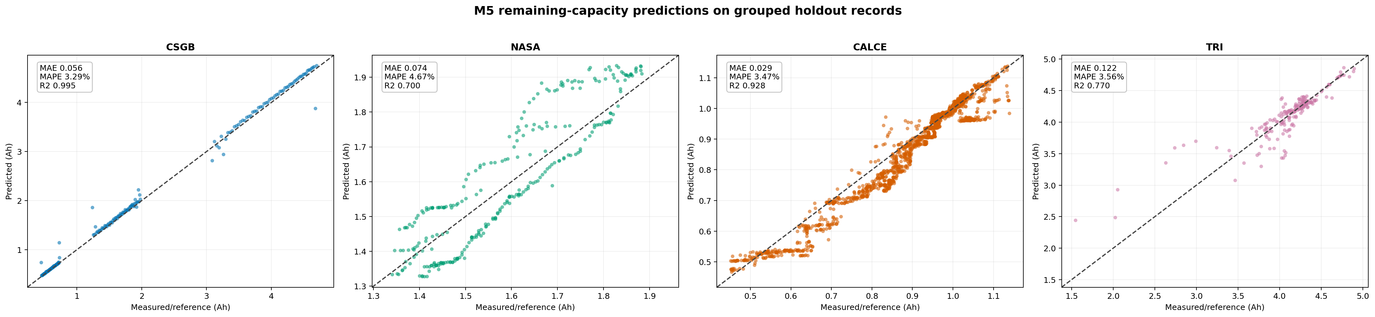
Figure 4. Actual versus predicted capacity on grouped holdouts.
CALCE produced the lowest absolute capacity error and the strongest real-data R². TRI extends the assessment from four batteries per source to 94 aged cells across eight rates; its 0.1222 Ah MAE corresponds to 3.56% MAPE and 2.53 percentage-point SOH MAE. CSGB's high R² reflects controlled construction and must not be treated as equivalent to real laboratory evidence.

7.2 SOH and runtime comparison
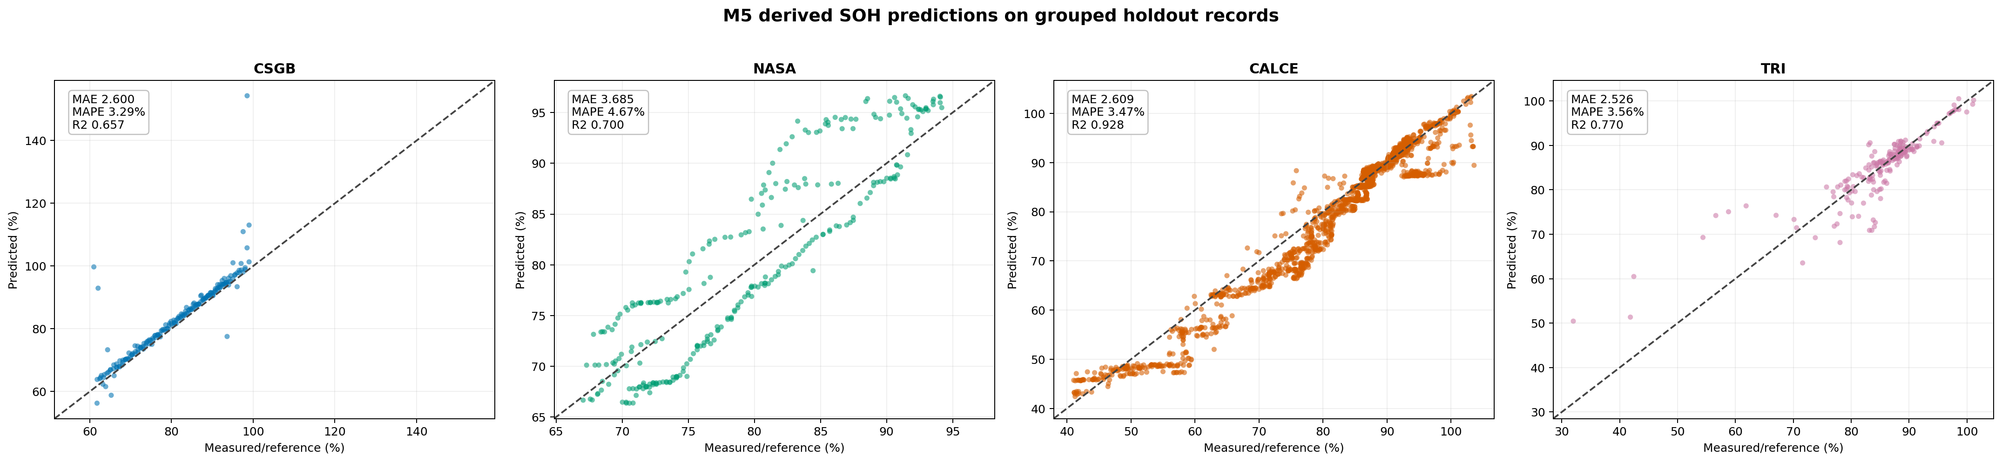
Figure 5. Actual versus predicted SOH on grouped holdouts.
Dataset | M4 MAE | M6 MAE | M4 MAPE | M6 MAPE | M6 MAE reduction | Lower MAE
CSGB | 8.756 | 1.519 | 18.45% | 2.91% | 82.66% | M6
NASA | 2.347 | 2.826 | 4.93% | 5.97% | -20.38% | M4
CALCE | 1.601 | 1.721 | 3.53% | 3.76% | -7.51% | M4
TRI | 33.681 | 34.638 | 3.56% | 3.34% | -2.84% | M4

Interpretation
M6 is decisively better on the varied-load CSGB benchmark. NASA and CALCE use constrained protocols where a capacity-informed energy formula is strongly aligned with runtime. TRI adds a much wider C/80-to-2C rate range and long low-rate durations: M4 has slightly lower aggregate MAE, while M6 has lower MAPE and lower MAE at five of eight rate levels. Absolute-minute MAE is dominated by the longest tests, so aggregate and rate-level results must be read together.

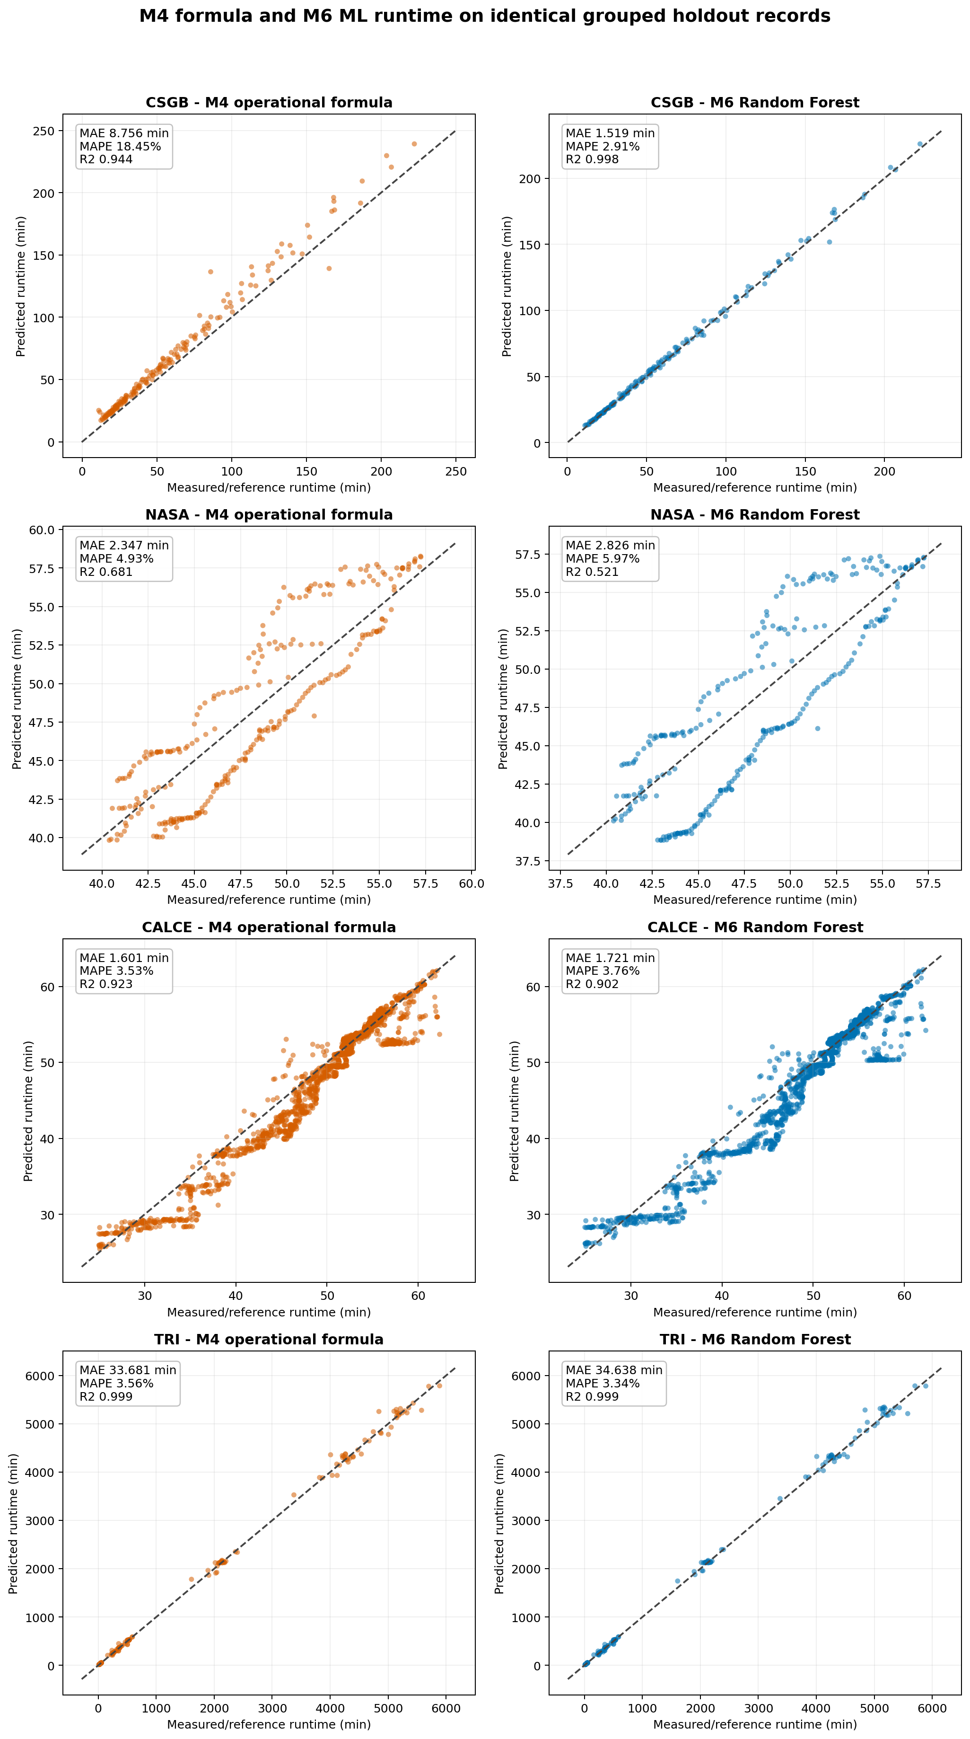
Figure 6. Formula and machine-learning runtime predictions on identical held-out records.

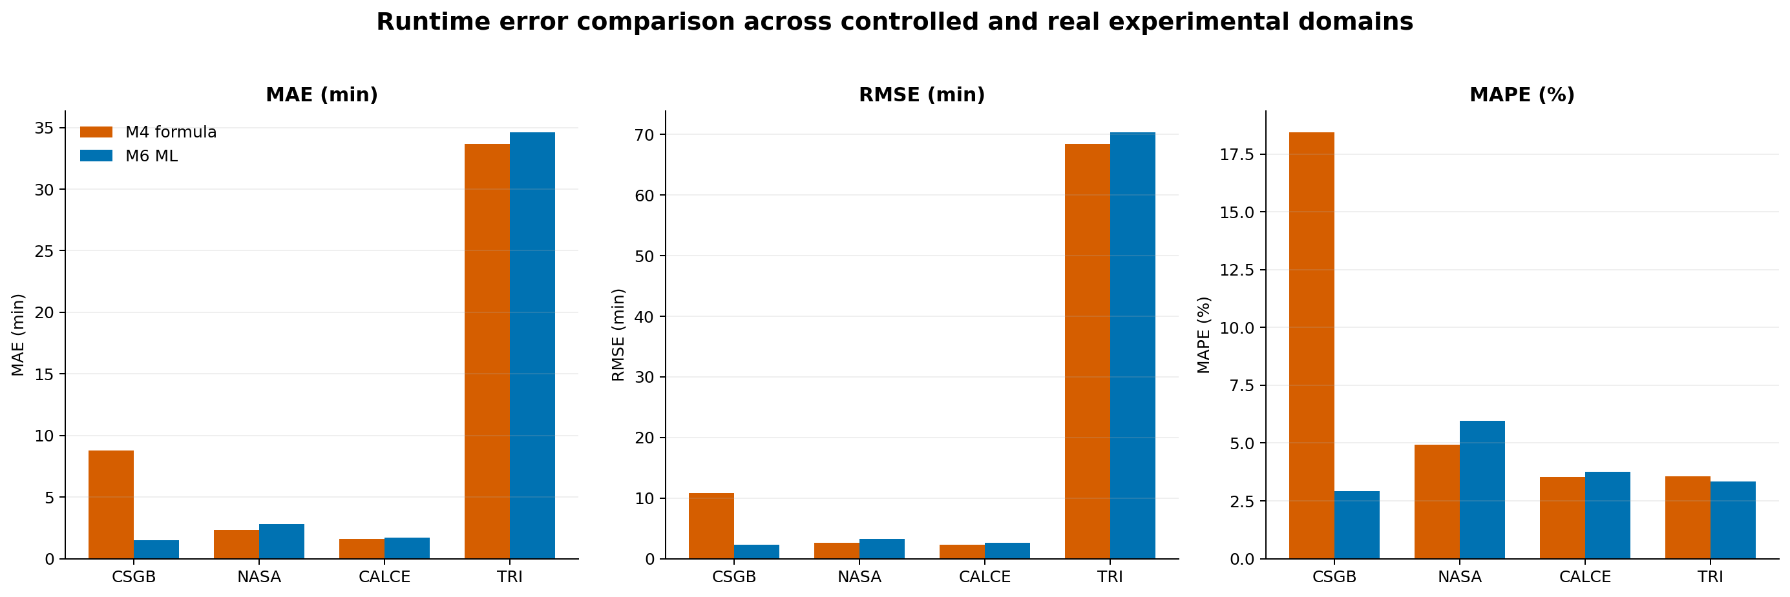
Figure 7. Runtime error metrics for M4 and M6.
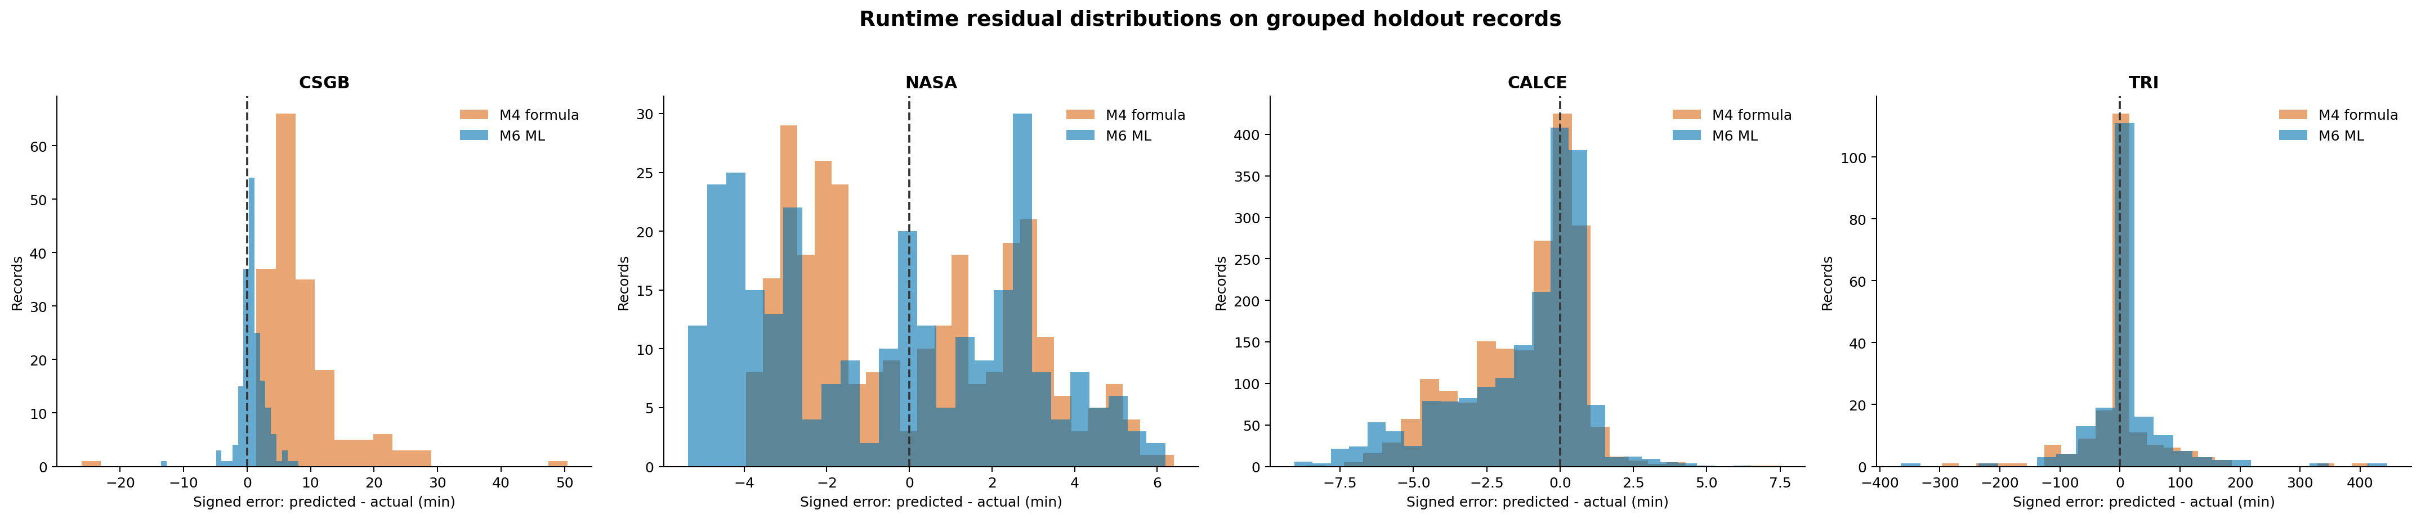
Figure 8. Runtime residual distributions.

7.3 Error stability across ageing
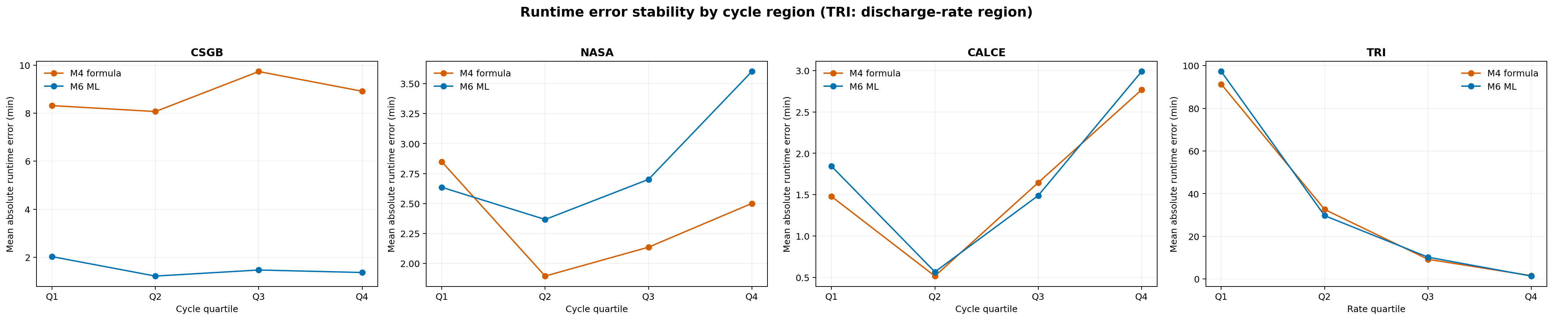
Figure 9. Runtime absolute error by cycle-age quartile.
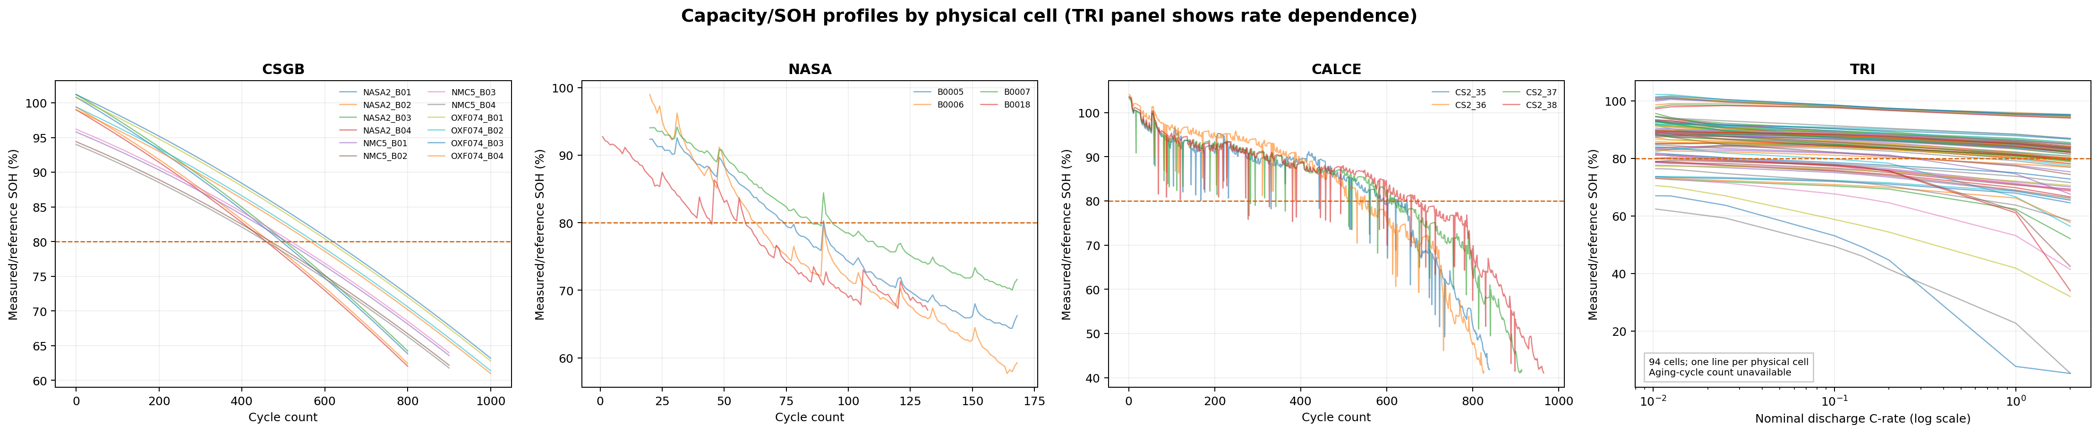
Figure 10. Held-out capacity degradation profiles.
The quartile and profile figures complement aggregate scores. For CSGB, NASA, and CALCE they show error across cycle-age bands and battery-specific degradation trajectories. TRI has no prior aging-cycle count in the raw files, so its panels use discharge-rate bands and rate-dependent capacity/SOH profiles instead of inventing an age sequence. Per-battery and per-rate metrics are exported for audit.

7.4 TRI rate-level comparison
Each TRI rate uses the same 24 held-out physical cells. The table shows why a single aggregate MAE is insufficient for this dataset.
Rate | Capacity MAE (Ah) | M4 MAE (min) | M6 MAE (min) | Lower MAE
C/80 | 0.090 | 89.978 | 81.535 | M6
C/40 | 0.099 | 48.866 | 44.400 | M6
0.05 A | 0.077 | 92.711 | 113.000 | M4
C/10 | 0.132 | 16.338 | 14.982 | M6
C/7 | 0.130 | 11.254 | 12.017 | M4
C/5 | 0.116 | 7.203 | 8.447 | M4
1C | 0.165 | 2.047 | 1.766 | M6
2C | 0.169 | 1.048 | 0.954 | M6
M6 has lower MAE at C/80, C/40, C/10, 1C, and 2C; M4 is lower at 0.05 A, C/7, and C/5. The complete eight-row export is outputs/tri/rate_level_metrics.csv.

8. Explainability and model interpretation
M8 produces three complementary explanation layers: Random Forest built-in importance, held-out permutation importance, and global/local Shapley attribution. When the optional shap package is installed, the pipeline uses TreeSHAP. In the supplied build runtime that package was unavailable, so a deterministic Monte-Carlo Shapley fallback (24 permutations) generated the included global/local outputs under the same export contract. Built-in importance describes tree usage, permutation importance tests predictive dependence, and Shapley values attribute predictions relative to an expected value.
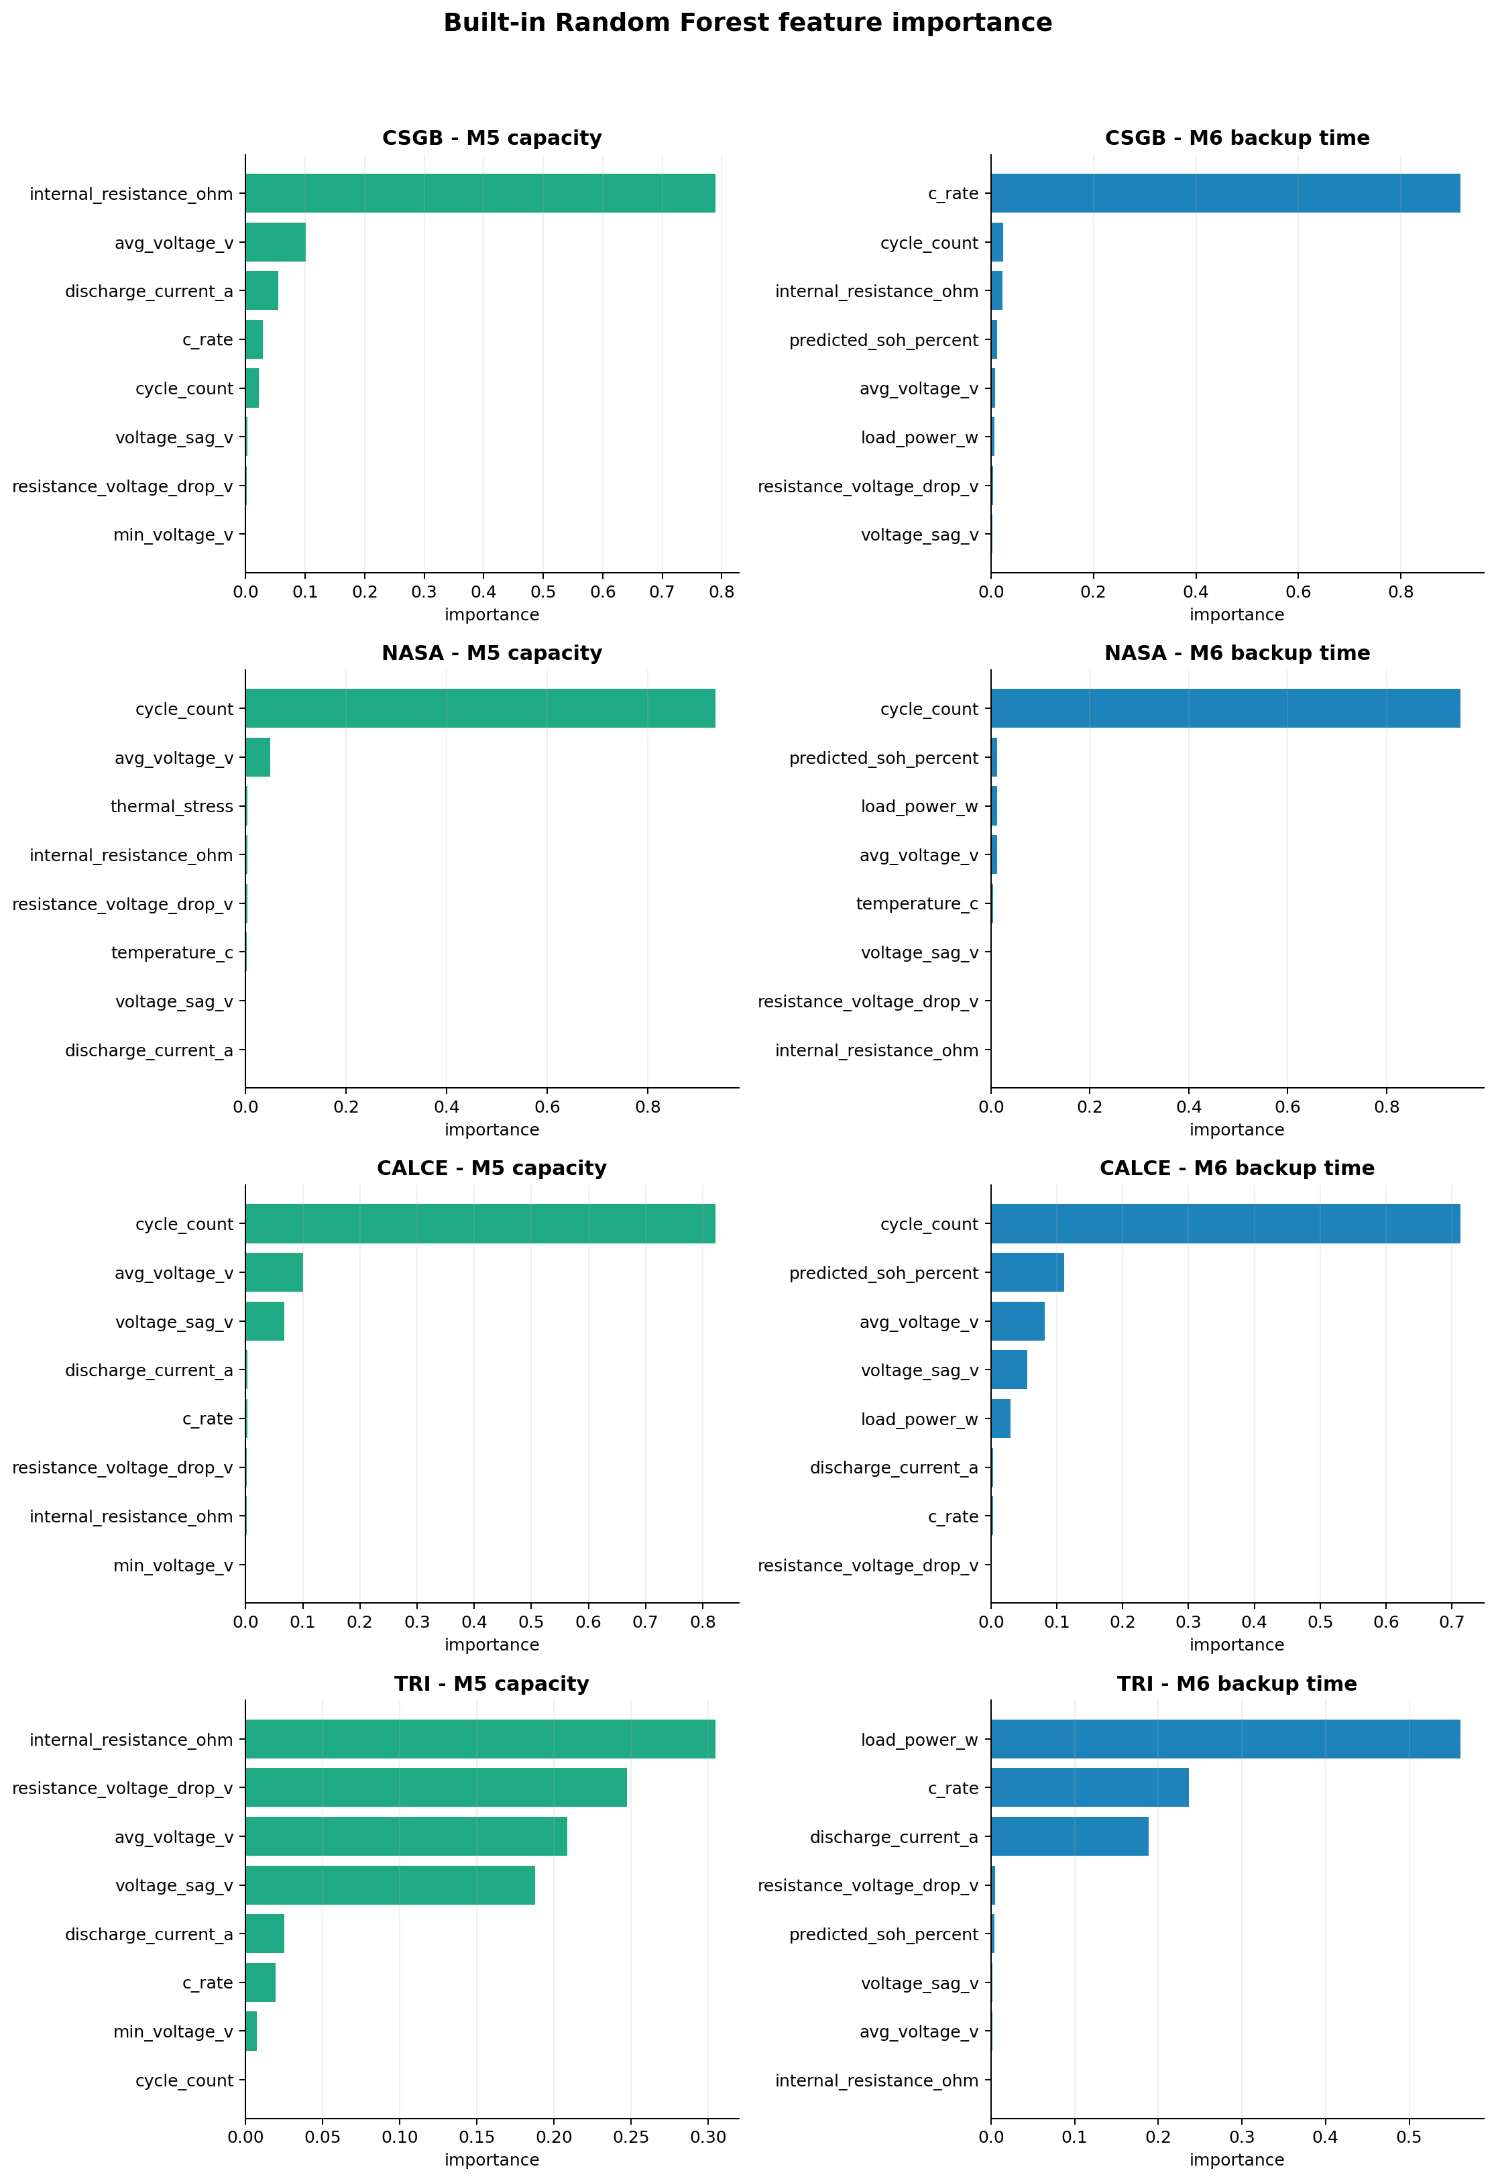
Figure 11. Built-in feature importance for M5 and M6.
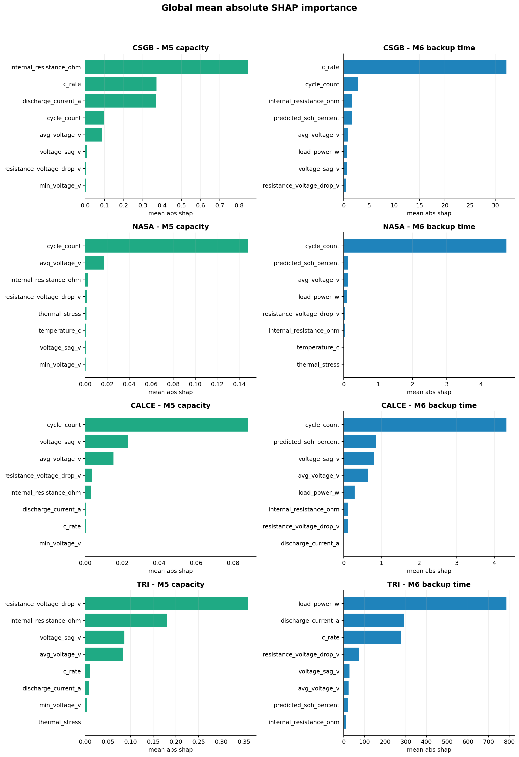
Figure 12. Mean absolute SHAP importance by evidence domain.

8.1 Global and local findings
Dataset | M5 dominant built-in feature | M6 dominant built-in feature | SHAP status | Rows explained
CSGB | Internal resistance (0.789) | C-rate (0.916) | Pass | 180
NASA | Cycle count (0.934) | Cycle count (0.950) | Pass | 200
CALCE | Cycle count (0.822) | Cycle count (0.713) | Pass | 200
TRI | Internal resistance (0.305) | Load power (0.561) | Pass | 192

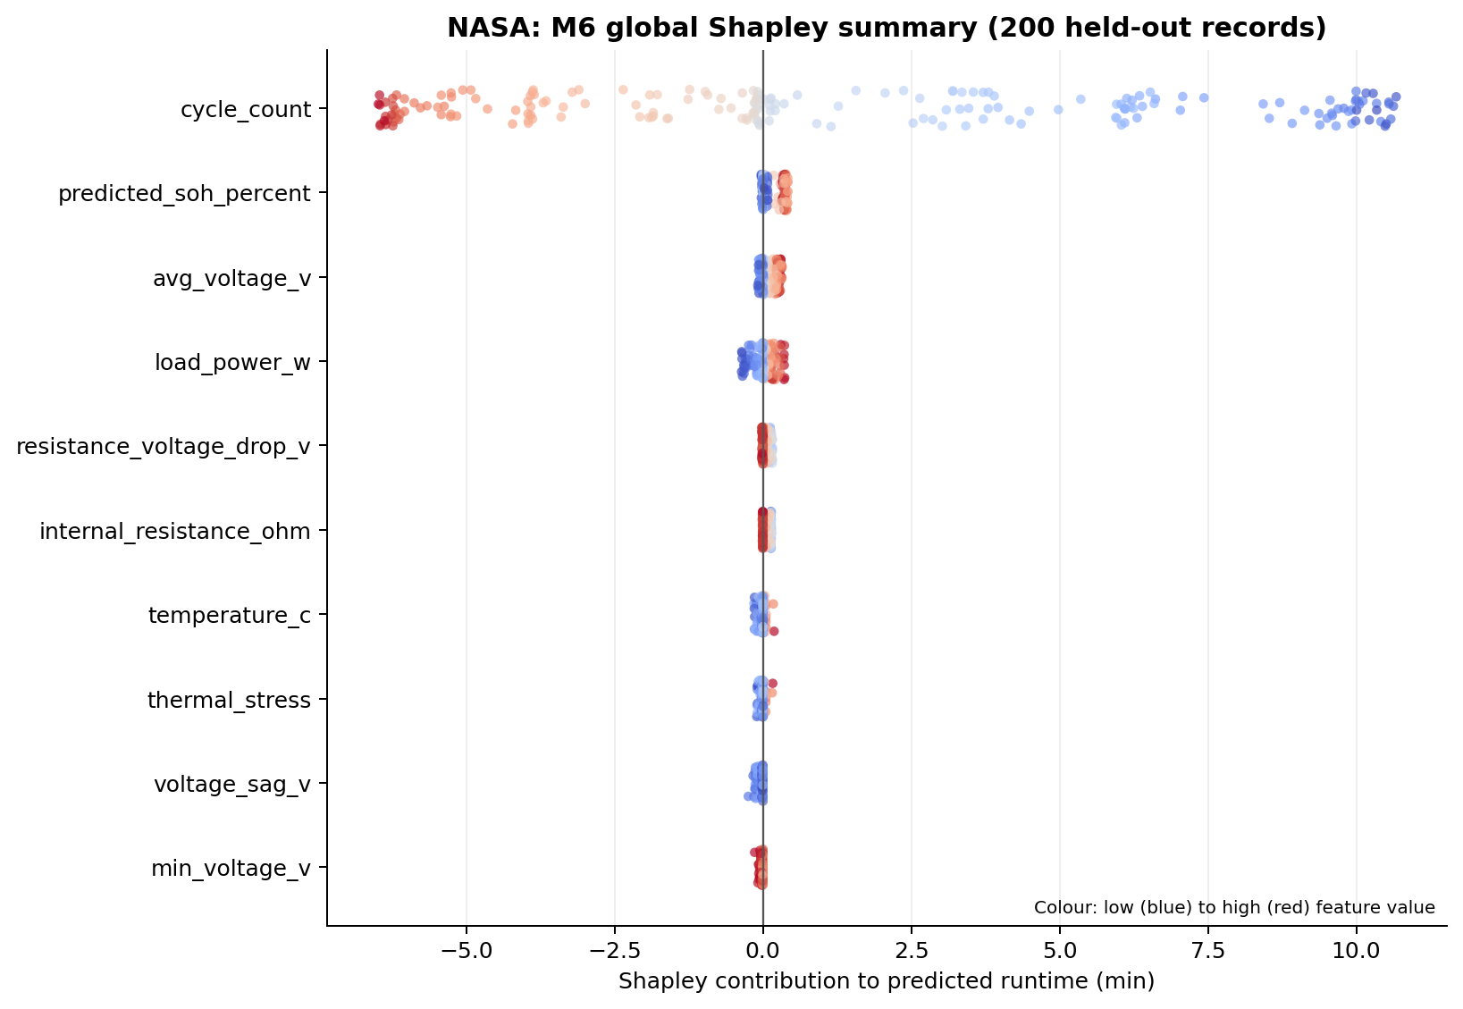
Figure 13. NASA M6 global SHAP summary.
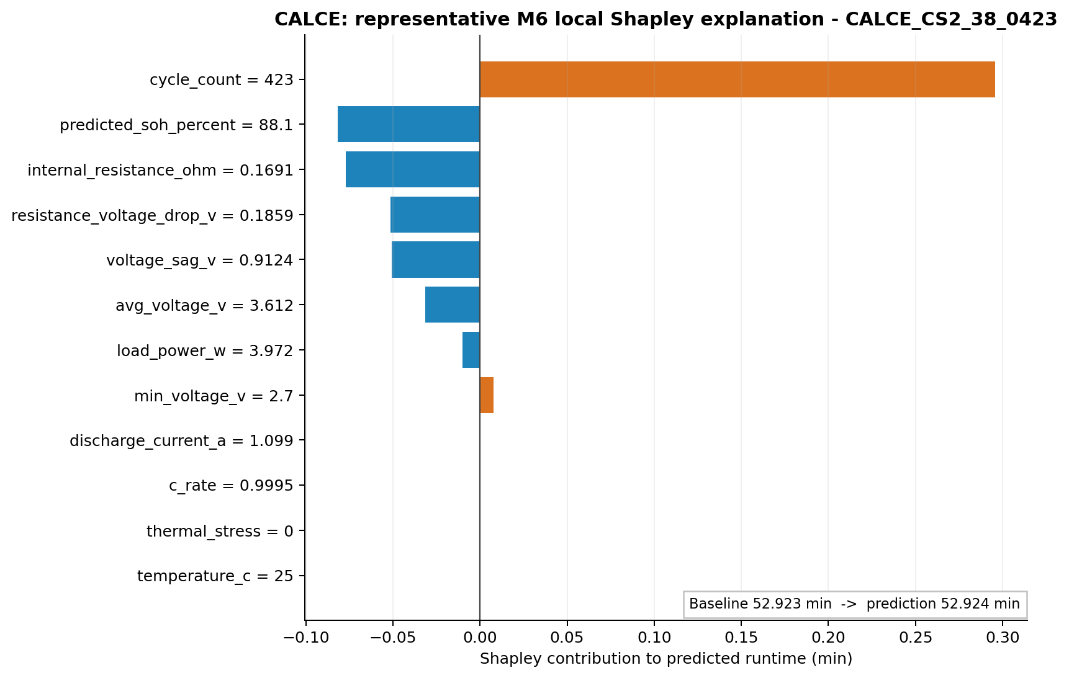
Figure 14. CALCE M6 local SHAP explanation.
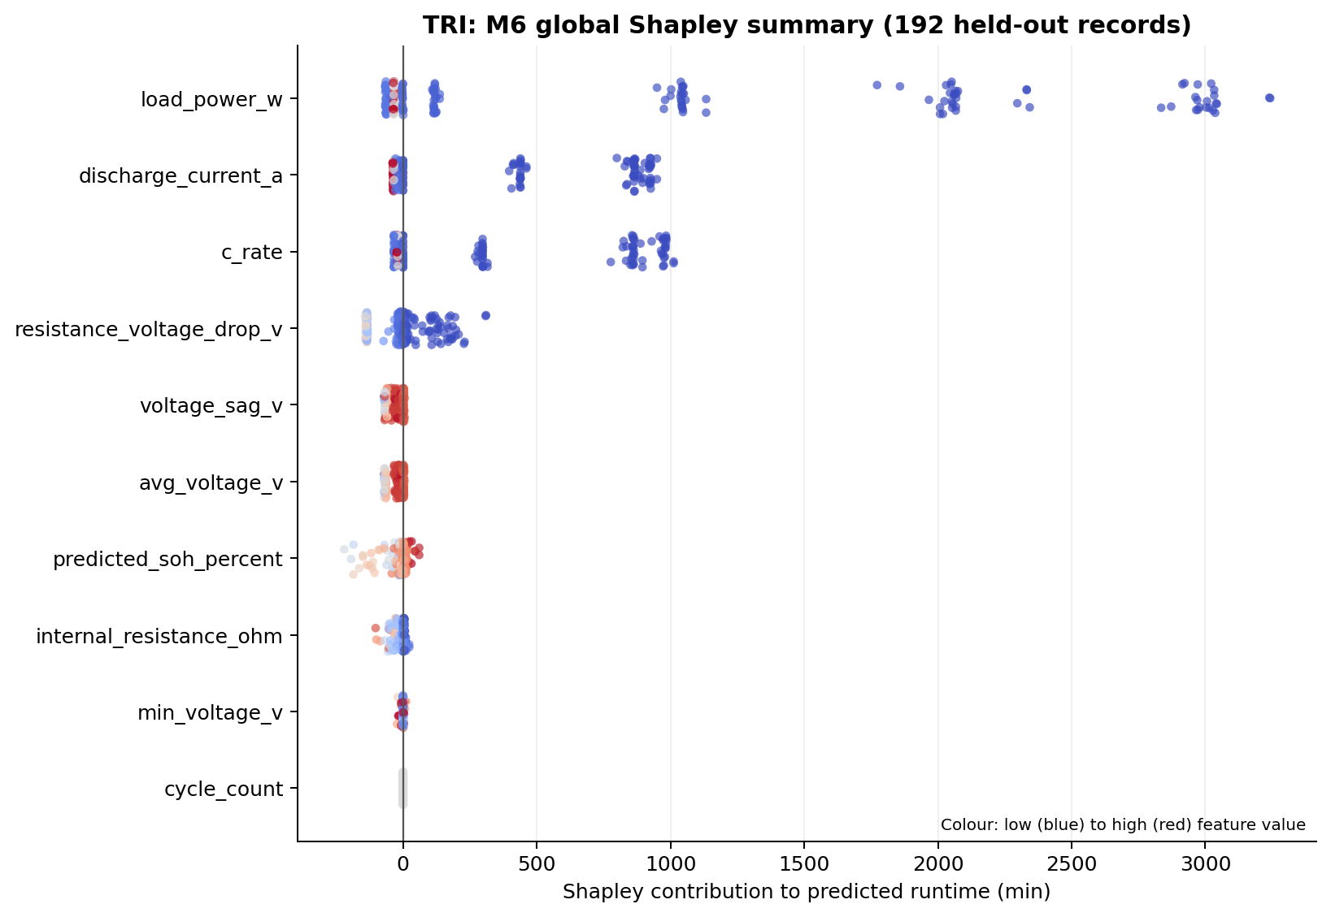
Figure 15. TRI M6 global Shapley summary.
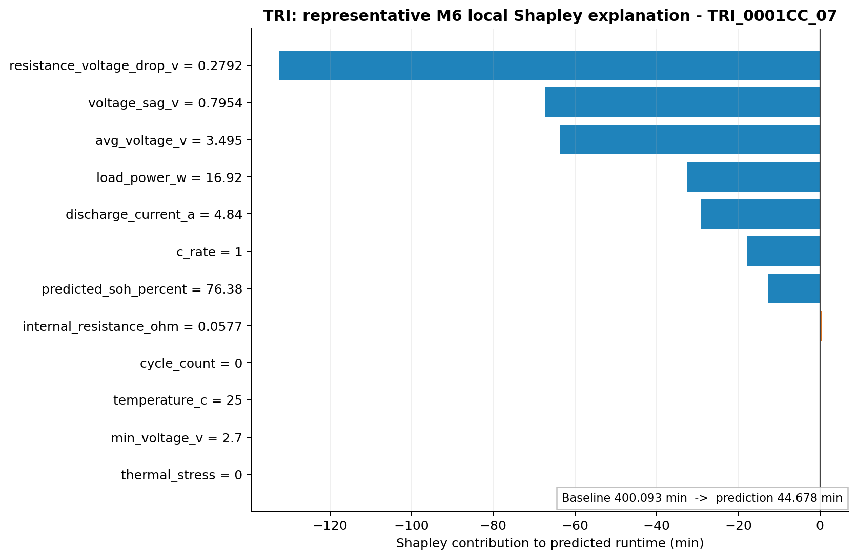
Figure 16. TRI M6 local Shapley explanation.
Feature dominance is domain-dependent. Resistance and C-rate dominate the varied CSGB construction; cycle count dominates the constrained NASA and CALCE protocols; and TRI uses resistance-related features for capacity while load power and C-rate dominate runtime. TRI's constant temperature and sentinel cycle count correctly receive no physical interpretation. Explanations must therefore be read within each source protocol.

9. Decision support and Streamlit dashboard

9.1 M9 decision support
M9 maps predicted SOH, available backup time, required runtime and data-quality flags to configurable labels and guidance. For conservative new-condition guidance, the dashboard uses the smaller of formula and ML runtime estimates. M9 remains secondary, non-safety-critical logic.
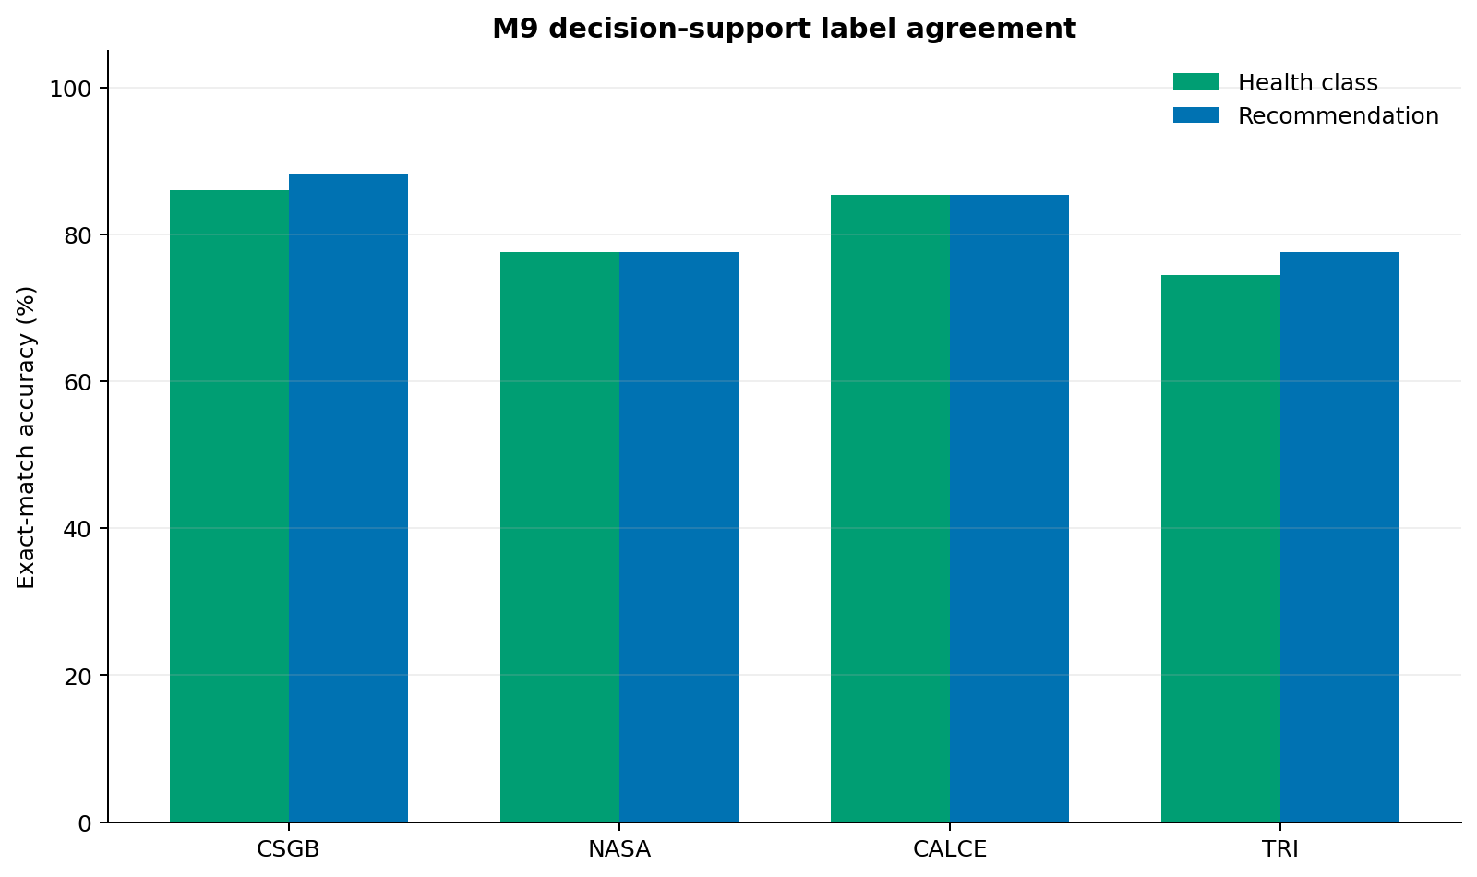
Figure 17. M9 exact-match agreement by dataset.
Reference-label caution
CSGB includes benchmark labels. NASA, CALCE, and TRI references are deterministic threshold labels derived from measured targets, not independent expert maintenance annotations. Their agreement scores validate rule wiring and sensitivity, not safety-classification accuracy.

9.2 M10 dashboard functions
Tab | Implemented function | Validation evidence
Overview | Evidence boundary, dataset inventory and key metrics | Backend/data checks + exported evidence
Data Quality | Quality, grouped-split and source-adapter status | Quality/split JSON + automated tests
Health and Runtime | Dataset results and comparison graphs | Backend/data checks + 22 PNG files
Explainability | Importance and global/local SHAP outputs | CSV/PNG contract + explanation tests
New Condition | Validated inputs; capacity, SOH, M4/M6 runtime and guidance | Backend smoke + guard tests
Downloads | Predictions, metrics and prepared data | Inventory and file-existence checks

10. Verification, persistence and performance

10.1 Automated validation
Layer | Observed result
Syntax compilation | Pass for implementation and tests
Standalone shared modules | M1–M9 regression checks pass
End-to-end pipeline | Pass on CSGB, NASA, CALCE, and TRI
Output contract | 4 dataset outputs, 2,532 held-out rows, 22 graphs, 8 models
Automated unit/integration suite | 20 executed: 19 pass, 1 dependency-aware skip
Streamlit application harness | AppTest skipped because Streamlit was absent; backend/guards/syntax pass

10.2 Model persistence
Dataset | Capacity max |Δ| | Runtime max |Δ| | Tolerance | Status
CSGB | 1.78e-15 | 8.53e-14 | 1.00e-9 | Pass
NASA | 8.88e-16 | 2.84e-14 | 1.00e-9 | Pass
CALCE | 8.88e-16 | 2.84e-14 | 1.00e-9 | Pass
TRI | 2.66e-15 | 1.82e-12 | 1.00e-9 | Pass

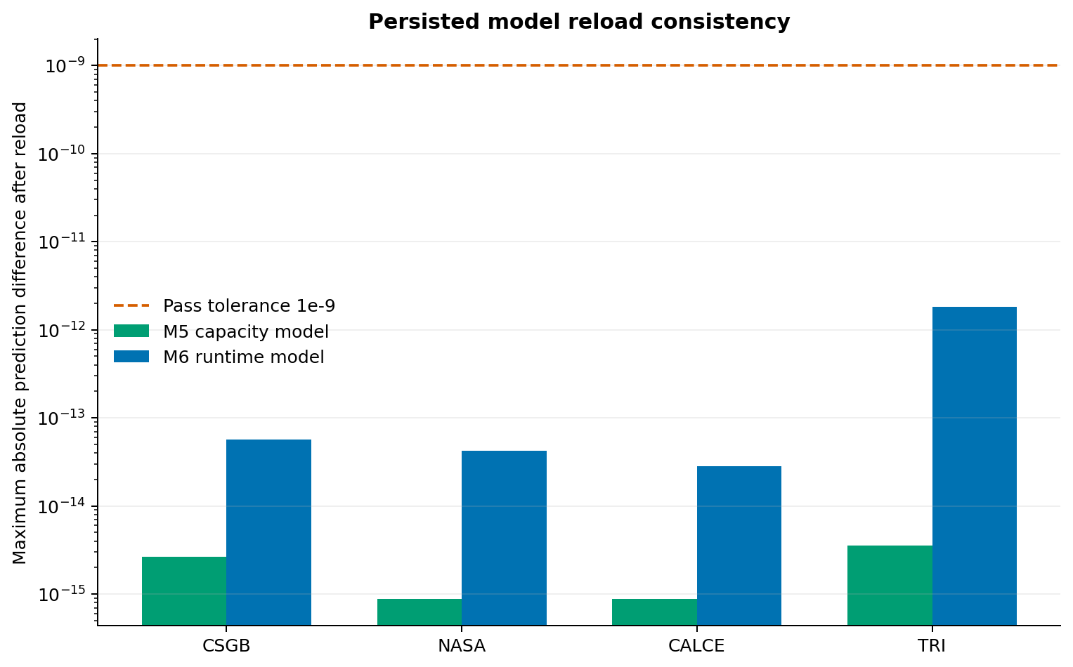
Figure 18. Persisted-model reload consistency.

10.3 Measured inference performance
Dataset | M5 inference (ms/row) | M6 inference (ms/row)
CSGB | 0.944 | 0.492
NASA | 0.748 | 0.356
CALCE | 0.118 | 0.047
TRI | 1.128 | 0.800

Times are observations from the validated environment, not service-level guarantees. The expanded four-domain pipeline completed in 87.25 seconds in the supplied execution environment.

10.4 Automated test coverage
Tests 1–10 | Tests 11–20
CSGB continuity dataset | Model persistence/reload
NASA real dataset | Global/local Shapley outputs
CALCE real dataset | Graph/model inventory
TRI 94-cell dataset | TRI rate-level output
Zero group overlap | Dashboard backend smoke
Oxford native-contract fixture | Dashboard input guards
Target-leakage exclusion | Power-consistency warning
Formula known answer | Conditional Streamlit AppTest
Separated metric domains | No overclaim on real runtime result
Prediction export contract | Truthful adapter status

11. Discussion, limitations and residual risks

11.1 What the evidence supports
- The modular workflow is executable, traceable and reproducible from prepared inputs.
- Battery-group holdouts prevent same-battery cycle leakage in the reported evaluations.
- Capacity/SOH prediction is effective on the selected NASA, CALCE, and TRI laboratory cells, with source- and protocol-specific variation.
- Formula and ML runtime estimates can be fairly compared on the same records, and the winning method depends on the load protocol.
- Global and local explanations, persistence, dashboard behavior and output contracts are verified.

11.2 Limitations
Limitation | Effect | Mitigation / next evidence
Few physical batteries per real dataset | Uncertainty around population-level generalization | Add more cells, LOBO folds and chemistry/protocol strata
NASA/CALCE/TRI discharge protocols are constrained | Limited evidence for highly dynamic inverter loads | Evaluate dynamic-load profiles and field-like power traces
CALCE temperature represented as 25°C metadata | Cannot infer true thermal response | Use time-resolved temperature datasets
CALCE resistance is a voltage-sag proxy | Not directly comparable with EIS resistance | Keep provenance flag; add source-specific features
Oxford official file not processed | No Oxford metrics or graphs | Run included adapter on authorized source file and report separately
M9 real-data labels are deterministic | Not expert-grounded recommendation validation | Obtain domain-expert labels and calibrate thresholds
No field or safety validation | Prototype cannot authorize operational decisions | Controlled field trial, uncertainty calibration and safety review
TRI lacks temperature and prior aging-cycle count | No TRI thermal or age-trajectory conclusion | Retain provenance flags; add characterization metadata or another compatible source

11.3 Residual-risk position
Submission boundary
The package is ready as an academic implementation-and-validation submission. It should be presented as a decision-support prototype whose strongest empirical evidence comes from grouped held-out public laboratory batteries—not as a finished commercial battery-management or safety system.

12. Deliverables, execution procedure and output inventory

12.1 Included deliverables
Deliverable | Quantity / location | Purpose
Final report | DOCX + PDF | Submission narrative and verified interpretation
Implementation | M1–M10 Python modules | Executable analytical and dashboard workflow
Prepared data | CSGB workbook + NASA/CALCE/TRI CSVs + provenance | Offline reproducibility without redistributing raw public archives
Aligned predictions | 4 CSV files; 2,532 rows | Record-level audit and further analysis
Metrics/explanations | CSV + JSON outputs | Quantitative comparison and interpretation
Graphs | 22 PNG files | Coverage, accuracy, residual, rate, SHAP, persistence, and M9 evidence
Persisted models | 8 Joblib files | Reloadable M5/M6 models for four domains
Verification | 20 tests + log + JSON + output inventory | Submission integrity

12.2 Windows execution
cd Phase3_Implementation
py -3.12 -m venv .venv
.venv\Scripts\python -m pip install -r requirements.txt
run_full_validation.bat
run_phase3_dashboard.bat
run_full_validation.bat regenerates predictions, metrics, models and graphs for all four domains, checks the output contract, and executes the automated suite. run_phase3_dashboard.bat starts the Streamlit interface after the pinned requirements are installed. Existing verified outputs are included, so the report can be reviewed without rerunning the models.

12.3 Expected successful output
- PHASE‑3 VALIDATION COMPLETED
- PHASE‑3 OUTPUT VERIFICATION: PASS
- Ran 20 tests … OK (skipped=1 when Streamlit is unavailable)
- VALIDATION SUITE STATUS: PASS
- Graphs: 22; models: 8; held-out prediction rows: 2,532
Submission check
Use the included MANIFEST_SHA256.csv and VALIDATION_SUMMARY.md to verify the ZIP. No manual insertion of graphs or replacement of placeholder results is required.

13. Conclusion and future work
Phase 3 closes the principal implementation items carried forward from Phase 2. Revision 2 adds a working TRI/Matr.io source path and 750 real multi-rate records from 94 aged cells to the existing NASA and CALCE evidence. The project now includes leakage-safe capacity/SOH and runtime workflows, a transparent operational formula baseline, aligned comparison exports, global/local Shapley explanations, model persistence, rule-based guidance, a Streamlit dashboard, and a passed analytical verification suite.
The most important result is methodological: model complexity did not guarantee lower runtime error. M6 learned the varied-load CSGB benchmark well; M4 retained lower aggregate MAE on the constrained NASA, CALCE, and TRI protocols; and TRI's rate-level analysis showed M6 winning five of eight rates and producing lower aggregate MAPE. This supports retaining both an auditable formula comparator and a learned model, with interpretation conditioned on protocol and error scale.

13.1 Recommended next work
- Run the Oxford source-native adapter on the authorized official MAT file and publish Oxford-only results without merging incompatible feature definitions.
- Add more physical batteries and repeat leave-one-battery-out or grouped cross-validation with fold-level confidence intervals.
- Collect or identify genuinely dynamic-load discharge profiles representative of inverter and UPS use.
- Calibrate predictive intervals and out-of-distribution warnings before any operational pilot.
- Obtain expert review of M9 thresholds and preserve the non-safety boundary unless formal assurance work is completed.
- Package the dashboard in a controlled deployment environment with versioned model cards and audit logging.
Final Phase‑3 outcome
The capstone target—an integrated, explainable framework for battery-health assessment and dynamic backup-time prediction—has been implemented and validated as an academic prototype, with evidence and limitations presented transparently.

References
[1] Birkl, C. (2017). Oxford Battery Degradation Dataset 1. University of Oxford Research Archive. https://doi.org/10.5287/bodleian:KO2kdmYGg
[2] Breiman, L. (2001). Random Forests. Machine Learning, 45, 5–32. https://doi.org/10.1023/A:1010933404324
[3] CALCE Battery Research Group. Battery Data. University of Maryland. https://calce.umd.edu/battery-data (accessed 20 August 2026).
[4] Lundberg, S. M., & Lee, S.-I. (2017). A Unified Approach to Interpreting Model Predictions. Advances in Neural Information Processing Systems 30.
[5] NASA Ames Prognostics Center of Excellence. PCoE Data Set Repository – Battery Data Set. https://www.nasa.gov/intelligent-systems-division/discovery-and-systems-health/pcoe/pcoe-data-set-repository/ (accessed 20 August 2026).
[6] Saha, B., & Goebel, K. (2007). Battery Data Set. NASA Ames Prognostics Data Repository.
[7] Scikit-learn developers. RandomForestRegressor and evaluation metrics documentation. https://scikit-learn.org/
[8] Team 19 – Axiom AI. (2026). Study Project Phase 1: Explainable Machine Learning Framework for Battery Health Assessment and Dynamic Backup-Time Prediction.
[9] Team 19 – Axiom AI. (2026). Study Project Phase 2: ML Battery Health Design and Proof of Concept.
[10] Toyota Research Institute. Diagnostic-free onboard battery health assessment - ResValData. MATR.io Dataset 10. https://data.matr.io/10/ (accessed 20 August 2026). License: CC BY-NC 4.0.
[11] Che, Y., et al. (2025). Diagnostic-free onboard battery health assessment. Joule. https://doi.org/10.1016/j.joule.2025.102010

Appendix A – Metric definitions and comparison mapping
Project output | Compared with | Purpose
M4 formula operational runtime | actual_backup_time_min | Transparent baseline accuracy
M5 predicted_capacity_ah | actual_capacity_ah | Remaining-capacity accuracy
M5 predicted_soh_percent | actual_soh_percent | Health-assessment accuracy
M6 ml_backup_time_min | actual_backup_time_min | Dynamic runtime accuracy
M9 predicted health class | health_class reference | Exact-match rule/label comparison
M9 recommendation | expected_recommendation reference | Exact-match guidance comparison

Metric formulas
Metric | Definition
MAE | mean(|prediction − actual|)
RMSE | sqrt(mean((prediction − actual)²))
MAPE | mean(|prediction − actual| / |actual|) × 100
Bias | mean(prediction − actual)
R² | 1 − Σ(actual − prediction)² / Σ(actual − mean(actual))²
Exact-match accuracy | matching labels / total labels × 100

Units
Capacity errors are in Ah; runtime errors are in minutes; SOH MAE is reported in percentage points (pp); MAPE and exact-match accuracy are percentages.

Appendix B – Graph and file inventory
No. | Graph | Analysis supported
01 | Dataset record coverage | Evidence volume and split
02 | Grouped split integrity | Train/holdout groups and overlap
03 | Capacity actual vs predicted | M5 accuracy
04 | SOH actual vs predicted | M5 health accuracy
05 | Runtime actual vs predicted | M4/M6 record-level fit
06 | Runtime error metrics | MAE/RMSE/MAPE comparison
07 | Runtime residual distributions | Bias/spread
08 | Runtime error by cycle quartile | Ageing stability
09 | Capacity degradation profiles | Trajectory tracking
10 | Built-in feature importance | Model structure
11 | Permutation feature importance | Held-out dependence
12 | SHAP mean absolute importance | Global attribution
13–16 | Runtime Shapley summaries | Domain-specific global explanations
17–20 | Runtime Shapley local plots | Representative record explanations
21 | Persistence reload consistency | Serialization integrity
22 | M9 exact-match accuracy | Guidance wiring

Key machine-readable files
File | Use
outputs/phase3_metrics.json | Complete dataset, split, model, explanation, persistence and timing metrics
outputs/phase3_metrics_table.csv | Compact cross-domain metric comparison
outputs/<dataset>/heldout_predictions.csv | Aligned record-level actual/predicted outputs
outputs/<dataset>/*feature_importance.csv | Built-in, permutation and SHAP global values
outputs/models/*.joblib | Eight persisted M5/M6 models
outputs/output_inventory.csv | Verified graph/model/data inventory
outputs/phase3_test_report.json | Machine-readable validation-suite status
TEST_EXECUTION_LOG.txt | Human-readable commands and observed results
outputs/tri/rate_level_metrics.csv | TRI held-out results separated across eight characterization rates

