**Memory Management Assessment**

**Question 3**

**Team member: BoNan Mai, HuaYi Lai, RuiMing Zhu**

# Question Analyze

According to the question, we need to allocate memory space for multiple processes, and the generation of internal fragmentation and external fragmentation generally depends on our memory allocation algorithm. In cases where memory space is not divided into blocks or fixed partitions, the generation of internal fragmentation is often due to **coding errors** in the memory allocation algorithm, resulting in allocating excessive memory space to processes. On the other hand, a significant portion of external fragmentation is **caused by the algorithm itself**, where different algorithms can result in **varying quantities and sizes** of external fragmentation.

Overall, the focus of this question is **mainly on external fragmentation**, and our goal is to minimize the wasted memory space caused by external fragmentation as much as possible.

# The Definition of Internal and External Fragmentation

## **Internal Fragmentation**

Internal Fragmentation refers to the situation in memory allocation where the memory block allocated to a process may be larger than the actual memory space required by the process. In such cases, the process can only utilize a portion of the memory block, while the remaining space goes unused and wasted. Internal fragmentation typically occurs in scenarios of static partitioning or fixed partitioning, where the memory is divided into fixed-sized blocks and processes can only use complete blocks. (Shown in Figure 1)

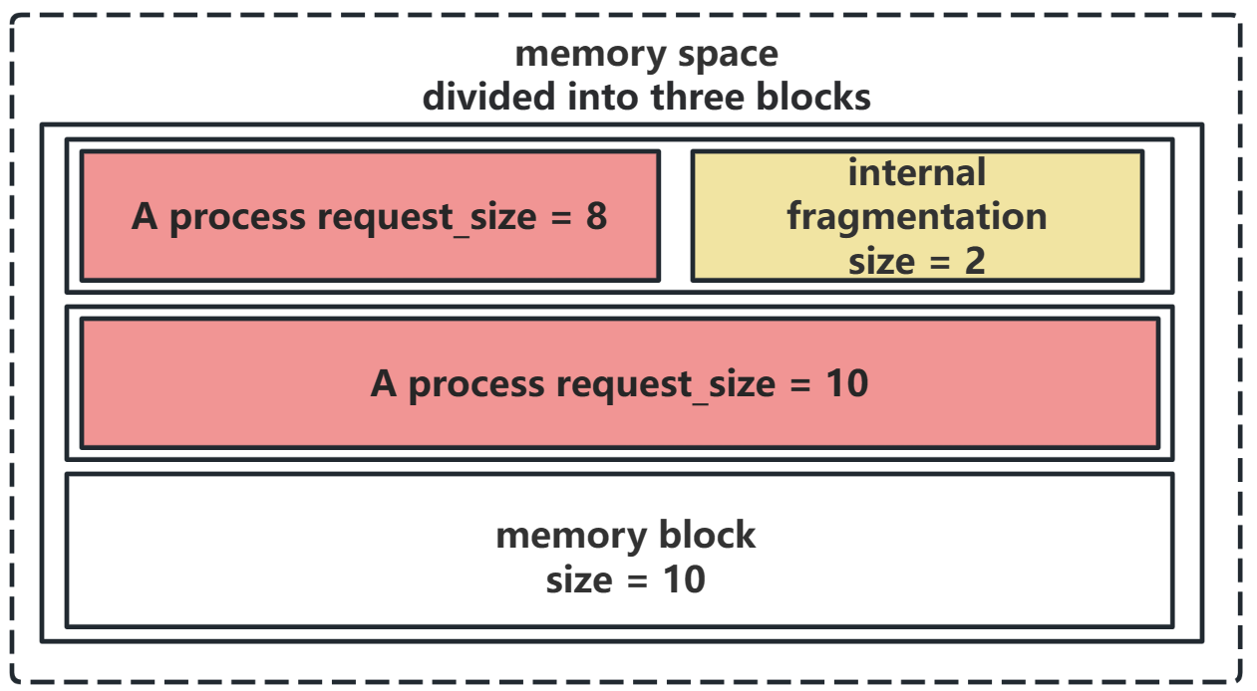

Figure 1: Example of Internal Fragmentation

## External Fragmentation

External fragmentation occurs in the entire memory space due to the discontinuity of allocated and deallocated memory, resulting in scattered free memory blocks. External fragmentation can affect multiple processes, especially in the case of dynamic memory allocation (such as the “Best-fit” algorithm). Since the free memory blocks are divided into multiple small fragments, these fragments may not fulfill the contiguous memory requirements of certain processes. As a result, they persist in the memory space, leading to memory fragmentation and waste. (Shown in Figure 2)

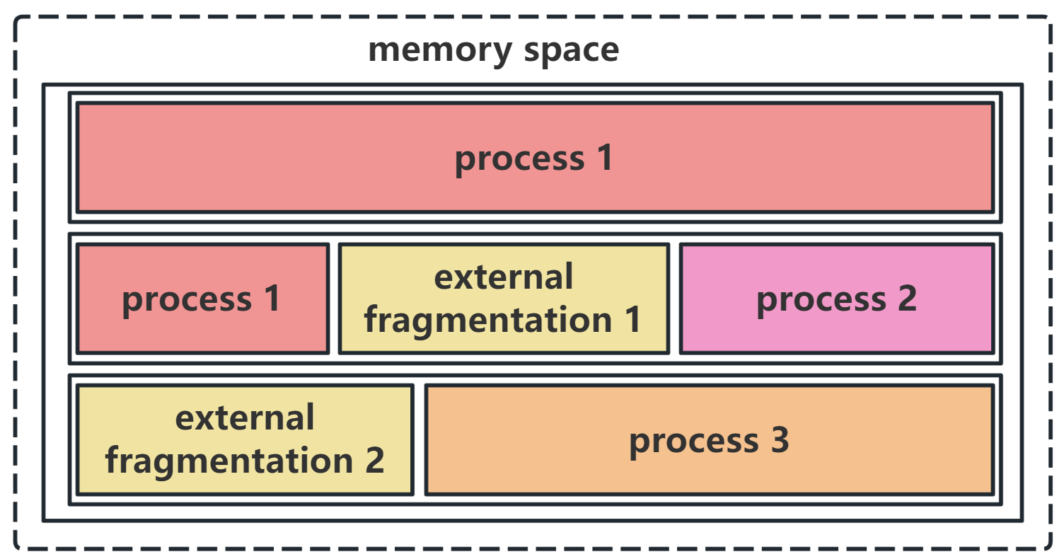

Figure 2: Example of External Fragmentation

# The Difference between Internal and External Fragmentation

## occurrence position

**Internal fragmentation** occurs within individual memory blocks, where the allocated memory space is larger than what is actually required by a process, resulting in wasted memory within the block.

In contrast, **external fragmentation** refers to the fragmentation of the entire memory space, where free memory is divided into small blocks scattered among allocated memory blocks. It occurs between memory blocks.

## Impact scope

**Internal fragmentation** is limited to influencing the memory blocks allocated to specific processes, causing wasted space within those blocks.

In contrast, **external fragmentation** affects the entire memory space and can impact the entire memory space, leading to an inability to fulfill the memory requirements of certain processes.