**Creative text generation from Images**

A Synopsis Submitted

in Partial Fulfillment of the Requirements

for the Course of

# Minor Project - II

In

Third year – Sixth Semester of

**Bachelor of Technology**

specialization

In

**Artificial Intelligence and Machine Learning**

Under

Dr. **Shiv Naresh Shivhare**

By

500075340 R177219007 Abhishek Srivastava

500075335 R177219035 Animesh Sundriyal

500075323 R177219016 Akash Joshi

500076006 R177219013 Aditya Rathore



DEPARTMENT OF INFORMATICS

SCHOOL OF COMPUTER SCIENCE

UNIVERSITY OF PETROLEUM AND ENERGY STUDIES, BIDHOLI, DEHRADUN, UTTRAKHAND, INDIA

**February, 2022**

**Synopsis**

**Introduction**

Vision is a common source of inspiration for poetry and as correctly stated by someone “an image is worth thousand words”. The objects and the sentimental imprints that one perceives after seeing an image may lead to various feelings depending on the reader. In old days there used to be concept of “situational poetry” where artists would write poems on any given situation. We aim to achieve this result through machine learning techniques of Convolutional Neural Networks and Recurrent Neural Networks.

The possibility of creating human-level content by AI requires building a deep and multi-modal understanding model. Poetry can be inspired by many things, among which vision is one of the prime sources. Generating poetry from image involves the task of text generation from a given image. The area of focus being - image captioning and literature creation. It is usually the case that different people have different readings and feelings of the same image. This makes it particularly interesting to read poems by others inspired by the same image. In this project, we present a system that mimic poetry writing of a poet by looking at an image.

The generated sentences should attain poetic grammar, structures, and language styles, and the semantic content should be relevant to the visual clues discovered from the images. In comparison with poetry generation from keywords, using image as inspiration for poetry has many advantages, for different people the same image could lead to different interpretations, thus using images to inspire poetry generation may often provide an enjoyable surprise and leave the impression of higher imagination

**Motivation**

Automatic generation of natural language from images has been an intriguing topic as it bridges the gap between human and machine creative ability. There have been approaches of image descriptions like image caption and paragraph. Image descriptions aim to generate sentence to describe facts from images in human-level languages an approach one step further is to tackle a more cognitive task i.e., generation of poetic language to an image for the purpose of poetry creation. Dramatic progress has been achieved by supervised convolutional neural network (CNN) models on image recognition tasks.

**Related Work**

Traditional approaches for poetry generation include template and grammar-based method, generative summarization under constrained optimization and statistical machine translation model. By applying deep learning approaches recent years, researches about poetry generation have entered a new stage. Recurrent neural network is widely used to generate poems that can even confuse readers from telling them from poems written by human poets.

Previous works of poem generation mainly focus on style and rhythmic qualities of poems, while recently, some works try to address conditional poem generation, inspired by the fact that many poems are generated based on visual contents, Liu et al. [1] proposed to generate poetic sentences according to a source image.

**Methodology**

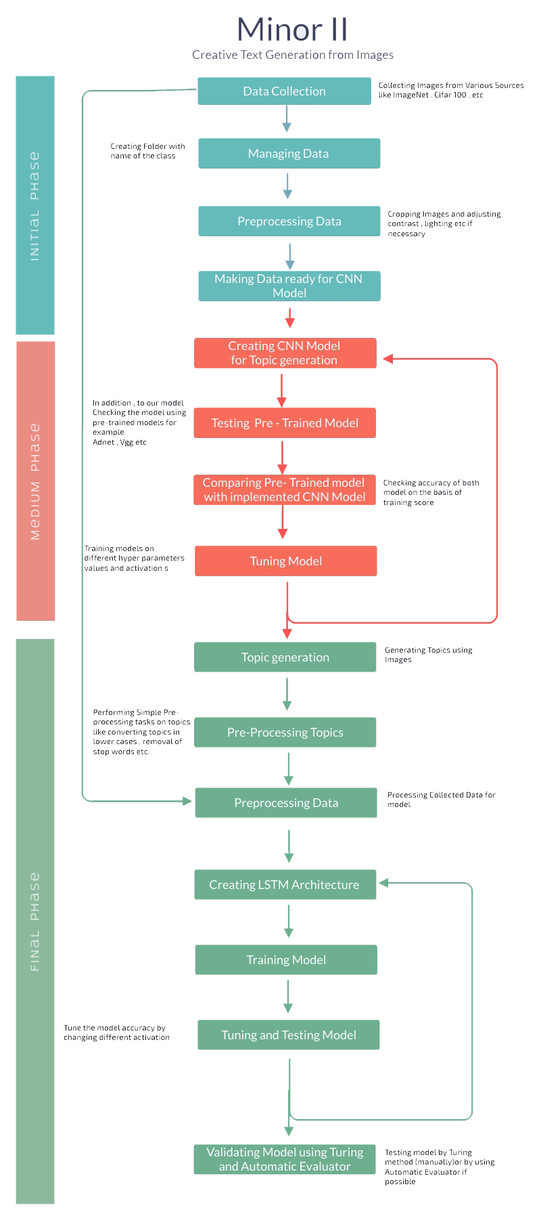

Fig (1). Phases of Working

|  |  |
| --- | --- |
| **February** | State-of-the-art survey. |
| **March** | Dataset collection, Exploratory data analysis |
| **April** | Model Building |
| **May** | Model optimizing and evaluation |

**References**

1. Liu, B., Fu, J., Kato, M. P., & Yoshikawa, M. (2018, October). Beyond narrative description: Generating poetry from images by multi-adversarial training. In Proceedings of the 26th ACM international conference on Multimedia (pp. 783-791).
2. Li, L., Yang, S., Su, L., Wang, S., Yan, C., Zha, Z. J., & Huang, Q. (2020, October). Diverter-guider recurrent network for diverse poems generation from image. In Proceedings of the 28th ACM International Conference on Multimedia (pp. 3875-3883).
3. Cheng, W. F., Wu, C. C., Song, R., Fu, J., Xie, X., & Nie, J. Y. (2018). Image inspired poetry generation in xiaoice. arXiv preprint arXiv:1808.03090.
4. Asghar, N., Poupart, P., Hoey, J., Jiang, X., & Mou, L. (2018, March). Affective neural response generation. In European Conference on Information Retrieval (pp. 154-166). Springer, Cham.
5. Donahue, J., Anne Hendricks, L., Guadarrama, S., Rohrbach, M., Venugopalan, S., Saenko, K., & Darrell, T. (2015). Long-term recurrent convolutional networks for visual recognition and description. In Proceedings of the IEEE conference on computer vision and pattern recognition (pp. 2625-2634).
6. Farhadi, A., Hejrati, M., Sadeghi, M. A., Young, P., Rashtchian, C., Hockenmaier, J., & Forsyth, D. (2010, September). Every picture tells a story: Generating sentences from images. In European conference on computer vision (pp. 15-29). Springer, Berlin, Heidelberg.
7. R.Bowman, Luke Vilnis, Oriol Vinyals, Andrew M. Dai, Rafal Jozefowicz & Samy Bengio Generating Sentences from a Continuous Space Samuel