# **Abhishek Shrivastava**

# SAP id : 500075340

# OOPs experiment No 2

# **Experiment No 1 :**

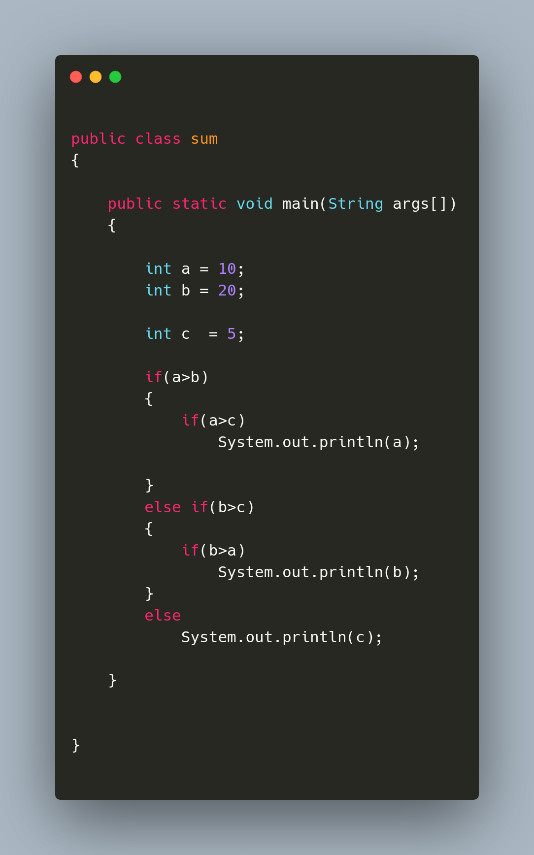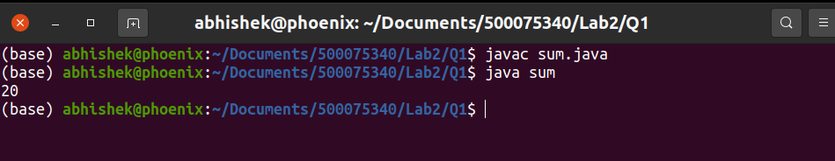

# **Experiment No 2 :**

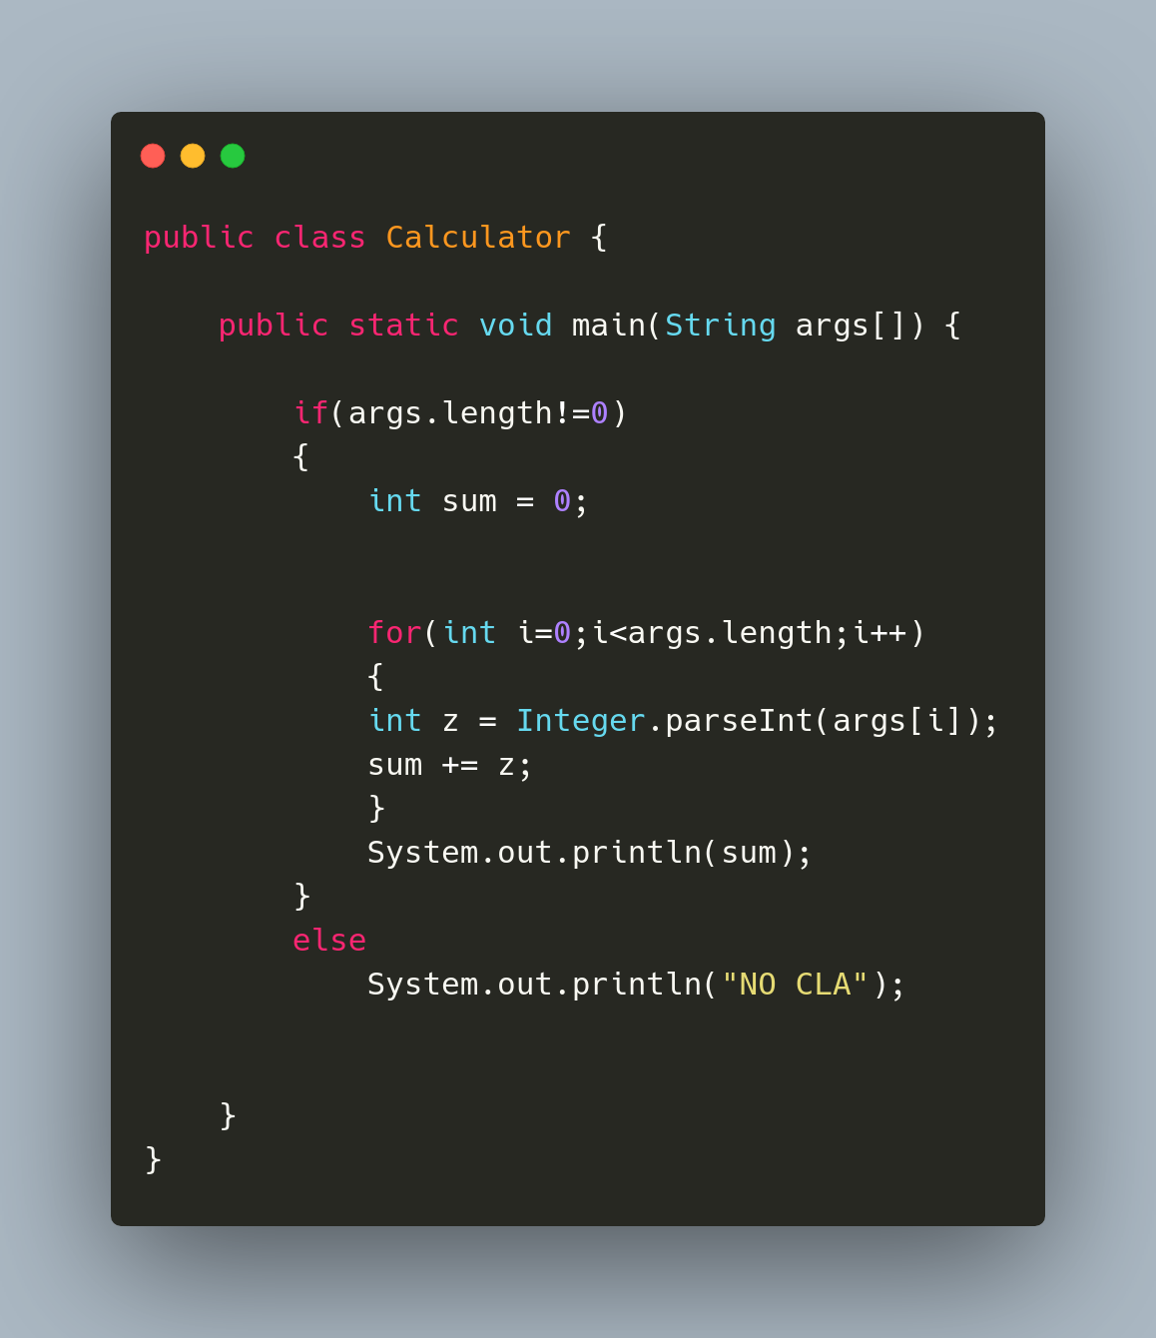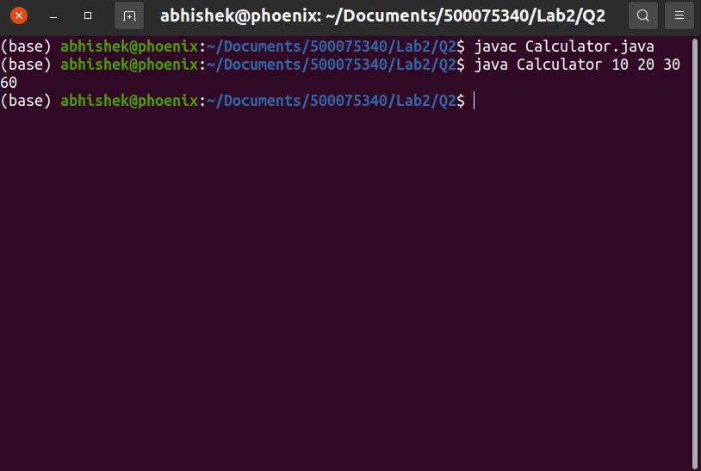

# **Experiment No 3:**

