* **Add team members as collaborators and assign them appropriate rights (if you are performing individual then create one dummy account for the task**

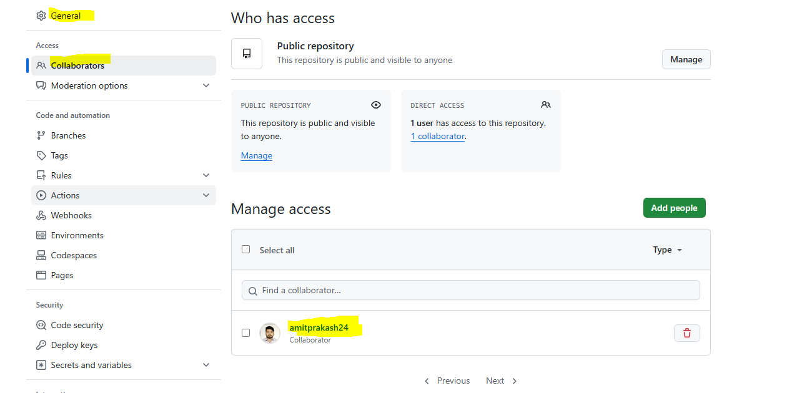

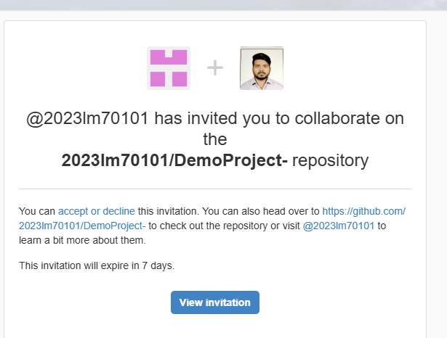

* Create a branch(development/production/feature)

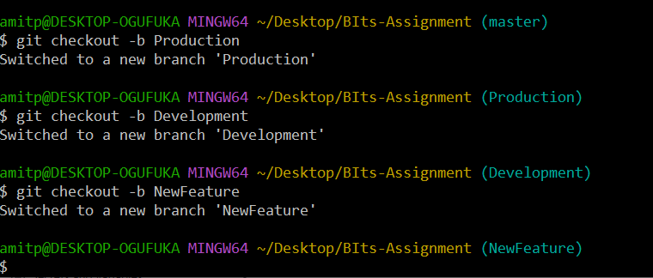

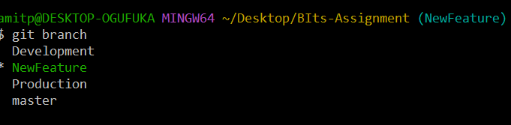

`

* **Edit files or create new files followed by commit**

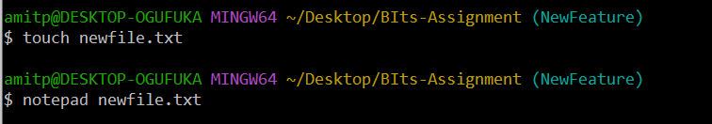

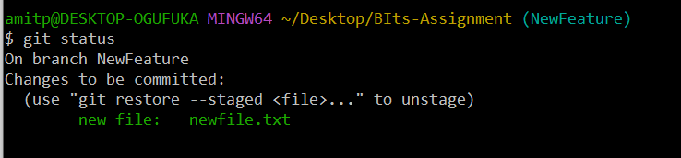

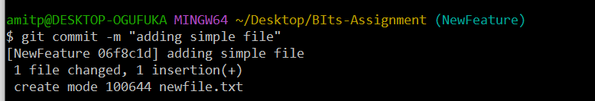

* Clone the repo and Create pull-request

**git clone https://github.com/2023lm70101/DemoProject-.git**

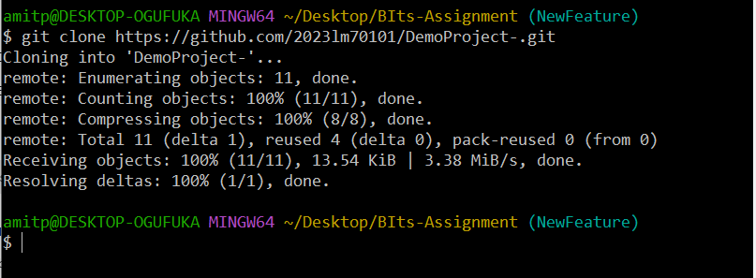

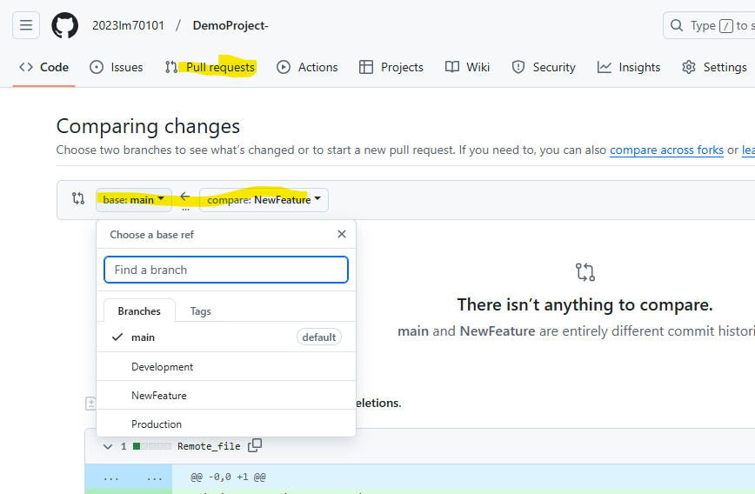

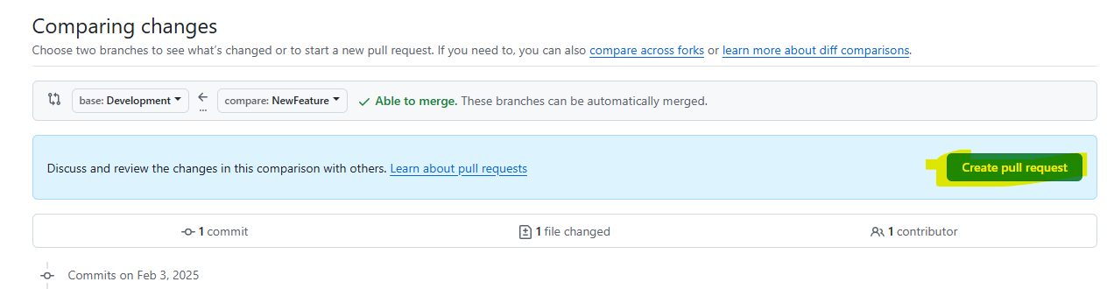

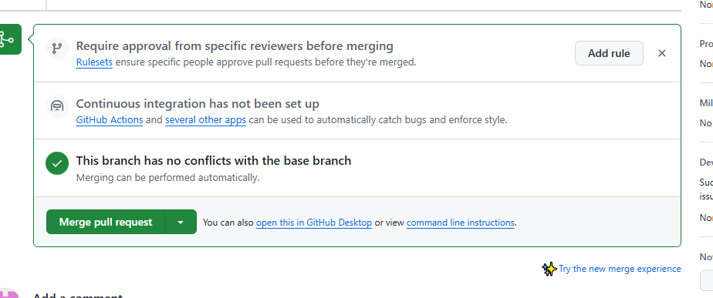

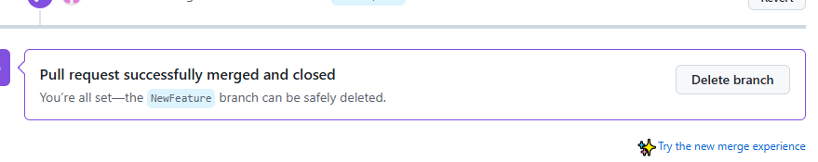

* While collaborating your work, showcase how conflicts are resolved
* Create tag such as open issue, or feature-added
* Do a force push/commit and then later reset the changes
* Stage “development branch to production branch”
* Showcase how features are released in versions (merging production to master branch)
* Also, state importance of Readme and gitignore files and their usage while working in a distributed environment.
* Pull Requests linked with e-mail to the manager who finally approves the changes.