CareBridge: A Citation-Grounded Vaccine Education Assistant for Clinicians and Patients
MSAI 633 — Assignment 1: Project Proposal
Due: Friday, October 9, 2026
Domain: Healthcare — CDC vaccination and preventive-care education
Team: Five unique members (names and assigned responsibilities in Section 1)
GitHub repository: https://github.com/2023lokesh/carebridge-rag
Live prototype: https://carebridge-vaccine-chatbot.onrender.com
Status: Hosted educational demo available; full graded crawl and evaluation remain pending

1. Purpose, user needs, and team roles
A physician often needs to explain complex recommendations clearly during a short encounter, and a patient needs trustworthy, understandable answers afterward. CareBridge will be a Retrieval-Augmented Generation (RAG) assistant that turns publicly available U.S. Centers for Disease Control and Prevention (CDC) vaccination information into plain-language, source-linked explanations. A clinician could use it to find the appropriate CDC Vaccine Information Statement (VIS), explain common vaccine reactions, or show where to verify a schedule. A patient could ask what a vaccine prevents, what questions to bring to a clinician, or how to read a public schedule.
The primary users are doctors, nurses, clinic educators, patients, and caregivers. The product is an educational reference, not a licensed medical professional, diagnostic tool, prescription writer, automated vaccine eligibility decision-maker, or EHR-connected clinical decision support system. It will not accept patient charts or calculate an individualized regimen. When safety, contraindications, complex medical conditions, pregnancy, or a person’s prior-dose history materially affect an answer, the chatbot will explain the limitation and refer the user to a licensed clinician. Emergency questions will receive an appropriate emergency-services referral instead of an improvised treatment plan.
Team composition: The five distinct team members below own specific workstreams. Cross-functional responsibilities are proposed collaboration tasks; contributions and reviews must be evidenced by each member’s GitHub activity.
Team member / role | Primary responsibility | Cross-functional contribution
Baroowah, Lakhyajyoti — Product Manager | Project scope, requirements, milestones, product acceptance criteria, user stories, and live demonstration. | Own project Issues/board and delivery tracking; coordinate golden-set review and final README/report quality.
Asha Kiran Narla — Full Stack Developer | FastAPI/web chatbot, session history, linked citations, accessible UI, retrieval trace, and API integration. | Add UI/API tests; peer-review integration and safety-related changes.
Deepaksai Pasupuleti — Lead Engineer | System architecture, service integration, retrieval/reranking design, CI quality gates, release technical reviews. | Review ingestion/indexing changes; coordinate experiments, deployment verification, and pull-request quality.
Munagala, Lokesh Sai Krishna — Data Engineer | Compliant CDC crawler, raw response archive, URL/content provenance, robots.txt and rate limiting, PII/PHI exclusions. | Audit corpus counts and normalized extraction; partner on source verification and reproducible ingestion reports.
Karthik Lakamraju — Data Engineer | HTML/PDF/table extraction, fixed and heading-aware chunking, embedding/index pipelines, safe re-chunk migration. | Test stale chunk deletion and metadata filtering; support retrieval measurement and manual document validation.
Collaboration commitments: Every team member will commit to at least two pipeline stages under their own GitHub account; use short-lived feature branches; and submit pull requests for another team member’s approval. Issue ownership, code reviews and protected-main enforcement still need to be recorded or verified.

2. Domain, CDC source, and corpus feasibility
Chosen domain: Healthcare — public vaccination and preventive-care patient education. Primary source site: https://www.cdc.gov. The proposed authorized corpus is limited to public CDC vaccination guidance under /vaccines/ and relevant COVID-19 vaccination content under /covid/ (subject to robots.txt and URL validation). No authentication, directory pages, patient records or PHI are permitted. The required target is at least 150 eligible source documents, including at least 5 PDFs and 3 distinct pages containing meaningful data tables. The current demonstration corpus is much smaller and does not establish that the minimums have been met.
Five publicly accessible, vaccination-relevant CDC PDFs located during proposal research:
- Hepatitis A Vaccine Information Statement (PDF)
- Human Papillomavirus (HPV) Vaccine Information Statement (PDF)
- Measles, Mumps, Rubella (MMR) Vaccine Information Statement (PDF)
- Tdap Vaccine Information Statement (PDF)
- Recombinant Zoster / Shingles Vaccine Information Statement (PDF)
Three public CDC pages containing structured schedule tables:
- Adult immunization schedule by age
- Adult schedule by medical condition / indication
- Child and adolescent catch-up schedule
Corpus feasibility: The proposal identifies five candidate Vaccine Information Statement PDF links and three candidate CDC HTML pages with immunization tables. These are candidate sources, not proof of a completed crawl. Before the team claims the minima, it must save and inventory raw files, confirm each PDF and table page was successfully crawled and extracted, deduplicate, and report verified counts. If fewer than 150 eligible items remain, extend within permitted CDC public guidance and discuss scope constraints with the instructor.
Each raw response is saved before parsing with source_url, UTC crawl timestamp, HTTP status, MIME type, raw SHA-256, and immutable raw path. Each normalized document stores doc_id, canonical URL, title, heading path, page type (HTML/PDF/table-bearing HTML), effective/review date if available, crawl timestamp, raw hash, normalized text and intact tables. Content hashes deduplicate duplicate pages and PDFs. Schedule pages can have different legal/effective versions; historical files are retained for audit but excluded from current-advice retrieval unless the question explicitly asks about a past period.

3. Technology choices and justification
Pipeline component | Choice and implementation rationale
Scraping / scheduling | Python 3.11, requests, BeautifulSoup4, urllib.robotparser; deterministic crawl queue, descriptive User-Agent with team contact email, at most 1 request/second, per-URL permission check
HTML / PDF / table extraction | trafilatura for boilerplate reduction; BeautifulSoup for heading paths and actual HTML table structure; PyMuPDF for PDF text with page coordinates; pdfplumber to test table extraction; reject illegible or ambiguous tables
Chunking | Compare fixed 450-token windows with 75-token overlap against heading-aware 250–650-token units that preserve VIS section headings and complete table rows when practical
Embedding | sentence-transformers/all-MiniLM-L6-v2, 384 dimensions, pin exact model revision; L2-normalize embeddings and query vectors; use cosine similarity and log the metric configuration
Vector DB | Persistent ChromaDB with deterministic IDs, filterable page_type / effective_date metadata, and verified deletion + collection-switch path
Retrieval | Implement and measure BM25 only, dense only, and hybrid via Reciprocal Rank Fusion RRF(k=60); unique candidate pool ≥20 before reranking
Reranker | cross-encoder/ms-marco-MiniLM-L-6-v2, score candidate pool and retain ≤5 evidence chunks; record added latency and ranking lift
Generation model | OpenAI gpt-4.1-mini (or validated available equivalent, exact deployment/version captured); strictly context-limited prompting, response checks, .env for credentials
Chat / tests / reporting | FastAPI + browser-based HTML/CSS/JavaScript multi-turn chat (implemented demo); clickable sources, refusal and expandable retrieval trace. pytest and API tests; reports in Markdown. Streamlit is not used in the current code.
Proposed full RAG stack versus implemented demo: The current hosted demo is FastAPI with a browser interface, BM25 retrieval and a TF-IDF lexical-vector proxy, with extractive, cited output. Sentence-transformer embeddings, ChromaDB persistence, a true cross-encoder reranker, and optional LLM generation are specified for the graded full system; they must not be reported as validated until run and measured on the actual corpus. Record exact dependency/model versions, embedding dimension, normalization and distance metric in the final report.

4. System architecture and end-to-end data flow
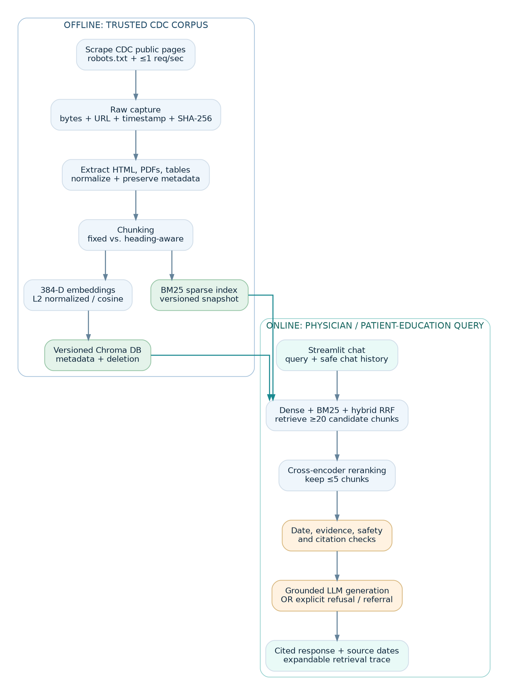
CareBridge RAG architecture with offline scraping, extraction, chunking, embeddings, vector and BM25 indexes; online retrieval, reranking, safety checks, generation and cited chat output.
Offline ingestion: (1) crawl only permitted public CDC URLs → (2) archive original bytes and provenance → (3) extract heading paths, PDF page text and intact table records → (4) normalize/deduplicate → (5) create both chunk strategies for comparison → (6) L2-normalize and embed chunks → (7) persist Chroma vectors and a matching BM25 snapshot. All indices reference the same document manifest and version.
End-to-end design: (1) receive a general educational question in the FastAPI/browser chat; (2) apply clinical-safety and topic filters; (3) retrieve source candidates (dense, BM25, hybrid modes to be evaluated in the full system); (4) apply vaccine-specific evidence checks so COVID questions never cite unrelated HPV/MMR passages; (5) rerank at least 20 candidates to at most 5 evidence chunks in the complete pipeline; (6) generate strictly grounded text or refuse when insufficient; (7) return clickable citations, source dates, a retrieval trace and a clinician referral when appropriate. The currently deployed lightweight demo does not yet constitute the fully measured nine-stage pipeline.
Example in-scope question: “What is the purpose of the HPV vaccine, according to the CDC?” Example clinician-assist question: “Which current CDC VIS can I give a patient who asks about Tdap?” Example out-of-scope question: “I am pregnant and have complex allergies; tell me exactly which vaccines to take today.” The last requires individualized clinical evaluation and should be referred, not answered with an invented regimen.

5. Two chunking strategies and safe re-chunk migration
Strategy A — fixed-size baseline: tokenize normalized content into 450-token chunks with 75-token overlap. Retain canonical URL, page type, effective date, original heading path, PDF page range, source span offsets and table indicator. This is easy to reproduce but may split contraindication context and table rows.
Strategy B — structure-aware: split first by document, VIS heading and PDF page/section; carry the full heading path into every chunk. Target 250–650 tokens, keep a table header with its corresponding rows, repeat necessary row/column labels, and avoid separating warnings from the clause qualifying them. When a very large table needs multiple chunks, repeat the header and tag a shared table_id; never silently flatten a row into unrelated prose. Compare chunk counts, minimum/median/p95/max token length, table row integrity, retrieval metrics and latency.
Deterministic identifiers: doc_id = sha256(canonical_url)[:16]; chunk_id = {doc_id}:{strategy_version}:{normalized_text_sha[:12]}:{ordinal:05}:{chunk_sha[:12]}. Canonicalize URLs (remove tracking parameters and fragments); content version and sequence make chunk identity reproducible. Store active_index_version independently of document storage.
Migration without recrawling: reconstruct Strategy B only from saved normalized text and tables; build a new version-named Chroma collection and BM25 index snapshot; compare expected chunk IDs with actual index IDs, fail if missing/extra IDs; rerun the same development queries; atomically switch the active-index pointer after acceptance; delete the old collection and stale BM25 snapshot and prove zero old-version/orphan IDs remain. Keep prior normalized documents and audit logs, not prior active chunks. On failure, roll back the pointer and report the failure instead of silently mixing strategies.

6. Grounding, refusals, clinical boundaries and citations
Grounding and citations: For every factual medical claim, provide a clickable CDC source URL pointing to evidence actually retrieved for that claim. Do not quote more than 25 consecutive words from any one page. Filter by vaccine/disease subject; reject mismatched evidence and refuse when relevant context is missing. Show page edition/effective date when known, clearly distinguish it from crawl time, and refer high-stakes personalized questions to a clinician. The demo implements links and a topical guard; claim-by-claim validity still requires evaluation on the verified corpus.
Insufficient-context decision: require topic relevance, evidence coverage, policy date compatibility, no unresolved contradictory guidance, and a calibrated retrieval-score threshold selected on development data only. Where evidence is absent, conflicting, stale or outside the corpus, return: “I do not have enough reliable information in the approved CDC sources to answer that question. Please check the linked CDC guidance or speak with your healthcare professional.” Thresholds do not substitute for factual source checking. High-stakes questions about individual contraindications, pregnancy, immunocompromise, anaphylaxis, adverse events, exact doses, diagnosis or treatment trigger qualified-clinician referral. When a user describes symptoms suggesting an immediate emergency, the chatbot advises calling local emergency services (911 in the United States) rather than attempting triage or treatment.
Injection resistance: all retrieved page content is untrusted data, never an instruction. Reject hostile retrieved text such as “ignore prior instructions”; cite only provenance-verified URLs; demonstrate a seeded injection test by Saturday. The UI visibly states that CareBridge is educational and does not replace a doctor’s judgment.

7. Evaluation set, baselines, metrics and scientific rigor
Evaluation requirement: Prepare at least 40 human-authored and human-verified golden questions using source pages, with the following exact category targets and a stratified 60/40 development/test split. The course requires authoring these before observing chatbot outputs; because a demo already exists, the team should disclose this sequencing concern and obtain instructor guidance rather than claiming a pre-output set was completed.
Golden-set category | All | Development | Held-out test
Single-hop factual | 15 | 9 | 6
Multi-hop across ≥2 pages | 6 | 4 | 2
Comparative | 4 | 2 | 2
Temporal / version-sensitive | 4 | 2 | 2
Unanswerable / absent | 8 | 5 | 3
Ambiguous or adversarial | 3 | 2 | 1
Total | 40 | 24 | 16
Examples to author and verify include VIS purpose, differences among public recommendations, conflicting older/current schedule cases, and refusal questions asking for a patient’s exact treatment or dose. Every answerable item stores a gold answer, gold URL(s), ≤25-word supporting evidence quote, item category and independent human verifier. For genuinely unanswerable items, log attempted searches and the reason supporting evidence was absent; AI suggestions without human verification do not qualify. Freeze items and a seeded category-stratified split before tuning. Tune only on the 24 development examples and run the 16-item held-out test once on Sunday.
Baseline | Configuration and comparison role
B0: closed-book | Same LLM with retrieval disabled; quantify prior knowledge and report headline metrics separately on B0-incorrect items
B1: lexical | BM25 alone on fixed-size chunks, no reranking
B2: naive dense | Dense retrieval alone using fixed 450/75 chunks, no BM25 or reranker
B3: final | Structure-aware chunks + hybrid RRF + cross-encoder rerank + grounded citation/refusal gates
Measure Recall@5, Recall@20, MRR, nDCG@10, human-checked answer correctness, claim-level citation validity, correct-refusal rate for unanswerables, over-refusal on answerables, p50/p95 latency, per-query LLM cost, and rerank’s added latency. Recall@20 is the reranker’s candidate-pool ceiling. Isolate each change from B2 to B3 (structure-aware alone; hybrid alone; rerank alone; safety/grounding gate), report deltas, and support improvement claims with 95% paired bootstrap confidence intervals or McNemar’s test where applicable. Label at least 15 actual observed failures among retrieval miss, extraction failure, chunk boundary, stale content, reranker demotion, unsupported claim, invalid citation and refusal errors. No scores or cost figures are fabricated in advance.

8. Major risks, mitigations and ethics assessment
Risk / challenge | Planned response and evidence
Medical misinformation / inappropriate individualized advice | Educational-only scope; claim-level CDC citations; refusal + licensed-clinician referral, emergency escalation for immediate danger; targeted high-stakes tests
Stale or conflicting vaccine recommendations | Store effective/review/crawl dates; prefer current CDC version explicitly identified on the live page; exclude archived schedule PDFs from normal retrieval; temporal-question routing and “as of” date labels
PDF and multidimensional schedule-table extraction failures | Compare PyMuPDF/pdfplumber outputs; preserve row/column headers and footnotes; manual spot checks; block answers dependent on unreadable tables
PHI/PII or inadvertent web-directory capture | URL denylist for /patients/, login, forms and directories; content scan/redaction or discard; synthetic test samples; no EHR/patient chart use; disable full chat logs and disclose retention
Retrieval miss, hallucination, invalid citations | Hybrid candidate pool ≥20; reranking; citation validator, grounded answer gate and monitored refusal metrics
Prompt injection embedded in web content | Treat crawled material as untrusted; no tool instructions from corpus; poisoned-fixture unit test by Saturday
Unequal accessibility / health literacy / language barriers | Plain language, explain medical terms, accessible Streamlit labels, visible limitations; no unsupported automatic translation or claimed clinical equivalence
Website burden / crawl permission | robots.txt respected programmatically, ≤1 request/second, descriptive contact User-Agent, backoff for 429/503, Retry-After obeyed, no authentication or prohibited paths
Explicit no-PII/PHI policy: Ingest only public non-personal CDC informational pages. Exclude any patient story with identifying clinical detail, personal emails/phone numbers, directories, uploaded files, medical records, appointment requests, or simulated data resembling a real person’s record. Do not solicit age + conditions + vaccine history combinations for patient-level recommendations. Validate index contents before deployment. No PHI, HIPAA-regulated records, or staff/personnel data are required or permitted.
Two ethics controls demonstrable by Saturday evening: (1) automated sensitive-URL/PII exclusion before indexing, including a negative fixture test; (2) an injected-content resistance test that proves the model will not treat retrieved instructions as authority. Document the controls and test outputs in reports/07_ethics.md. Risk disclosure, date labels and clinician escalation are additional protections.

9. GitHub, reproducibility and Friday–Sunday plan
Repository and collaboration status: https://github.com/2023lokesh/carebridge-rag — repository exists, source code is committed, and the project has GitHub Issues for remaining tasks. Hosted demo: https://carebridge-vaccine-chatbot.onrender.com. The professor also requires a protected main branch, no direct pushes, short-lived feature branches, and at least one peer approval per pull request. Protection, individual cross-stage contributions and review history are not verified as compliant and must be established. Never commit .env, private data, passwords or API keys.
Code and report organization: Current repository contains FastAPI app and UI code, demo CDC-linked corpus, crawler/extraction/chunking/evaluation modules, tests, deployment configuration, README and reports/00_proposal.md. The course additionally requires reports/01_ingestion.md through 07_ethics.md with measured outcomes, reproducible commands and an AI-use disclosure; report completion and measured results are outstanding and must be verified rather than inferred from scaffolding.
Milestone commitments (per course handout): Friday — domain, proposal, team roles, repository with protected main and task board, 150 raw pages including five PDFs and three table pages, plus 15 verified gold items. Saturday — end-to-end B2, 40 human-checked gold items, fixed-versus-structure chunking, migration with zero orphans, dense/BM25/hybrid/reranker comparison, reports 01–04 and two code-level ethics safeguards. Sunday — final 60/40 held-out evaluation (run test only once), ablations, 95% confidence intervals or paired test, at least 15 manually labeled failures, reports 05–07, and an 8–10-minute demonstration.

10. Scope, evidence status and academic honesty
Evidence and academic integrity: The five-person team roster, public GitHub repository and hosted educational demo are now established. However, the demo uses a limited curated source set, not a verified 150-page compliant crawl; downloaded PDF/table counts, two-strategy chunk metrics, true dense/vector indexing, measured cross-encoder lift, human-verified 40-question golden set, B0–B3 experiment, confidence intervals and reviewed contributions are not substantiated. The team must report only measurements it actually computes, identify any missed Friday sequencing requirements, and disclose ChatGPT-assisted proposal/code drafting in the README. Medical information remains educational and does not replace clinical judgment.

References and verified starting links
- MSAI 633 — Residency Project Instructions (course handout uploaded with the assignment), sections 1–10.
- CDC. Vaccine Information Statements: index and PDF downloads.
- CDC. Adult Immunization Schedule by Age.
- CDC. Adult Immunization Schedule by Medical Condition.
- CDC. Child and Adolescent Catch-up Immunization Schedule.
- CDC. Vaccine Communication Resources for Healthcare Providers.

