**1)** Simple Website you can build

**Index.html**

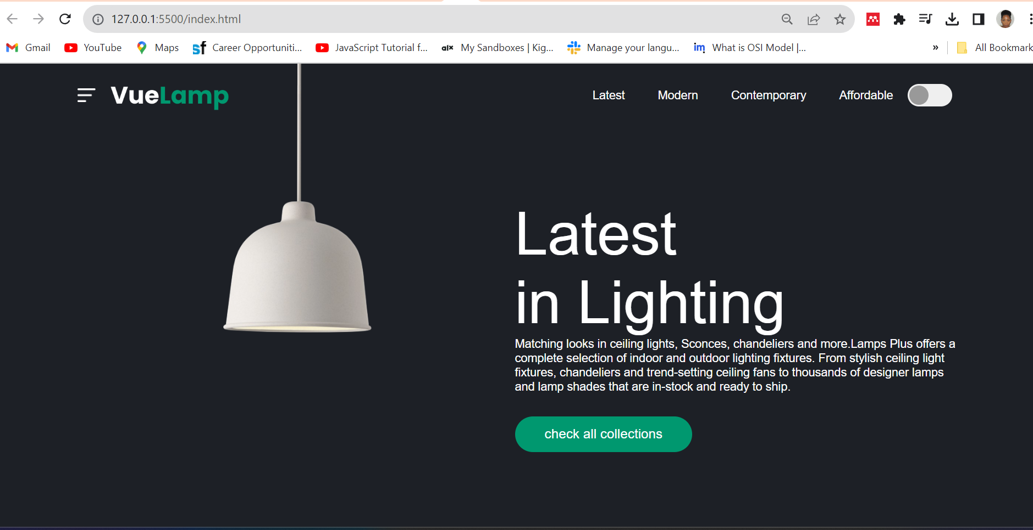

<!DOCTYPE html>

<html lang="en">

<head>

    <meta charset="UTF-8">

    <meta name="viewport" content="width=device-width, initial-scale=1.0">

    <title>Easy Tutorial Youtube channel</title>

    <link rel="stylesheet" href="styles.css">

</head>

<body>

    <div class="hero">

        <nav>

            <img src="images/menu.png" class="menu-img">

            <img src="images/logo.png" class="logo">

            <ul>

            <li><a href="">Latest</a></li>

            <li><a href="">Modern</a></li>

            <li><a href="">Contemporary</a></li>

            <li><a href="">Affordable</a></li>

        </ul>

        <button type="button" onclick="toggleBtn()" id="btn"><span> </span></button>

        </nav>

        <div class="lamp-container">

            <img src="images/lamp.png" class="lamp">

            <img src="images/light.png" class="light" id="light" >

        </div>

        <div class="text-container">

            <h1>Latest<br>in Lighting</h1>

            <p>Matching looks in ceiling lights,

                Sconces, chandeliers and more.Lamps Plus offers a complete selection of indoor and outdoor lighting fixtures. From stylish ceiling light fixtures, chandeliers and trend-setting ceiling fans to thousands of designer lamps and lamp

                shades that are in-stock and ready to ship.</p>

            <a href="">check all collections</a>

            <div class="control">

                <p>04</p>

<div class="line"><span></span></div>

<p>05</p>

            </div>

        </div>

    </div>

    <script>

        var btn = document.getElementById("btn");

        var light = document.getElementById("light");

        function toggleBtn()

        {

            btn.classList.toggle("active");

            light.classList.toggle("on");

        }

    </script>

</body>

</html>

**Styles.css**

*{

    margin: 0;

    padding: 0;

    font-family: 'poppins', sans-serif;

    box-sizing: border-box;

}

.hero{

    background: #1d2026;

    min-height: 100vh;

    width: 100%;

    color: #fff;

    position: relative;

}

nav{

    display: flex;

    align-items: center;

    padding: 20px 8%;

}

nav .menu-img{

    width: 25px;

    margin-right: 20px;

    cursor: pointer;

}

nav .logo{

    width: 160px;

    cursor: pointer;

}

nav ul{

    flex: 1;

    text-align: right;

}

nav ul li{

    display: inline-block;

    list-style: none;

    margin: 0 20px;

}

nav ul li a{

    text-decoration: none;

    color: #fff;

}

button{

    background: #efefef;

    height: 30px;

    width: 60px;

    border-radius: 20px;

    border: 0;

    outline: 0;

    cursor: pointer;

    transition: background 0.5s, margin-left 0.5s;

}

button span{

    display: block;

    background: #999;

    height: 26px;

     width: 26px;

     border-radius: 50%;

     margin-left: 2px;

}

.lamp-container{

    position: absolute;

    top: -20px;

    left: 22%;

    width: 200px;

}

.lamp{

width: 100%;

}

.light{

    position: absolute;

    top: 97%;

    left: 50%;

    transform: translateX(-50%);

    width: 700px;

    margin-left: -10px;

    opacity: 0;

    transition: opacity 0.5s;

}

.text-container{

    max-width: 600px;

    margin-top: 7%;

    margin-left: 50%;

}

.text-container h1{

    font-size: 80px;

    font-weight: 400;

}

.text-container a{

    text-decoration: none;

    background: #00986f;

    padding: 14px 40px;

    display: inline-block;

    color: #fff;

    font-size: 18px;

    margin-top: 30px;

    border-radius: 30px;;

}

.control{

display: flex;

align-items: center;

justify-content: flex-end;

margin-top: 150px;

}

.control .line{

    width: 250px;

    height: 4px;

    background: #fff;

    margin: 0 20px;

    border-radius: 2px;

}

.control .line span{

    width: 50%;

     height: 8px;

     margin-top: -2px;

     border-radius: 4px;

     background: #00986f;

     display: block;

}

.active

{

    background: green;

}

.active span{

    background: white;

    margin-left: 31px;

}

.on{

    opacity: 1;

}

2)funwebsite

Home.html

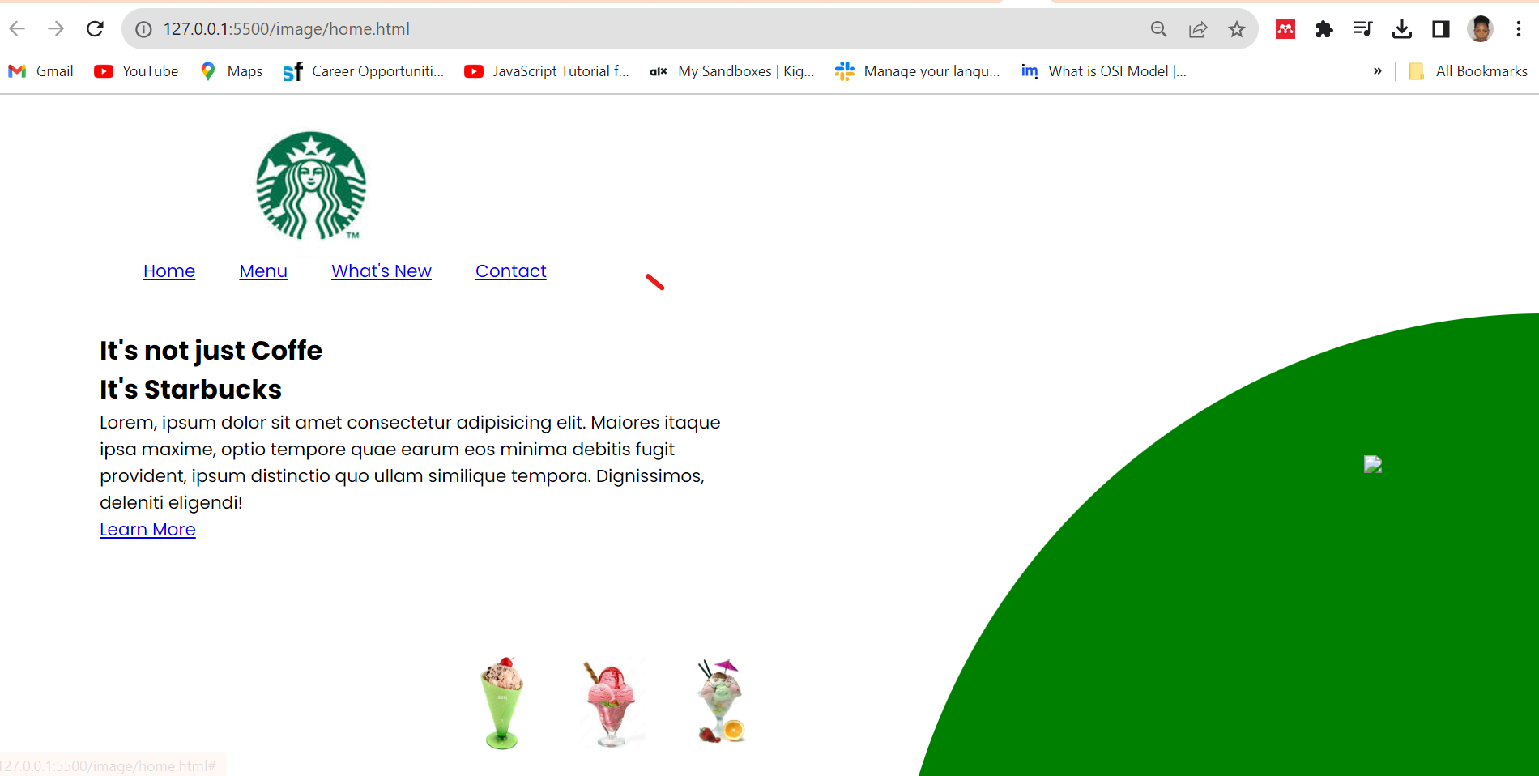

<!DOCTYPE html>

<html lang="en">

<head>

    <meta charset="UTF-8">

    <meta name="viewport" content="width=device-width, initial-scale=1.0">

    <title>Document</title>

    <link rel="stylesheet" href="style.css">

</head>

<body>

    <section>

        <div class="circle"></div>

        <header>

        <a href="#"><img src="logo.jpg" class="logo"></a>

        <ul>

            <li><a href="#">Home</a></li>

            <li><a href="#">Menu</a></li>

            <li><a href="#">What's New</a></li>

            <li><a href="#">Contact</a></li>

        </ul>

        </header>

        <div class="content">

            <div class="textBox">

                <h2>It's not just Coffe<br>It's<span>Starbucks</span></h2>

                <p>Lorem, ipsum dolor sit amet consectetur adipisicing elit. Maiores itaque ipsa maxime, optio tempore quae earum eos minima debitis fugit provident,

                    ipsum distinctio quo ullam similique tempora. Dignissimos, deleniti eligendi!</p>

               <a href="#">Learn More </a>

            </div>

            <div class="imgBox">

<img src="img1.jpg" class="starbucks">

        </div>

        </div>

        <ul class="thumb">

            <li><img src="thumb1.jpg" onclick="imgSlider('img1.jpg')"></li>

            <li><img src="thumb2.jpg" onclick="imgSlider('img2.jpg')"></li>

            <li><img src="thumb3.jpg" onclick="imgSlider('img3.jpg')"></li>

        </ul>

        <!--<ul class="sci">

            <li><img src="facebook.png"></li>

            <li><img src="tuitter.png"></li>

            <li><img src="instagram.png"></li>-->

    </section>

    <script type="text/javascript">

        function imgSlider(anything)

        {

            document.querySelector('.starbucks').src = anything;

        }

    </script>

</body>

</html>

Style.css

@import url('https://fonts.googleapis.com/css?family=Poppins:200,300,400,500,600,700,800&display=swap');

*{

    margin: 0;

    padding: 0;

    font-family: 'poppins', sans-serif;

    box-sizing: border-box;

}

section{

    position: relative;

    width: 100%;

    min-height: 100vh;

    padding: 100px;

    display: flex;

    justify-content: space-between;

    align-items: center;

    background: white;

}

    header{

        position: absolute;

        top: 0;

        left: 0;

        width: 100%;

        padding: 20px 100px;

        display: flex;

        justify-content: space-between;

        align-items: center;

    }

header .logo{

    position: relative;

    max-width: 80px;

}

header ul{

    position: relative;

    display: flex;

}

header ul li{

    list-style: none;

}

header ul li a

{

display: inline-block;

color: #333;

font-weight: 400;

margin-left: 40px;

text-decoration: none;

}

.content{

    position: relative;

    width: 100%;

    display: flex;

    justify-content: space-between;

    align-items: center;

}

.content .textBox{

    position: relative;

    max-width: 600px;

}

.content.textBox h2{

    color: #333;

    font-size: 4em;

    line-height: 1.4em;

    font-weight: 500;

}

.content.textBox h2 span{

    color: #017143;

    font-size: 1.2em;

    font-weight: 900;

}

.content.textBox p{

    color: #333;

}

.content.textBox a{

    display: inline-block;

    margin-top: 20px;

    padding: 8px 20px;

    background: #017143;

    color: #fff;

    border-radius: 40px;

    font-weight: 500;

    letter-spacing: 1px;

    text-decoration: none;

}

.content .imgBox{

    width: 600px;

    display: flex;

    justify-content: flex-end;

    padding-right: 50px;

    margin-top: 50px;

}

.content .imgBox img{

    max-width: 340px;

}

.thumb{

    position:  absolute;

    left: 40%;

    bottom: 20px;

    transform: translateX(-50%);

    display: flex;

}

.thumb li{

list-style: none;

display: inline-block;

margin: 0 20px;

cursor: pointer;

transition: 0.5s;

}

.thumb li:hover{

    transform: translate(-15px);

}

.thumb li img{

    max-width: 60px;

}

.sci{

    position: absolute;

    top: 50%;

    right: 30px;

    transform: translateY(-50%);

    display: flex;

    justify-content: center;

    align-items: center;

    flex-direction: column;

}

.sci li{

    list-style: none;

}

.sci li a{

    display: inline-block;

    margin: 5px 0;

    transform: scale(0.6);

    filter: invert(1);

}

.circle{

    position: absolute;

    top: 0;

    left: 0;

    width: 100%;

    height: 100%;

    background: green;

clip-path: circle(600px at right 800px);

}

Reference

<https://herpeerafrica.coursify.me/student/courses/website-development-project-based-course/sections/163494/contents/485577>

<https://herpeerafrica.coursify.me/student/courses/website-development-project-based-course/sections/163494/contents/485578>

**EXPERIENCE**

**Exploring the Her Peer Africa Tech Maven Program**

**Since embarking on this journey in July with the program, I've found immense joy and fulfillment in being an active participant. The road has been lengthy, yet what truly stands out to me is the program's remarkable flexibility.**

**This flexibility allowed me to seamlessly integrate program sessions into my daily routine, striking a harmonious balance between my regular activities and the enriching learning experiences. The serene ambiance provided by my tutor, Miss Davidson, left a lasting impression. Her reassuring words during our orientation, where she envisioned us as Frontend Web Developers, have lingered in my mind. Despite initial self-doubt, I now find myself seriously considering the title of a Frontend Web Developer.**

**The learning sessions were a highlight for me, presenting opportunities to acquire new knowledge and skills. I particularly enjoyed the unveiling of the new web app, a user-friendly tool that greatly facilitates progress tracking.**

**While my journey in the program has been generally positive, it hasn't been without its challenges. One notable obstacle was the lack of commitment and irregular attendance among some learners, resulting in the occasional cancellation of sessions and hindered progress. Additionally, breaks in learning proved to be a challenging aspect.**

**In reflecting on my overall experience in the program, I express gratitude for the opportunities it has presented. Thank you for this invaluable experience.**