**A**doption of **I**nnovation by **H**ealthcare **O**rganizations **P**rerequisites **S**cale

**Academic Client**:

* Idan Cohen Ben-Chain

**Team Members:**

* Hagai Kordonsky
* Shaked Matityahu
* Idan Lobel
* Amihai Blekherov

Table of Contents

**1** Introduction 3

**1.1** Vision 3

**1.2** The Problem Domain 4

**1.3** Stakeholders 5

**1.3.1** Users 5

**1.3.2** Experts 5

**1.4** Software Context 6

**1.4.1** Backend Server 6

**1.4.2** Front server 6

**1.4.3** Google mail 6

**1.4.4** Private key distribution 6

**1.5** System Interfaces 7

**2** Functional Requirements 8

**3** Non-Functional Requirements 9

**4** Usage Scenarios 10

**4.1** Usage Diagram 10

4.2 Use Cases 10

**4.2.1** Enter 10

**4.2.2** Register 11

**4.2.3** Login 11

**4.2.4** Create Project with default options 12

**4.2.5** View the project 12

**4.2.6** Invite to project 13

**4.2.7** Create project with customized options(criteria and formula) 13

**4.2.8** Vote 14

**4.2.9** Archive a completed project 14

**4.2.10** View analytical reports 15

**4.2.11** View voting factors explanation 15

**4.2.12** Fill a contact/support form 15

**4.2.13** Logging 16

**4.2.14** Publish a comment in a project’s comment section 16

**4.2.15** Change the site’s language 16

**4.3** Usage Example 17

1. Introduction**:**
   1. Vision**:**

The main goal of our project is to create a platform that would help businesses (medical organizations in particular) to assess their readiness integrating successfully new technologies into their organization.

Consider a regional healthcare network preparing to implement a cutting-edge AI diagnostic tool across its hospitals and clinics. This tool promises to improve patient outcomes by providing faster and more accurate diagnoses. However, the organization is unsure whether it is ready to adopt such a technology and maximize its benefits effectively.

Using **AIHOPS**, the healthcare network accesses a streamlined and visually appealing platform to assess its readiness. The platform guides stakeholders—ranging from hospital administrators to IT staff—through a structured evaluation based on the project's academically developed formula. The evaluation process examines critical factors, including:

1. **Innovation Availability**: Is the AI diagnostic tool ready for integration into healthcare settings?
2. **Organizational Attention**: How focused is the organization on addressing diagnostic accuracy and speed, which the tool aims to improve?
3. **Implementation Timeline Likelihood**: How soon does the organization plan to implement the tool, and is it ready to meet this timeline?
4. **Stakeholder Support**: Are key stakeholders, including clinicians and administrators, supportive of the tool, and does it align with organizational culture?
5. **Financial Feasibility**: What are the financial implications of adopting the tool, balancing initial costs against long-term benefits?
6. **Training Requirements**: How much training will staff need to use the tool effectively?
7. **Workflow Impact**: What changes will the tool bring to existing workflows, and will it enhance or disrupt current processes?
8. **Regulatory and Ethical Compliance**: Does the tool meet the regulatory and ethical standards required for implementation?

**Outcome:**  
The results of the assessment provide a detailed readiness report. For example, the organization may discover that while the AI tool is highly innovative and has strong stakeholder support, there are challenges in regulatory compliance and training requirements. With these insights, the healthcare network prioritizes addressing compliance gaps and schedules staff training workshops.

By leveraging AIHOPS, the organization ensures that the AI diagnostic tool is integrated smoothly, maximizing its benefits while minimizing disruption. Additionally, the data collected during the assessment contributes to refining AIHOPS’ evaluation formula, ensuring it becomes even more effective for future users.

This real-world example demonstrates how AIHOPS equips healthcare organizations with the tools to assess, plan, and execute innovation adoption successfully.

* 1. The Problem Domain**:**

The rapid pace of technological advancement has brought technological leaps, but it also highlights a significant challenge for healthcare organizations: assessing their readiness to adopt groundbreaking innovations effectively.

Existing assessment tools are often too generic and user-centered, lacking the healthcare-specific focus needed to navigate the unique complexities of this field.

**2024 Incident example**:

Consider a healthcare organization in Switzerland facing the dilemma of whether to adopt a revolutionary AI-driven diagnostic tool. Idan’s colleague, a decision-maker in this organization, shared their struggle. Lacking a structured, tailored process for evaluating new technologies, the team embarked on lengthy internal discussions. They examined various factors—such as financial costs and potential workflow changes—but without a systematic framework, they ultimately rejected the tool.

Unbeknownst to them, had they utilized Idan’s formula and the AIHOPS platform, they would have identified a high readiness score for adoption. The formula would have provided clear, actionable insights, demonstrating that the innovation met critical criteria, such as regulatory compliance, stakeholder support, and financial feasibility. Furthermore, the platform would have significantly accelerated their evaluation process, saving time and effort while avoiding the missed opportunity of a beneficial technological leap.

This example illustrates how AIHOPS fills a critical gap, equipping healthcare organizations with a precise, efficient, and healthcare-specific tool to assess and embrace transformative innovations confidently.

We will create a platform for AIHOPS, which is a customizable tool that will help to assess their readiness for adopting innovative technologies.

* 1. Stakeholders**:**
     1. Users**:**

There are 2 types of users in our systems:

* **Manager**

Is the one who will be using our system in order to conduct surveys - about integrating new technologies into the workers workflow.

With the help of these surveys, the management will assess the probability of succeeding in integrating this new tech, and the benefit it will bring to the company; by asking the opinions of the people who will be using it and currently fill the positions that will be most affected by the changes.

* **Employee**

The employees who currently fill the positions that are expected to be affected by the changes that are considered to be implemented.

This platform gives them the opportunity to express their opinion and take their experience into consideration.

* + 1. Experts**:**

Our platform will be keeping statistics and data about businesses wanting to integrate different types of technologies into their company, and the success rate of such steps.

* The success rate will help the experts to perfect the assessment formula.
* The data might help the experts to determine new tech opportunities and initiatives to help businesses grow and improve the efficiency of the workflows.

* 1. Software Context**:**
     1. Backend Server**:**

Implemented by using python and flask.

The backend server is an API reflecting all functionality and generically represents our systems domain layer, allowing for a flexible front layer representation and tools.

The backend server will handle all requests and data processing, DB access and maintenance.

* + 1. Front server**:**

Will handle all user interaction with the backend server, displaying a pleasant and intuitive interface.

By separating our program into a backend and front server, we allow for future additions of multiple front servers, for example - if we would like to implement an android app in the future, we won’t need to adjust the backend functionality, but instead we’d just represent it with tools for android (i.e. react native).

* + 1. Google mail**:**

Our system will use the google API in order to sent invites and reminders and user registration verifications.

* + 1. Private key distribution**:**

Our system will support a private key distribution in order for the project manager to not invite users individually via email, he will generate a projects private key and distribute it to his colleges/employes via WhatsApp for example.

* 1. System Interfaces**:**
* **User Point of view:**

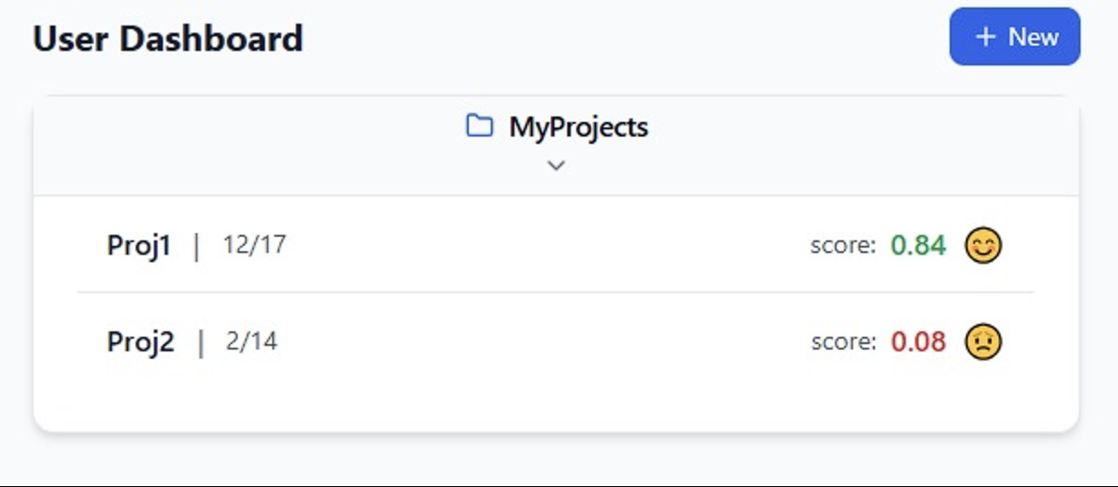This is the User Dashboard. In this view, the user will be able to see the ongoing projects that he is a part of, and create new projects – which is the main functionality of the system. He can also view the score and the progress meter.

* **Researcher point of view:**

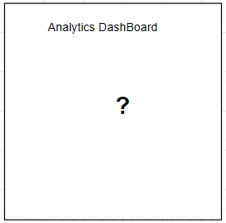

* **The client doesn’t have specified requirements at the moment, that’s something that’ll be cleared up later on.**

1. Functional Requirements**:**

* **User Authentication and Validation:**
  + A guest user must be able to register for the platform.
  + To finalize the registration process, the guest user must verify their email address via a confirmation link (sent to his Email address).
  + Registered users can log in using their credentials (email and password).
  + User login information must be securely encrypted, ensuring compliance with data protection regulations.
  + Implement **password recovery** functionality, allowing users to reset their password via a secure email link.
* **Projects:**
  + A registered user can create a **new project**, either by using default factors or customizing the list of factors and severity levels.
  + Project creators can invite participants to join the project via email, sending personalized invitations.
  + (NTH) A registered user can distribute a **secret access key** to other registered users outside the platform, enabling access to join the project directly (without inviting them via an email invitation for example).
  + Project members can cast votes on all project factors, scoring both their impact and the likelihood of severity.
  + The platform must display real-time **voting progress**, showing:
    - The number of votes cast so far.
    - The overall project score, aggregated based on user input.
  + Project voting: a vote consists of scoring every one of the factors and probability of severity levels.
* **Commenting and Discussion**:
  + Allow project participants to leave comments and discuss scores directly within the project interface (NTH).
  + Users can **archive projects** once completed.
  + Users can **duplicate projects** to create similar assessments without starting from scratch (NTH).
* **Provide data analytics and reporting capabilities:**
  + Experts using the platform can access analytics and reporting capabilities.
  + Experts using the platform can generate various analytical reports.
  + **The client doesn’t have specified requirements at the moment, that’s something that’ll be cleared up later on.**
* **Localization and Multi-Language Support (NTH):**
  + Provide multi-language options to support a global user base.
  + Allow users to set their preferred language and regional formats (e.g., date and currency).
* **Audit and Logging:**
  + Maintain detailed logs of all system activities for monitoring and auditing purposes.
  + Ensure logs include actions such as project creation, voting, data exports, and user authentications.
* **Support and Documentation**:
  + Provide built-in user support features, such as a knowledge base, tutorials, and FAQs.
  + Allow users to contact support or provide feedback directly through the platform.

1. Non-Functional Requirements**:**

* **User-Friendly and Accessible UI**:
  + The platform must have an intuitive interface, suitable for users with varying technical expertise.
  + Provide accessibility features such as screen reader compatibility, high-contrast modes, and keyboard navigation (NTH).
* **Data:**
  + Persist all user information, project data, and voting history securely in a relational database.
  + Ensure data consistency and integrity, preventing loss or corruption during concurrent user activity.
  + Implement **automatic backups** and version control for critical data to mitigate risks (NTH).
* **Data Protection**:
  + Enforce robust security measures, including encryption of sensitive data, secure login mechanisms, and periodic security audits.
  + Ensure compliance with regulatory standards.
* **Scalability and Performance**:
  + Design the system to handle a growing number of users and projects without compromising performance.
  + Support dynamic scaling based on real-time demand to ensure smooth operation during peak usage.
* **System Availability**:
  + Achieve a good uptime, supported by failover mechanisms.
  + Implement real-time monitoring and alerting for critical system failures or downtime.
* **Cross-Platform Support**:
  + Ensure the platform is accessible via desktop browsers, as well as mobile devices through a responsive web design (NTH).

1. Usage Scenarios**:**
   1. Usage Diagram**:**

* 1. Use Cases:
     1. Enter

|  |  |
| --- | --- |
| Id | 0 |
| Primary actors | Any type of user |
| Description | A user initiating a first communication with the system |
| Trigger | Going to systems url |
| Pre-Conditions | * Backend server is running * Frontend server is running |
| Post-Conditions | A session has been generated for this user, and the user has its cookie |
| Flow of events | User enters our websites url |
| Alternative Flows | Failure, page not found -> our website is not online |

* + 1. Register

|  |  |
| --- | --- |
| Id | 1 |
| Primary actors | user |
| Description | The user creates a member |
| Trigger | Clicking the register button |
| Pre-Conditions | * Back and front servers are running * User has a cookie |
| Post-Conditions | A new name-passwd has been saved |
| Flow of events | * User navigates to website * Clicks register * Fills in desired username and password * Clicks register * Indication about successful registration appears |
| Alternative Flows | * User name is taken: causes invalid username msg and registration fails * Password does not oblige the rules: causes registration failure and indicates the rule that the password did not oblige to |

* + 1. Login

|  |  |
| --- | --- |
| Id | 2 |
| Primary actors | User |
| Description | User performs a login to the system gaining permissions to view organizations |
| Trigger | Click the login button in login page |
| Pre-Conditions | * Website is running * User has a cookie (of a user) * User has a username and password of a valid member |
| Post-Conditions | * Member is logged in the system * If the member was logged in elsewhere, he will be automatically logged out there |
| Flow of events | * User navigates to website * Clicks login * Fills in desired username and password * Clicks login * Indication about successful login appears |
| Alternative Flows | * Login fails either because of invalid user name or password, resulting in an indication stating login failed. * The user can recover his password by clicking on the “recover password” button. |

* + 1. Create Project with default options

|  |  |
| --- | --- |
| Id | 3 |
| Primary actors | Member |
| Description | Creating a project |
| Trigger | Click new project |
| Pre-Conditions |  |
| Post-Conditions | * Every invited member can join the project * The project appears in projects managers dashboard |
| Flow of events | * A member logs in the system * Navigating to the dashboard * Clicks new project * Fills in the details * Clicks create project |
| Alternative Flows | Click on create a project from existing project (duplicate). |

* + 1. View the project

|  |  |
| --- | --- |
| Id | 4 |
| Primary actors | Member |
| Description | Viewing the project – project members, voting progress and current score. |
| Trigger | Click on desired project. |
| Pre-Conditions |  |
| Post-Conditions |  |
| Flow of events | * A member logs in the system * Navigating to the dashboard * Clicks to expand the desired project |
| Alternative Flows |  |

* + 1. Invite to project

|  |  |
| --- | --- |
| Id | 5 |
| Primary actors | Member |
| Description | Inviting members to a project:   * Via an email invitation. * Via a private secret key code. |
| Trigger | Click invite |
| Pre-Conditions |  |
| Post-Conditions | Every invited member can join the project |
| Flow of events | * A project manager logs in the system * Navigating to the dashboard * Clicks to expand his managed project * Clicks invite * Adds emails * Clicks invite |
| Alternative Flows | The members can be invited by a private secret key code. |

* + 1. Create project with customized options(criteria and formula)

|  |  |
| --- | --- |
| Id | 6 |
| Primary actors | Member |
| Description | Create a new project with different factors and severity factors |
| Trigger | * Clicks new project and custom formula |
| Pre-Conditions |  |
| Post-Conditions | * The project appears in projects managers dashboard |
| Flow of events | * A member logs in the system * Navigating to the dashboard * Clicks new project * Fills in the details * Clicks create project * Clicks custom formula * Adds/subs/changes factors * Changes severity factors * Clicks create |
| Alternative Flows | Click on create a project from existing project (duplicate). |

* + 1. Vote

|  |  |
| --- | --- |
| Id | 7 |
| Primary actors | Project member |
| Description | Project member votes on the project |
| Trigger | Click vote |
| Pre-Conditions | * This member is a part of a project |
| Post-Conditions | * Members vote has been submitted and updated in the dashboards of all project members |
| Flow of events | * Member logs in the system * Navigates to dashboard * Clicks the project he wants to vote on * Clicks vote * Fills his choices * Clicks vote |
| Alternative Flows |  |

* + 1. Archive a completed project

|  |  |
| --- | --- |
| Id | 8 |
| Primary actors | Project manager |
| Description | Project manager archives a completed project |
| Trigger | Click archive |
| Pre-Conditions | * This user is the manager of the project |
| Post-Conditions | * The project has been archived (it will not appear for the project members any more). |
| Flow of events | * Project manager logs in the system * Navigates to dashboard * Clicks the project he wants to archive * Clicks archive |
| Alternative Flows |  |

* + 1. View analytical reports

|  |  |
| --- | --- |
| Id | 9 |
| Primary actors | Expert |
| Description | An expert views the analytical reports. |
| Trigger | Click on view analytical reports. |
| Pre-Conditions | * The user is an expert. |
| Post-Conditions |  |
| Flow of events | * Expert logs in the system * Navigates to analytical reports * Clicks on view analytical reports |
| Alternative Flows |  |

* + 1. View voting factors explanation

|  |  |
| --- | --- |
| Id | 10 |
| Primary actors | Member |
| Description | When voting, the member of a project can view the meaning and definition of the factors. |
| Trigger | Hover above the ‘?’ sign next to the relevant factor. |
| Pre-Conditions | * The user is a project member. |
| Post-Conditions |  |
| Flow of events | * Project member logs in the system. * Navigates to Project Dashboard. * Clicks on vote on project. * Hover above the ‘?’ sign next to the desired factor. |
| Alternative Flows |  |

* + 1. Fill a contact/support form

|  |  |
| --- | --- |
| Id | 11 |
| Primary actors | User. |
| Description | A user fills out a contact/support form which is being sent to the admin. |
| Trigger | A user click on ‘contact/support’. |
| Pre-Conditions |  |
| Post-Conditions | A filled out form has been sent to the admin’s email. |
| Flow of events | * Clicks on contact/support. |
| Alternative Flows |  |

* + 1. Logging

|  |  |
| --- | --- |
| Id | 12 |
| Primary actors | System |
| Description | The system saves actions and failures into an output text file. |
| Trigger | A system function has been called. |
| Pre-Conditions | The server is up and running. |
| Post-Conditions | The action (or failure) has been added to the log file. |
| Flow of events | * The server is up and running. * A system function has been called. * The action/failure has been added to the log file. |
| Alternative Flows |  |

* + 1. Publish a comment in a project’s comment section

|  |  |
| --- | --- |
| Id | 13 |
| Primary actors | Member |
| Description | A project member comments in the project’s comment section. |
| Trigger | Clicks on publish a comment. |
| Pre-Conditions | The user is a member of the project. |
| Post-Conditions | The comment has been published (added to the project’s comment section). |
| Flow of events | * The user logs-in into the system. * Navigates to the Project’s Dashboard. * Write down a comment in the comment box and clicks on publish. |
| Alternative Flows |  |

* + 1. Change the site’s language

|  |  |
| --- | --- |
| Id | 14 |
| Primary actors | User |
| Description | A user clicks on the language sign and chooses his desired language. |
| Trigger | Clicks on the language sign. |
| Pre-Conditions |  |
| Post-Conditions | The site is now being presented in the chosen language. |
| Flow of events | * A user clicks on the language sign. |
| Alternative Flows |  |

* 1. Usage Example**:**

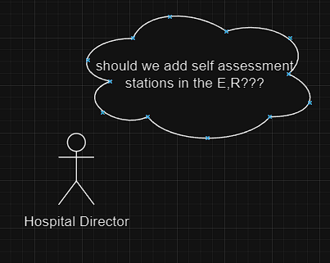

Hospital director faces a dilemma – how to separate the critically conditioned patients from the commonly ill patients.

Someone suggests to him to add self assessment stations to the E.R.

The Hospital Director invites the E.R. stuff members to the project in the AIHOPS platform to take the survey.

The project gets a positive result – the organization is ready to adopt this technology.

Self assessment stations are deployed in the hospital’s E.R. for the use of the patients. Now the E.R. team are free to take of the critically ill patients.