Import Data using Transform Maps (Spreadsheet)

Introduction :
Team Leader : Tejasri B (Mail ID : 202400013@sigc.edu)
Team ID : SWTID-2026-7337
Team Members :
Harishma M (Mail ID : 202400549@sigc.edu)
Shanmugapriya K (Mail ID:202400600@sigc.edu)
Priyadharshini N (Mail ID : 202400777@sigc.edu)
Problem Statement :
Organizations often receive large amounts of employee data in Excel spreadsheets. Manually entering each employee record into ServiceNow is time-consuming, repetitive, and can lead to data-entry errors.
Therefore, there is a need for an efficient method to import employee data from a spreadsheet into ServiceNow automatically, while ensuring that the data is correctly mapped and stored in the appropriate fields.
Solution :
The project uses ServiceNow Import Sets and Transform Maps to import employee data from an Excel spreadsheet. The data is first loaded into an Import Set table and then mapped to the required target fields using a Transform Map. After transformation, the records are automatically created in the target table and verified for accuracy and data integrity.
Step by Step process:

Phase 1: Prepare the sheets

1.Open New Google Spreadsheet
2.Create New Google Spreadsheet with sample data as shown below

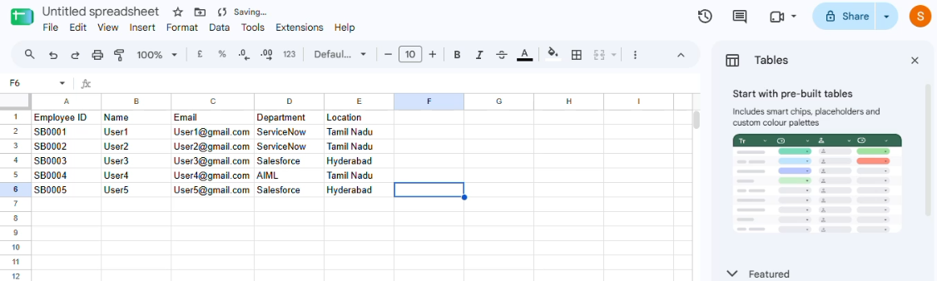
3.Download the spreadsheet as Sample sheet 13.xlsx format.

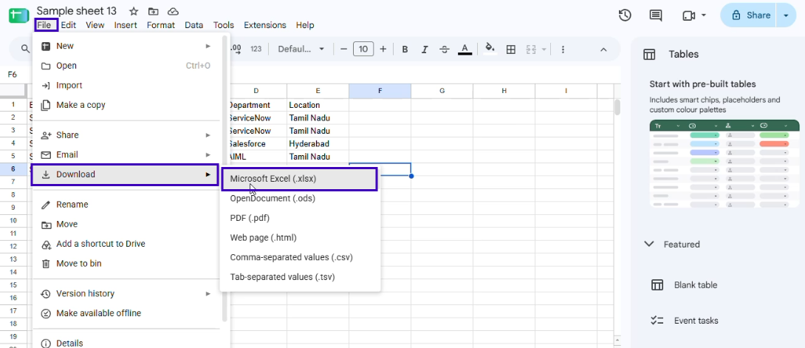
Phase 2: Create new Custom table
Navigation:
• Tables > Create New
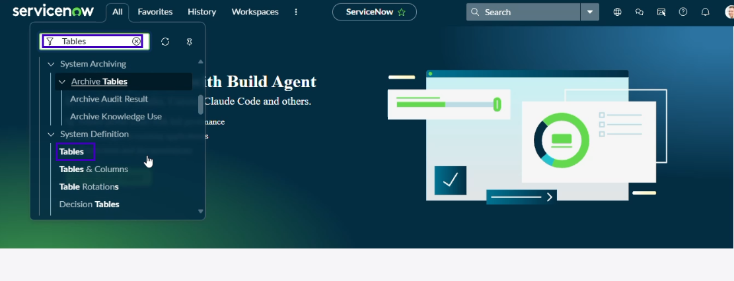
• Label: Employee Test
• Name: u_employee_test
• After creating and saving the Employee Test table, scroll down to the bottom of the table form.

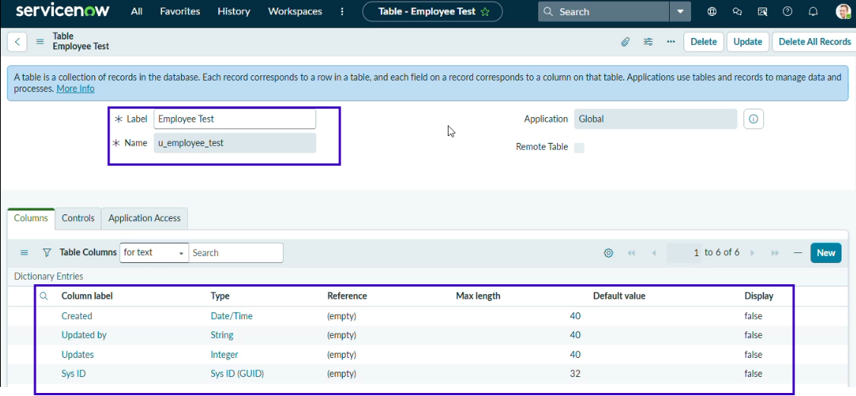

• Click Show Form to open the table form.
• On the form, locate the Form Context Menu / Additional Actions option on the left side of the form header.
• Click the Form Context Menu / Additional Actions icon.
• Click configure , select Form Layout.
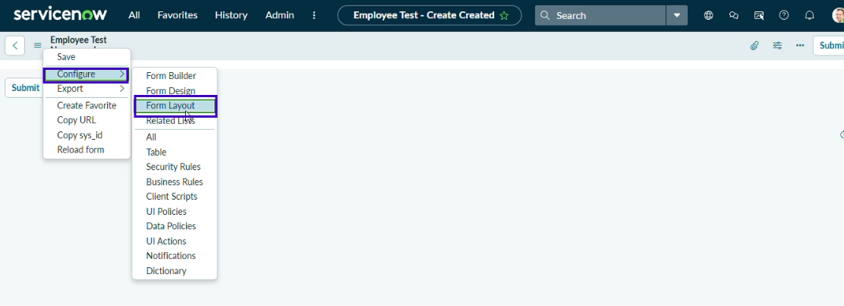

• The Form Layout page will open, where you can configure the fields displayed on the form
• After opening Form Layout, click New to create a new field.
• Enter the field details:
• Column Label: Employee ID
• Type: String
• Click Add to create the field.

• Repeat the same steps to create the following fields:
Employee Name – Type: String
Email – Type: String
Department – Type: String
Location – Type: String
• After creating all the required fields, click Save.
• Verify that the newly created fields are displayed on the Employee Test form.

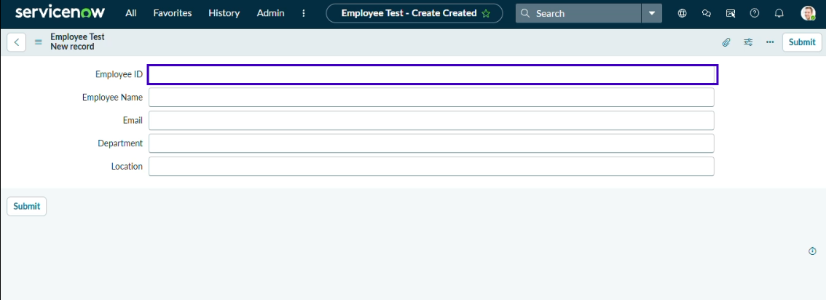
Click on Submit or Save.

Phase 3: Import Set Table
Navigation:
In Application Navigator → Load Data

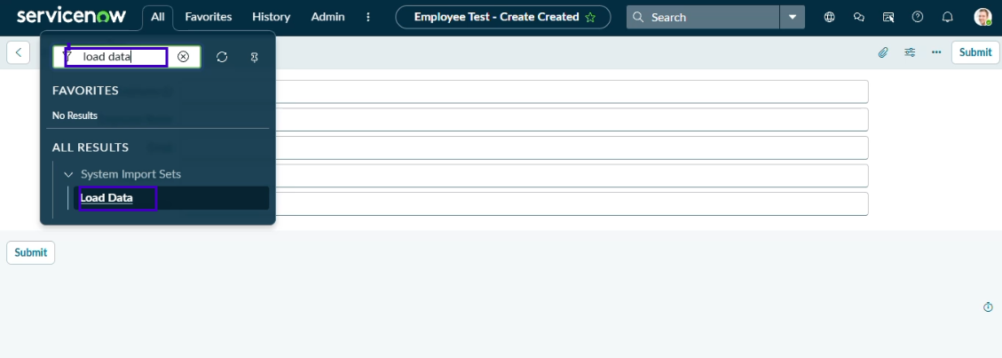
Click on Load Data and create an import table
Fill details as shown below
• Label: Employee Import
• Name: u_employee_import (auto populated)

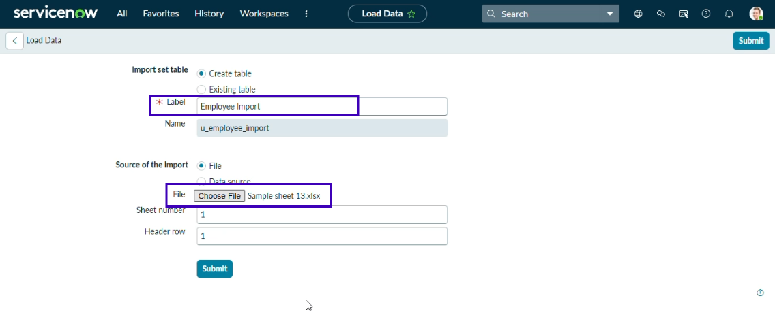
• Click on Submit
Once we click on Submit, we can see the success message as shown below.
Also, we need to make sure to click on the Create Transform Map.

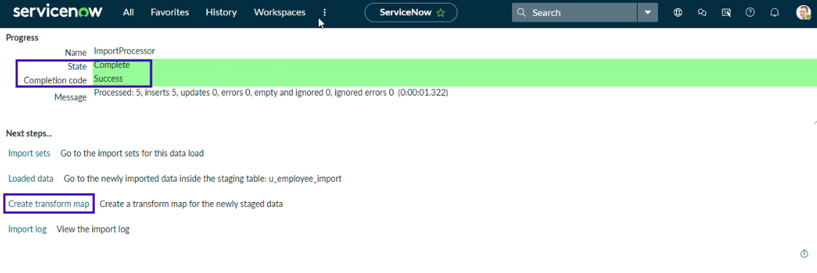Phase 4: Create Transform Map
In this phase we need to create the Transform Map by clicking on the Create Transform Map button
Give inputs as
Name: Sample Spreadsheet Import
Source Table: Employee Import is auto populated
Target Table: Employee Test - as we created earlier
Click on Auto Map Matching fields.
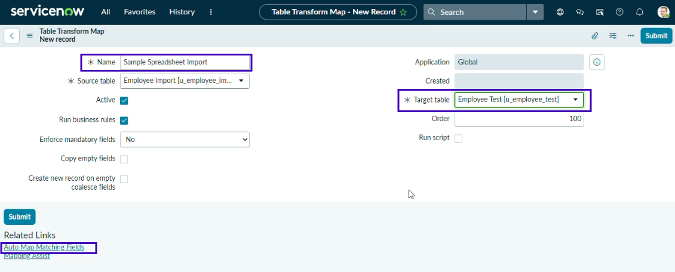
Now click on Mapping Assist and map the fields with Source & Target Table

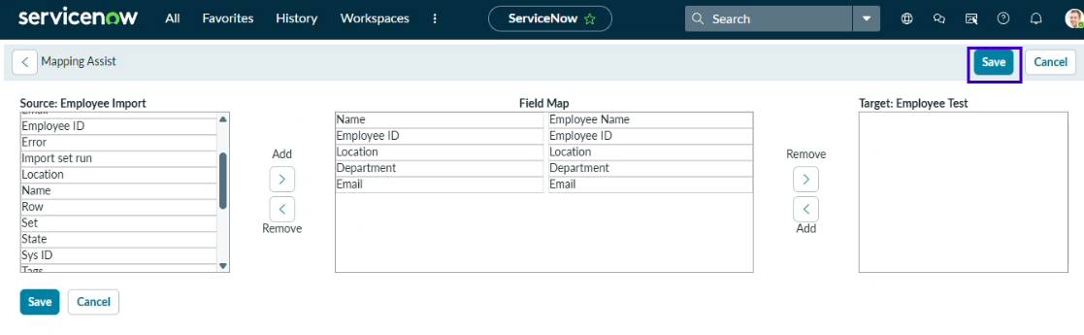
Click on Save
Make sure both Source & Target table fields are mapped

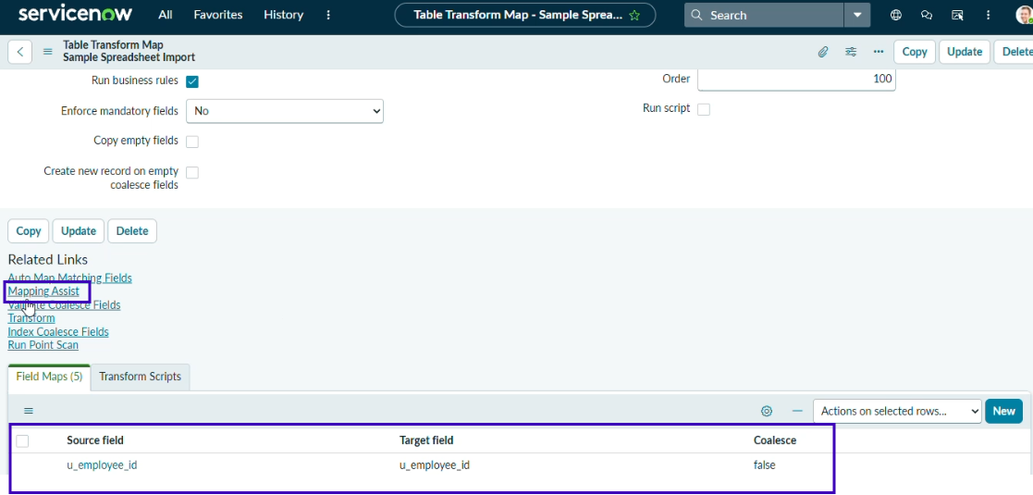
• Now click on Transform

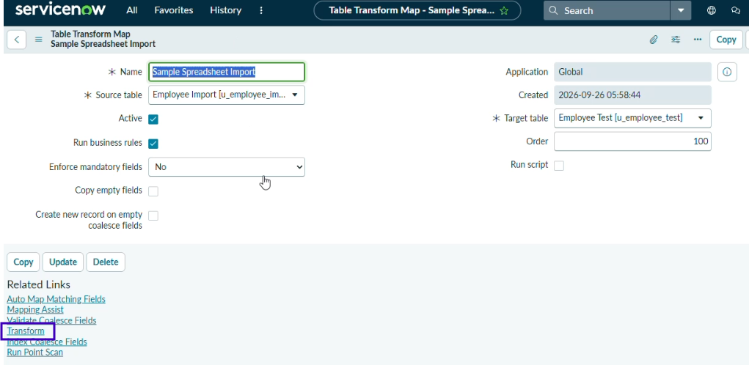
• After opening that it will shows like it and click transform

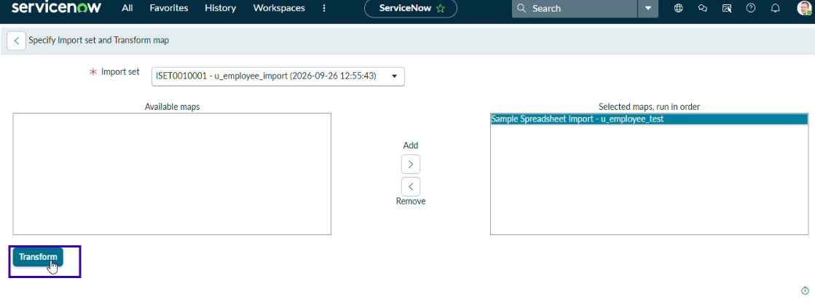
•After clicking Transform, it shows the status completed.
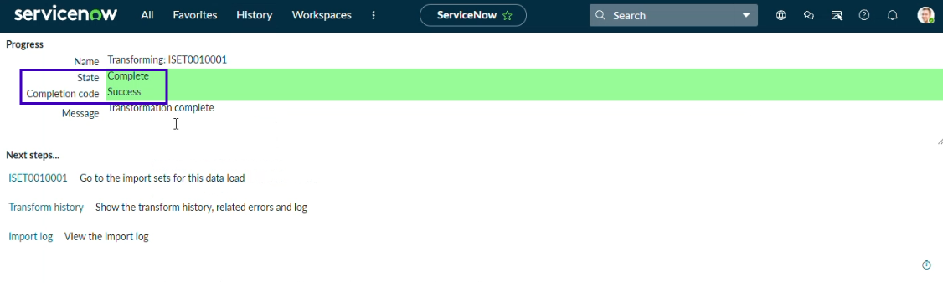Phase 5: Transform Data & Validate
Navigation:
• Open Employee Test Table from application navigator.

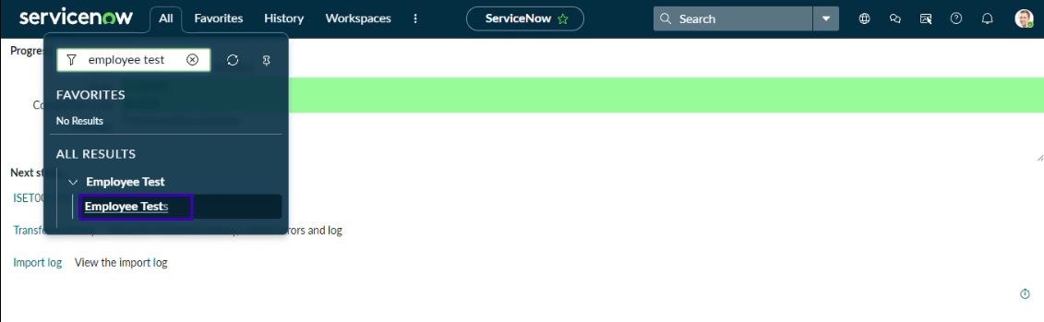
• As our import succeeded, all the records are created in the Employee Test Table.
• After selecting that it shows like this

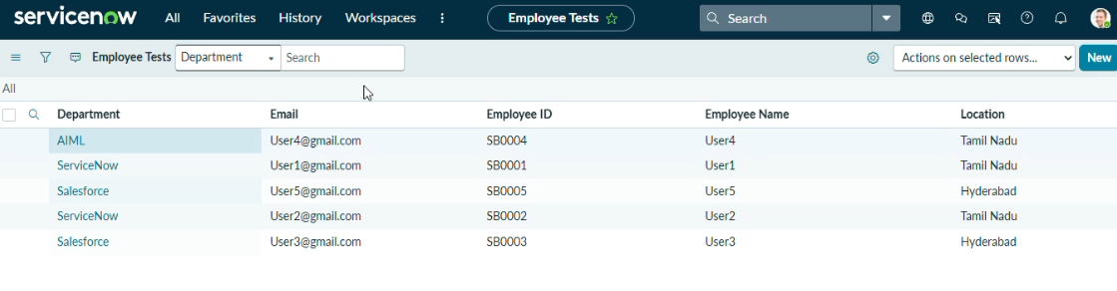
• We rearrange the fields accordingly by using Personalized List Columns.

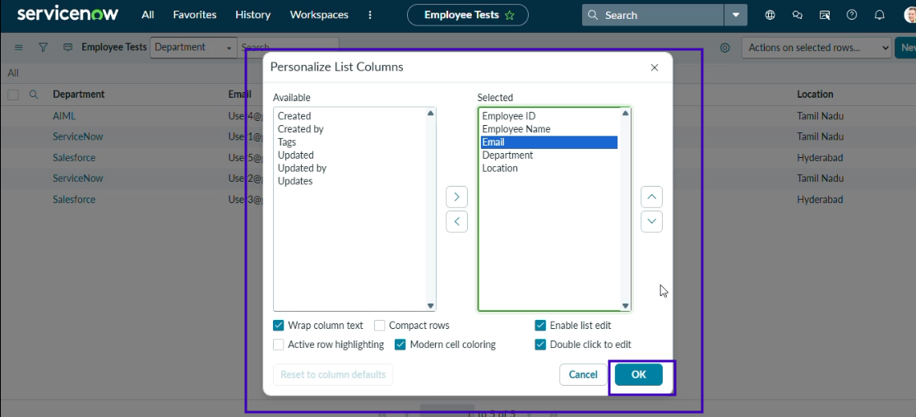
• Click on OK
• Now all the records are successfully imported into the ServiceNow system with the Import Set and Transform Map.

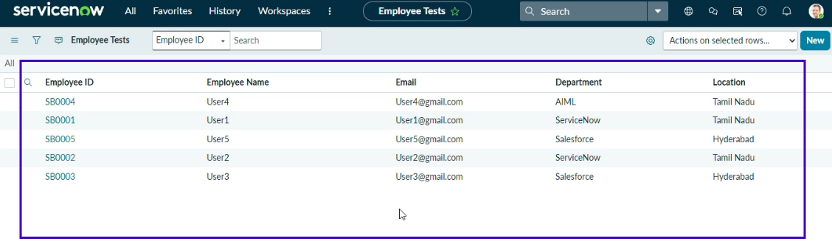
Phase 6: Enable Coalesce to Avoid Duplicate Records
In real projects, employee data may be imported multiple times. Coalesce helps prevent duplicate records. It identifies existing records and updates them with new values instead of creating duplicates. This keeps the data accurate and consistent.
Steps :
- Open Transform Maps under System LDAP.
- Open Sample Spreadsheet Import.
- In Field Maps, set one field’s Coalesce to True.
- Save the Transform Map.
- Add new data from the Excel file.

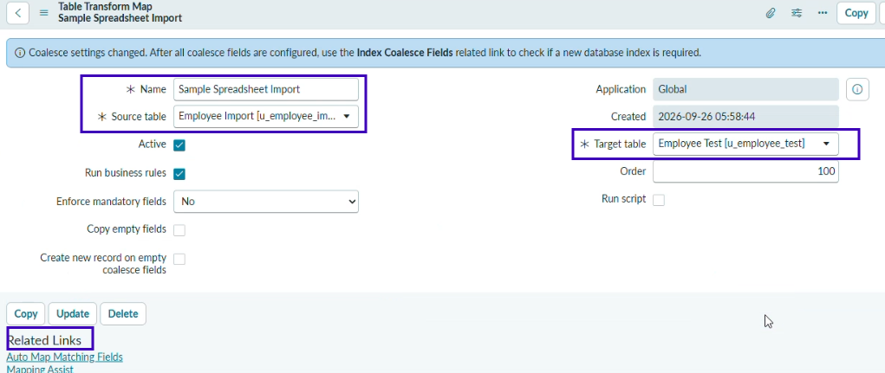
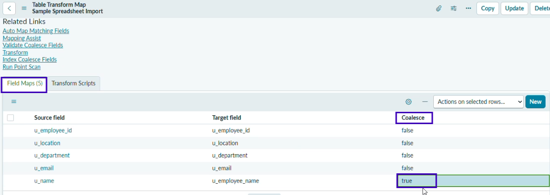
PHASE 7 : Inserting New Data In Excel Format
Steps :
- Go to All → System Import Sets → Load Data.
- Select Existing Table → Employee Import.
- Select File and upload the Excel file.
- Set Sheet Number: 1 and Header Row: 1.
- Click Submit.

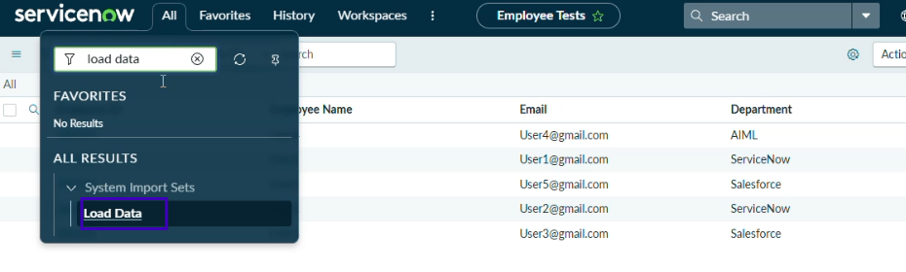• After clicking Load Data
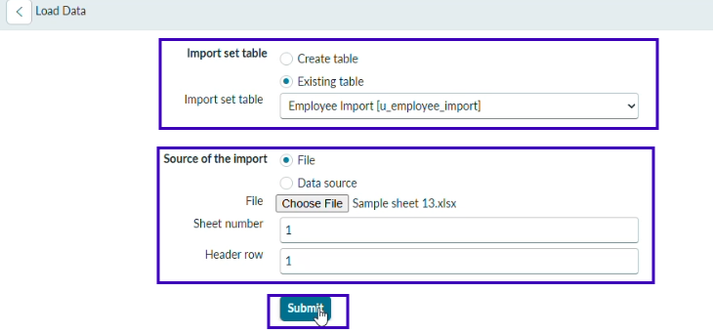
• Newly Created Excel Data

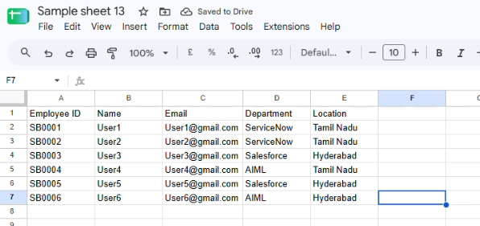

• Now after submitting the form, it appears as State Completed and Success.

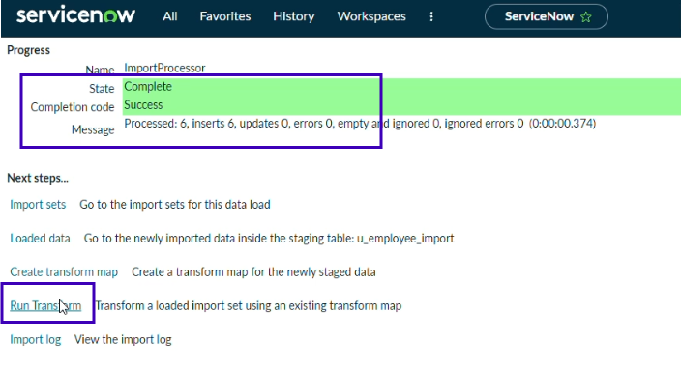
• Click Run Transform under Next Steps.
• Select the previously created Import Set and Transform Map
• Click Transform.

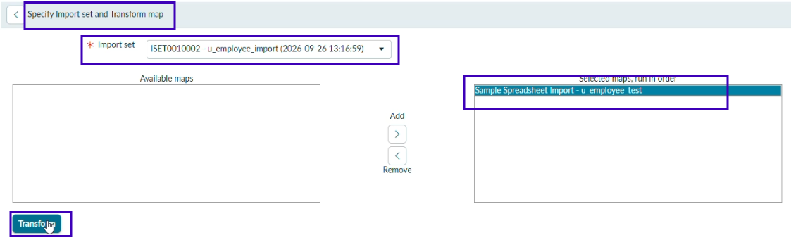
• Now it shows the State is completed and Success.

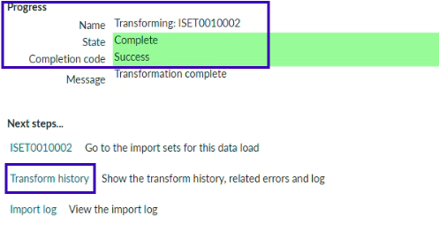

• Now again click on the Transform history then it shows the newly added data

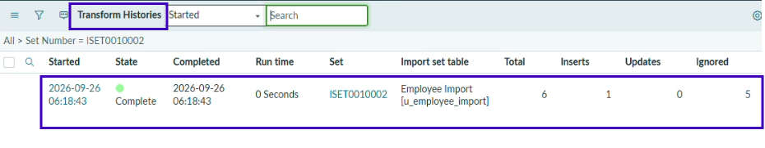
• Open the Employee Tests table and see the rows and inserted.

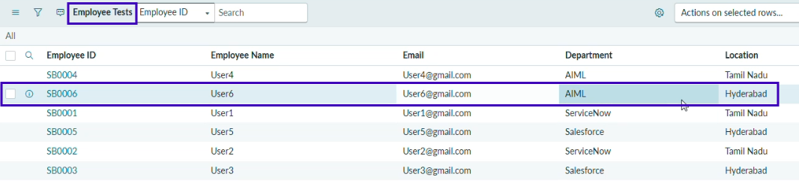
PHASE 8 : Create Reports on Employee Test Table
Navigation steps :
1. Go to All → Usage and Governance → Reports.
2. Click New to create a report.
3. Create 3 reports as required.

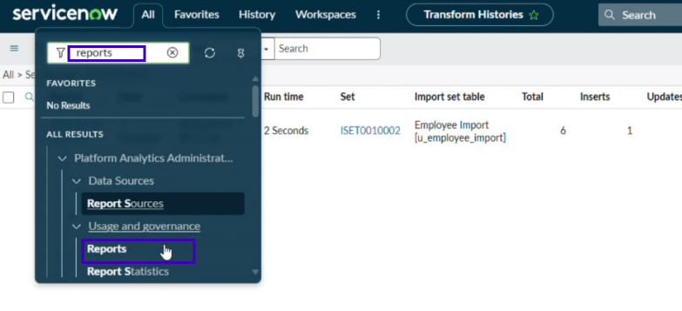
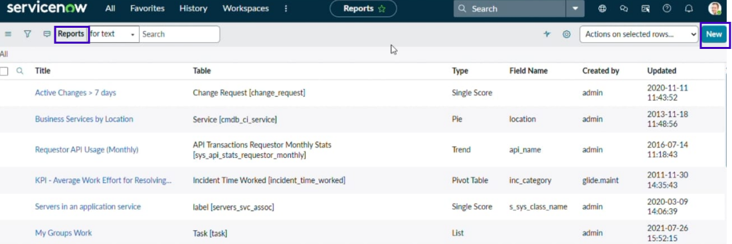
Report 1 : Employees by Department

In Data, enter
1.Report Name: Employees by Department
2.Source Type: Table
3.Table: Employee Test
4.Click Next.
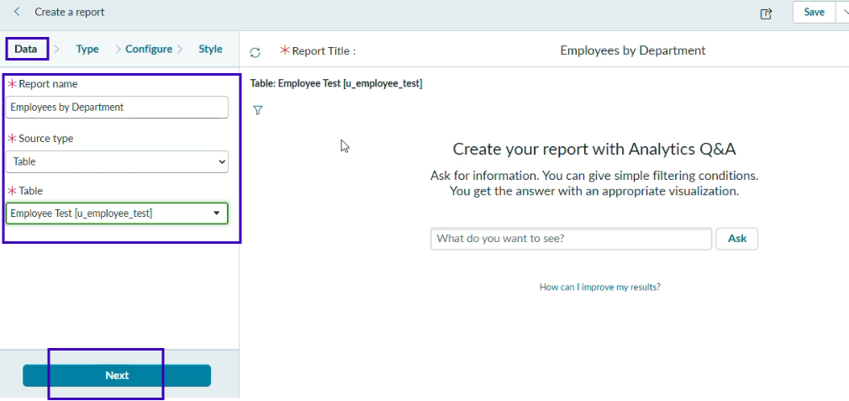
• In Type Select Pie Chart and click Next
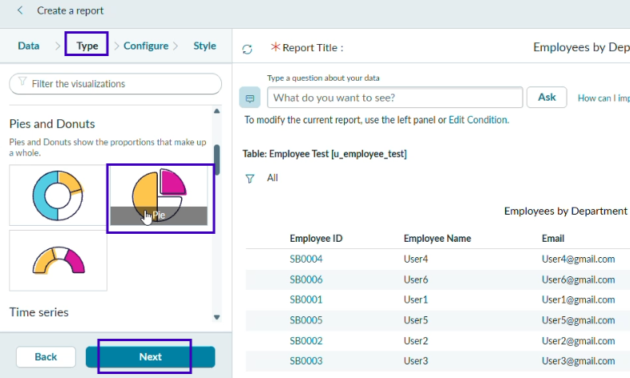
• Now In Configure Select Group by Department Field.
• In the Aggregation Field Select Count.
• Then Click Next.
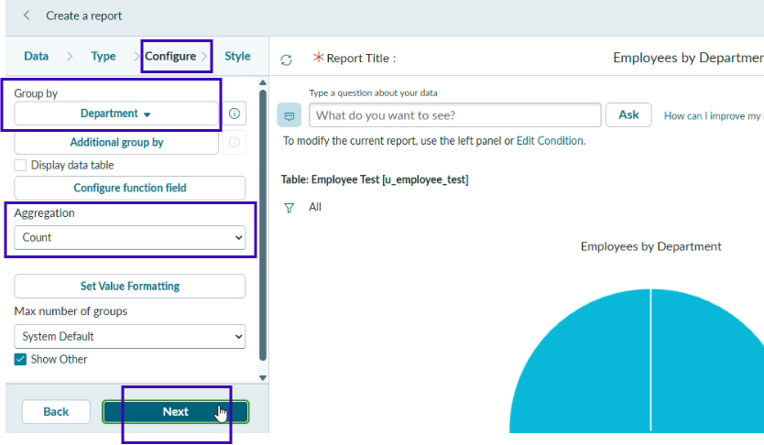
• In Style Leave Chart Color as default.
• Click Run to execute the report.
• Click Save to save the report.

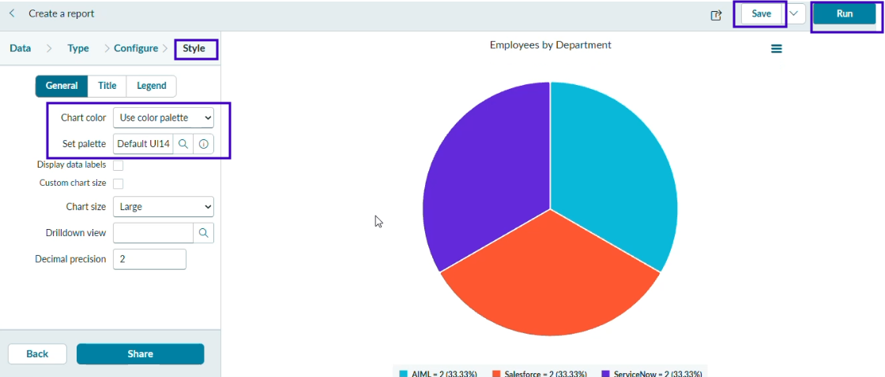
Report 2 : Employees by Location
Configuration
- Table: Employee Test
- Type: Bar Chart
- Aggregation: Count
- Group By: Location
Steps :
- Create a New Report.
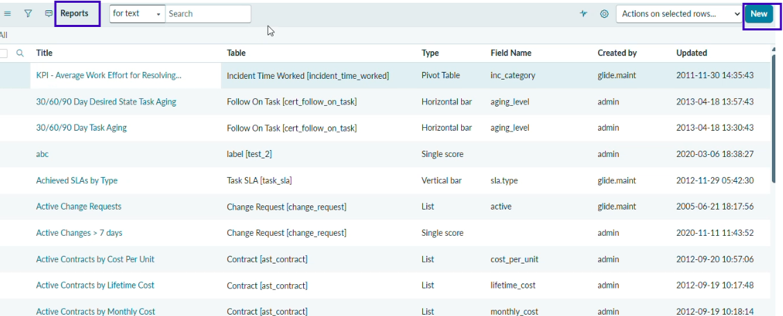
- In Data, Report name : Employees by Location.
Source : Table
Table Select : Employee Test. Click Next

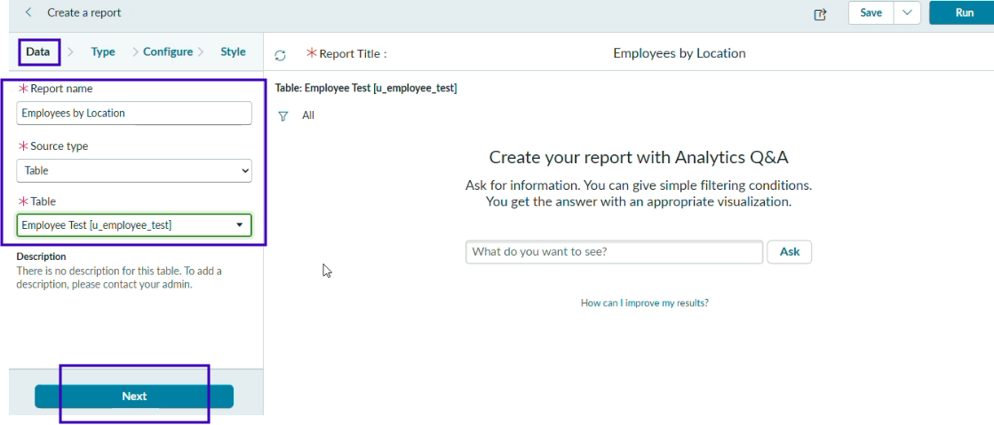
- Select Type : Bar Chart and click Next

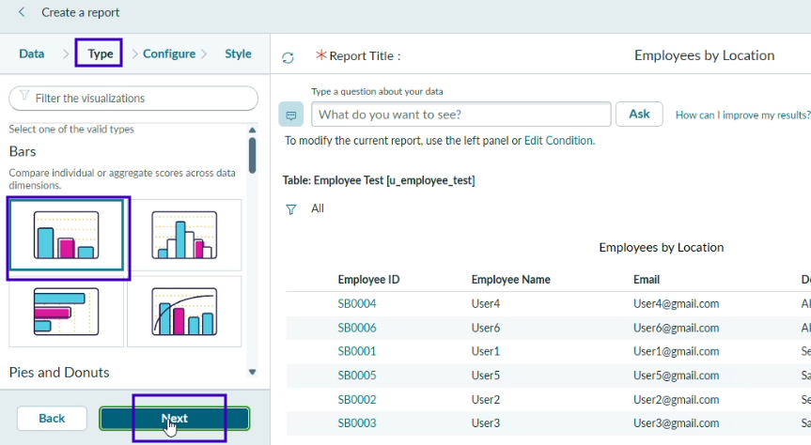
- In Configure Select Group by Field : Location.
And Aggregation is Count and click Next

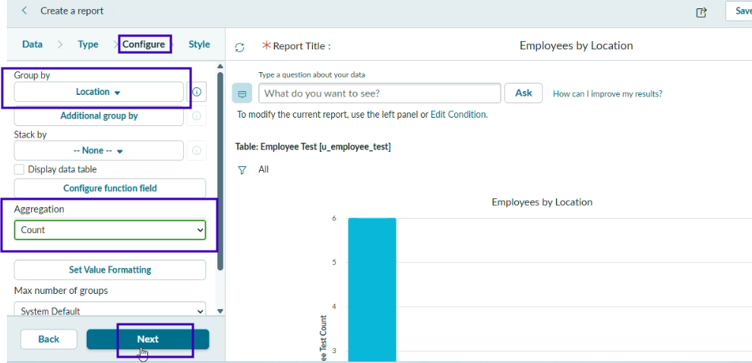
- In Style Leave Chart Color as default then Run and Save the report
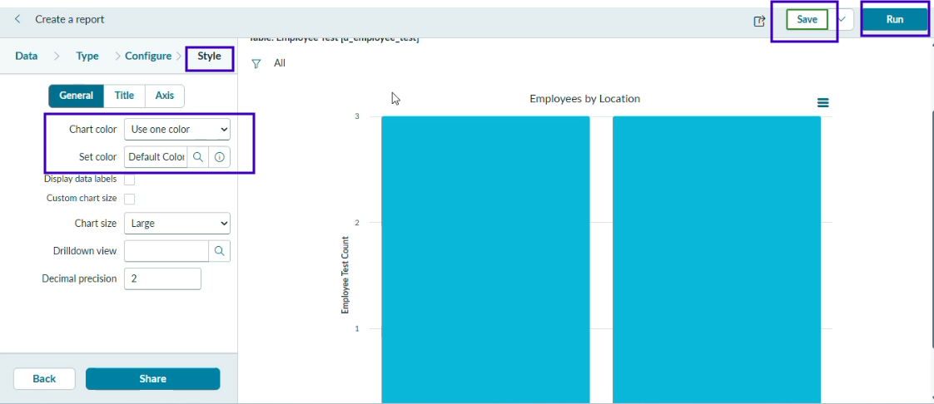
Report 3 : Employee List Report
Configuration
1.Create a New Report name : Employee List Report.
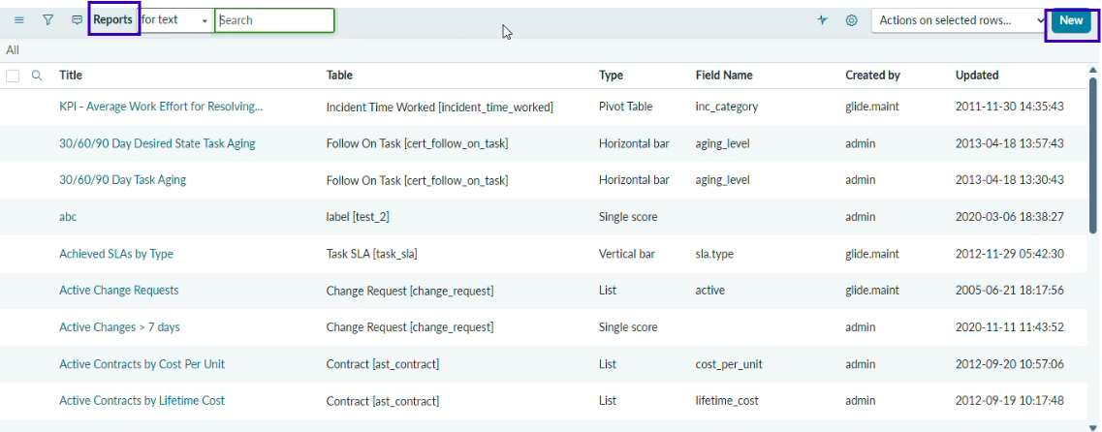
2. In Data , Report name : Employee List Report
Source Type: List.
Table : Employee Table and click Next
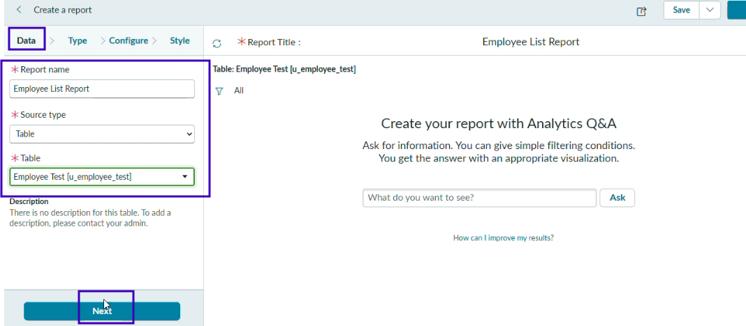
3. Select Type : List and click Next

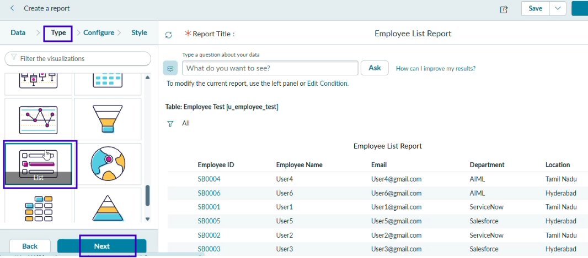
4. In Configure Select Columns
  - Employee ID.
  - Employee Name.
  - Email.
  - Department.
  - Location.
Select Ok and click Next.

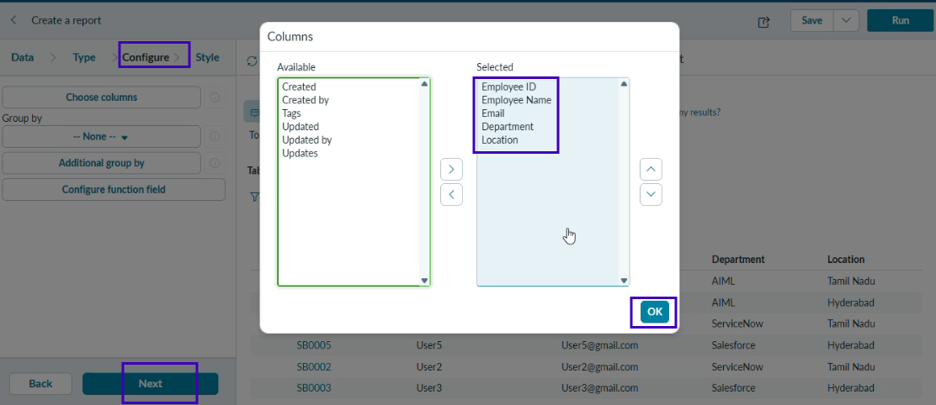
5.Not required to choose anything in Style, click Run and Save the report.

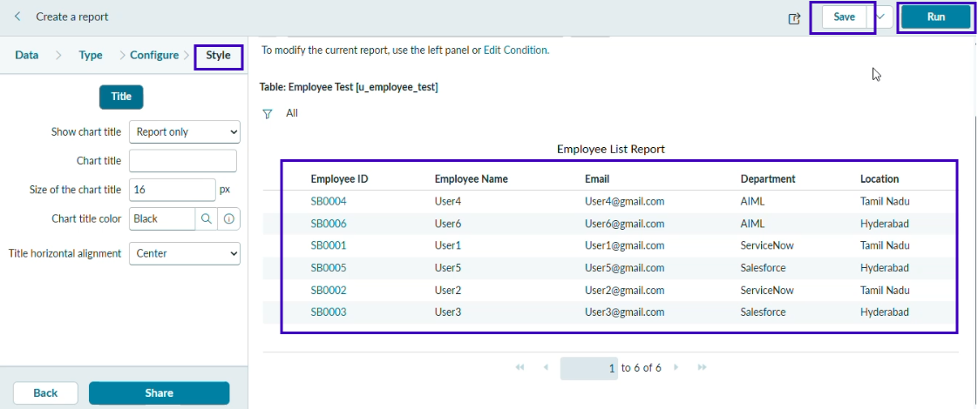
PHASE 9 : Add Reports to Dashboard

Create Dashboard

Navigation :
- Open All menus → Search for Dashboards.
- Under Self Service → Click Dashboards.
- On the top right corner Click Create Dashboards or /
- You can create Directly by using the backend name [ PA_DASHBOARDS.FORM ].
- Then Click New to Create new Dashboards.
- Only the backend name will open the form if the ACL has the pa_dashboards access to Admin Overrides True only.
- Then only we have access to the form.

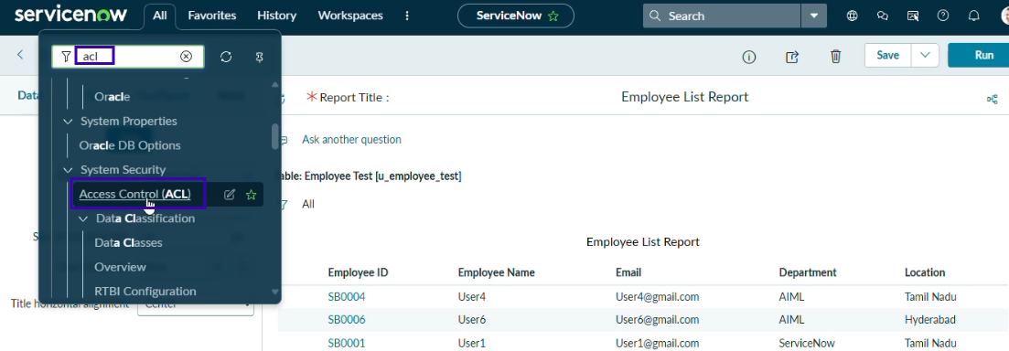
- After Opening the ACL Search the pa_dashboards on Name Column.

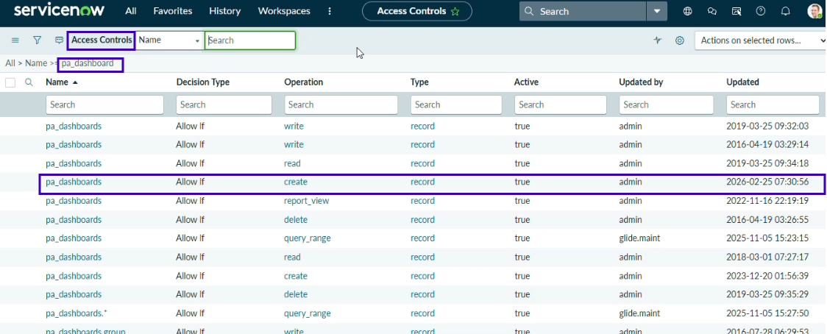
- Now Open the Create Operation row.
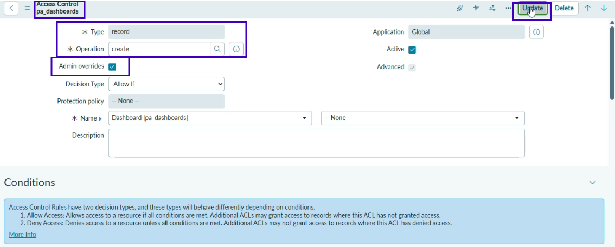
- Then Click Enable the True for Admin Overrides and Update the Form.
- Then the creation of dashboards will be possible by using the backend name.
- Now Open the PA_DASHBOARDS.FORM create dashboard.
- Dashboard name : Employee Analytics Dashboards.
- Save the Form.
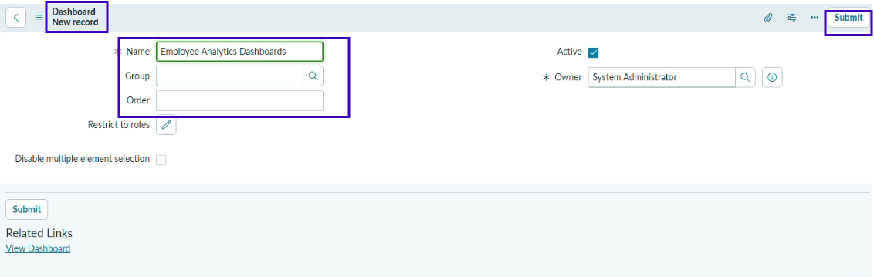
Add Reports to Dashboards.
Navigation Steps:
- Open the Previously Created Reports.
- On All menus → type Reports Under Usage and Governance select reports.
- Open the Employees by Department.
- Select the Edit Report and Click the Share button then the right top corner Select the Add to Dashboards Option.
- Then Choose the Created dashboard name and Click Add button.
- Same Like that do the remaining 2 reports in the same navigation how we added Employees by Department.
- The Employees by Location and Employee List Report these two reports are also added to the created dashboard.

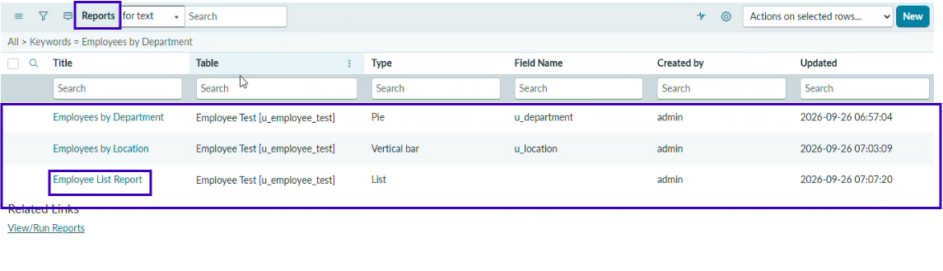
- After Opening the Report Click the View Report Button on the right side of the Context menu.

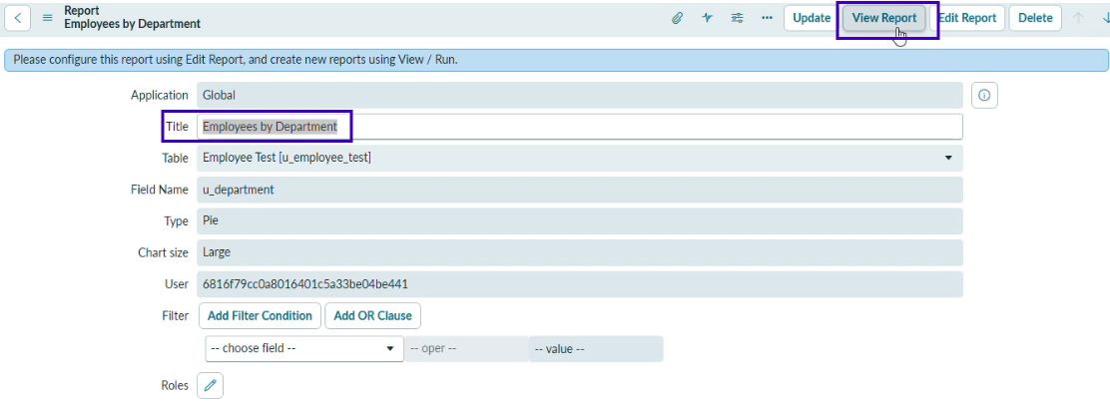
- After Clicking the View Report button, Now Click the Share button and then share options are visible on the right side.
- Now click the Add to Dashboards.

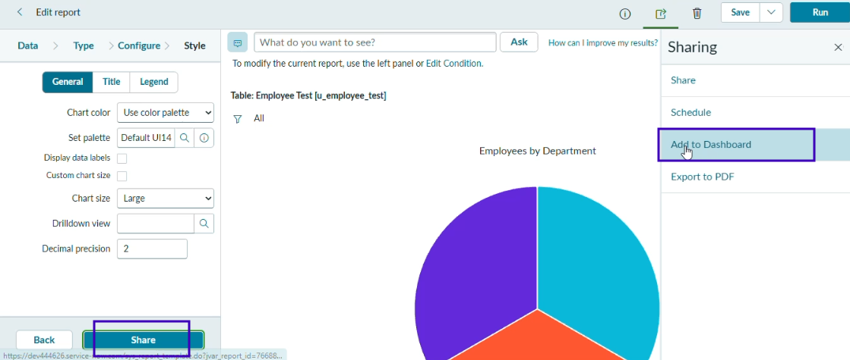
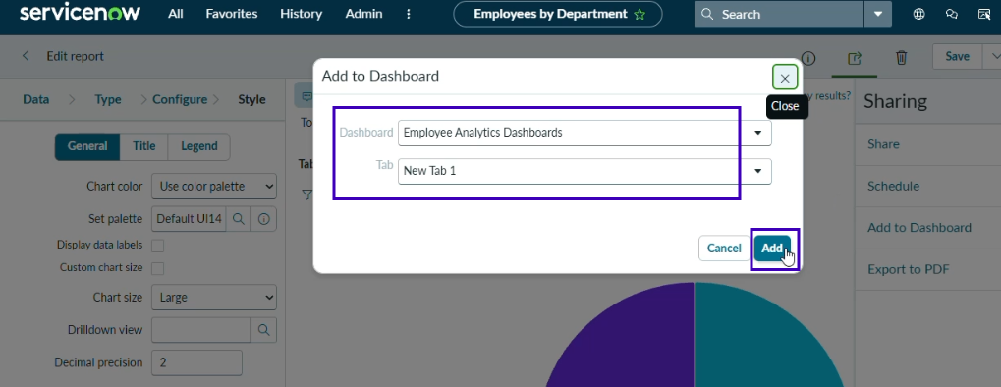
- Now Add the Dashboard that you created called Employee Analytics Dashboards.
- Then Click Add button.
- Now the Report is added to the dashboards.
- Now, Same in the process, adding two reports to the dashboard.

After adding all the reports to the dashboard

- Employees by Department
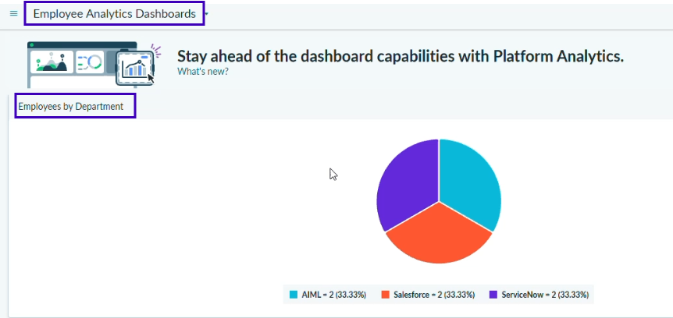
2. Employees by Location
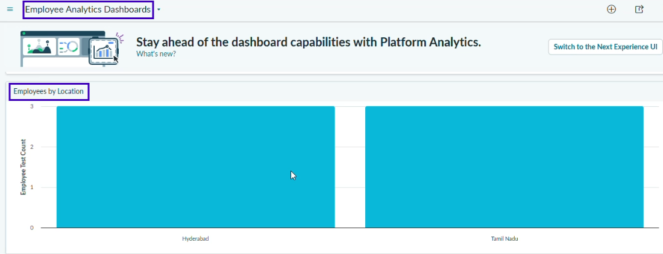

3. Employees List Report
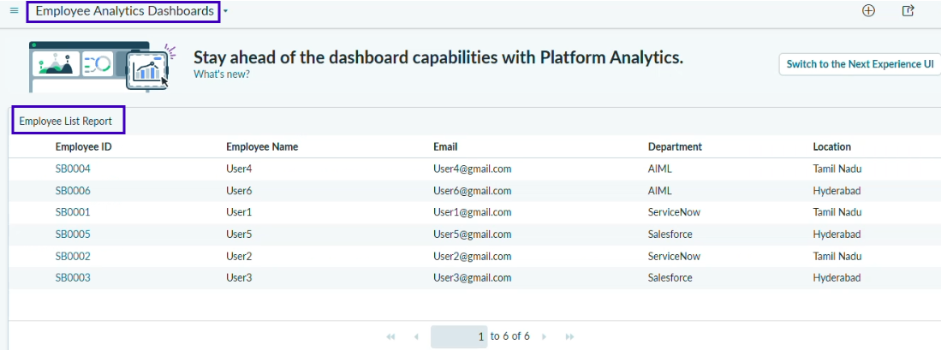
- From the + icon also we add widgets that our reports from there.
- If we want we can also configure the background color.

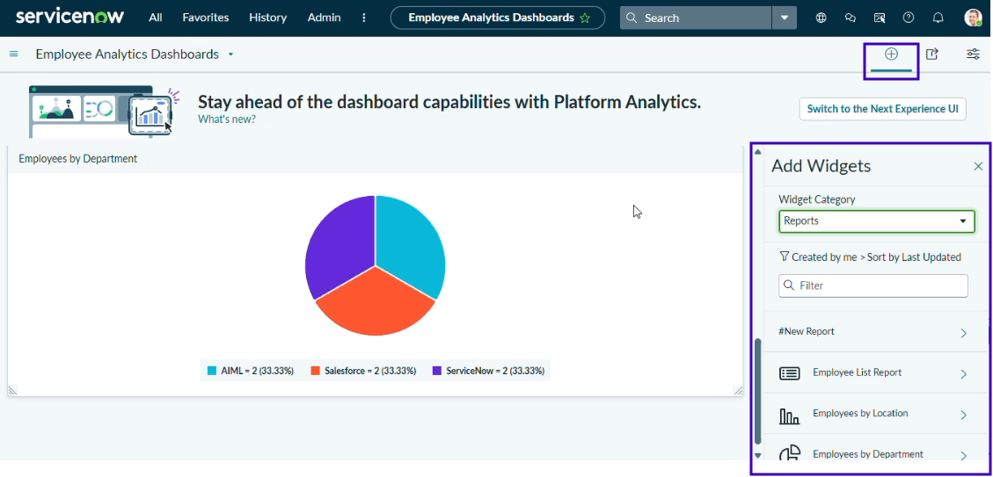
- Here the three Reports are added successfully by varying Department , Location and List Report.
- We can also restrict the Users,Groups and Roles From Share Option.

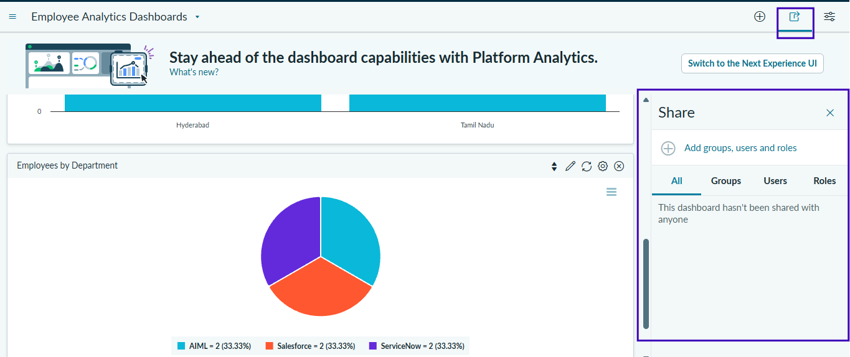

Conclusion :
- The project successfully automated employee data import using ServiceNow Import Sets and Transform Maps.
- Coalesce prevents duplicate records and updates existing employee data.
- The system improves data accuracy, consistency, and efficiency.
- Reports were created to monitor employee records and import activities.
- A Dashboard provides a centralized view of employee data.
- Charts and lists make the data easier to understand and analyze.
- Overall, the project provides a reliable and efficient employee data management solution.

