PROJECT DOCUMENTATION

MicroGoals – Secure Goal Management Backend API

1. INTRODUCTION
- Project Title
Micro Goal - Secure Goal Management Backend API
- Team ID
SWTID-2026-1266
- Team Leader:
Pooja Sri.R (Mail ID: 202400106@sigc.edu)
- Team Members:
Dharshini.R (Mail ID: 202400362@sigc.edu)
Keshika.E (Mail ID: 202400103@sigc.edu)
Loseka Sri.G (Mail ID: 202400695@sigc.edu)

2. PROJECT OVERVIEW
Purpose:
- Micro Goal is a backend application designed to help users authenticate securely and manage their goals/tasks efficiently. The platform focuses on user management and task tracking.
Features:
- Secure user registration and authentication
- Task creation and management
- Task deletion functionality
- API-driven architecture

3. ARCHITECTURE
- Backend: Node.js and Express.js for server logic and APIs
- Database: MongoDB for storing user credentials and task data

4. SETUP INFORMATION
- Prerequisites:
>> Node.js
>> MongoDB
>> Git
>> Express.js
>> Mongoose
>> Visual Studio Code
2. Installation Steps:
>> git clone <repo-link>
>> cd server
>> npm install

5. FOLDER STRUCTURE
Micro-Goal/
│
│ -- server/ # Node.js backend
│ └── controllers/
│ └── models/ # Contains UserModel.js
│ └── routes/ # Contains AuthMessage.js
│ └── utils/ # Contains generateToken.js
│ └── .env
│ └── index.js
│ └── package.json

6. RUNNING THE APPLICATION
Backend:
- cd server
- nodemon index.js
Access: The server runs on port 8000 -> http://localhost:8000

7. API DOCUMENTATION
- User APIs:
/api/user/signup (POST)
/api/user/login (POST)
- Task APIs:
/api/task/create (POST)
/api/task/delete/:id (DELETE)

8. AUTHENTICATION
- JWT-based authentication for secure login (generateToken.js)
- Passwords encrypted using bcrypt

9. USER INTERFACE
This project currently demonstrates backend APIs via Postman. Frontend integration can be attached to these endpoints.

10. TESTING
Manual testing demonstrated via Postman
Validated JWT token generation, user creation, and task deletion workflows.

11.DEMO LINK:
Demo video :
https://drive.google.com/file/d/1xmN8UNhE5AgtQGedgxw39StZkgJkE-5T/view?usp=sharing

12. KNOWN ISSUES
Application is strictly backend-focused currently; requires a frontend client for end-user interaction.
13. FUTURE ENHANCEMENTS
- Frontend Integration – Develop a React.js or mobile UI to interact with the backend.
- Advanced Task Filtering – Ability to sort and filter micro-goals by date or priority.
- Push Notifications – Reminders for pending tasks.
- Collaborative Goals – Multiple users working on shared micro-goals.

14 . EXECUTION OF PROJECT IN THUNDER CLIENT:
1.SIGNUP NEW USER
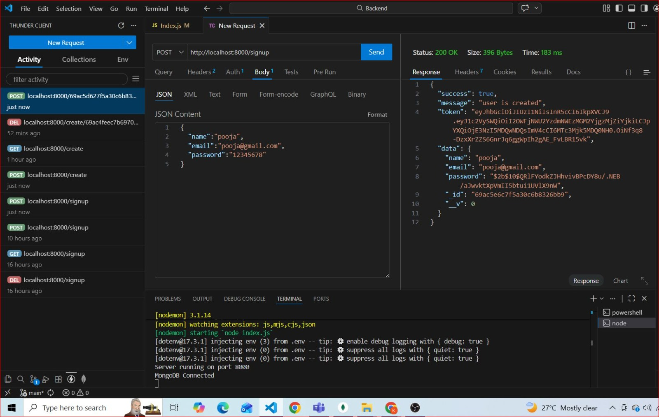

2 . CREATING AUTHENTICATION USING GENERATED TOKEN

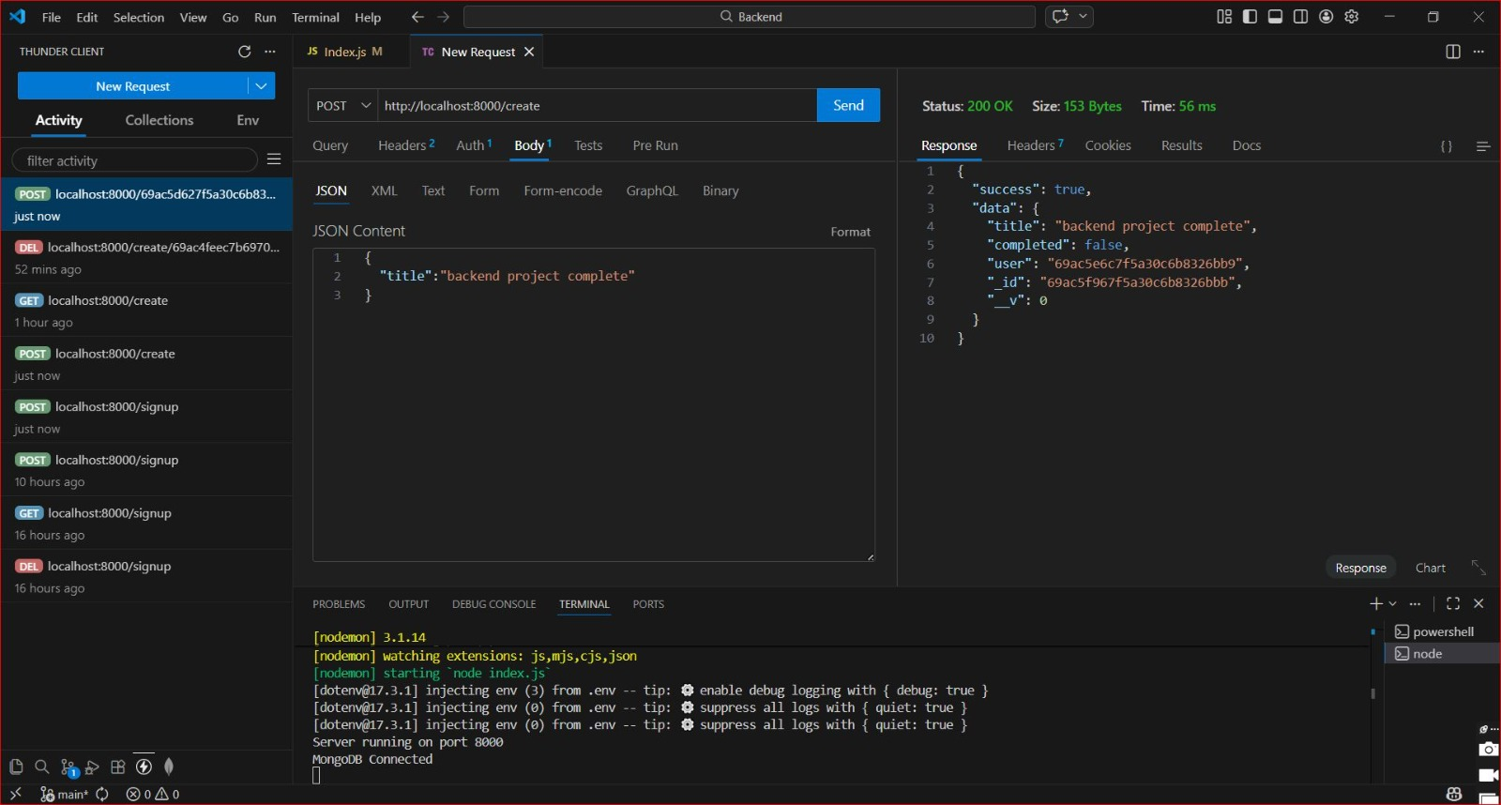

3 . DELETING DATA OF USER
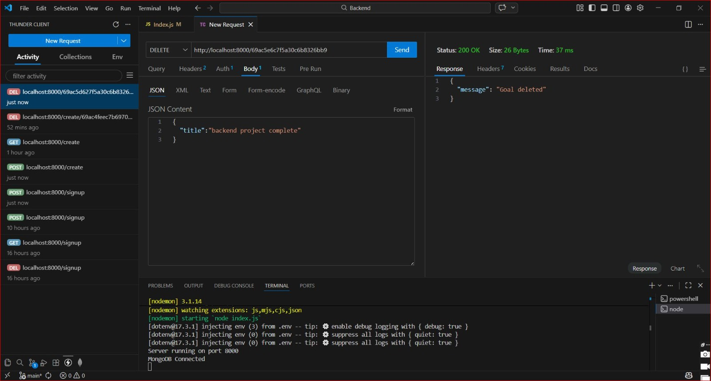

THANK YOU !!!!

