PRODUCT INVENTORY MANAGEMENT SYSTEM

TEAM LEADER: PRIYADHARSHINI N
Email:
• -202400661@sigc.edu
TEAM MEMBERS: LAVANYA E
• -202400450@sigc.edu
• RAMYA V
• -202400660@sigc.edu
• DEEPA SRI AP
• -202400171@sigc.edu
• JEGATHEESHWARI A
• -202400357@sigc.edu

1. Project Overview:
The Product Inventory Management System is a backend web application developed using Node.js, Express.js, and MongoDB.
It provides a secure solution for managing product data through RESTful APIs with JWT authentication.

Key Objectives
• Secure user authentication using JWT
• CRUD operations for product inventory
• User‑specific product management
• Scalable backend using Node.js and MongoDB

Target Users
• Small business owners
• Freelancers and sellers
• Students learning backend development
• Developers practicing API development

2. Project Instructions:
• Create backend project folder
• Configure Express.js server
• Setup MongoDB database
• Implement authentication APIs
• Implement product CRUD APIs
• Test APIs using Thunder Client

[Insert Project Thumbnail Image Here]

3. Pre‑Requisites:
Node.js – JavaScript runtime for backend
MongoDB – Database storage
npm – Package manager
VS Code – Development environment

Knowledge Requirements
• JavaScript ES6
• Node.js and Express.js
• MongoDB and Mongoose
• JWT Authentication

4. Project Architecture:
[Insert Architecture Diagram Here]

Technical Architecture
Controllers – Handle authentication and product logic
Models – Define database schema
Routes – API endpoints
Middleware – JWT verification

5. Database Architecture:
Users Collection: name, email, password, timestamps
Products Collection: name, price, quantity, description, userId

[Insert ER Diagram Here]

6. Core Features:
1. User Authentication
2. Product CRUD operations
3. Private user product access
4. Product search

7. Project Setup:
Initialize project using: npm init -y

Install packages:
express
mongoose
cors
dotenv
jsonwebtoken
bcryptjs

[Insert Folder Structure Image Here]

8. Project Execution:
1. Open terminal in server folder
2. Run npm start
3. Server connects to database9. API Testing:
Use Thunder Client to test APIs
DEMO VIDEO LINK : https://drive.google.com/file/d/1Z8Y0KMnA8ZK7zOn_GM5g9sN3pfsYdwx9/view?usp=drivesdk

[Insert Register API Screenshot Here]

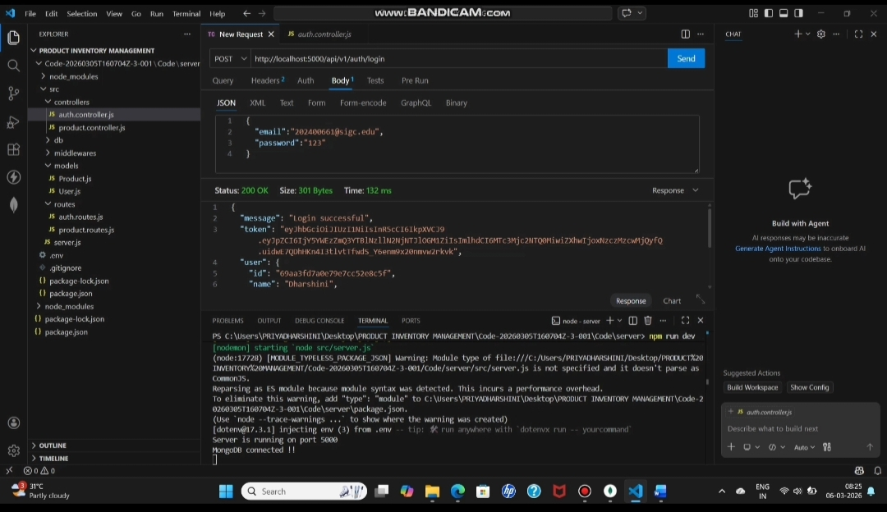
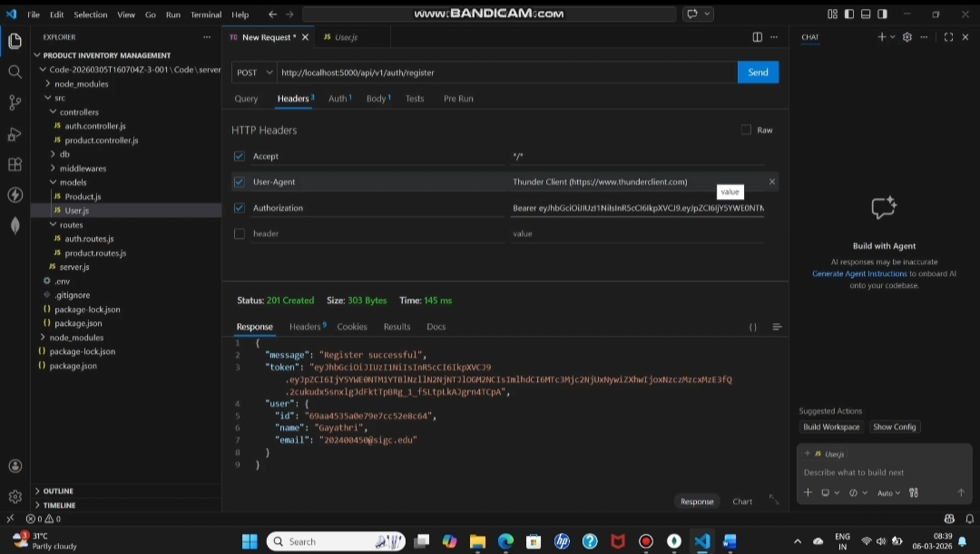
[


Insert Login API Screenshot Here]

[Insert Get Products Screenshot Here]
