Contact Manager
Ideation Phase
Brainstorm & Idea Prioritization

Date | 08/03/2026
Team ID | SWTID-2026-5114
Project Name | Contact Manager

Brainstorm & Idea Prioritization
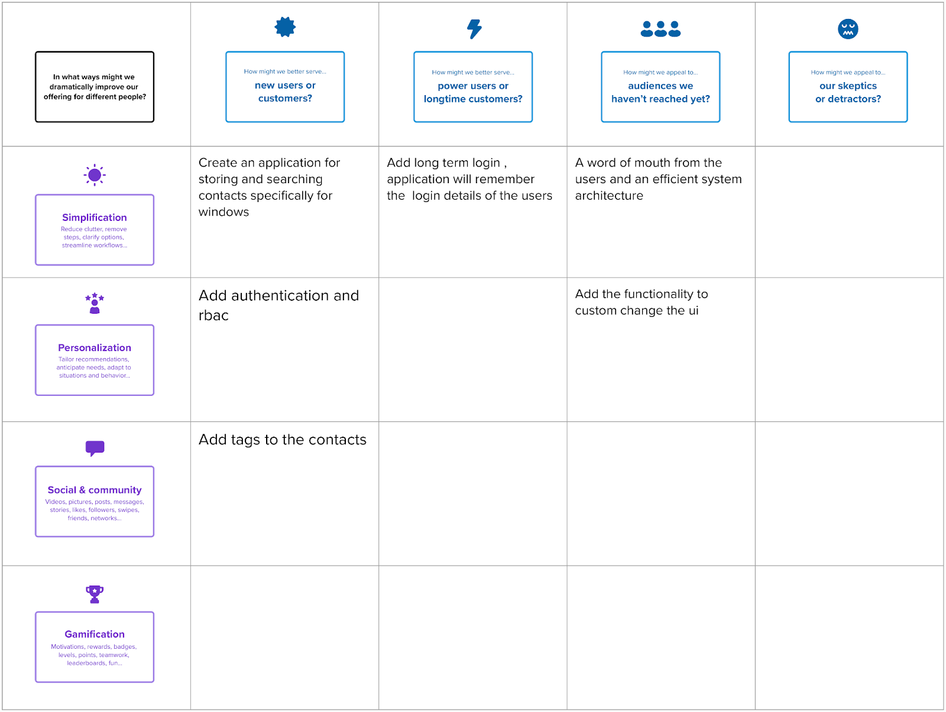

Ste 2 : Idea Prioritization
