LibSpace API – A Robust Backend for Library operations

Team ID: SWTID-2026-7141
Team Size : 4
Developed By:
Team Leader:
R.ADITYA
Team Members:
S.HARSHINE
R.VARSHA
M.KIRUTHIKA

1. Introduction
LibSpace is a web-based backend system designed to manage basic library operations.
The main purpose of this project is to demonstrate how user authentication and book management can be implemented
using modern backend technologies.

The system allows users to register an account, log in securely, and perform operations related to books.
Once authenticated, users can add books, view available books, update book details, and delete books from the system.

This project focuses on building a RESTful backend using Node.js and Express.js while integrating MongoDB for data storage.

2. Objectives of the Project
The main objectives of the LibSpace project include:
- Implementing secure user authentication.
- Performing CRUD operations on books.
- Understanding RESTful API design.
- Learning backend development using Node.js and Express.js.
- Integrating a database for data storage and retrieval.

3. Technologies Used
Node.js – Runtime environment for executing JavaScript on the server side.
Express.js – Framework used for building RESTful APIs and handling routing.
MongoDB – NoSQL database used to store user and book information.
Mongoose – Used for schema modeling and interaction with MongoDB.
Postman – Tool used for testing API endpoints.
Visual Studio Code – Development environment used to write and manage project code.

4. System Architecture
The LibSpace backend follows a layered architecture to maintain clean code and organization.

API Layer (Routes): Handles HTTP requests and defines endpoints such as register, login, add book, update book, and delete book.

Business Logic Layer (Controllers): Processes requests, validates input data, manages authentication, and performs CRUD operations.

Data Access Layer (Database): Interacts with MongoDB to store and retrieve user and book data.

5. Features of the System
User Authentication:
- User registration with name, email, and password
- Secure password hashing
- Login verification
- Token-based authentication using JWT
- Logout functionality
- Delete user account

Book Management:
- Add new books
- View available books
- Retrieve book by ID
- Update book details
- Delete books

Each book is linked to a specific user in the database.

6. Database Design
MongoDB is used as the database. Two main collections are used:

Users Collection:
Stores user information including name, email, and password.

Books Collection:
Stores book details including title, author, URL, and user reference.

A one-to-many relationship exists between users and books. One user can have multiple books, while each book belongs to a single user.

7. Project Implementation
The project is implemented using a modular structure.

Main folders include:
- Config – database connection
- Controllers – application logic
- Models – database schemas
- Routes – API endpoints
- Middlewares – authentication verification

This structure helps maintain clean and scalable code.

8. API Testing
API endpoints are tested using Postman.

Different HTTP methods are used:
POST – create users and books
GET – retrieve book data
PUT – update book details
DELETE – remove books or user accounts

Testing ensures the APIs return correct responses and status codes.

9. Project Execution
Steps to run the project:

1. Install dependencies using npm install.
2. Configure environment variables.
3. Connect the project to MongoDB.
4. Start the server using npm start or npm run dev.
5. Test APIs using Postman.

Once the server starts successfully, APIs can be accessed through the base URL.

10. Screenshot

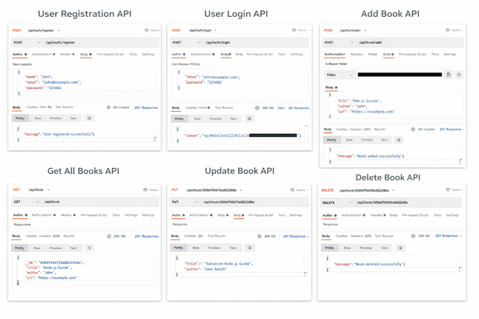

11. Conclusion
The LibSpace project demonstrates the development of a backend system using Node.js, Express.js, and MongoDB.

It provides secure authentication and book management features through RESTful APIs. Through this project, we gained practical experience in backend development, API design, database integration, and API testing using Postman.

12. Demo Link
https://drive.google.com/file/d/1WbMOLFUkHuUTD4NzMfeCZyd9aCf4UVLh/view?usp=sharing

