

Cairo university
Faculty of Computers and AI
Introduction to Software Engineering-CS251

Assignment2
Smart Wallet SDS

Name | ID | e-mail | Section
Yassen Mohamed Abdelaziz | 20240663 | 20240663@stud.fci-cu.edu.eg | S26
Ali Ahmed Mahmoud | 20240331 | 20240331@stud.fci-cu.edu.eg | S3
Abdullah Yousef Abdullah | 20240337 | 20240337@stud.fci-cu.edu.eg | S25
Sayed Mamdouh | 20240256 | 20240256@stud.fci-cu.edu.eg | S26

- Leader information:
Name : Yassen Mohamed Abdelaziz
ID :20240663
E-mail : 20240663@stud.fci-cu.edu.eg
Phone : 01064681901

Contents
System Architecture 3
System Architecture – Smart Wallet 3
1. High-Level Overview 3
2. Frontend (Client Side) 4
3. Backend (Server Side) 4
4. Database Layer 4
5. Security Layer 5
6. API Layer 5
7. Workflow Summary 5
Class diagram 6
Sequence diagrams 7
Sign-up 8
Log in 9
Add transaction 10
Budget limit 12
Setting goals 13
State diagram 14
Application of SOLID Principles: Smart Wallet Project 15
1. Single Responsibility Principle (SRP) 15
2. Open/Closed Principle (OCP) 15
3. Liskov Substitution Principle (LSP) 16
4. Interface Segregation Principle (ISP) 16
5. Dependency Inversion Principle (DIP) 17

Task1:

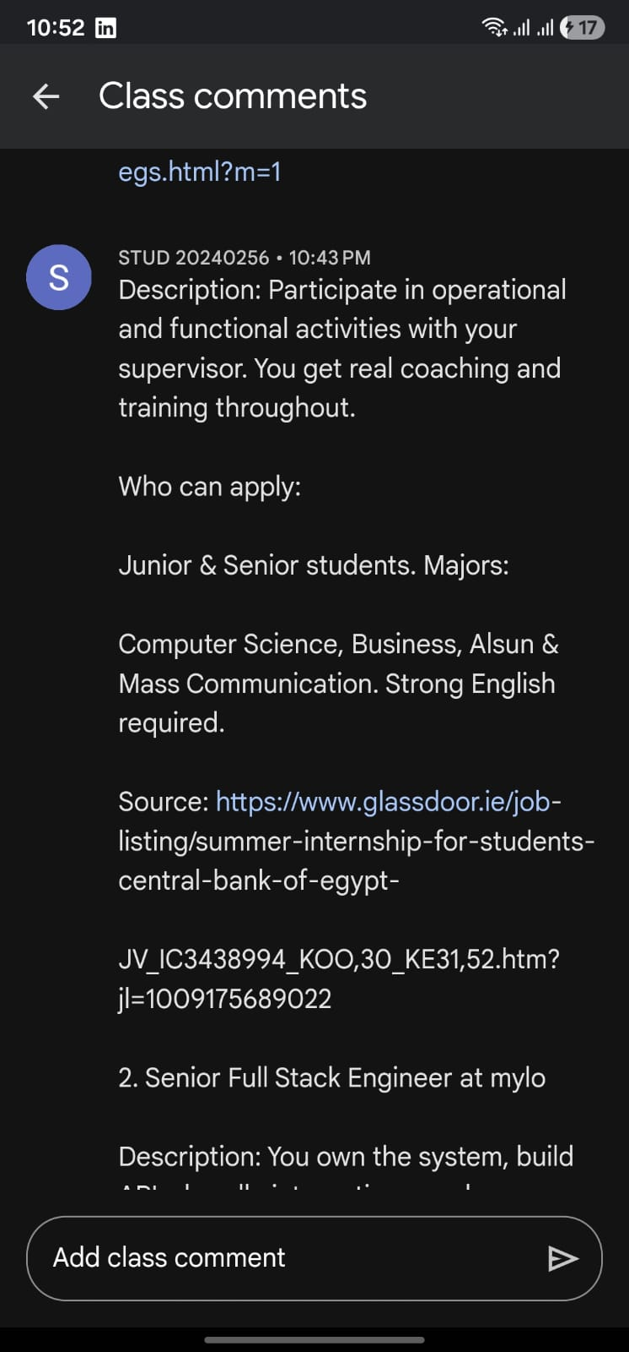

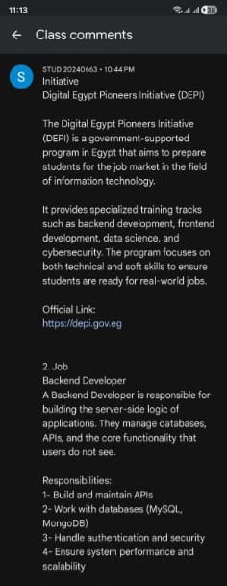
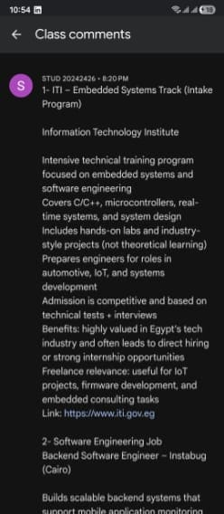

System Architecture

System Architecture – Smart Wallet
The Smart Wallet system is designed as a secure, scalable, and modular financial platform that allows users to manage digital funds, track transactions, and perform wallet operations efficiently.

1. High-Level Overview
users to manage wallets, track transactions, set budgets, and achieve saving goals.
The system follows a client-server architecture:
- Frontend (Client Side)
- Backend (Server Side)
- Database Layer

2. Frontend (Client Side)
Responsible for user interaction.

Responsibilities:
- User registration & login UI
- Wallet dashboard
- Transaction interface
- Budget & goals UI
- Responsive design

Technologies:
- HTML
- CSS
- JavaScript

3. Backend (Server Side)

Responsibilities:
- Authentication & authorization
- Wallet management
- Transaction processing
- Budget & saving goals logic
- AI chatbot

Technologies:
- Django

4. Database Layer

Entities:
- Users
- Wallets
- Transactions
- Categories
- Budgets
- Saving Goals
- Notifications

Relationships:
- One Wallet → Many Transactions
- One Wallet → Many Categories
- One Category → Many Budgets

Technology:
- SQLite

5. Security Layer
• Password hashing
• Input validation

• Permission-based access control
• Transaction verification rules

6. Workflow Summary
• User interacts with frontend
• Frontend sends requests
• Backend processes request
• Database stores/retrieves data
• Response returned to frontend

Class diagram:

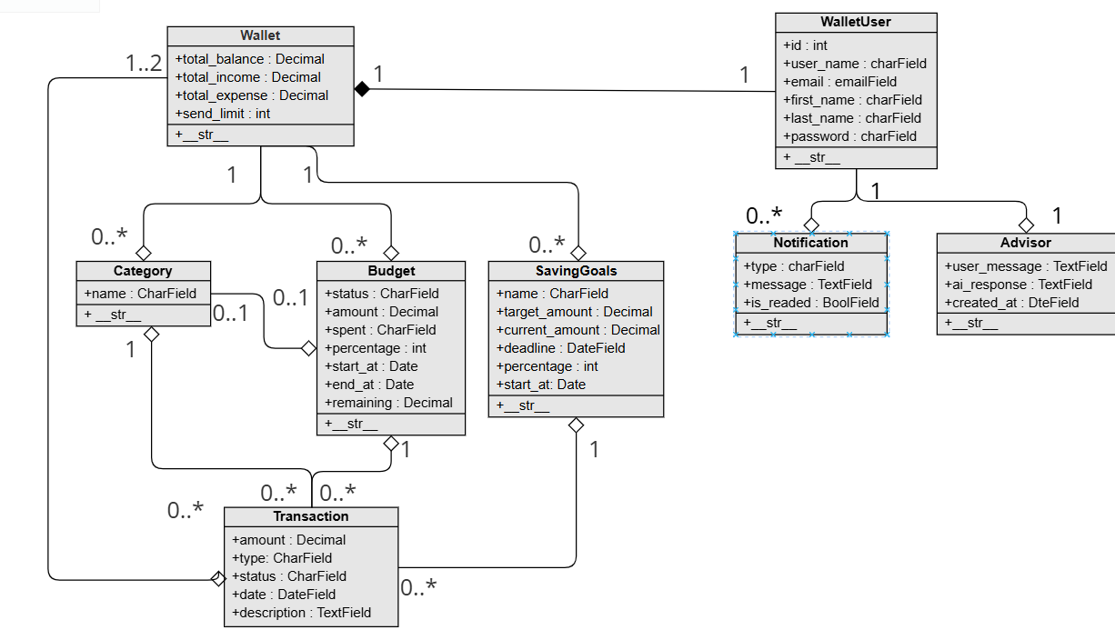

Sequence diagram

Sign-up
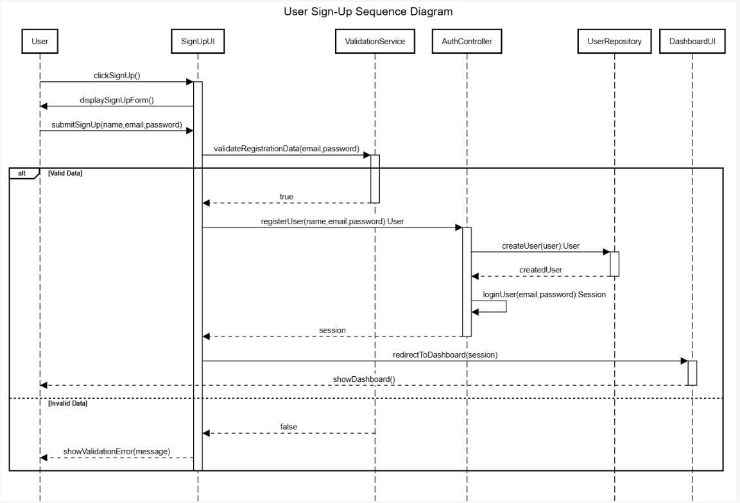

Sequence Diagram | Class Used | Methods Used
User Sign Up | UserController  ValidationService  UserRepository | registerUser()  validateEmail()  saveUser()

Log in
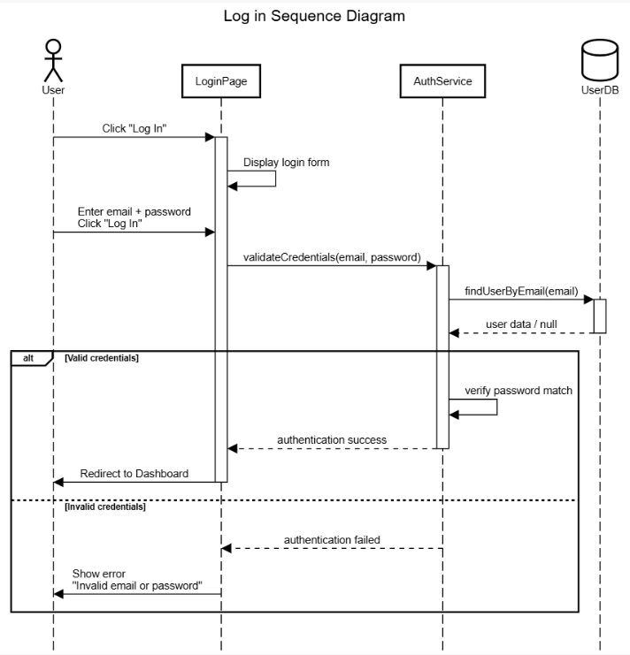

Class / Component | All Methods / Actions Used | Purpose / Context
LoginPage | Display login form, validateCredentials(email, password), Redirect to Dashboard, Show error | Manages the user interface, captures input, and handles navigation or error display based on auth results.
AuthService | findUserByEmail(email), verify password match | The core authentication engine that verifies credentials against stored data and returns success or failure.
UserDB | findUserByEmail(email) | The data layer responsible for searching for a user record and returning user data or a null value.

Add transaction

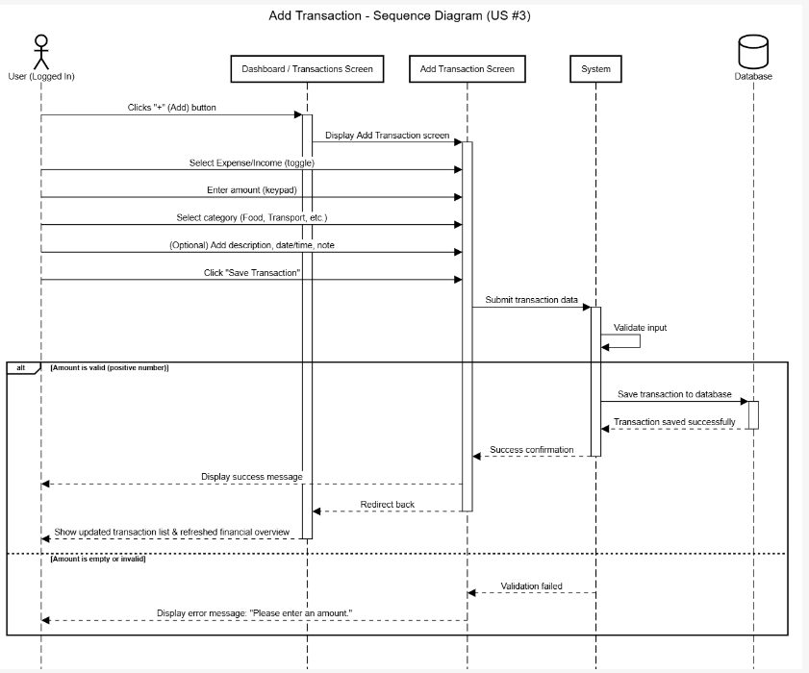

Class Used | All Methods Used | Purpose / Context
UI_Manager | showAddTransactionScreen(), showDashboard() | Handles high-level navigation and screen transitions.
AddTransactionForm | getType(), getAmount(), getCategory(), getDescription(), getDateTime(), submit(), displayError(message), displaySuccess(message) | Manages the user input interface, data collection, and local feedback/validation messages.
TransactionController | validateInput(amount, category, type), createTransaction(data), saveToDatabase(transaction) | Orchestrates the backend logic, ensuring data integrity before persistence.
Database | saveTransaction(transaction), updateUserBalance(userId) | The final persistence layer that stores the record and recalculates the user's total balance.

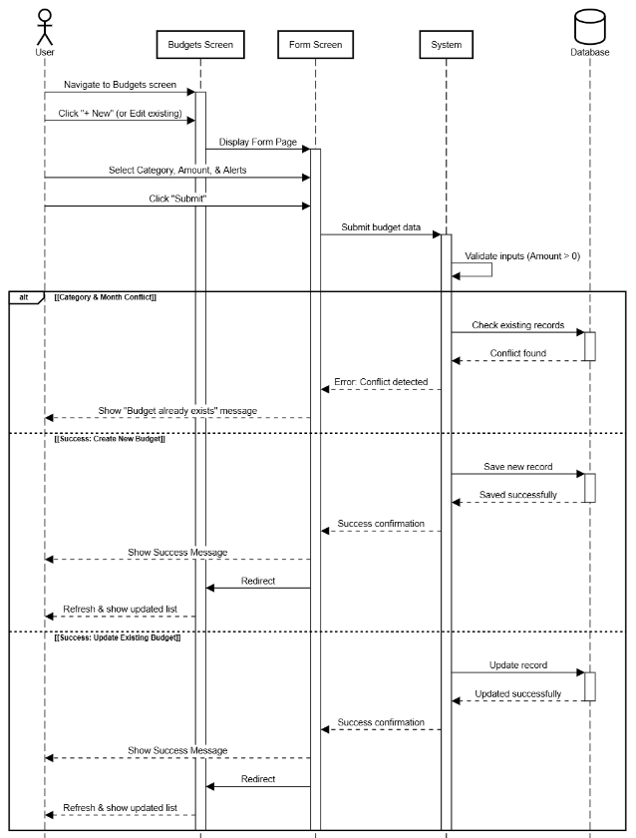
Budget limit

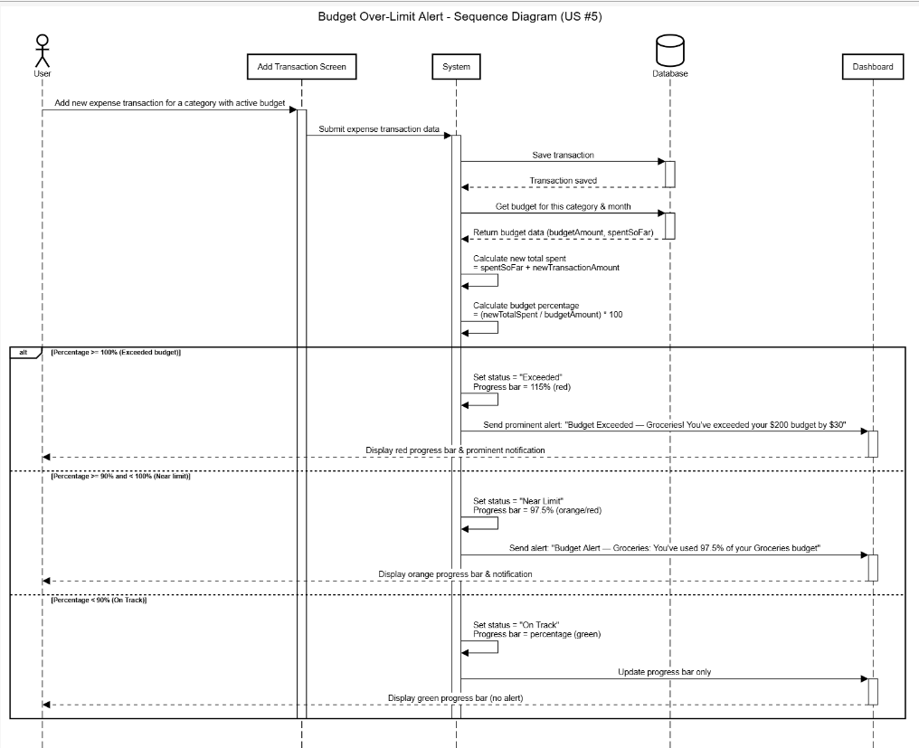

Class Used | All Methods Used | Purpose / Context
AddTransactionScreen | submitExpense() | The entry point where the user inputs a new expense.
BudgetController | saveExpenseAndCheckBudget(transaction), getBudget(category), calculateSpentPercentage(category), getBudgetStatus(percentage), triggerAlert(category, percentage, exceededAmount) | The core logic engine that evaluates if an expense pushes the user over their set limit.
Database | saveTransaction(transaction), getBudget(category), getSpentAmount(category) | Handles the permanent storage of the expense and retrieves current budget thresholds.
Dashboard | updateProgressBar(category, percentage, color), showAlert(message, type) | The UI layer responsible for visual feedback, such as changing progress bar colors or popping up an alert.

Setting goals
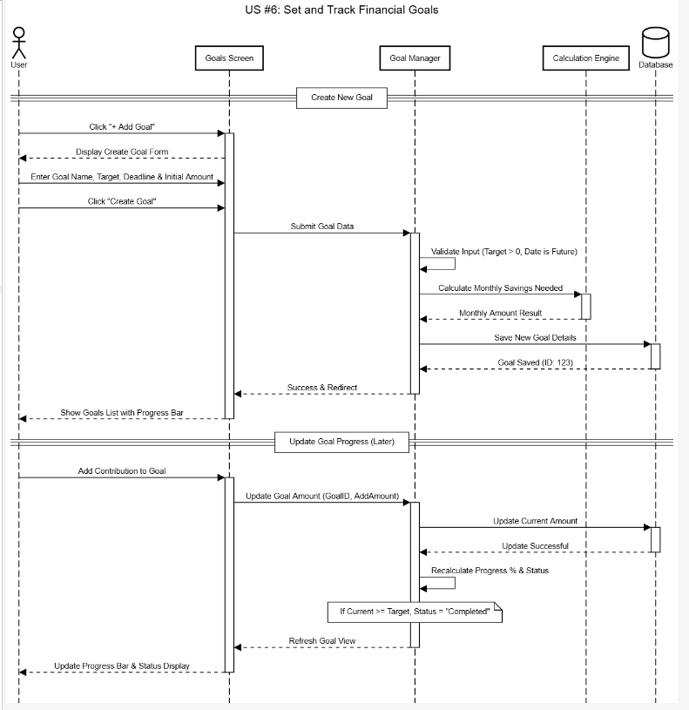

Class Used | All Methods Used
GoalsScreen | showCreateForm(), refreshList(), updateProgressBar(), addContribution()
CreateGoalForm | getName(), getTargetAmount(), getDeadline(), getInitialAmount(), submit(), displaySuccess()
GoalController | validateInput(name, targetAmount, deadline), calculateMonthlySavings(), createGoal(data), addContribution(goalId, amount), calculateProgress(current, target), getStatus(percentage)
Class Used | All Methods Used

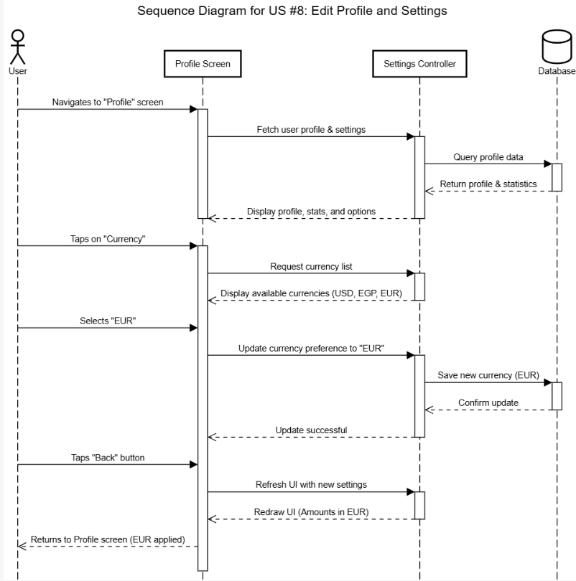
Edit profile:

Step | Actor Action | System Component / Logic | Data Involved | Expected Outcome
1 | User navigates to Profile screen | ProfileController.load() | User ID, Profile Stats | System fetches name, email, and stats from DB.
2 | User views settings list | SettingsMenu.display() | Notification, Currency, Lang | UI renders a list of configurable options.
3 | User taps "Currency" | UI.showSelectionList() | List of Currencies | A selection modal/list appears (USD, EUR, EGP).
4 | User selects "EUR" | PreferenceService.update() | currency_code = "EUR" | The system prepares a "Write" request for the DB.

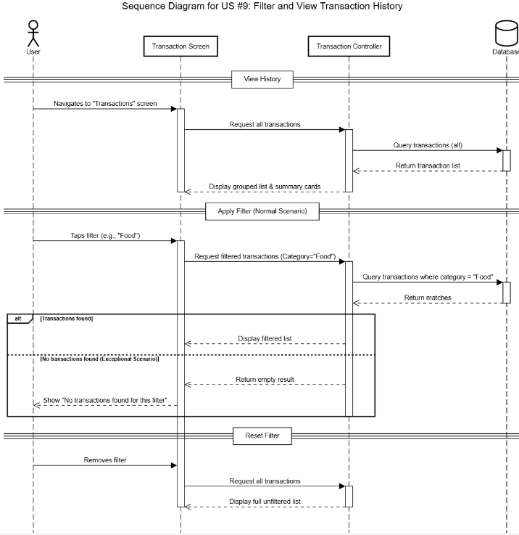
View history:

Step | Actor Action | System Component | Data / Parameters | Expected Outcome
1 | Open Transaction Screen | TransactionController.init() | UserID | Full history loaded and grouped by date.
2 | Select Category Filter | FilterEngine.apply() | Category: "Food" | List is pruned to show only specific category data.
3 | DB Query | SQL/NoSQL Query | WHERE cat='Food' | System retrieves matching rows from storage.
4 | Handle Empty Result | UI.StateMapper | Empty Set | System renders a "No transactions found" placeholder.
5 | Clear Filter | FilterEngine.reset() | None | UI state returns to the original full list view.

State diagram
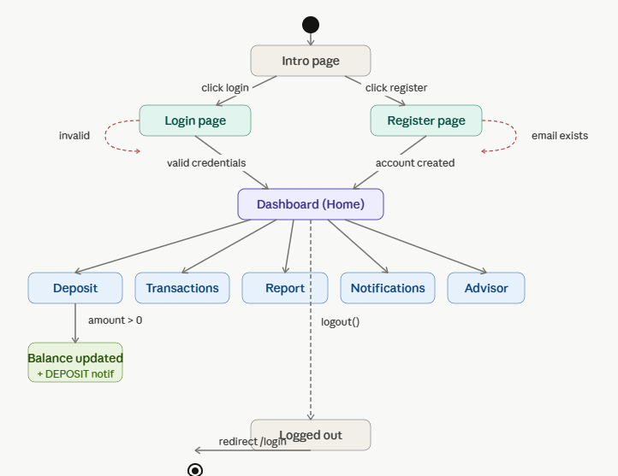

Application of SOLID Principles: Smart Wallet Project

1. Single Responsibility Principle (SRP)
“A class should have only one reason to change.”
Current State: The current Back end Layer (as defined in the SDS) combines user authentication, wallet management, and transaction processing. This creates "God Classes" that are difficult to debug.

SOLID Implementation: We will decouple these responsibilities into distinct classes:
AuthenticationService : Responsible strictly for JWT token generation and login/registration logic.
WalletManager: Responsible for creating wallets and checking current balances.
TransactionProcessor: Responsible for the logic of moving funds (Deposit, Withdraw, Transfer).
Benefit: If the security requirements change (e.g., switching to multi-factor authentication), you only modify the AuthenticationService without risking the transaction logic.

2. Open/Closed Principle (OCP)
“Software entities should be open for extension, but closed for modification.”
Current State: The system currently supports basic transactions. If we want to add new types like "Recurring Subscription" or "Investment Portfolio," we shouldn't have to rewrite the existing Transaction logic.
SOLID Implementation: Define a base abstract class or interface called Transaction.
Concrete classes like StandardTransaction and RecurringTransaction will extend this base.
The TransactionProcessor will work with the Transaction type, allowing us to add a CryptoTransaction class later without changing a single line of code in the processor.

Benefit: Reduces the risk of introducing bugs into the "Standard" payment logic when adding new financial features.

3. Liskov Substitution Principle (LSP)
“Objects of a superclass should be replaceable with objects of its subclasses without breaking the application.”
Current State: If we create a LockedSavingsGoal subclass from a general Goal class, and the base class has a withdraw() method, the LockedSavingsGoal might throw an error because the funds are frozen.
SOLID Implementation: We must ensure that subclasses do not "weaken" the base class's behavior.
Instead of putting withdraw() in the base Goal class, we create an interface IWithdrawable.
Only goals that actually allow withdrawals will implement this interface.
Benefit: Ensures the system remains stable and predictable when handling different types of financial targets.

4. Interface Segregation Principle (ISP)
“Clients should not be forced to depend on methods they do not use.”
Current State: Your SRS defines different actors (User, Admin). If we use one large IUserService interface, the regular User object would be forced to have methods like deleteUserAccount() or viewSystemLogs().
SOLID Implementation: Split the interfaces based on actor needs:
IUserFinancialActions: Contains addTransaction(), setBudget().

IAdminActions: Contains manageUserRoles(), generatePlatformReport().
Benefit: Keeps the code lean and prevents a regular user from having access to administrative methods, improving security.

5. Dependency Inversion Principle (DIP)
“High-level modules should not depend on low-level modules. Both should depend on abstractions.”
Current State: The SDS specifies SQLite as the database. If the WalletManager directly instantiates a SQLiteDatabase object, the system is "tightly coupled" to SQLite.
SOLID Implementation: * Create an interface called IDataStore.
The WalletManager will depend on IDataStore.
We then "inject" the SQLiteImplementation into the manager.
Benefit: If the project grows and you need to switch to PostgreSQL or MongoDB, you only write a new implementation of IDataStore without rewriting your core business logic.

