Links and Devices
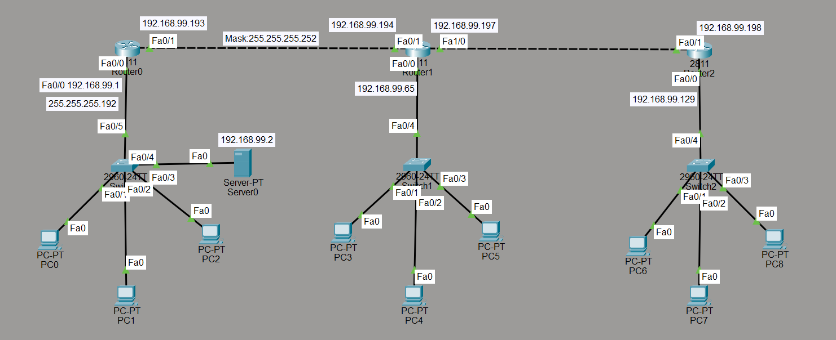

DHCP
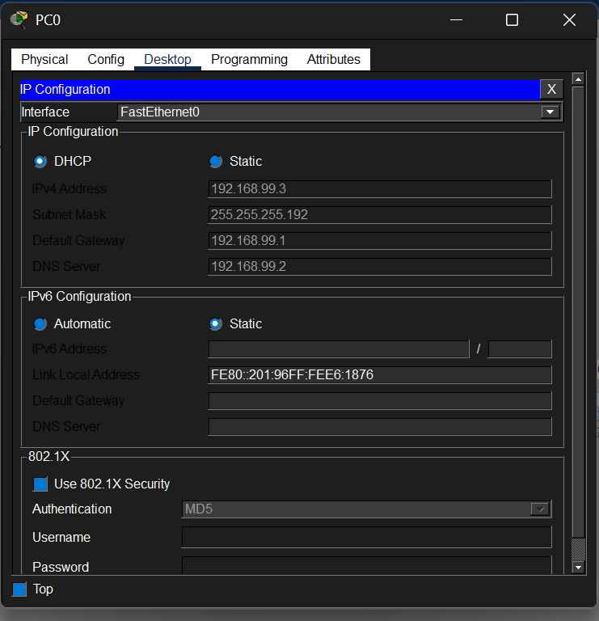

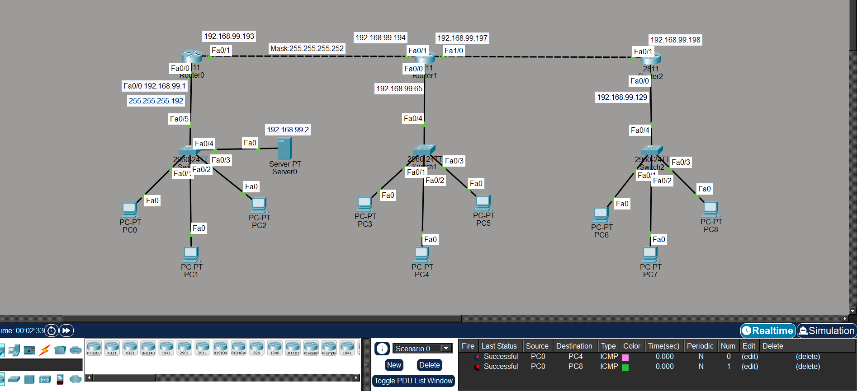
Successful Ping
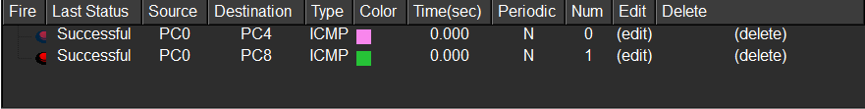

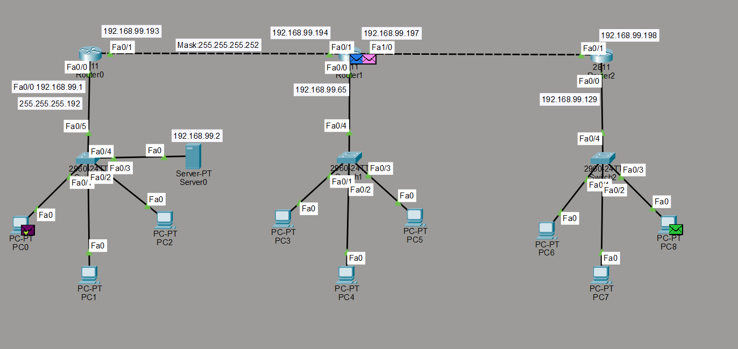
Web-server Access:

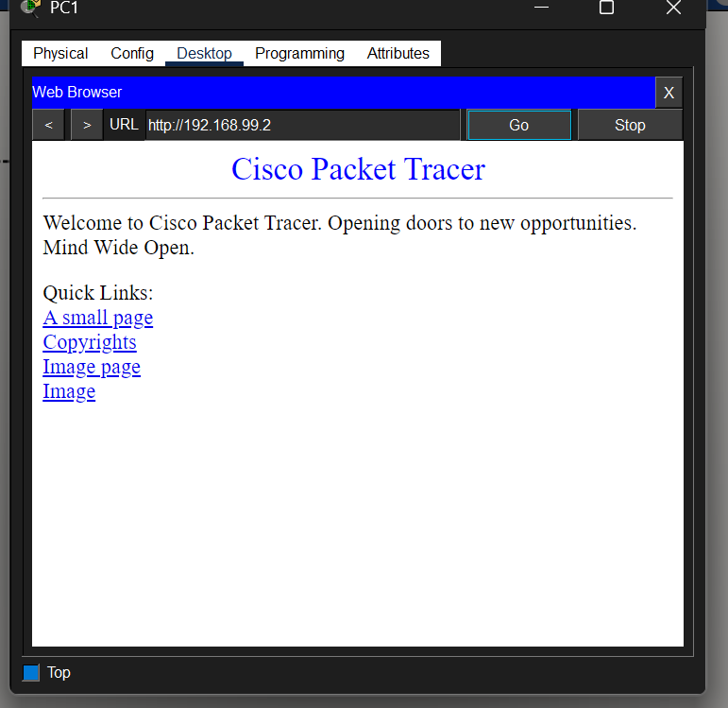

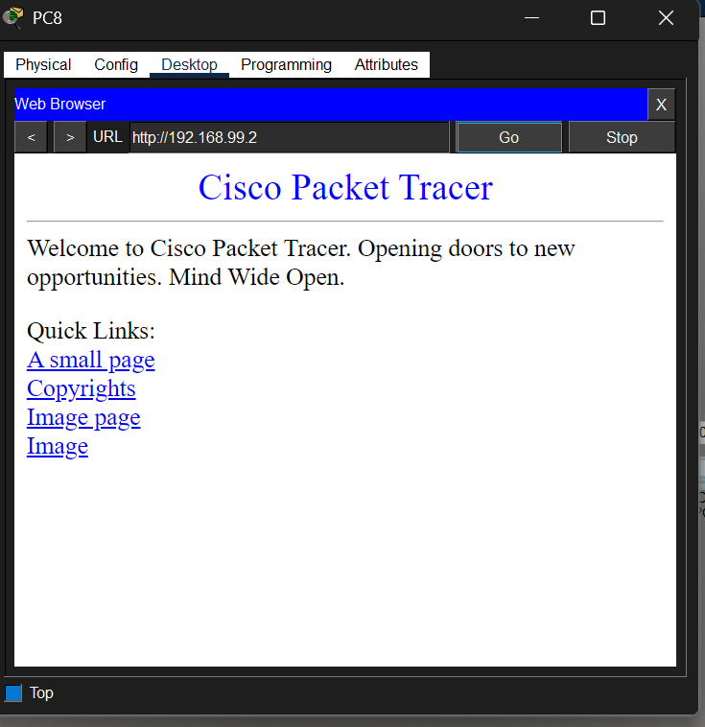

Devices Used in the Bank Network
Device | Quantity | Short Description
Router | 3 | Connects different networks and allows communication between Head Office and branches through routing.
Switch | 3 | Connects multiple devices within the same local area network (LAN).
PC (Personal Computer) | Multiple | Used by bank employees to access network services and communicate with servers.
Web Server | 1 | Hosts the bank website and provides web services to users.
DNS Server | 1 | Translates domain names like www.bank.com into IP addresses.
DHCP Server | 1 | Automatically assigns IP addresses, subnet masks, gateways, and DNS settings to PCs.
Copper Straight-Through Cable | Multiple | Used to connect PCs and servers to switches and routers to switches.
Copper Cross-Over Cable | 2 | Used to connect routers directly to each other through FastEthernet ports.

Functional Description

Router
A router forwards data packets between different networks. In this project, routers connect the Head Office with Branch 1 and Branch 2.

Switch
A switch connects devices inside the same LAN and helps devices communicate efficiently within a branch office.

PC

PCs represent client computers used by bank employees for accessing services and communication.

DNS Server
The DNS server converts human-readable domain names into IP addresses so users can access servers using names instead of numbers.

DHCP Server
The DHCP server dynamically provides network configuration information to client PCs automatically.

Cables
Network cables establish physical connections between devices and enable data transmission throughout the network.

