SariSari Hub: Digital Utang Ledger & Quick Inventory App for Micro-Enterprises
A Flutter-Based Mobile Application

A Project Paper
Presented to the Faculty of Palawan State University – Taytay Campus

In Partial Fulfillment of the Requirements
for the Course IT E3/L IT Elective 3

Submitted by:
Cindy M. Tablazon
BSIT_3

Submitted to:
Ace York C. Mangalino

November 2026

Table of Contents
Introduction 1
Why Flutter Is the Appropriate Choice 1
Objectives 2
Project Overview 2
Key Flutter Features to Be Utilized 3
Target Audience 3
Cross-Platform Reach 3
User Demographics 4
Features 4
Widget-Based Architecture 4
Flutter Packages and Plugins 5
Application Features 5
Testing and Evaluation 8
Testing Frameworks and Tools 8
Automated Testing and Debugging 8
Quality Assurance Plan 8
Project Timeline and Budget 9
Development Timeline 9
Estimated Budget 10
Cost-Saving Aspects of Flutter 11
References 12
Developer Profile 13
Appendix: User Interface Design 14

Introduction
Sari-sari stores are the small neighborhood retail outlets that supply Filipino households with everyday goods such as canned sardines, instant noodles, bottled water, and rice, often sold by the piece. Most of these stores are run by a single owner or a family, and their records are still kept in notebooks, on scraps of paper, or in the owner’s memory. Sales are not tallied, stock levels are guessed, and utang (credit extended to regular customers) is tracked by hand, which makes it easy to lose money through forgotten balances, unnoticed stockouts, and unclear profits.
SariSari Hub: Digital Utang Ledger & Quick Inventory App for Micro-Enterprises is a mobile application designed to solve these problems with a simple, owner-friendly interface for sari-sari store owners, micro-grocers, and local retail stalls. It lets a store owner record sales in a few taps, maintain a customer utang ledger with due dates and reminders, monitor product stock and supplier contacts, track expenses, and view easy-to-read reports of sales, profit, and cash flow. The application has been designed in thirty screens, from account creation to help and support, using a green-and-white visual identity and a five-tab navigation consisting of Home, Utang, Stock, Reports, and More.
This project will be developed using the Flutter framework for mobile app development. Flutter, an open-source UI toolkit from Google, is the chosen technology stack for the entire application, with Dart as the programming language (Dart, n.d.; Flutter, n.d.-a).

Why Flutter Is the Appropriate Choice
Flutter is the appropriate choice for SariSari Hub for three main reasons. First, its cross-platform capability allows a single Dart codebase to produce both Android and iOS applications, which matters because the app’s users may own very different devices. Second, Flutter provides a rich set of widgets, including Material Design components for cards, lists, forms, buttons, and navigation bars, which match closely the screens already designed for the app (Flutter, n.d.-c; Google, n.d.). Third, Flutter has a robust developer community and a large package repository, pub.dev, where well-maintained libraries for databases, charts, notifications, and authentication are readily available (pub.dev, n.d.).

Objectives
The project aims to achieve the following objectives:
- To develop a cross-platform mobile application for sari-sari store owners, micro-grocers, and local retail stalls using Flutter within the 22-day project period.
- To provide quick sales recording and a transaction history that replaces handwritten sales notes.
- To digitize the utang ledger, including customer profiles, due dates, payments, and friendly reminders.
- To help owners monitor inventory, low-stock items, suppliers, purchases, and expenses.
- To present simple reports on sales, profit, and cash flow that support better business decisions.
- To evaluate the quality and reliability of the application through automated and user acceptance testing.

Project Overview
SariSari Hub is a store-management companion that organizes the three things sari-sari owners care about most: sales, utang, and inventory. The application opens with a welcome screen and a short onboarding flow in which the owner creates an account, verifies a mobile number through a six-digit code, and enters basic store details. After onboarding, a dashboard summarizes the day through sales, utang balance, product count, and net income, and provides quick actions for adding a sale or an utang entry.
Flutter will enable cross-platform development, allowing the app to run on both Android and iOS from one codebase. This reduces development time and cost because screens, business logic, and tests are written once instead of twice (Flutter, n.d.-a). For a single-developer academic project with a fixed schedule, this is a decisive advantage.

Key Flutter Features to Be Utilized
- Hot reload. Code changes appear in the running app in a moment without losing app state, which speeds up building and refining the thirty designed screens (Flutter, n.d.-b).
- Pre-designed widgets. Built-in Material widgets such as Scaffold, AppBar, Card, ListView, TextField, NavigationBar, and Chip form the basis of the dashboard, ledger lists, and input forms.
- Responsive user interfaces. Layout widgets such as Column, Row, Expanded, Flexible, and LayoutBuilder, together with MediaQuery, allow the screens to adapt to different phone sizes.
- Custom theming. A single ThemeData object will define the green brand color, rounded cards, and typography so the whole app stays consistent.
- Rich animations and custom drawing. Flutter’s own rendering lets the weekly performance bar chart and the “Sale saved!” confirmation transition feel smooth.

Target Audience

Cross-Platform Reach
Flutter’s versatility and cross-platform compatibility will allow SariSari Hub to serve a broader user base, covering both Android and iOS users without maintaining two separate applications. Because most budget smartphones in the Philippines run Android while some owners and family members use iPhones, a single codebase gives the project the widest practical reach. Flutter also allows the same app to adapt to different screen sizes, which suits owners who use inexpensive phones with smaller displays.

User Demographics
The primary users of SariSari Hub are sari-sari store owners, micro-grocers, and local retail stalls in the Philippines, under the theme of Local Retail and Commerce, such as the sample “Aling Nena’s Store” in Calamba, Laguna, shown in the design. They are typically adults aged 25 to 65, many of whom are women who run the store as a household enterprise, and who may have limited experience with business software. For this reason the interface uses large buttons, short labels, peso amounts shown prominently, and familiar Filipino terms such as “utang.”
The secondary users are family members or hired helpers who assist at the counter or stall, which the app supports through team access and staff permissions in the store settings. Indirect beneficiaries include regular customers who receive clearer, friendlier utang reminders and more accurate records of what they owe and have paid.

Features

Widget-Based Architecture
In Flutter, everything on the screen is a widget, and complex screens are built by composing small widgets together (Flutter, n.d.-c). SariSari Hub will follow this approach. Reusable widgets such as StatCard (used for “Sales Today,” “Utang Balance,” “Current Balance,” and similar summary cards), ListItemCard (the rounded row with an icon tile, title, subtitle, and trailing amount), PrimaryButton (the full-width green button), and LabeledTextField (used in every form) will be created once and reused across all thirty screens. This keeps the user interface consistent, reduces repeated code, and makes later changes easy to apply.
The code will be organized by feature, with separate folders for onboarding, dashboard, sales, utang, inventory, reports, and settings. Each feature will contain its presentation layer (screens and widgets), domain layer (models and rules), and data layer (repositories and local database access) so that business logic can be tested independently of the interface.

Flutter Packages and Plugins
The following packages from pub.dev are planned to enhance the app’s features (pub.dev, n.d.). Final versions will be selected during development.
Table 1
Planned Flutter Packages and Plugins
Package | Purpose | Related Screens
flutter_riverpod | State management for cart, ledger, and inventory data | Quick sale, Utang ledger, Inventory
go_router | Declarative navigation and bottom-tab routing | All screens
drift (SQLite) | Offline-first local database for products, sales, and customers | Sales, Utang, Inventory
firebase_auth | Mobile number sign-up and six-digit OTP verification | Create account, Verify phone
cloud_firestore | Optional cloud backup and sync of store data | Data backup
fl_chart | Weekly performance bar chart and cash-flow visuals | Sales overview, Reports, Cash flow
intl | Peso currency, date, and time formatting; English and Filipino text | All screens, Language
flutter_local_notifications | Low-stock alerts, due-date and daily summary notifications | Notifications, Utang reminders
url_launcher | Calling suppliers and sending SMS reminders to customers | Supplier list, Utang reminders
local_auth and flutter_secure_storage | PIN and biometric protection of store records | PIN & security
image_picker | Product and store photos from camera or gallery | Add product, Store profile
google_fonts | Inter typeface used in the interface design | All screens
flutter_test, integration_test, mocktail | Unit, widget, and integration testing with mock repositories | Testing and Evaluation

Application Features
SariSari Hub has been designed as thirty screens grouped into seven functional areas. Screenshots of every screen are provided in the Appendix.

1. Onboarding and Account Setup
The welcome screen introduces the app with the tagline “Your neighborhood store, organized.” The owner then creates an account by entering a full name, mobile number, and password, and verifies the number by typing a six-digit code with an option to resend it. The “Set up your store” screen collects the store name, owner name, store address, and business type, and the store profile screen displays the store’s name, category, location, status, store hours, and contact number, each of which can be edited.

2. Dashboard
The dashboard greets the owner, shows whether the store is open, and presents a “Today’s snapshot” made up of sales today with a comparison to yesterday, total utang balance with the number of customers, number of products with low-stock count, and net income so far. Quick actions for “Add sale” and “Add utang” and a recent activity list allow the most frequent tasks to be started with one tap. A bottom navigation bar provides access to Home, Utang, Stock, Reports, and More.

3. Sales Management
The Quick Sale screen lets the owner search for products, tap the plus button to add items, and watch the total update, for example ₱52.00 for sardines, noodles, and bottled water, before proceeding to payment. A confirmation screen shows “Sale saved!” with the total paid and payment method, and offers shortcuts to record another sale or return to the dashboard. The Transaction History screen lists every sale for the day with the customer name, time, payment method (cash or GCash), and amount.

4. Utang Ledger
The Utang Ledger shows total utang and overdue amounts, a customer search field, and a list of customers with balances and due dates. Owners can add a customer profile with name, mobile number, and address, open a customer profile to view the current balance, total paid, and ledger activity, and add a new utang entry with customer, amount, and due date. When a customer pays, the Payment Received screen updates the balance immediately. The Utang Reminders screen color-codes balances that are due today, upcoming, or overdue, and sends kind, personal reminders to selected customers.

5. Inventory Management
The Inventory screen displays the total number of items and the number of low-stock items, with a searchable product list marked as in stock, low, or out. Owners can add products with name, selling price, cost price, and initial stock; view product details such as selling price, stock left, cost price, and category; and make stock adjustments after restocking or spoilage. The Low-Stock Alerts screen lists items that need attention with a Restock shortcut, and the Supplier List stores supplier names, numbers, and addresses with one-tap calling.

6. Expenses, Purchases, and Reports
The Purchase Record screen saves each restock purchase with the supplier, items purchased, and total amount. The Expenses screen summarizes the month’s expenses, shows the biggest cost category, and lists recent expenses such as wholesale restock, electricity, and plastic bags. The Sales Overview, Reports, and Cash Flow screens present total sales, net profit, a weekly performance bar chart, the best-selling day, and the top product category, allowing owners to compare money coming in and going out.

7. Notifications, Settings, and Support
The Notifications screen gathers low-stock alerts, payment records, daily summaries, and backup confirmations in one place. Store Settings provides access to business information, account and profile, team access, data backup, PIN and security, and language. The Backup & Security screen helps keep records protected, and the Help & Support screen offers a getting-started guide, utang and inventory tips, and a way to contact the support team.

Testing and Evaluation

Testing Frameworks and Tools
The Flutter ecosystem provides several testing tools that will be used to ensure the quality and reliability of SariSari Hub (Flutter, n.d.-d). The Flutter Test framework (flutter_test) supports three levels of testing. Unit tests will verify pure Dart logic such as computing the total of a sale, applying a payment to an utang balance, deciding whether a product is low in stock, and calculating net profit. Widget tests will use the WidgetTester to build individual screens, tap buttons, enter text, and confirm that the correct widgets appear. Integration tests, written with the integration_test package, will run the complete app on an emulator or physical device to check full user flows.
Additional tools include mocktail, which replaces the database and network layers with mock repositories so tests run quickly and consistently; golden tests, which compare rendered screens to reference images to catch unintended visual changes; the flutter analyze command and the lint rules in analysis_options.yaml, which detect code problems early; and Flutter DevTools, which provides a widget inspector, performance view, and memory profiler.

Automated Testing and Debugging
Flutter’s support for automated testing makes app testing and debugging more efficient. Tests can be run with a single command, flutter test, and can be repeated after each change to catch regressions immediately. Combined with hot reload, the developer can fix a failing screen, see the result instantly, and rerun only the affected tests. The flutter test --coverage option will be used to measure which parts of the business logic are covered, with a target of at least 70 percent coverage for the domain layer. Because the app is offline-first, tests will also cover cases in which the device has no internet connection.

Quality Assurance Plan
In addition to automated tests, the application will undergo user acceptance testing with a small group of sari-sari store owners, who will perform tasks such as recording a sale, adding an utang entry, and adjusting stock, and then rate ease of use. Sample test cases are shown below.
Table 2
Sample Test Cases
ID | Test Description | Expected Result | Test Type
TC-01 | Add sardines (₱25), noodles (₱15), and water (₱12) to a sale | Total shows ₱52.00 | Unit
TC-02 | Record a ₱200 payment on a ₱450 balance | New balance shows ₱250 | Unit
TC-03 | Product with 4 pieces left and a threshold of 6 | Flagged as low stock | Unit
TC-04 | Enter a mobile number and six-digit code | User proceeds to store setup | Widget
TC-05 | Complete a sale and open Transaction History | New sale appears at top of the list | Integration
TC-06 | Use the app with airplane mode on | Sales and ledger are saved locally | Integration

Project Timeline and Budget

Development Timeline
The project is limited to 22 days, from October 14 to November 18, 2026. The use of Flutter helps meet this deadline, because one codebase and one set of tests cover both Android and iOS, and hot reload shortens the design-to-code cycle. The schedule follows the four project phases and is shown below.
Table 3
Project Timeline
Dates | Activity | Output
Oct 14–21 (Days 1–7) | Theme selection and idea brainstorming (Days 1–2); paper UI sketches (Days 3–4); Figma wireframes (Days 5–7) | Theme, sketches, wireframes
Oct 26–Nov 3 (Days 8–14) | High-fidelity UI design in Figma (Days 8–10); start of Flutter development and UI implementation (Days 11–14) | 30 screens, Flutter UI
Nov 4–11 (Days 15–20) | Core functionality: sales, utang ledger, and inventory (Days 15–17); testing and bug fixing (Days 18–20) | Working app, test results
Nov 12–18 (Days 21–27) | Project documentation (Days 21–22); presentation preparation and delivery (Days 23–27) | Project paper, presentation

To fit the short schedule, development will prioritize the core modules named in the project title, namely the utang ledger, quick sale, and inventory. Supporting modules such as reports, cash flow, team access, and backup are treated as planned features that will be completed as time permits.

Estimated Budget
The estimated budget below covers the 22-day development period. Amounts are planning estimates in Philippine pesos. Most tools are free, and the developer’s own computer and phone are used.
Table 4
Estimated Project Budget
Item | Basis | Amount (₱)
Internet and electricity | 1 month | 1,500
Flutter, Dart, Android Studio, and VS Code | Free and open source | 0
Figma (UI design) | Free plan | 0
Android test device or emulator | Personal device | 0
Firebase (authentication and backup) | Free Spark plan | 0
Printing, ID photo, and documentation | One-time | 500
Subtotal |  | 2,000
Contingency | 10% of subtotal | 200
Total |  | 2,200

If the app is released publicly after the project, a Google Play developer account (about ₱1,450, one-time) and an Apple Developer Program membership (about ₱5,700 per year) would be needed. These are not included in the total above, and the amounts depend on the exchange rate.

Cost-Saving Aspects of Flutter
Flutter offers several cost-saving advantages. The ability to maintain a single codebase for multiple platforms means that features such as the utang ledger or the inventory module are coded, tested, and debugged once. Building separate native Android and iOS applications would require two codebases and, in a team setting, two skill sets, which would likely lengthen the schedule and increase labor cost. Flutter’s free and open-source license, free development tools, and the large number of free packages further reduce expenses, while hot reload and automated testing reduce the time spent on repeated manual checks. The Apple Developer Program fee can also be postponed until iOS release, allowing the Android version to be completed and tested first.

References
Dart. (n.d.). Dart overview. https://dart.dev/overview
Firebase. (n.d.). Firebase documentation. https://firebase.google.com/docs
Flutter. (n.d.-a). Flutter documentation. https://docs.flutter.dev
Flutter. (n.d.-b). Hot reload. https://docs.flutter.dev/tools/hot-reload
Flutter. (n.d.-c). Introduction to widgets. https://docs.flutter.dev/ui/widgets-intro
Flutter. (n.d.-d). Testing Flutter apps. https://docs.flutter.dev/testing/overview
Google. (n.d.). Material Design 3. https://m3.material.io
pub.dev. (n.d.). Dart packages. https://pub.dev

Developer Profile
  2″ × 2″  ID Photo | Cindy M. Tablazon  Project Developer, SariSari Hub  BSIT_3  Palawan State University  Email: 2024100047t@psu.palawan.edu.ph  Mobile: 09465927093

Technical Skills

- Mobile development: Flutter and Dart, Material widgets, responsive layouts, theming
- State management and architecture: Riverpod, feature-based folder structure, repository pattern
- Data and backend: SQLite/Drift local database, Firebase Authentication and Cloud Firestore
- UI/UX design: Figma, wireframing, and prototyping of the thirty-screen SariSari Hub interface
- Testing and quality: flutter_test, integration_test, mocktail, Flutter DevTools
- Tools: Git and GitHub, Android Studio, Visual Studio Code, Microsoft Office

Appendix: User Interface Design
The following figures show the thirty screens of SariSari Hub designed in Figma.

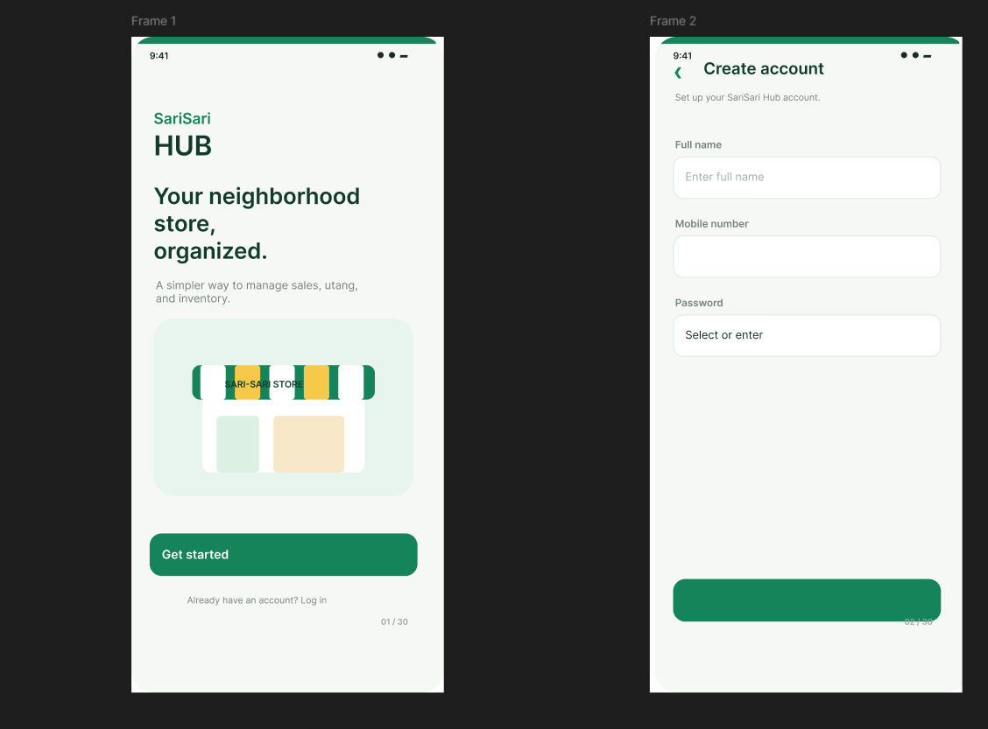
Figure 1. Welcome and Create account
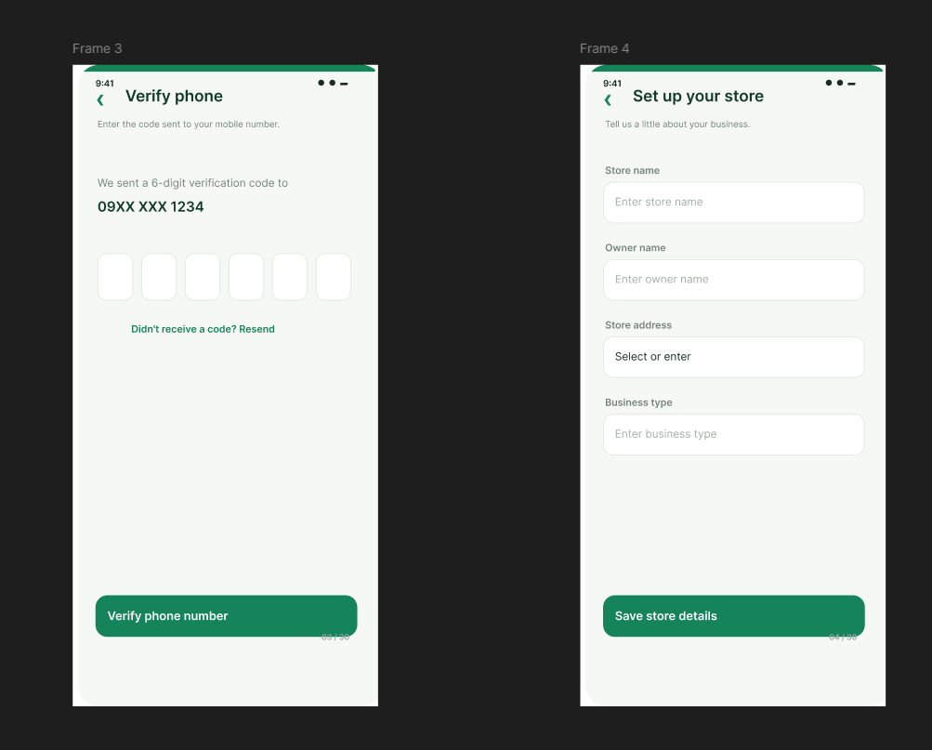
Figure 2. Verify phone and Set up your store
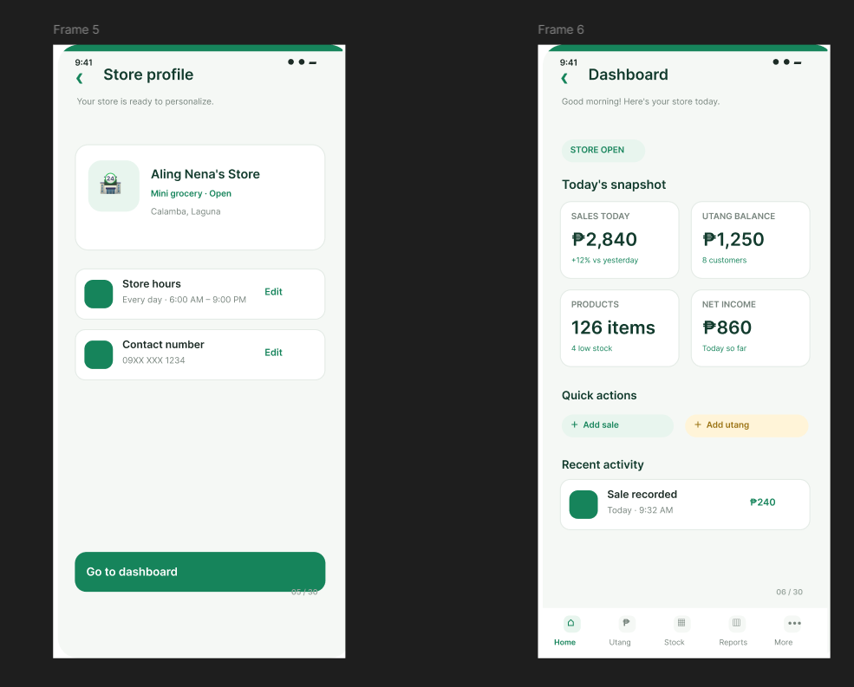
Figure 3. Store profile and Dashboard
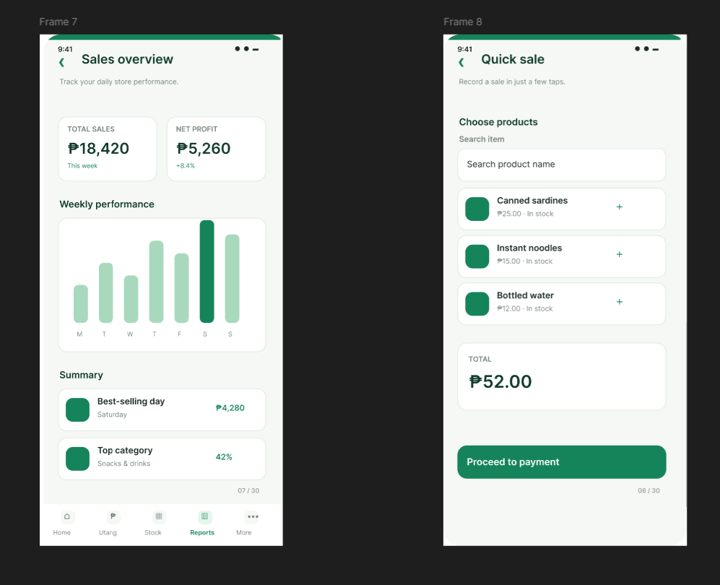
Figure 4. Sales overview and Quick sale
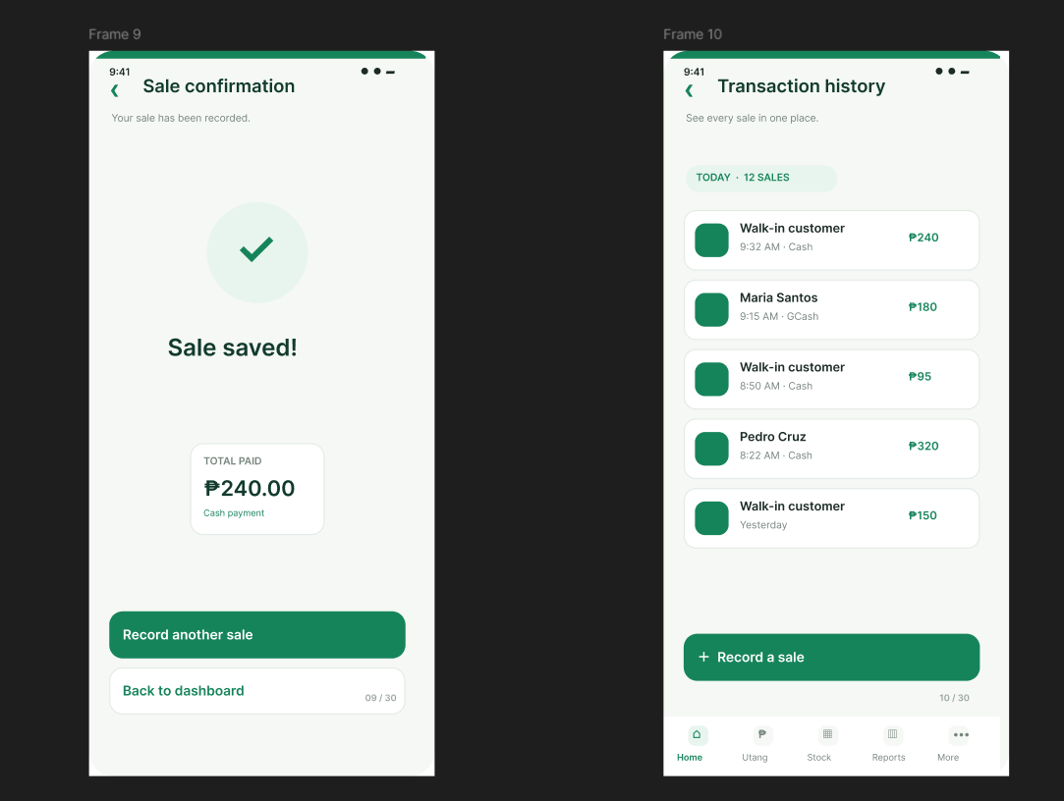
Figure 5. Sale confirmation and Transaction history
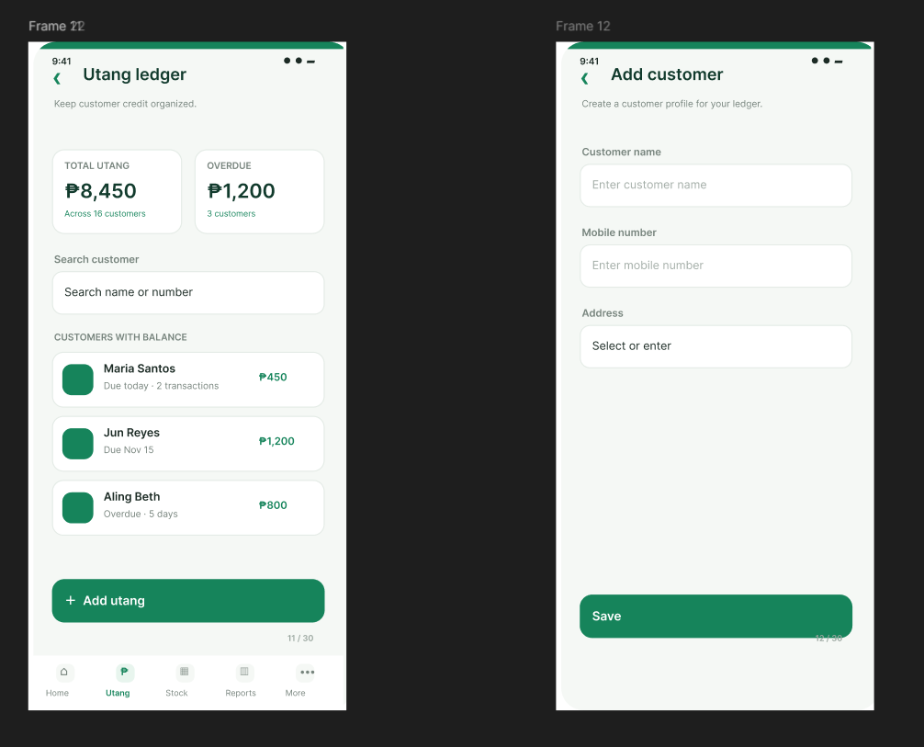
Figure 6. Utang ledger and Add customer
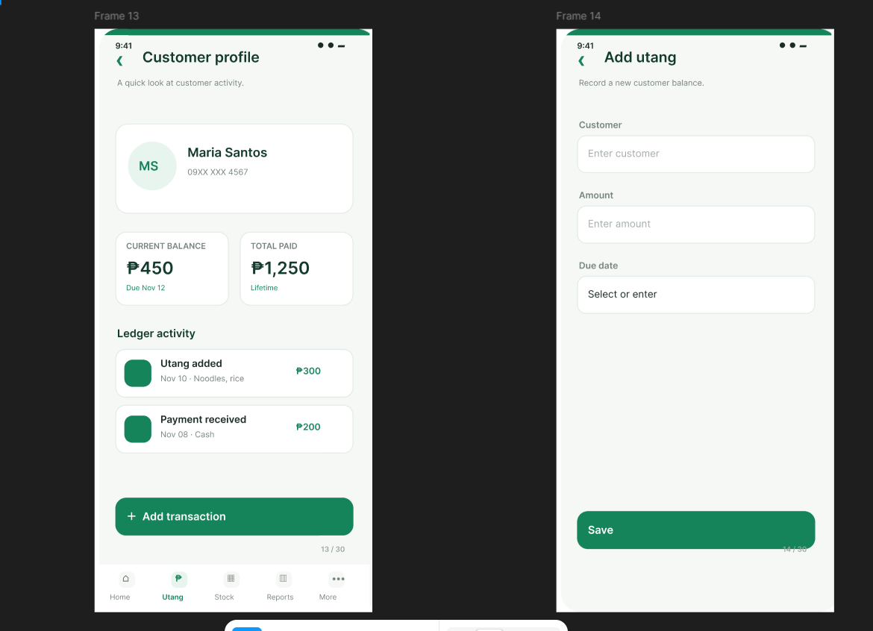
Figure 7. Customer profile and Add utang
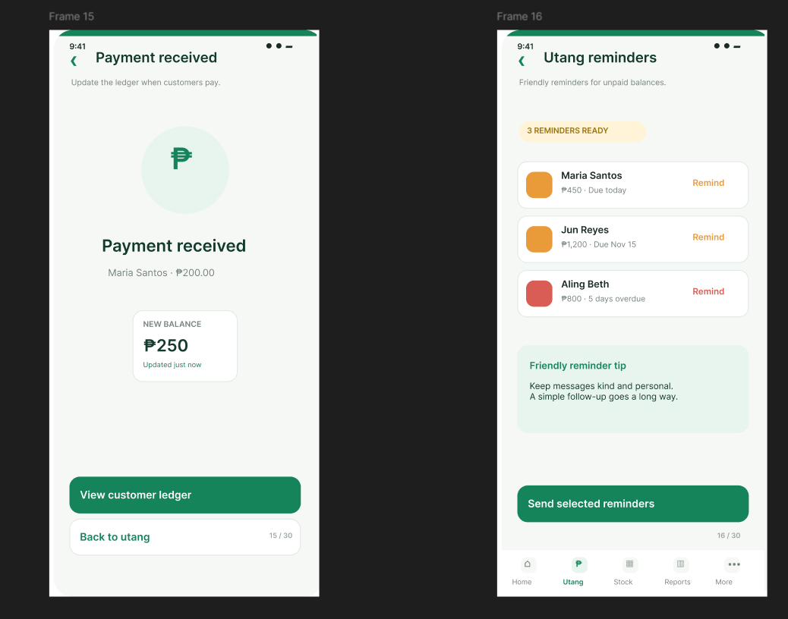
Figure 8. Payment received and Utang reminders
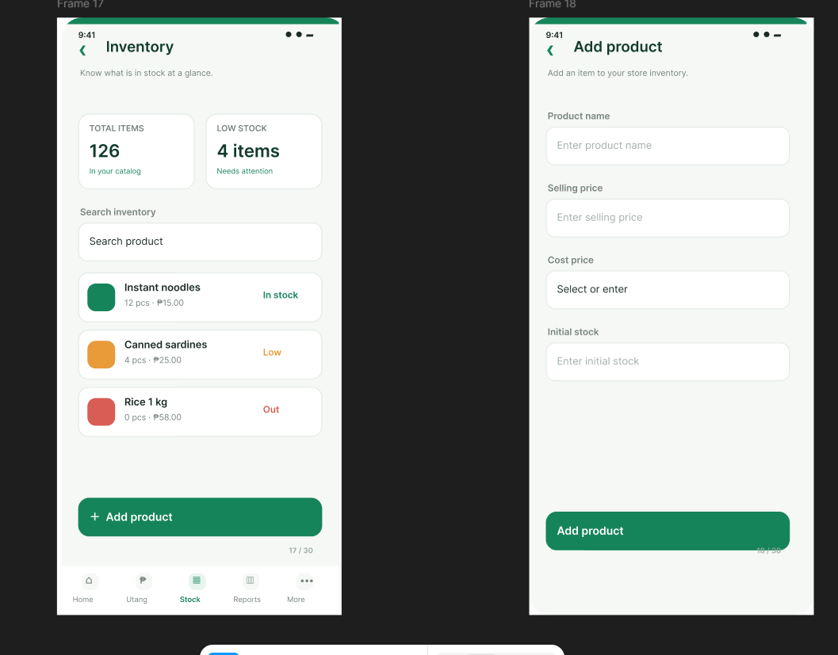
Figure 9. Inventory and Add product
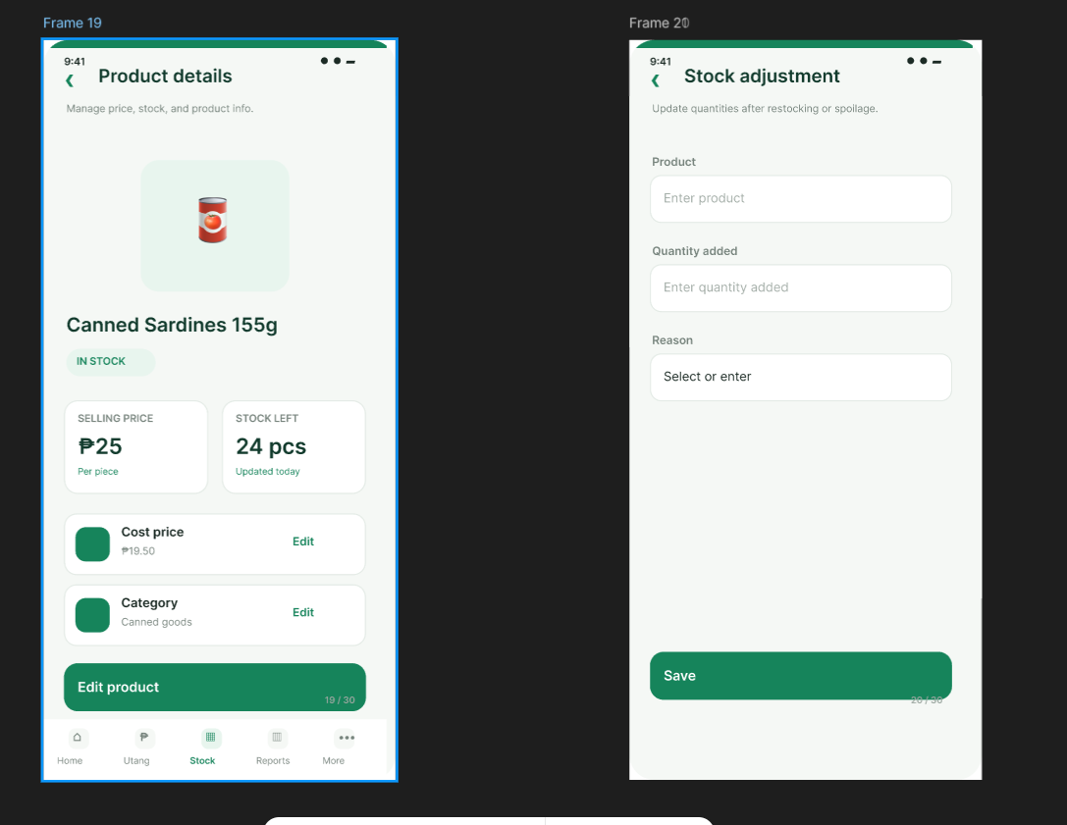
Figure 10. Product details and Stock adjustment
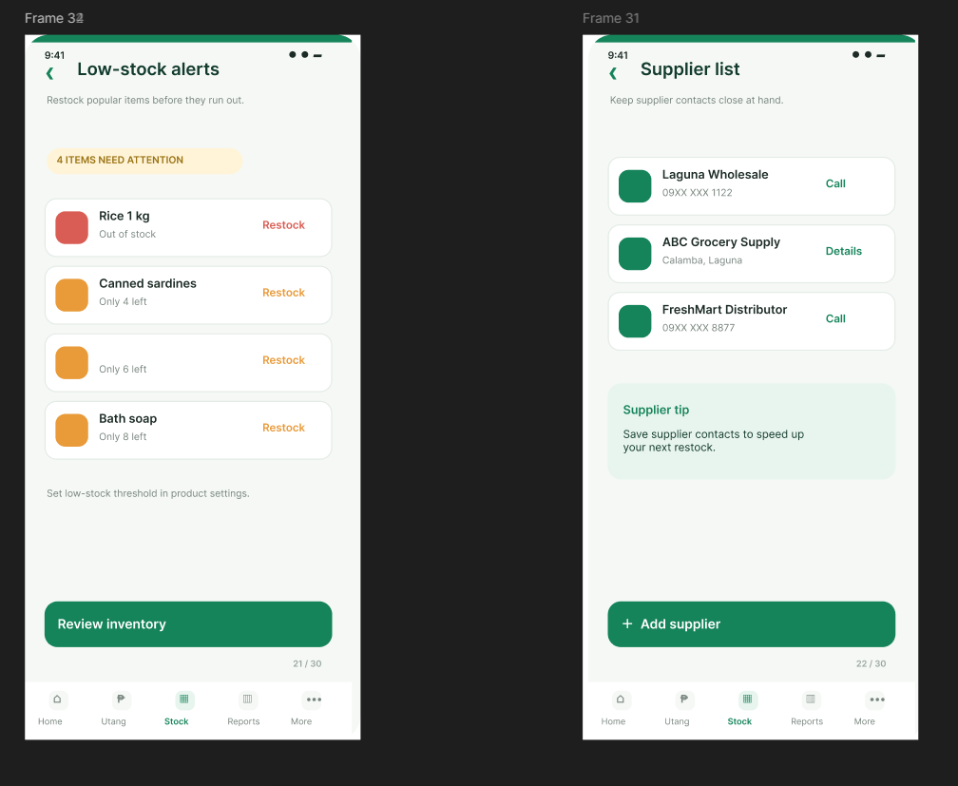
Figure 11. Low-stock alerts and Supplier list
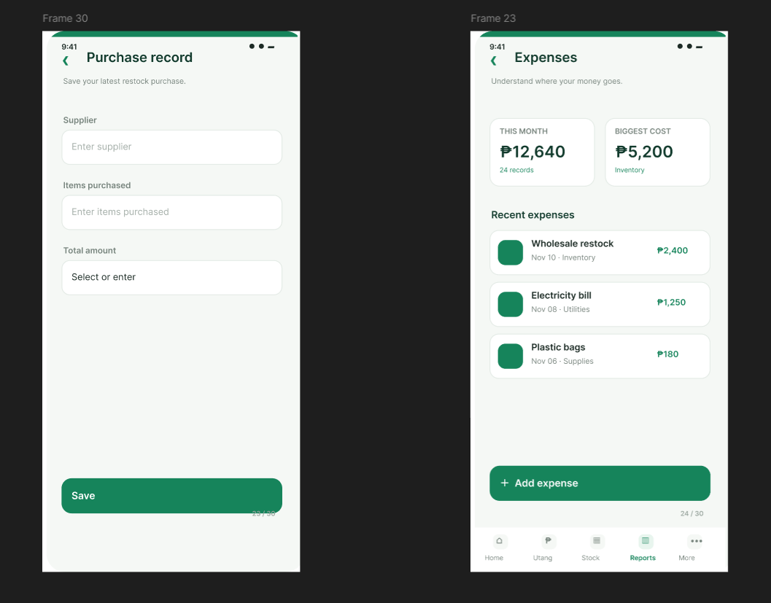
Figure 12. Purchase record and Expenses
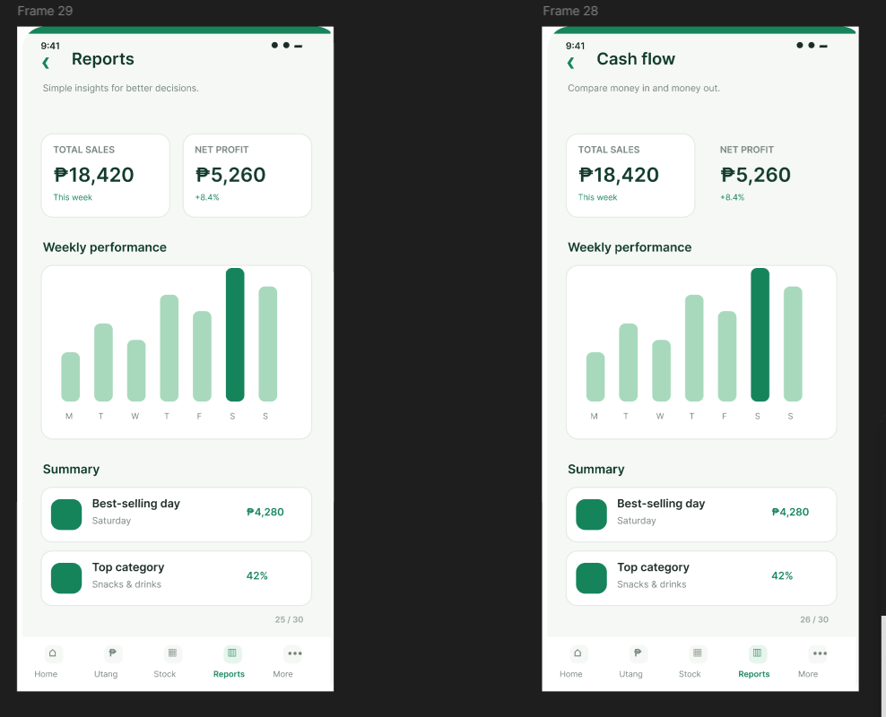
Figure 13. Reports and Cash flow
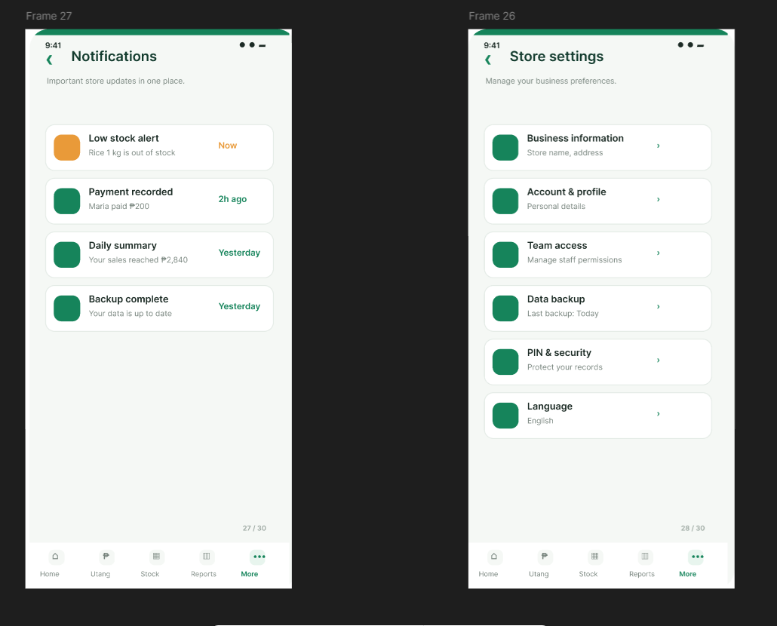
Figure 14. Notifications and Store settings
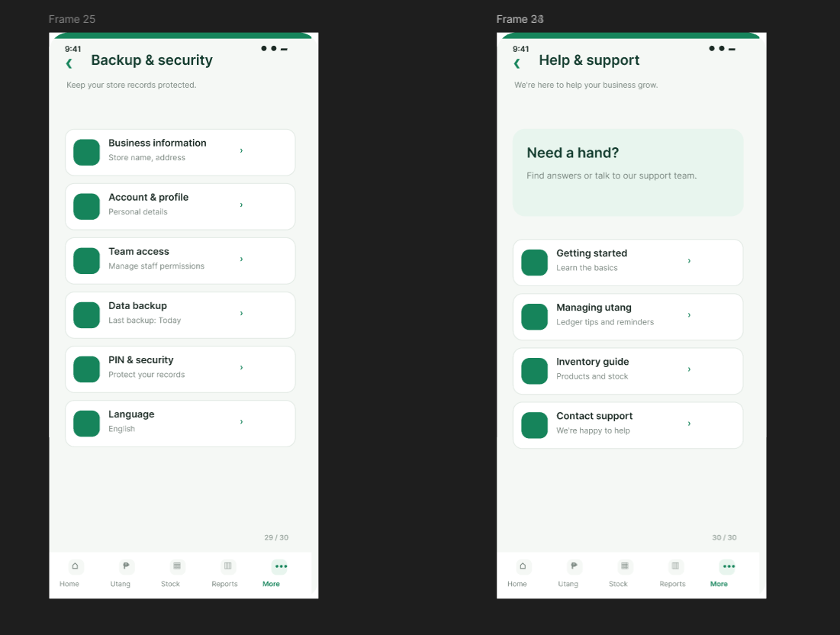
Figure 15. Backup & security and Help & support

