

SCHOOL OF INFORMATION TECHNOLOGY
General Luna Road, Baguio City Philippines 2600

Telefax No.: (074) 442-3071 Website: www.ubaguio.edu E-mail Address: sit@e.ubaguio.edu


HUMAN-COMPUTER INTERACTION 1
2ndSemester SY 2025-2026

Name: _Francisco, Ryza Joyce L._____________ ____ Date: ___01 – 16 -26__
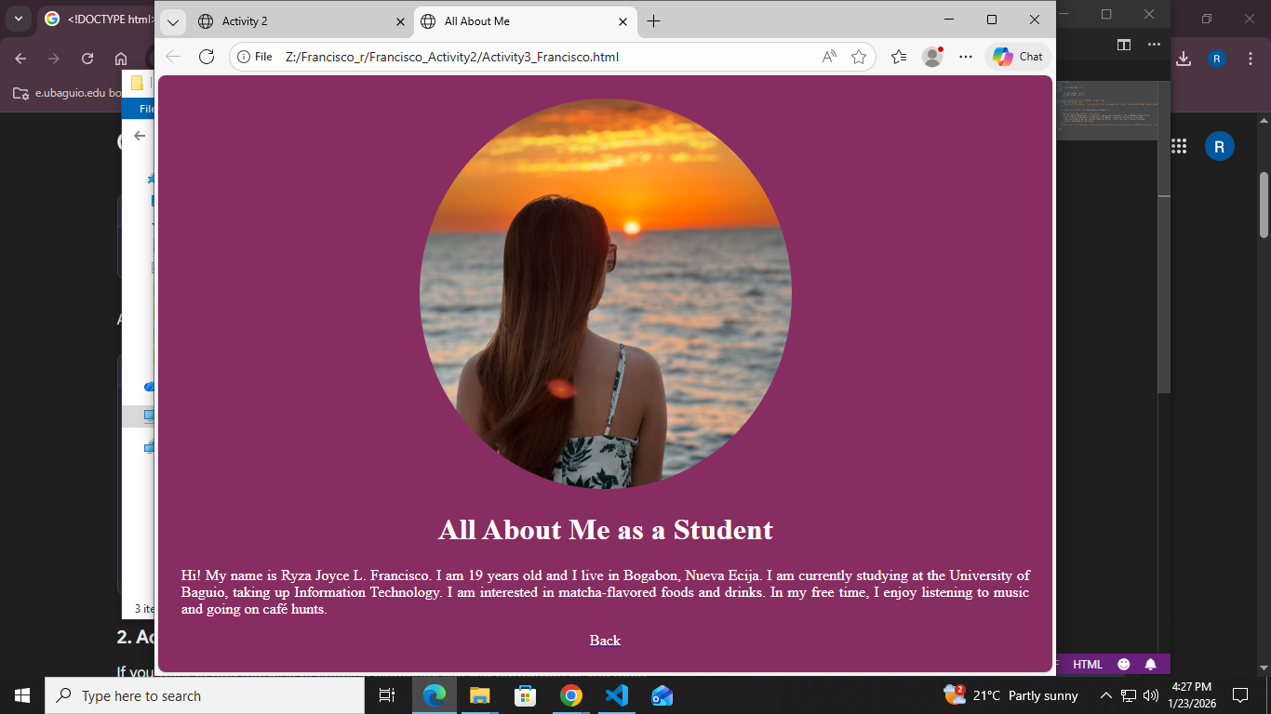
Course and Year: ____BSIT(ICT) - 1______ ________ Section: ___IDA6______
<!DOCTYPE html>
<html>
<head>
<title>All About Me</title>
</head>
<style>
h1 {text-align: center}
p {text-align: center}
</style>

<body style="background-color: #882D61; margin: 25px;">
<div style="text-align: center">
<img src="Z:\Francisco_r\Francisco_Activity2/ryza.jpeg" alt="school" style="width:400px; height:420px; border-radius:50%;">
</div>

<h1 style="color:white;">All About Me as a Student</h1>

<p style="text-align: justify; color:white;">
Hi! My name is Ryza Joyce L. Francisco. I am 19 years old and I live in Bogabon, Nueva Ecija.
I am currently studying at the University of Baguio, taking up Information Technology.
I am interested in matcha-flavored foods and drinks. In my free time, I enjoy listening
to music and going on café hunts.
</p>
<a href="file:///Z:/Francisco_r/Francisco_Activity2/Francisco_Activity2.html"><p style="color:white; text-align: center">Back</p></a>

</body>
</html>

