

CCT College Dublin Continuous Assessment

Programme Title: | MSc in Data Analytics
Cohort: | MSc in Data Analytics FT (Sept 26 start)
Module Title(s): | Programming for DA  Statistics for Data Analytics  Machine Learning for Data Analysis  Data Preparation & Visualisation
Assignment Type: | Individual | Weighting(s): | Programming for DA 50%  Stats for Data Analytics 50%  ML for Data Analysis 50%  Data Prep & Vis 50%
Assignment Title: | Integrated CA1 Sem 1 MSc in Data Analytics
Issue Date: | 1st October 2026
Lecturer(s): | Sam Weiss  Taufique Ahmed  Muhammad Iqbal  David McQuaid
Late Submission Penalty: | Late submissions will be accepted up to 5 calendar days after the deadline. All late submissions are subject to a penalty of 10% of the mark awarded.
Method of Submission: | Moodle
Instructions for Submission: | All files to be uploaded to Moodle separately (Do NOT Zip your submission)  Expected files : Written report (word document ONLY, No PDF’s), Code files (Jupyter notebook)Please upload your datasets to Google Drive and ensure the folder is accessible (NOT PRIVATE) and include the drive link in your report
Submission Date: | 1st November 2026 | Feedback Date: | Three weeks after final submission [Including late and PMCs]

CCT College Dublin
School of Computing

Data Analytics for Immersive Environments

Ireland Overseas Visitor Spending Analysis:
Trends, Statistical Modelling and Predictive Insights

Author: Youness El Morsli
Student ID: 2024524
E-mail: 2024524@student.cct.ie
Date of Submission: 1 November 2026
GitHub Link: https://github.com/2024524-youness/ireland-visitor-spending
Google Drive Link:
https://drive.google.com/drive/folders/1aGt0B5IL6TyXIY55q04yWDCth3MJYuAm?usp=sharing

Abstract
This report analyses overseas visitor spending in Ireland from January 2023 to August 2026 using monthly CSO data across four markets: Great Britain (XB), Other Europe (OTHEUR3), United States and Canada (USCA) and Other Regions (OTHR1). Following CRISP-DM, the work moves from data cleaning through statistical testing to machine learning. USCA generates the most total spending (EUR 11,142m) while OTHR1 visitors spend the most per trip (median EUR 2,058). All four markets fell in 2025 relative to 2024. A Binomial test finds no statistically significant change in the GB spending pattern (p = 0.19). Ridge Regression reduces the baseline forecast error by 33 percent on the held-out test set.

1. Introduction
Tourism is one of Ireland's most important economic sectors. It brings in foreign money, keeps hotels and restaurants alive, and supports a lot of jobs outside Dublin too. When I started looking at the CSO data for this project I wanted to understand something specific: which visitor markets are actually the most valuable, and do the patterns hold up under proper statistical testing or is it just obvious from a glance at a bar chart?
Three research questions shaped the whole analysis. RQ1 asks which markets generate the most total spending and the most per individual trip, because those two things are not the same and the gap between them turned out to be much larger than I expected. RQ2 asks whether the monthly spending data shows a significant seasonal pattern and whether 2025 represents a statistically meaningful change from 2024. RQ3 asks whether a machine learning model can do meaningfully better than just predicting that this month will look like the same month last year.
To answer these I used two CSO datasets covering 44 months: ITM02 for trip volumes and ITM06 for expenditure figures. All the preparation, testing and modelling was done in Python in a Jupyter notebook following CRISP-DM throughout.

2. Materials and Methods

2.1 Data Sources
Both datasets come from the Central Statistics Office of Ireland, published at data.cso.ie/table/ITM02 and data.cso.ie/table/ITM06 under a Creative Commons Attribution 4.0 licence. The CSO is Ireland's national statistics body, so the data is about as reliable a source as exists for this kind of question. The raw files and the cleaned merged output are available in the project Google Drive, and the analysis code is on GitHub (links in the title block above).
ITM02 tracks trips by foreign overnight visitors broken down by 12 country or region codes, 1,144 rows total. ITM06 covers expenditure: total spend in millions of euros (ITM06C01) and mean spend per trip in euros (ITM06C03), 3,300 rows. Both share a time key TLIST(M1) in the format YYYYMM. After cleaning and merging, the final working table had 176 rows — 44 months by four visitor groups.

2.2 Project Framework
I used CRISP-DM to structure the work: Business Understanding, Data Understanding, Data Preparation, Modelling, Evaluation and Deployment (Chapman et al., 2000). I chose it over KDD (Fayyad et al., 1996) because KDD is less focused on tying technical steps back to the original business question, and over SEMMA because SEMMA is tied to SAS and skips the business understanding phase. Knowing from the start that ITM06 only publishes four aggregated market groups directly shaped how I had to handle ITM02's 12 detailed codes — without that business understanding step I might have wasted time trying to merge incompatible granularities.
The modelling task is supervised regression: the target is monthly spending in millions of euros, a continuous number, with labelled historical observations to train on.

2.3 Data Preparation
Filtering. I kept only STATISTIC = ITM02C01 (total trip count, not sub-counts) and dropped the '-' aggregate residency row from ITM02. For ITM06 I kept ITM06C01 and ITM06C03 and the '-' expenditure-type row, then dropped the aggregate residency row. The alternative — filtering after the merge — was rejected because it would have built a larger intermediate table with the aggregate rows already included, making double-counting harder to spot.
Date key. TLIST(M1) is stored as a string like '2023M01', not a real date. pandas.to_datetime (McKinney, 2010) with format '%YM%m' converts it; year and month are then extracted as separate integers. Parsing with string slicing was considered but rejected — it is fragile if the format ever changes.
Mapping 12 markets to 4 groups. ITM02 has 12 codes while ITM06 only publishes four groups (XB, OTHEUR3, USCA, OTHR1). A Python dictionary maps each code to its group; .map() applies it to the column. A conditional replace chain was considered but a dictionary is more readable and easier to audit.
Aggregation. After mapping, FR, DE and IT all share the OTHEUR3 label for the same month, so their trip counts need adding together. groupby-sum does this, giving 176 rows. The alternative of keeping all 12 rows and merging on them was rejected because ITM06 has no data at that granularity.
Pivoting ITM06. The spending data was long format — ITM06C01 and ITM06C03 as separate rows. pandas.pivot_table reshaped it to wide format with both as columns. I used pivot_table rather than pivot because it handles any duplicate index entries gracefully rather than raising an error.
Merging. Five shared keys joined the two tables with an inner join. The validate='one_to_one' parameter makes pandas crash if any key appears more than once — a useful safety check. A left join was considered but rejected: any non-matching rows would produce NaN spending values that would silently corrupt the analysis.
Feature engineering. spend_per_trip_eur divides total euros by total individual trips after unit conversion from millions and thousands. spend_lag12 is the same group's spending in the same calendar month one year earlier, computed with groupby('group').shift(12) to keep lags within each market. A 3-month rolling average was considered as an alternative lag but was rejected because it blurs seasonal peaks in a way that hurts interpretability.
Outlier detection. The IQR fence (Q1 - 1.5xIQR, Q3 + 1.5xIQR) was applied within each group separately. One outlier was flagged: OTHR1 in December 2023 with a spend per trip of EUR 3,181. This was investigated and retained because it appears to reflect genuine high-value Christmas travel rather than a data error. Capping was considered but rejected to preserve the real signal.
Encoding and leakage prevention. All preprocessing — StandardScaler on the three numeric features, OneHotEncoder (drop='first') on group — sits inside a scikit-learn Pipeline (Pedregosa et al., 2011). This ensures the scaler and encoder fit only on training data in each fold and never see the test set. Fitting them upfront on all data was the obvious first approach, but it would have leaked test-set statistics into training. Year was excluded from the features because the test set contains 2026, a year never seen in training, which would force Ridge to extrapolate linearly to an unseen value.

2.4 Statistical and Machine Learning Methods
Three probability distributions were chosen to match the nature of each variable. The Binomial suits the monthly 2025-vs-2024 comparison because each month is a binary outcome (above or below prior year) with a fixed number of trials. The null hypothesis is p = 0.5 (equal chance of rising or falling). The Poisson fits the count of months per year where GB spending exceeds the historical mean, since that is a count of events in a fixed time period with a roughly stable rate. The Normal was fitted to GB spend per trip, and the Shapiro-Wilk test was used to check whether the assumption holds.
For machine learning, data was split chronologically: 80 rows for training (January 2024 to August 2025) and 48 rows for testing (September 2025 to August 2026). A naive lag baseline was established first. Ridge Regression and Random Forest were both tuned with GridSearchCV using TimeSeriesSplit (four folds), scored on negative MAE. The winner was chosen on CV score — not test MAE — to avoid using the test set for model selection. Performance was measured with MAE, RMSE and R-squared.

3. Results and Discussion

3.1 Exploratory Analysis and Visualisation
The time series (Figure 1) shows that USCA consistently reaches the highest absolute spending, peaking at EUR 448.9m in a single month. Other Europe peaks at EUR 384.3m. Great Britain tops out at EUR 216.1m — lower than I expected given how often it is cited as Ireland's biggest visitor market. All four groups share a clear seasonal pattern: spending builds from spring, peaks in summer and then falls — for Great Britain and Other Europe the main drop comes by October, but for USA and Canada the sharper decline comes in November. February is the quietest month for USCA, Other Europe and OTHR1; for GB the winter trough is more spread across January and February. Tufte's data-ink principle (Tufte, 2001) guided the chart design: top and right spines removed, muted grey axis lines, light dashed y-gridlines only, and direct labelling instead of legend boxes.
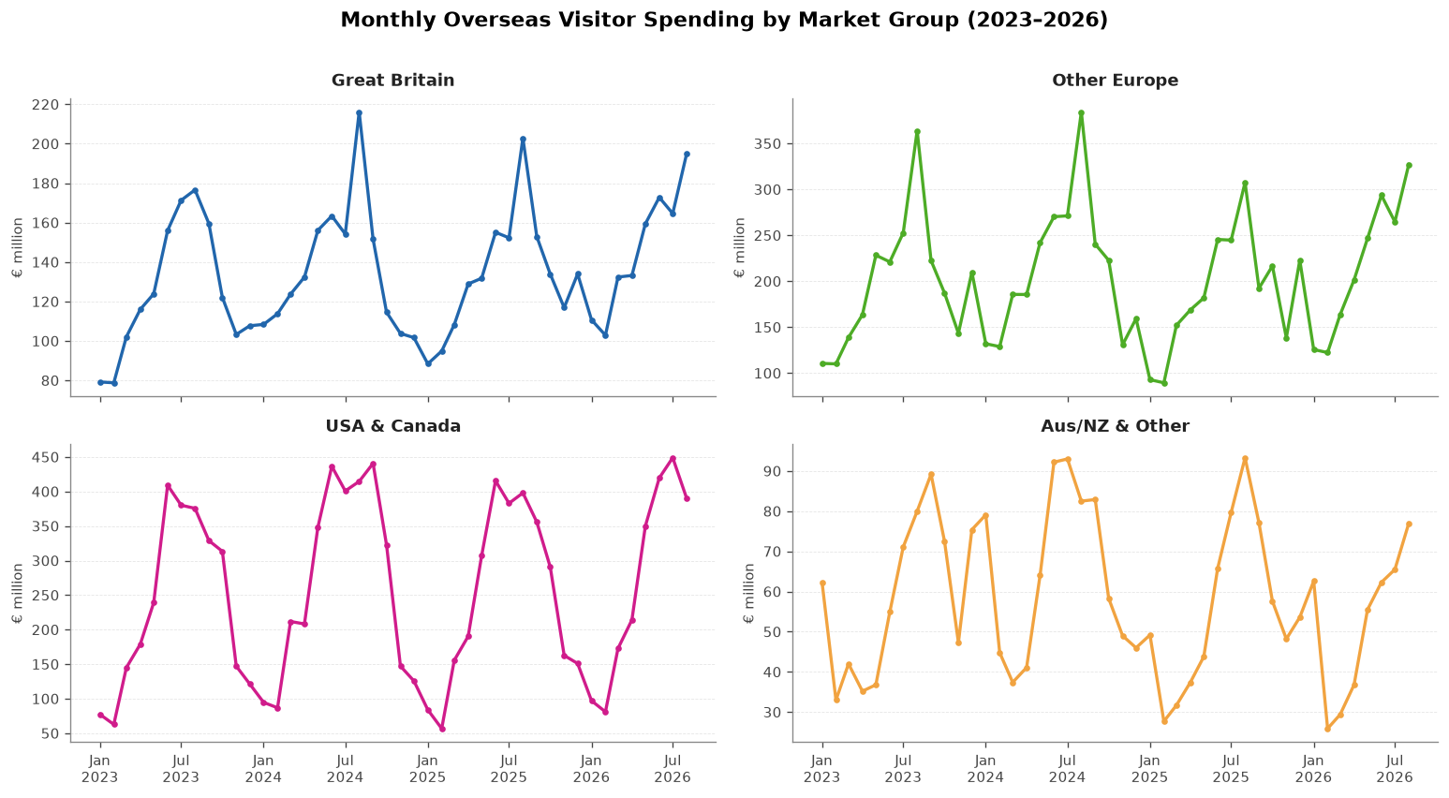
Figure 1: Monthly visitor expenditure by market group, January 2023 – August 2026 (EUR million). Tufte principle applied: maximum data-ink ratio, all non-data ink removed.
The spend per trip box plots (Figure 2) tell a different story to the totals. OTHR1 — Australia, New Zealand and Other Regions — has the highest median spend per trip at EUR 2,058, just ahead of USCA at EUR 1,961. Great Britain sits at the bottom with a median of EUR 637, which makes sense given geographical proximity: shorter stays, more frequent visits, less outlay per trip. The OTHR1 box has a tight IQR of EUR 381 despite its high median, suggesting long-haul visitors are actually fairly consistent in their per-trip spending. There is one clear outlier: OTHR1 in December 2023 at EUR 3,181 per trip. This was investigated and retained — it appears to reflect genuine high-value travel rather than a data error. Tufte's data-ink ratio principle informed the choice of box plots: four distributions in one compact panel, comparing spread and outliers without adding decorative elements.
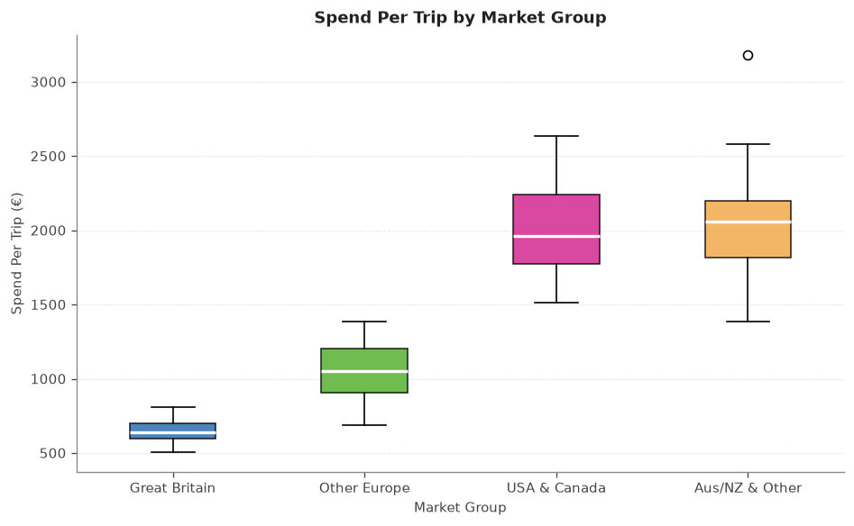
Figure 2: Box plots of spend per trip (EUR) by visitor market group, 2023–2026. One retained outlier visible: OTHR1 December 2023 at EUR 3,181.
The seasonal chart (Figure 3) confirms the summer peak across all groups. USCA stays elevated longer into September compared to the European markets, which probably reflects longer transatlantic trip planning cycles. OTHR1 peaks latest of all, around August to September, consistent with Southern Hemisphere holiday timing. Lines are labelled directly at their endpoints following Tufte's principle of integrating labels with data rather than separating them into a legend (Tufte, 2001).
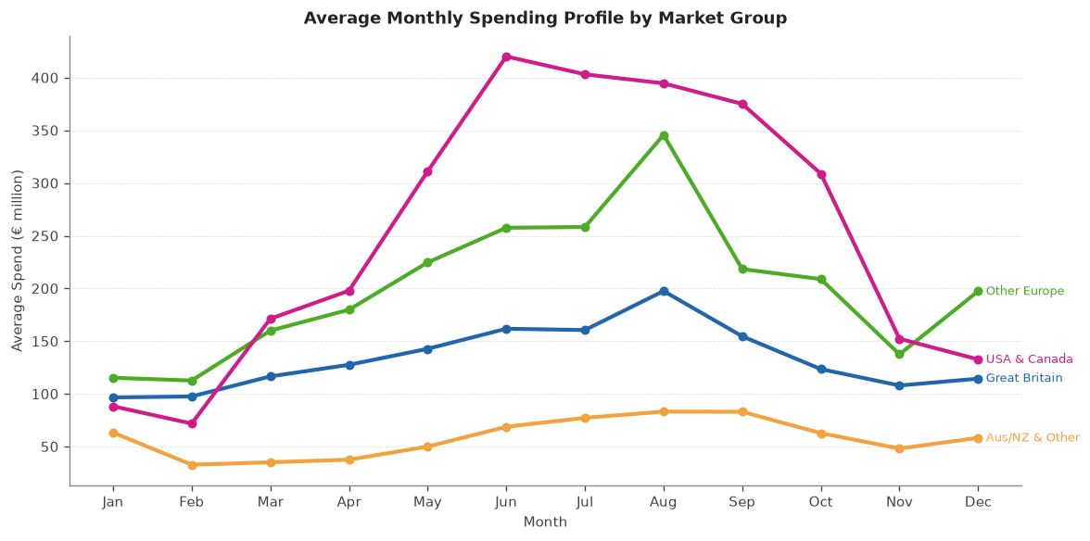
Figure 3: Average monthly spending by calendar month, averaged across all years (EUR million). Direct labelling at line endpoints eliminates the need for a legend.
The year-on-year comparison (Figure 4) was the most surprising finding. All four markets fell in 2025 compared to 2024. OTHR1 dropped the most at -13.7 percent, Other Europe fell -11.7 percent, USCA fell -8.9 percent, and Great Britain held up best at only -2.4 percent. The universal nature of the decline rules out a market-specific explanation and suggests a broad demand-side headwind affecting all source markets simultaneously in 2025. The correlation between trips and spending (Figure 5) is r = 0.618 when all groups are pooled. That is a moderate positive relationship, weaker than it would be within a single group, because the four markets have very different per-trip spend levels that dilute the pooled correlation.
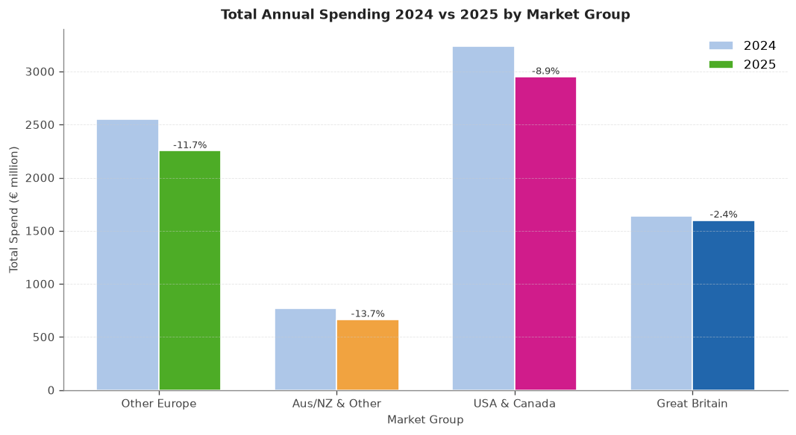
Figure 4: Year-on-year comparison of total visitor spending, 2024 vs 2025 (EUR million). All four markets declined.
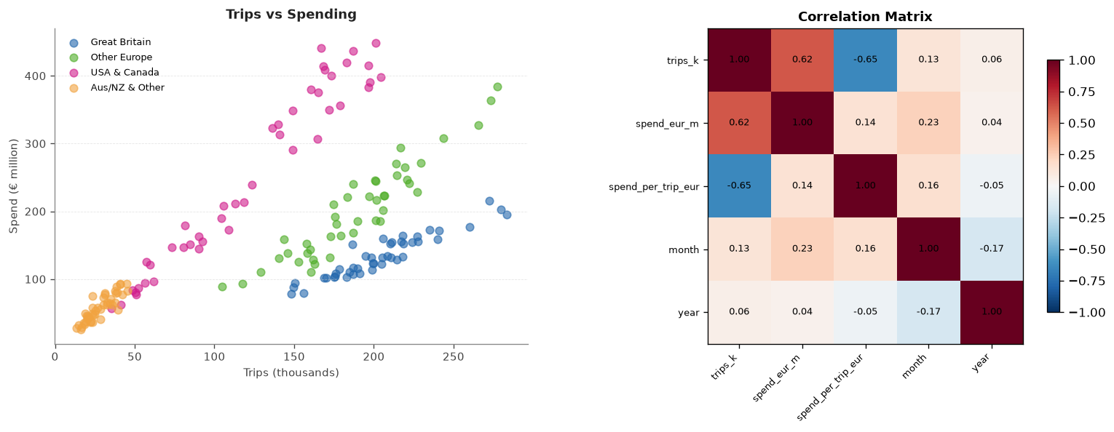
Figure 5: Scatter plot of trips vs spending (left) and Pearson correlation matrix (right).

3.2 Statistical Analysis
Table 1 shows the descriptive statistics for monthly spending by group. USCA has the highest mean at EUR 253.22m and the largest standard deviation (EUR 130.01m) and IQR (EUR 234.30m), reflecting both its market size and how variable its summer peaks are. Its CV of 0.51 is the highest among the four groups. XB has the lowest CV at 0.24, meaning its spending is the most stable month to month. OTHR1 is the smallest market at a mean of EUR 57.96m.
Table 1: Descriptive statistics for monthly visitor spending (EUR million) by market group.
Group | Mean | Median | Std | Min | Max | IQR | CV
XB (GB) | 134.26 | 132.10 | 32.24 | 78.8 | 216.1 | 47.65 | 0.24
OTHEUR3 | 202.38 | 196.95 | 70.21 | 89.5 | 384.3 | 102.73 | 0.35
USCA | 253.22 | 226.65 | 130.01 | 56.8 | 448.9 | 234.30 | 0.51
OTHR1 | 57.96 | 56.55 | 19.69 | 25.9 | 93.3 | 34.03 | 0.34

Binomial Test. The question was whether the pattern of 2025 vs 2024 monthly GB spending represents a statistically significant decline. Each of the 12 calendar months is treated as a Bernoulli trial: did 2025 beat 2024 or not? Under H0 the probability of success is p = 0.5 (no systematic change). The observed count of months where 2025 exceeded 2024 was k = 4 out of n = 12, meaning January through August all fell while September through December recovered. The formula for the one-sided left-tail p-value is:
P(X <= k | n, p) = SUM_{i=0}^{k} C(n,i) * p^i * (1-p)^(n-i)
P(X <= 4 | n=12, p=0.5) = 0.1938
Because p = 0.1938 > 0.05 I fail to reject H0. The decline is real in the data but not large enough to rule out chance variation at the conventional significance level. Figure 6 shows the PMF with the left-tail rejection region shaded, and the right panel shows how the Binomial converges to a Normal distribution as n grows.
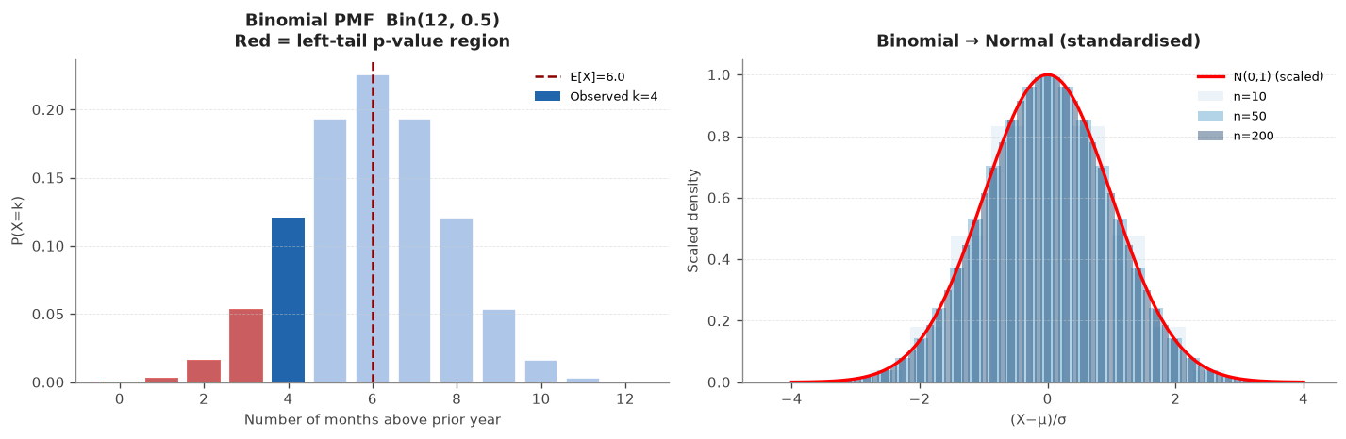
Figure 6: Binomial PMF (n=12, p=0.5). Left panel: observed k=4 with left-tail region shaded (p-value = 0.1938). Right panel: standardised Binomial converging to N(0,1) as n increases.
Poisson Distribution. I counted how many months per year GB spending exceeded the overall mean of EUR 134.3m, using only the three complete years 2023-2025 (2026 excluded as it only has 8 months). The counts were 4, 5 and 4 respectively. The Poisson PMF for k events with rate lambda is:
P(X = k) = (lambda^k * e^(-lambda)) / k!
With lambda = 4.33, P(X = 4) = 0.193 and P(X >= 4) = 0.629. However the Poisson assumption requires mean approximately equal to variance. Here the empirical mean is 4.33 but the variance is only 0.33, giving a mean-to-variance ratio of 13.0. This severe underdispersion means the Poisson is actually a poor fit for this variable. The near-identical counts each year (4, 5, 4) arise because the same seasonal structure repeats reliably — the model would need to be a Binomial(12, p) to properly respect the upper bound of 12 months, but Poisson is used here as the required distributional exercise. Figure 7 shows the distribution.
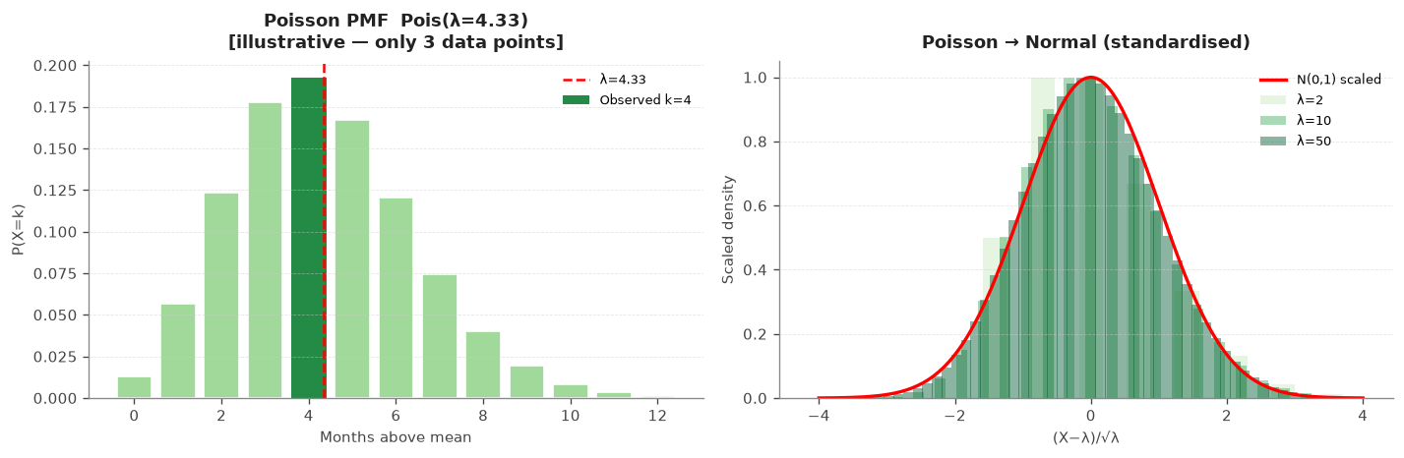
Figure 7: Poisson PMF (lambda = 4.33). Annual observed counts (4, 5, 4) marked. Note: severe underdispersion (variance = 0.33 vs mean = 4.33) limits the fit.
Normal Distribution. GB spend per trip (n = 44 months) has sample mean mu = EUR 650.92 and standard deviation sigma = EUR 70.18. The Normal PDF is:
f(x) = (1 / (sigma * sqrt(2*pi))) * exp(-(x - mu)^2 / (2 * sigma^2))
Under this model P(X > mu + sigma) should be 1 - Phi(1) = 0.1587. The empirical proportion in the data was 0.1818, reasonably close. The 68 percent rule check found 68.18 percent of values within one standard deviation, against the theoretical 68.27 percent. The Shapiro-Wilk test (Shapiro and Wilk, 1965) gives W = 0.9744 and p = 0.4282; failing to reject normality at alpha = 0.05, so the Normal model is a reasonable fit. Figure 8 shows the Q-Q plot and density overlay.
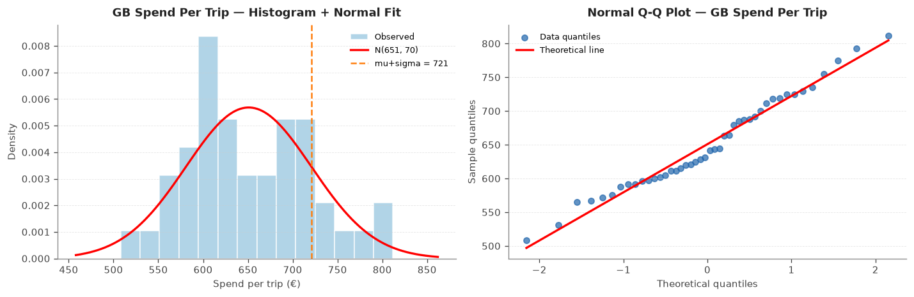
Figure 8: Normal fit for GB spend per trip (mu = 650.92, sigma = 70.18). Q-Q plot (left) and density overlay (right). Shapiro-Wilk p = 0.4282.
Large-sample convergence. The right panel of Figure 6 illustrates how the standardised Binomial(n, 0.5) distribution converges towards N(0,1) as n increases from 10 to 200. At n = 10 the discrete bars are visible and the Normal curve is a rough approximation. By n = 200 the fit is near-perfect. This raises the question of whether the Binomial(12, 0.5) and Poisson(4.33) used in this analysis can themselves be approximated by a Normal. The standard rule for the Binomial requires np >= 10 and n(1-p) >= 10, though some textbooks accept the lenient threshold of np >= 5. Here np = 6 and n(1-p) = 6: borderline, passing the lenient rule but failing the strict one. Given n = 12, the exact PMF is the more defensible choice. For the Poisson, the Normal approximation requires lambda >= 10; with lambda = 4.33 it is not valid either. Both distributions are too small-sample here to be treated as Normal, and the exact PMF calculations used above are therefore the appropriate approach.

3.3 Machine Learning Results
Table 2 shows all model results. The naive baseline — predicting that this month's spending equals the same month last year — gets a test MAE of EUR 21.11m and R-squared of 0.927. That is already a strong benchmark, confirming that year-on-year persistence is the dominant signal.
Table 2: Model performance on training and test sets (from notebook output).
Model | Split | MAE (EURm) | RMSE (EURm) | R-squared
Baseline (lag12) | Train | 24.35 | 31.96 | 0.914
Baseline (lag12) | Test | 21.11 | 28.52 | 0.927
Ridge (alpha=0.01) | Train | 15.90 | 22.48 | 0.958
Ridge (alpha=0.01) | Test | 14.18 | 19.73 | 0.965
Random Forest | Train | 16.71 | 22.16 | 0.959
Random Forest | Test | 20.73 | 27.33 | 0.933

Ridge Regression (Hoerl and Kennard, 1970) brings the test MAE from EUR 21.11m down to EUR 14.18m — a 33 percent improvement over the baseline. Its test R-squared of 0.965 is actually slightly better than its training R-squared of 0.958, which means it is not overfitting at all. That is a reassuring result for a small dataset where overfitting is a real risk.
Random Forest (Breiman, 2001) is the opposite: training R-squared of 0.959 and test R-squared of 0.933, a gap of 2.6 percentage points indicating overfitting. Its test MAE of EUR 20.73m is barely better than the naive baseline and considerably worse than Ridge. The cross-validation scores confirm this: Ridge CV MAE was 24.30 against Random Forest's 46.46, so Ridge was the clear winner and was selected as the final model.
The per-fold CV results for Ridge (best alpha = 0.01) were fold 1: EUR 17.75m, fold 2: EUR 21.26m, fold 3: EUR 22.40m, fold 4: EUR 35.79m. The errors rise steadily across folds and fold 4 is clearly the hardest. With TimeSeriesSplit each successive fold tests on a later window while training on progressively more data. Fold 4 covers the summer of 2025, which is precisely when the broad market decline was sharpest, making it harder to predict from patterns established in earlier years. That explains the jump from fold 3 to fold 4 rather than indicating model instability.
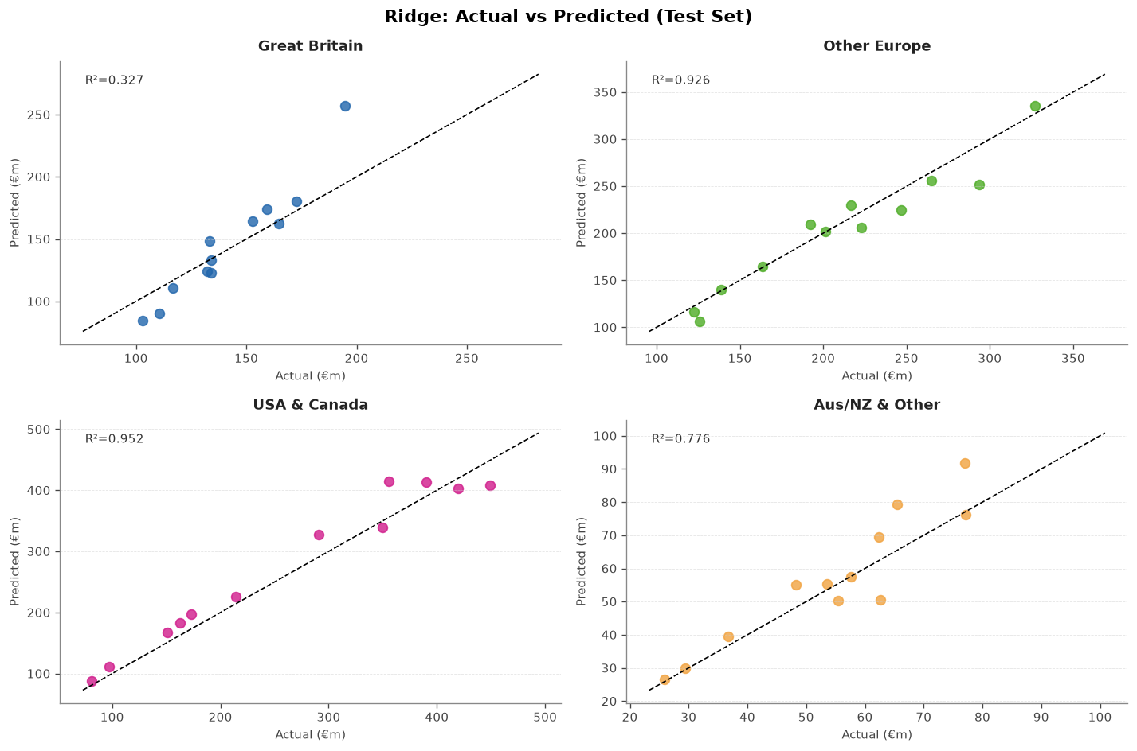
Figure 9 is an actual-vs-predicted scatter on the 48 test observations. Most points lie close to the diagonal, consistent with an R-squared of 0.965. USA & Canada has the highest group-level R² (0.952), followed by Other Europe (0.926). Aus/NZ & Other has a lower R² of 0.776, while Great Britain has the lowest at 0.327. Great Britain's monthly spending varies over a relatively narrow range, consistent with its lowest coefficient of variation (0.24) in Table 1, so even modest errors in euros can account for a large share of its variation. Its low R² therefore does not necessarily imply large absolute prediction errors in euros.
Figure 9: Actual vs predicted monthly spending (EUR million) on the test set — Ridge Regression.
Figure 10 shows the Ridge coefficient chart. Among the numeric features (all scaled to the same standard deviation by the Pipeline's StandardScaler), trips_k carries the largest coefficient at 83.1, followed by spend_lag12 at 49.9; month is small at 3.4. The USCA group dummy has a coefficient of 106.4 and OTHR1 of 95.3, but these cannot be directly compared to the scaled numeric features because the group indicators are unscaled 0/1 values. What the chart confirms is that trip volume is the strongest numeric driver of spending, with the lag providing additional year-on-year persistence signal.
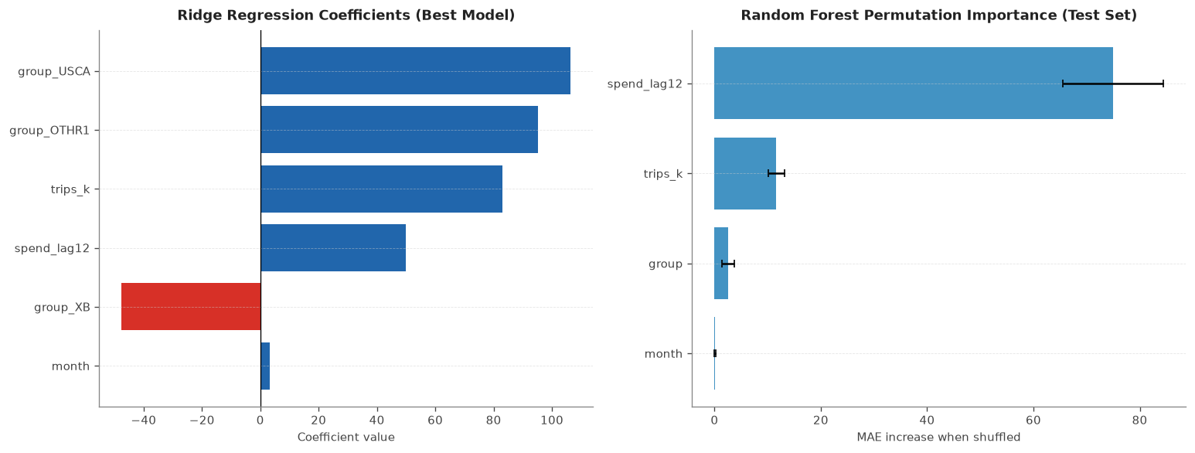
Figure 10: Ridge regression coefficients sorted by absolute size. trips_k is the largest numeric predictor (83.1); group dummies are on a different scale and not directly comparable.

4. Conclusions
Going back to the three research questions, the findings are fairly clear even though some of them surprised me. On RQ1, USCA generates the most total spending at EUR 11,142m across the period, well ahead of Other Europe at EUR 8,905m and Great Britain at EUR 5,907m. But on a per-trip basis OTHR1 visitors spend the most, with a median of EUR 2,058 per trip versus EUR 637 for GB visitors. The implication for tourism strategy is that if the goal is total revenue, USCA is the priority market; if the goal is high-value visitors, OTHR1 and USCA are both strong targets. GB generates the most trips but the least value per visit.
On RQ2, the data shows a clear seasonal pattern across all markets with summer peaks and winter troughs, and all four markets fell in 2025 relative to 2024. The Binomial test (p = 0.1938) finds no statistically significant change in the GB monthly pattern, meaning the -2.4 percent annual decline is not large enough to rule out random variation. The Poisson model with lambda = 4.33 fits the count of high-spending months mechanically, but the severe underdispersion (variance = 0.33 vs mean = 4.33) means it is a poor theoretical fit. The Normal distribution fits GB spend per trip well enough (Shapiro-Wilk p = 0.4282) and neither the Binomial(12, 0.5) nor the Poisson(4.33) can be approximated as Normal given that np = 6 and lambda = 4.33 are both below the thresholds needed.
On RQ3, Ridge Regression beats the naive baseline with a test MAE of EUR 14.18m and R-squared of 0.965, a 33 percent improvement, and shows no overfitting. Random Forest overfits and barely improves on the baseline. The largest numeric driver in the Ridge model is trips_k, with spend_lag12 providing secondary persistence signal. Future work could bring in exchange rates or flight capacity data, and the universal 2025 decline is worth investigating further — it is not explained by anything in the current feature set.

References
Breiman, L. (2001) 'Random Forests', Machine Learning, 45(1), pp. 5-32.
Central Statistics Office (2026) ITM02: Trips by Foreign Resident Overnight Visitors. Available at: https://data.cso.ie/table/ITM02 (Accessed: 31 October 2026).
Central Statistics Office (2026) ITM06: Expenditure of Foreign Resident Overnight Visitors. Available at: https://data.cso.ie/table/ITM06 (Accessed: 31 October 2026).
Chapman, P., Clinton, J., Kerber, R., Khabaza, T., Reinartz, T., Shearer, C. and Wirth, R. (2000) CRISP-DM 1.0: Step-by-step data mining guide. SPSS Inc.
Fayyad, U., Piatetsky-Shapiro, G. and Smyth, P. (1996) 'From Data Mining to Knowledge Discovery in Databases', AI Magazine, 17(3), pp. 37-54.
Hoerl, A.E. and Kennard, R.W. (1970) 'Ridge Regression: Biased Estimation for Nonorthogonal Problems', Technometrics, 12(1), pp. 55-67.
McKinney, W. (2010) 'Data Structures for Statistical Computing in Python', Proceedings of the 9th Python in Science Conference, pp. 51-56.
Pedregosa, F. et al. (2011) 'Scikit-learn: Machine Learning in Python', Journal of Machine Learning Research, 12, pp. 2825-2830.
Shapiro, S.S. and Wilk, M.B. (1965) 'An analysis of variance test for normality (complete samples)', Biometrika, 52(3-4), pp. 591-611.
Tufte, E.R. (2001) The Visual Display of Quantitative Information. 2nd edn. Cheshire, CT: Graphics Press.

Appendix A: AI Declaration
A.1 The Four Ds
Disclosed | Described | Demonstrated | Documented
Yes - ChatGPT (OpenAI) used as a supporting tool | Helped troubleshoot Python errors, clarify technical concepts and organise notes and explanations. | Main project work, coding, analysis and interpretation completed by me; ChatGPT suggestions used as guidance where needed. | This appendix

A.2 Examples of AI Assistance Requested
ChatGPT (OpenAI) was used as a supporting tool during the development of this assignment in the following ways:
1. To help understand Python error messages and troubleshoot coding issues encountered while working in the Jupyter notebook.
2. To suggest possible code corrections or adjustments when errors occurred during implementation.
3. To clarify Python functionality and technical concepts relevant to the project.
4. To help organise my notes and improve the structure, presentation and readability of written explanations in the report.
These points describe the types of assistance requested and are not verbatim copies of individual prompts.
A.3 What I Accepted, Changed or Rejected
The main project work, including data preparation, coding, statistical analysis, machine learning implementation, interpretation of results and development of the Jupyter notebook, was completed by me. ChatGPT was used as a supporting tool rather than as a replacement for my own work. I considered its suggestions in the context of my own implementation and used them mainly to troubleshoot errors, understand technical issues and improve the organisation and presentation of my notes. The final decisions, analysis and content of the assignment remained my responsibility.
A.4 Data Protection and Ethics
The CSO datasets contain only anonymised aggregate statistics with no personally identifiable information. Both are published under CC BY 4.0, meaning they are legally free to use with attribution. ChatGPT was used for coding support and assistance with organising written content. Responsibility for the appropriate use of the data, the accuracy of the analysis and the final submitted work remains with me. There are no ethical concerns with using publicly available non-personal government statistics for academic analysis.

