- Architecture Diagram
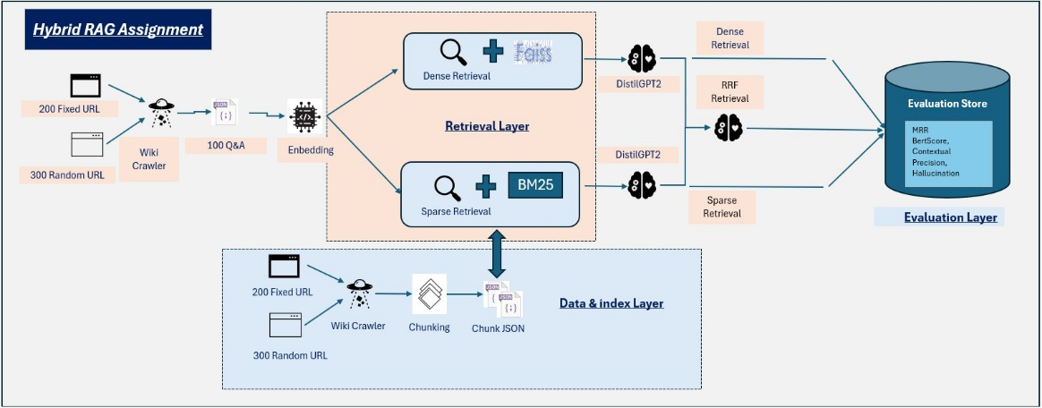
Training/indexing

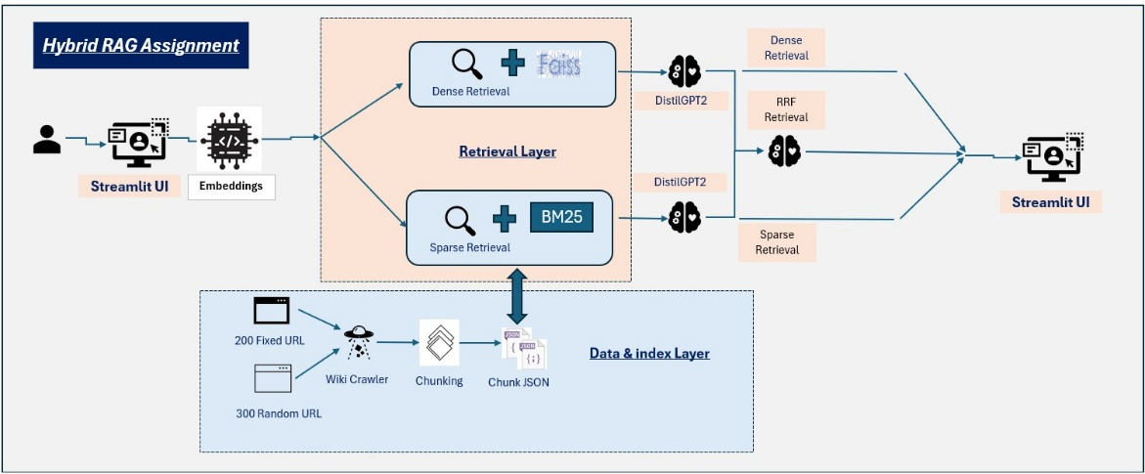
Inferencing

- Evaluation Results:
- Metrics Table (MMR, BERTScore, Contextual precision, Hallucination) :
https://github.com/2024aa05042/conversation-ai-rag-assignment2/blob/main/data/qa_metrics_table.xlsx
Screenshots:
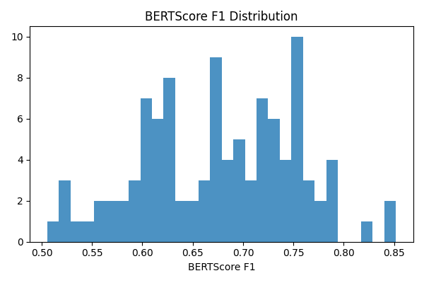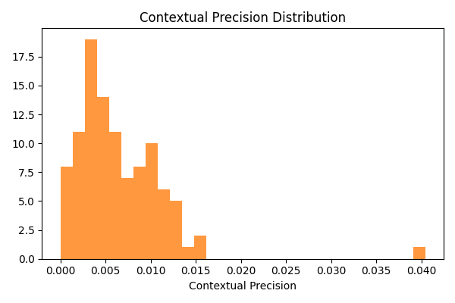
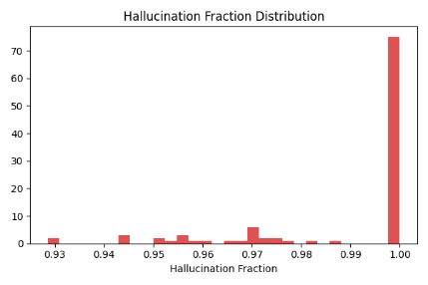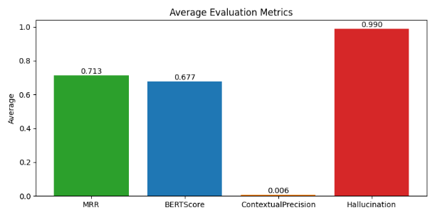
- Innovative analysis: Used adversarial testing, ablation studies and error analysis as a part of innovation techniques.
- Adversarial Testing: Stress-test a QA or RAG system to reveal weaknesses that don’t appear on standard benchmarks.
Challenging Questions
Ambiguous questions: Have multiple plausible interpretations.
Negated questions: Include negation or double negation.
Multi-hop questions: Require combining facts from multiple sources.
Paraphrasing Robustness
Ask the same question in multiple phrasings.
Goal: Ensure performance is stable under rewording.
Metric: Consistency of answers and retrieval results across paraphrases.
Unanswerable Questions (Hallucination Detection)
Questions whose answers are absent from the corpus.
Goal: See if the model abstains instead of hallucinating.
Metrics: hallucination rate.
Adversarial Results JSON: https://github.com/2024aa05042/conversation-ai-rag-assignment2/blob/main/data/adversarial_results.json
- Ablation Studies: Identify which components of your system actually contribute to performance.
Experimenting with K, N, RRF k
- K (top-K retrieved docs):
- Higher K → more recall, but more noise and cost.
- Lower K → cleaner context, but risk of missing info.
- N (context chunks used by generator):
- Impacts token budget and distraction.
- Too large N can degrade generation quality.
- RRF k (Reciprocal Rank Fusion constant):
      - Controls how steeply rank importance decays.
      - Lower k → top ranks matter more.
      - Higher k → smoother contribution from lower ranks.
Report metrics: (EM, F1, Recall@K) per setting.
Ablation Results JSON: https://github.com/2024aa05042/conversation-ai-rag-assignment2/blob/main/data/ablation_results.json

Screenshots:
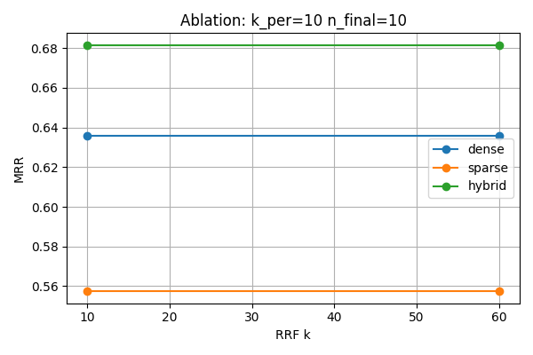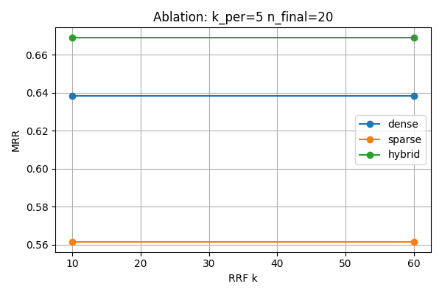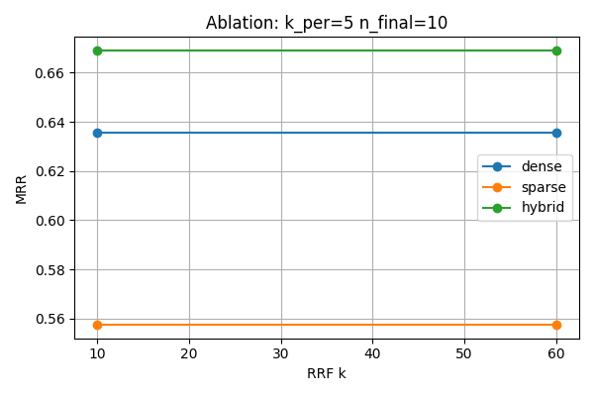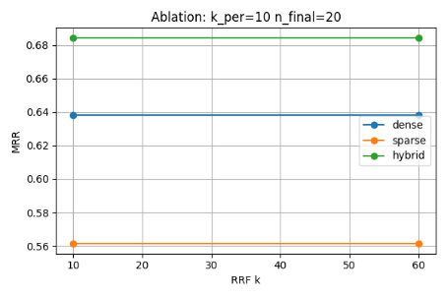

- Error Analysis: Systematically understand why the system fails.
- Failure Categories
- Retrieval Errors
- Relevant document not retrieved.
- Causes: poor indexing, bad embeddings, query mismatch.
- Generation Errors
- Answer contradicts context.
- Hallucinations or reasoning mistakes.
- Context Issues
- Relevant info retrieved but:
    - Buried in long context
    - Conflicting passages
    - Truncated input
- By Question Type
Analyze errors separately for:
- Factual
- Multi-hop
- Temporal
- Comparative
- Negated
- Unanswerable
This reveals patterns (e.g., multi-hop → retrieval failures).
- Visualizations
Common and useful:
- Confusion-style matrices (question type × error type)
- Bar charts (error counts per category)
- Recall@K curves
- Pipeline breakdown charts (retrieval vs generation contribution)
- Outcome
- Produces actionable insights:
  - Improve retriever
  - Add re-ranking
  - Modify prompts
  - Add abstention logic
Screenshots:
