End-to-End MLOps Pipeline for Heart Disease Prediction

1. Introduction
This project implements a complete end-to-end MLOps pipeline for predicting heart disease risk using the UCI Heart Disease dataset. The objective is to design a production-grade ML system covering data ingestion, experimentation, CI/CD, containerization, deployment, monitoring, and documentation as per industry best practices.

2. Dataset Description
The Heart Disease UCI dataset contains patient health indicators such as age, sex, blood pressure, cholesterol, ECG results, maximum heart rate, and exercise-induced angina. The target variable is binary, indicating presence or absence of heart disease.

3. Data Acquisition & EDA
The dataset was downloaded from the UCI Machine Learning Repository (processed.cleveland.data). Exploratory Data Analysis included distribution plots, correlation heatmaps, and class balance visualization. These analyses helped identify feature importance and potential multicollinearity.
Feature Semantics and Encoding Strategy
Feature | Raw Data Type | ML Feature Type | Justification
age | Numeric | Numerical | Continuous patient age
trestbps | Numeric | Numerical | Resting blood pressure
chol | Numeric | Numerical | Serum cholesterol
thalach | Numeric | Numerical | Maximum heart rate
oldpeak | Numeric | Numerical | ST depression
sex | Numeric | Categorical | Binary gender indicator
cp | Numeric | Categorical | Chest pain category
fbs | Numeric | Categorical | Boolean condition
restecg | Numeric | Categorical | ECG category
exang | Numeric | Categorical | Exercise-induced angina
slope | Numeric | Categorical | Slope classification
ca | String/Numeric | Categorical | Discrete vessel count
thal | String | Categorical | Clinical thalassemia state

Although several features such as sex, cp, and fbs are numerically encoded in the dataset, they represent categorical clinical states rather than continuous quantities. Treating these variables as numerical would introduce artificial ordering and distance assumptions. Therefore, a unified preprocessing pipeline was constructed using ColumnTransformer, incorporating appropriate imputation and one-hot encoding strategies. The preprocessing pipeline was bundled with the model to ensure identical behavior during training and inference.

4. Feature Engineering & Modeling
Numerical features were standardized using StandardScaler. Categorical features were encoded where required. Two models were trained: Logistic Regression and Random Forest. Hyperparameters were tuned using cross-validation. Logistic Regression was selected due to stable ROC-AUC and interpretability. Two classification models were trained and evaluated: Logistic Regression and Random Forest. Logistic Regression was selected for deployment due to its interpretability and stable ROC-AUC performance, which is particularly important in clinical decision-support systems. Random Forest was used as a benchmark non-linear model and demonstrated competitive performance, validating the robustness of the selected feature set.
Model | Accuracy | ROC-AUC | Remarks
Logistic Regression | 0.885 | 0.966 | Interpretable, production-ready
Random Forest | 0.885 | 0.941 | Non-linear benchmark

5. Experiment Tracking with MLflow
MLflow was used to log parameters, metrics, models, and artifacts. Each experiment run captured accuracy, and ROC-AUC scores along with model artifacts and preprocessing pipelines.
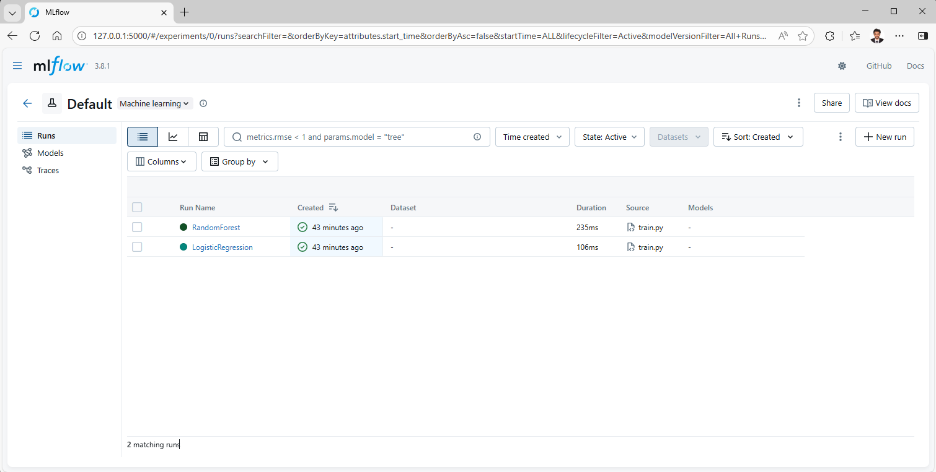

6. Model Packaging & Reproducibility
The final model and preprocessing pipeline were serialized using joblib. A requirements.txt file ensures reproducibility. All scripts can be executed from a clean environment using the provided dependencies.

7. CI/CD Pipeline (Github repo link - 2024aa05887-coder/MLOps-Assignment1-Group68: This is a repo to implement MLOps Assignment - 1)
A GitHub Actions CI pipeline was implemented to automate linting, unit testing, and training verification. The pipeline fails on test or code errors, ensuring robustness.
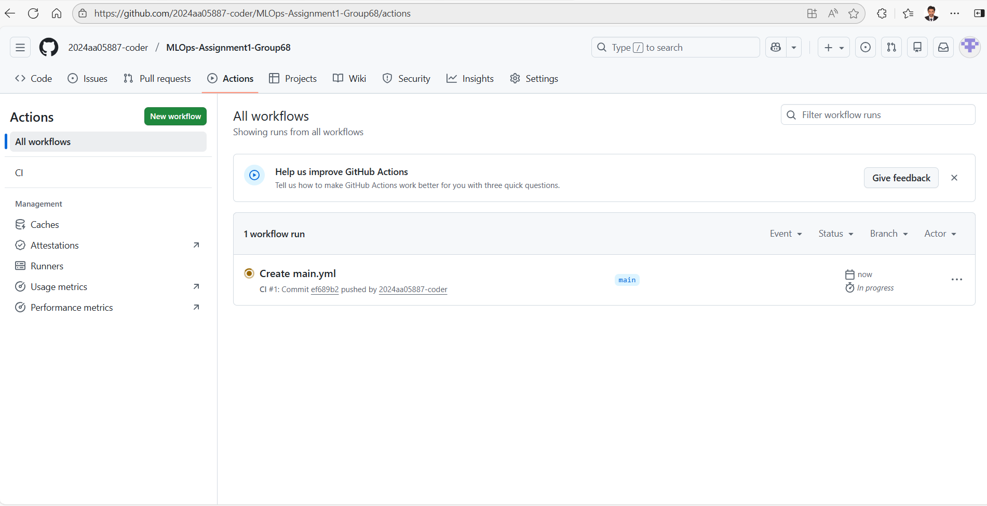

8. Containerization
The trained model was containerized using Docker and served via a FastAPI REST API. The /predict endpoint accepts JSON input and returns predictions with confidence scores.

9. Deployment
The Docker container was deployed to Kubernetes using a deployment manifest. The service was exposed using a NodePort or LoadBalancer for external access.

10. Monitoring & Logging
API request logs were enabled using FastAPI logging. Kubernetes pod logs were used for basic monitoring. This setup can be extended with Prometheus and Grafana.

11. Architecture Overview
The system architecture includes data ingestion, ML training with MLflow tracking, CI/CD automation, Dockerized inference service, Kubernetes deployment, and monitoring.

12. Conclusion
This project demonstrates a production-ready MLOps pipeline aligned with real-world ML system design. It ensures scalability, reproducibility, automation, and observability.

