The solution was developed and validated on a local Kubernetes cluster to ensure reproducibility and rapid iteration.
The same Docker image and Kubernetes manifests were then deployed to a cloud environment (OSHA VM) with no code changes, demonstrating cloud portability

After EDA:
• ✔ Dataset loaded via code (reproducible)
• ✔ Raw data stored under data/raw/
• ✔ EDA performed in a notebook (appropriate use)
• ✔ Mandatory plots available for the report later
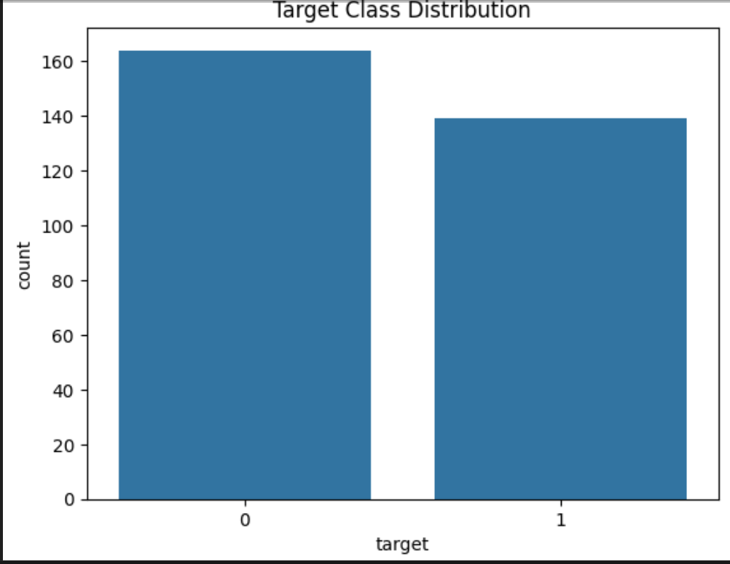
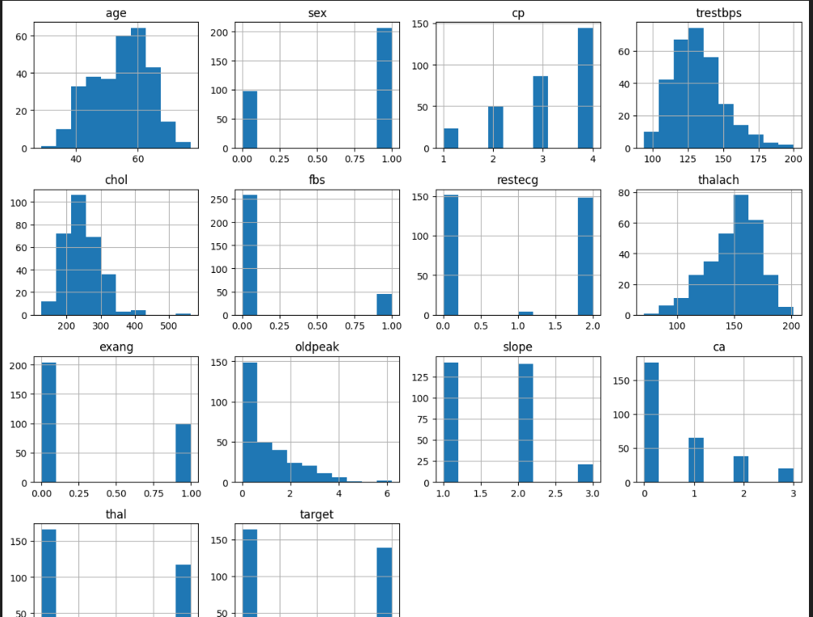
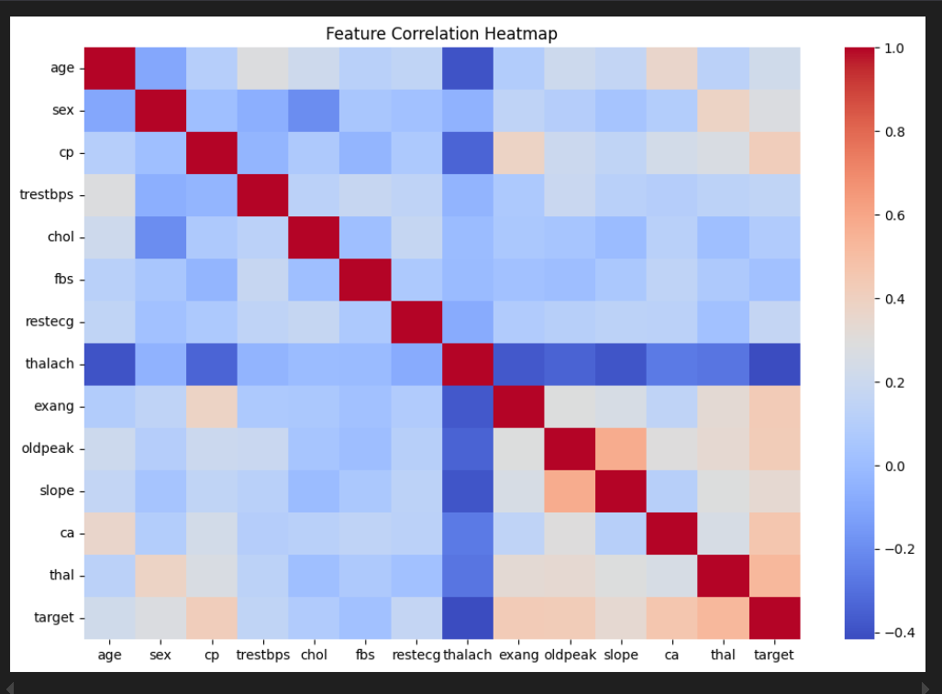
Metrics after training with two different classifiers
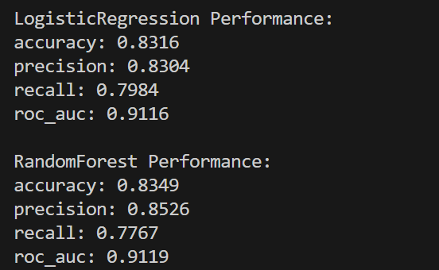

Quick interpretation
- Random Forest
  - Slightly higher accuracy and precision
  - Slightly lower recall
- Logistic Regression
  - More balanced recall
  - Almost identical ROC-AUC
For a risk prediction problem:
- Recall matters (catching disease cases)
- But Random Forest is still marginally better overall
We will select Random Forest as the final model
Trained models are saved under models folder
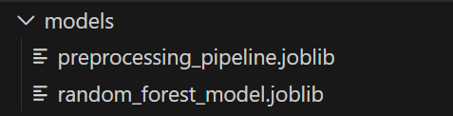

Why joblib and not pickle

joblib advantages
- Optimized for NumPy arrays
- Faster and smaller for ML objects
- Standard in scikit-learn ecosystem
This is why scikit-learn documentation itself recommends it.

Stage | What we did
Training | Fit model + pipeline
Persistence | Save as .joblib
CI/CD | Verify artifacts exist
Docker | Copy files into image
API | Load once, reuse
Monitoring | Track predictions

After integrating with mlFlow, trained the models again:
LogisticRegression Performance:
accuracy: 0.8316
precision: 0.8304
recall: 0.7984
roc_auc: 0.9116
2025/12/28 17:00:06 WARNING mlflow.models.model: `artifact_path` is deprecated. Please use `name` instead.
2025/12/28 17:00:13 WARNING mlflow.models.model: Model logged without a signature and input example. Please set `input_example` parameter when logging the model to auto infer the model signature.

RandomForest Performance:
accuracy: 0.8349
precision: 0.8526
recall: 0.7767
roc_auc: 0.9119

Launch ML Flow UI:
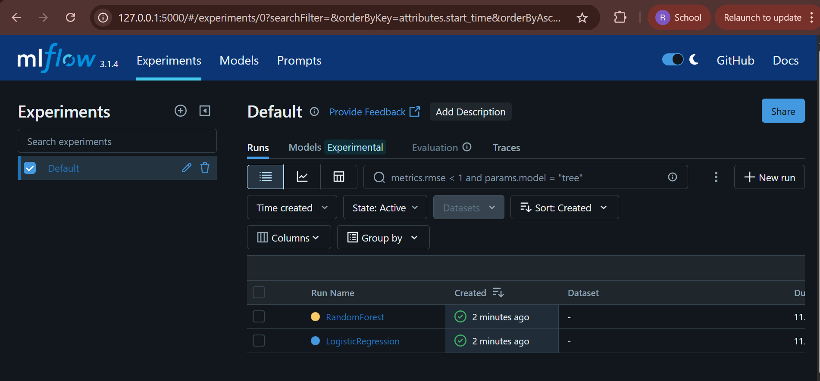
Random Forest:
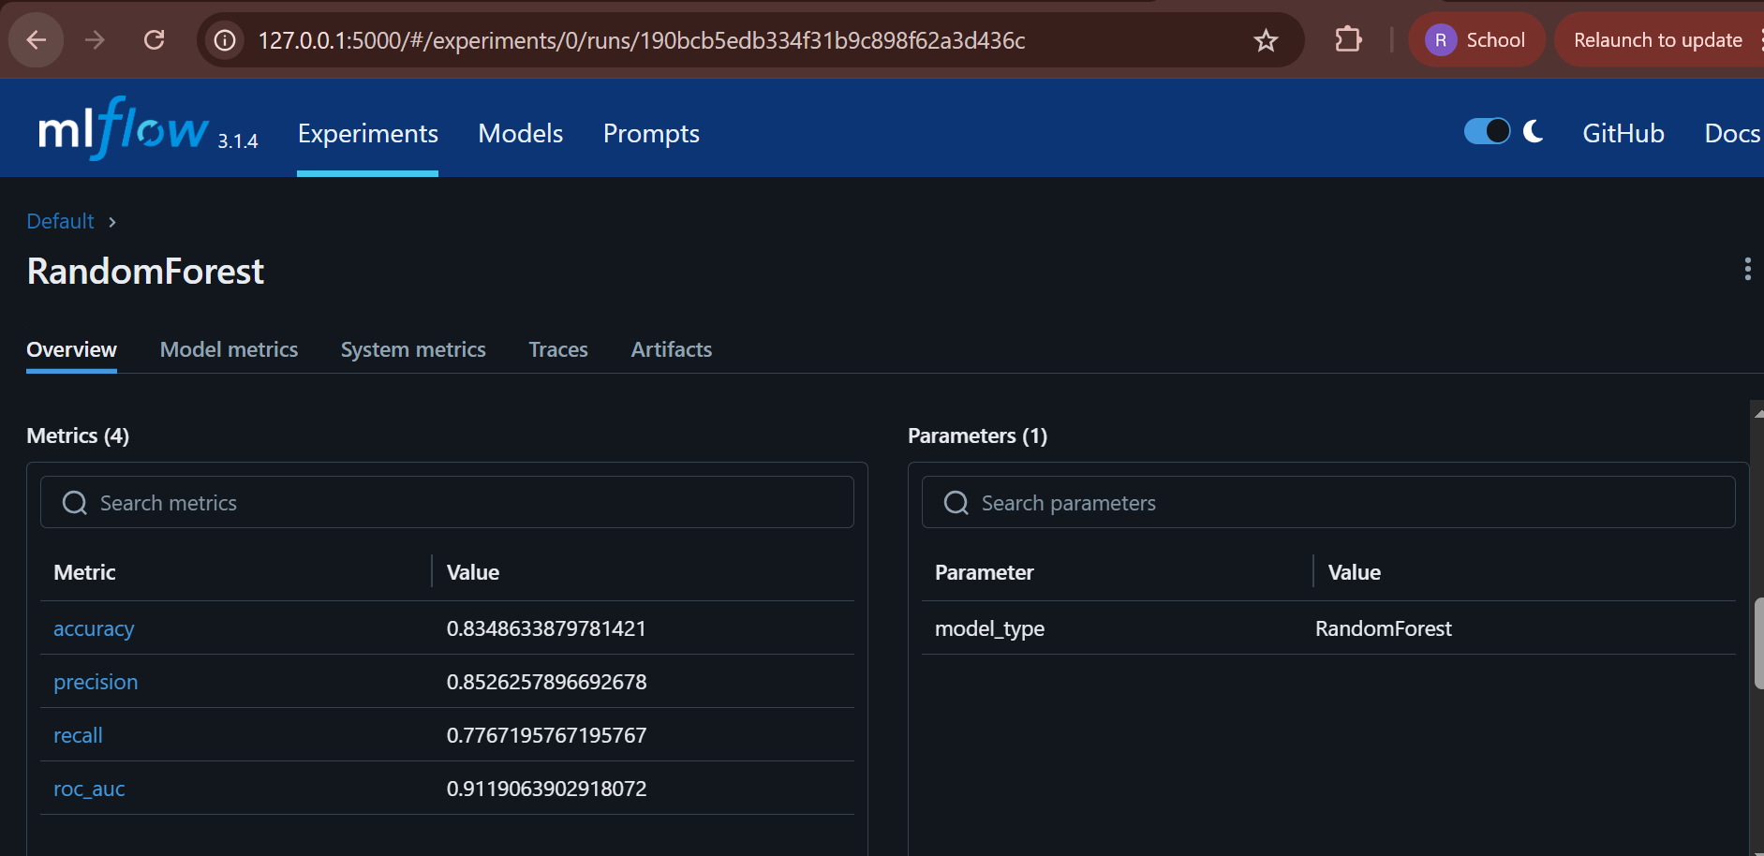
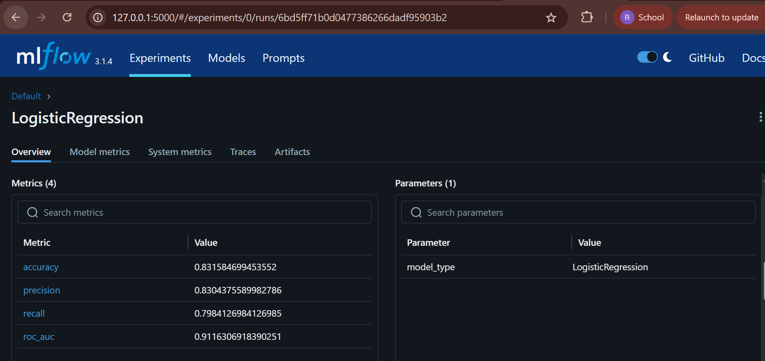

Line-by-line confirmation
- Save the final model in a reusable format → ✅
  - Saved as random_forest_model.joblib
  - Additionally logged in MLflow (counts as reusable format)
- Write a clean requirements.txt (or Conda env file) → ✅
  - requirements.txt exists
  - Contains only what we actually use
  - We’ll add a final polish later (after CI/CD)
- Provide preprocessing pipeline / transformers → ✅
  - Pipeline with SimpleImputer + StandardScaler
  - Saved as preprocessing_pipeline.joblib
  - Ensures training = inference preprocessing
- Ensure full reproducibility → ✅
  - Scripted data loading
  - Scripted preprocessing
  - Scripted training
  - Serialized artifacts
Install Pytest and run the Unit tests:
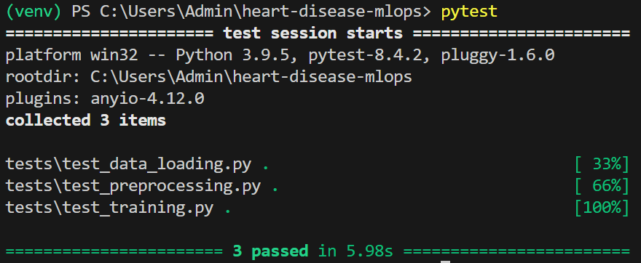
ci.yml file configured to run unit tests automatically whenever there is ‘push’ to main branch
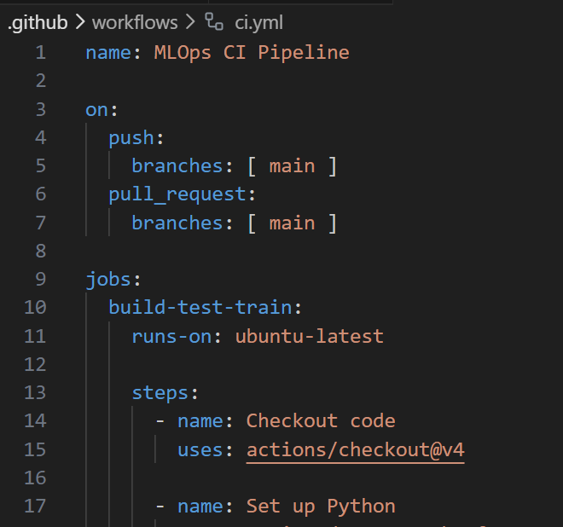
Build successful on Github Actions after few retries and updating the train.py to utilize cross-platform MLFlow path handling
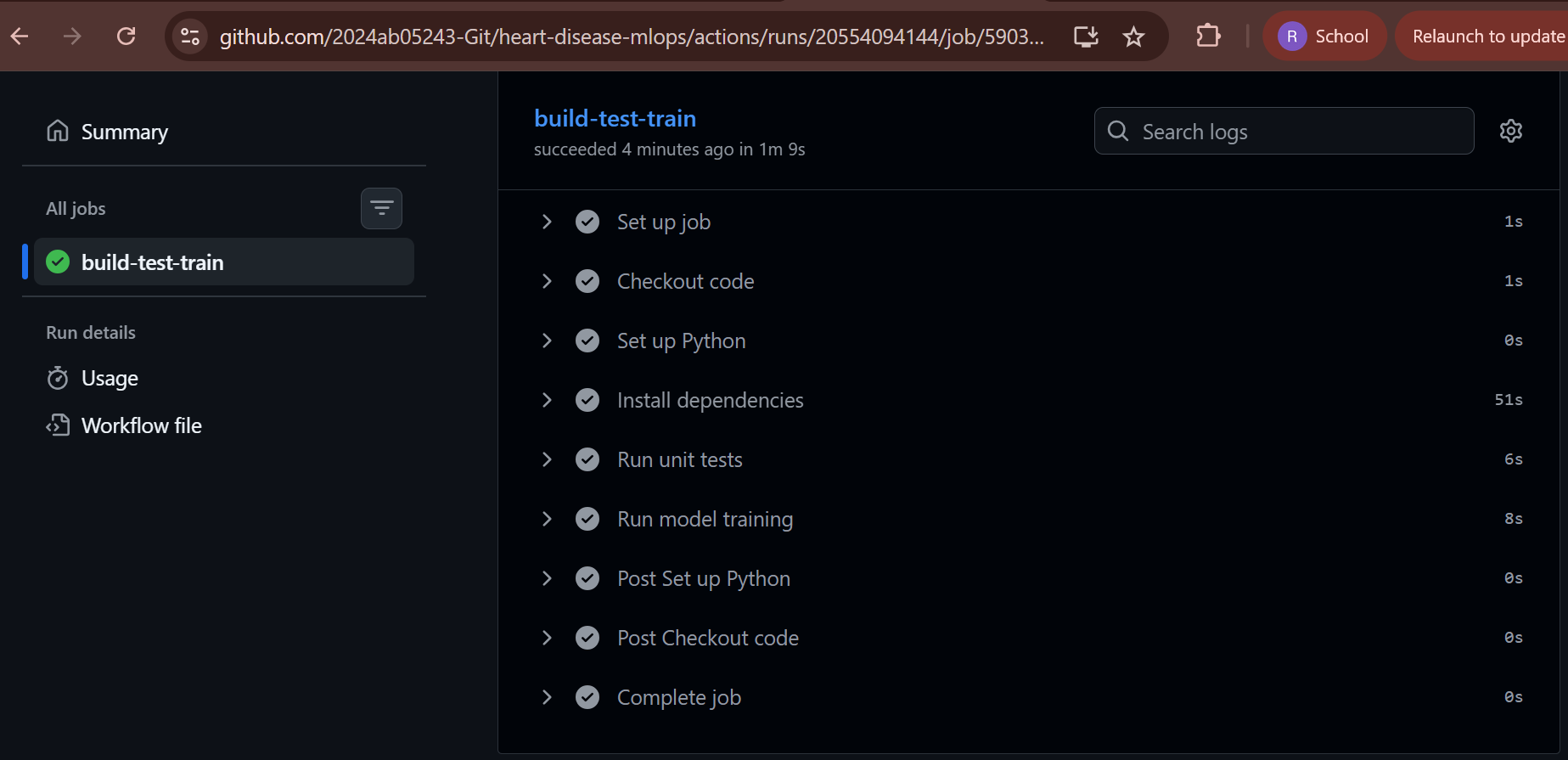
Added Linting for static code checks and the step failed as expected for errors related to empty lines:
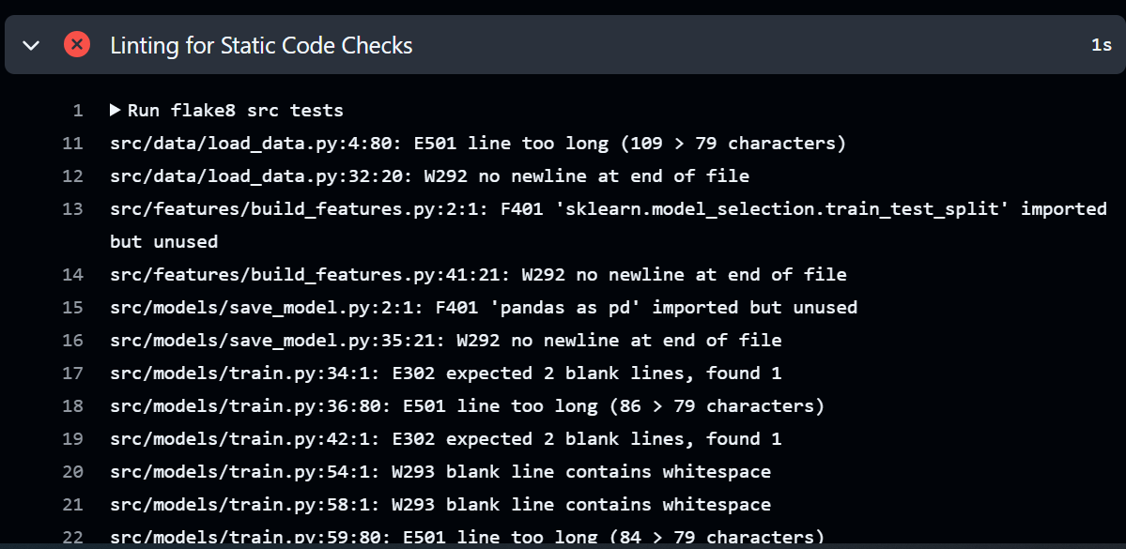
Artifacts Captured correctly
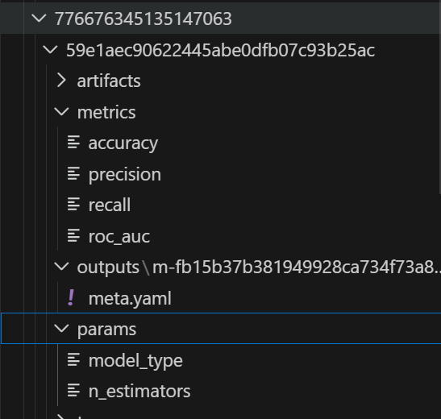
Fixing all static errors with ‘Black’ module
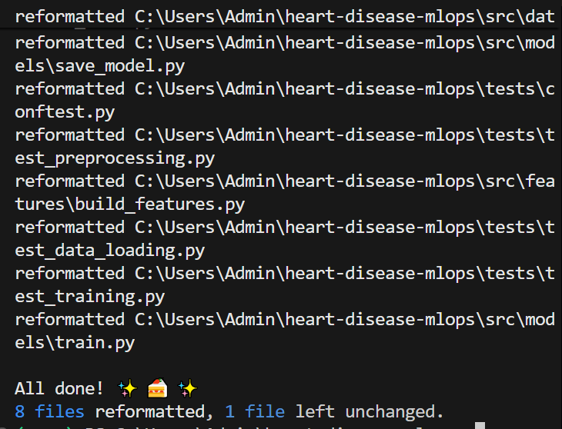
Corrected few others manually and pushed the code.
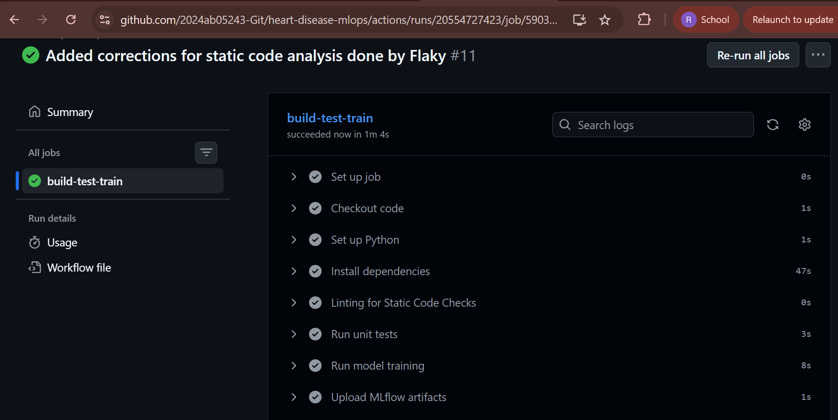
MLFlow Artifacts:
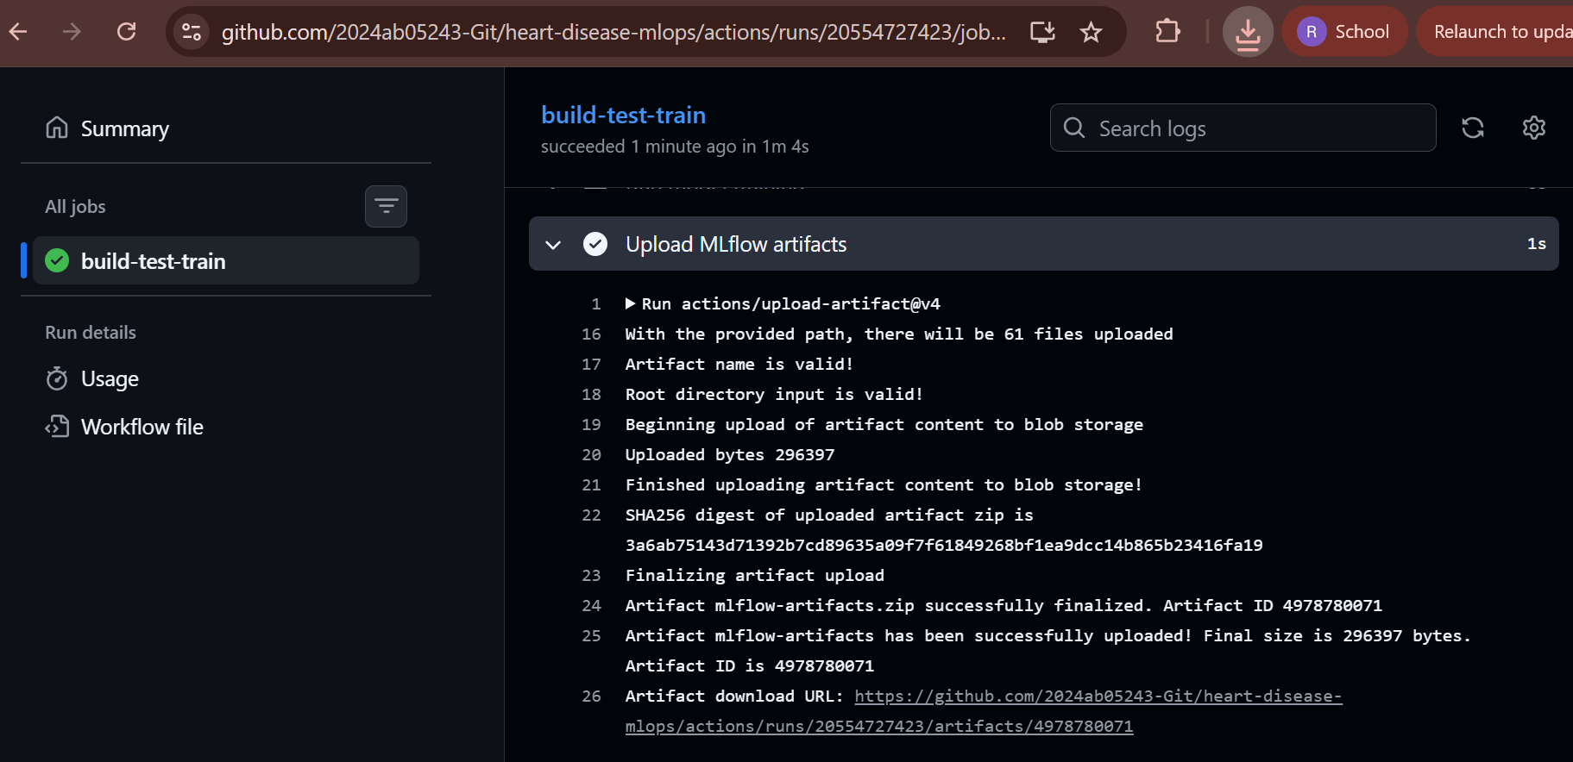
API on local using Flask:
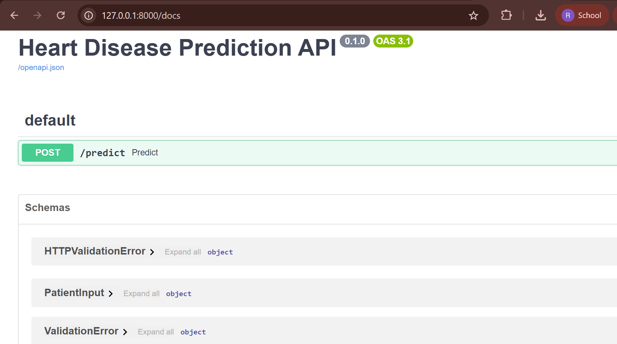
Executed the below example for Prediction ‘Single Instance’:
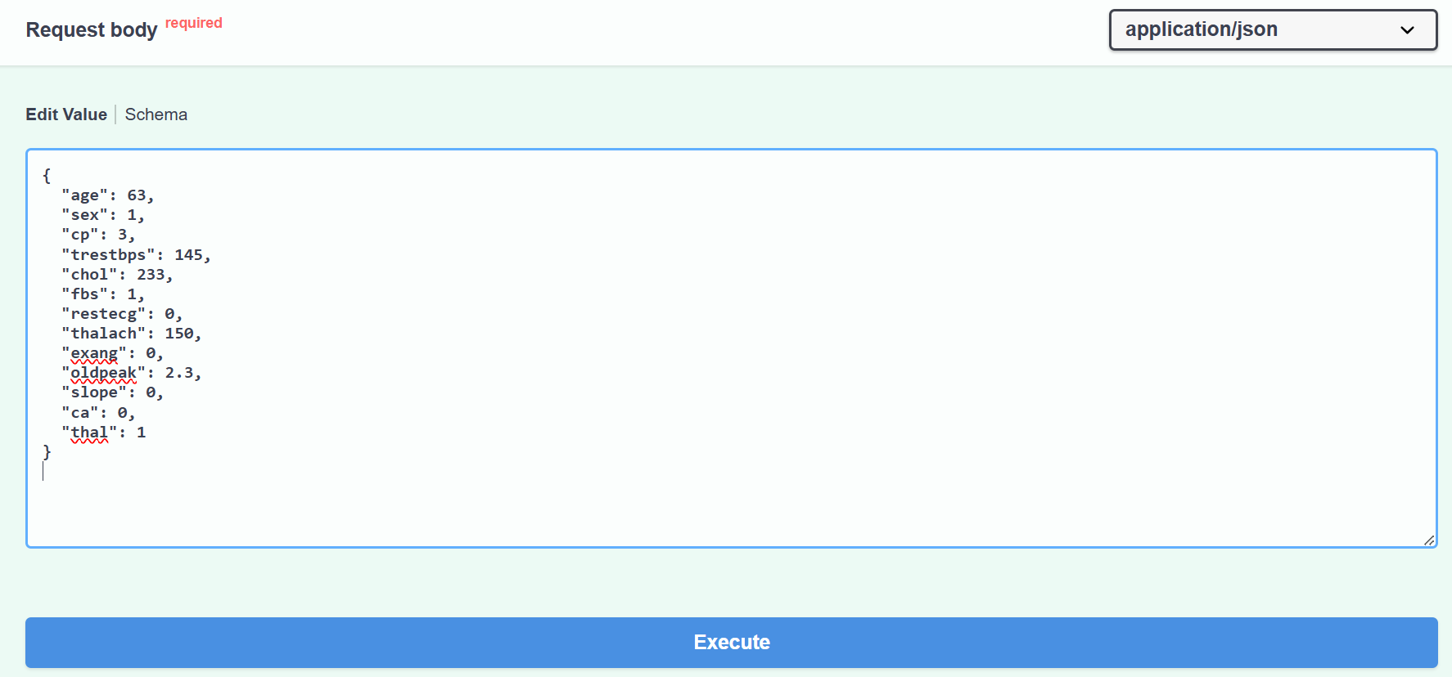
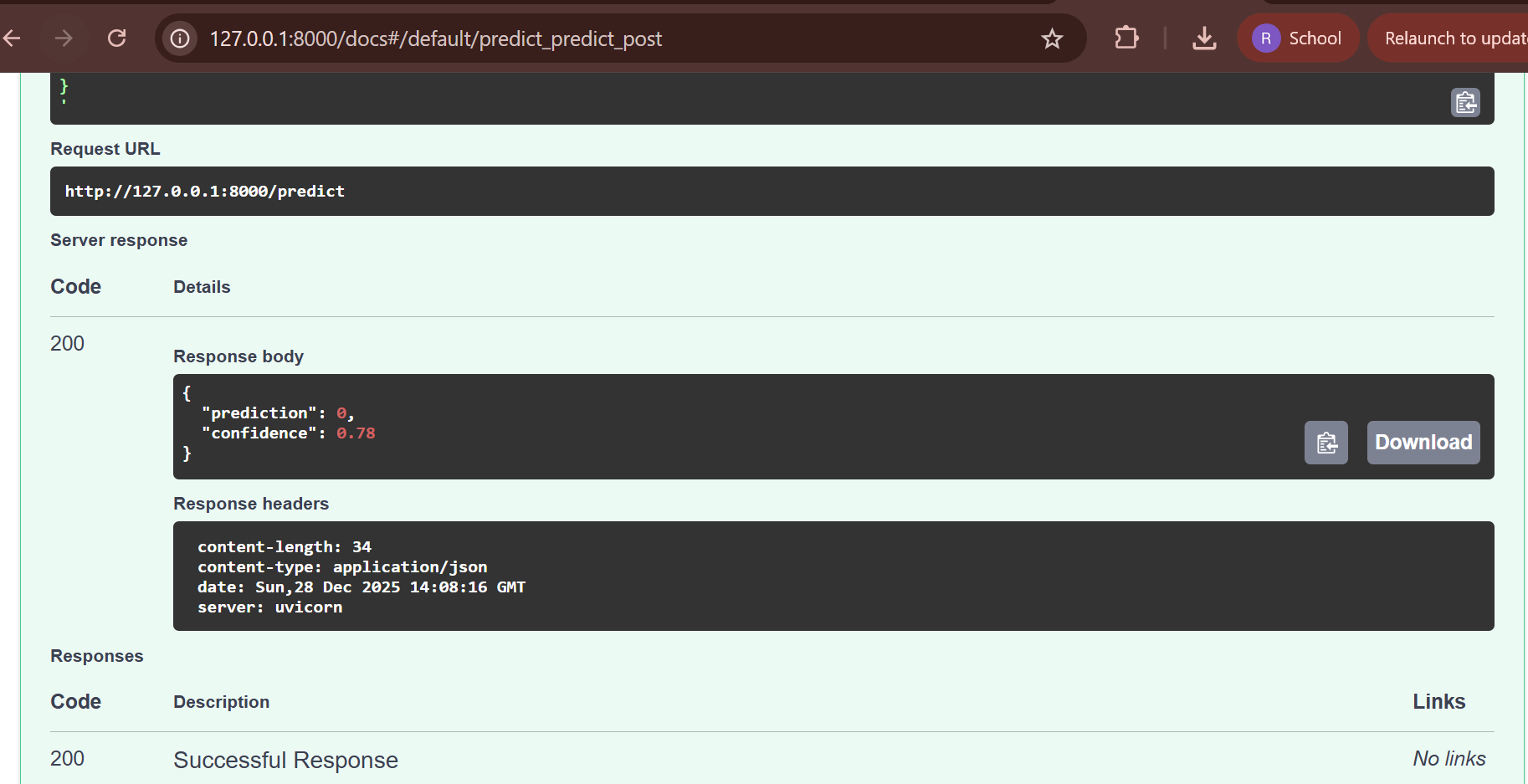

Add Docker File and build a docker Image:
docker build -t heart-disease-api -f docker/Dockerfile .
and docker run -p 8000:8000 heart-disease-api
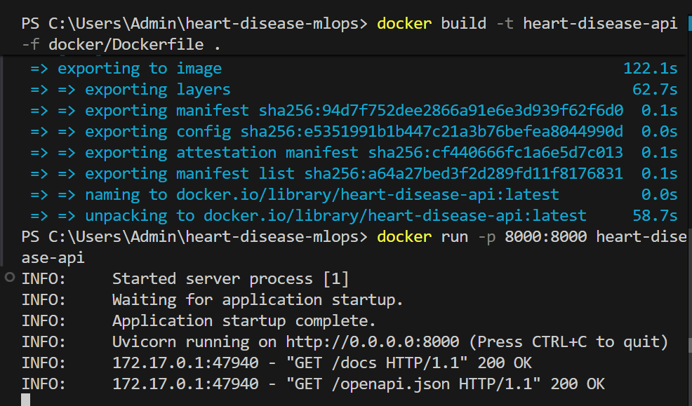
Prediction Model now runs on Docker
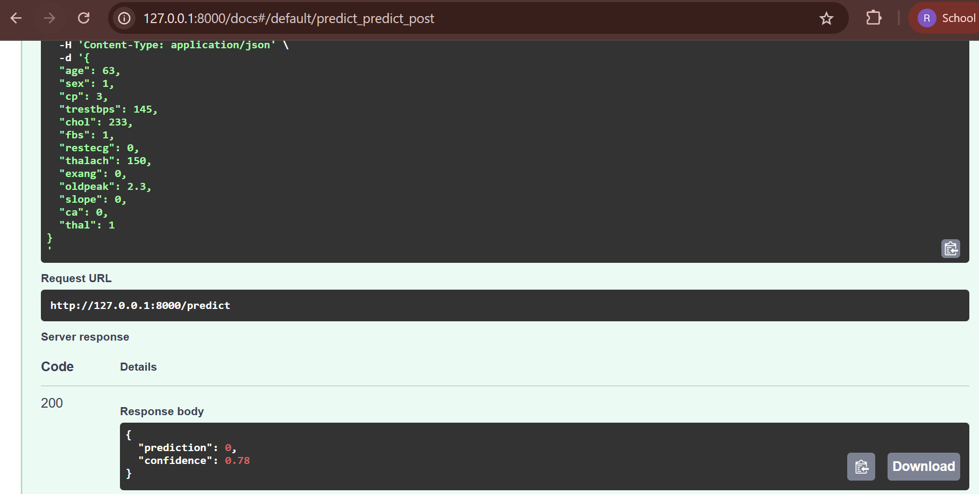
Kubernetes Cluster:
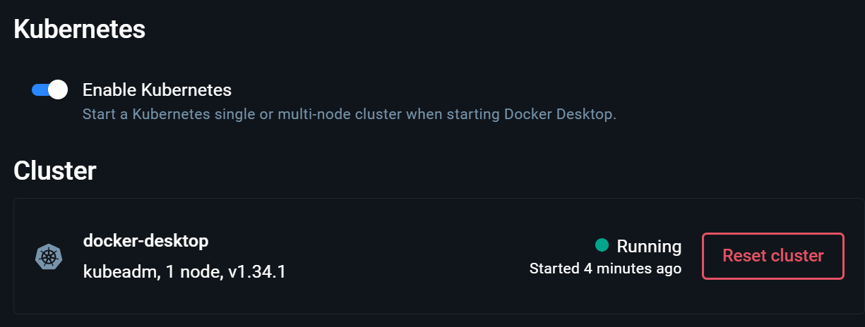
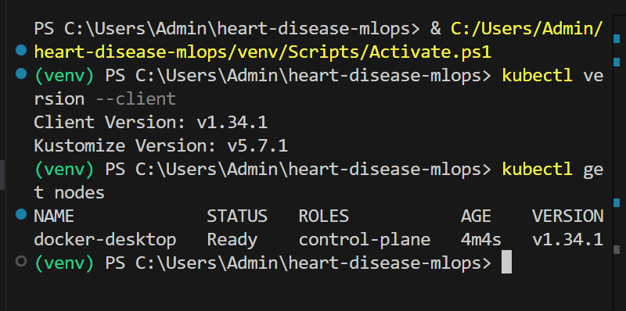
Kubernetes PODS running
kubectl apply –f k8s/deployment.apps/heart-disease-service created
kubectl get pods
kubectl get services
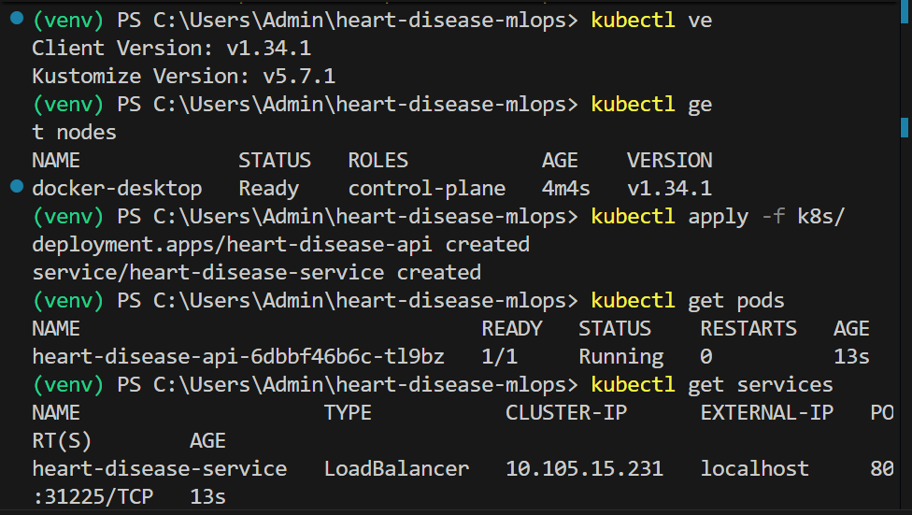
Predict Model on Kubernetes with Load Balancer
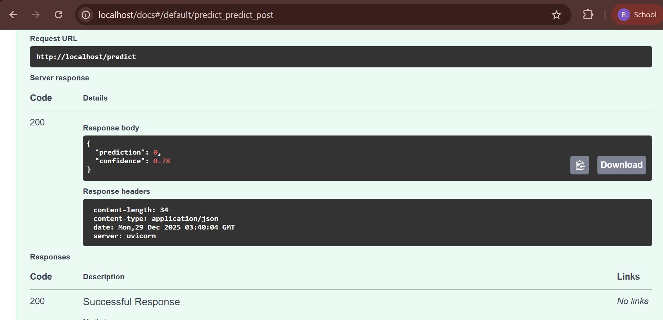
Kubernetes pods running
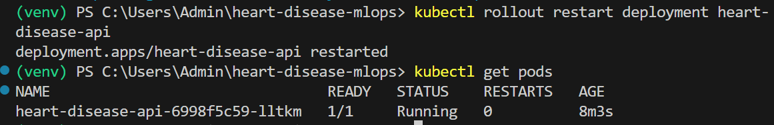
Metrics:
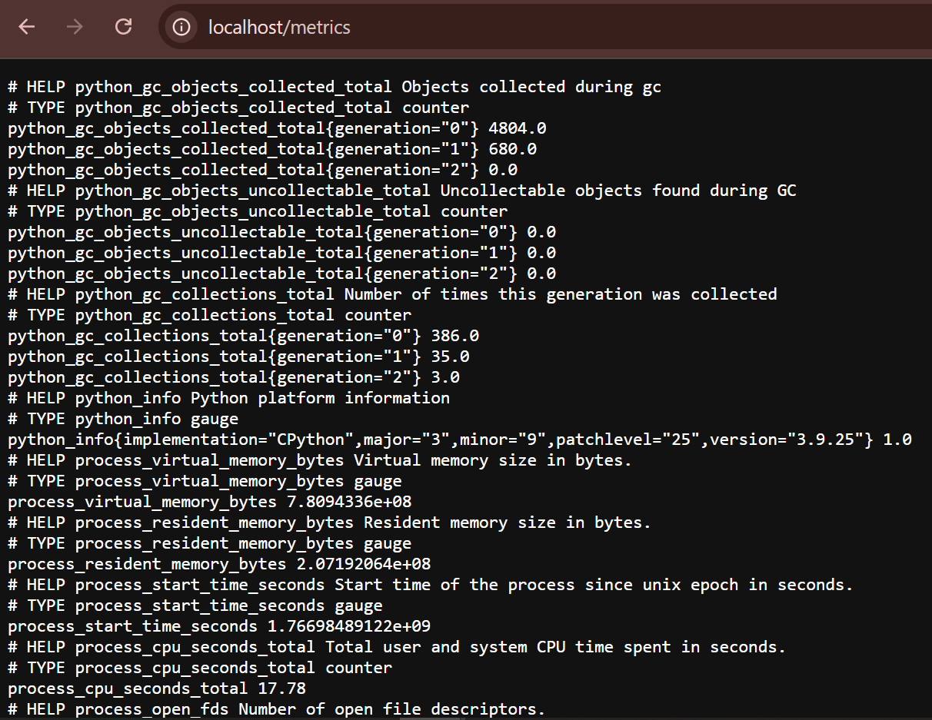
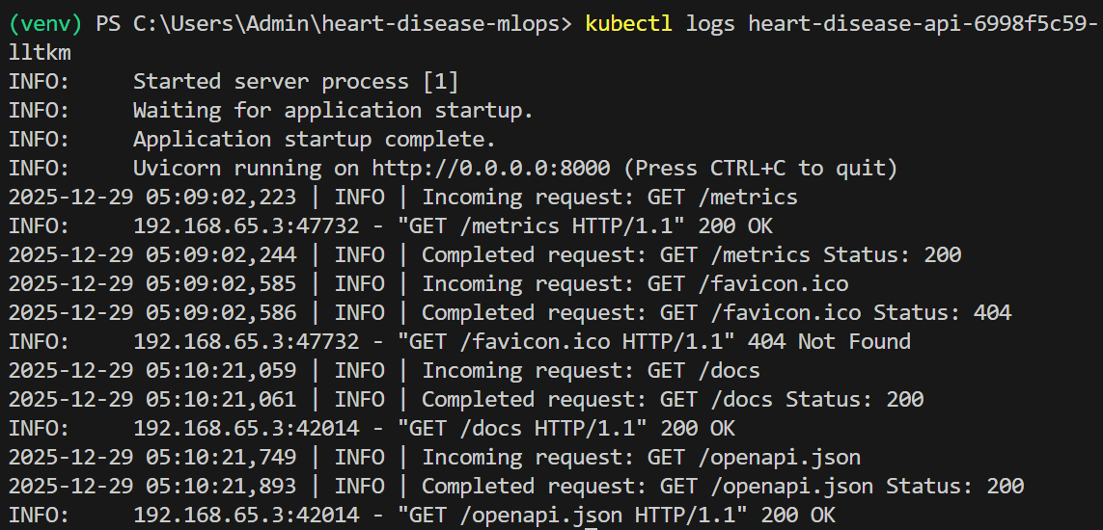
API request logging was integrated using FastAPI middleware. Monitoring was demonstrated via a Prometheus-compatible /metrics endpoint and runtime logs, forming a lightweight API metrics and logs dashboard without additional visualization tooling.

