Run the below commands on the VM
sudo dnf update -y
sudo dnf install -y dnf-utils
sudo dnf config-manager --add-repo https://download.docker.com/linux/centos/docker-ce.repo
sudo dnf install -y docker-ce docker-ce-cli containerd.io docker-buildx-plugin docker-compose-plugin

Start Docker:
sudo systemctl start docker
sudo systemctl enable docker

Allow non-root Docker
sudo usermod -aG docker $USER
Build Docker Image:
docker build -t heart-disease-api -f docker/Dockerfile .
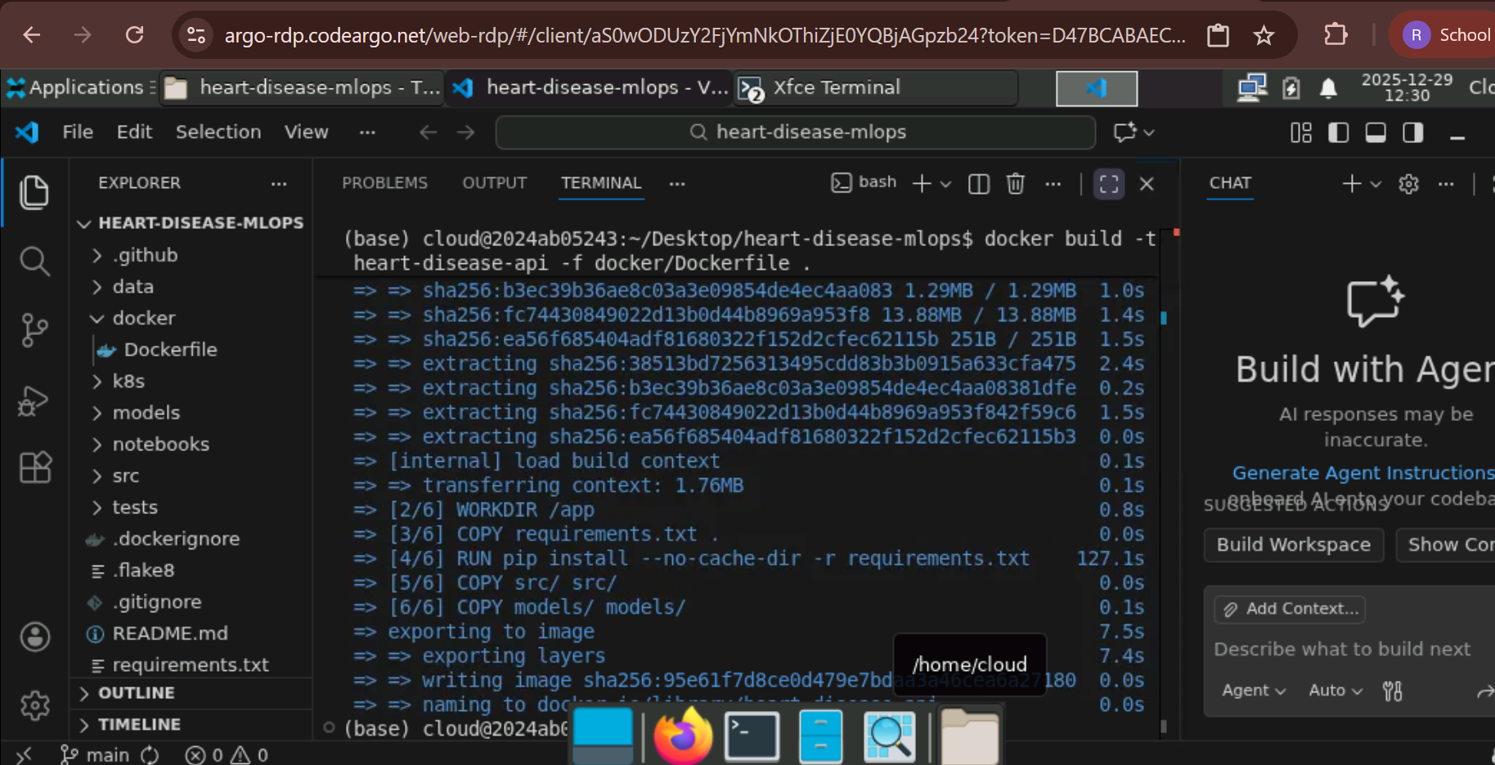
docker run -d -p 8000:8000 --name heart-api heart-disease-api
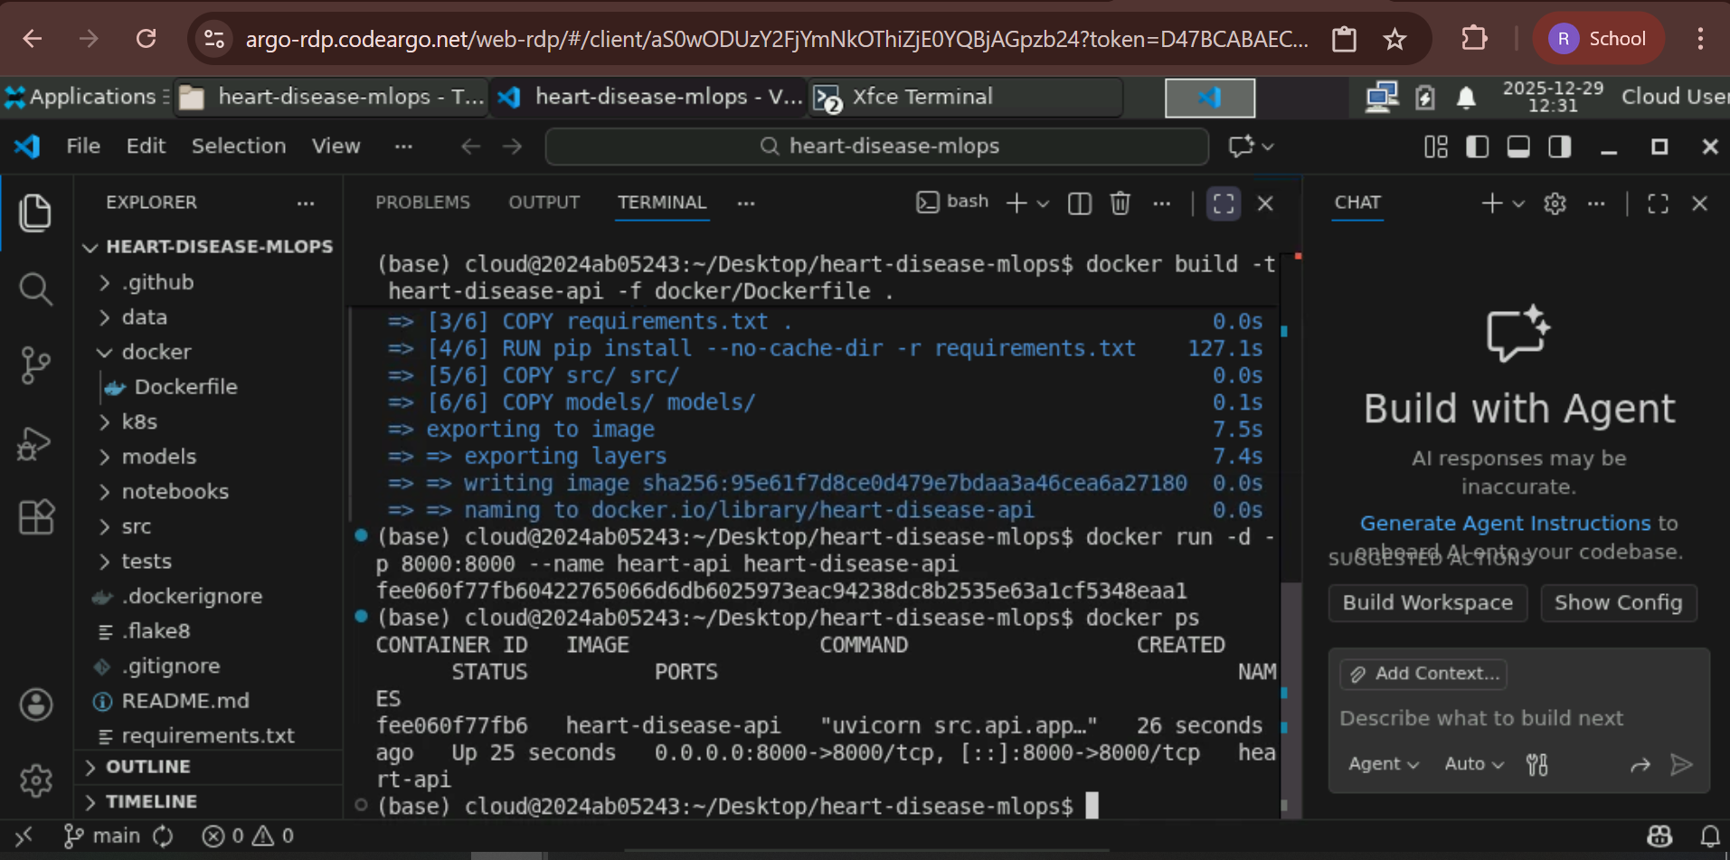
Service Running on Docker:
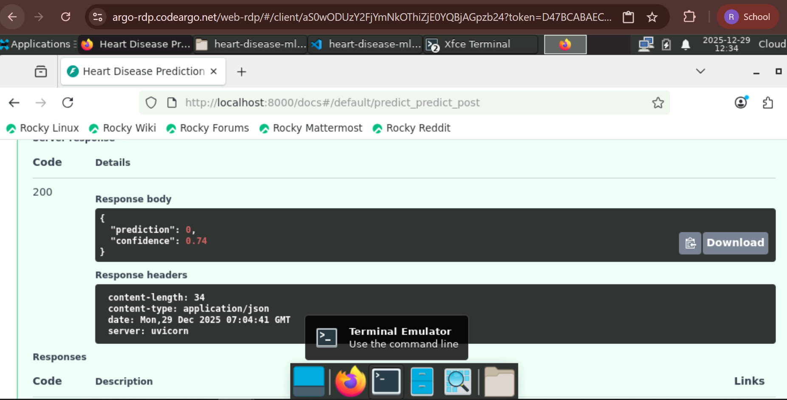
We can then open a firewall and make this a public accessible API. Since its Organization hosted AWS VMs, we stop here.

