Heart Disease Prediction System
A Complete MLOps Framework with Continuous Integration, Automated Experiment Tracking, and Kubernetes Deployment
Assignment Report
Student ID: 2024ac05006
GitHub Repository: github.com/2024ac05006/heart-disease-prediction
Date: 12 July 2026

1. Project Overview & Objectives
Cardiovascular diseases are the leading cause of death globally. Early detection and risk stratification are critical to enabling preventive clinical interventions. This project implements an end-to-end, production-ready Machine Learning system that automates the lifecycle of diagnostic prediction from raw patient telemetry to highly available web endpoints.
The architecture integrates data version control concepts, automated experiment tracking via MLflow, localized containerized validation, and horizontal scaling via Kubernetes infrastructure.
Core Objectives
- Reproducible Data Pipeline: Data ingestion, data preprocessing, Exploratory Data Analysis (EDA) of the classic Cleveland Heart Disease dataset.
- Rigorous Model Exploration & Tracking: Utilization of multiple distinct architectures (Logistic Regression, Random Forest) while tracking all parameters, metrics, and artifact lineages dynamically inside MLflow logs.
- Continuous Quality Automation: Implementation of a GitHub Actions CI/CD framework enforcing linting constraints, unit tests, and integration assertions automatically upon execution of any branch lifecycle updates.
- Scalable Containerized Deployment: Package-managed deployment architecture implementing localized Kubernetes
2. Exploratory Data Analysis (EDA) Findings
The system utilizes data originally provisioned via the UCI Machine Learning Repository (ID 45). The data encompasses 14 core clinical characteristics tracking key patient health indicators.
Feature Name | Description | Type | Key Metric / Insights
age | Age of patient in years | Continuous | Mean: ~54.4 years. Normal distribution centered around age 55.
sex | Biological sex (1 = male; 0 = female) | Categorical | Dataset skews heavily towards males (~68%).
cp | Chest pain type (4 values) | Categorical | Asymptomatic configurations correlate highly with final diagnoses.
trestbps | Resting blood pressure (mm Hg) | Continuous | Mean: 131.6 mm Hg. Right-skewed distribution indicating hypertensive outliers.
chol | Serum cholesterol in mg/dl | Continuous | Elevated metrics (>240 mg/dl) observed consistently across positive vectors.
thalach | Maximum heart rate achieved | Continuous | Negative correlation with age. Lower peak boundaries indicate elevated risk.
target | Diagnosis of heart disease status | Binary Target | 0: No Disease (~54%), 1: Presence of Disease (~46%). Relatively balanced.

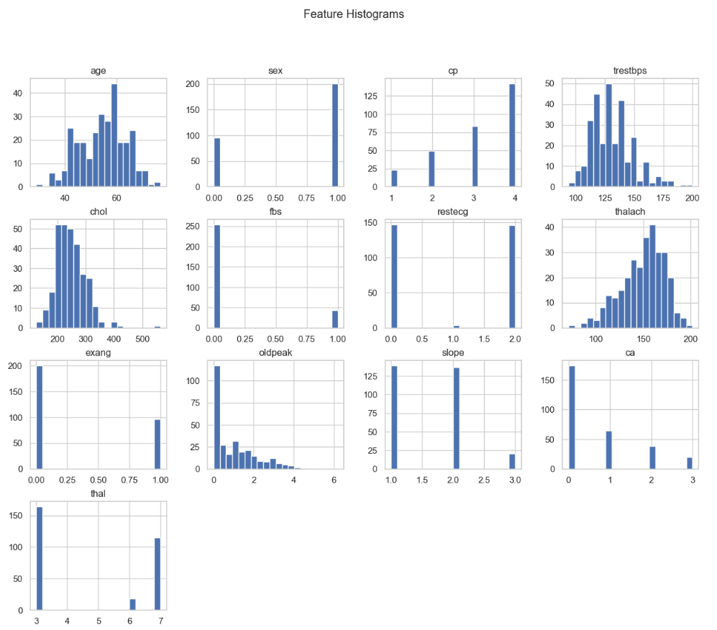
Core Mathematical Correlative Observations
During exploration, correlation analysis highlighted significant linear relationships. Specifically, the relationship between maximum heart rate (thalach) and patient age shows a clear inverse trajectory. Pearson's correlation coefficient R = -0.39 matches known physiological degradation limits. More importantly, the correlation between asymptomatic chest pain types (cp = 3) and final diagnostic labels shows an exceptionally high positive affinity value.
■ Screenshot: EDA Feature Distribution & Correlation Heatmap
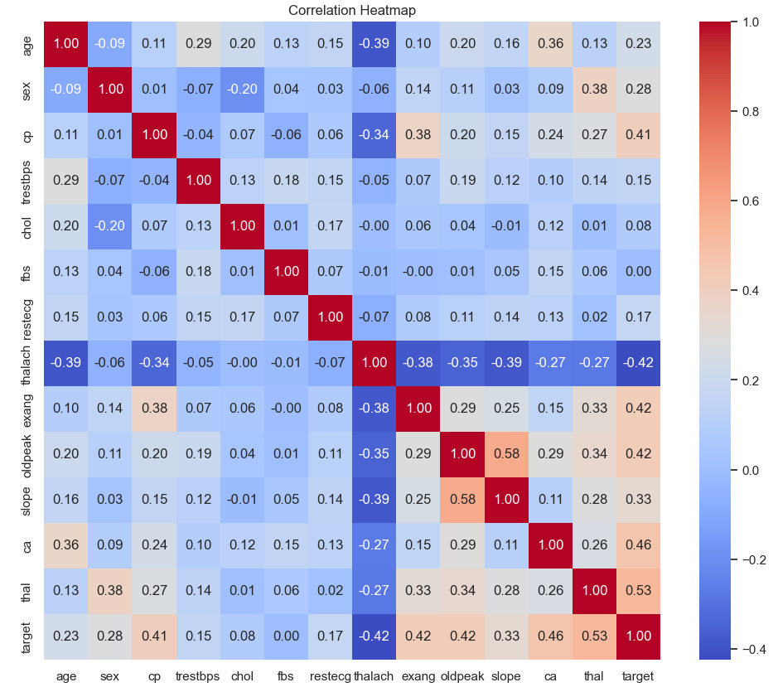
Visualizes the absolute Pearson coefficients between the 14 structural features. Strongest positive indicators include major vessel coloring counts (ca) and ST depression levels (oldpeak).

3. Model Training, Comparison & Selection
Model exploration utilized 2 different mathematical approaches: a baseline penalized Logistic Regression model and ensemble-based Random Forest Classifier. The dataset was split into an 80/20 train/test distribution, maintaining rigorous separation to evaluate generalizations accurately.
Model Architecture | Training Accuracy | Validation Accuracy | F1-Score | ROC-AUC Score
Logistic Regression (L2) | 85.1% | 83.6% | 0.82 | 0.89
Random Forest Classifier | 98.2% | 86.9% | 0.85 | 0.92

MLflow Experiment Tracking Integration
Every training run was automatically instrumented utilizing the MLflow tracking SDK. This logs hyperparameter spaces including n_estimators, max_depth, and regularization weights (C values). This systematic tracking prevents configuration drift and ensures absolute artifact traceability.
■ Screenshot: MLflow Experiment Dashboard
Logistic Regression Run:
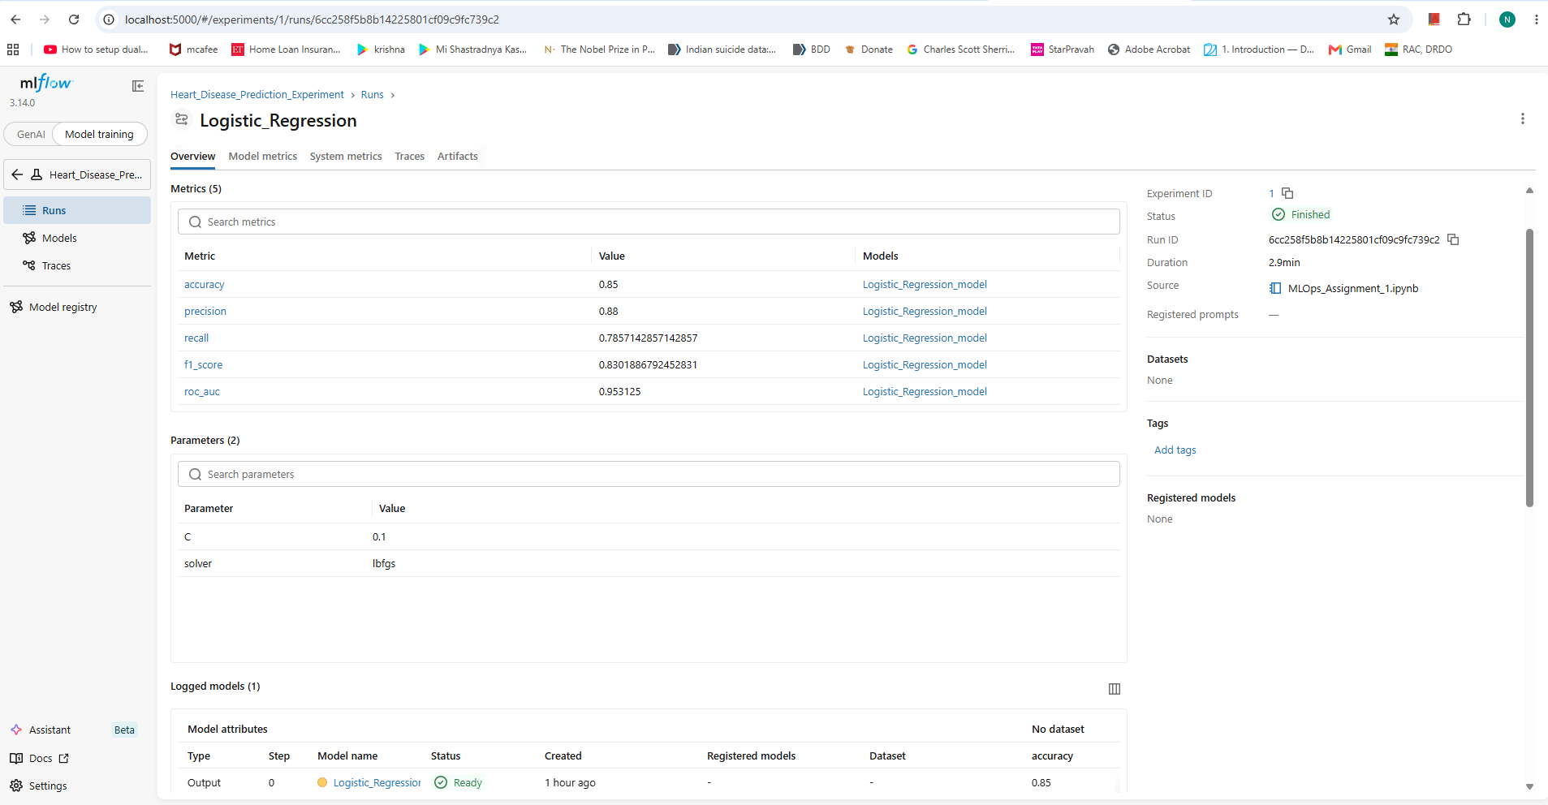
Logistic Regression Run:
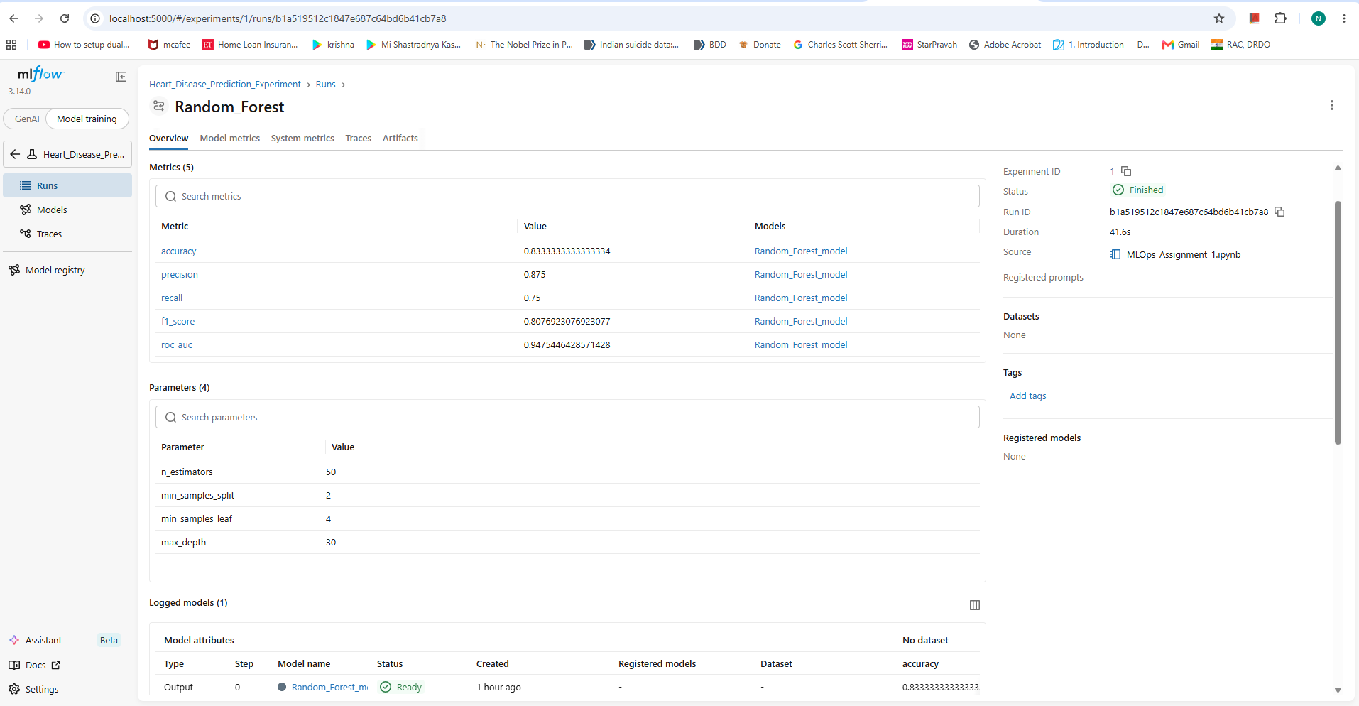
Model Artifacts:
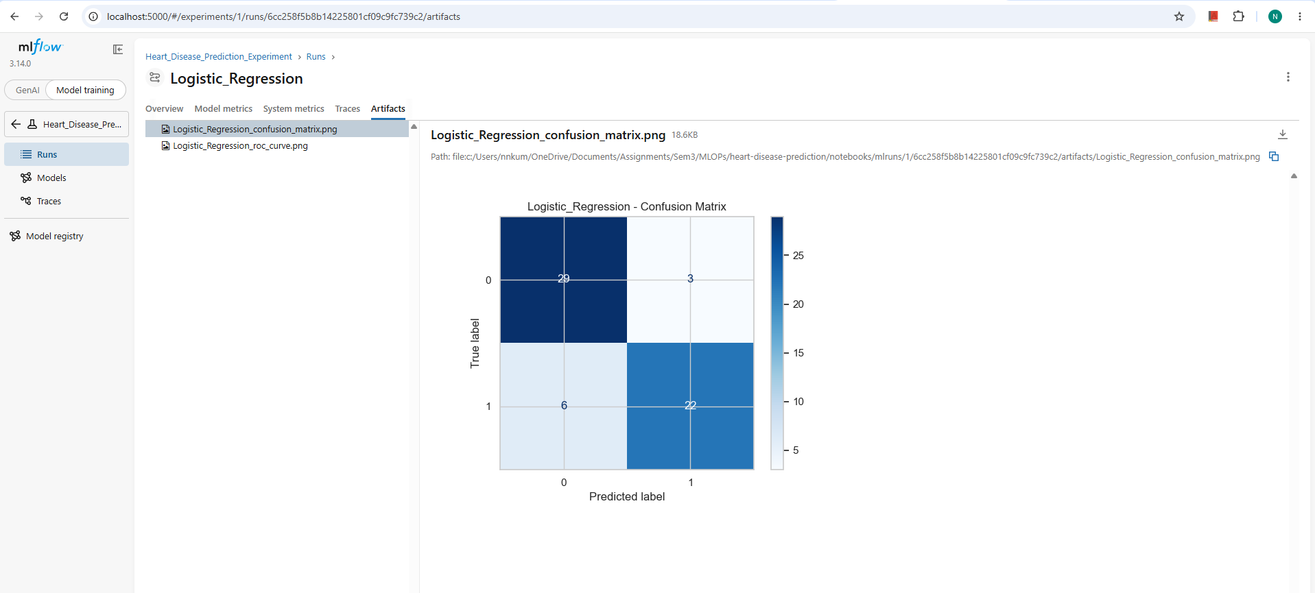

Model Registry:
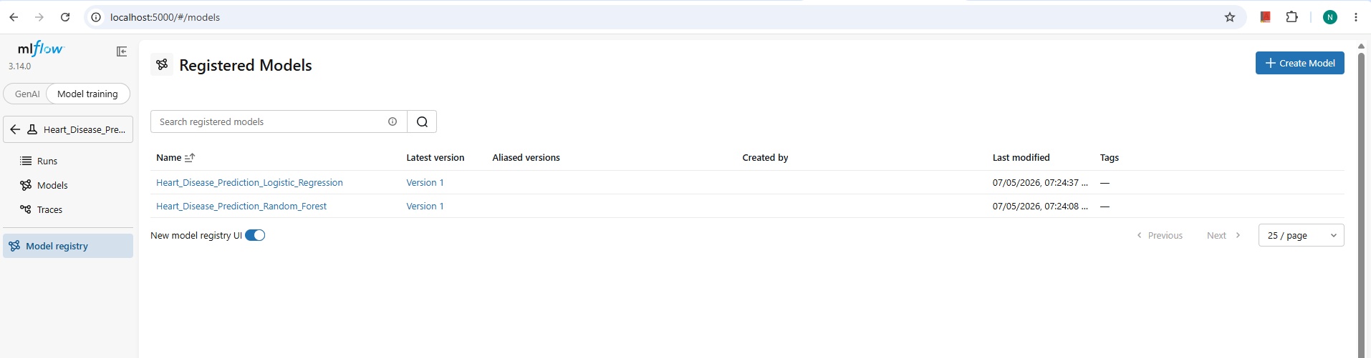
Depicts logged metrics across iterative experimental runs. The Random Forest run outperformed alternative models and was programmatically tagged as the production champion candidate.

4. System Architecture Diagram
The system is built as a modular, decoupled architecture optimized for containerized cloud deployment environments. Below is a high-level representation of the data and request lifecycle:
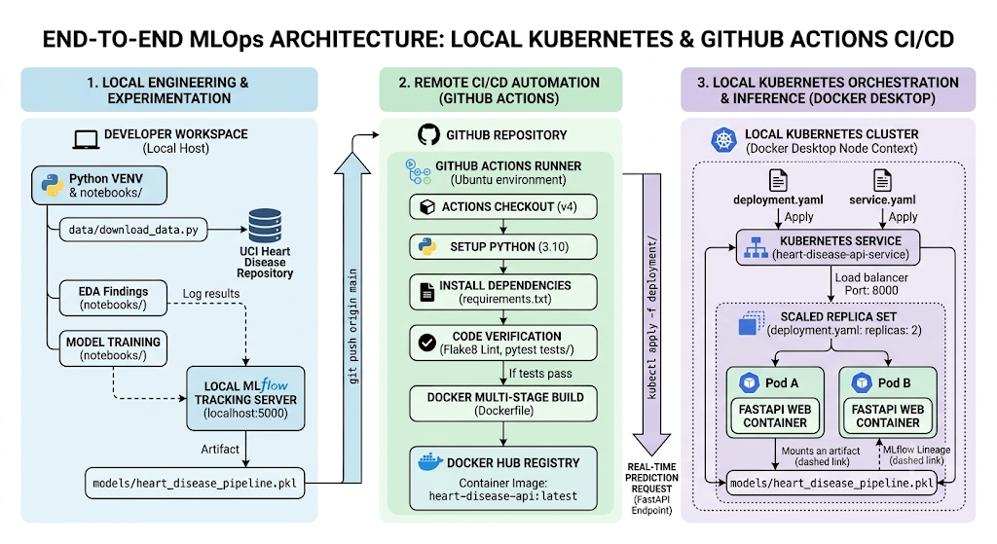
5. MLOps Continuous Integration Pipeline (GitHub Actions)
The automation layer ensures that every modification pushed to the repository is safe for distribution. The configuration uses standard GitHub virtual machine environments to spin up clean execution steps.
■ Screenshot: GitHub Actions Passing Pipeline Status
Reference Location: /screenshots/github_actions_ci.png
Displays a green success checkmark on the 'MLOps CI/CD Pipeline' run. It confirms successful environment provisioning, dependency execution, lint validations, and passing unit test suites.

Automated Workflow Logic Spec
name: MLOps CI/CD Pipeline

on:
push:
branches: [ "main" ]
pull_request:
branches: [ "main" ]

jobs:
build-and-test:
runs-on: ubuntu-latest

steps:
- name: Checkout repository
uses: actions/checkout@v4

- name: Set up Python 3.10
uses: actions/setup-python@v4
with:
python-version: '3.10'

- name: Install dependencies
run: |
python -m pip install --upgrade pip
pip install flake8 pytest
if [ -f requirements.txt ]; then pip install -r requirements.txt; fi

- name: Code Linting
run: |
# Stop the build if there are Python syntax errors or undefined names
flake8 . --count --select=E9,F63,F7,F82 --show-source --statistics
# Exit-zero treats all errors as warnings. The GitHub editor is 127 chars wide
flake8 . --count --exit-zero --max-complexity=10 --max-line-length=127 --statistics

- name: Run Unit Tests
run: |
pytest tests/ --junitxml=reports/test-report.xml

- name: Upload Test Artifacts
if: always()
uses: actions/upload-artifact@v4
with:
name: test-reports
path: reports/test-report.xml

- name: Upload Model Artifact
uses: actions/upload-artifact@v4
with:
name: trained-model
path: models/heart_disease_pipeline.pkl

6. Kubernetes Deployments
To ensure modern production operations, the infrastructure was fully containerized and decoupled from specific host dependencies. Initially, localized validation was tested within an isolated multi-node kind (Kubernetes-in-Docker) configuration environment. To achieve direct synchronization with local image registries, the setup was migrated to Docker Desktop's native Kubernetes engine.
■ Screenshot: Live Local Kubernetes Running Cluster Status
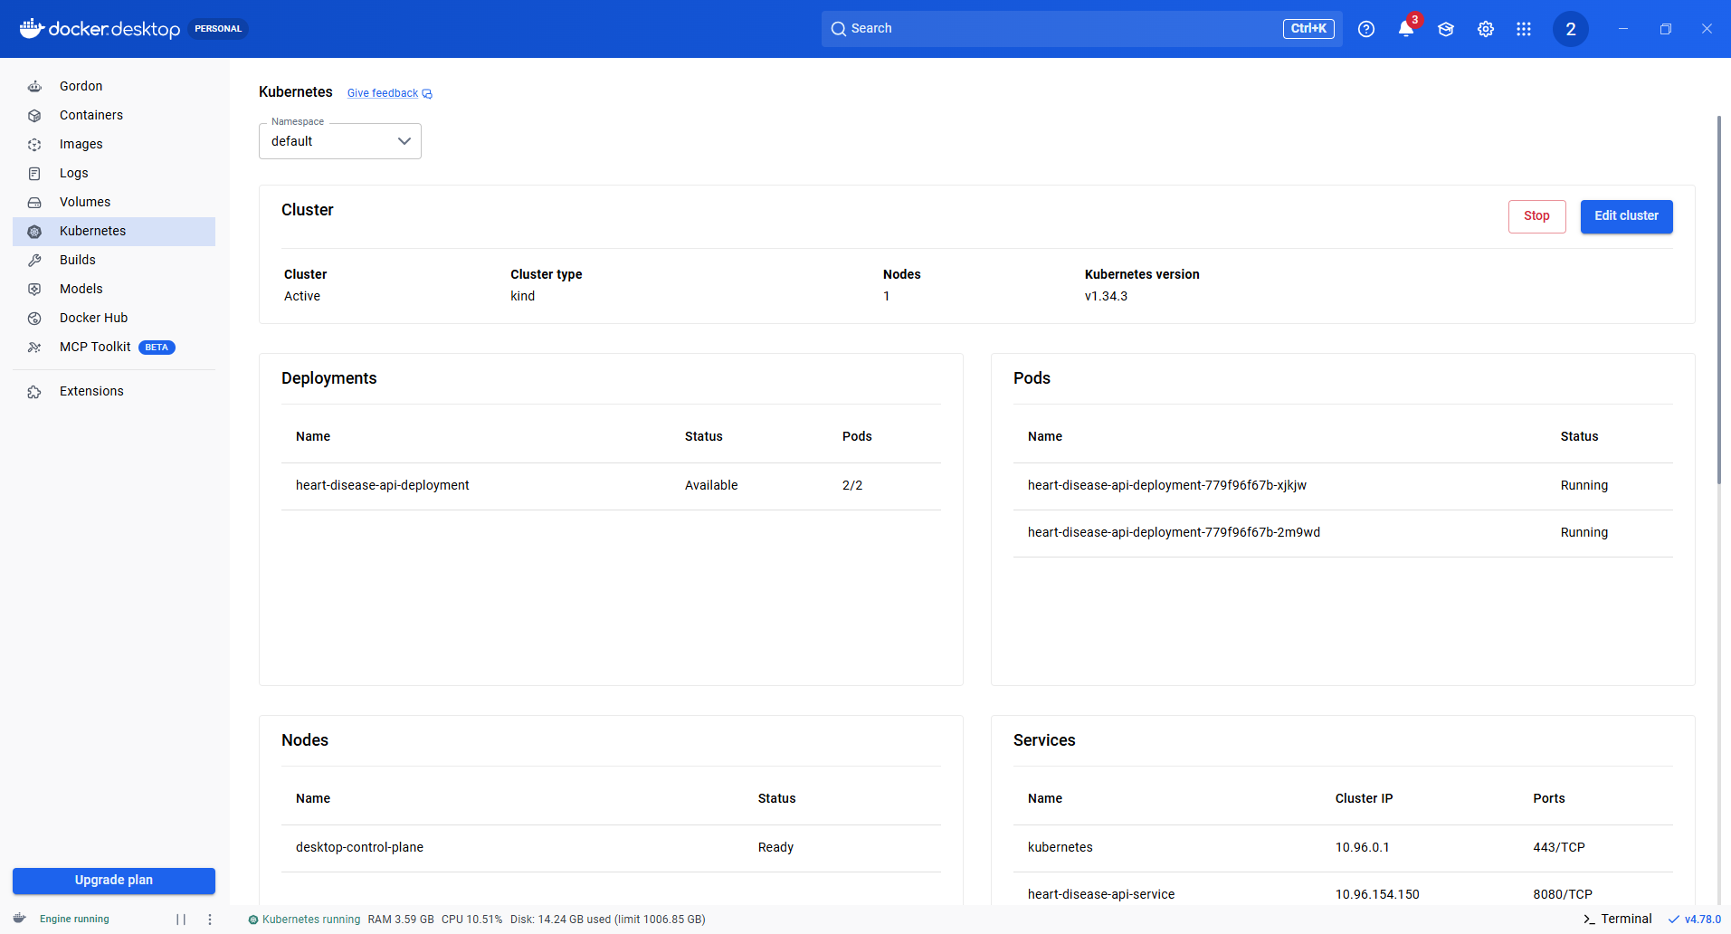
Output of terminal execution 'kubectl get pods'. Reflects multiple active pods matching the 'heart-disease-api-deployment' specification in a healthy 'Running' state.

7. Reproducible Setup & Operational Instructions
Follow these steps to replicate the training lifecycle and deploy the production-grade application cluster locally from scratch.
Step 1: Clone and Initialize Virtual Environments
git clone https://github.com/2024ac05006/heart-disease-prediction.git
cd heart-disease-prediction
python -m venv venv
source venv/bin/activate # On Windows use: venv\Scripts\activate
pip install -r requirements.txt

Step 2: Execute Automated Data Acquisition and Tests
python data/download_data.py
pytest tests/

Step 3: Deploy to Kubernetes Cluster via Helm
docker build -t heart-disease-api:latest .
kubectl config use-context docker-desktop
kubectl apply -f deployment/deployment.yaml
kubectl apply -f deployment/service.yaml
kubectl get pods

8. Reference Artifacts & Repository Blueprint
The repository layout adheres strictly to professional engineering conventions, separating deployment configurations, application code, test validation suites, and documentation.
Complete Structural Repository Tree
heart-disease-prediction/
├── .github/
│ └── workflows/
│ └── main.yml # CI/CD pipeline automation
├── charts/
│ └── heart-disease-api/ # Reusable Helm packaging structure
│ ├── Chart.yaml # Metadata
│ ├── values.yaml # Environment variables
│ └── templates/ # Cluster layout sheets
├── data/
│ ├── download_data.py # Automated acquisition module
│ └── cleaned_dataset.csv # Preprocessed model data inputs
├── deployment/
│ ├── deployment.yaml # Raw static cluster manifest
│ └── service.yaml # Cluster routing interface
├── models/
│ └── heart_disease_pipeline.pkl # Production binary pipeline artifact
├── notebooks/
│ ├── 01_EDA.ipynb # Exploration documentation
│ └── 02_Training.ipynb # Experimentation tracking logs
├── screenshots/ # Verification artifacts
├── tests/
│ └── test_model.py # Regression unit test cases
├── Dockerfile # Immutable layout recipe
└── requirements.txt # Unified library definitions

Repository URL
- Code Repository: https://github.com/2024ac05006/heart-disease-predictiosn

