SPEC-DOC · WF-01 · GHOSTRECON

TECHNICAL WIREFRAME SPECIFICATION
Structural layout reference for the GhostRecon reconnaissance platform. Covers all seven primary routes, component inventory per screen, and the navigation graph a user follows from first visit to exported results.
DOCUMENT  UX-WF-GR-01 | FIDELITY  Low / structural | VIEWPORT REF 1440 × 900 | SCREENS 7 routes | STATUS  Draft — rev.01

// LAYOUT GRID — 12 COLUMN, 24PX GUTTER, 80PX MARGIN
All component widths below snap to this grid at the 1440px reference viewport.

// 01 — NAVIGATION GRAPH

SCREEN-TO-SCREEN FLOW
no account →
→
visitor
/login
1
/signup
2
↓ session established
→
→
→
/dashboard
3
/newrecon
4
/allrecons
5
/recon/{scopeid}
6
/account
7
export · csv / txt / pdf

// 02 — SCREEN SHEETS

COMPONENT INVENTORY PER ROUTE
SHEET 01 / 07  LOGIN  GET /login |  | Session entry point. Success sets a session cookie and redirects to /dashboard.
COMPONENT NOTES
- TEXT INPUT
Accepts username or email in one field.
- PASSWORD INPUT
Masked. Inline error on failed auth, no page reload.
- PRIMARY BUTTON
Full width. Disabled state until both fields are filled.
 | ghostrecon.local/login
USERNAME / EMAIL 1
☐
REMEMBER ME
FORGOT PASSWORD?
PASSWORD
2
3
NO ACCOUNT?
CREATE ONE
→
sign in
3
SHEET 02 / 07 Account creation. Hidden site-wide if admin
SIGN UP disables signup in /account.
GET /signup
ghostrecon.local/signup  FULL NAME  EMAIL ADDRESS  PASSWORD  CONFIRM PASSWORD  1  create account | COMPONENT NOTES  ₁ MATCH VALIDATION  Client-side check against password field before submit is allowed.

SHEET 03 / 07 Landing screen post-auth. Aggregate stats, trend
DASHBOARD charts, recent scope activity.
GET /dashboard
ghostrecon.local/dashboard  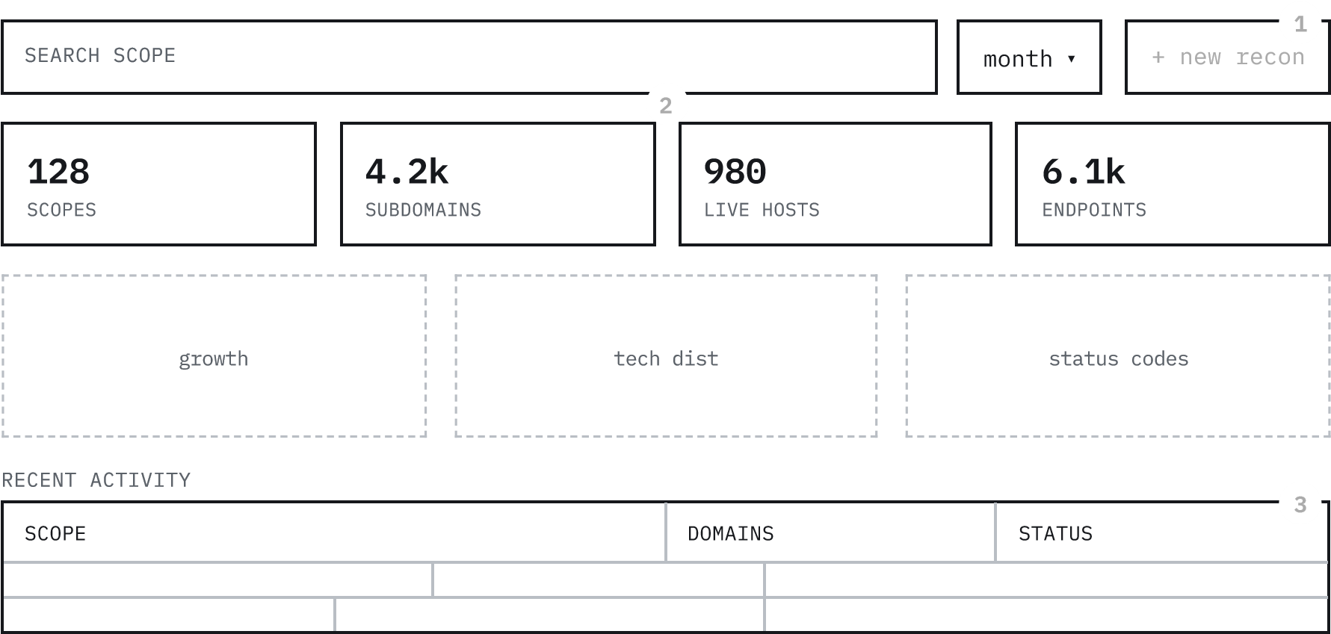 |  |  | COMPONENT NOTES  - PERSISTENT CTA  Stays fixed at top-right through scroll. Routes to /newrecon.  - STAT TILE ROW  4-up grid, re-queries on filter change (month / date-range / search).  - ACTIVITY TABLE  Row click opens /recon/{scopeid}.  Status cell is color-coded.
SHEET 04 / 07  NEW RECON  GET/POST /newrecon |  | Scope definition form. Submit triggers the Subfinder → Naabu → HTTPX → Katana pipeline.
 |  |  | COMPONENT NOTES ₁ REQUIRED FIELD
 | ghostrecon.local/newrecon

 |  |  |  | Primary target domain — the only
 | SCOPE NAME (ORGANIZATION)  CONTACT EMAIL  CONTACT URL  TARGET DOMAIN  ADDITIONAL DOMAINS  1  2  + add domain  RECURSIVE SUBDOMAIN LEVEL  start recon |  | 2 | mandatory input besides scope name.  REPEATABLE ROW  Add-domain clones the input row for multi-domain scopes.
SHEET 05 / 07
ALL RECON PROJECTS
GET /allrecons
Full

scope

index.

Sortable

table,

per-row

status

and
quick

actions.
COMPONENT NOTES
1
ROW ACTIONS
"View"

→

/recon/{scopeid}.

"Redo"

re-
triggers

the

pipeline

in

place,

status
updates

live.
ghostrecon.local/allrecons
SCOPE
CREATED
SUBS
LIVE
STATUS / ACTIONS
view
redo
1
view
redo
SHEET 06 / 07 Primary results screen — six data tabs sharing one
RECON DETAILS table pattern: search, sort, paginate, export.
GET /recon/{scopeid}
ghostrecon.local/recon/8f2a1c  3 DOMAINS 214 SUBDOMAINS 61 LIVE HOSTS 312 ENDPOINTS  domains  subdomains  live hosts  ports  urls  endpoints  SEARCH  sort  ▾  csv  txt  pdf  1  2  SUBDOMAIN IP STATUS | COMPONENT NOTES  - TAB BAR  6 tabs, same table pattern underneath each. Active tab persists in the URL hash.  - EXPORT CLUSTER  Exports respect current search/sort/filter state, not just raw table data.
SHEET 07 / 07 Profile fields, integration keys, and the site-wide
ACCOUNT signup toggle.
GET/POST /account
ghostrecon.local/account  NAME  EMAIL  TELEGRAM CHAT ID  GITHUB API KEY  DISABLE SIGNUP PAGE  1  save changes | COMPONENT NOTES  ₁ ADMIN TOGGLE  App-wide switch — when on, /signup redirects to /login for all visitors.

UX-WF-GR-01 — rev.01 — component specs and routes sourced from txt.md. Grid: 12-col / 24px gutter / 1440px reference. Fidelity: structural only, not final visual design.

