MLOps Heart Disease Risk Prediction
End-to-End Machine Learning Operations Project Report
Raw UCI data acquisition | EDA | Model training | MLflow | CI/CD | Docker | Kubernetes | Railway

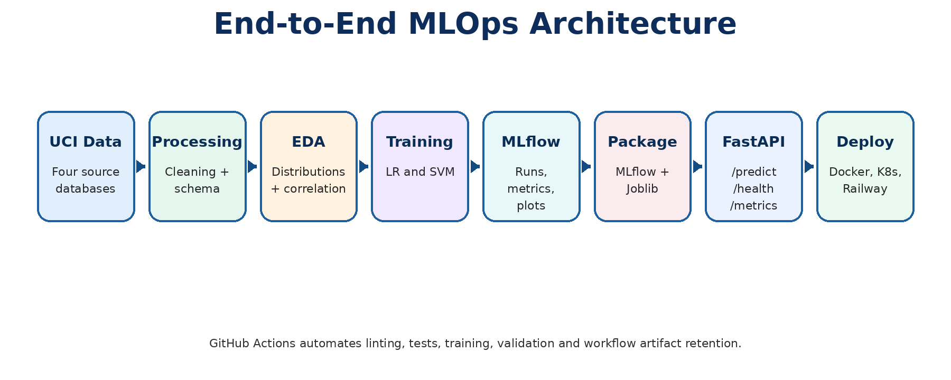
Figure 1. End-to-end MLOps architecture.

Figure 2. One-page execution map with commands.
Item | Evidence
Repository | https://github.com/2024ad05460-hub/MLOPS.git
Dataset | UCI Heart Disease raw 76-attribute source files
Target | Binary heart disease risk classification
Model serving | FastAPI with /health, /predict and /metrics endpoints
Deployment evidence | Local FastAPI, Docker, GitHub Actions, Kubernetes local deployment and Railway cloud deployment
Drive | https://drive.google.com/drive/folders/12ZUrvO7q2iyv-i4JJDqAh1MGatoJHHyn?usp=drive_link

Summary
This final report documents the complete MLOps implementation for heart disease risk prediction using the UCI Heart Disease data. The solution implements raw-data acquisition, preprocessing, exploratory analysis, model training and tuning, experiment tracking, model packaging, automated testing, CI/CD, containerized serving, local Kubernetes deployment and cloud deployment evidence.
The final model-development workflow now includes three classifiers: Logistic Regression, Random Forest Classifier and Support Vector Machine. Random Forest is included as the strongest model from the current evidence package, with the highest recall, F1-score, accuracy and ROC-AUC in the model comparison output.
The report also includes all 52 screenshots from the attached Run Report as a dedicated execution-evidence appendix, without removing the previously supplied screenshots.
Summary item | Current evidence
Best model selected | RandomForestClassifier
Selection rule | Prioritize recall, then ROC-AUC, then F1 due to healthcare-style false-negative risk
Random Forest test accuracy | 84.6%
Random Forest class-1 recall | 90.1%
Random Forest ROC-AUC | 90.7%
Unit tests | Pytest API, data-processing and model-training tests
Code quality | Ruff linting
Serving and monitoring | FastAPI + request logging + Prometheus-compatible metrics endpoint

Report Structure

- Project context and objectives
- Data acquisition and exploratory data analysis
- Feature engineering and model development
- Experiment tracking with MLflow
- Model packaging and reproducibility
- CI/CD pipeline and automated testing
- Model containerization and API serving
- Production deployment
- Monitoring and logging
- Setup and execution instructions
- Evidence appendix with all run screenshots

1. Project Context and Objectives
The project objective is to deliver a reproducible MLOps pipeline for binary heart disease risk prediction. The API accepts patient-level clinical features and returns a predicted class, confidence score, probability of heart disease and model metadata.
- Use raw UCI source files rather than processed convenience files.
- Develop a clear data pipeline with cleaning, target conversion and profiling.
- Train and compare multiple classification models under cross-validation.
- Track model experiments and artifacts with MLflow.
- Package the final model and preprocessing pipeline for reproducible serving.
- Validate the codebase with linting and unit tests.
- Serve the model through a containerized FastAPI service and demonstrate deployment evidence.

2. Data Acquisition and Exploratory Data Analysis

2.1 Dataset acquisition approach
The acquisition workflow downloads the official UCI Heart Disease raw archive files and constructs the model-ready dataset from the original 76-attribute institutional source files. The modeling workflow intentionally excludes the processed.* convenience files to preserve the raw-only policy.
Raw source database | File used
Cleveland | cleveland.data
Hungarian | hungarian.data
Switzerland | switzerland.data
Long Beach VA | long-beach-va.data

2.2 Cleaning and preprocessing controls
- Raw records are tokenized into 76-attribute patient records.
- The 14 documented machine-learning variables are extracted directly from the raw records.
- Missing markers such as -9, -9.0 and ? are converted to missing values.
- Numeric fields are converted with type coercion.
- Original UCI diagnosis is converted into a binary target: 0 = no disease, 1 = disease risk present.
- EDA output tables and figures are saved under artifacts/eda and artifacts/figures/eda.

2.3 EDA visualizations
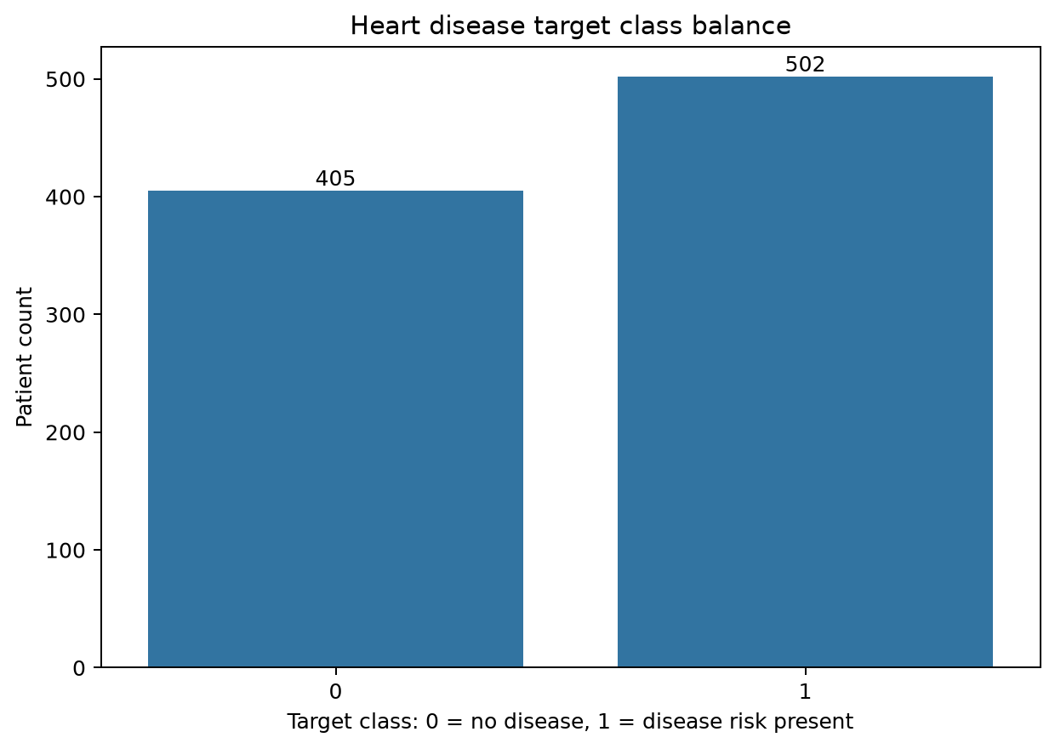
Figure 3. Raw-only heart disease target class balance.
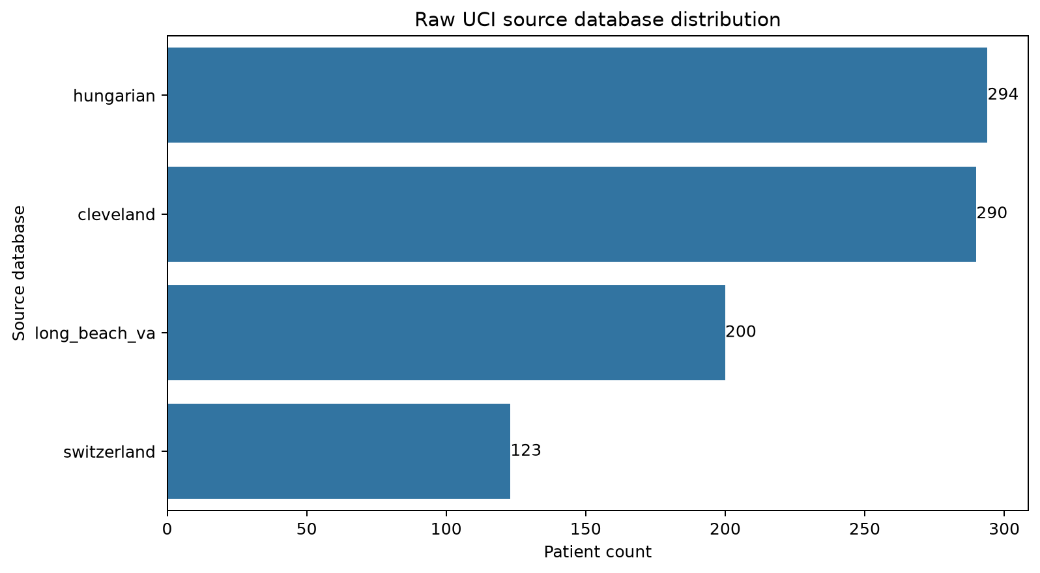
Figure 4. Source-database distribution across UCI raw institutional databases.
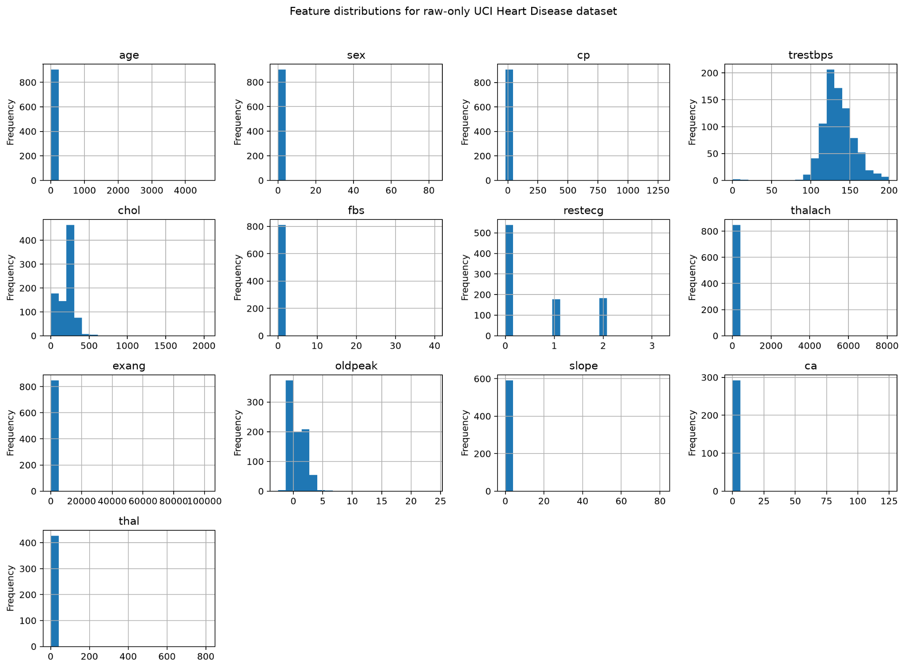
Figure 5. Feature distributions for selected raw-only UCI variables.
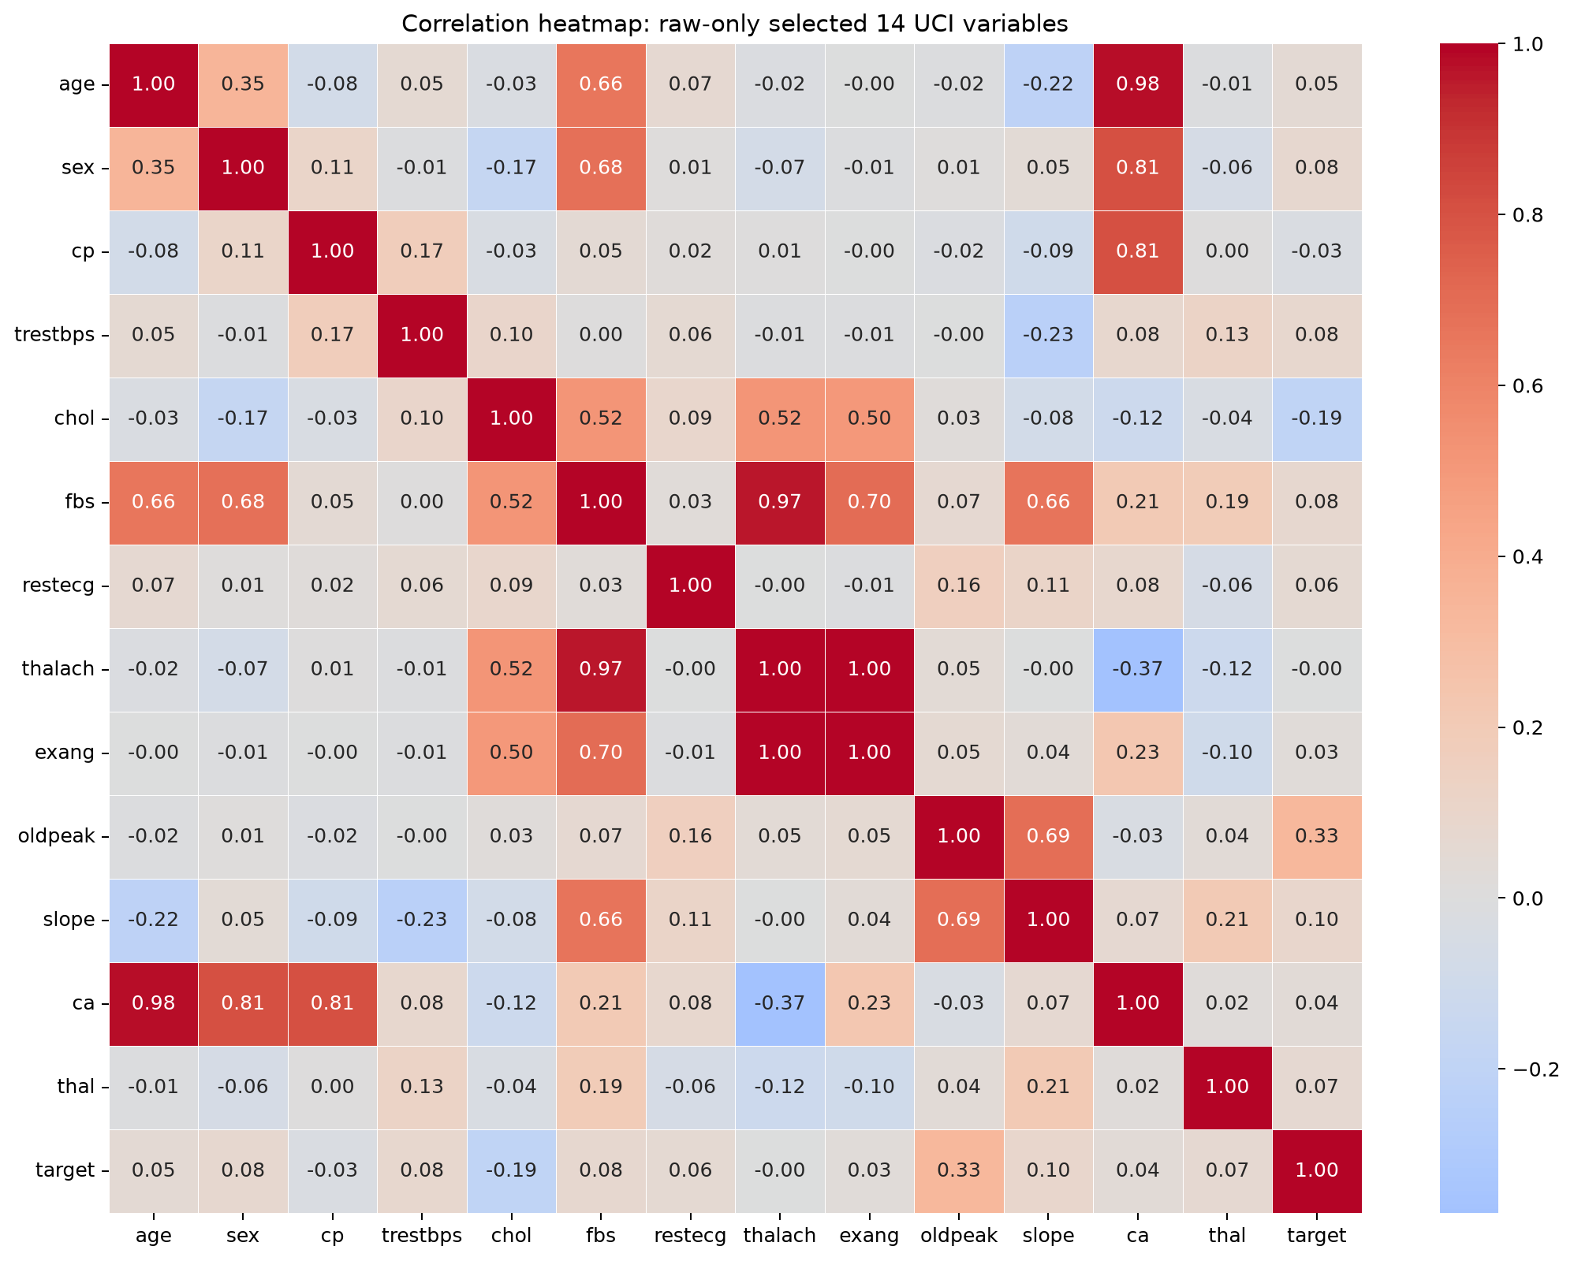
Figure 6. Correlation heatmap across selected variables and target.
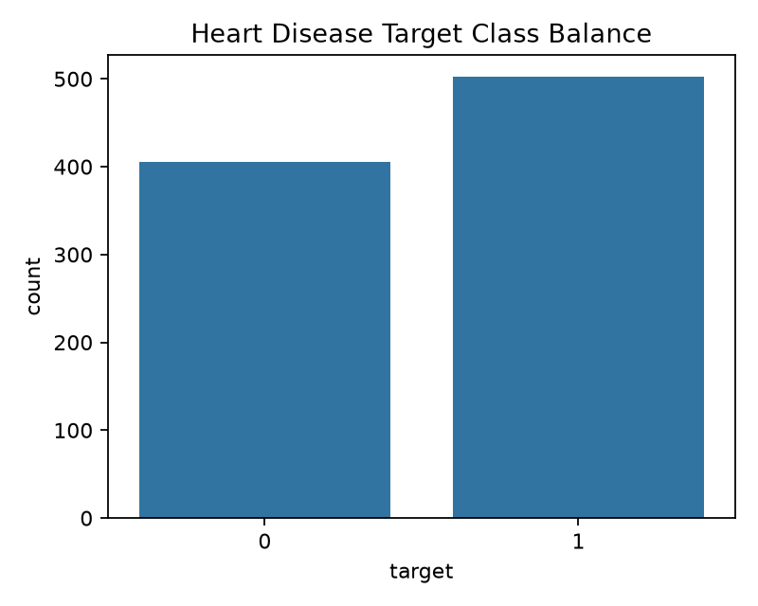
Figure 7. Training workflow class-balance output.
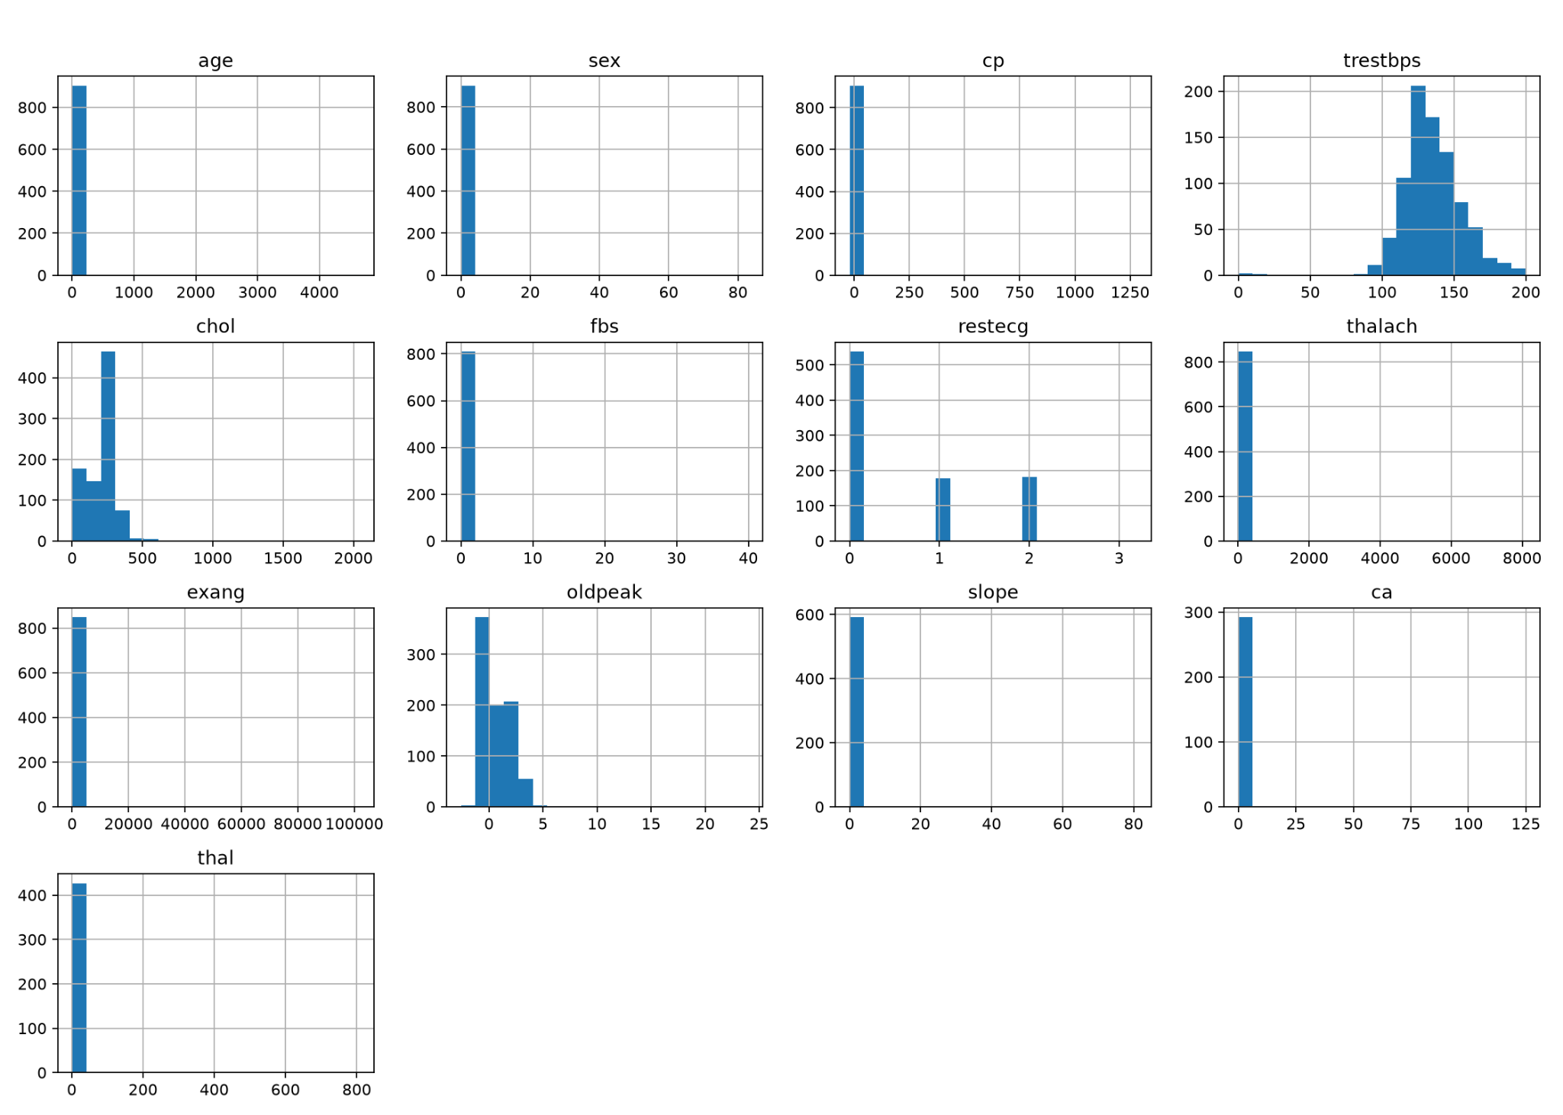
Figure 8. Training workflow feature histogram output.
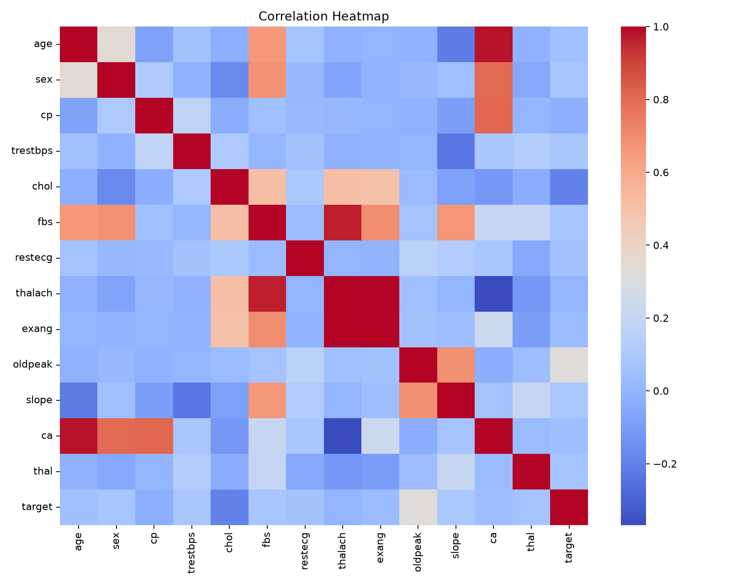
Figure 9. Training workflow correlation heatmap output.
EDA interpretation: the target distribution is reasonably balanced for binary classification, with disease-risk-present observations slightly higher than no-disease observations. The source-distribution chart demonstrates that the modeling dataset consolidates multiple institutional raw sources. The feature histograms and heatmaps provide both modeling insight and data-quality evidence for the preprocessing pipeline.

3. Feature Engineering and Model Development

3.1 Final feature set
Feature group | Variables | Processing
Numeric | age, trestbps, chol, thalach, oldpeak, ca | Median imputation and StandardScaler
Categorical | sex, cp, fbs, restecg, exang, slope, thal | Most-frequent imputation and OneHotEncoder(handle_unknown=ignore)
Target | target | Binary: 0 = no disease, 1 = disease risk present

3.2 Model candidates and tuning
The training script evaluates three classification models using scikit-learn pipelines, preprocessing transformers and GridSearchCV. The search score is ROC-AUC, and the final selection rule prioritizes recall, then ROC-AUC, then F1-score. This selection rule is appropriate for a healthcare-style screening problem because false negatives are operationally more serious than false positives.
Model | Role in project | Tuned hyperparameters
Logistic Regression | Interpretable baseline classifier | C, solver
Random Forest Classifier | Tree-based ensemble model for nonlinear interactions | n_estimators, max_depth, min_samples_leaf
Support Vector Machine | Margin-based classifier with nonlinear kernel option | C, kernel

3.3 Model comparison summary
Model | Accuracy | Precision | Recall | F1 | ROC-AUC | Best CV ROC-AUC | Best parameters
RandomForestClassifier | 84.6% | 83.5% | 90.1% | 86.7% | 90.7% | 88.7% | classifier__max_depth: 6, classifier__min_samples_leaf: 3, classifier_...
SupportVectorMachine | 81.9% | 80.9% | 88.1% | 84.4% | 90.6% | 88.8% | classifier__C: 2.0, classifier__kernel: rbf
LogisticRegression | 80.2% | 80.4% | 85.1% | 82.7% | 90.0% | 87.4% | classifier__C: 0.1, classifier__solver: lbfgs

Result: RandomForestClassifier is the strongest candidate in this run. It achieves the best test accuracy, recall, F1-score and ROC-AUC while maintaining strong class-0 and class-1 performance.

Logistic Regression
The Logistic Regression model provides an interpretable baseline and achieves a ROC-AUC of about 0.900.
precision recall f1-score support
0 0.80 0.74 0.77 81
1 0.80 0.85 0.83 101
accuracy 0.80 182
macro avg 0.80 0.80 0.80 182
weighted avg 0.80 0.80 0.80 182

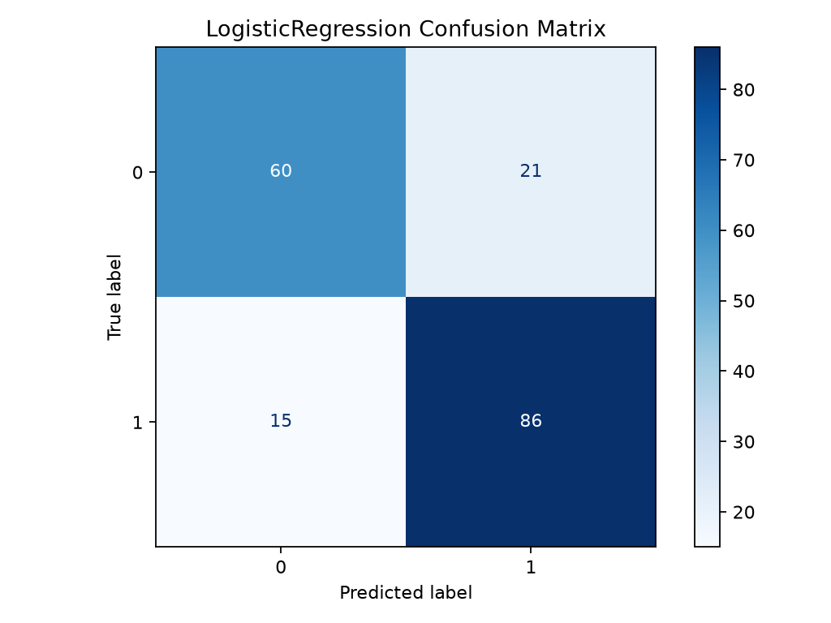
Logistic Regression confusion matrix.
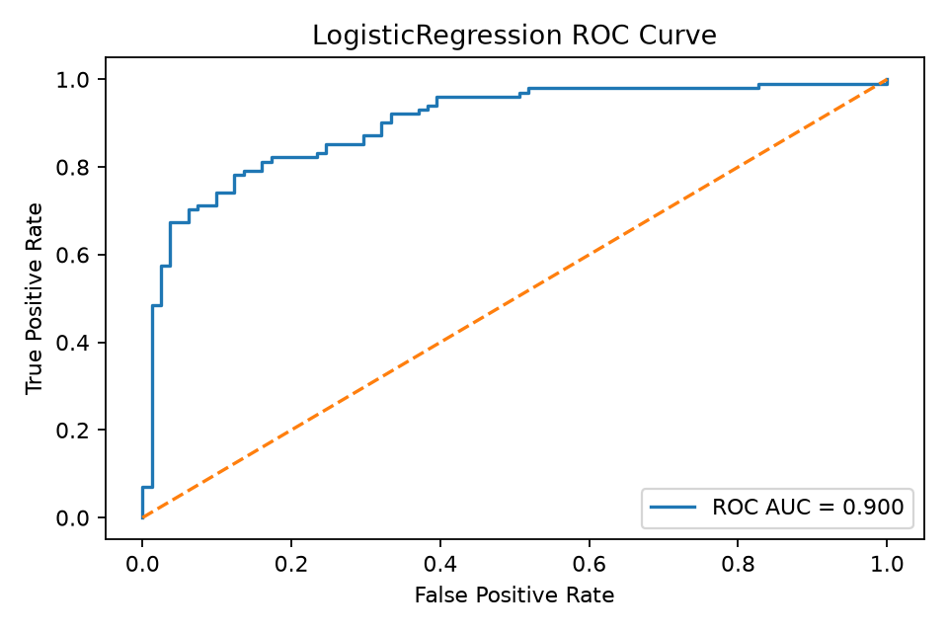
Logistic Regression ROC curve.

Random Forest Classifier
The Random Forest model is the final recommended model based on the current evidence package. It achieves the strongest recall and ROC-AUC balance.
precision recall f1-score support
0 0.86 0.78 0.82 81
1 0.83 0.90 0.87 101
accuracy 0.85 182
macro avg 0.85 0.84 0.84 182
weighted avg 0.85 0.85 0.85 182

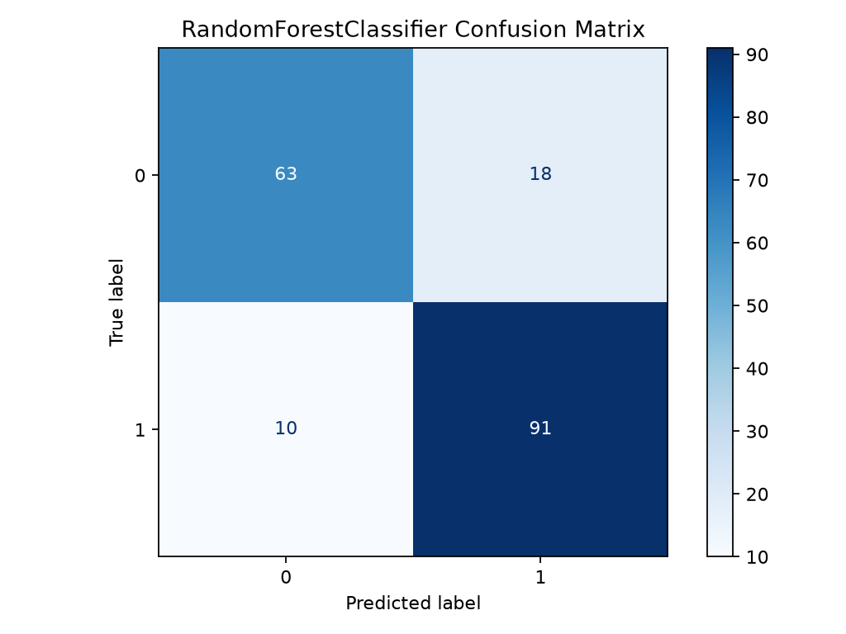
Random Forest Classifier confusion matrix.
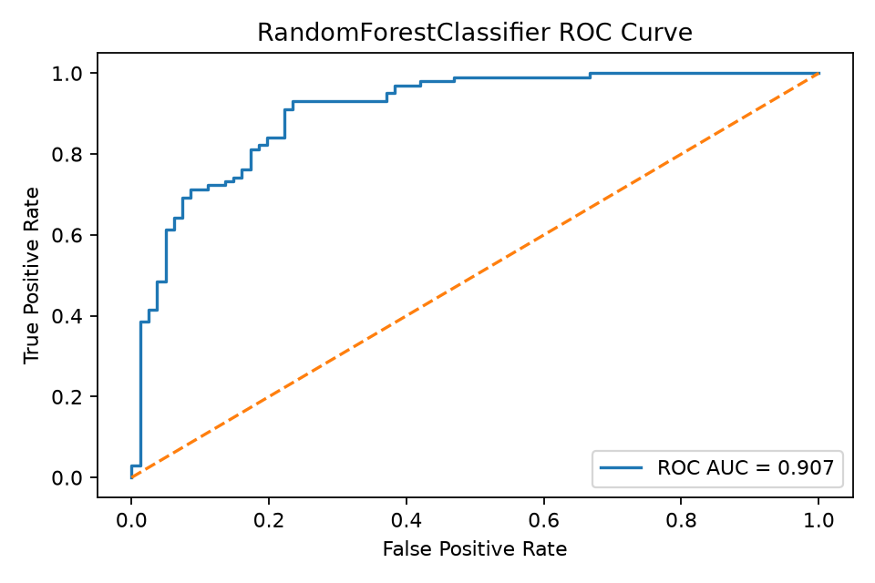
Random Forest Classifier ROC curve.

Support Vector Machine
The Support Vector Machine provides strong ROC-AUC and recall, but the Random Forest result is stronger overall in this evidence package.
precision recall f1-score support
0 0.83 0.74 0.78 81
1 0.81 0.88 0.84 101
accuracy 0.82 182
macro avg 0.82 0.81 0.81 182
weighted avg 0.82 0.82 0.82 182

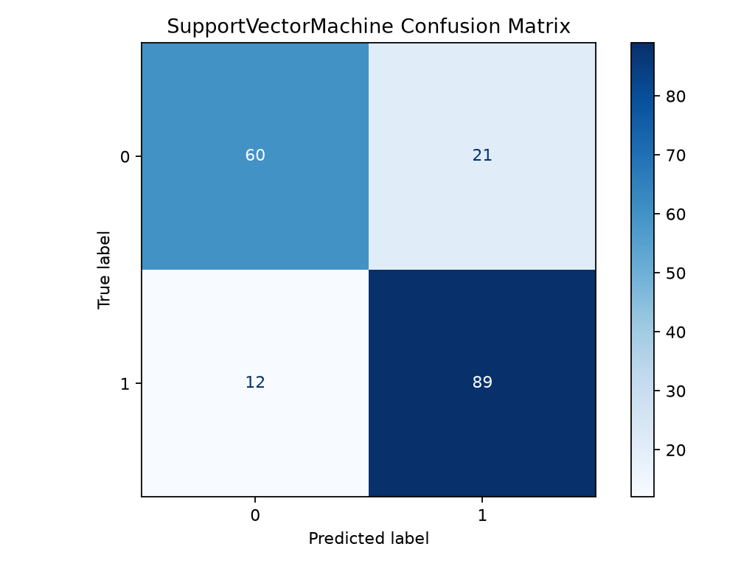
Support Vector Machine confusion matrix.
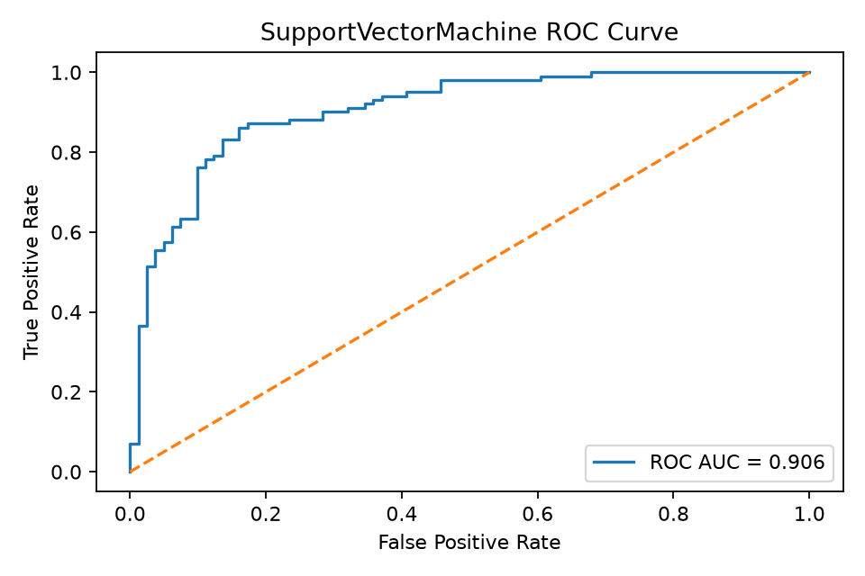
Support Vector Machine ROC curve.

4. Experiment Tracking with MLflow
MLflow is integrated into the training workflow to provide experiment traceability. Each model run logs the model type, hyperparameters, cross-validation ROC-AUC, test metrics, confusion matrix, ROC curve, classification report and serialized MLflow model artifact.
- Tracking store: mlruns directory.
- Experiment name: heart-disease-risk-prediction-mlops-raw-76-only.
- Logged artifacts: confusion matrix, ROC curve, classification report and MLflow model.
- Logged metrics: best_cv_roc_auc, accuracy, precision, recall, F1-score and ROC-AUC.
mlflow ui --backend-store-uri mlruns --host 127.0.0.1 --port 5000
# Open: http://127.0.0.1:5000

5. Model Packaging and Reproducibility
The final selected model is saved as a reusable Joblib artifact. The fitted preprocessing pipeline is also saved separately to support reproducibility, feature transformation consistency and future validation. The project also includes MLflow model packaging artifacts such as MLmodel, conda.yaml, python_env.yaml and model.pkl.
Artifact | Purpose
models/final_model.joblib | Reusable final inference pipeline/model artifact
models/preprocessing_pipeline.joblib | Reusable fitted preprocessing transformer
models/model_metadata.json | Model name, version, selection rule, feature list and metrics
model_comparison.csv | Cross-model comparison table
requirements.txt or environment files | Dependency reproducibility
MLmodel / conda.yaml / python_env.yaml / model.pkl | MLflow model packaging evidence

dir models
python -c "import joblib; model=joblib.load('models/final_model.joblib'); print(type(model))"
python -m pip check

6. CI/CD Pipeline and Automated Testing
The project validates quality and reproducibility through both local commands and GitHub Actions. The local validation evidence shows Ruff and Pytest passing. The workflow design includes linting, unit tests, data acquisition, EDA, training, artifact validation and artifact upload for each workflow run.
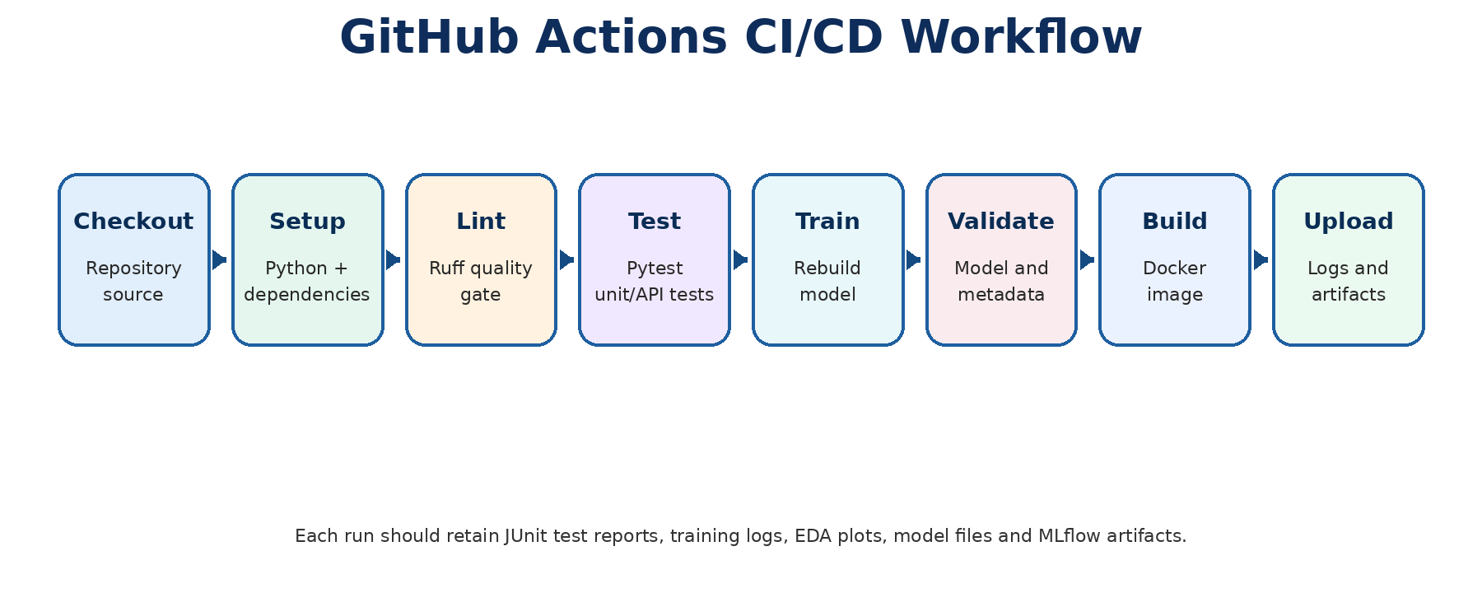
Figure 10. CI/CD workflow view.
Test file | Validation coverage
tests/test_api.py | Root endpoint, health endpoint and prediction response/schema behavior
tests/test_data_processing.py | Binary target conversion and retained feature columns
tests/test_model_training.py | Preprocessor output shape and train/predict pipeline sanity check

ruff check src api tests
pytest -q
# Expected: all checks passed and all tests passed

7. Model Containerization and API Serving
The serving layer uses FastAPI. The application exposes root, health, predict and metrics endpoints. The /predict endpoint accepts validated JSON input and returns prediction, risk label, confidence, probability, model name and model version. Docker packages this API for consistent local and deployment execution.
Endpoint | Method | Purpose
/ | GET | Service landing response with endpoint list
/health | GET | Model-artifact readiness and model path check
/predict | POST | Prediction API for patient JSON payload
/metrics | GET | Prometheus-compatible request, error, latency and prediction counters
/docs | GET | Swagger UI for manual API testing

python -m uvicorn api.main:app --host 0.0.0.0 --port 8000
# Local browser URL: http://127.0.0.1:8000/docs
docker build -t heart-disease-mlops:latest .
docker run --rm -p 8000:8000 heart-disease-mlops:latest

8. Production Deployment

8.1 Local Kubernetes deployment
The Kubernetes evidence demonstrates local container orchestration using Docker Desktop Kubernetes. The service is exposed by Kubernetes manifests and tested through port forwarding to access Swagger and health endpoints.
kubectl get nodes
kubectl apply -f deployment/deployment.yaml
kubectl apply -f deployment/service.yaml
kubectl get deployments
kubectl get pods
kubectl get services
kubectl port-forward service/heart-disease-service 8000:80

8.2 Railway cloud deployment
Railway is used as the public cloud deployment endpoint for the Dockerized API. The deployment is verified through public routes such as /, /health, /docs and /metrics. Public URL used in the evidence package: https://heart-disease-mlops-api-production.up.railway.app

9. Monitoring and Logging
Monitoring is implemented at the API layer through structured request logging and Prometheus-compatible metrics. The middleware records request method, endpoint, status code and latency. Counters track total API requests, model predictions and API errors; a histogram records latency.
Monitoring element | Implementation
Request logging | FastAPI middleware logs method, endpoint, status and latency
Request count | api_requests_total counter by method, endpoint and status
Prediction count | model_predictions_total counter by predicted class
Error count | api_errors_total counter by endpoint
Latency | api_request_latency_seconds histogram by endpoint

10. Setup and End-to-End Execution Instructions
cd C:\Users\ASUS\MLOPS\mlops-heart-disease-v3
.\.venv\Scripts\activate
python -m pip install --upgrade pip
pip install -r requirements.txt
python -m src.data_acquisition
python -m src.eda
python -m src.train
ruff check src api tests
pytest -q
mlflow ui --backend-store-uri mlruns --host 127.0.0.1 --port 5000
python -m uvicorn api.main:app --host 0.0.0.0 --port 8000
docker build -t heart-disease-mlops:latest .
docker run --rm -p 8000:8000 heart-disease-mlops:latest
git add .
git commit -m "Final MLOps heart disease project"
git push

11. Architecture diagram

