Run Screenshot 01: Activate virtual environment
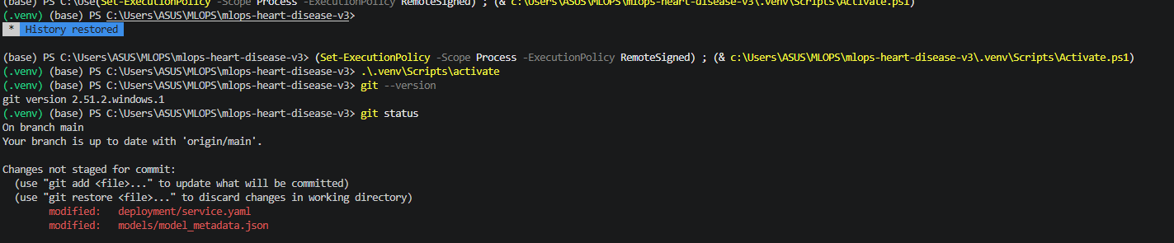
Run Screenshot 01. Activate virtual environment.

Run Screenshot 02: Activate virtual environment
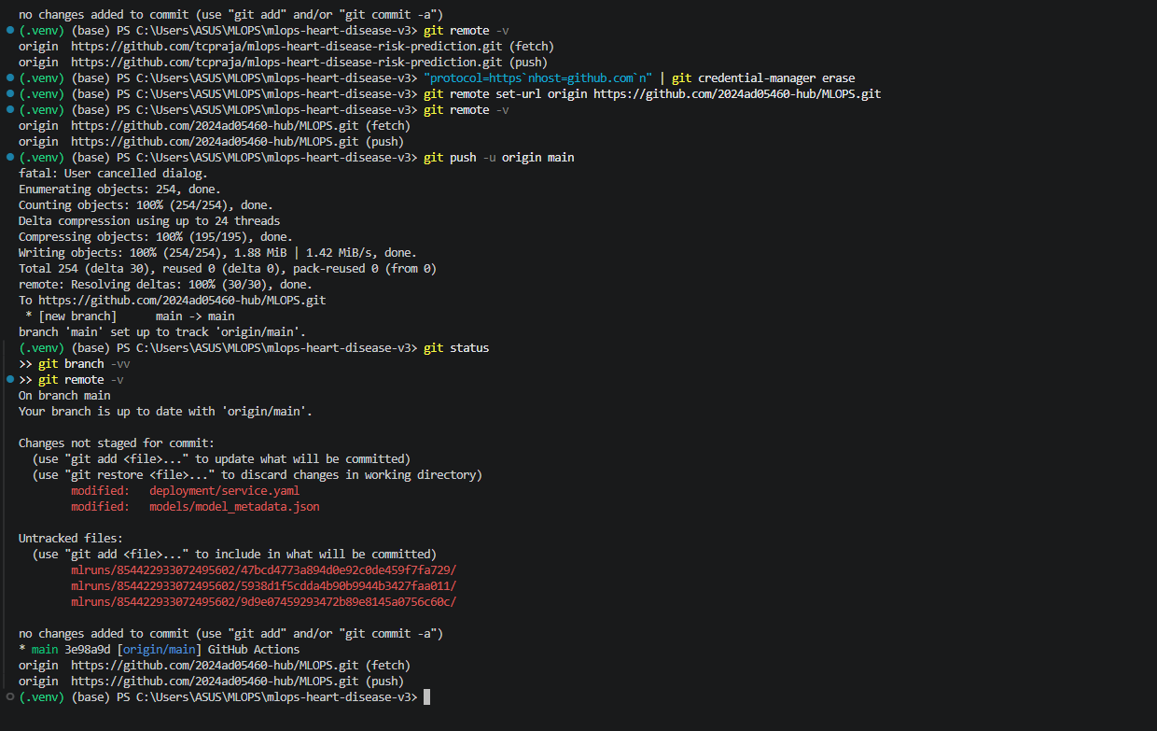
Run Screenshot 02. Activate virtual environment.

Run Screenshot 03: Install dependencies
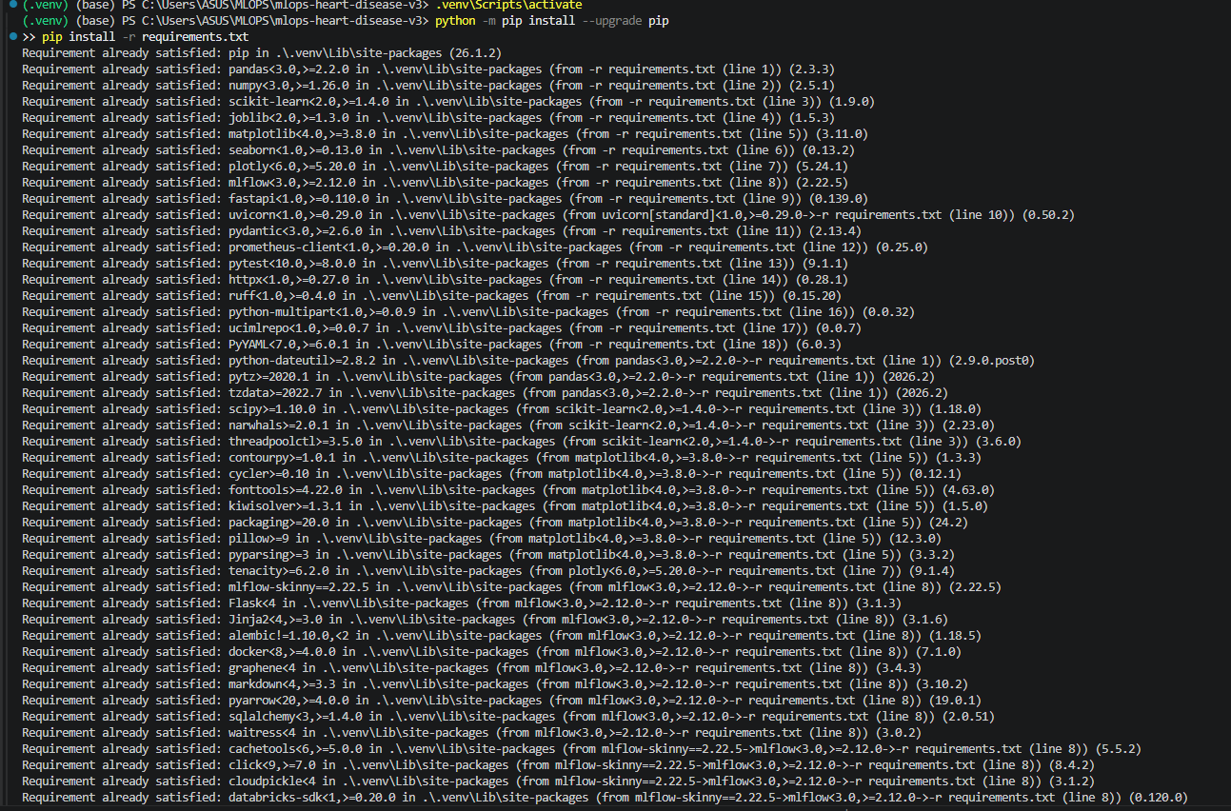
Run Screenshot 03. Install dependencies.

Run Screenshot 04: Install dependencies
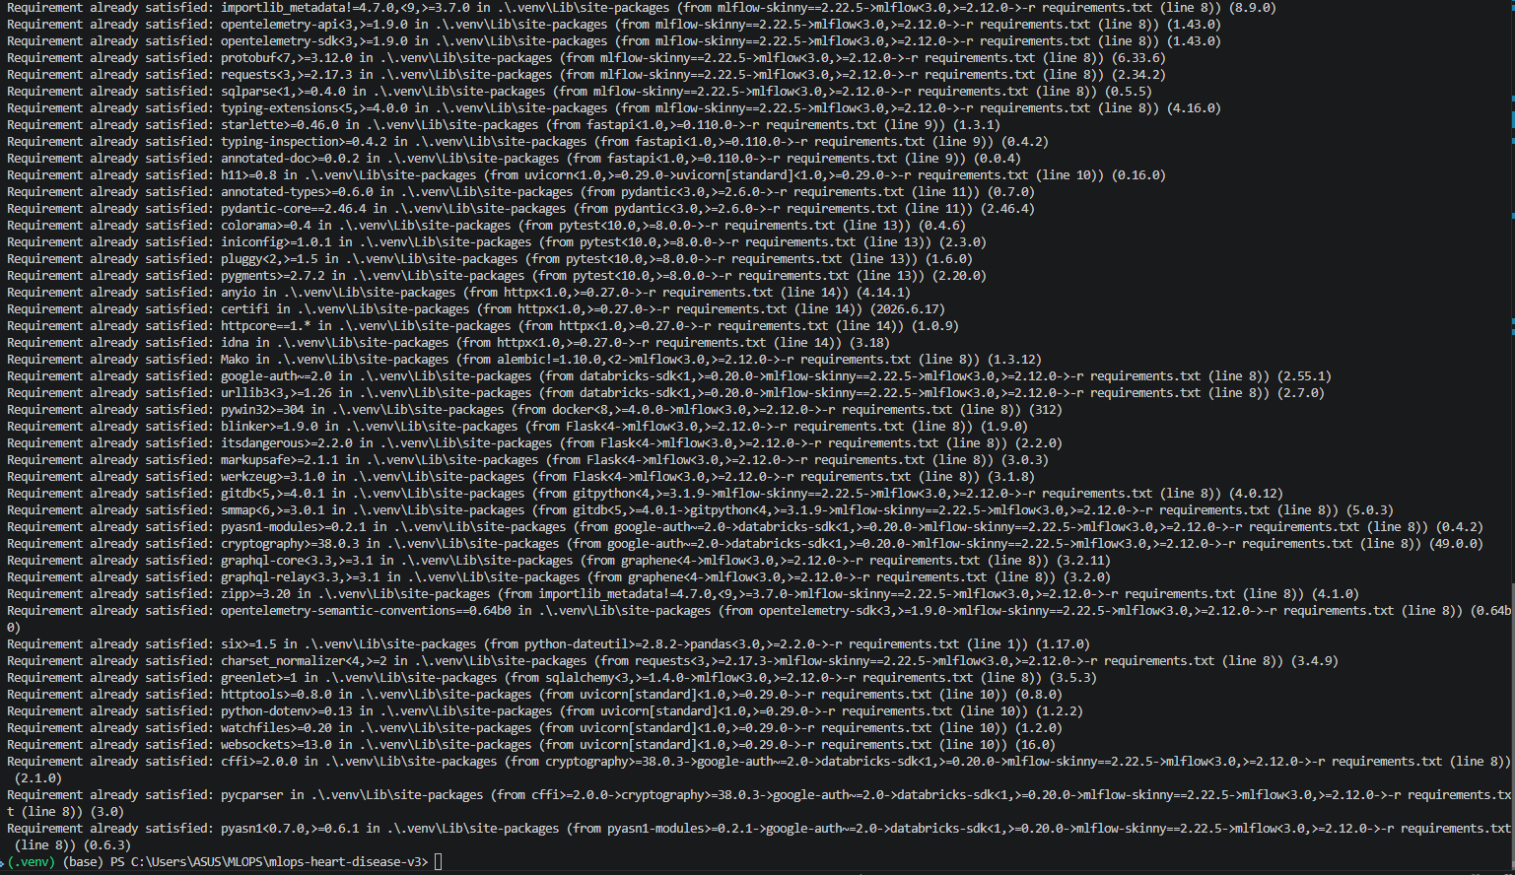
Run Screenshot 04. Install dependencies.

Run Screenshot 05: Run data acquisition
Run Screenshot 05. Run data acquisition.

Run Screenshot 06: Run EDA
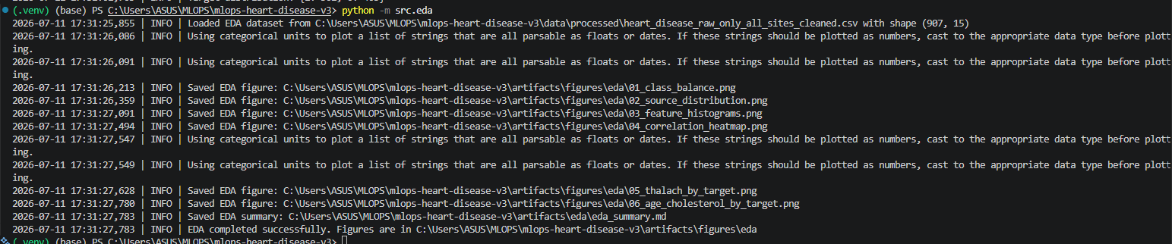
Run Screenshot 06. Run EDA.

Run Screenshot 07: Run EDA
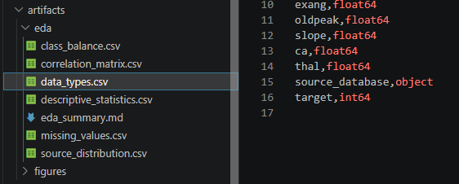
Run Screenshot 07. Run EDA.

Run Screenshot 08: Run EDA
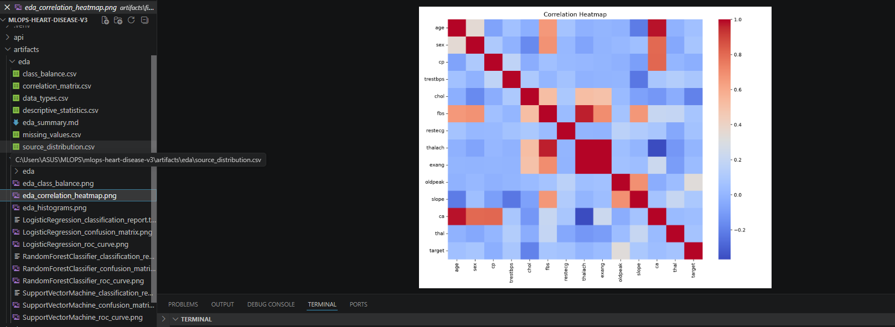
Run Screenshot 08. Run EDA.

Run Screenshot 09: Train models
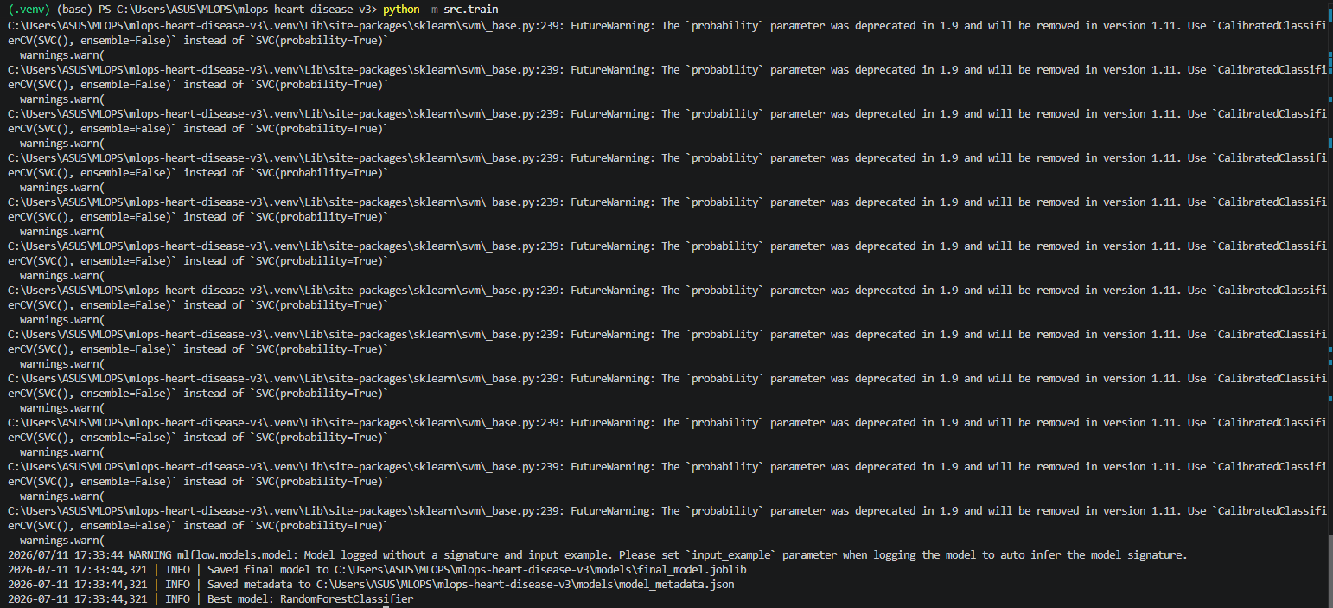
Run Screenshot 09. Train models.

Run Screenshot 10: Train models
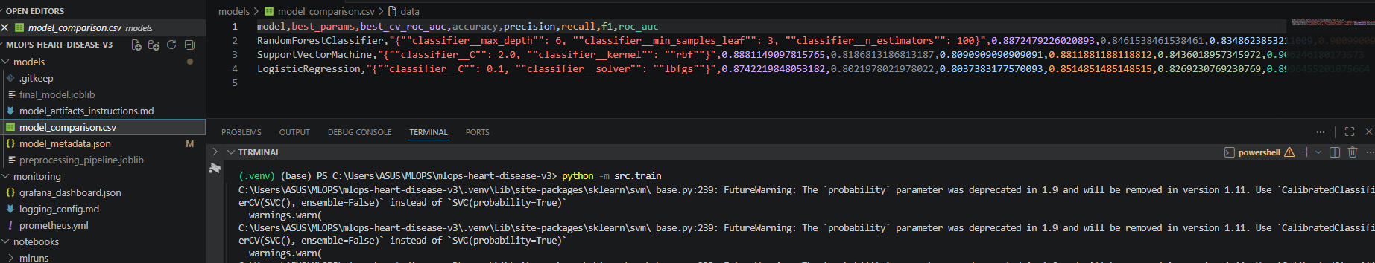
Run Screenshot 10. Train models.

Run Screenshot 11: Train models
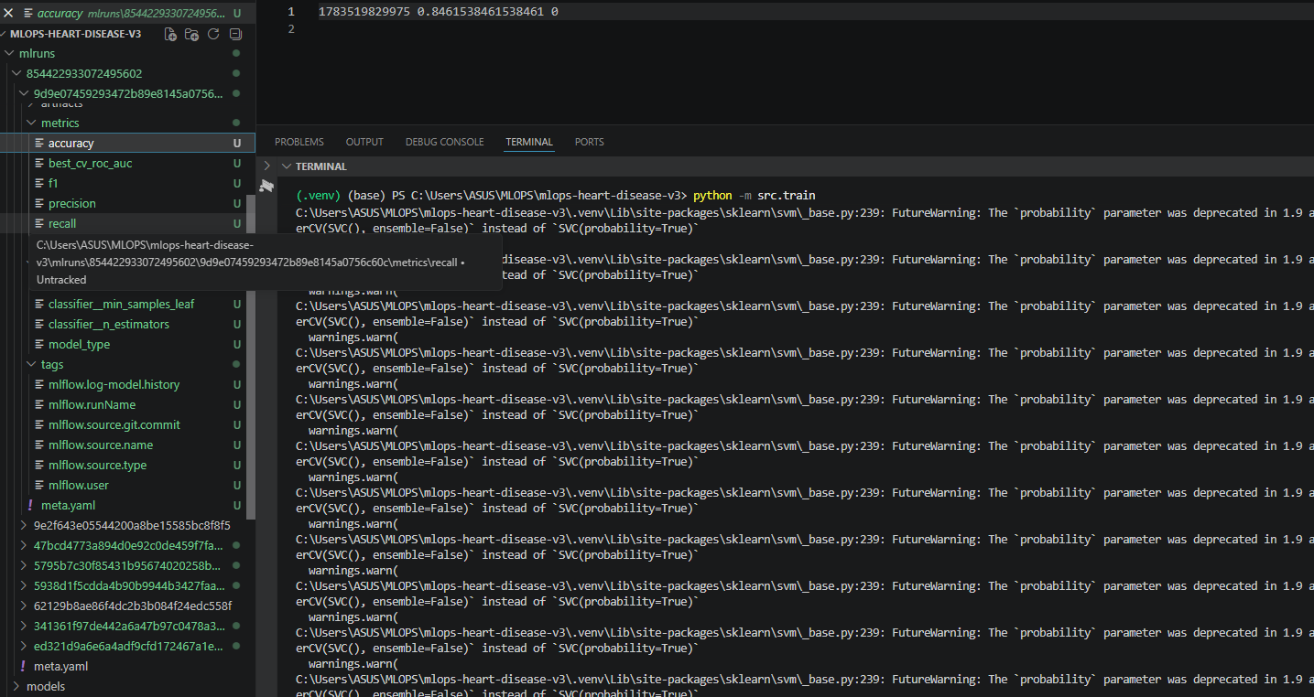
Run Screenshot 11. Train models.

Run Screenshot 12: Open MLflow tracking UI
Run Screenshot 12. Open MLflow tracking UI.

Run Screenshot 13: Open MLflow tracking UI
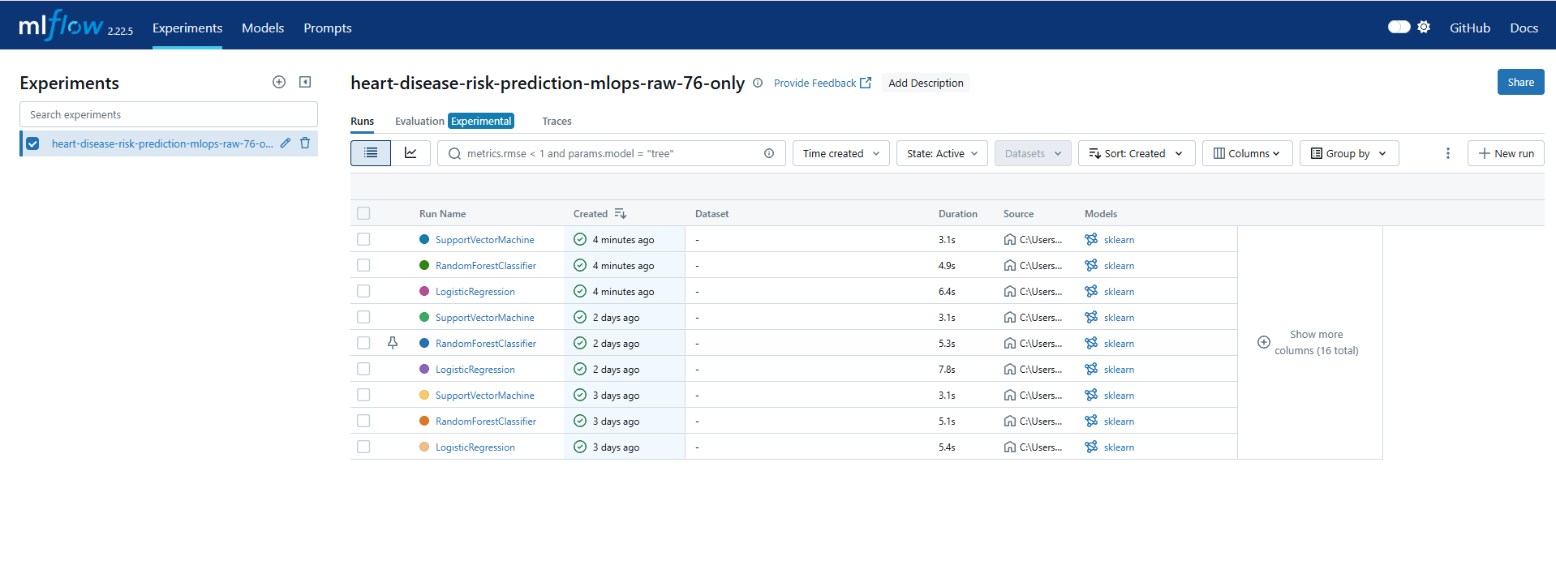
Run Screenshot 13. Open MLflow tracking UI.

Run Screenshot 14: Open MLflow tracking UI
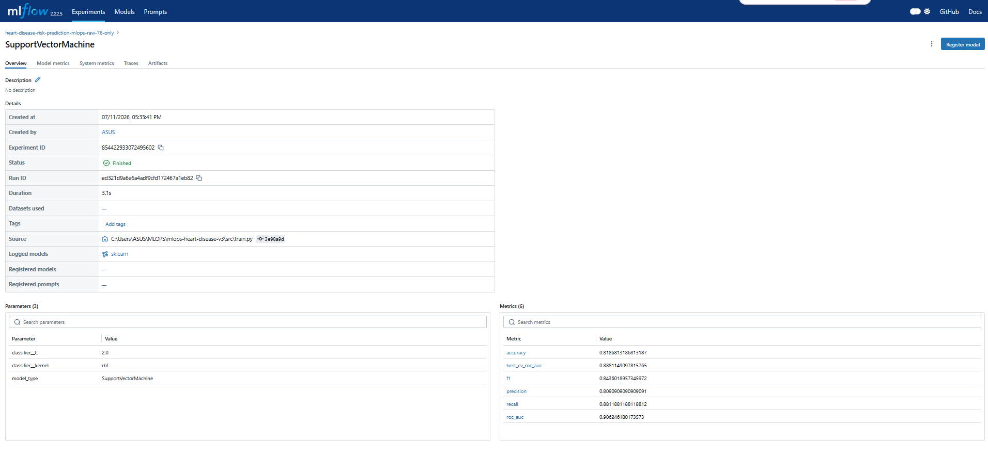
Run Screenshot 14. Open MLflow tracking UI.

Run Screenshot 15: Open MLflow tracking UI
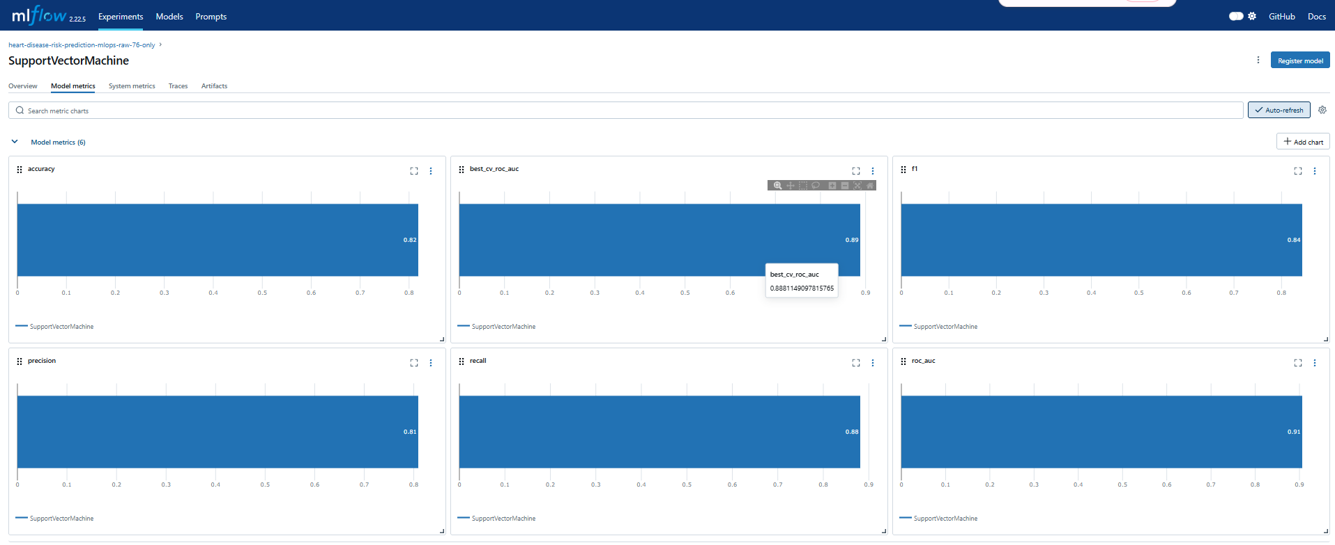
Run Screenshot 15. Open MLflow tracking UI.

Run Screenshot 16: Open MLflow tracking UI
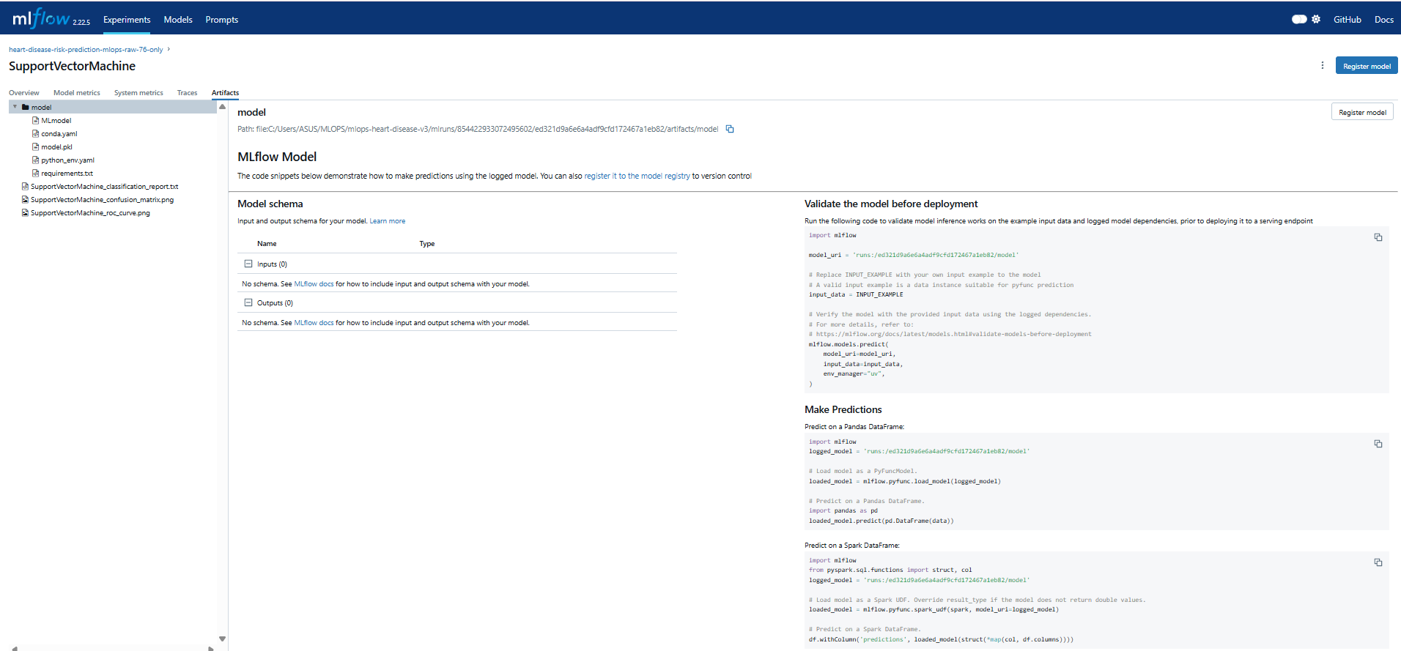
Run Screenshot 16. Open MLflow tracking UI.

Run Screenshot 17: Open MLflow tracking UI
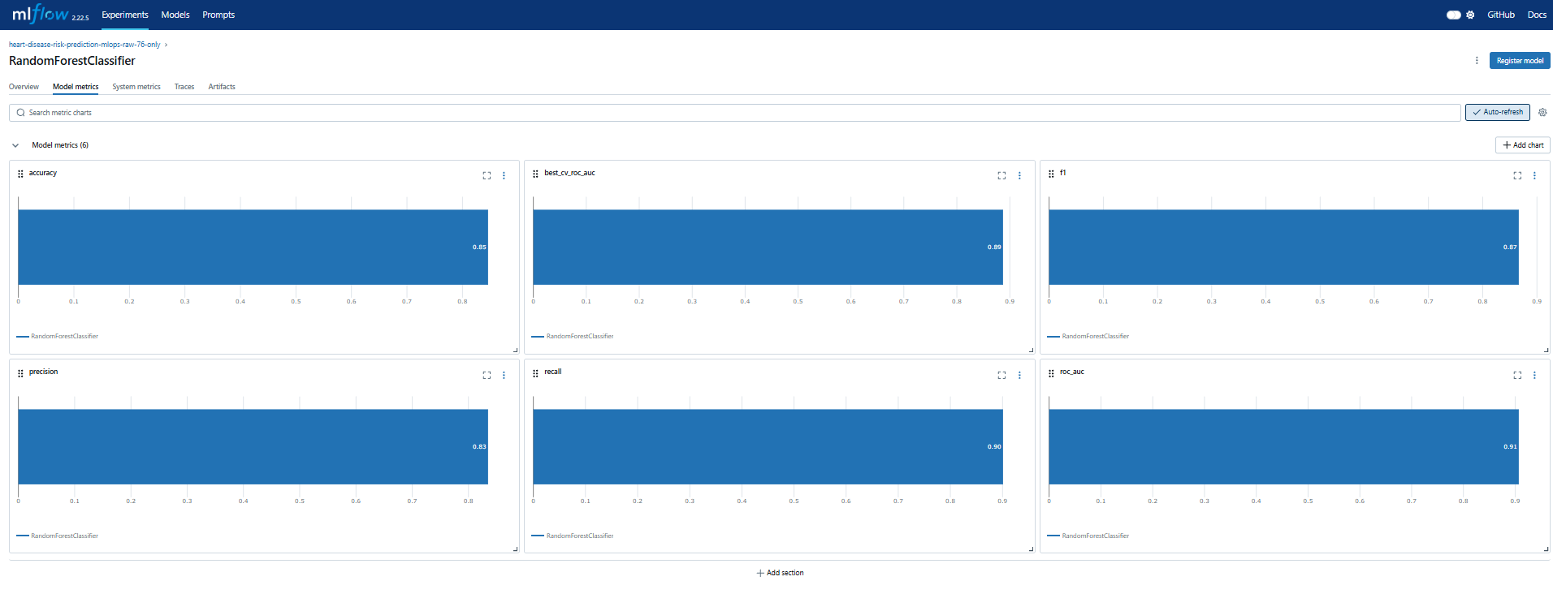
Run Screenshot 17. Open MLflow tracking UI.

Run Screenshot 18: Open MLflow tracking UI
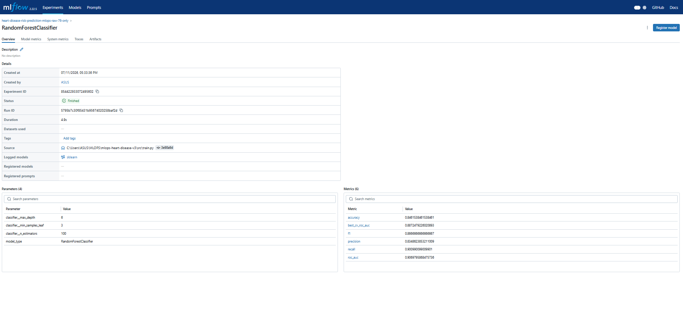
Run Screenshot 18. Open MLflow tracking UI.

Run Screenshot 19: Open MLflow tracking UI
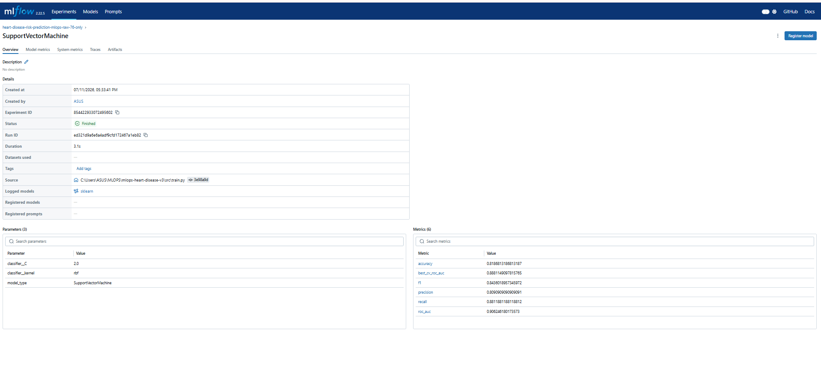
Run Screenshot 19. Open MLflow tracking UI.

Run Screenshot 20: Open MLflow tracking UI
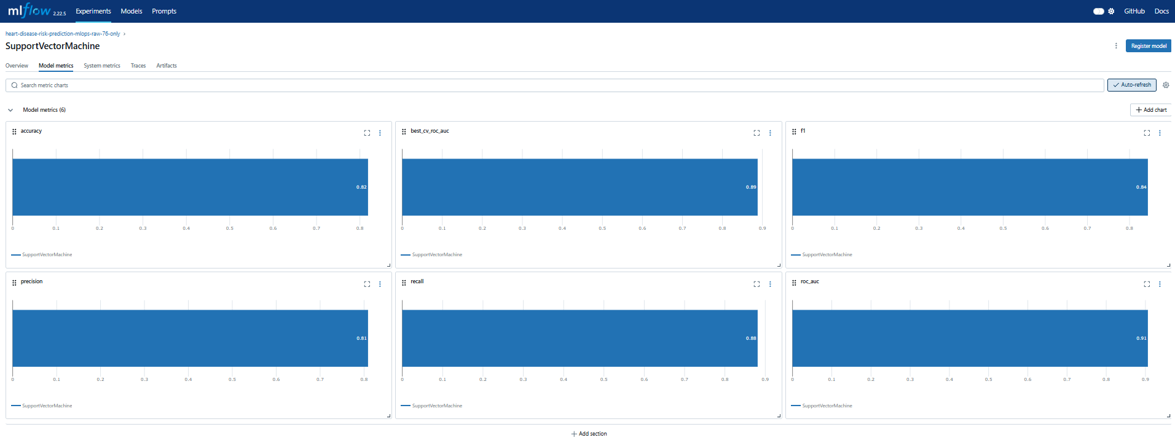
Run Screenshot 20. Open MLflow tracking UI.

Run Screenshot 21: Open MLflow tracking UI
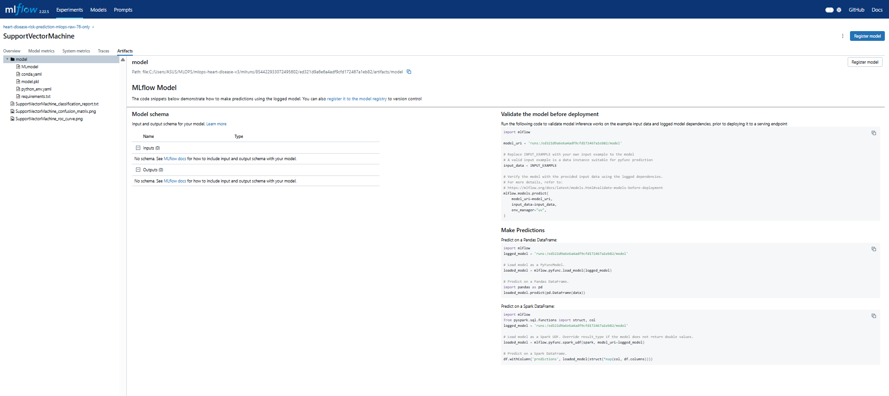
Run Screenshot 21. Open MLflow tracking UI.

Run Screenshot 22: Run code quality check
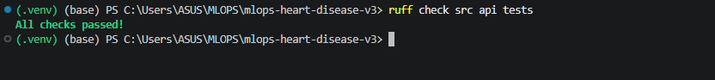
Run Screenshot 22. Run code quality check.

Run Screenshot 23: Run unit tests
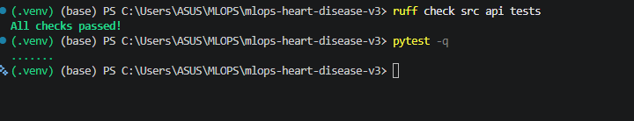
Run Screenshot 23. Run unit tests.

Run Screenshot 24: Run unit tests
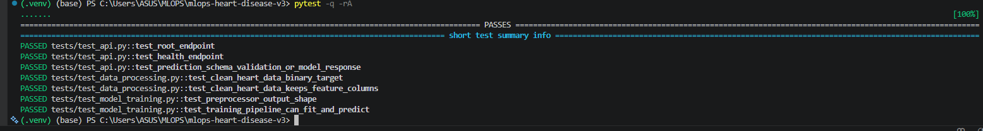
Run Screenshot 24. Run unit tests.

Run Screenshot 25: Model packaging and reproducibility
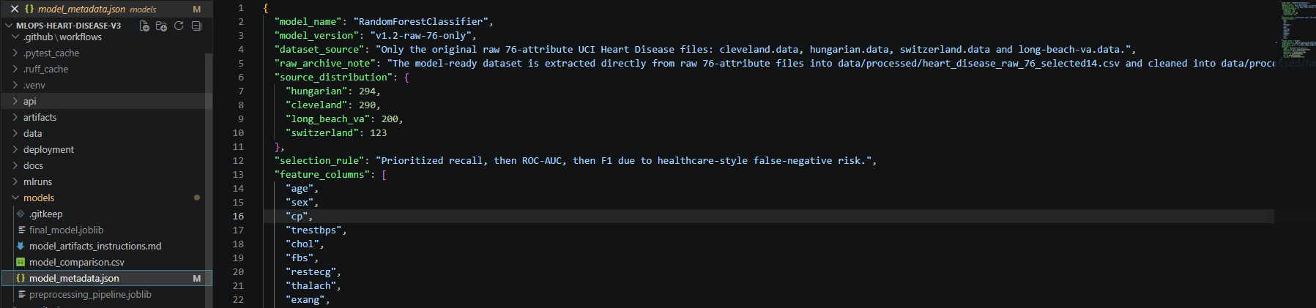
Run Screenshot 25. Model packaging and reproducibility.

Run Screenshot 26: Run FastAPI locally
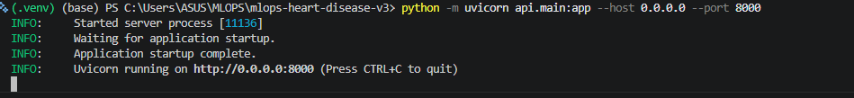
Run Screenshot 26. Run FastAPI locally.

Run Screenshot 27: Run FastAPI locally
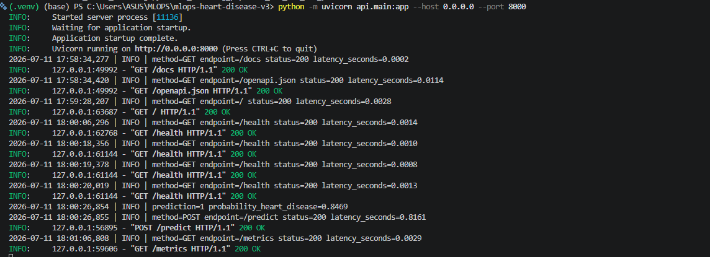
Run Screenshot 27. Run FastAPI locally.

Run Screenshot 28: Start Docker Desktop
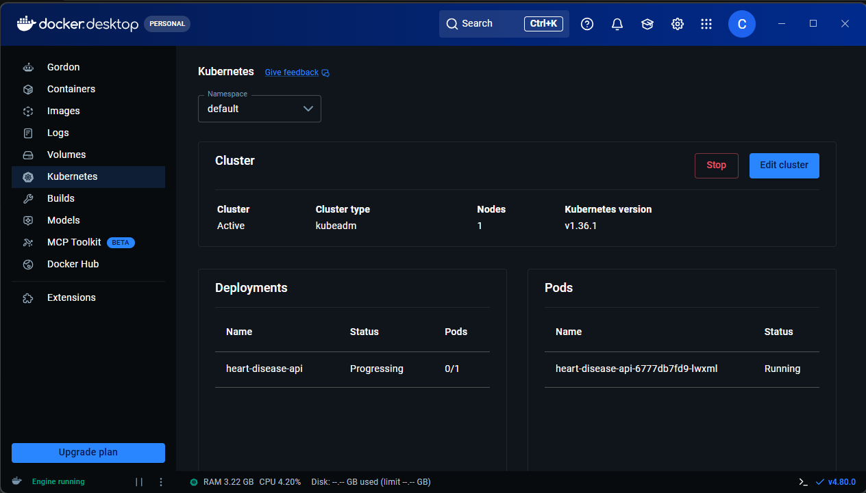
Run Screenshot 28. Start Docker Desktop.

Run Screenshot 29: Build Docker image
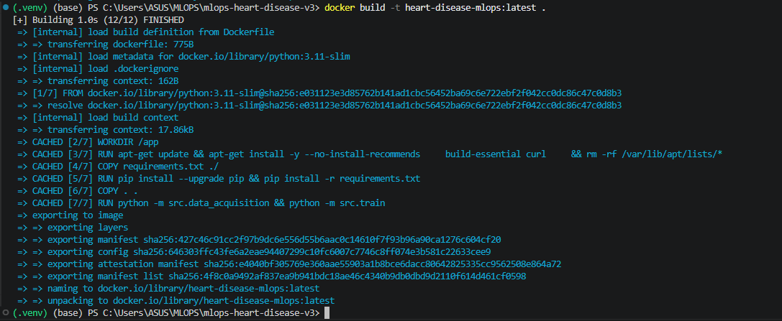
Run Screenshot 29. Build Docker image.

Run Screenshot 30: Run Docker container
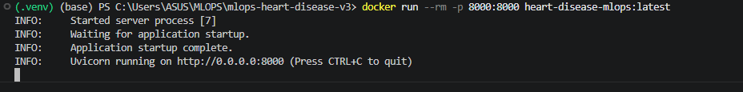
Run Screenshot 30. Run Docker container.

Run Screenshot 31: Run Docker container
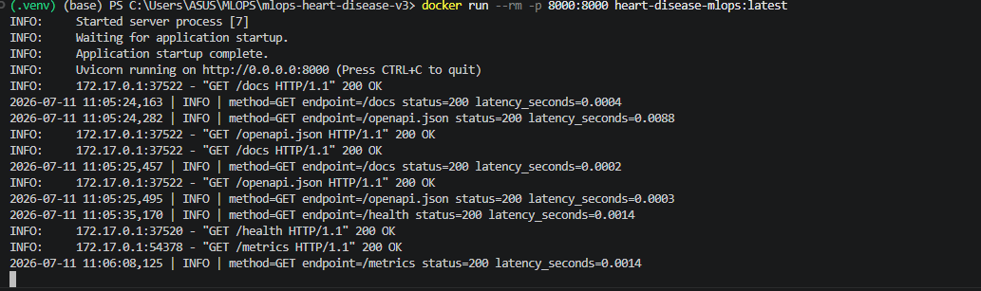
Run Screenshot 31. Run Docker container.

Run Screenshot 32: Run Docker container
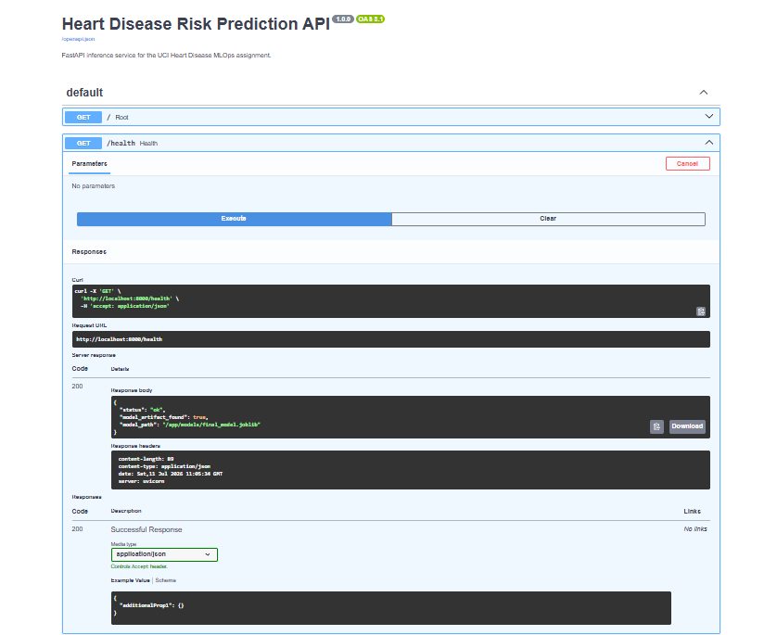
Run Screenshot 32. Run Docker container.

Run Screenshot 33: Run Docker container
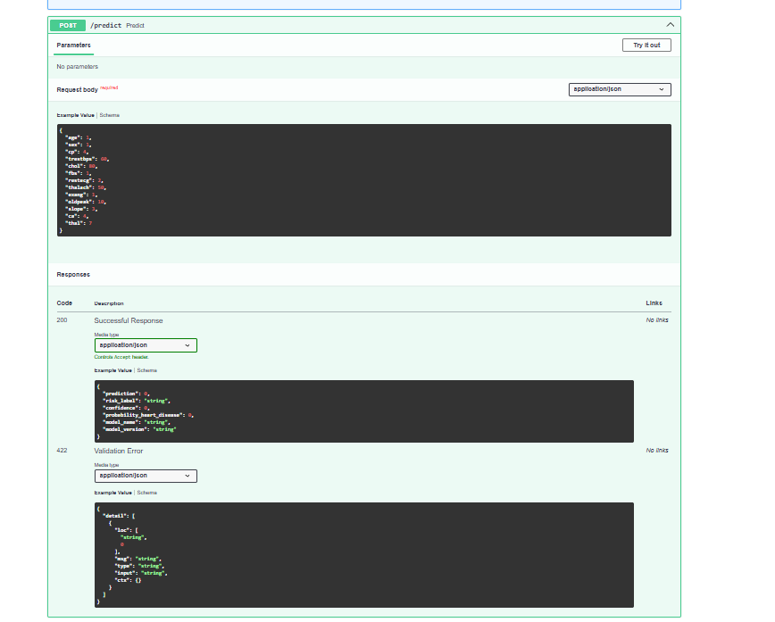
Run Screenshot 33. Run Docker container.

Run Screenshot 34: Run Docker container
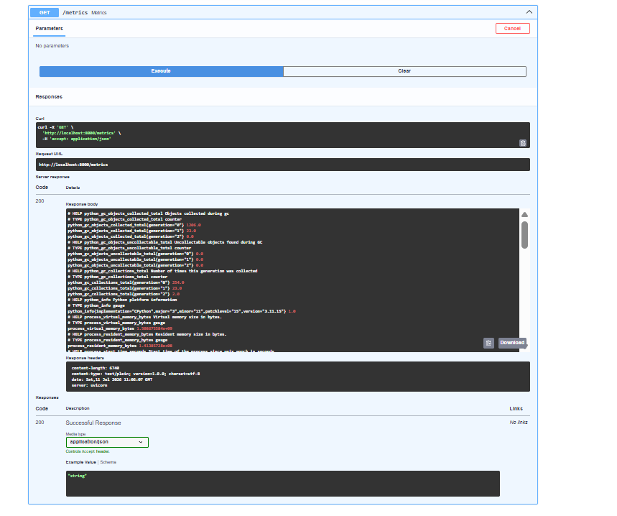
Run Screenshot 34. Run Docker container.

Run Screenshot 35: Run Docker container
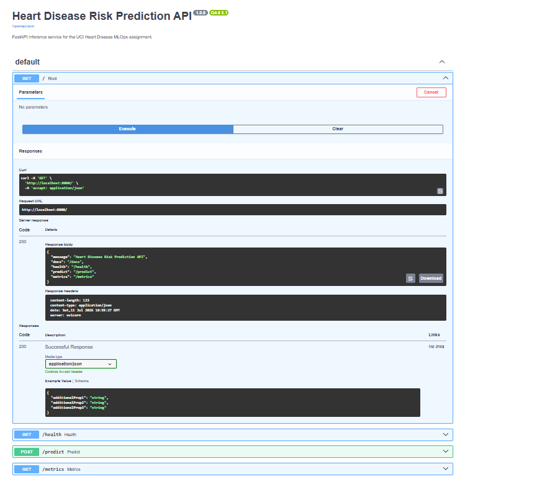
Run Screenshot 35. Run Docker container.

Run Screenshot 36: Run Docker container
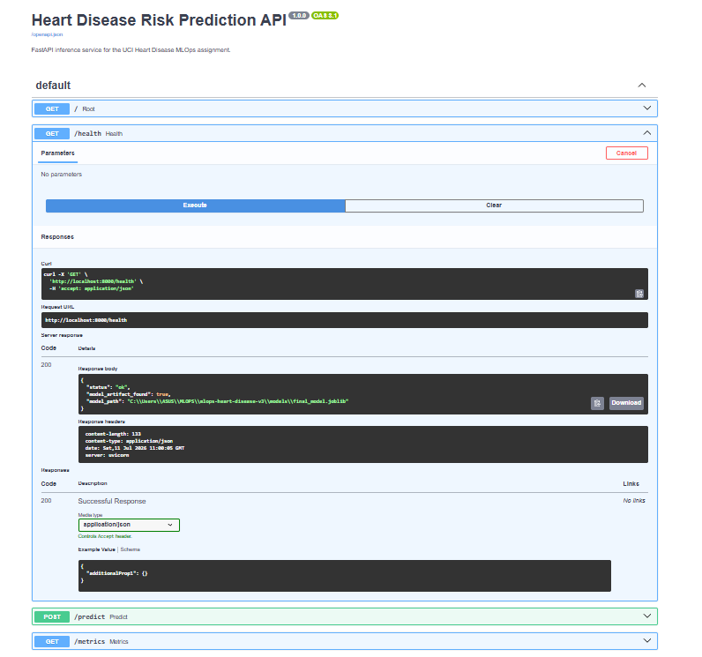
Run Screenshot 36. Run Docker container.

Run Screenshot 37: Run Docker container
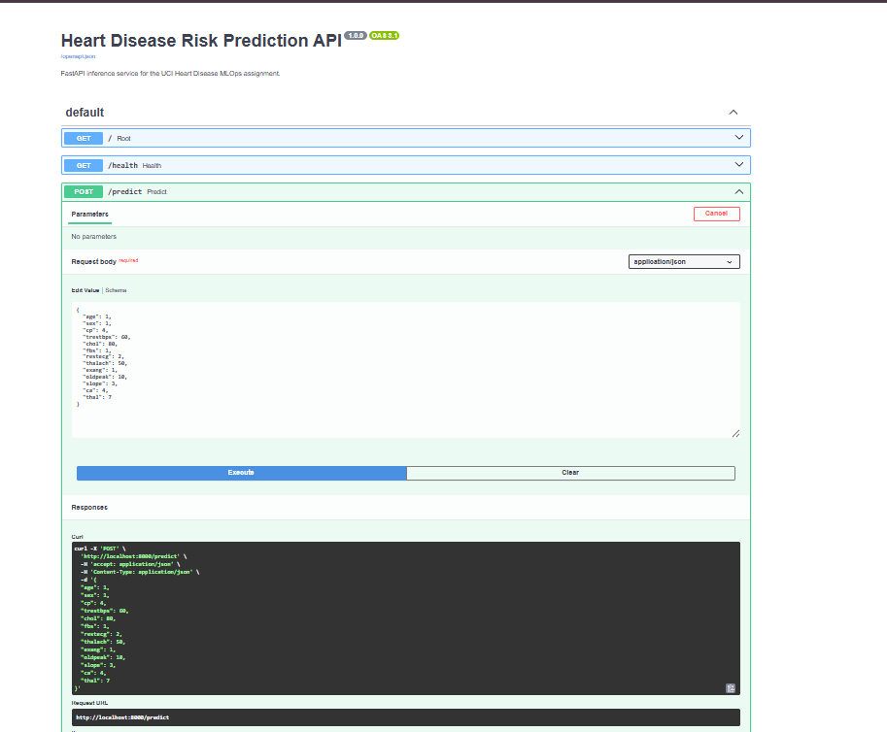
Run Screenshot 37. Run Docker container.

Run Screenshot 38: Run Docker container
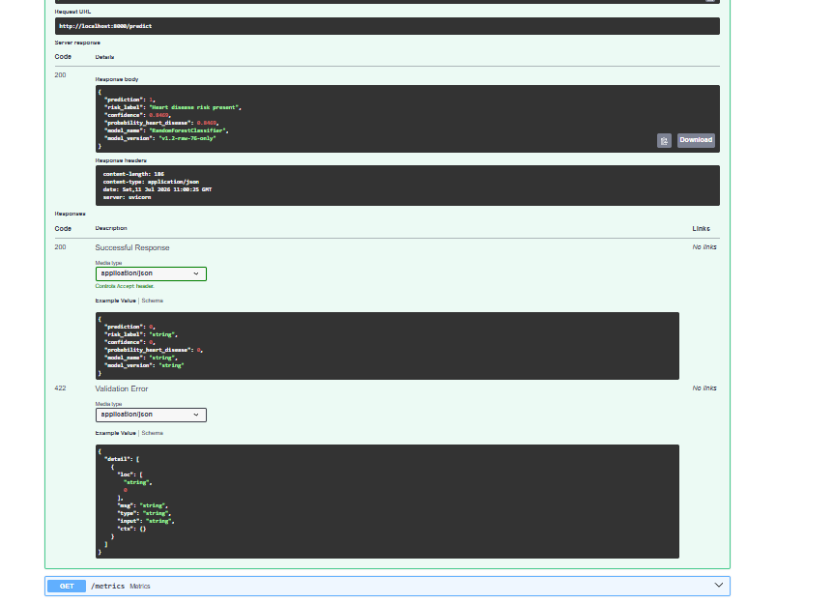
Run Screenshot 38. Run Docker container.

Run Screenshot 39: Run Docker container
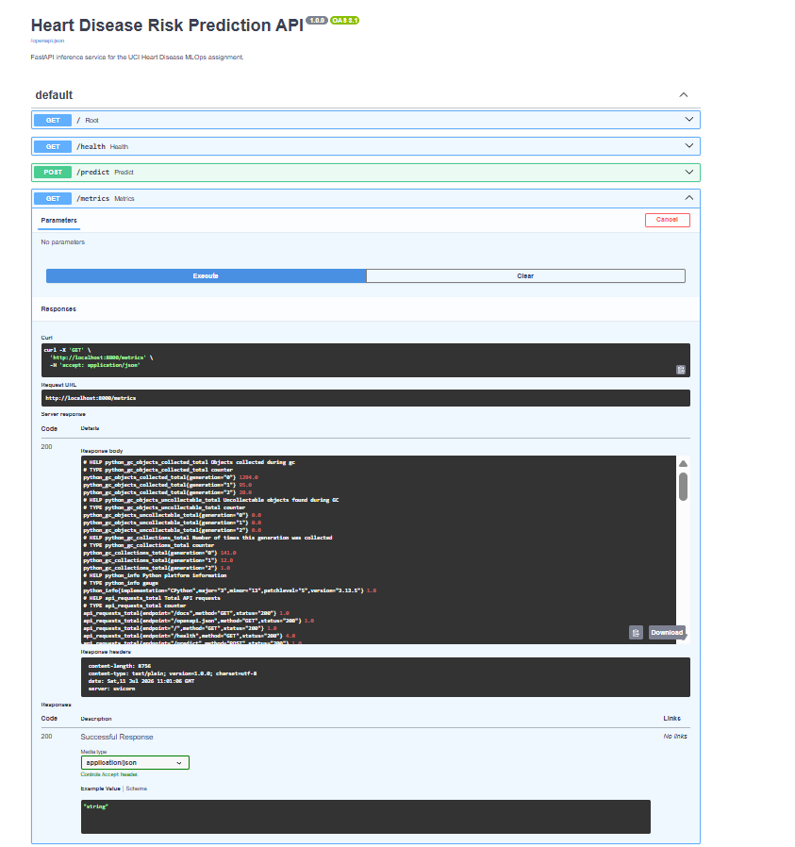
Run Screenshot 39. Run Docker container.

Run Screenshot 40: Commit and push code
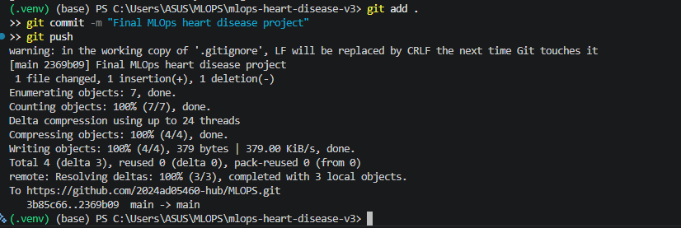
Run Screenshot 40. Commit and push code.

Run Screenshot 41: Commit and push code
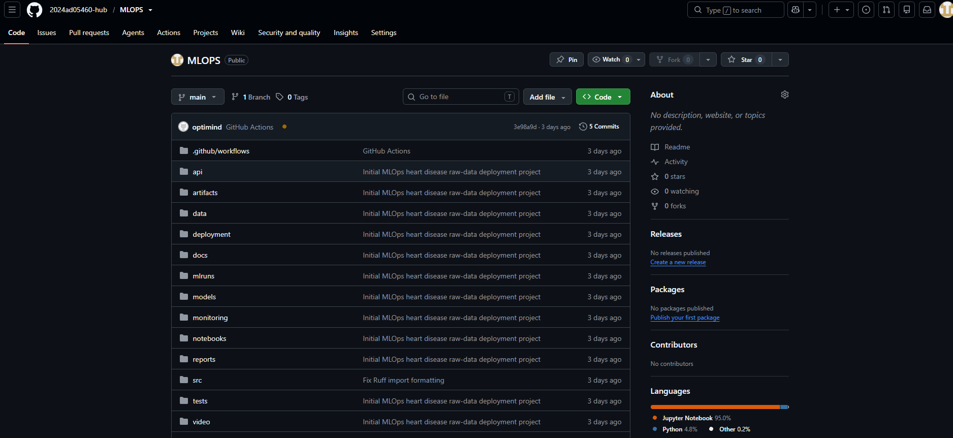
Run Screenshot 41. Commit and push code.

Run Screenshot 42: Commit and push code
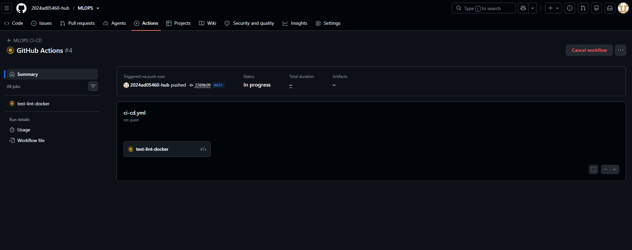
Run Screenshot 42. Commit and push code.

Run Screenshot 43: Commit and push code
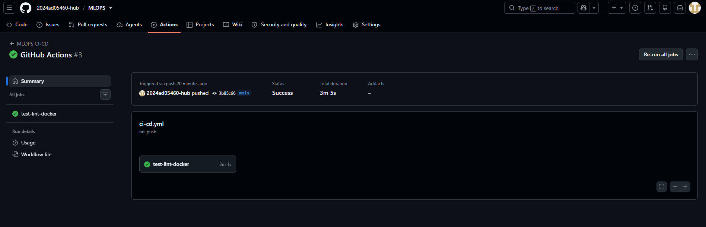
Run Screenshot 43. Commit and push code.

Run Screenshot 44: Kubernetes local deployment
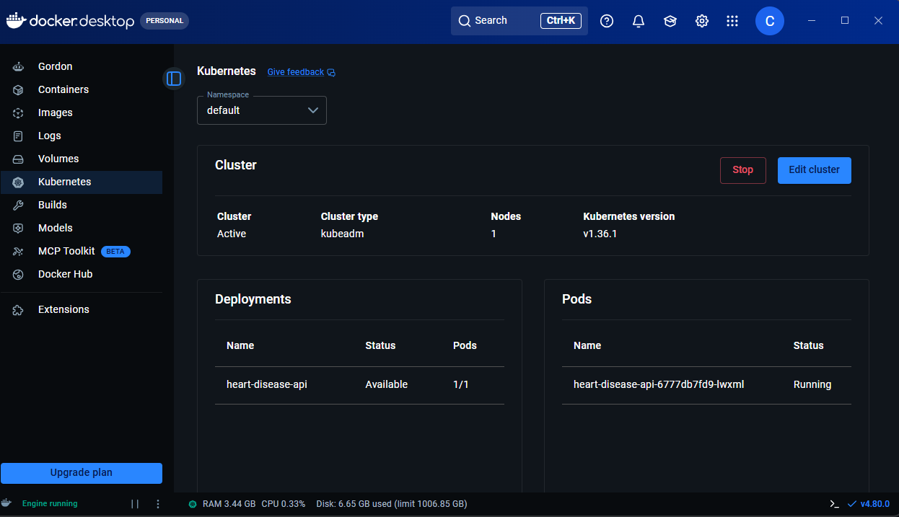
Run Screenshot 44. Kubernetes local deployment.

Run Screenshot 45: Build Docker image again
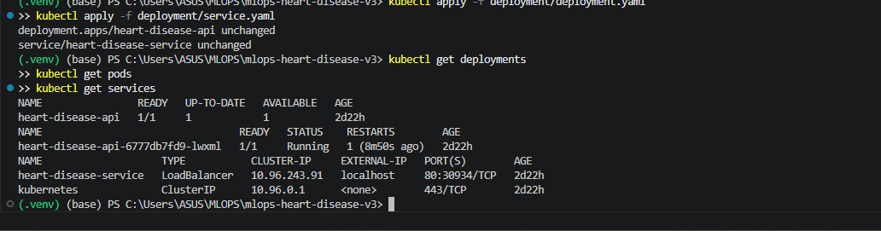
Run Screenshot 45. Build Docker image again.

Run Screenshot 46: Check Kubernetes resources
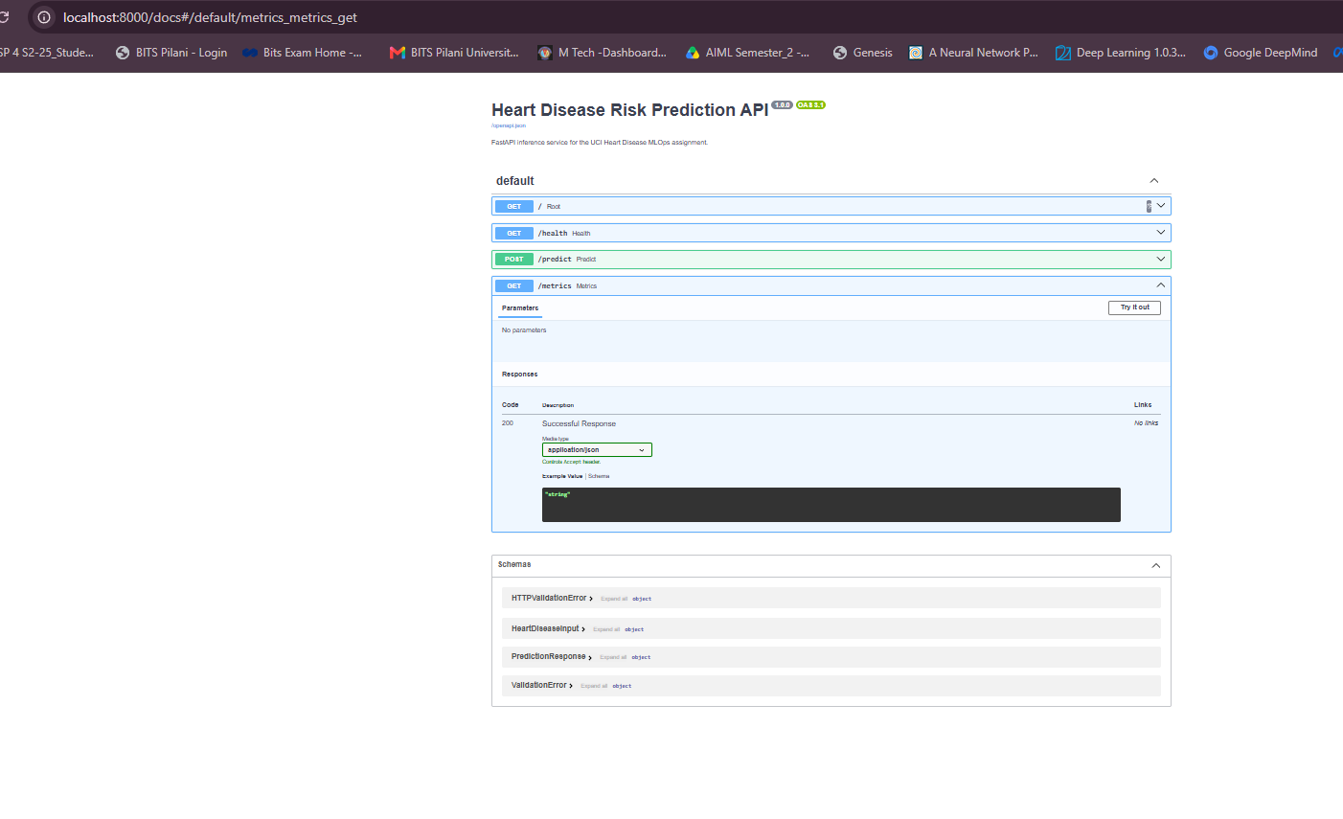
Run Screenshot 46. Check Kubernetes resources.

Run Screenshot 47: Port forward Kubernetes service
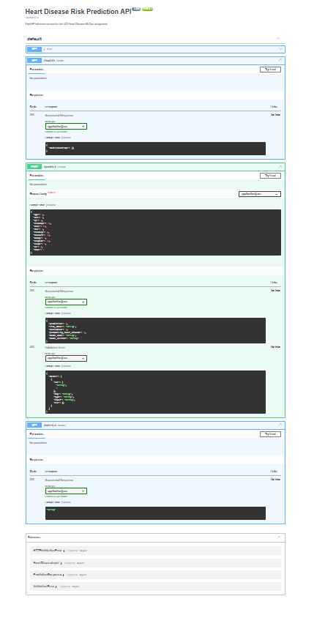
Run Screenshot 47. Port forward Kubernetes service.

Run Screenshot 48: Port forward Kubernetes service
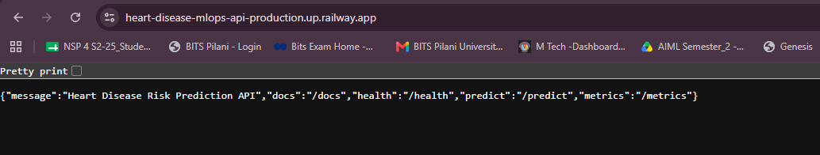
Run Screenshot 48. Port forward Kubernetes service.

Run Screenshot 49: Test Railway public deployment
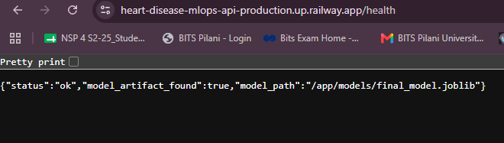
Run Screenshot 49. Test Railway public deployment.

Run Screenshot 50: Test Railway public deployment
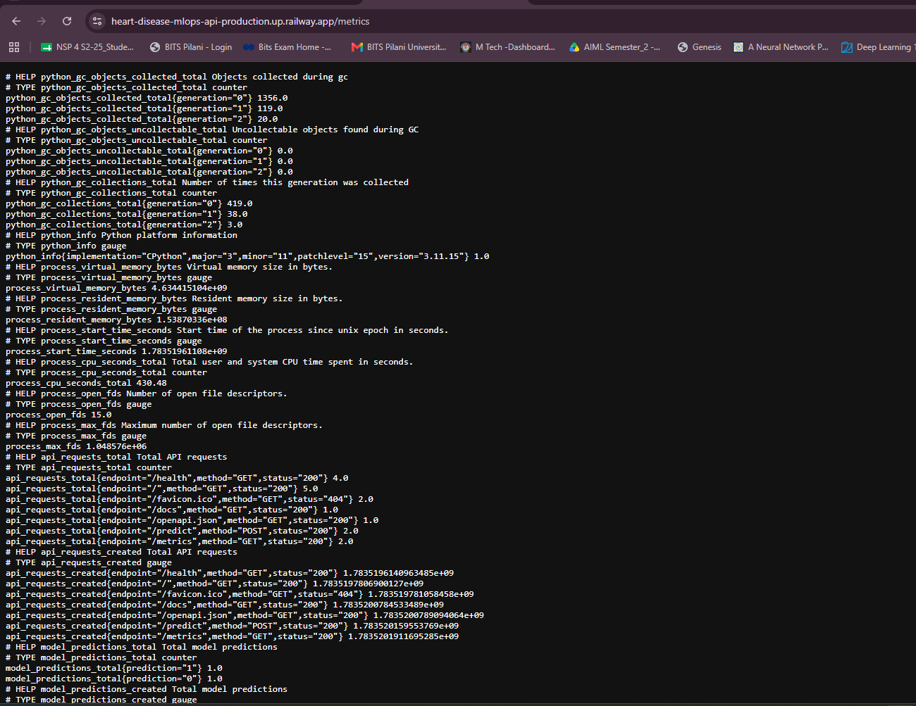
Run Screenshot 50. Test Railway public deployment.

Run Screenshot 51: Test Railway public deployment
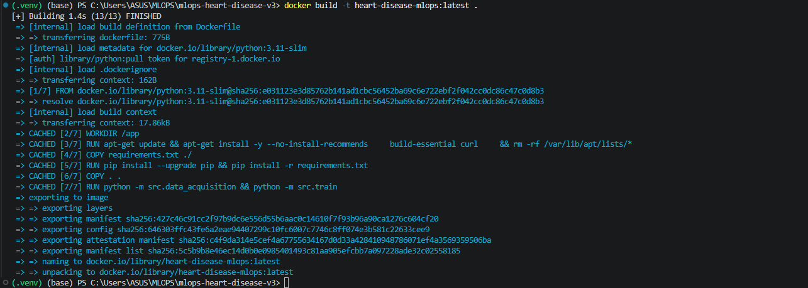
Run Screenshot 51. Test Railway public deployment.

Run Screenshot 52: Test Railway public deployment
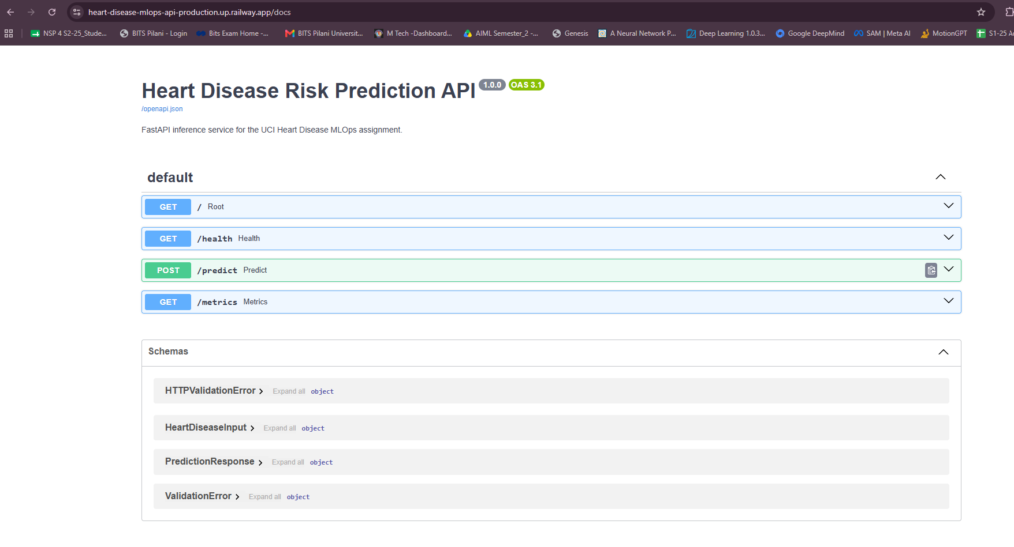
Run Screenshot 52. Test Railway public deployment.

Appendix

Appendix A. Evidence Checklist
Evidence area | Included proof
Data acquisition | src/data_acquisition.py and run screenshots
EDA | Class balance, source distribution, histograms, heatmaps and EDA summary outputs
Feature engineering | src/preprocessing.py ColumnTransformer with numeric and categorical pipelines
Model development | Logistic Regression, Random Forest Classifier and Support Vector Machine
Experiment tracking | MLflow runs, metrics and artifacts
Packaging | final_model.joblib, preprocessing_pipeline.joblib, MLflow model files
Testing | Ruff and Pytest screenshots plus test source files
CI/CD | GitHub Actions workflow evidence and repository push screenshots
Containerization | Docker build/run screenshots and commands
Deployment | Kubernetes and Railway screenshots
Monitoring | FastAPI request logging and /metrics endpoint

Appendix B. Source Code and Notebook
File | Purpose | Status
config.py | Project paths, feature lists, raw UCI source files, model paths and experiment name | Available
data_acquisition.py | Download raw UCI files, parse 76-attribute records, clean features and binary target | Available
eda.py | Generate EDA tables and figures | Available
preprocessing.py | Build numeric and categorical preprocessing pipelines | Available
train.py | Train/tune LR, RF and SVM; log MLflow artifacts; save final model | Available
evaluate.py | Evaluate saved model on cleaned dataset | Available
inference.py | Load model and metadata, generate one prediction | Available
main.py | FastAPI app with endpoints, logging and metrics | Available
schema.py | Pydantic request/response schema | Available
test_api.py | API tests | Available
test_data_processing.py | Data-processing tests | Available
test_model_training.py | Model-training/preprocessor tests | Available
01_data_acquisition_eda.ipynb | Data acquisition and EDA notebook | Available
02_model_training_tuning.ipynb | Model training and tuning notebook | Available
03_inference_testing.ipynb | Inference testing notebook | Available

Appendix C. Full Classification Reports

Logistic Regression
precision recall f1-score support
0 0.80 0.74 0.77 81
1 0.80 0.85 0.83 101
accuracy 0.80 182
macro avg 0.80 0.80 0.80 182
weighted avg 0.80 0.80 0.80 182

Random Forest Classifier
precision recall f1-score support
0 0.86 0.78 0.82 81
1 0.83 0.90 0.87 101
accuracy 0.85 182
macro avg 0.85 0.84 0.84 182
weighted avg 0.85 0.85 0.85 182

Support Vector Machine
precision recall f1-score support
0 0.83 0.74 0.78 81
1 0.81 0.88 0.84 101
accuracy 0.82 182
macro avg 0.82 0.81 0.81 182
weighted avg 0.82 0.82 0.82 182

Appendix D. Complete Run Report Screenshots
This appendix includes all 52 screenshots extracted from the attached Run Report document. The screenshots are retained as execution evidence across environment setup, data acquisition, EDA, model training, MLflow, testing, packaging, FastAPI, Docker, GitHub Actions, Kubernetes and Railway deployment.

