Question 3 Answers
We used echo command to add text to a file while also creating a new file.

Ln command is used to create a hard link to an existing file. Hard links have same inode as original files.

Ln -s command is used to create symbolic or soft links to a file. These links have a different inode that the original file and can even be created across directories.

- 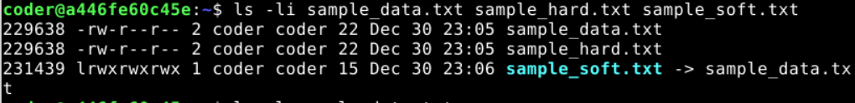
We used the ls command to display the inodes of all the files with the new links that we created.

- We note that the original file sample_data.txt and sample_hard.txt share the same inode numbers because hard links refer to the same disk locations. However, symbolic links have different inode numbers they only store the file path for original files.

The ls -l command along with file name is used to display the file’s permissions, ownership, group, size and timestamps.

Here we used du -sh command to check disk usage. Be careful while typing this command as using only ‘-h’ instead of ‘-sh’ can result in an extremely lengthy answer which is very confusing to interpret. The “s” here signifies summary.

- 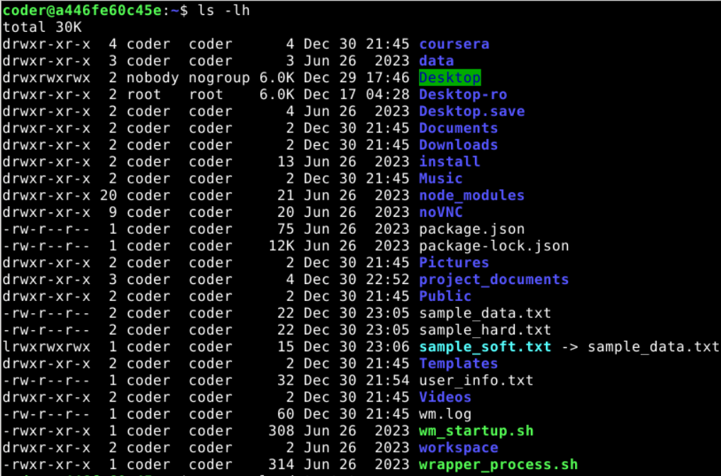
The ls -lh command is used t display a list of files and directories along with their size, permissions, timestamp, owner, group.

The rm command is used to delete the sample_soft.txt file that signifies the soft link. The cat command is used to confirm that the original file remains unaffected even when we delete the soft link file.
- 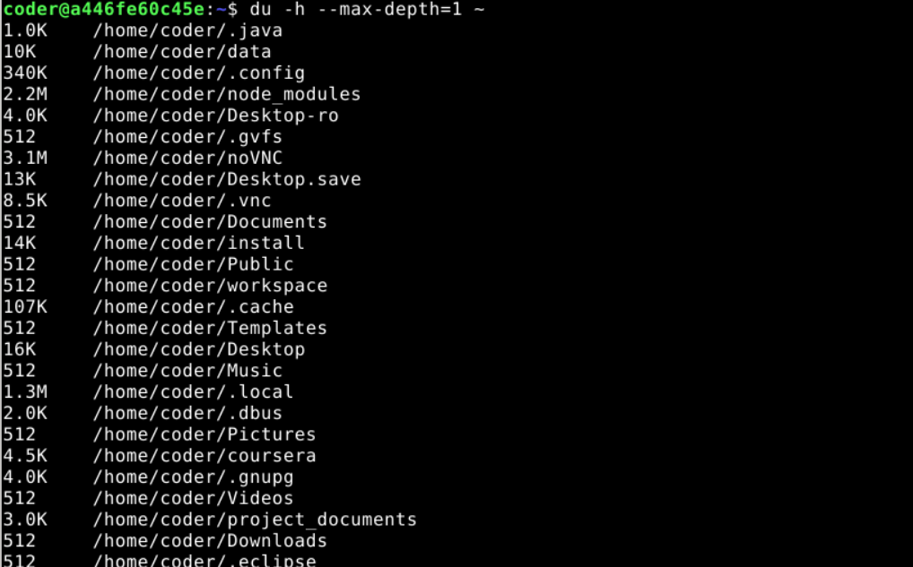
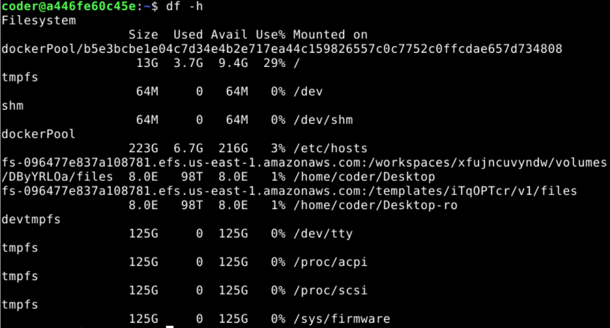
The du -h command shows a list of all files and directories currently using the disk space and how much exactly each one is using. And the df -h command shows us the disk usage by filesystem. Both can be used to analyse the disk space usage.

