Question 1 Answers
- 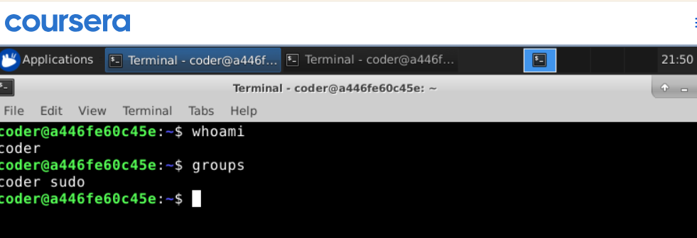
The whoami command shows us our current username that we are logged in with. The Groups command shows all the groups that my current user id belongs to, and as a verification my user ID is displayed in the output.

- 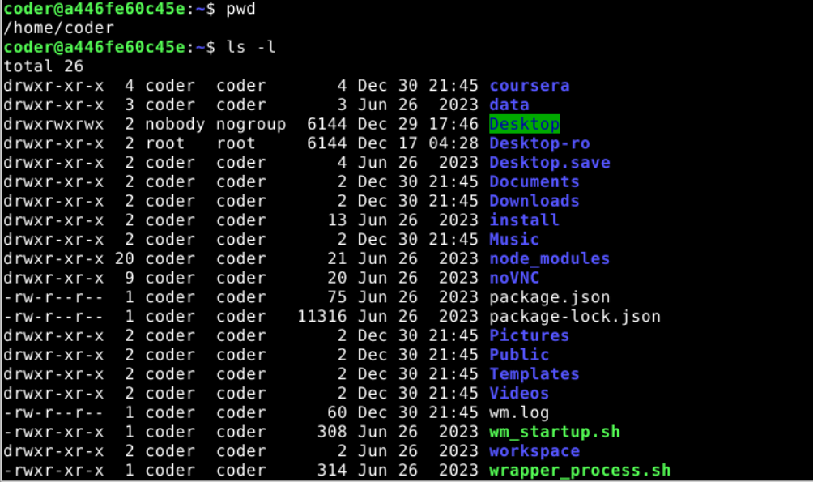
The pwd command shows my present working directory. And the ls -l command displays all the files and directories in the long format listing at my current location.

Here we created a new file with specified name and added the text to it using the echo command.

- 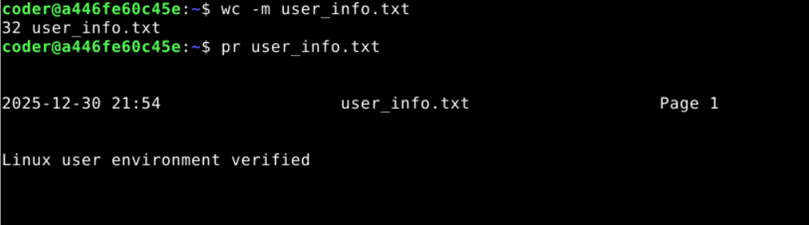
The wc -m command is used to count the total number of a specific characters in a file.
- 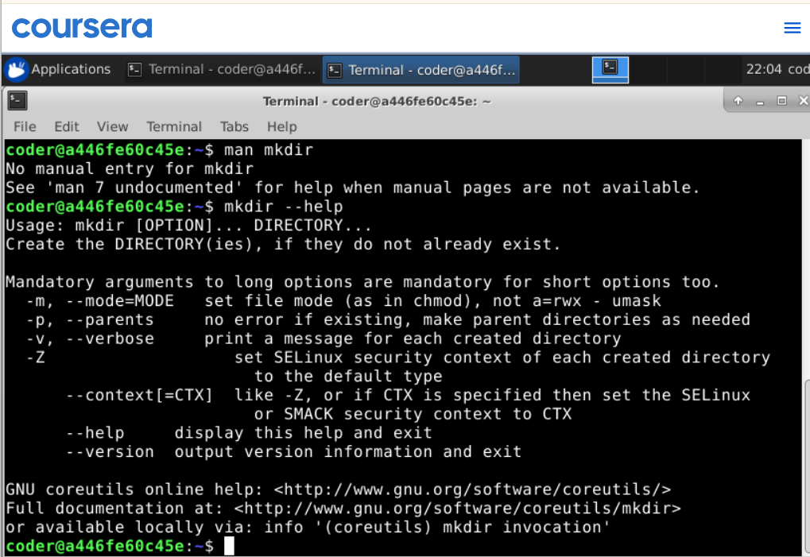
Ideally, we use “man mkdir” to get to the manual page of mkdir. However, as man repository was not installed, I used mkdir –help command to know more about mkdir command. For example, we can use mkdir -p to create a parent directory if it does not already exist.

- 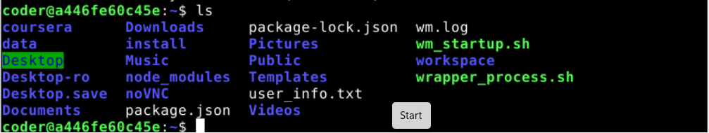
The ls command is used to list all files and directories in the home directory. The output is by default alphabetically sorted.
This code is used to search for specific characters or words in a file. But currently this file does not exist, so we got an error.

This command is used to show the currently running version of Linux Kernal on system.

- 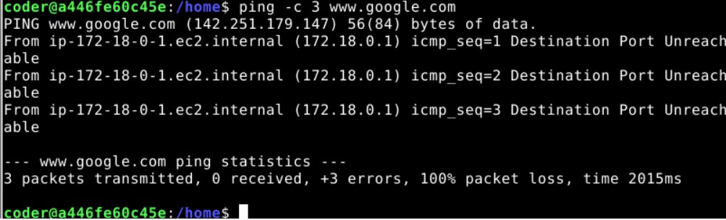
Ping command is used to test connectivity by sending ICMP packages to server, in our case we used Google server to test connectivity.

This command is used to display the running time of the system along with logged in users and average load times.

