Question 4 Answers
The uptime command displays how long the system has been up since the last reboot.

- 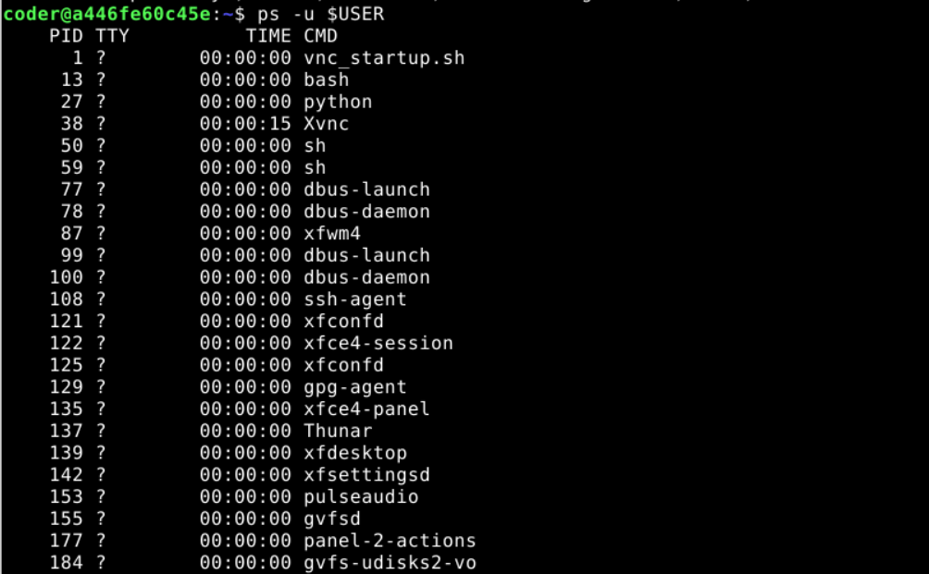
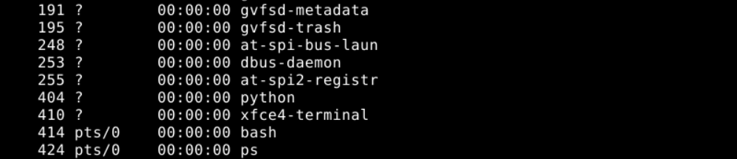
This command is used to list all the currently running processes under current user.

- 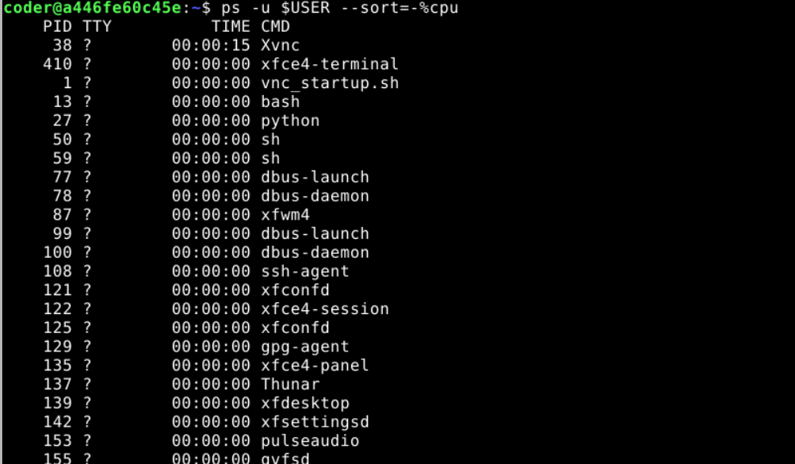
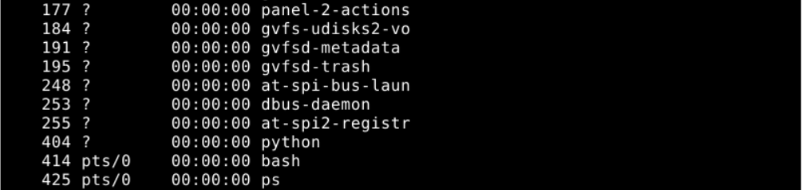
This command is used to check which process is using the maximum CPU among all the currently running processes.

We used the sleep command to start the process in the background. And then used the jobs command to confirm whether the process is running or not.

- 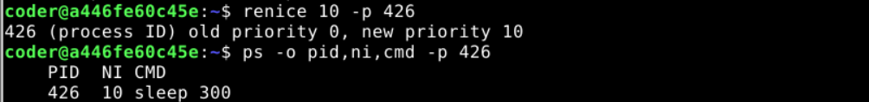
This command is used to change the niceness of a process that is currently running. Then we used the second command to confirm the update.

This command is used to show memory usage in a human readable format.

- 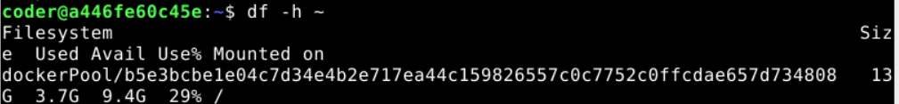
This command is used to show disk usage of filesystem in human readable format.

The echo command can be used to display the name and path of shell currently in use.

We used the uname command to create a new file and redirect all system information output to it. We also used cat to verify data recording.

Ncdu was not installed on my system. So I used du -sh command to display the largest directory on the system.

