Question 2 Answers
- 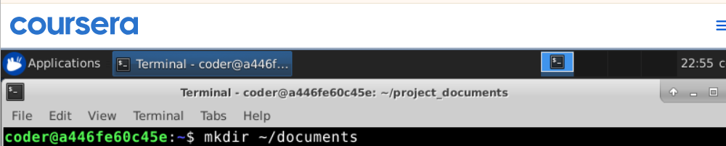
This command is used to create new directories.

First, we used cd ~/ to move around to the directory. Then we used touch command to create a new file named plan.txt. Currently the file is empty as we did not add anything text to it.

Here we used echo command to add text to plan.txt file and confirmed it added using the cat command.

We used ls -l along with file name to check file permissions, ownership, size of file, and timestamps. We also confirmed that I am the owner of this file.

We used cp command to create a copy of our original file plan.txt, we also gave a new file name to the copied file.

First, I used cd ~ to move up in the directory and then used mv command to rename my directory.

We used mkdir command to create a new directory named archive.

We again used the mv command to move our plan_copy.txt file to the newly created directory named archive. This is a good practice to create backups.

- 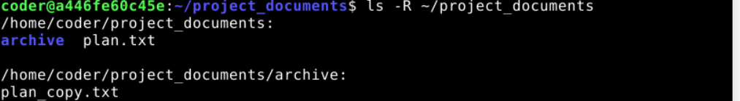
We used the -R command with ls to get the full directory structure for all existing files under this directory.

Realpath command is used to confirm the new location of a file inside a directory.

