AI Usage Log and Reflection Report
Date: 08 November 2025
Course: SE ZG503 - Full Stack Application Development (2024-2025)
Project Title: School Equipment Lending Portal
Phase: 2 – AI-Assisted Development

1. AI Tools Used
For this phase, the following AI-assisted coding tools were used to enhance and refactor the existing manual implementation:
- GitHub Copilot (for in-editor code suggestions and refactoring)
- Claude (for documentation and code optimization guidance)
- Chatgpt (debugging and improvements)

2. AI Usage Log
The following table summarizes the usage of AI tools during the enhancement phase.
Date | Tool Used | Prompt Given | Output / Result Summary | Used In (Module / Component)
04 Nov 2025 | GitHub Copilot | Refactor EquipmentService to add null checks and better error messages. | Added null validation, custom exceptions, and structured error handling. | Backend – Spring Boot
05 Nov 2025 | Claude | Generate detailed Markdown API documentation for this Spring Boot controller. Include endpoint paths, HTTP methods, request/response JSON examples, roles (from @PreAuthorize), and HTTP status codes. | Produced a complete Markdown document converted to PDF for inclusion in project docs. | Documentation can be accessed via link or QR:  https://l1nq.com/4sbKY  
07 Nov 2025 | ChatGPT | Analysed and optimize client-side logic to prevent approval errors and improve delete equipment flow. | Added client-side validation for approval, handled “item in use” gracefully, and optimized API parallel fetching. | Frontend – React (Approval, Equipment Components)

Verification Proof:
Area | Proof | Comments
Error Handling | 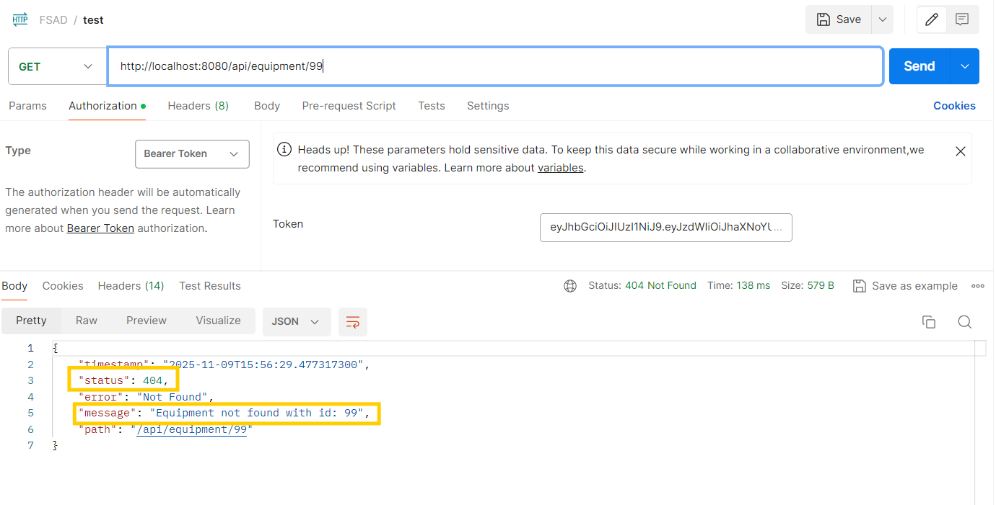 | Clear informative message when wrong id is tried to be accessed.
Delete Equipment | 
  Before:
  Crashed or gave 500
  After:
  Graceful “Cannot delete — item in use”
UI |  | Before: Plain static layout, minimal styling  After: Centered modern card with icons, gradient background, hover effects, and clear visual hierarchy
Performance | Refer code for observing changes in this part. | Before:
  Sequential API calls
  After:
  Parallel fetch with Promise.all()

3. Reflection on AI-Assisted Development
During Phase 2, AI tools significantly accelerated development, especially in repetitive and documentation-heavy tasks. GitHub Copilot helped in auto-generating boilerplate code for REST controllers, while Claude provided valuable insights into improving code readability and project structure.
However, AI-generated code often required manual review to fix logical inconsistencies or missing validations. For example, certain Copilot suggestions skipped input validation logic, which was corrected manually. This experience highlighted that AI is a supportive tool, not a replacement for developer understanding.
Key learnings:
- AI can drastically reduce boilerplate coding time.
- It enhances code quality by suggesting modern patterns.
- Developers must critically evaluate AI output before integration.
- Debugging AI-generated code deepens understanding of frameworks.

4. Summary
The AI-assisted phase improved the efficiency and maintainability of the School Equipment Lending Portal. It provided a hands-on understanding of how AI can be integrated responsibly in full-stack software development. The reflection process also emphasized ethical and practical boundaries for using AI in academic work.

