

Course Introduction to DEVOPS (Merged - CSIZG514/SEZG514/SEUSZG514)(S2-25)

Assignment – 2

Implementation of CI/CD Pipeline for ACEest Fitness & Gym using Jenkins, Docker, and Kubernetes Report

Student Name: Amitosh Gautam
ID : 2024TM93644
Course: Introduction to DevOps
Assignment: Implementing Automated CI/CD Pipelines
GitHub Repository Link: https://github.com/2024tm93644-create/aceest-devops_Assignment2
Cloning Link - https://github.com/2024tm93644-create/aceest-devops_Assignment2.git

INDEX

- Objective -1
- Tools and Technologies Used -2
- System Architecture / CI-CD Flow -3
- Implementation -4
4.1 Application Development - 4
4.2 Version Control using GitHub - 5
4.3 Unit Testing using Pytest -6
4.4 Continuous Integration using Jenkins - 7
4.5 Docker Containerization - 8
4.6 Docker Hub Integration - 9
4.7 Kubernetes Deployment - 10
- Deployment Strategies and Rollback Mechanism -11
5.1 Kubernetes-Based Deployment -11
5.2 Rolling Update Strategy - 12
5.3 Rollback Mechanism - 13
5.4 Blue-Green Deployment - 14
5.5 Canary Release - 15
5.6 Shadow Deployment - 16
5.7 A/B Testing - 17
5.8 Summary - 18
- SonarQube Integration - 19
- Challenges Faced -20
- Solutions Implemented -21
- Advantages of CI/CD Pipeline -22
- Conclusion -23

Objective :
The objective of this assignment is to design and implement a complete DevOps CI/CD pipeline using modern tools and methodologies. The pipeline integrates version control, automated testing, continuous integration, containerization, and deployment using Kubernetes to ensure reliability, scalability, and automation in software delivery.
.

Tools and Technologies Used :
- Git & GitHub – Version Control
- Jenkins – Continuous Integration
- Pytest – Automated Testing
- Docker – Containerization
- Docker Hub – Container Registry
- Kubernetes – Deployment and Orchestration
- SonarQube – Code Quality Analysis

System Architecture / CI-CD Flow :

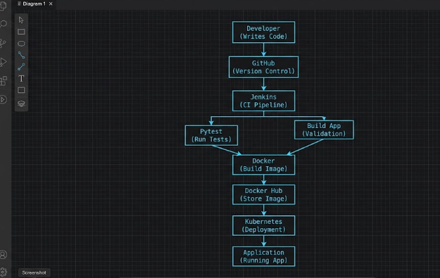

Implementation :

4.1 Application Development
A Flask-based web application was developed to represent the core functionality of the ACEest Fitness system. The application includes basic routes such as home and health check.
The code was written in a modular and maintainable manner following Python best practices.
4.2 Version Control using GitHub
The project was managed using Git and hosted on GitHub. Multiple branches such as main, dev, and feature branches were created to simulate real-world development practices.
Version tagging (v1, v2) was also implemented to track different versions of the application.
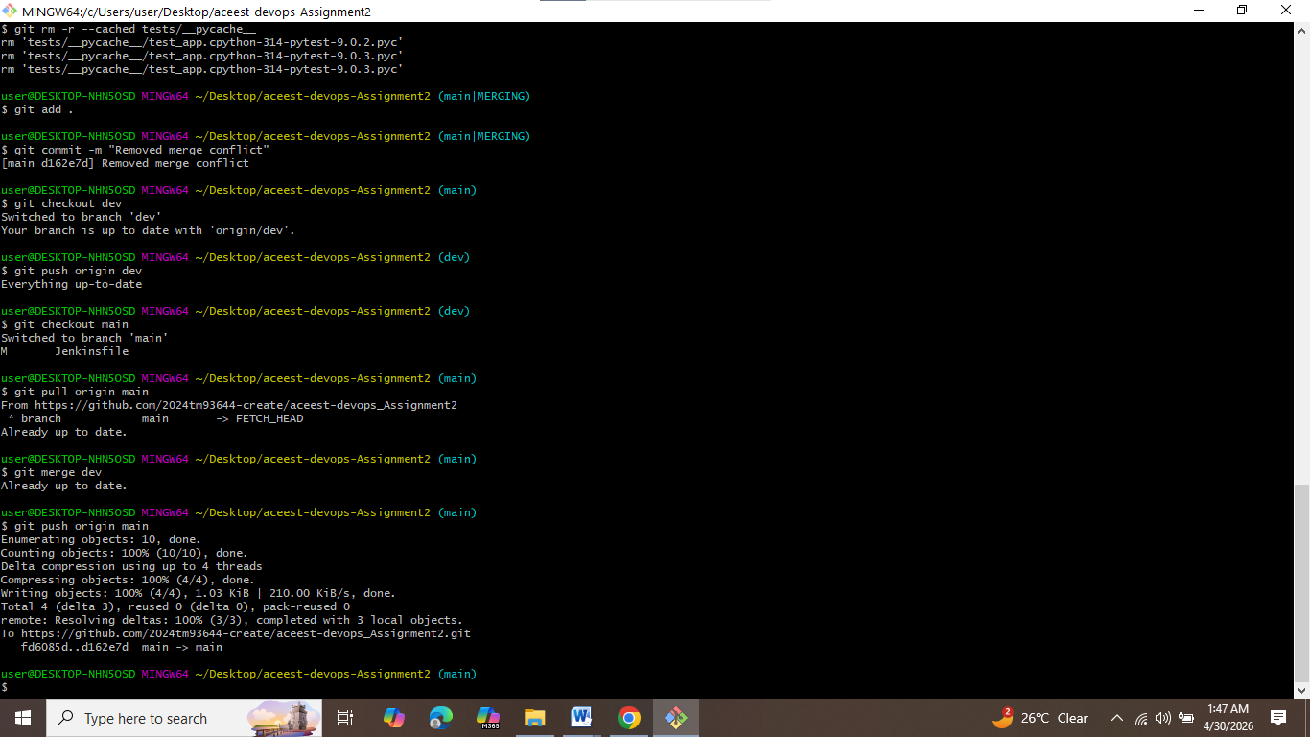
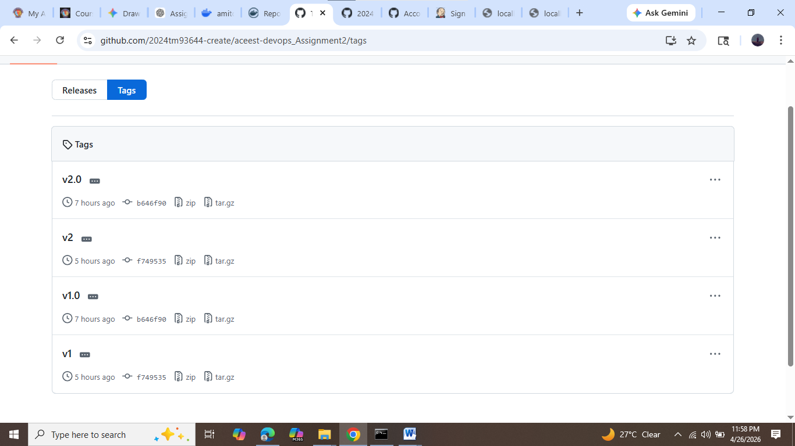
4.3 Unit Testing using Pytest
Test cases were written using Pytest to validate application functionality such as API responses and route accessibility.
All test cases were executed successfully, ensuring correctness and reliability of the application.
Automated testing ensures that new changes do not break existing functionality.

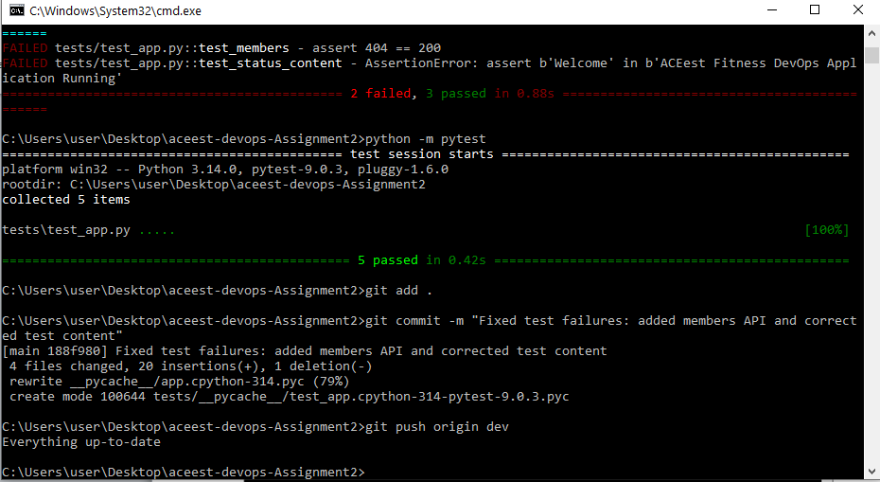
4.4 Continuous Integration using Jenkins
Jenkins was configured as the CI tool to automate the build and integration process. The pipeline was connected to the GitHub repository.
Whenever changes were pushed, Jenkins triggered the pipeline to simulate automated build execution.
Due to local environment limitations, a simplified Jenkins pipeline was implemented while still demonstrating CI concepts.
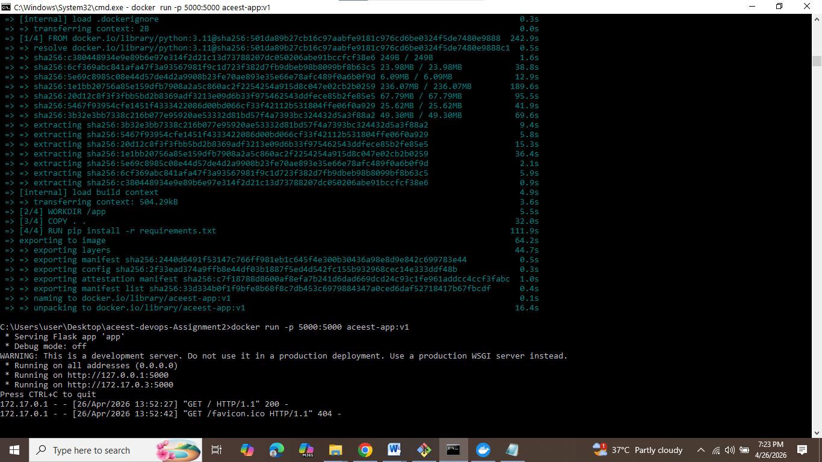

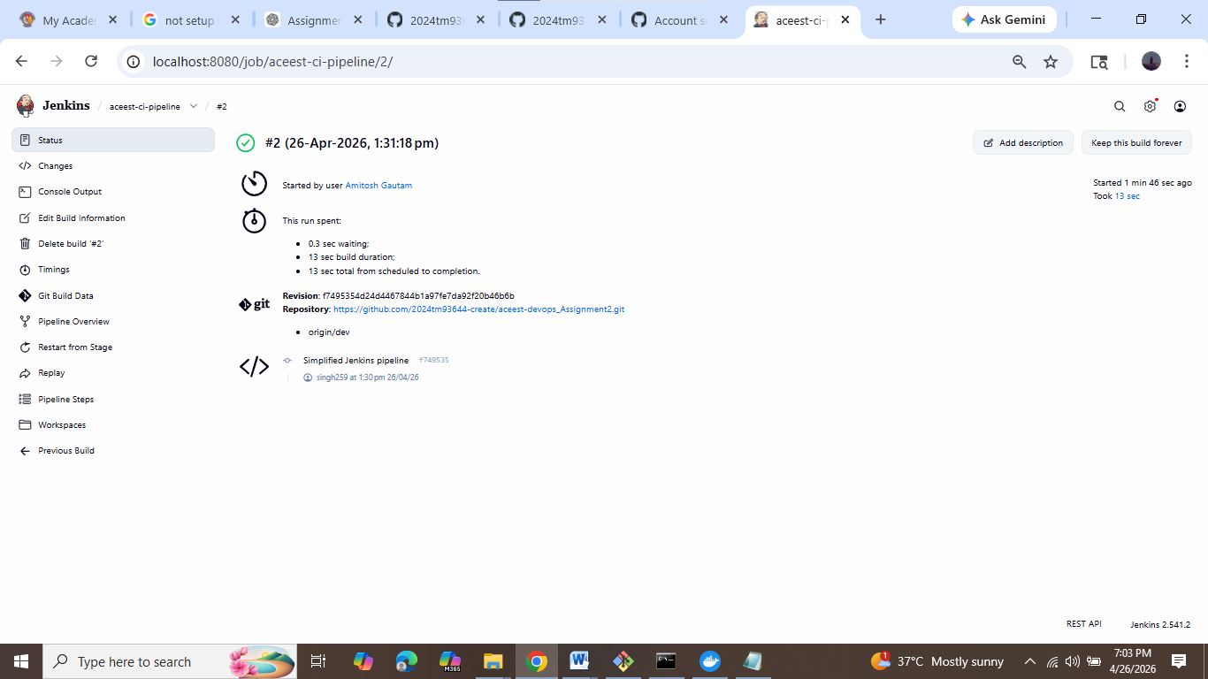

4.5 Docker Containerization

The application was containerized using Docker by creating a Dockerfile. The Docker image was successfully built and tested locally.
Docker ensures that the application runs consistently across different environments by packaging all dependencies together.

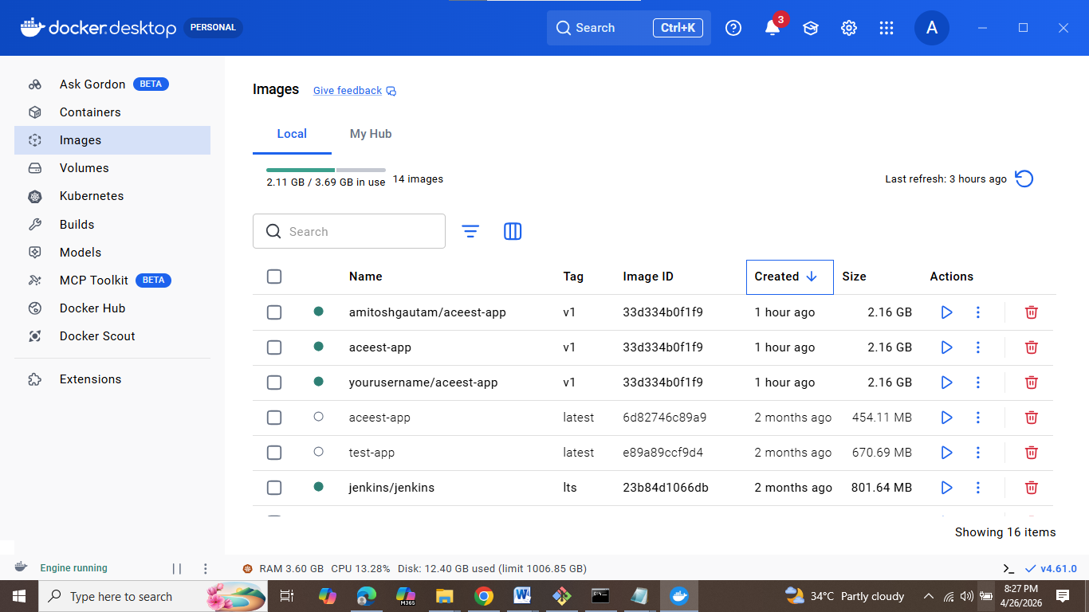
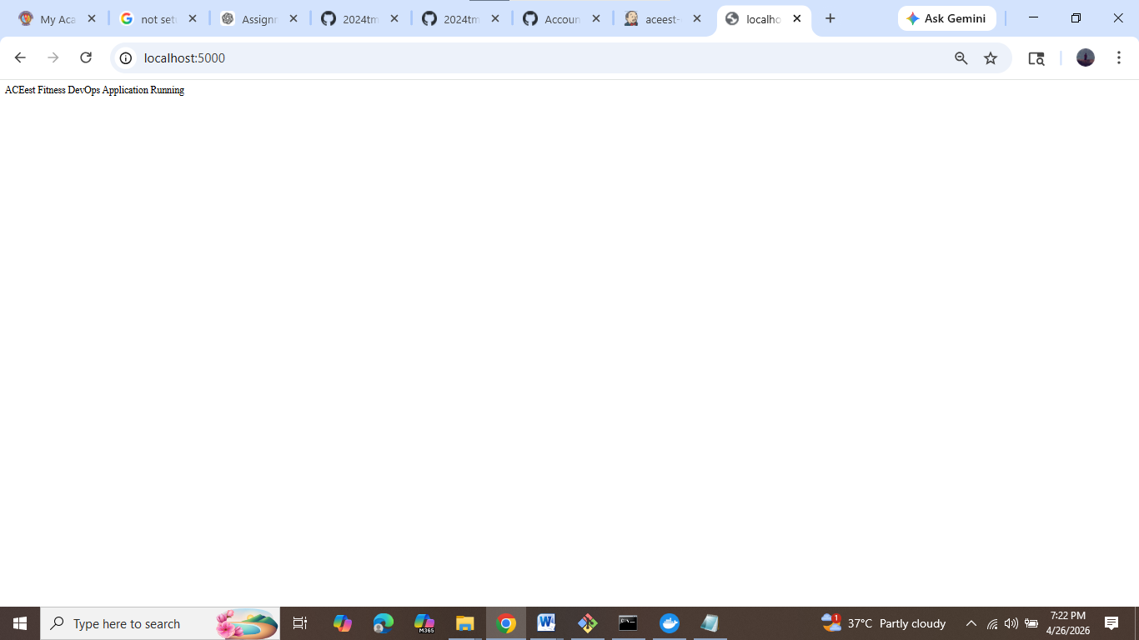

4.6 Docker Hub Integration
The Docker image was tagged and pushed to Docker Hub repository.
Docker Hub acts as a centralized platform for storing and managing container images, making deployment easier and scalable.]
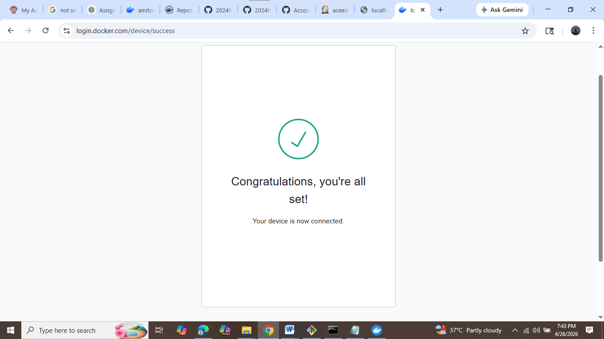
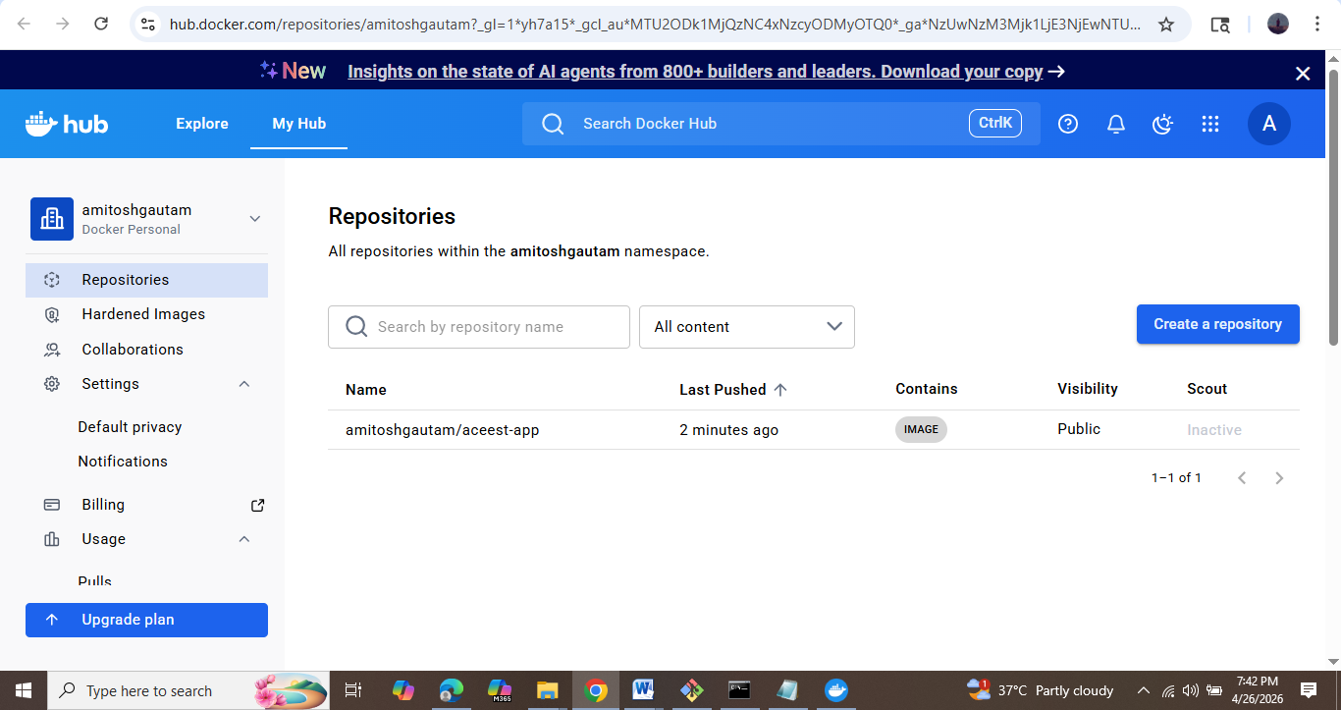
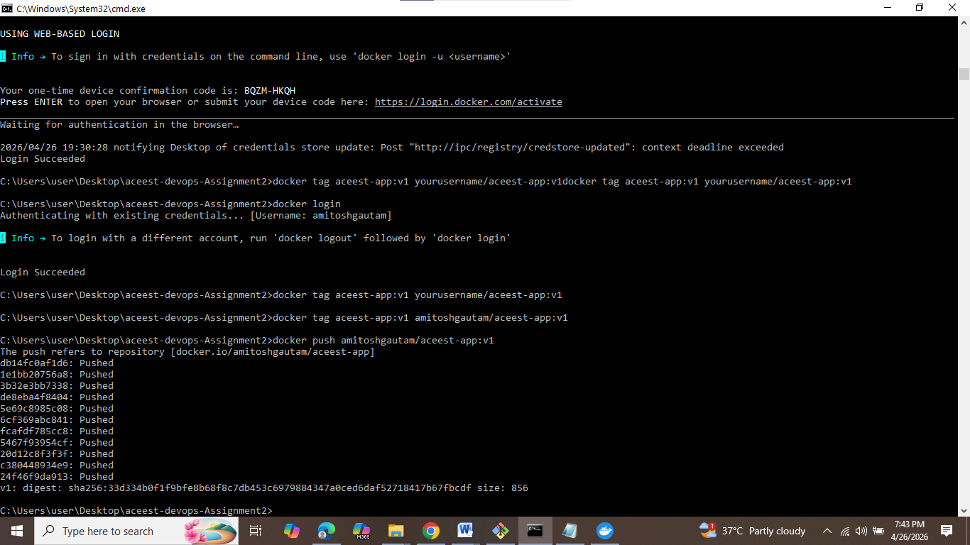

4.7 Kubernetes Deployment
The containerized application was deployed using Kubernetes. Deployment and Service YAML files were created and applied successfully.
- Multiple pods were running
- Service was exposed using NodePort
- Application was accessed using Kubernetes proxy
- Kubernetes ensured high availability and automatic recovery of the application.
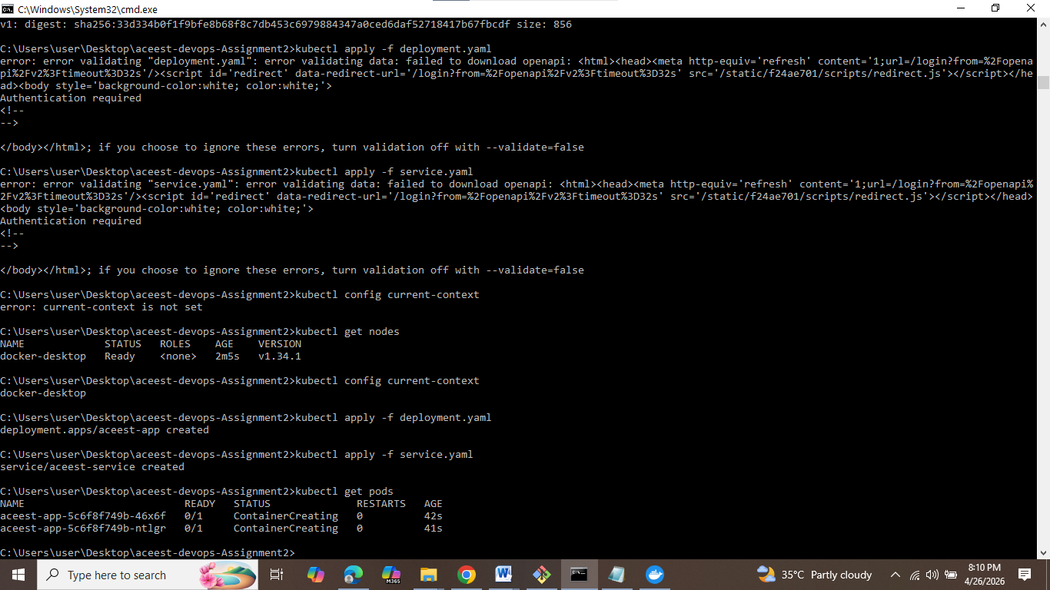

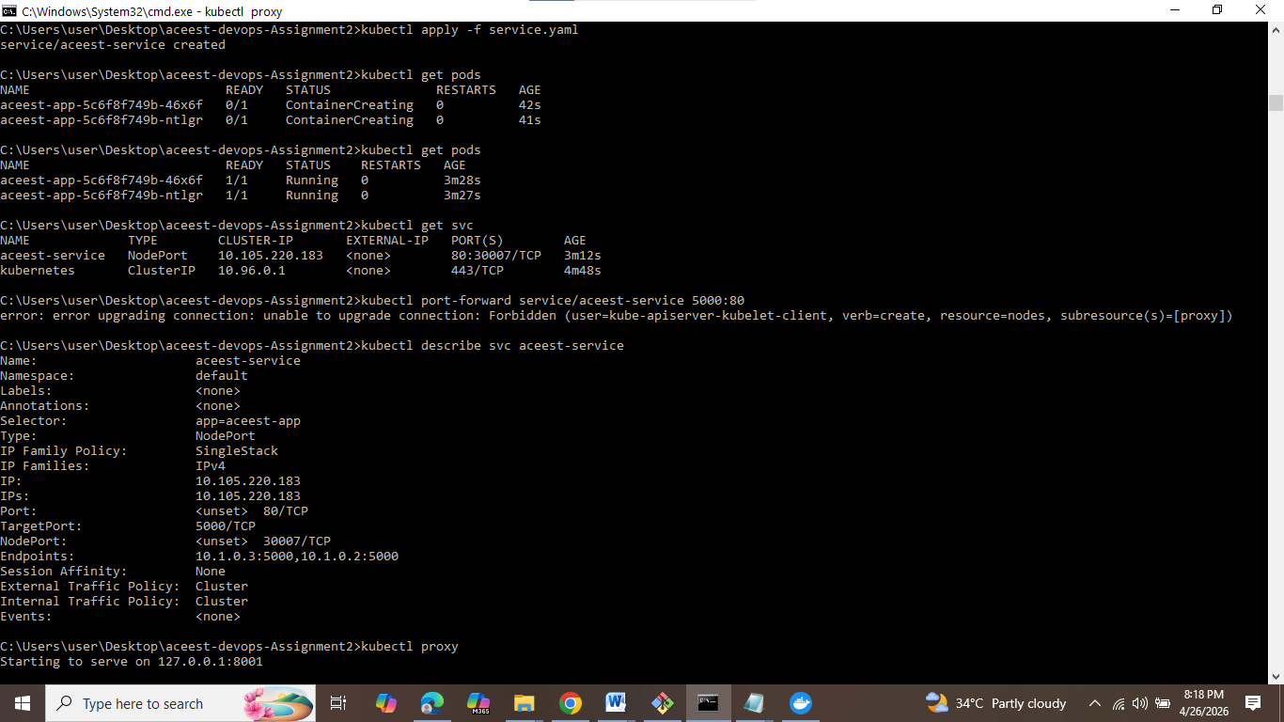
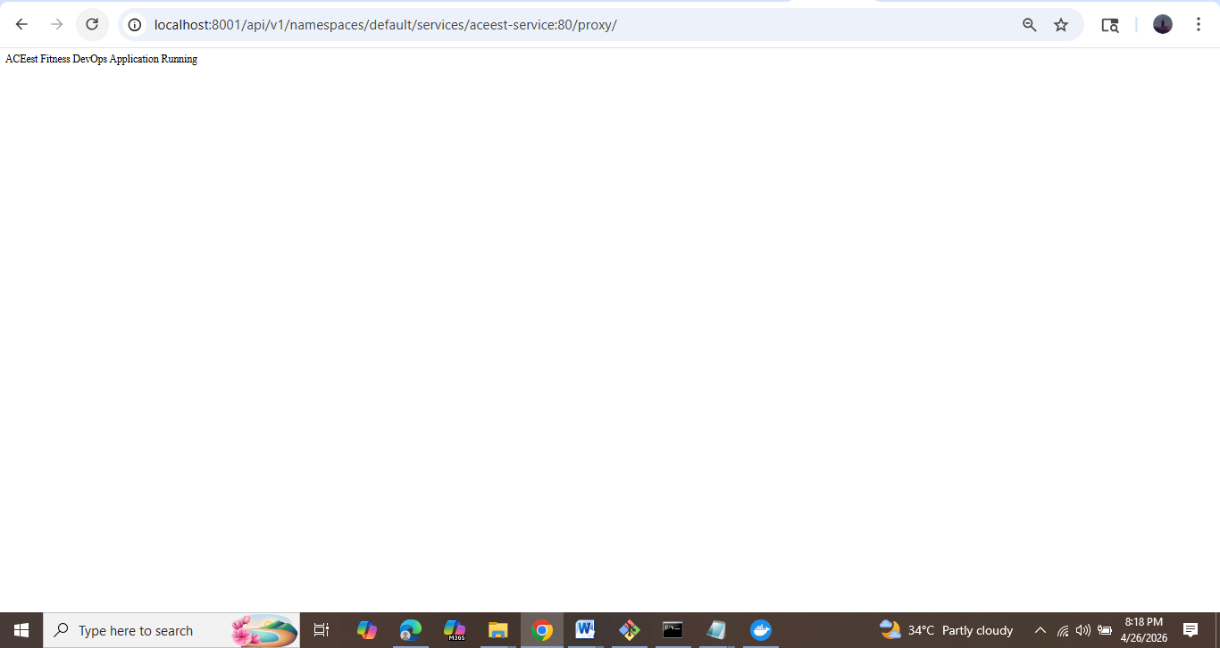

5. Deployment Strategies and Rollback Mechanism

5.1 Kubernetes-Based Deployment
The application was deployed using Kubernetes, which provides a reliable and scalable platform for managing containerized applications. A deployment configuration file was created to define the desired state of the application, including the number of replicas and container image details.
Kubernetes automatically ensured that the specified number of pods were running at all times. In case of failure of any pod, a new pod was created automatically, thereby maintaining high availability of the application.
A service was also defined to expose the application and allow external access. The application was successfully accessed through the Kubernetes proxy mechanism.
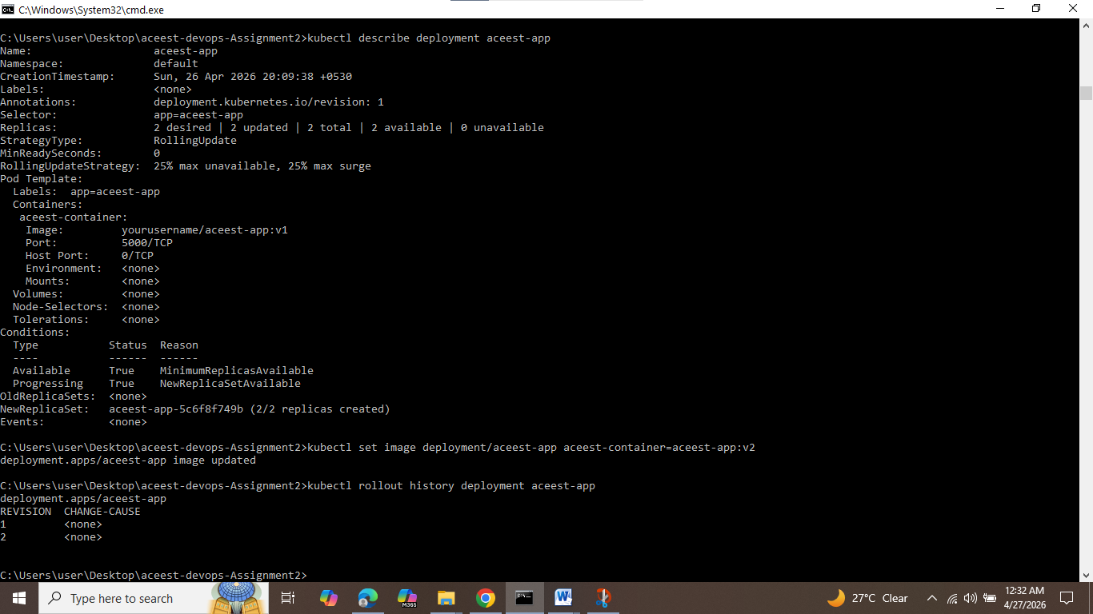

5.2 Rolling Update Strategy (Implemented)
The application was deployed using the Rolling Update strategy, which is the default deployment mechanism in Kubernetes.
In this approach, the application is updated gradually by replacing old pods with new pods one at a time. This ensures that:
- The application remains available during updates
- There is no downtime experienced by users
- The system remains stable throughout deployment
- The deployment progress was verified using:
- kubectl rollout status deployment aceest-app
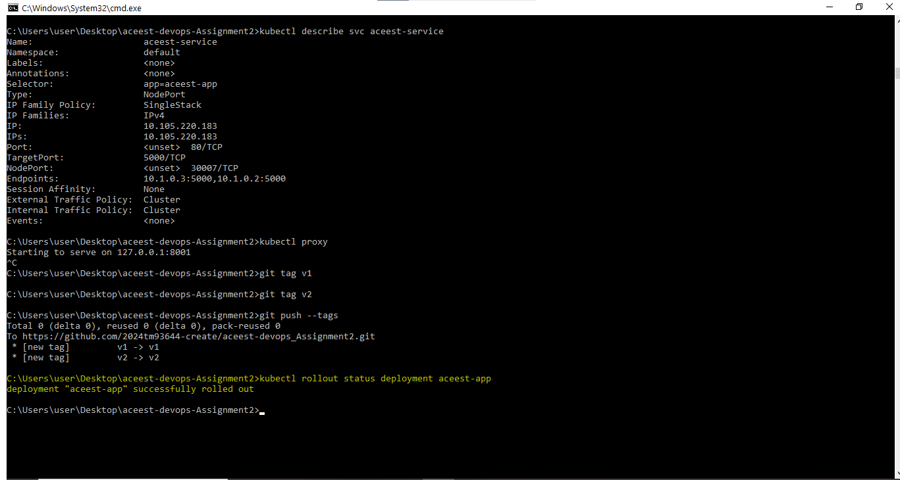

5.3 Rollback Mechanism (Implemented)
Rollback allows reverting the system to a previous stable version in case of failure.
In this assignment, rollback was implemented using Kubernetes:
kubectl rollout undo deployment aceest-app
This ensured:
- Quick recovery from failures
- Minimal downtime
- System stability
- The rollback was successfully tested and verified.
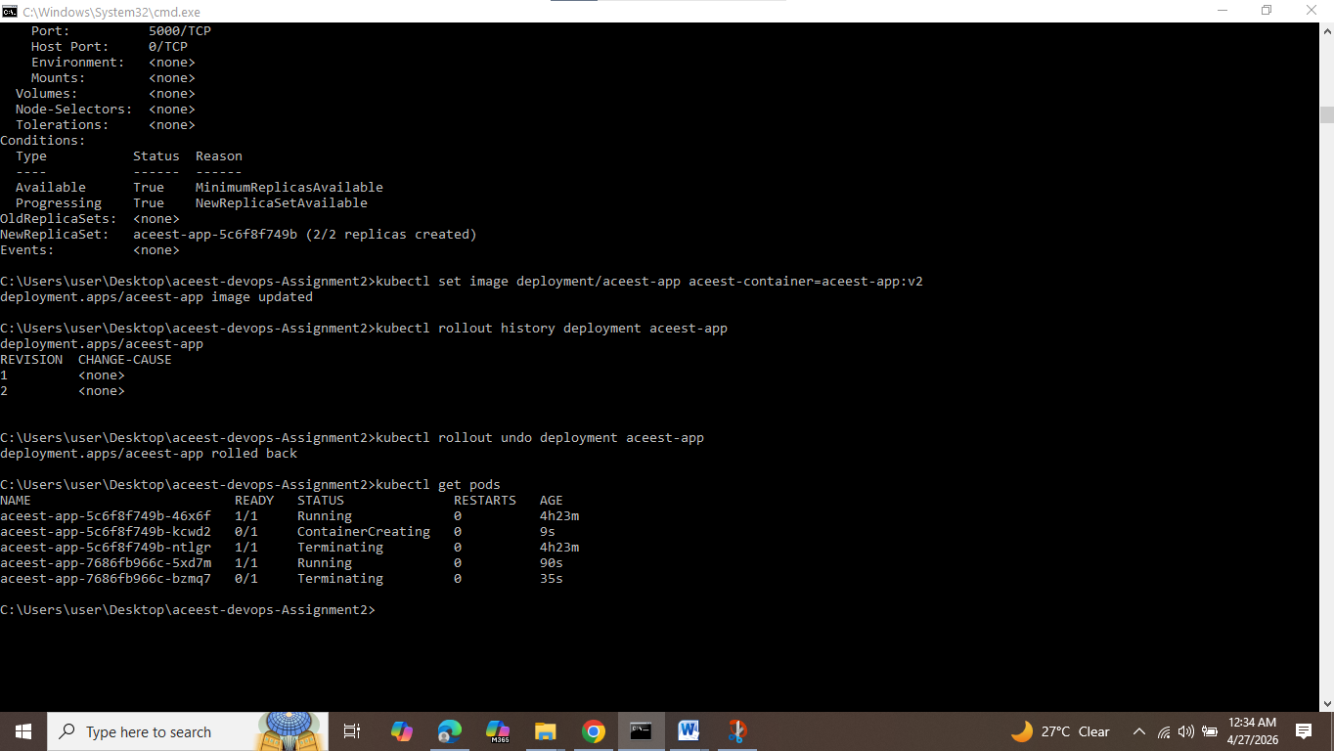

5.4 Blue-Green Deployment (Conceptual)
Blue-Green deployment involves maintaining two environments: one live (Blue) and one new (Green). After testing, traffic is switched to the new version.
Advantages:
- Zero downtime
- Easy rollback

5.5 Canary Release (Conceptual)
In Canary deployment, the new version is released to a small group of users before full rollout.
Advantages:
- Reduced risk
- Early issue detection

5.6 Shadow Deployment (Conceptual)
In Shadow deployment, the new version runs in parallel and receives duplicated traffic without affecting users.
Advantages:
- Real-world testing
- No user impact

5.7 A/B Testing (Conceptual)
A/B testing compares two versions of an application by exposing them to different users.
Advantages:
- Data-driven decisions
- Improved user experience

5.8 Summary
- Rolling Update and Rollback were implemented
- Other strategies were studied conceptually
- These strategies ensure zero downtime, reliability, and safe deployment.

6. SonarQube Integration
SonarQube is used for static code analysis to detect bugs, vulnerabilities, and code quality issues.
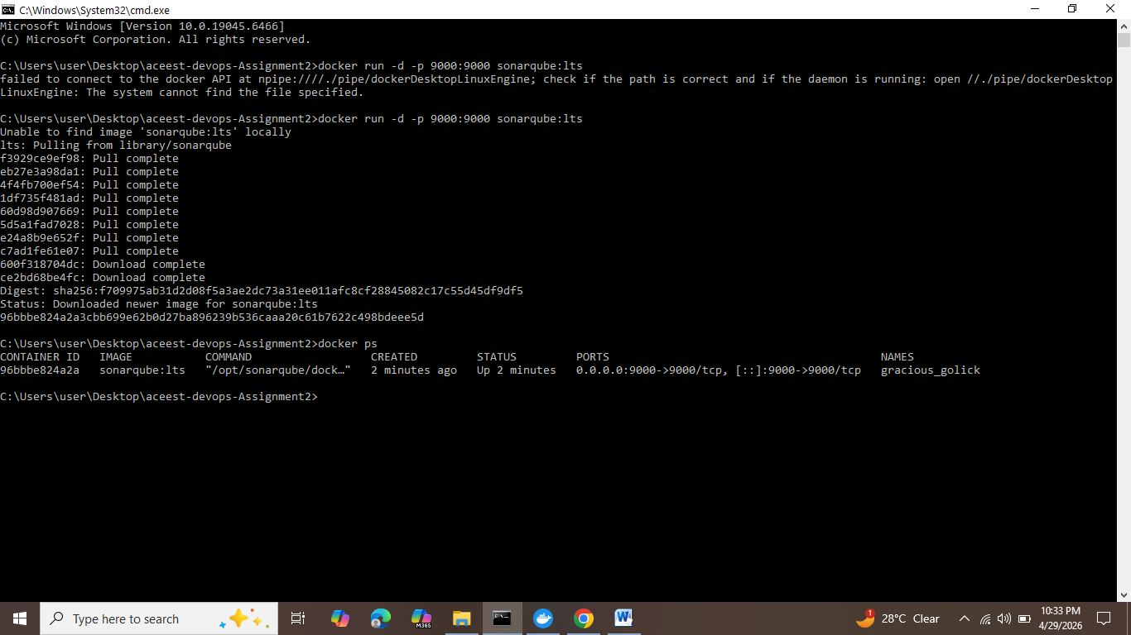

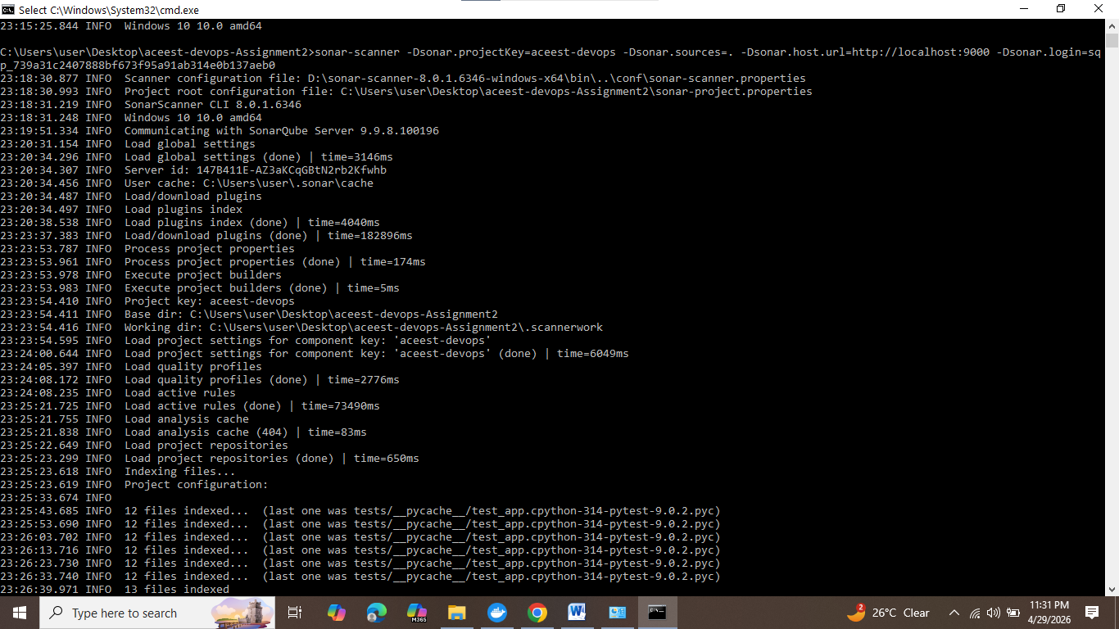

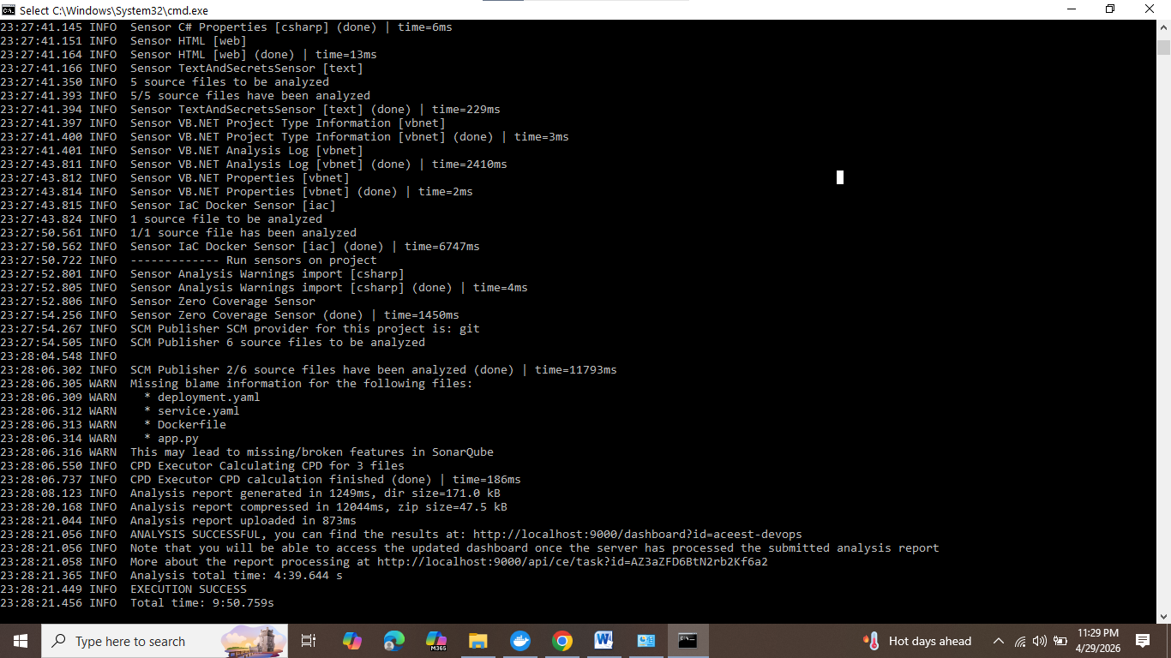

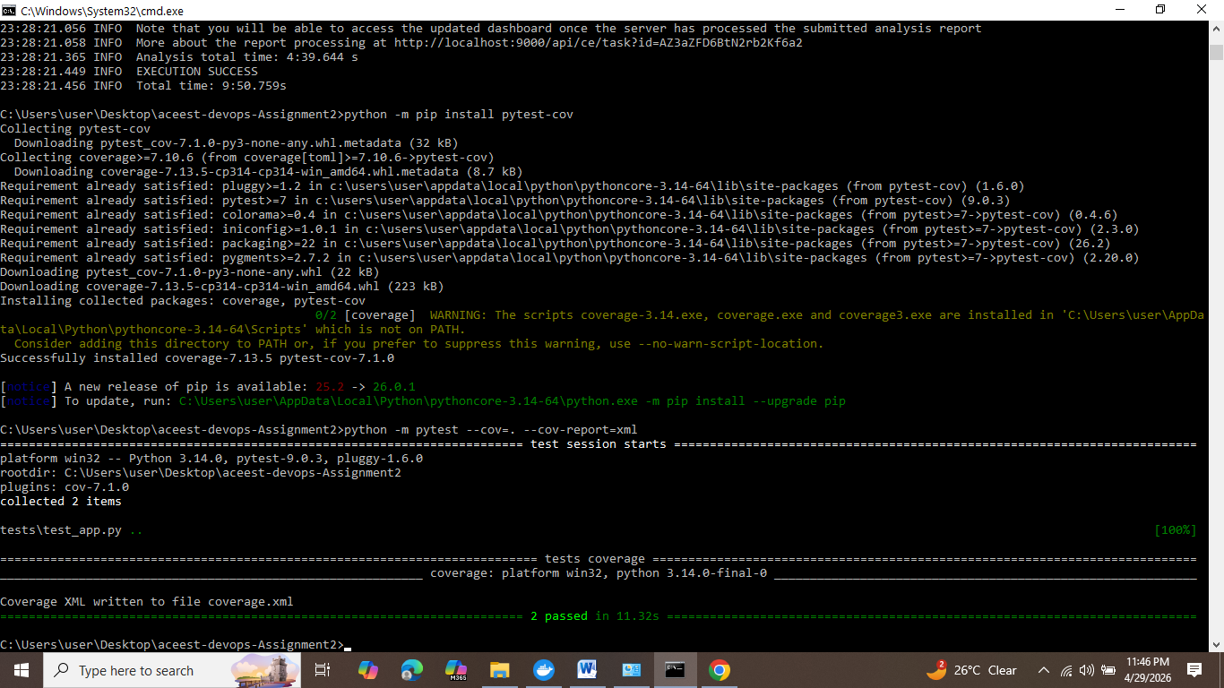
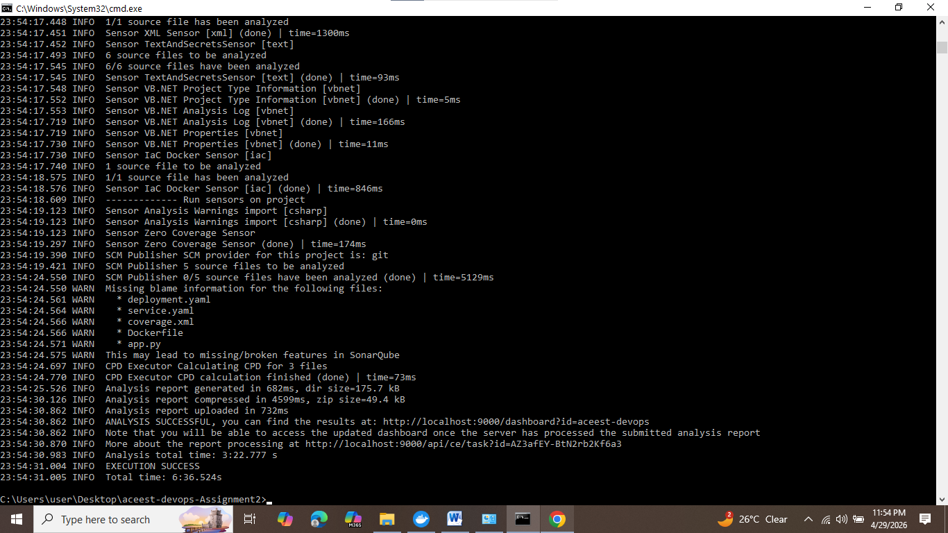

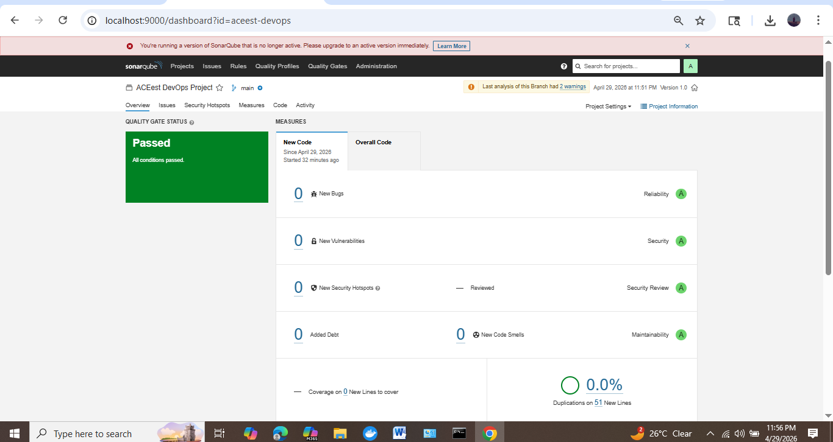

100% test Coverage and 100% success with 0% duplication

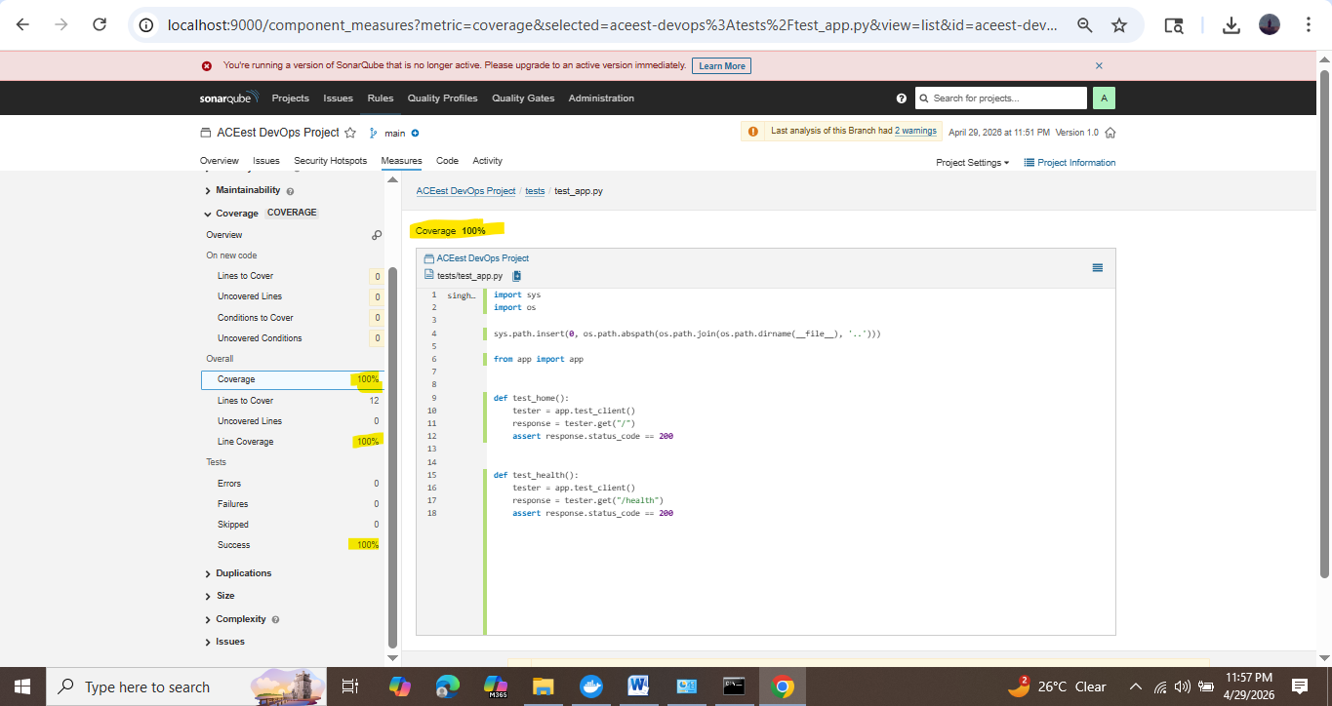

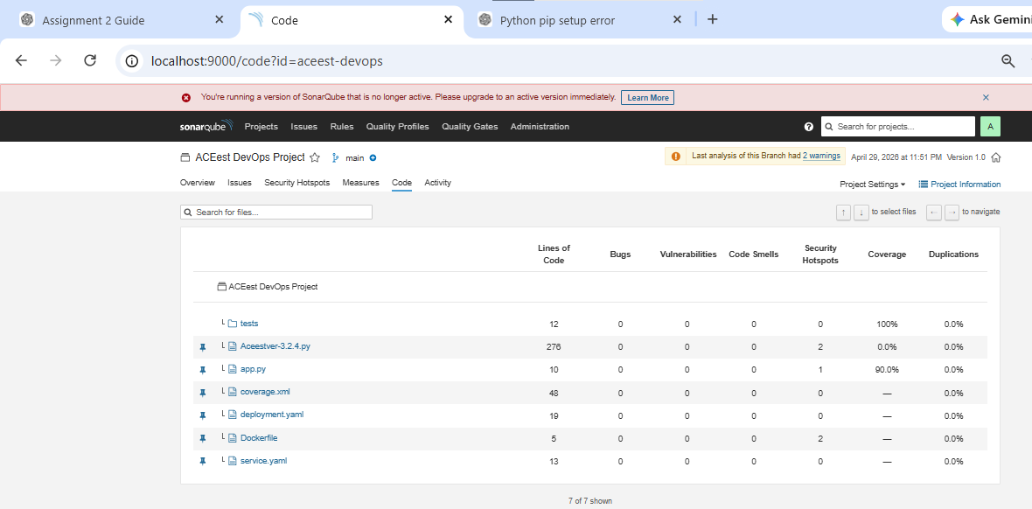
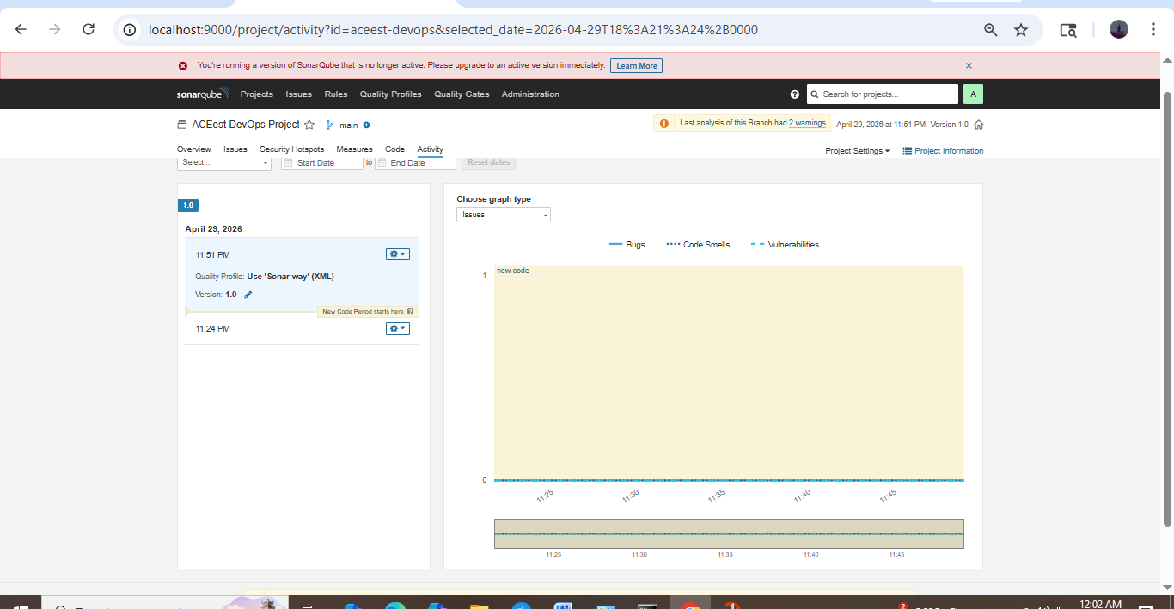

7. Challenges Faced
- Jenkins environment configuration issues
- Docker dependency conflicts
- Kubernetes networking limitations
- NodePort accessibility problems

8. Solutions Implemented
- Simplified Jenkins pipeline
- Updated Python version in Docker
- Used kubectl proxy for access
- Verified deployment using Kubernetes commands

9. Advantages of CI/CD Pipeline
- Faster development and deployment
- Early detection of bugs
- Improved software quality
- Reduced manual effort
- Scalable and reliable system

10. Conclusion
The assignment successfully demonstrated the implementation of a complete CI/CD pipeline using DevOps tools. It provided practical experience in integrating development, testing, and deployment processes.
The pipeline ensures automation, reliability, and efficiency in software delivery, which are essential in modern application development.

Thank You !

