Figma :

ORGANIZATION MEMBER :

ROUTE : /organization/sessions (GETCOLLECTION)
ROUTE : /organization/{organizationMemberId}/sessions (GETCOLLECTION)

Variables : $sessionId, $trainingName, $offerNumber, $trainerFirstName, $trainerLastName, $trainerId, $internshipStart, $internshipEnd, $validationPercentage

ROUTE : organization/session/{sessionId}

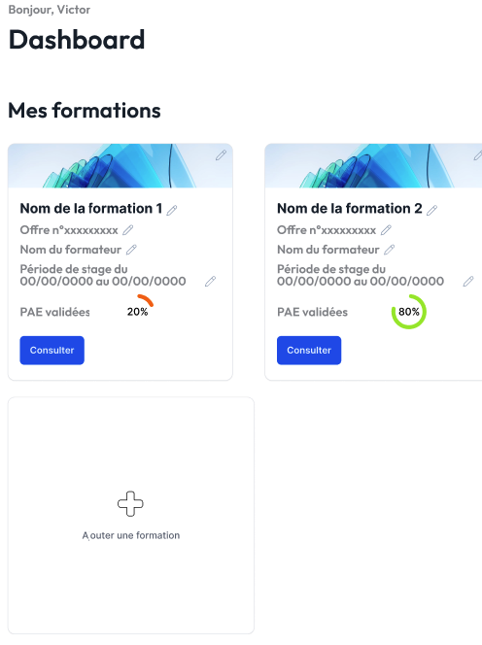

ROUTE : /organization/session/add (POST)
Variables : $trainingName, $offerNumber, $trainerId, $internshipStart, $internshipEnd

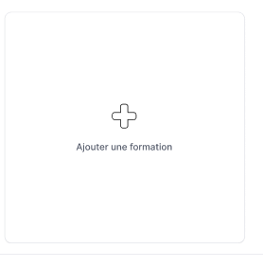

ROUTE : /organization/session/{sessionId}/edit (PATCH)
Variables : $sessionId, $trainingName, $offerNumber, $trainerId, $internshipStart, $internshipEnd



ROUTE : /organization/session/{sessionId}/archive (PATCH)
Variables : $sessionId, $sessionStatus

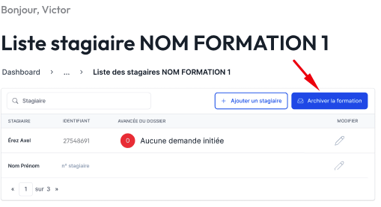

ROUTE : /organization/session/{sessionId}/interns (GETCOLLECTION)

Variables : $sessionId, $internFirstName, $internLastName, $internId, $login, $infoFormStatus, $trainingName

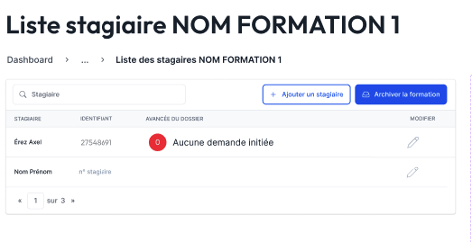

ROUTE : /organization/session/{sessionId}/intern/add (POST)
Variables : $sessionId, $internLastName, $internFirstName, $internEmail, $login
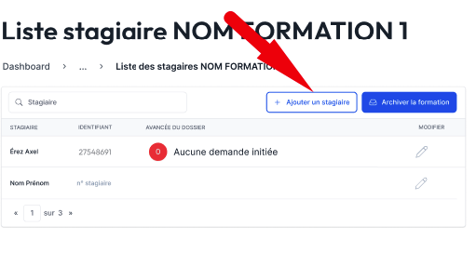

INTERN MEMBER :

ROUTE : /intern/infoForm (POST)
Variables : $trainingSessionId, $organizationId, $internId, $infoFormStatus, $infoFormOrganizationId, $infoFormOrganizationStatus, $inforFormInternMemberId, $inforFormInternMemberDateStart, $inforFormInternMemberDateEnd, $inforFormInternMemberStatus, $infoFormInternCompanyId, $infoFormCompanyStatus, $infoFormCompanyId, $infoFormInternCompanyLegalRepresentativeFirstName, $infoFormInternCompanyLegalRepresentativeLastName, $infoFormInternCompanyLegalRepresentativeEmail, $infoFormInternCompanyName

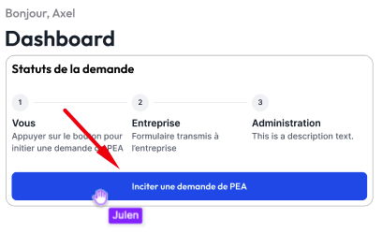

ROUTE : /intern/infoForm/infoFormIntern/{infoFormInternId} (GET)
Variable : $internFirstName, $internLastName, $internEmail, $trainingName, $offerNumber, $internshipPeriodStart, $internshipPeriodEnd

ROUTE : /intern/infoForm/infoFormIntern/{infoFormInternId} (PATCH)
Variable : $internshipPeriodStart, $internshipPeriodEnd

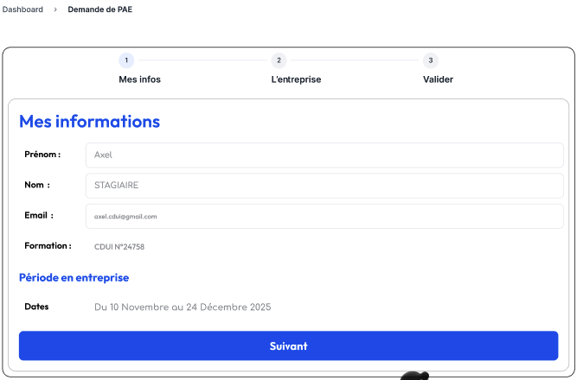

ROUTE : /intern/infoForm/{infoFormId}/infoFormIntern/infoFormInternCompany/ (PATCH)
Variable : $companyName, $companyAddress, $companyContactName $companyContactEmail, $infoFormCompanyStatus, $legalRepresentativeLastName, , $legalRepresentativeFirstName, $legalRepresentativeEmail

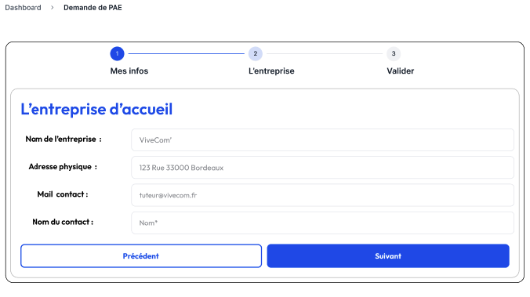

ROUTE : /intern/infoForm/{infoFormId}/infoFormIntern/validation (PATCH)
Variable : $infoFormId, $infoFormStatus, $inforFormInternStatus, $inforFormCompanyStatus

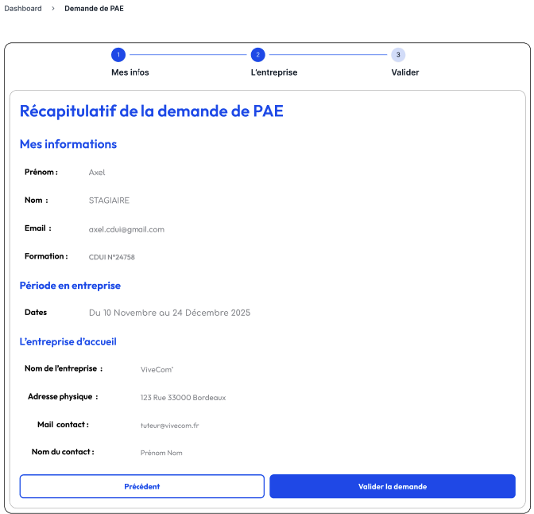

COMPANY MEMBER :

ROUTE : /company/infoForm/{infoFormId}/infoFormCompany/{infoFormCompanyId} (GET, PATCH)
Variable : $infoFormId, $companyName, $companyAddress, $companyActivity, $companyPhoneNumber, $companyEmail, $companyFax, $companySiret, $companyLegalRepresentativeLastName, $companyLegalRepresentativeFirstName, $companyLegalRepresentativeEmail, $companyTutorLastName, $companyTutorFirstName, $companyTutorEmail, $companyTutorPhoneNumber

ROUTE : /company/infoForm/{infoFormId}/infoFormCompany/{infoFormCompanyId}/validation (PATCH)
Variable : $infoFormId, $companyName, $companyAddress, $companyActivity, $companyPhoneNumber, $companyEmail, $companyFax, $companySiret, $companyLegalRepresentativeLastName, $companyLegalRepresentativeFirstName, $companyLegalRepresentativeEmail, $companyTutorLastName, $companyTutorFirstName, $companyTutorEmail, $companyTutorPhoneNumber, $infoFormStatus, $infoFormCompanyStatus, $infoFormOrganizationStatus

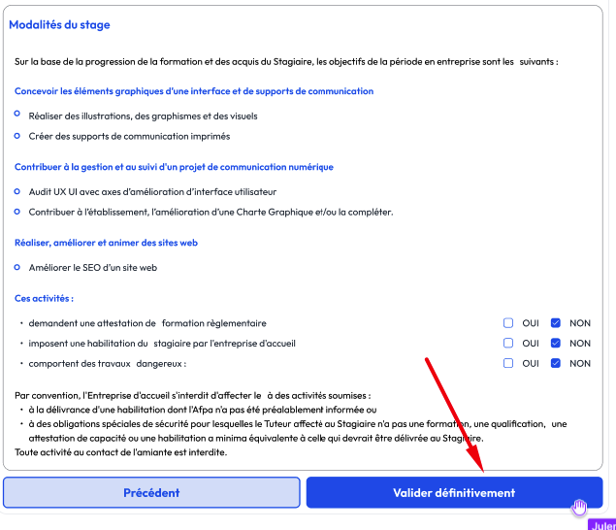
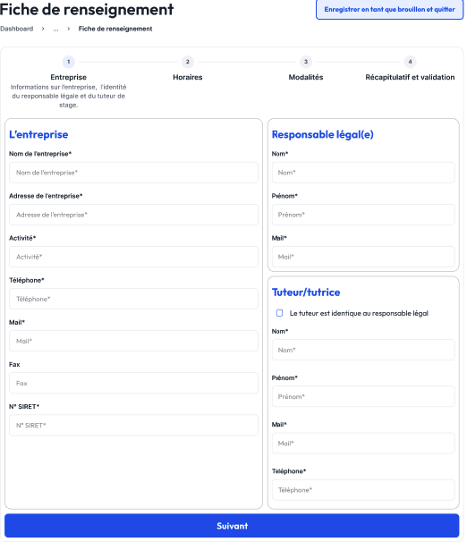

ACCOUNT :

ROUTE : /account/{id}/info (GET, PUT)

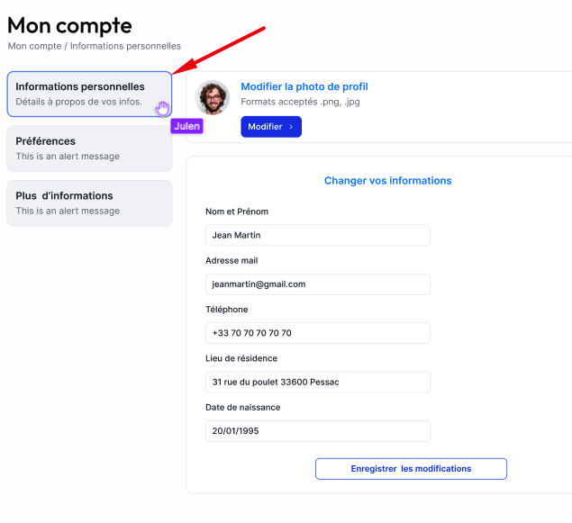

ROUTE : /account/{id}/preferences (GET, PUT)
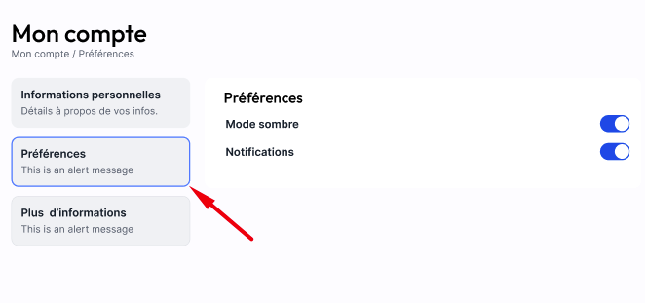
ROUTE : /account/{id}/more (GET, PUT)
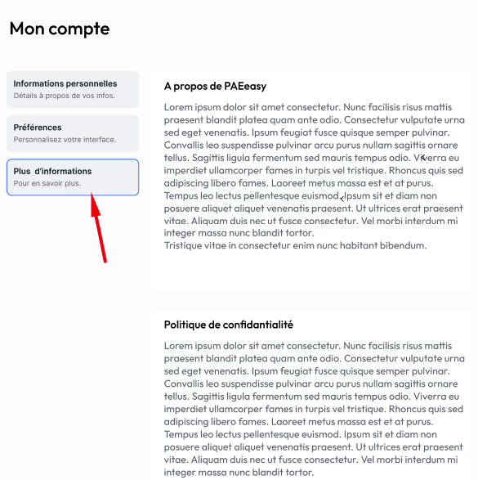
NOTIFICATIONS :

ROUTE : /notifications/user{id} (GET, ALL)
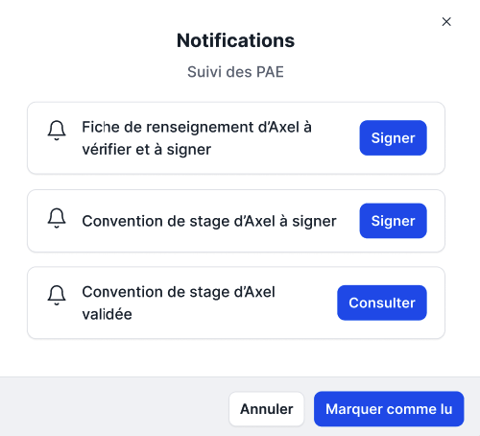
ROUTE : /notification/user{id}/show/{id} (GET, ONE)
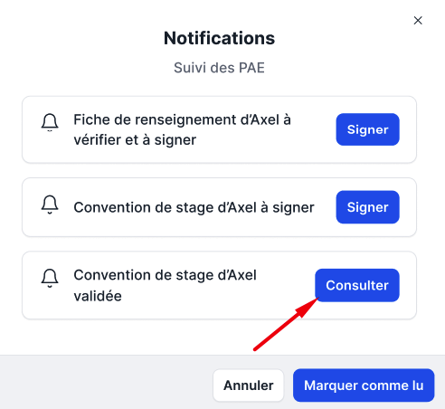
ROUTE : /notifications/user{id}/sign/{id} (GET, ALL)
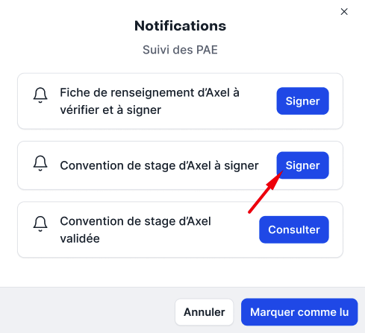

DATES :

ROUTE : /internship-dates/{id} (GET)
ROUTE : /training-dates/{id} (GET)

RESUME CARD :

ROUTE : /resume-card/intern (GET)
ROUTE : /resume-card/organization (GET)
ROUTE : /resume-card/company (GET)

RESUME FORM :

ROUTE : /resume-form/{id} (GET)
ROUTE : /resume-form/validation-status/{id} (PUT)

STATUS :

ROUTE : /status/{id} (GET)
ROUTE : /status/company/{id} (GET)
ROUTE : /status/intern/{id} (GET)
ROUTE : /status/organization/{id} (GET)

ROUTE : /percentage-form-validation/{id} (GET)

ROUTE : /user/{id} (GET)

