Cloud Native HW4

R13922213 梁正

1. Docker Hub

* Create a repo on Docker Hub named 2025cloud

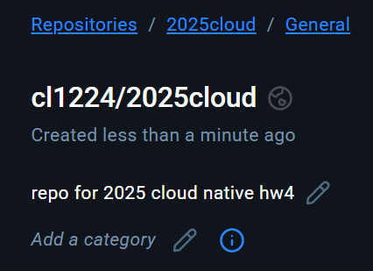

1. Git Repo & README & Dockerfile

* Dockerfile in Git repo

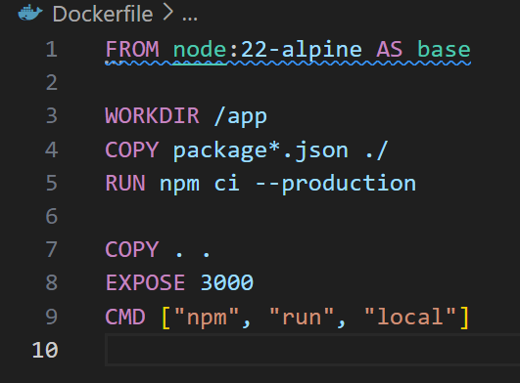

* Build docker image

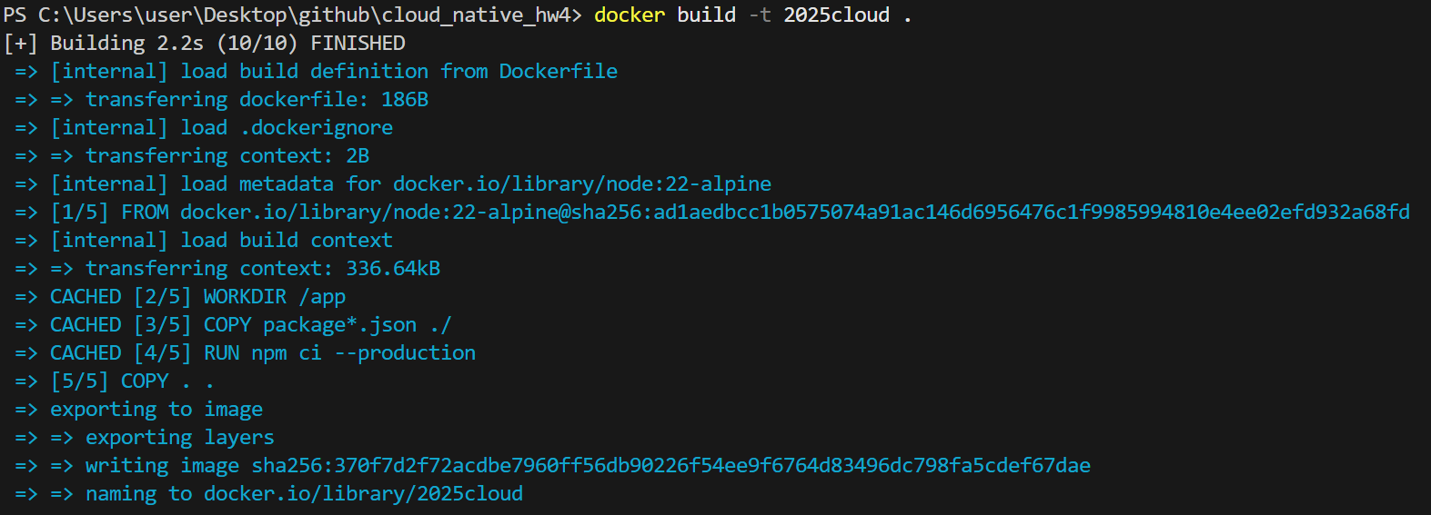

* Run the docker container from built image



With flag –d and –p, the container is run in detached mode and exposes port 3000