Practical Assignment-3
1. Develop a Shopping cart in PHP with following requirements:
Admin Site:
1) Login
2) Manage Category (CRUD)
3) Manage Products (Product data with pictures. Upload picture and resize them)
4) Logout
User Site:
Categories  Garments  Mobiles  Laptops
  Pic  pname price | p2 | p3
  p4

1) List Categories
2) Display products of category whose hyperlink is clicked(Apply pagination, load data with ajax).
3) Register user (Use CAPTCHA)
4) Login
Ans:-
Home:-
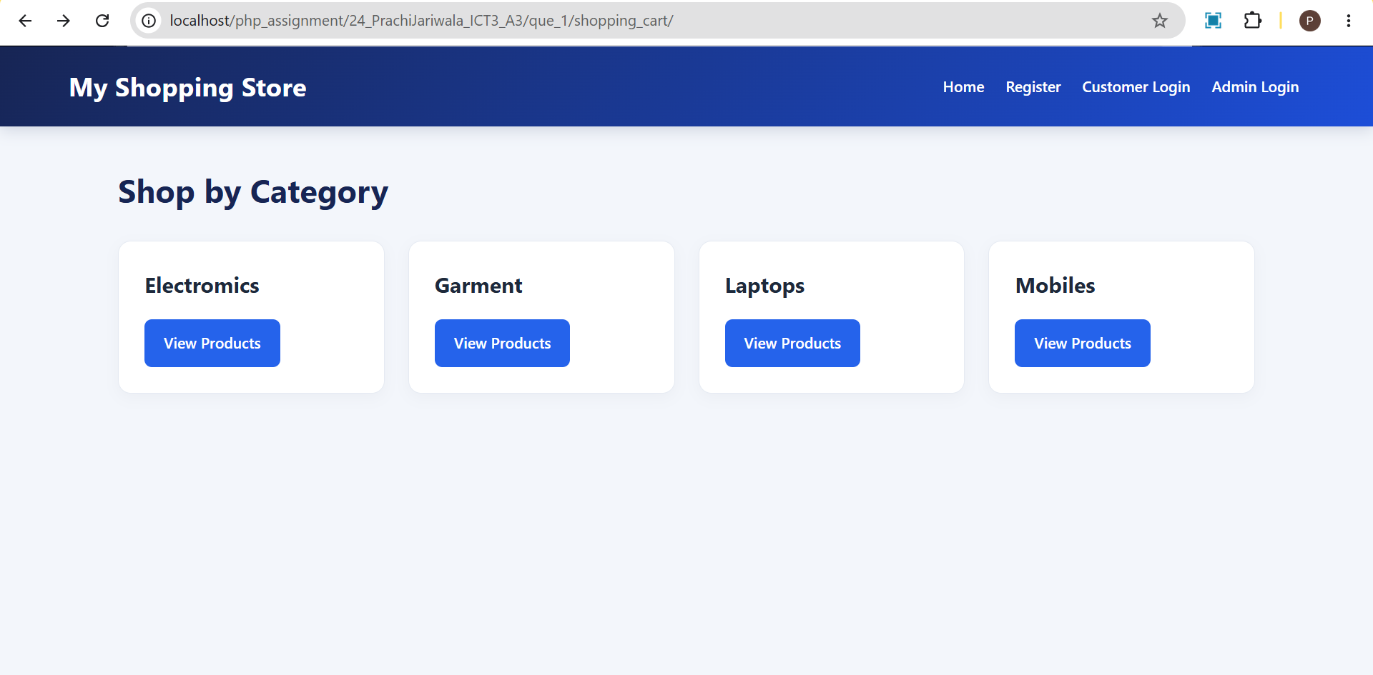
Admin Site:-
Admin Login:-
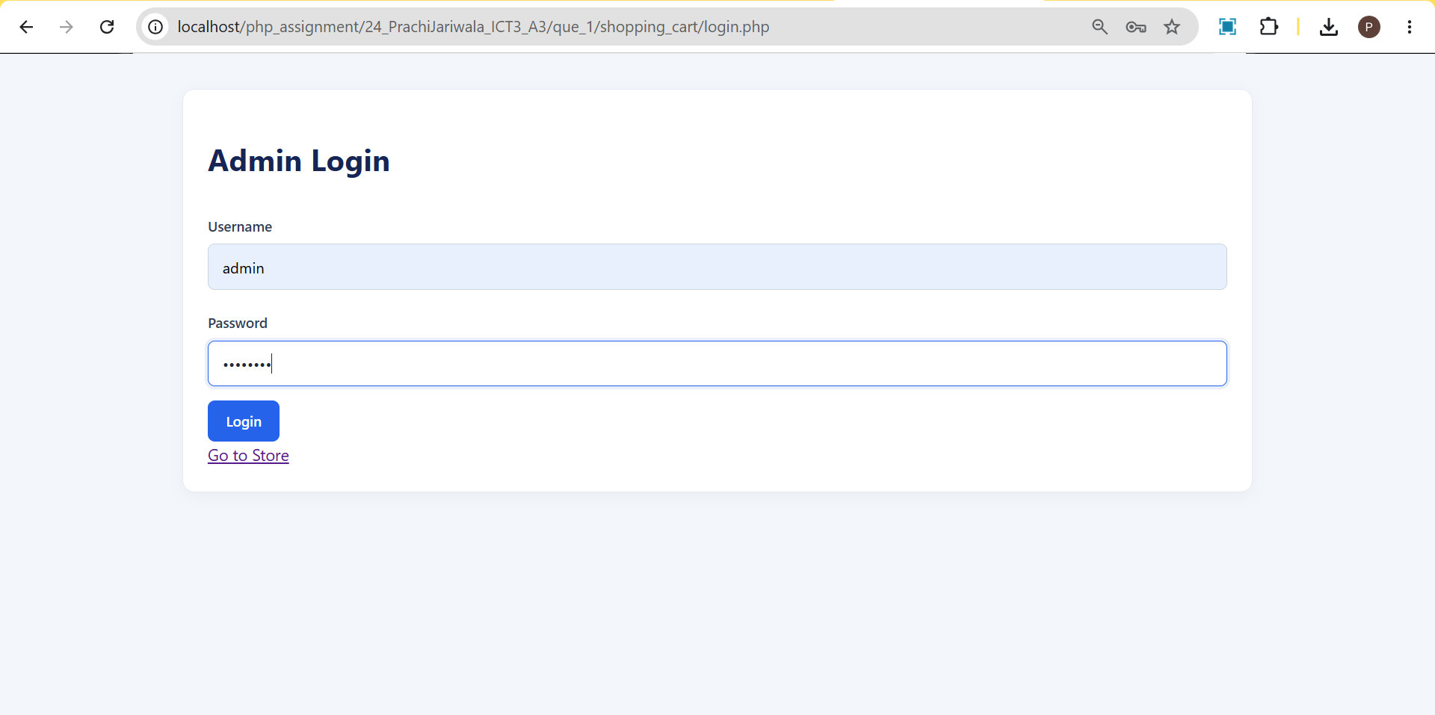

Admin Dashboard:-
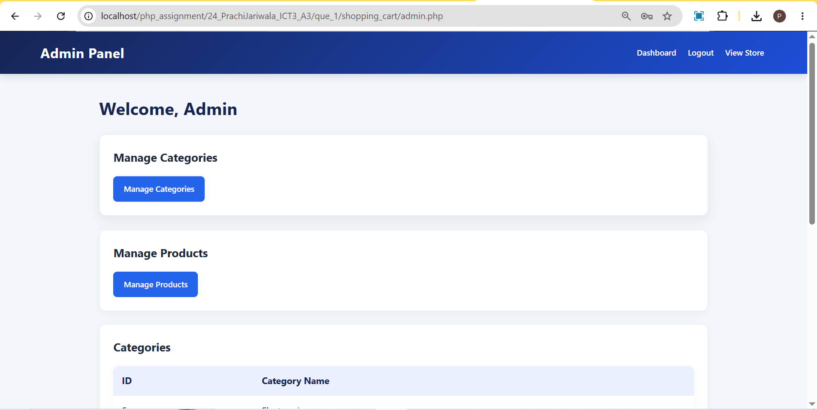

Manage Category Page:-
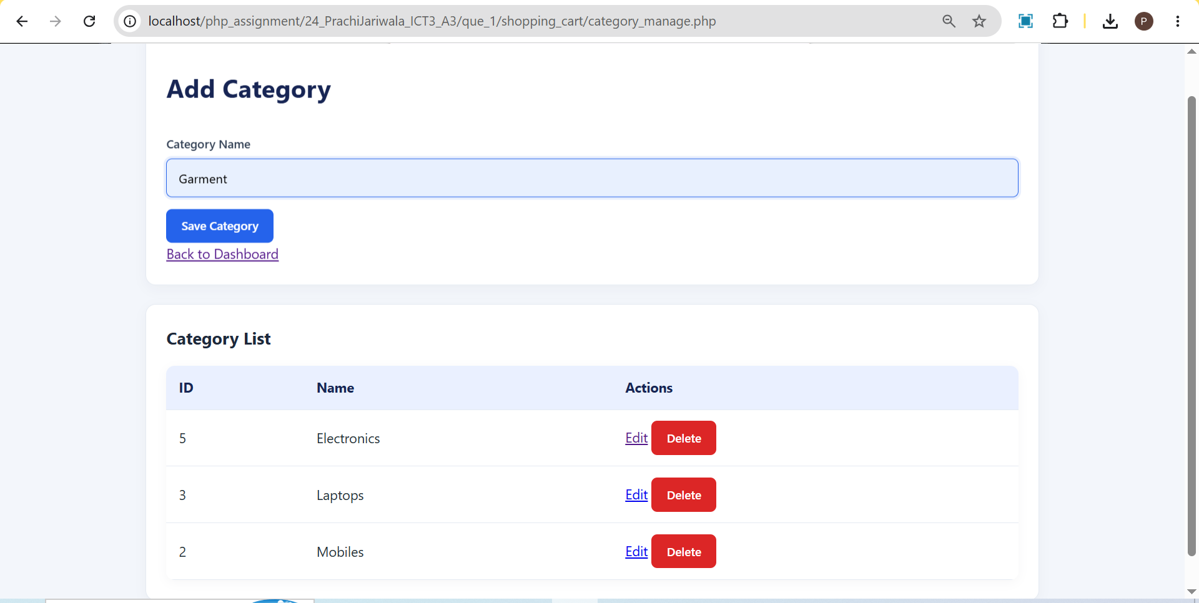

Manage Product Page:-
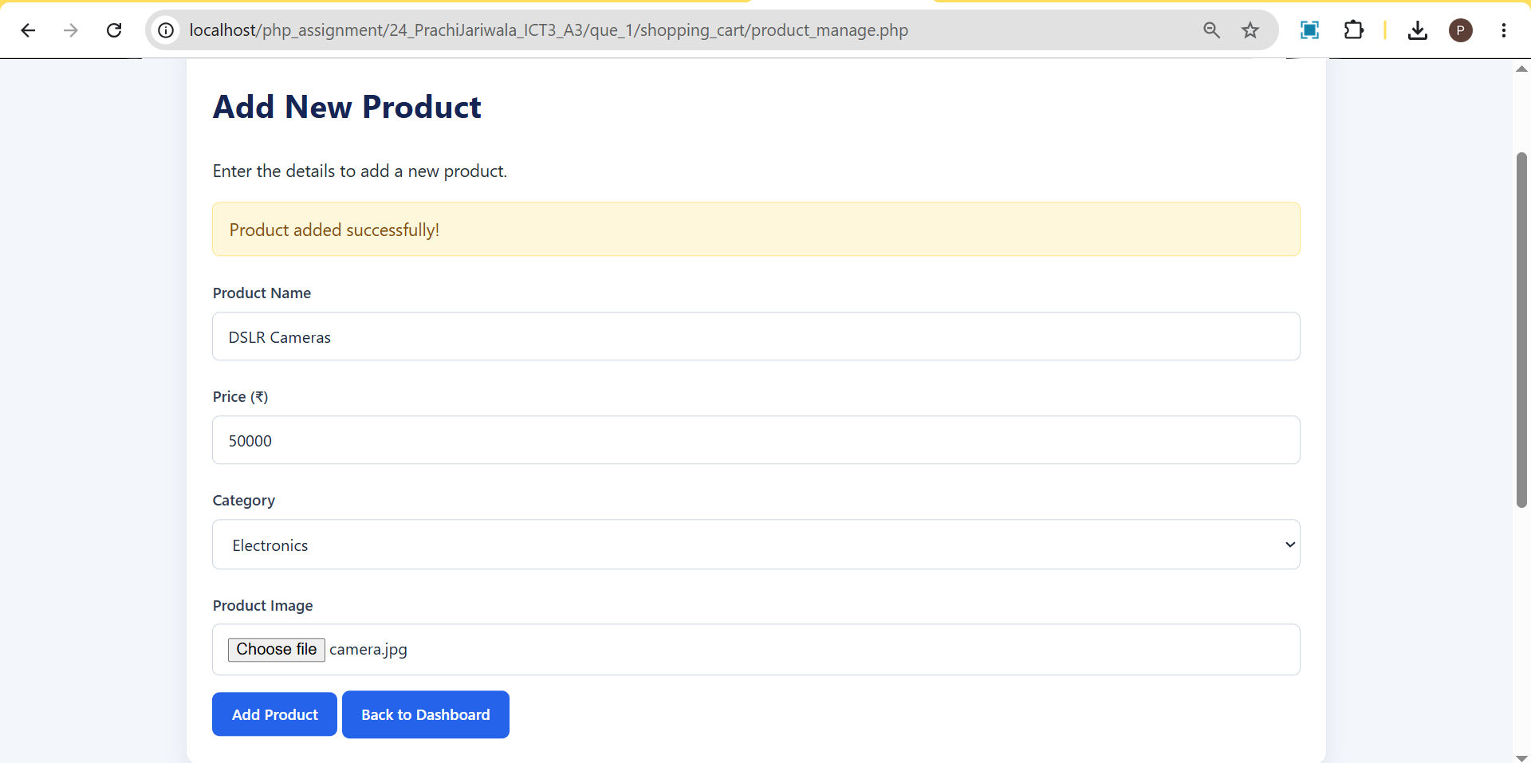

User Site:-

Register:-
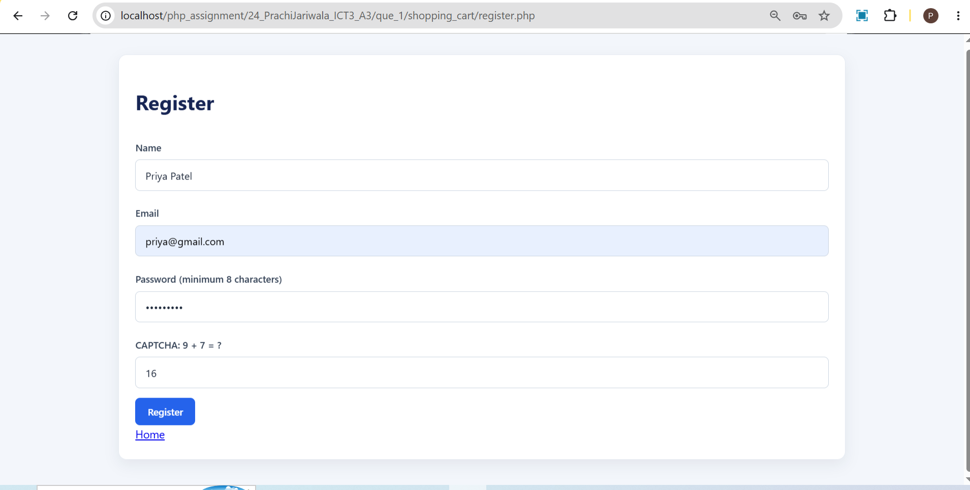

Login:-
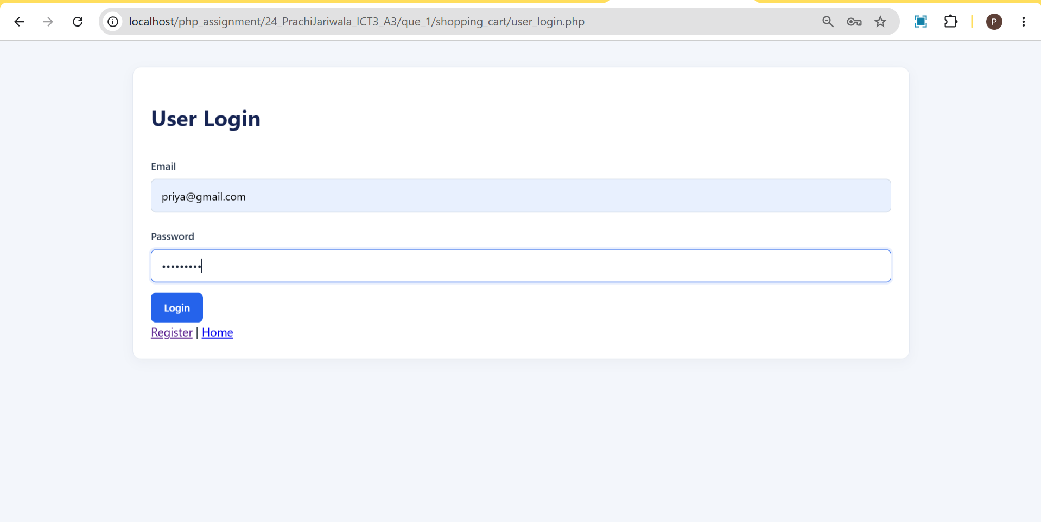

After login Redirect to home with session:-
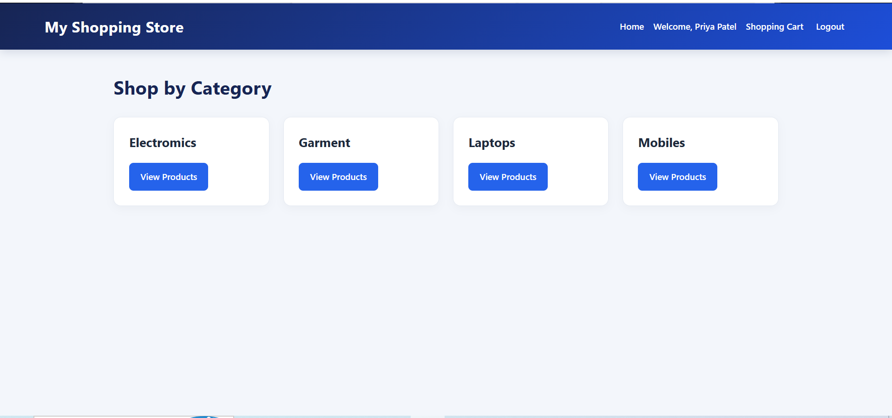
Category wise Product Page:-
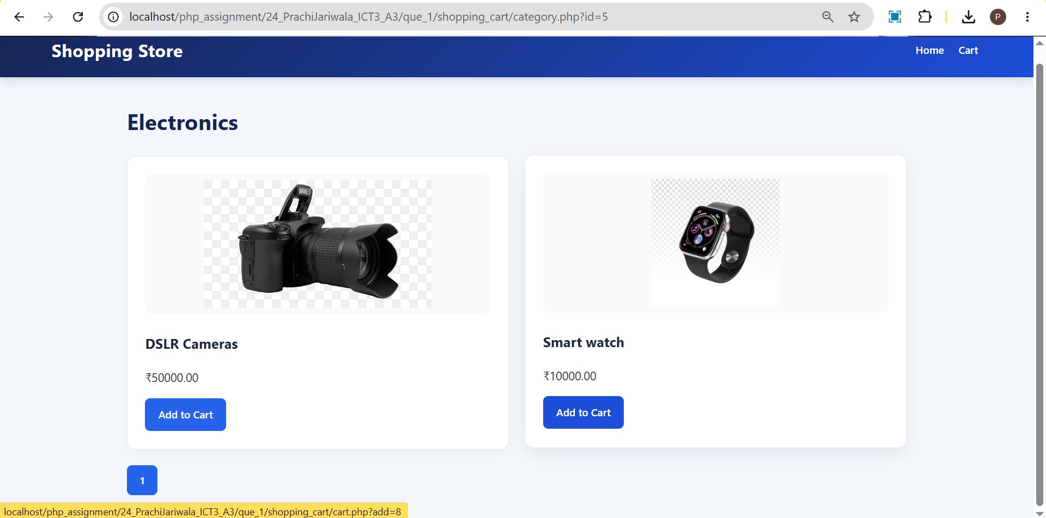

Shopping Cart Page:-
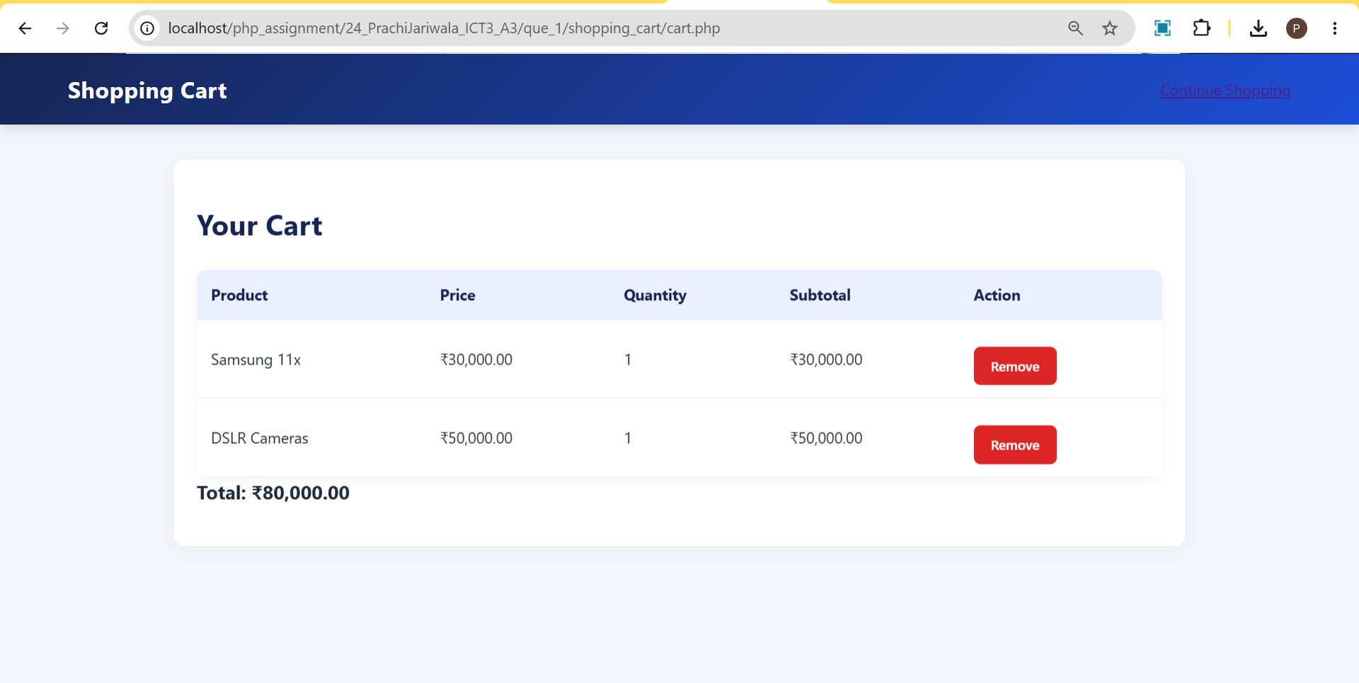

2. Read data from students.xml file and store them in students table of MySQL.
Ans:-
Students.xml
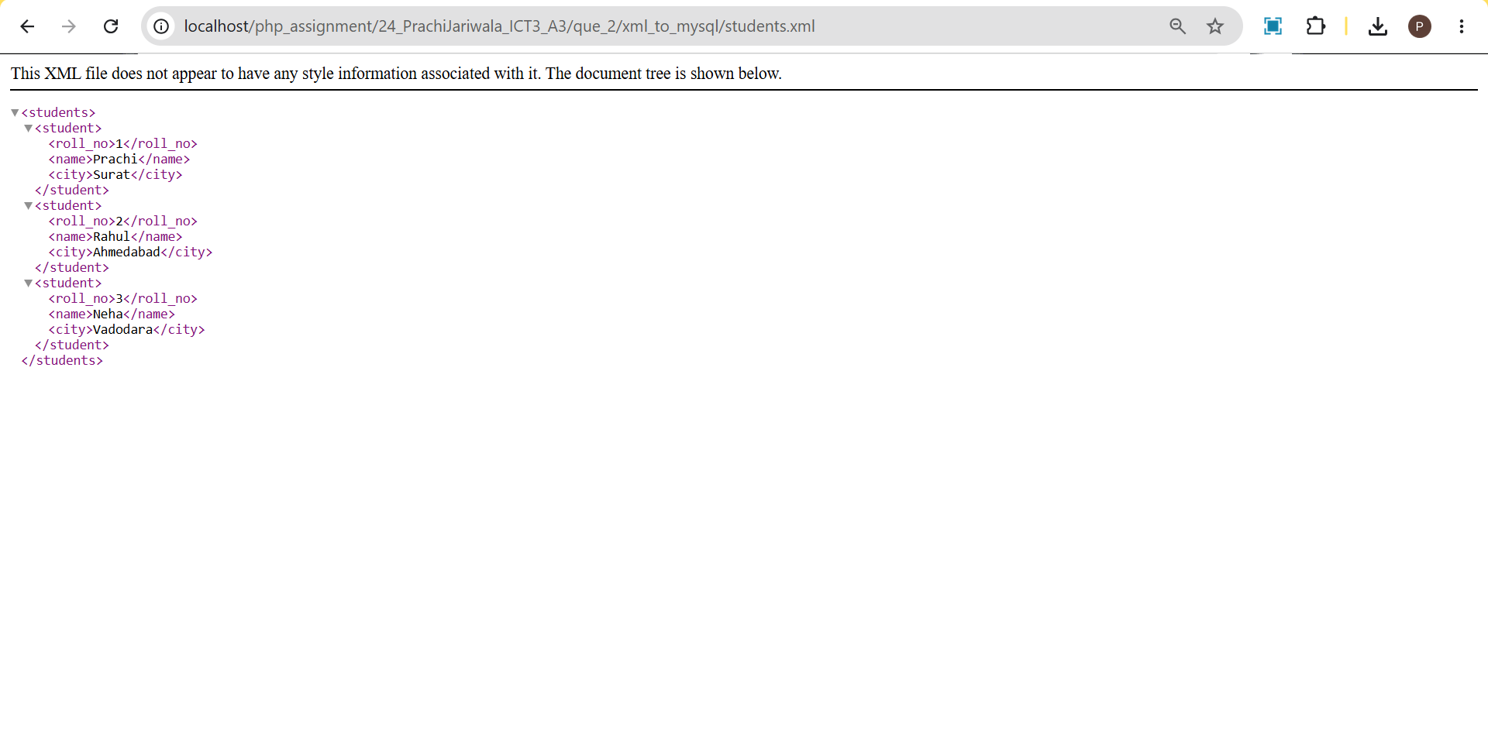
Import.php
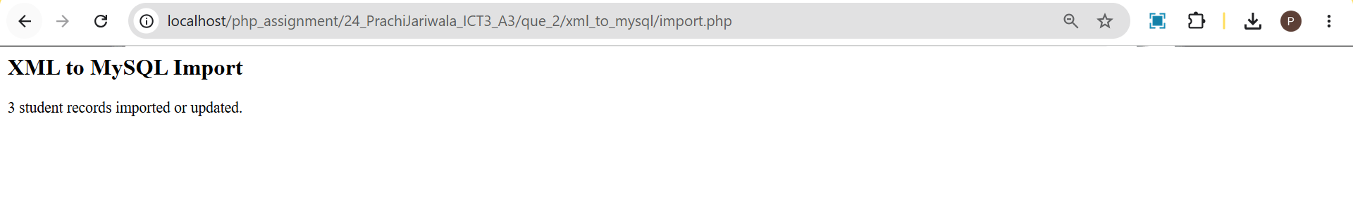
MySql Table:-
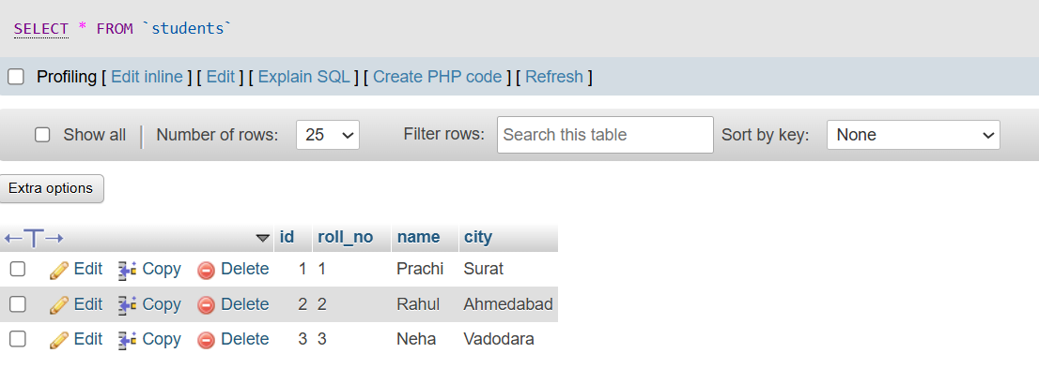
3. Read data from students table of MySQL and store them in students.xml file.
Ans:-
MySql Table:-

Export.php
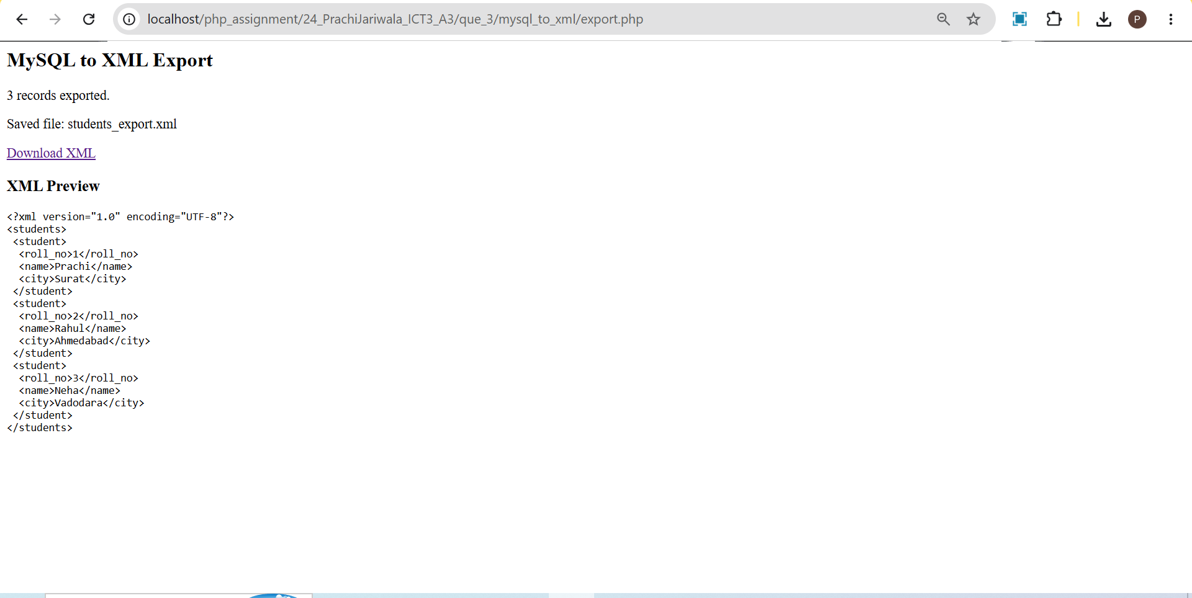

4. List files in a directory.
Ans:-
Files in Directory:-
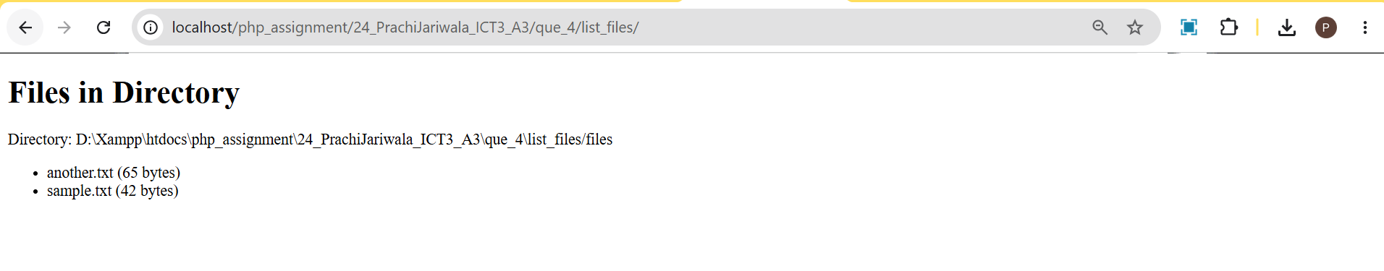

5. Call express rest api in php.
Ans:-
Student List from Express API:-
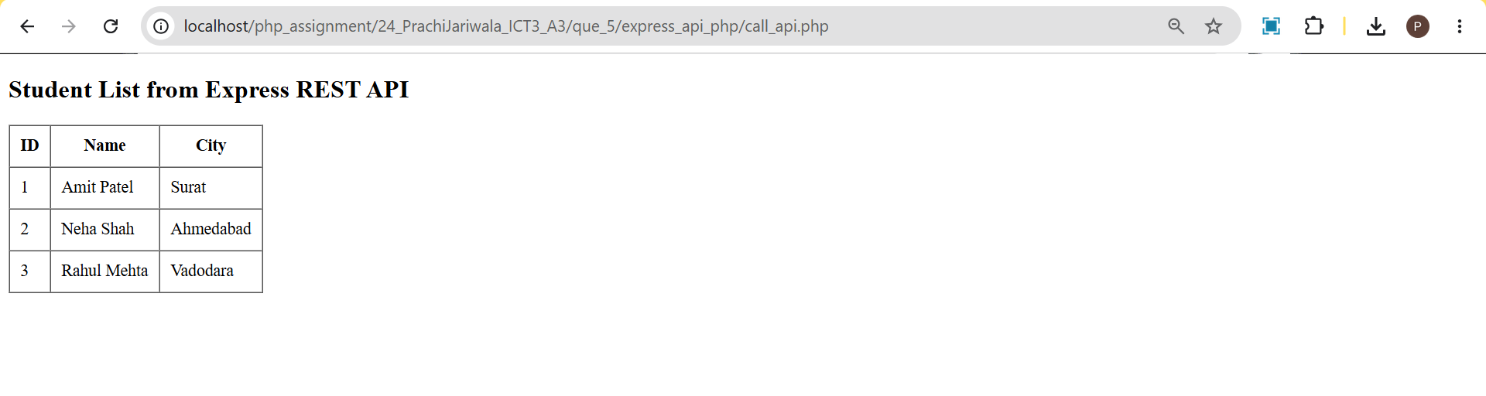

6. Call php rest api in express.
Ans:-
Data From Mysql Table to Express API:-
