SHE SHIELD
Design Document & Presentation Deck
Cyber-Integrated Safety Platform for Women

Team Members
SUBMITTED BY
Jainam Shah – 202512012 (Backend APIs)
Maahir Shah – 202512022 (Database Architecture)
Hitarth Shah – 202512042 (AI Threat Models)
Jay Shah – 202512059 (DevOps & Integration)
Nirmal Patel – 202512102 (Authentication & RBAC)
Priya Shah – 202512105 (Navigation & User Flow)
Jenil Shah – 202512110 (Cybersecurity & Vault)
Krisha Doshi – 202512112 (Mobile UI Engineering)

Course: WSSOA (IT644) · Autumn Semester 2026
Dhirubhai Ambani University, Gandhinagar
Date of Submission: 29/08/2026 · Document Version: 1.0

1. Project Overview & Credentials
Execution Flow: Project Declaration → Team Organization → Engineering Ownership
- Title: SHE SHIELD — Cyber-Integrated Safety Platform for Women.
- Course: WSSOA (IT644) Project Presentation I, Autumn 2026, Dhirubhai Ambani University.
- Engineering Roles: Clean 8-member ownership covering Mobile UI, Navigation, Backend APIs, Database, AI Models, DevOps, Auth/RBAC, and Cybersecurity.
Speaker Script (Natural, concise verbal delivery):
"Good afternoon professors and peers. Welcome to our Project Presentation I for IT644. We present SHE SHIELD, a cyber-integrated safety platform for women developed by our eight-member team at Dhirubhai Ambani University."

2. Problem Analysis
Execution Flow: Market Gap 1 (Physical vs Cyber) → Market Gap 2 (Panic Latency) → Market Gap 3 (Evidence Destruction)
- Gap 1 (Single-Vector Focus): Existing apps handle only physical panic buttons and completely ignore cyber harassment, doxxing, and online blackmail.
- Gap 2 (Panic Latency): Victims under attack cannot unlock screens or navigate apps; stealth triggers (BLE, voice phrase 'capcap') are missing.
- Gap 3 (Digital Evidence Loss): Chats and threats are deleted before reporting; screenshots lack cryptographic integrity for court admissibility under Section 65B.
Speaker Script (Natural, concise verbal delivery):
"Existing safety apps have three fatal flaws: they ignore cyber harassment, they require complex screen interactions that fail during acute panic, and digital evidence is easily erased before police reporting."

3. Solution Architecture
Execution Flow: Stealth Trigger → Instant Multi-Target Alert → Continuous Route Tracking → Forensic Evidence Notarization
- Pillar 1 (Physical SOS & Transit): BLE wearable button, voice 'capcap', power double-click, sub-2s dispatch, and Cab Guardian route deviation alerts (>30m).
- Pillar 2 (AI Cybercrime & OCR): OCR extracts blackmail text and timestamps; PyTorch NLP evaluates danger severity (e.g. 92%) and builds structured police dossiers.
- Pillar 3 (Cryptographic Evidence Vault): Continuous background blackbox recording, client-side SHA-256 digital fingerprinting, and AES-256 cloud encryption for court validity.
Speaker Script (Natural, concise verbal delivery):
"SHE SHIELD bridges physical transit safety with cyber protection through three pillars: stealth multi-modal triggers with Cab Guardian route monitoring, AI-powered cybercrime OCR intake, and a tamper-proof cryptographic evidence vault."

4. Stakeholders & Role-Based Access Control
Execution Flow: Primary User (Trigger & Report) ↔ Guardian (Live Telemetry) ↔ Police (Dispatch & Dossier) ↔ Admin (Audit & Rules)
- Women / Primary User: Dispatches stealth SOS (<= 2s), activates Cab/Walk Guardian, submits cyber reports, accesses personal Evidence Vault.
- Trusted Guardians: Receives live GPS waypoint streams, route deviation push alerts (>30m), automated SMS fallback links, confirms safe arrivals.
- Police & Responders: Live emergency radar map, prioritized incident queue, victim medical/biometric profiles, court-ready incident dossiers.
- System Administrators: Manages RBAC role permissions, high-risk unsafe zone polygons, immutable audit logs, AI model parameters.
Speaker Script (Natural, concise verbal delivery):
"We implement strict Role-Based Access Control: Women control their personal telemetry and evidence; Guardians receive scoped live breadcrumbs only during active trips; Responders access geographic incident maps; and Administrators enforce security."

5. Functional Requirements Specification
Execution Flow: FR-01 (<=2s Dispatch) → FR-02 (Live Stream) → FR-03 (Deviation Alert) → FR-04 (Cyber Triage) → FR-05 (Evidence Hashing)
- FR-01 (Instant SOS Dispatch): Sub-2-second dispatch latency (<= 2s) from trigger event to server acknowledgement.
- FR-02 (Live GPS Streams): High-frequency waypoint stream every 3–5 seconds with Kalman filtering.
- FR-03 (Route Deviation Alerts): Haversine distance algorithm flagging transit diversions exceeding 30 meters.
- FR-04 (Cyber Incident Logging): OCR screenshot text parsing and NLP threat severity calculation under 3 seconds.
- FR-05 (Evidence Hashing): Client-side SHA-256 digital fingerprinting calculated prior to cloud upload.
Speaker Script (Natural, concise verbal delivery):
"Our life-safety requirements mandate sub-2-second emergency dispatch latency, continuous 3-second GPS waypoint updates, automatic 30-meter cab deviation detection, and instant client-side SHA-256 evidence hashing."

6. Non-Functional Requirements & Compliance
Execution Flow: 99.9% Availability → 30-Day Location Privacy → Offline SMS Fallback → SHA-256 Legal Integrity
- NFR-01 (High Availability): 99.9% uptime SLA on emergency endpoints via auto-scaling WSGI workers and Redis queues.
- NFR-02 (Location Privacy): DPDP Act & GDPR compliance with automated 30-day scheduled purging of non-incident breadcrumbs.
- NFR-03 (Offline SMS Fallback): Local SQLite coordinate queueing and automated SMS fallback with Google Maps links.
- NFR-04 (SHA-256 Integrity): Immutable cryptographic audit trail guaranteeing court admissibility under Section 65B of Evidence Act.
Speaker Script (Natural, concise verbal delivery):
"Non-functional mandates ensure 99.9% emergency availability, automated 30-day purging of location logs for privacy compliance under DPDP regulations, offline SMS fallbacks when cellular data drops, and Section 65B evidence integrity."

7. Design Components : Three-Tier System Architecture
Execution Flow: Tier 1: Frontend (Flutter & React) → Tier 2: Backend & AI (Flask & PyTorch/OCR) → Tier 3: Database & Storage (AES-256 Vault & Relational DB)
- Tier 1 (Frontend Layer): Flutter Mobile App for women (60fps, BLE triggers, background telemetry) + React.js Web Command Dashboard for police & administrators via HTTPS/REST.
- Tier 2 (Backend & AI Layer): Central API Gateway enforcing JWT authentication & security → Python Flask Microservices (Auth, Emergency SOS, Travel Tracker, Cybercrime Intake) ↔ AI Threat Engine (Distress Audio Classifier & OCR Screenshot Scanner).
- Tier 3 (Database & Storage Layer): Relational Database storing user accounts, roles, complaint logs, and emergency sessions + Encrypted Evidence Vault enforcing AES-256 file encryption & SHA-256 integrity hashes.
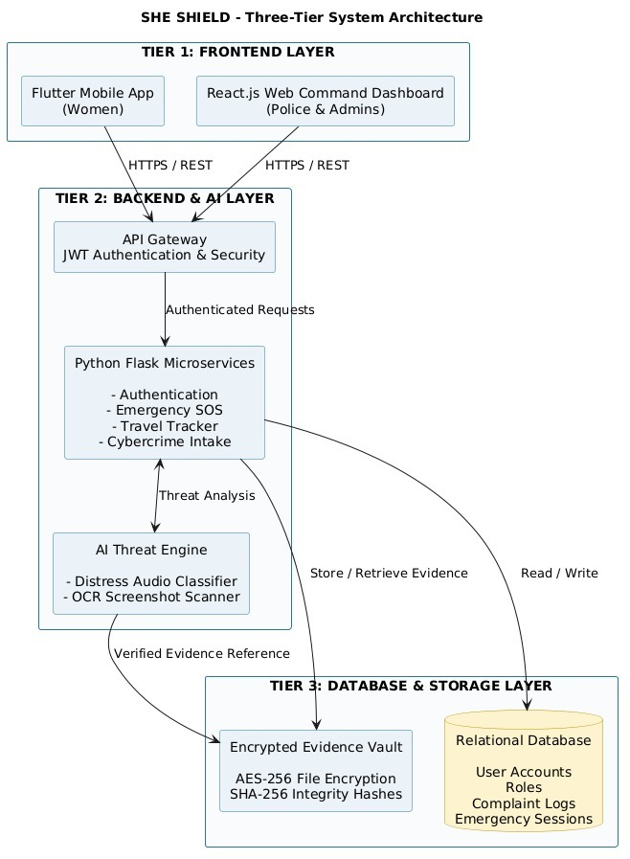
Figure: Slide 7: Design Components — Three-Tier System Architecture
Speaker Script (Natural, concise verbal delivery):
"Our primary design component is this Three-Tier System Architecture. Tier 1 delivers native mobile and web command interfaces. Tier 2 orchestrates Flask microservices and AI threat scanning behind a JWT gateway. Tier 3 secures persistent relational data and AES-256 encrypted evidence assets."

8. Design Components : Use Case Model & System Boundary
Execution Flow: Woman User (4 Use Cases) | Trusted Guardian (2 Use Cases) | Police/Admin (3 Use Cases)
- Woman (Primary User): Trigger Emergency SOS, Upload & Secure Evidence, Report Cybercrime Harassment, Track Travel & Cab Journey.
- Trusted Guardian: Receive Emergency SMS with Live GPS Link, View Real-Time Safety Status.
- Police / Administrator: Manage Emergency Cases, Review Cybercrime Complaints, Monitor Live Emergency Alerts on Command Radar.
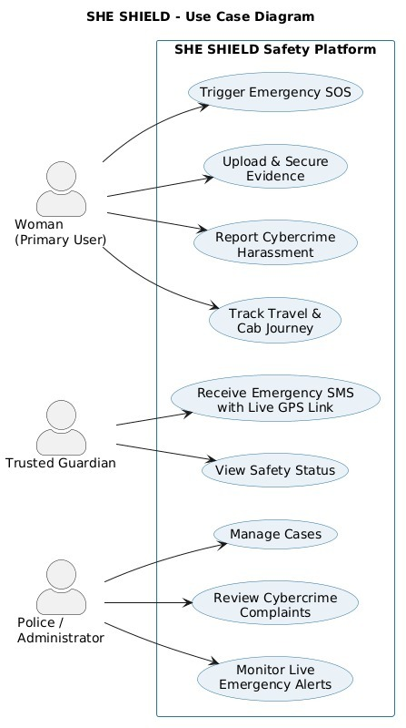
Figure: Slide 8: Design Components — Use Case Model & System Boundary
Speaker Script (Natural, concise verbal delivery):
"This design component illustrates our Use Case Model across the SHE SHIELD system boundary. Each actor has clearly defined, focused capabilities: women manage transit and emergency triggers, guardians monitor journeys, and police respond to active alerts."

9. Design Components : Emergency SOS Flow
Execution Flow: Woman Triggers SOS → App Captures GPS → Alert to Backend → Save in Database → Fork (Guardian SMS + Police Dashboard) → Display Confirmation
- Phase 1 (Initiation & Telemetry): Woman triggers SOS via button, BLE, or voice → App captures GPS location coordinates.
- Phase 2 (Ingestion & Storage): App dispatches alert payload to backend → Emergency session committed to relational database.
- Phase 3 (Parallel Execution Fork): Simultaneously sends SMS with live location link to Trusted Guardian AND shows real-time emergency alert on Police Dashboard.
- Phase 4 (Join & Confirmation): Displays visual SOS confirmation to the woman and maintains tracking until safely resolved.
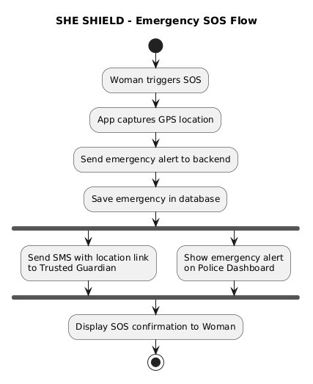
Figure: Slide 9: Design Components — Emergency SOS Flow
Speaker Script (Natural, concise verbal delivery):
"Here is our Emergency SOS execution flow. From the moment distress is triggered and GPS is acquired, the backend commits the record and immediately forks into two parallel channels: dispatching an SMS link to guardians and illuminating the police dashboard simultaneously."

10. Technology Stack Justification
Execution Flow: Flutter (60fps Mobile) + React.js (Police Desk) + Flask (AI-Ready APIs) + PostgreSQL (ACID Data) + Redis (Sub-ms GPS)
- Flutter (Dart 3.x): Single codebase for Android & iOS, 60fps native performance, direct platform bindings to BLE wearable pendants.
- React.js: High-density interactive dashboard for emergency dispatchers with real-time WebSocket state management.
- Python Flask: Lightweight WSGI microservices, native integration with PyTorch/OpenCV AI models, asynchronous worker queues.
- PostgreSQL: Strict ACID compliance, relational integrity for RBAC roles, audit trails, and structured police complaints.
- Redis: Sub-millisecond latency for live GPS waypoint distribution and session queues.
Speaker Script (Natural, concise verbal delivery):
"Our technology choices are purpose-built for life-safety: Flutter for fast, native mobile interactions; React for high-density police dispatching; Flask for seamless AI integration; and PostgreSQL plus Redis for durable and ultra-fast data handling."

11. Security Architecture & Legal Validity
Execution Flow: JWT RBAC Tokens → AES-256-GCM Vault → Sliding-Window Rate Limiting → Section 65B Court Admissibility
- Role-Based Access Control via JWT: Stateless RSA-256 signed tokens enforcing granular permission scopes with 15-minute token expiry.
- AES-256-GCM Vault Encryption: Authenticated Galois/Counter Mode cipher protecting all vaulted audio, video, and screenshot assets.
- IP-Level & Token-Level Rate Limiting: Sliding-window rate limiters backed by Redis to defend emergency dispatch gateways against DDoS attacks.
- Section 65B Forensic Admissibility: Client-side SHA-256 hashing guarantees bit-level media authenticity, completely eliminating evidence tampering claims.
Speaker Script (Natural, concise verbal delivery):
"Security by design is enforced across the platform: cryptographically signed JWT tokens, authenticated AES-256-GCM vault encryption, Redis sliding-window rate limiters, and client-side SHA-256 hashing for courtroom evidentiary admissibility."

12. Implementation Progress & GitHub Milestones
Execution Flow: M1 (Architecture) → M2 (Auth & RBAC) → M3 (SOS Center) → M4 (Travel Monitor) → M5 (Cybercrime Desk) → M6 (Command Hub)
- Milestone 1 (Foundations): System architecture, UI wireframes, theme setup, Provider state framework (100% Completed).
- Milestone 2 (Auth & RBAC): User, Guardian, Responder, Admin registration and role-based route guard (100% Completed).
- Milestone 3 (SOS Center): Multi-modal trigger engine, 5s cancellable timer, volume button trigger, BLE sync (100% Completed).
- Milestone 4 (Travel Monitor): Cab Guardian & Walk Guardian with 30m route offset deviation calculation (100% Completed).
- Milestone 5 (Cybercrime Desk): Cyber complaint intake, OCR screenshot scan, PyTorch threat score, PDF export (100% Completed).
- Milestone 6 (Command Hub): Admin Command Center, Responder live radar, and Evidence Locker vault (100% Completed).
- Repository Status: All core code modules completed, verified, and live on the SheShield GitHub repository.
Speaker Script (Natural, concise verbal delivery):
"Over Weeks 1 through 11, our team achieved 100% completion across all six planned milestones. All modules—from stealth SOS triggering and Cab Guardian to cybercrime OCR scanning and admin command consoles—are functional and tracked on GitHub."

13. Project Roadmap & Conclusion
Execution Flow: Weeks 12-13 (Integration) → Week 14 (Field Benchmarks) → Week 15 (Load Tests) → Week 16 (Release & Viva Defense)
- Weeks 12–13 (End-to-End Integration): Connect Flutter mobile client, Flask microservices, and React admin desk under simulated network loss.
- Week 14 (GPS Geofencing Benchmarks): Field-test Haversine route deviation accuracy and calibrate Kalman filtering in dense urban areas.
- Week 15 (High-Concurrency Load Testing): Simulate 5,000+ simultaneous emergency SOS trigger bursts using Locust and conduct penetration audits.
- Week 16 (Final Release & Viva Defense): Production Docker containerization, signed APK release, community pilot trials, and Viva Voce evaluation.
Speaker Script (Natural, concise verbal delivery):
"Our next steps focus on rigorous end-to-end integration, real-world urban GPS deviation benchmarks, and high-concurrency load testing simulating 5,000 simultaneous alerts. Thank you for your time, and we welcome your questions."

