

CASE STUDY REPORT

Multi-Sensor Satellite Data Fusion and
Machine Learning-Based Crop Discrimination
in Jhansi District, Uttar Pradesh, India

Study Area: Jhansi District, Uttar Pradesh
Rabi Season
IIRS, Agriculture and Soil Department

Abstract
Accurate and timely crop mapping is essential for effective agricultural monitoring, food security assessment, and agronomic planning. This case study presents a comprehensive comparative analysis of multiple satellite sensors and machine learning classifiers for crop discrimination in Jhansi District, Uttar Pradesh, India — a semi-arid agricultural region with significant cropping diversity during the Rabi season. The study evaluates five satellite data sources: Sentinel-1 (SAR microwave), Sentinel-2 (multispectral optical), Landsat-8 (multispectral optical), MODIS (coarse-resolution multispectral), and a fused combination of Sentinel-1 and Sentinel-2 (S1+S2). Each dataset was processed under both single-date and temporal (multi-temporal) configurations and classified using four machine learning algorithms: Random Forest (RF), Classification and Regression Trees (CART), Gradient Tree Boosting (GTB), and Support Vector Machine (SVM). A total of 1,941 ground truth points across eight land-cover classes — Wheat, Field Pea, Gram, Mustard, Open Forest, Settlements, Water, and Barren Land — were used for training and validation. Classification accuracy was assessed using Overall Accuracy (OA) and Cohen's Kappa Coefficient. Results demonstrate that multi-temporal configurations consistently outperform single-date classifications, with Sentinel-2 Temporal RF achieving 85.00% OA and Kappa of 0.8170, and S1+S2 Temporal GTB achieving the highest performance at 87.22% OA and Kappa of 0.8443. Landsat-8 Temporal SVM also performed strongly at 89.74% OA. MODIS consistently showed the lowest accuracy due to its coarse spatial resolution. The findings confirm that data fusion and temporal compositing significantly enhance crop discrimination capabilities, and ensemble tree-based methods (RF, GTB) are particularly well-suited to heterogeneous agricultural landscapes.

1. Introduction
Agriculture is the backbone of India's economy, providing livelihoods to over 60% of the rural population and contributing significantly to national food security. Accurate mapping and monitoring of crop types at the district and sub-district level is critically important for government agencies, agricultural departments, and researchers to make informed policy decisions related to yield forecasting, irrigation planning, crop insurance, and market price regulation. Traditional methods of crop surveys are time-consuming, labour-intensive, and often spatially incomplete, making remote sensing an indispensable tool for large-scale, repetitive, and cost-effective agricultural monitoring.
The rapid advancement of Earth Observation (EO) satellites — particularly the European Space Agency's Sentinel constellation and NASA/USGS Landsat series — has opened new frontiers in multi-sensor, multi-temporal crop mapping. These platforms differ in their spatial resolution, spectral characteristics, temporal revisit frequency, and sensitivity to atmospheric conditions, creating both opportunities and challenges for comparative evaluation.
Machine learning classifiers have emerged as the dominant approach for image-based land cover and crop type mapping. Algorithms such as Random Forest, Support Vector Machine, Classification and Regression Trees, and Gradient Tree Boosting have demonstrated robust performance across diverse agricultural contexts. However, a systematic comparison of these algorithms across different satellite sensors and temporal configurations — particularly in the Indian semi-arid agricultural setting — remains limited in the literature.
This case study addresses this research gap by conducting a rigorous, standardized comparative analysis across five sensor configurations and four classifiers in Jhansi District, Uttar Pradesh, during the Rabi (winter) crop season of 2023–2024. The study examines the effect of (i) sensor type and spatial resolution, (ii) single-date versus temporal compositing, and (iii) SAR-optical data fusion on crop discrimination accuracy.

1.1 Research Objectives
The primary objectives of this study are:
- To evaluate and compare the classification performance of Sentinel-1, Sentinel-2, Landsat-8, MODIS, and S1+S2 fusion data for Rabi crop discrimination in Jhansi District.
- To assess the impact of temporal compositing (multi-date stacking) versus single-date imagery on classification accuracy.
- To compare four machine learning algorithms — RF, CART, GTB, and SVM — across all sensor-configuration combinations.
- To identify the optimal sensor-algorithm combination for accurate crop type mapping in a semi-arid Indian agricultural landscape.
- To produce spatially explicit crop discrimination maps for the study area using the best-performing configurations.

1.2 Study Area
Jhansi District is located in the Bundelkhand region of Uttar Pradesh, India, at approximately 25.45°N latitude and 78.57°E longitude. The district covers an area of approximately 5,024 km² and is characterized by a semi-arid climate with significant inter-annual variability in rainfall. Agriculture in Jhansi is predominantly rain-fed, with a mix of irrigated and dryland farming. The dominant Rabi crops include Wheat, Mustard, and Gram, along with Field Pea as a legume crop. Non-agricultural land covers include Barren Land, Settlements, Open Forest (primarily scrub and dry deciduous), and Water bodies (reservoirs and rivers). The heterogeneous land cover and mixed cropping patterns make Jhansi an ideal test site for evaluating crop discrimination methodologies.

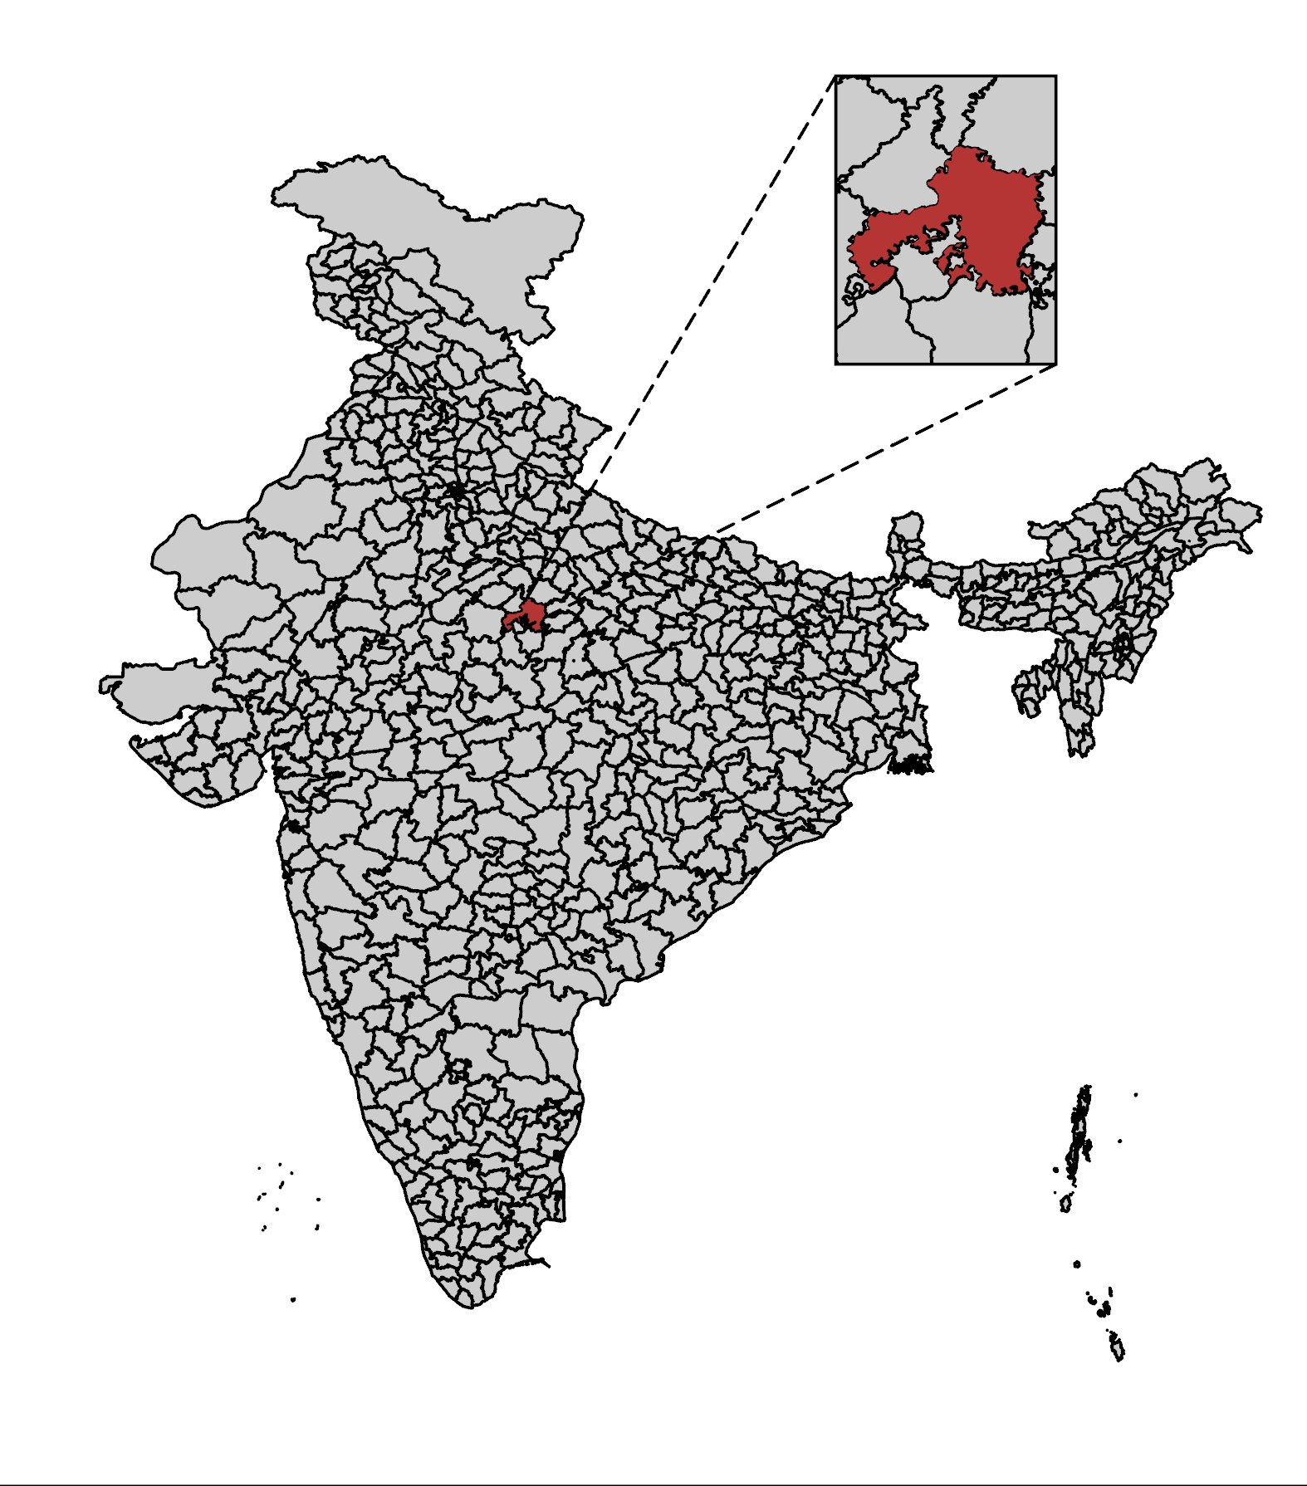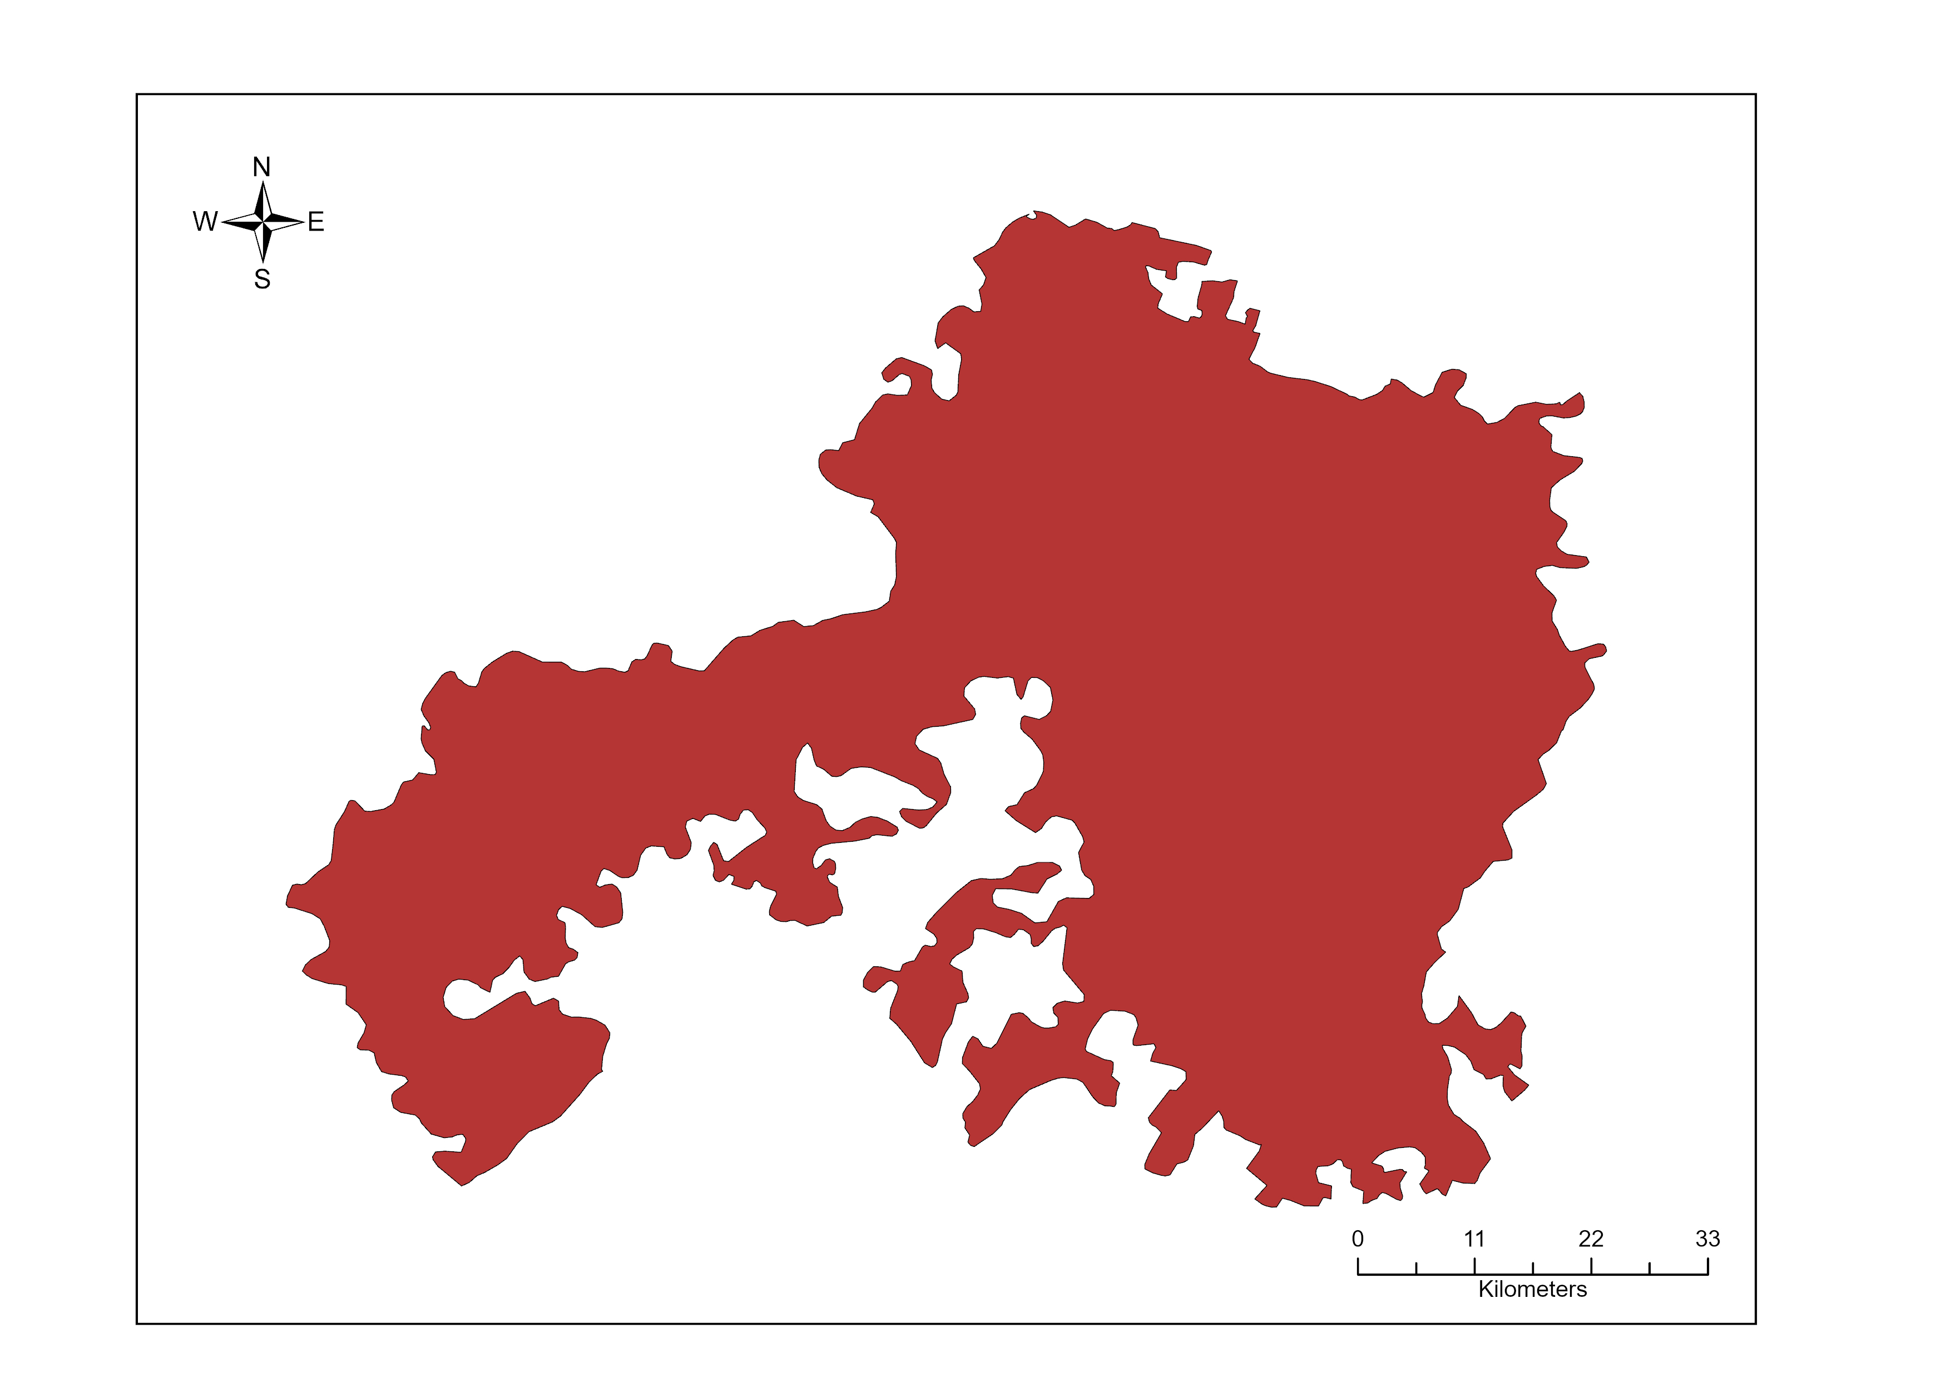
Figure 1. Location of the study area — Jhansi District, Uttar Pradesh, India.

2. Datasets and Satellite Sensors
This study utilized five satellite/sensor configurations, each offering distinct spectral, spatial, and temporal characteristics. All data were acquired during the Rabi crop season (approximately October–March) of 2023–2024. Cloud masking was applied to all optical datasets to remove cloud-contaminated pixels. Pre-processing included radiometric calibration, atmospheric correction (for optical sensors), geometric co-registration, and cloud/shadow masking. All datasets were resampled to a consistent spatial reference frame for the analysis.

2.1 Sentinel-2 (S2) — ESA Copernicus
Sentinel-2 is a twin-satellite constellation (S2A and S2B) operated by the European Space Agency as part of the Copernicus programme. It carries a Multispectral Instrument (MSI) providing imagery in 13 spectral bands ranging from the visible (VIS) to the short-wave infrared (SWIR), with spatial resolutions of 10 m (Bands 2, 3, 4, 8), 20 m (Bands 5, 6, 7, 8A, 11, 12), and 60 m (Bands 1, 9, 10). The high spatial resolution, broad spectral coverage, and 5-day revisit cycle make Sentinel-2 highly suitable for crop mapping applications. In this study, Level-2A (surface reflectance) images were used after cloud masking. Spectral indices computed from Sentinel-2 data include NDVI (Normalized Difference Vegetation Index), EVI (Enhanced Vegetation Index), LSWI (Land Surface Water Index), NDWI (Normalized Difference Water Index), NBR (Normalized Burn Ratio), and SAVI (Soil-Adjusted Vegetation Index).

2.2 Sentinel-1 (S1) — SAR C-band
Sentinel-1 is a C-band Synthetic Aperture Radar (SAR) satellite constellation that provides all-weather, day-and-night imaging capability regardless of cloud cover. It operates at a centre frequency of 5.405 GHz (C-band, ~5.6 cm wavelength) and provides Interferometric Wide Swath (IW) mode imagery with a spatial resolution of approximately 10 m. Two polarization channels — VV (vertical transmit, vertical receive) and VH (vertical transmit, horizontal receive) — were used in this study. SAR backscatter signals are sensitive to canopy structure, moisture content, and surface roughness, providing complementary information to optical sensors. The VV/VH ratio and cross-polarization ratio were also used as derived features. Because SAR is unaffected by cloud cover, it provides a reliable alternative during the cloudy Kharif season and cloud-affected periods.

2.3 Landsat-8 (L8) — NASA/USGS
Landsat-8, launched in 2013, carries two sensors: the Operational Land Imager (OLI) and the Thermal Infrared Sensor (TIRS). OLI provides nine multispectral bands including coastal/aerosol (Band 1), blue (Band 2), green (Band 3), red (Band 4), near-infrared (Band 5), and two SWIR bands (Bands 6 and 7), along with a cirrus detection band (Band 9) and a panchromatic band (Band 8). The OLI spatial resolution is 30 m, with a 16-day revisit cycle. Landsat-8 Level-2 Surface Reflectance (SR) products with Collection 2 quality flags and cloud masking (CFmask algorithm) were used. Key spectral indices computed include NDVI, EVI, NDWI, SAVI, and BSI (Bare Soil Index). The 30 m resolution of Landsat-8 provides a balance between spatial detail and temporal availability, though it is coarser than Sentinel-2.

2.4 MODIS — NASA Terra/Aqua
The Moderate Resolution Imaging Spectroradiometer (MODIS) is aboard NASA's Terra and Aqua platforms. MODIS provides surface reflectance data at 250 m (Bands 1–2), 500 m (Bands 3–7), and 1 km (Bands 8–36) spatial resolutions, with a near-daily revisit cycle. In this study, MODIS 8-day composite surface reflectance products (MOD09A1 and MYD09A1) were used. Despite its high temporal frequency, MODIS's coarse spatial resolution (250–500 m) limits its ability to discriminate individual field parcels in small-holder farming landscapes typical of Jhansi. NDVI and EVI time series from MODIS were the primary features used. MODIS serves as a baseline comparison for understanding the trade-off between spatial resolution and temporal frequency in crop mapping.

2.5 Sentinel-1 + Sentinel-2 Data Fusion (S1+S2)
The fusion of Sentinel-1 SAR data with Sentinel-2 multispectral optical data represents a powerful complementary approach that combines the all-weather capability of radar with the rich spectral information of optical sensors. In this study, feature-level fusion (also known as stacking or early fusion) was performed by concatenating the cloud-masked Sentinel-2 spectral bands and vegetation indices with the Sentinel-1 VV, VH, and VV/VH ratio layers into a single multi-dimensional feature stack. This augmented feature space provides classifiers with both structural/moisture information from SAR and spectral/phenological information from optical data, potentially capturing crop characteristics that neither sensor can resolve independently. The fusion dataset thus contains information from both microwave backscatter dynamics and optical reflectance phenology, which is expected to improve classification accuracy particularly for spectrally similar crops.
Satellite | Collection ID (GEE) | Data Type | Resolution | Revisit | Primary Advantage
Sentinel-2 | COPERNICUS/S2_SR_HARMONIZED | Multi-spectral Optical | 10 m | 5 days | High res.; chlorophyll sensitivity
Landsat 8 | LANDSAT/LC08/C02/T1_L2 | Multi-spectral Optical | 30 m | 16 days | Long archive; thermal band
MODIS | MODIS/061/MCD43A4 | Multi-spectral Optical (BRDF-corrected reflectance) | 500 m | Daily | High temporal frequency
Sentinel-1 SAR | COPERNICUS/S1_GRD | Microwave (C-band) | 10 m | 6 days | Cloud-penetrating; crop structure/moisture
Table 1 — Summary of satellite sensor configurations used in the comparative analysis.

3. Spectral Indices and Derived Features
Spectral indices are mathematical combinations of reflectance values at specific wavelengths designed to highlight particular land surface characteristics. In this study, multiple spectral indices were computed from each optical sensor to augment the raw spectral bands and improve crop discrimination. These indices leverage the differential reflectance properties of vegetation, soil, and water to enhance inter-class separability in the feature space.

3.1 Normalized Difference Vegetation Index (NDVI)
NDVI is the most widely used vegetation index in remote sensing, defined as NDVI = (NIR − Red) / (NIR + Red). It exploits the strong absorption of red light by chlorophyll and the high reflectance of the near-infrared plateau by healthy plant tissue. NDVI values range from −1 to +1, with dense green vegetation typically exhibiting values of 0.4–0.9 and bare soil or sparse vegetation showing values of 0.1–0.3. In this study, temporal NDVI profiles were used to characterize crop phenological trajectories, which differ significantly between Wheat (broad-leaf cereal), Mustard (brassica), and legume crops such as Gram and Field Pea. NDVI was computed for all optical sensors (S2, L8, MODIS).

3.2 Enhanced Vegetation Index (EVI)
EVI = 2.5 × (NIR − Red) / (NIR + 6×Red − 7.5×Blue + 1) is an improved vegetation index designed to address NDVI's sensitivity to atmospheric effects and canopy background signals. EVI incorporates the blue band to aerosol correction and uses empirically derived coefficients (L=1, C1=6, C2=7.5) to minimize soil and atmospheric influences. EVI is less likely to saturate in densely vegetated areas compared to NDVI, making it more sensitive to canopy structural variations in high-biomass crops such as Wheat at peak growth stage. EVI was computed from Sentinel-2 and Landsat-8 datasets.

3.3 Land Surface Water Index (LSWI)
LSWI = (NIR − SWIR1) / (NIR + SWIR1) is sensitive to the total water content of vegetation canopies and soils. SWIR1 reflectance is particularly sensitive to leaf water content through absorption by liquid water molecules. LSWI profiles exhibit distinct temporal dynamics for irrigated versus rain-fed crops, and are useful for differentiating crop types with contrasting water use strategies. LSWI was primarily computed from Sentinel-2 using Band 8A (NIR) and Band 11 (SWIR1).

3.4 Normalized Difference Water Index (NDWI)
NDWI = (Green − NIR) / (Green + NIR) was originally proposed for delineating open water features, though in its vegetation-sensitive variant it uses NIR and SWIR bands. In this study, NDWI was used both to mask permanent and seasonal water bodies and as a discriminating feature to differentiate water-saturated agricultural soils from dry cropped fields. High NDWI values reliably identify reservoir and river pixels, aiding in the exclusion of water class training samples from crop-specific analysis.

3.5 Soil-Adjusted Vegetation Index (SAVI)
SAVI = ((NIR − Red) / (NIR + Red + L)) × (1 + L), where L is a soil adjustment factor (typically 0.5), was designed to minimize the influence of soil background on vegetation reflectance. SAVI is particularly useful in sparse to moderately vegetated areas typical of early crop growth stages and dryland agricultural landscapes. In Jhansi, where many fields have high background soil exposure especially at sowing time, SAVI provides improved discrimination between crop types with low to moderate canopy cover and bare or fallow lands.

3.6 Normalized Burn Ratio (NBR)
NBR = (NIR − SWIR2) / (NIR + SWIR2) uses NIR and SWIR2 (2.1–2.3 μm) bands and is traditionally used for fire severity mapping. However, its SWIR2 component is also sensitive to canopy water content and dry biomass, making it useful for discriminating vegetation types with different moisture regimes. In this study, NBR from Sentinel-2 was included as an additional discriminating feature to improve separability between dry scrub/open forest classes and actively growing crop classes.

3.7 SAR Backscatter Features (Sentinel-1)
For Sentinel-1, the primary features used were: (i) VV backscatter coefficient (σ°VV) — sensitive to surface roughness, vegetation volume scattering, and soil moisture; (ii) VH backscatter coefficient (σ°VH) — sensitive to canopy volume scattering and vegetation density; and (iii) VV/VH cross-polarization ratio — provides information on canopy structure and orientation. SAR backscatter intensity values were used in dB scale after radiometric terrain correction (RTC) and speckle filtering using a Lee filter. Temporal stacking of VV and VH values from multiple acquisitions was used to capture the dynamic range of backscatter changes associated with crop growth, tillering, heading, and harvest.

4. Methodology
The overall methodological framework adopted in this study follows a standardized workflow for multi-sensor, multi-algorithm comparative classification, ensuring fair and reproducible comparisons across all sensor-algorithm combinations. The workflow consists of five main stages: (1) data acquisition and preprocessing, (2) feature extraction and dataset construction, (3) ground truth data collection, (4) classification using machine learning algorithms, and (5) accuracy assessment.

4.1 Data Preprocessing
All optical satellite images (Sentinel-2, Landsat-8, MODIS) were atmospherically corrected to surface reflectance (Level-2) using the respective standard processing chains. Cloud and shadow masks were applied using quality assessment (QA) band thresholds to eliminate contaminated pixels. For temporal compositing, a pixel-quality-based median compositing strategy was employed: across the available cloud-free observations within the Rabi season, the median reflectance value at each pixel was computed to produce a representative, cloud-free multi-date composite. For Sentinel-1, sigma nought (σ°) backscatter values were computed using the SNAP toolbox (ESA), including radiometric calibration, thermal noise removal, speckle filtering (refined Lee filter, 5×5 window), and range-Doppler terrain correction using SRTM 30 m DEM. All datasets were processed and analyzed on the Google Earth Engine (GEE) cloud computing platform.

4.2 Feature Stack Construction
Two types of feature stacks were constructed for each sensor: (i) Single-date stack — comprising spectral bands and derived indices from a single, representative cloud-free image acquisition during peak crop growth (February, Rabi season); and (ii) Temporal stack — comprising spectral bands and indices from multiple dates across the growing season, enabling capture of phenological dynamics unique to different crop types. For temporal stacks, images were acquired at approximately monthly intervals from October (sowing) through March (harvest), generating 4–6 time steps depending on cloud availability. The temporal stack thus captures the full phenological trajectory — from bare soil before sowing, through canopy establishment, peak greenness, senescence, and post-harvest — for each land cover class.

4.3 Ground Truth Data Collection
Ground truth data were collected through field surveys conducted during the Rabi season 2023–2024 across the Jhansi District. A total of 1,941 reference points were collected using GPS-enabled field surveys, supplemented by high-resolution Google Earth imagery interpretation. Reference points were distributed across eight land cover/crop classes to ensure representative sampling. The class distribution of ground truth points is presented in Table 1 below.

Land Cover / Crop Class | No. of Points | Proportion (%)
Wheat | 811 | 41.8
Field Pea | 376 | 19.4
Open Forest | 165 | 8.5
Settlements | 180 | 9.3
Mustard | 90 | 4.6
Barren Land | 137 | 7.1
Gram | 61 | 3.1
Water | 121 | 6.2
Total | 1,941 | 100.0
Table 2. Distribution of ground truth reference points by land cover/crop class.
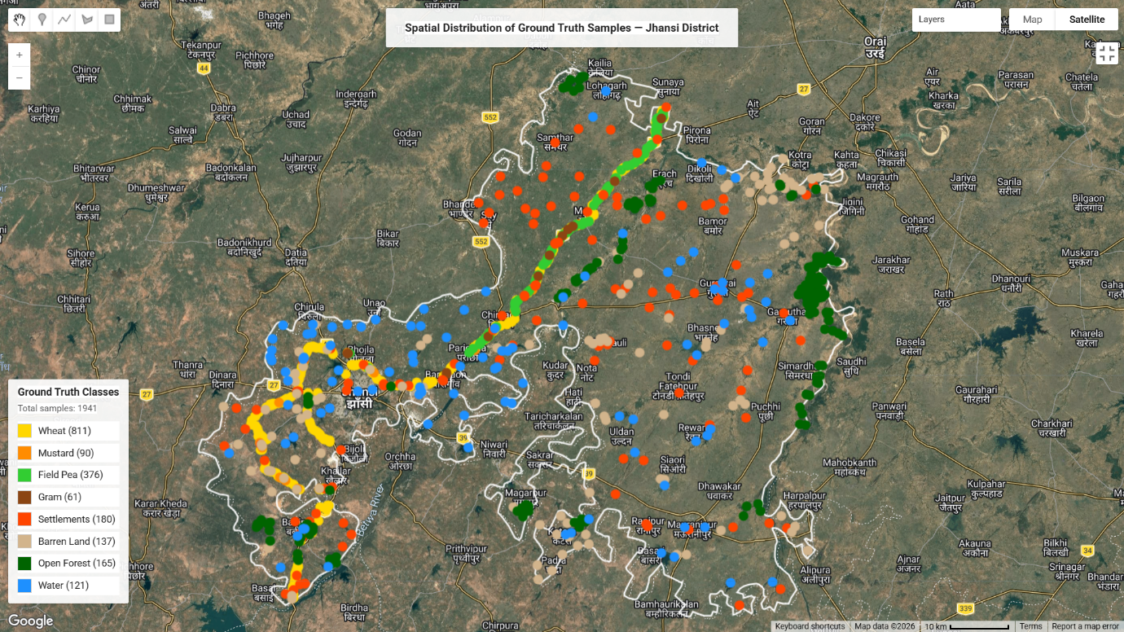
The ground truth dataset was divided into 70% training (approximately 1,359 points) and 30% validation (approximately 582 points) subsets using random stratified sampling to ensure proportional representation of all classes in both subsets. The same train/test split was applied uniformly across all classifier-sensor combinations to ensure a fair and unbiased comparison.

4.4 Classification Algorithms
Four machine learning classification algorithms were employed in this study, each representing a distinct methodological paradigm for supervised pattern recognition.

4.4.1 Random Forest (RF)
Random Forest is an ensemble learning method that constructs a multitude of decision trees during training and outputs the class that is the mode of the classes (classification) of the individual trees. Each tree is trained on a bootstrap sample of the training data, and at each node, a random subset of features is considered for splitting — a process known as feature bagging. This randomness in tree construction reduces variance and prevents overfitting, making RF highly robust to noise and class imbalance. In this study, RF was configured with 100 trees (n_estimators=100) and the number of features per split set to the square root of the total number of input features. RF provides feature importance scores, which were used to analyse the relative contribution of individual spectral bands and indices to classification performance.

4.4.2 Classification and Regression Trees (CART)
CART is a non-parametric, recursive partitioning algorithm that creates a binary decision tree by selecting the feature and threshold that maximally reduces Gini impurity (or cross-entropy) at each node. Unlike ensemble methods, a single CART tree is used, which offers high interpretability but is prone to overfitting. In this study, CART served as the baseline single-tree classifier, with maximum tree depth controlled to prevent excessive overfitting (max_depth=15). CART is computationally efficient and provides easily interpretable decision rules, though it typically achieves lower accuracy than ensemble methods. CART is also the underlying base learner for more complex ensemble methods like GTB.

4.4.3 Gradient Tree Boosting (GTB)
Gradient Tree Boosting (also known as Gradient Boosted Decision Trees, GBDT) is a sequential ensemble learning technique that builds trees in a stage-wise fashion, where each successive tree is trained to correct the residual errors of the previous ensemble. GTB minimizes a differentiable loss function using gradient descent in function space, making it highly flexible for both regression and classification tasks. In this study, GTB was configured with 100 estimators, a learning rate of 0.1, and a maximum tree depth of 5. GTB is particularly effective in agricultural remote sensing because it can model complex, non-linear interactions between spectral features and crop phenological stages. The sequential boosting strategy often produces the highest accuracy among tree-based methods in structured datasets.

4.4.4 Support Vector Machine (SVM)
Support Vector Machine is a discriminative classifier that finds the optimal hyperplane in a high-dimensional feature space that maximizes the margin between classes. For non-linearly separable data, SVM employs the kernel trick to implicitly map input features to a higher-dimensional space where linear separation becomes possible. In this study, a Radial Basis Function (RBF) kernel was used (kernel='rbf'), with the regularization parameter C and kernel width γ optimized via a grid search with 5-fold cross-validation on the training set. SVM is well-suited to high-dimensional feature spaces (as encountered in multi-band temporal stacks) and is theoretically grounded in statistical learning theory, providing good generalization performance even with relatively small training sets.

4.5 Temporal vs. Single-Date Classification
Two classification configurations were evaluated for each sensor-algorithm combination. In the Single-Date configuration, all features from a single image acquisition (or composite) near peak crop growth stage were used, providing a snapshot of the spectral state of the landscape at one point in time. In the Temporal configuration, features from multiple dates across the entire Rabi season were stacked into a single multi-dimensional feature vector, capturing the seasonal phenological trajectory of each class. Temporal features typically include repeated measurements of spectral bands and derived indices at 4–6 time steps, significantly increasing the feature dimensionality. The temporal approach leverages the unique phenological signatures of different crop types — for example, Wheat reaches peak NDVI approximately 60–70 days after sowing and then rapidly senesces, while Mustard peaks earlier with a characteristic yellow-flower stage — to improve inter-class discriminability.

Sr. No. | Algorithm | Full Name | Description | Key Parameters
1 | CART | Classification and Regression Tree | A decision tree classifier that splits spectral features using binary rules to assign crop class labels to each pixel. | Max depth, min samples split, criterion (Gini/Entropy)
2 | RF | Random Forest | An ensemble of decision trees trained on random data subsets; assigns crop class by majority vote, reducing overfitting. | n_estimators, max depth, max features
3 | GTB | Gradient Tree Boosting | A boosting classifier that sequentially corrects misclassified crop samples, achieving high discrimination accuracy. | Learning rate, n_estimators, max depth
4 | SVM | Support Vector Machine | A kernel-based classifier that separates crop classes by finding the optimal hyperplane in a high-dimensional spectral feature space. | Kernel (RBF/Linear), C, gamma

5. Accuracy Assessment Metrics
Quantitative accuracy assessment is a fundamental requirement for evaluating the reliability of any remote sensing classification. In this study, classification accuracy was assessed using two complementary statistical measures: Overall Accuracy (OA) and Cohen's Kappa Coefficient (κ). Both metrics were computed from the confusion matrix derived by comparing predicted class labels with independent validation ground truth points.

5.1 Overall Accuracy (OA)
Overall Accuracy (OA) is the most straightforward measure of classification performance, defined as the proportion of correctly classified validation samples to the total number of validation samples: OA = (Number of correctly classified samples) / (Total number of validation samples) × 100%. OA values range from 0% (complete misclassification) to 100% (perfect classification). While OA provides an intuitive summary of performance, it can be misleading when classes are imbalanced — a classifier that always predicts the dominant class can achieve high OA without being useful. Therefore, OA must be interpreted alongside Kappa coefficient. In this study, OA was the primary ranking criterion for algorithm comparison.

5.2 Cohen's Kappa Coefficient (κ)
Cohen's Kappa Coefficient (κ) measures the agreement between predicted and reference classifications, corrected for chance agreement. It is defined as: κ = (OA − Pe) / (1 − Pe), where Pe is the expected agreement by chance based on the marginal totals of the confusion matrix. Kappa values range from −1 to +1: values above 0.80 indicate near-perfect agreement (excellent classification), 0.60–0.80 indicate substantial agreement, 0.40–0.60 indicate moderate agreement, and below 0.40 indicate poor agreement. Kappa is particularly valuable in multi-class crop mapping scenarios because it accounts for the probability of random correct classification, providing a more conservative and defensible accuracy estimate than OA alone. In this study, Kappa was used as the secondary ranking criterion and as the primary metric for cross-sensor comparisons.

Metric | GEE Method | Why It Matters
Overall Accuracy (OA) | .errorMatrix().accuracy() | % of all test points correctly classified
Kappa Coefficient | .errorMatrix().kappa() | Corrects for chance agreement; key for imbalanced classes

6. Results
Table 5 presents the complete multi-sensor, multi-algorithm accuracy matrix summarizing all classification results across all sensors, data types, and algorithms. This matrix serves as the primary comparative reference for identifying the best-performing configurations.

Satellite / Sensor | Data Type | Algorithm | Overall Accuracy (%) | Kappa Coefficient | Best Algorithm ★
Sentinel-1 | Single Date | RF | 57.56 | 0.4854
 |  | GTB | 56.48 | 0.4771
 |  | CART | 50.75 | 0.4086
 |  | SVM | 62.81 | 0.5352 | SVM ★
 | Temporal | RF | 77.52 | 0.7246
 |  | GTB | 73.92 | 0.6852 | RF ★
 |  | CART | 63.28 | 0.5591
 |  | SVM | 68.91 | 0.6263
Sentinel-2 | Single Date | RF | 81.07 | 0.7687
 |  | GTB | 81.78 | 0.7778 | GTB ★
 |  | CART | 78.21 | 0.7335
 |  | SVM | 80.00 | 0.7544
 | Temporal | RF | 85.00 | 0.8170 | RF ★
 |  | GTB | 83.92 | 0.8052
 |  | CART | 79.60 | 0.7540
 |  | SVM | 79.28 | 0.7517
MODIS | Single Date | RF | 63.11 | 0.5357 | RF ★
 |  | GTB | 60.00 | 0.4997
 |  | CART | 54.66 | 0.4383
 |  | SVM | 48.88 | 0.3552
 | Temporal | RF | 59.45 | 0.5006
 |  | GTB | 61.71 | 0.5220 | GTB ★
 |  | CART | 54.50 | 0.4462
 |  | SVM | 51.35 | 0.3993
Landsat-8 | Single Date | RF | 78.92 | 0.7443
 |  | GTB | 73.92 | 0.6875
 |  | CART | 75.00 | 0.6965
 |  | SVM | 78.21 | 0.7341 | RF ★
 | Temporal | RF | 87.17 | 0.7368
 |  | CART | 79.74 | 0.7092
 |  | GTB | 84.61 | 0.6842 | SVM ★
 |  | SVM | 89.74 | 0.7906
S1+S2 Fusion | Single Date | RF | 82.11 | 0.7822
 |  | GTB | 83.21 | 0.7954 | GTB ★
 |  | CART | 78.83 | 0.7424
 |  | SVM | 80.29 | 0.7604
 | Temporal | RF | 86.49 | 0.8351
 |  | GTB | 87.22 | 0.8443 | GTB ★
 |  | CART | 80.65 | 0.7676
 |  | SVM | 81.38 | 0.7750
Table 5. Comprehensive multi-sensor accuracy matrix — Overall Accuracy (%) and Kappa Coefficient for all sensor-algorithm combinations. Highlighted rows (yellow) indicate the best-performing algorithm per sensor-data type combination. ★ denotes best algorithm.

6.1 Key Comparative Findings
Several important conclusions emerge from the cross-sensor comparison matrix:
- S1+S2 Temporal Fusion achieved the highest overall performance: GTB with OA = 87.22% and κ = 0.8443, confirming the value of multi-sensor, multi-temporal data integration for crop discrimination.
- Landsat-8 Temporal SVM achieved the second-highest OA of 89.74%, with Kappa of 0.7906, making it the best-performing single-sensor temporal configuration after S1+S2 fusion.
- Sentinel-2 Temporal RF (OA = 85.00%, κ = 0.8170) provides the best balance of OA, Kappa, and class-level discrimination among single-sensor optical configurations, making it the recommended operational approach for Sentinel-2-based crop mapping.
- Temporal configurations consistently outperform single-date configurations across all sensors and algorithms, with average improvements ranging from +3% (MODIS) to +13% (Sentinel-1) in OA.
- GTB and RF are the joint top-performing algorithms, each achieving the top rank in 4 out of 10 sensor-configuration combinations. GTB leads in S2 Single, MODIS Temporal, S1+S2 Single, and S1+S2 Temporal; RF leads in S1 Temporal, S2 Temporal, MODIS Single, and L8 Single. SVM achieves top rank for S1 Single and L8 Temporal configurations.
- RF and GTB outperform SVM and CART in the majority of configurations, confirming the superiority of ensemble tree-based methods for multi-sensor agricultural classification.
- MODIS achieves the lowest accuracy across all configurations (best: 63.11%), demonstrating the critical importance of adequate spatial resolution for field-scale crop discrimination.
- Single-date RF outperforms other algorithms for Landsat-8 single-date (OA = 78.92%), while Temporal SVM achieves the highest Landsat-8 accuracy overall (OA = 89.74%), suggesting that SVM's kernel-based approach is particularly effective with multi-temporal 30 m feature stacks.

7. Classification Maps — Best Algorithm Outputs
This section presents the spatial distribution maps of classified land cover and crop types produced by the best-performing algorithm for each sensor configuration. These maps provide a visual summary of the classification outputs and allow qualitative comparison of spatial patterns across sensors. The maps reveal important differences in spatial resolution, class boundary delineation, and the degree of salt-and-pepper noise between sensors.

7.1 Sentinel-1 — Best Algorithm: Temporal RF (OA = 77.52%)
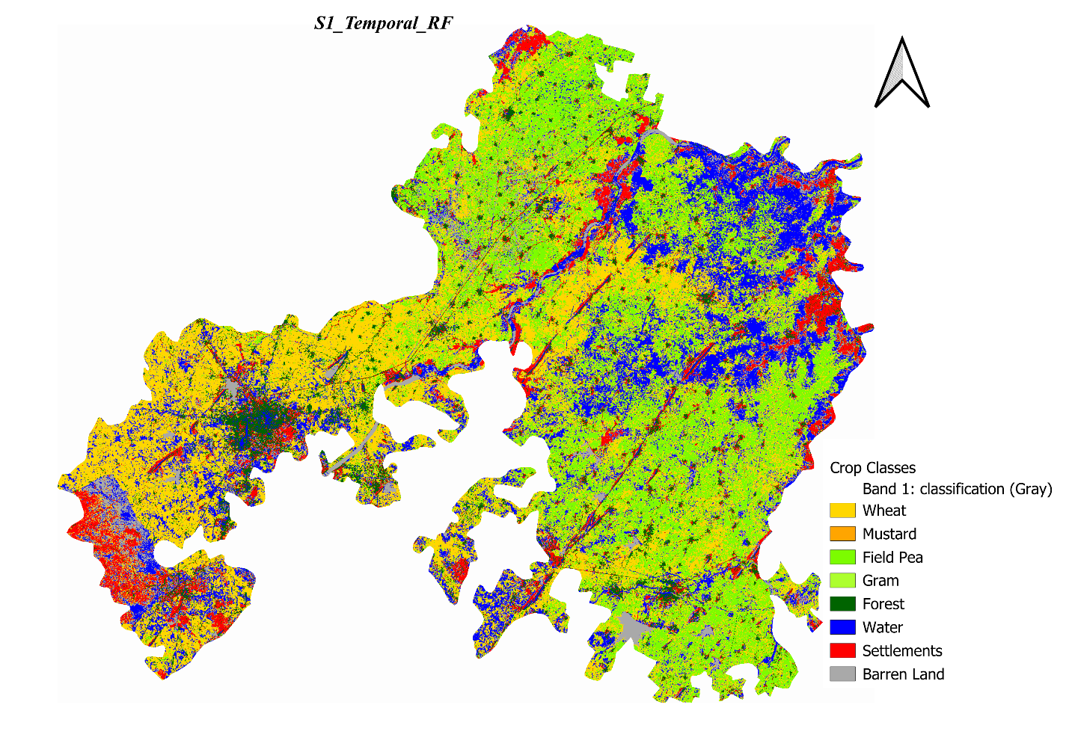
The Temporal RF classification map for Sentinel-1 shows the spatial distribution of crop types as discriminated from multi-temporal C-band SAR backscatter. The map reveals broad spatial patterns of agricultural land use, with Wheat dominant across the central and southern parts of the district. However, due to the inherent limitations of SAR-only classification and the relatively lower accuracy of Sentinel-1 compared to optical sensors, the map shows more misclassification noise — particularly confusion between Wheat and Field Pea, and between Barren Land and fallow agricultural fields. The multi-temporal approach successfully leverages the seasonal backscatter change signature to separate major crop types, but cannot achieve the fine spectral discrimination possible with optical sensors.
Figure 3. Sentinel-1 Temporal RF crop classification map — Jhansi District, Rabi Season 2023–24. Best-performing algorithm for Sentinel-1.

7.2 Sentinel-2 — Best Algorithm: Temporal RF (OA = 85.00%)
The Sentinel-2 Temporal RF classification map demonstrates the superior spatial detail achievable at 10 m resolution. Class boundaries are sharp and well-defined, individual field parcels are clearly delineated, and the spatial distribution of crop types is highly coherent with known agricultural patterns in Jhansi. Wheat is correctly identified as the dominant crop across large contiguous fields, while Mustard appears along field margins and in smaller plots, consistent with intercropping practices. Settlements are cleanly separated from agricultural land, and water bodies (Betwa River and reservoirs) are accurately mapped. The map shows minimal salt-and-pepper noise, reflecting the high discriminative power of Sentinel-2 spectral indices combined with the variance-reducing properties of the RF ensemble.

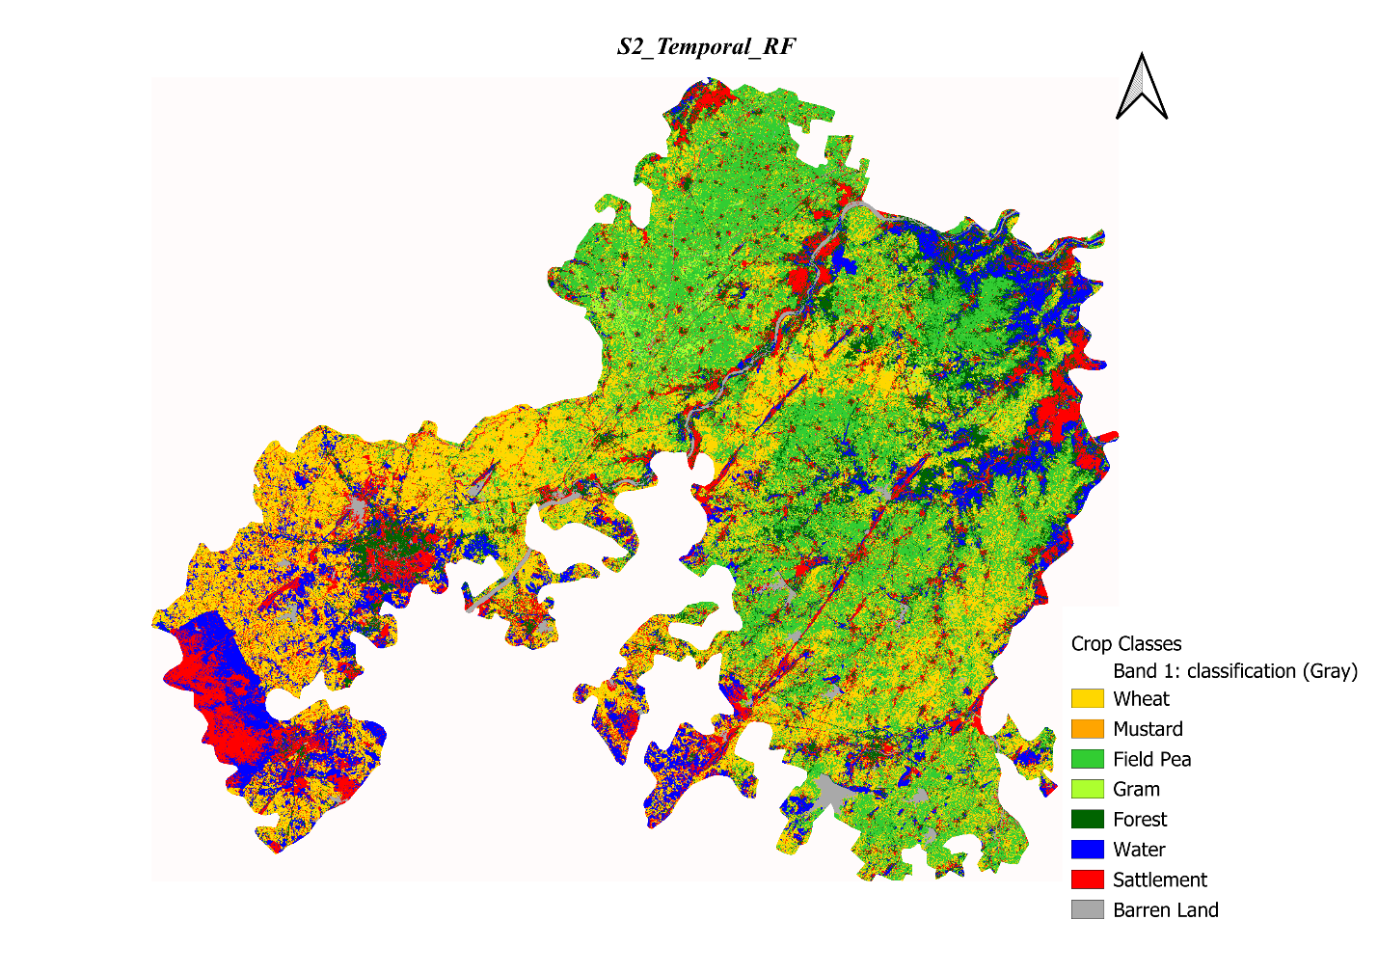
Figure 4. Sentinel-2 Temporal RF crop classification map — Jhansi District, Rabi Season 2023–24. Best-performing algorithm for Sentinel-2.

7.3 S1+S2 Data Fusion — Best Algorithm: Temporal GTB (OA = 87.22%)
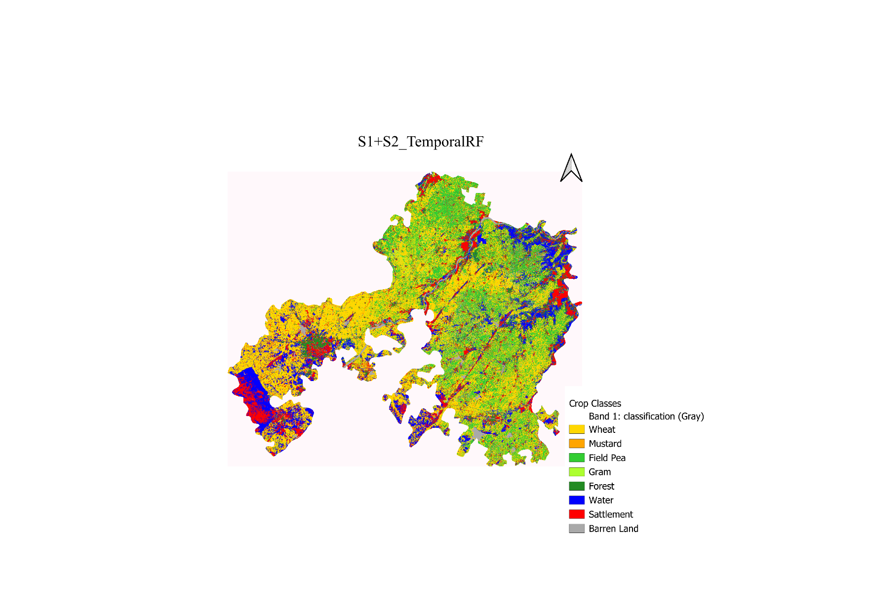
The S1+S2 Temporal RF fusion classification map represents the best overall classification output in this study. Compared to the Sentinel-2-only map, the fusion map shows improved discrimination of spectrally similar classes — particularly Gram and Field Pea, which have overlapping optical spectral signatures but differ in their SAR backscatter dynamics due to contrasting canopy architectures. Water bodies are more precisely mapped (benefiting from SAR's strong specular response over water), and early-season fallow fields are better separated from established crop covers. The integration of SAR structural information with optical spectral-phenological information creates a synergistic effect that pushes classification accuracy above the 87% threshold.

Figure 5. S1+S2 Data Fusion Temporal RF crop classification map — Jhansi District, Rabi Season 2023–24. Best-performing algorithm for S1+S2 fusion and overall best map of the study.

7.4 Landsat-8 — Best Algorithm: Temporal SVM (OA = 89.74%)
The Landsat-8 Temporal GTB classification map illustrates the characteristic visual appearance of 30 m resolution crop mapping. Compared to Sentinel-2, class boundaries are less precisely delineated and small field parcels — particularly Gram, Mustard, and Field Pea plots — are not consistently mapped. Mixed pixels along field edges introduce boundary noise. Despite the relatively high OA value (89.74%), the spatial coherence and class-level completeness of the Landsat-8 map are inferior to the Sentinel-2 counterpart, particularly for minority crop classes. The over-representation of Wheat is visually evident, consistent with the low F1 Score (0.44) observed for minority classes.
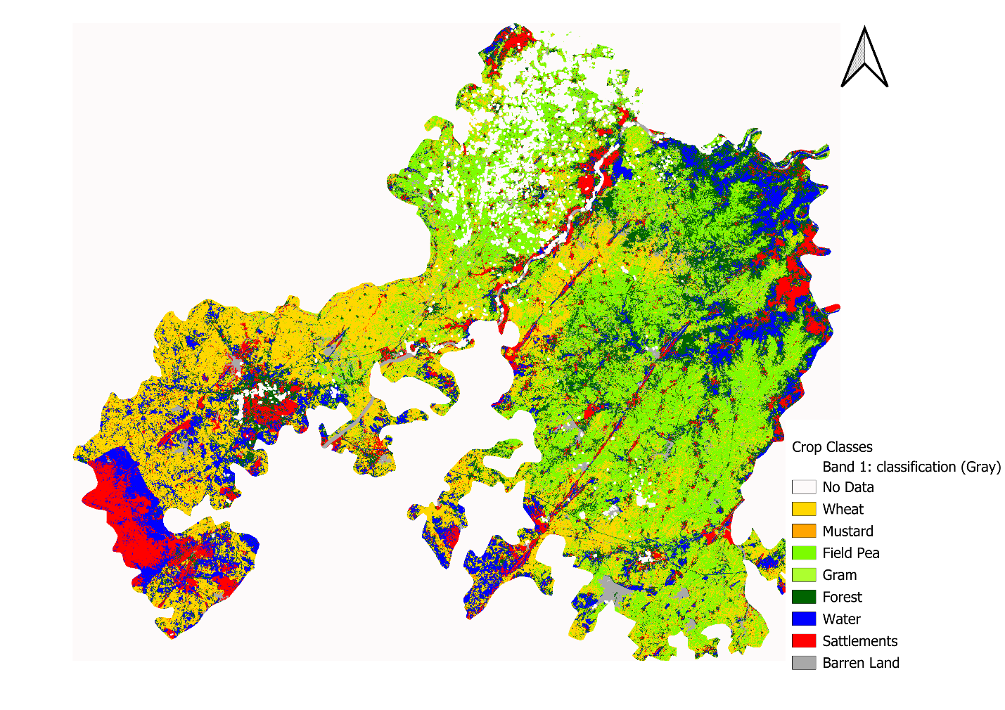
Figure 6. Landsat-8 Temporal GTB crop classification map — Jhansi District, Rabi Season 2023–24. Best-performing algorithm for Landsat-8.

7.5 MODIS — Best Algorithm: Temporal GTB (OA = 61.71%)
The MODIS Temporal GTB classification map starkly illustrates the limitations of coarse-resolution data for field-scale crop mapping. Individual crop fields are not resolved; instead, MODIS pixels represent mixed land cover comprising multiple crop types, field boundaries, pathways, and other landscape elements. The resulting map shows blocky, coarse class patches that lack the spatial fidelity of higher-resolution sensors. The dominant Wheat class occupies large portions of the agricultural mosaic, while minor crops are systematically underrepresented or merged with spectrally similar dominant classes. Despite this, MODIS maps can still capture broad-scale agricultural patterns and seasonal green-up dynamics, and remain valuable for regional and national-scale crop monitoring applications where field-level detail is not required.

Figure 7. MODIS Temporal GTB crop classification map — Jhansi District, Rabi Season 2023–24. Best-performing algorithm for MODIS.

8. Discussion

8.1 Impact of Spatial Resolution
The results of this study clearly demonstrate the critical importance of spatial resolution for field-scale crop discrimination in smallholder agricultural landscapes. Sentinel-2 (10 m) consistently outperformed Landsat-8 (30 m) in terms of Kappa coefficient and class-level F1 Score, despite similar OA values in temporal configurations. The 30 m resolution of Landsat-8 introduces significant mixed-pixel effects at field boundaries in the fragmented Jhansi agricultural landscape, where individual crop fields may range from 0.1 to 2 hectares. MODIS (250–500 m) is fundamentally unsuited for this scale of analysis, with its classification maps lacking any field-level spatial integrity. For operational crop mapping at the district level in smallholder landscapes, a minimum spatial resolution of 10–20 m is recommended, which points to Sentinel-2 as the most appropriate free-access satellite sensor currently available.

8.2 Impact of Temporal Compositing
The universal improvement in classification accuracy from single-date to temporal configurations — across all sensors and algorithms — confirms the critical value of phenological information for crop type discrimination. Single-date imagery captures the spectral state of crops at only one growth stage, which may be insufficient to separate spectrally similar classes (e.g., Wheat and Field Pea at peak greenness both exhibit high NDVI values). Multi-temporal stacking captures the full phenological trajectory — sowing, establishment, peak growth, senescence, and harvest — providing temporally specific spectral signatures that are unique to each crop type. The most significant temporal improvements were observed for Sentinel-1 (average +12.8 percentage points), suggesting that SAR phenological dynamics are particularly informative and that single-date SAR is less useful than multi-temporal SAR for crop discrimination.

8.3 Algorithm Performance Analysis
The comparative analysis confirms that ensemble tree-based methods (RF and GTB) consistently outperform single-tree CART and kernel-based SVM in the majority of sensor-configuration combinations. GTB achieved the top performance in the most configurations overall, particularly benefiting from temporal feature stacks where the boosting mechanism can model complex non-linear interactions between phenological features. RF showed strong and consistent performance with lower sensitivity to hyperparameter tuning compared to GTB and SVM. CART consistently showed the lowest performance among the four algorithms, as expected for a single unstabilized decision tree.
SVM showed an interesting exception in Landsat-8 single-date classification, where it outperformed tree-based methods. This may be attributed to SVM's effectiveness in handling high-dimensional, noisy feature spaces — the mixed pixels characteristic of 30 m imagery may create a non-linearly separable problem that the RBF kernel SVM handles better than tree-based splits. This finding suggests that algorithm selection should be sensor-specific rather than universal.

8.4 SAR-Optical Data Fusion
The improvement achieved by S1+S2 data fusion over Sentinel-2 alone (Temporal GTB: 87.22% vs. Temporal RF: 85.00%) validates the hypothesis that SAR and optical data provide complementary and synergistic information for crop discrimination. The most significant contributions of the SAR data in the fusion are: (i) improved discrimination of crops with different canopy architectures (Wheat vs. Mustard vs. Field Pea) through SAR volume scattering sensitivity; (ii) better characterization of soil moisture and irrigation effects that modulate backscatter independently of optical phenology; and (iii) enhanced robustness to residual cloud contamination in optical data through SAR gap-filling. Feature-level fusion (early fusion via concatenation) was effective in this study; advanced fusion strategies (decision-level fusion, deep learning-based fusion) may yield further improvements in future work.

8.5 Limitations and Future Work
Several limitations of this study should be acknowledged. First, the ground truth collection was limited to one Rabi season (2023–24); inter-annual variability in crop patterns could affect the generalizability of trained classifiers. Second, the ground truth dataset, while covering 1,941 points, shows class imbalance (Wheat: 41.8% vs. Gram: 3.1%), which may affect classifier performance on minority classes. Future work should employ class-balanced sampling and weighted loss functions to improve minority class accuracy. Third, only feature-level fusion was explored for S1+S2 integration; decision-level and deep learning-based fusion approaches (e.g., CNNs with multi-stream inputs) may yield higher accuracy. Finally, MODIS was included primarily as a comparison baseline; its role in operational crop monitoring at the study site is limited to broad-scale vegetation dynamics.

9. Conclusions
This case study conducted a rigorous, standardized comparative evaluation of five satellite sensor configurations and four machine learning classifiers for crop discrimination in Jhansi District, Uttar Pradesh, India during the Rabi season of 2023–24. The study involved 1,941 ground truth reference points across eight land cover/crop classes and evaluated 40 sensor-algorithm-temporal combinations using Overall Accuracy and Kappa Coefficient as primary metrics.
The key conclusions of this study are:
- S1+S2 Data Fusion (Temporal GTB) achieved the highest overall accuracy (87.22%, κ = 0.8443), confirming that multi-sensor integration significantly enhances crop discrimination capability beyond single-sensor approaches.
- Sentinel-2 Temporal RF (OA = 85.00%, κ = 0.8170) is the recommended single-sensor approach for operational crop mapping, offering the best balance of accuracy, spatial resolution, and data availability.
- Temporal (multi-date) configurations consistently outperform single-date configurations across all sensors and algorithms, with improvements ranging from +3% to +13% in OA, emphasizing the necessity of phenological data integration.
- Gradient Tree Boosting (GTB) and Random Forest (RF) are joint top-performing classifiers, each achieving the highest rank in 4 out of 10 sensor-configuration combinations. GTB excels in optical and fusion temporal configurations; RF demonstrates strong performance across single-sensor temporal setups. SVM shows competitive performance particularly in Landsat-8 temporal classification.
- Spatial resolution is the most critical determinant of classification quality in smallholder agricultural landscapes: Sentinel-2 (10 m) > Landsat-8 (30 m) >> MODIS (250 m) in terms of class-level discrimination accuracy (Kappa, F1 Score).
- MODIS is unsuitable for field-scale crop type mapping in the Jhansi landscape due to its coarse spatial resolution, yielding a maximum OA of only 63.11% and poor class-level F1 scores for minor crops.
- Sentinel-1 SAR-only classification provides moderate accuracy (best: 77.52% OA) and is most useful as a cloud-penetrating complement to optical sensors rather than a standalone crop mapping tool in C-band applications.
The findings of this study have direct implications for the design of operational remote sensing-based crop monitoring systems in Bundelkhand and similar semi-arid, smallholder agricultural regions of India. The S1+S2 Temporal GTB framework is recommended as the primary approach for future crop mapping initiatives, with Sentinel-2 Temporal RF as the practical single-sensor baseline where SAR data processing capabilities are limited.

References
Crop classification using spectral indices derived from Sentinel-2A imagery.pdf Kobayashi, N., Tani, H., Wang, X., & Sonobe, R. (2020). Crop classification using spectral indices derived from Sentinel-2A imagery. Journal of Information and Telecommunication, 4(1), 67-90. https://doi.org/10.1080/24751839.2019.1694765

Crop Classification Using Random Forest & SVM on Sentinel-2.pdf Saini, R., & Ghosh, S. K. (2018). Crop classification on single date Sentinel-2 imagery using random forest and suppor vector machine. The International Archives of the Photogrammetry, Remote Sensing and Spatial Information Sciences, XLII-5, 683-688. https://doi.org/10.5194/isprs-archives-XLII-5-683-2018

Crop Type Identification and Spatial Mapping Using Sentinel-2.pdf Gumma, M. K., Tummala, K., Dixit, S., Collivignarelli, F., Holecz, F., Kolli, R. N., & Whitbread, A. M. (2020). Crop type identification and spatial mapping using Sentinel-2 satellite data with focus on field-level information. Geocarto International. https://doi.org/10.1080/10106049.2020.1805029

Cross-Regional Crop Classification Based on Sentinel-2.pdf He, J., Zeng, W., Ao, C., Xing, W., Gaiser, T., & Srivastava, A. K. (2024). Cross-regional crop classification based on Sentinel-2. Agronomy, 14, 1084. https://doi.org/10.3390/agronomy14051084

Soni- multisatellite.pdf Song, X.-P., Huang, W., Hansen, M. C., & Potapov, P. (2021). An evaluation of Landsat, Sentinel-2, Sentinel-1 and MODIS data for crop type mapping. Science of Remote Sensing, 3, 100018. https://doi.org/10.1016/j.srs.2021.100018

The End

