LINKED LIST MANAGEMENT SYSTEM
Project Report
Submitted by: Pratik Kumar
Course: B.Tech
Department: SSCSE
Subject: Data Structures and Algorithms
Technology Used: Java
IDE: IntelliJ IDEA Community Edition

1. Introduction
A linked list is a linear data structure consisting of nodes. Each node stores data and a reference to another node. Unlike arrays, linked lists do not require elements to be stored in consecutive memory locations.
This project implements two types of linked lists: Singly Linked List and Doubly Linked List. It provides a menu-driven interface to perform common linked list operations.
2. Aim of the Project
To develop a menu-driven Java application that implements Singly Linked Lists and Doubly Linked Lists manually and demonstrates their operations.
3. Objectives
- Understand the concept of linked lists.
- Implement nodes using Java classes.
- Perform insertion and deletion operations.
- Search and update node values.
- Display and count nodes.
- Find minimum, maximum, and middle elements.
- Reverse and sort the list.
- Remove duplicate values.
- Compare singly and doubly linked lists.
4. Software Requirements
- Programming Language: Java
- JDK: Version 16
- IDE: IntelliJ IDEA Community Edition
- Operating System: Windows
5. Data Structures Used
5.1 Singly Linked List
Each node contains data and a reference to the next node. The last node points to null.
5.2 Doubly Linked List
Each node contains data, a reference to the previous node, and a reference to the next node. The list supports forward and backward traversal.
6. Main Features
- Insert at the beginning, end, or a specified position.
- Insert before or after a given value.
- Delete by position or value.
- Search and update elements.
- Display the list.
- Count nodes.
- Find minimum and maximum values.
- Find the middle node.
- Reverse and sort the list.
- Remove duplicate values.
- Display a comparison of both linked list types.
7. Implementation
The project is divided into three Java files:
- Main.java: Displays menus and accepts user input.
- SinglyLinkedList.java: Implements singly linked list operations.
- DoublyLinkedList.java: Implements doubly linked list operations.
The nodes and operations are implemented manually without using Java's built-in LinkedList class.
8. Testing and Results
The application was tested by performing insertion, deletion, searching, updating, sorting, reversing, counting, and duplicate-removal operations.
Record the actual results of your tests and include screenshots of the console output in this section.
9. Conclusion
This project demonstrates the implementation and use of Singly Linked Lists and Doubly Linked Lists in Java. It provides practical experience with nodes, references, traversal, insertion, deletion, and other common data structure operations.
10. Future Enhancements
- Add input validation for invalid entries.
- Improve the menu interface.
- Add automated test cases.
- Save and load list data from a file.

WORKING OF THE CODE
Screenshot 1 — Main menu
Purpose: Show that your project has a menu-driven interface.

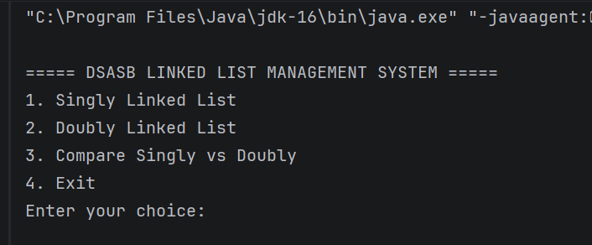
Figure 1: Main Menu of the Linked List Management System.
Screenshot 2 — Singly Linked List
Purpose: Demonstrate insertion and display operations.
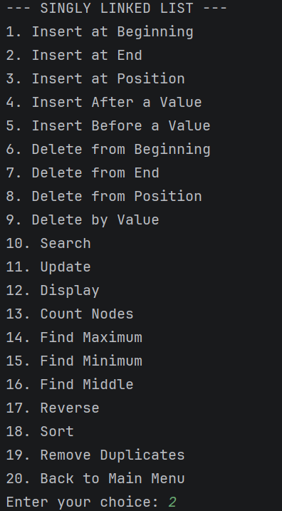
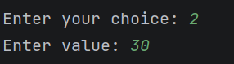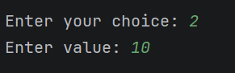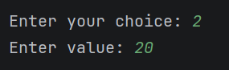

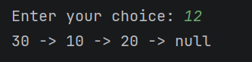
Figure 2: Insertion and Display Operations in a Singly Linked List
Screenshot 3 — Doubly Linked List
Purpose: Demonstrate that the list supports traversal in both directions
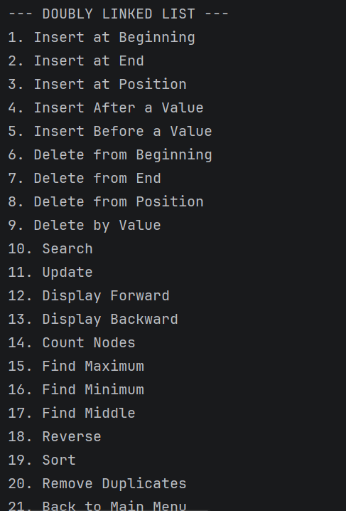
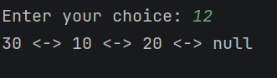
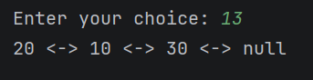
Figure 3: Forward and Backward Traversal in a Doubly Linked List
Screenshot 4 — Advanced operations
Purpose: Demonstrate sorting, reversing, and duplicate removal.
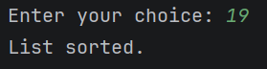
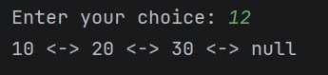
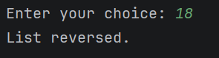
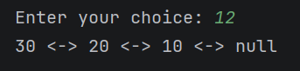
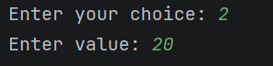
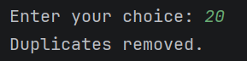
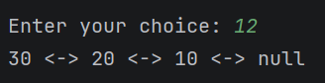
Figure 4: Sorting, Reversing, and Duplicate Removal in a Doubly Linked List

