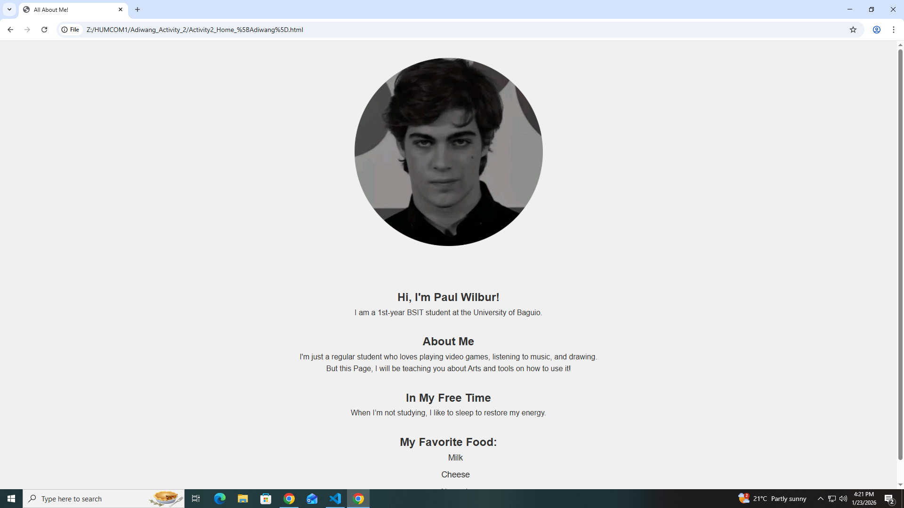

Reflection:

At first, it was confusing, as I learn step-by-step slowly, I easily understand what they are used for. After I created my Webpage, I can improve it any time I like to make it authentic.

Raw Code:
/* Index */
<!DOCTYPE html>
<html lang="en">
<head>
<meta charset="UTF-8">
<meta name="viewport" content="width=device-width, initial-scale=1.0">
<link rel="stylesheet" href="myStyle.css">
<title>All About Me!</title>
</head>
<body>
<header>
<h1>All About Me</h1>
</header>

<section class="bio-section">
<div class="profile-pic-container">
<img src="PFP1.png" alt="Paul's PFP" class="round-logo">
</div>

<div class="bio">
<h2>Hi, I'm Paul Wilbur!</h2>
<p>I am a 1st-year BSIT student at the University of Baguio.</p>

<h2>About Me</h2>
<p>I'm just a regular student who loves playing video games, listening to music, and drawing.</p>
<p>But this Page, I will be teaching you about Arts and tools on how to use it!</p>

<h2>In My Free Time</h2>
<p>When I’m not studying, I like to sleep to restore my energy.</p>

<h2>My Favorite Food:</h2>
<ul>
<li>Milk</li>
<li>Cheese</li>
<li>Almonds</li>
</ul>
</div>
</section>
</body>
</html>

