Ireland Housing Dataset

by
Maria Teresa Vargas Campos
2025653

Higher Diploma in Science in Data Analytics for Business
Integrated CA2:
Modules:
- Machine Learning
- Data Preparation
Lecturers:
- David McQuaid
- Dr. Muhammad Iqbal

CCT College

Dublin, Ireland

Contend
1.1 Introduction (102): 3
1.2 Objectives: (63) 3
1.3 Key Features: 3
2 DATA PREPARATION 4
2.1 Characterisation of the data set (48) 4
2.2 Exploratory Data Analysis 4
2.3 PLot differents features (scatter) 5
2.3.1 Ploting a histogram 5
2.3.2 Detecting Outliers 7
3 APPLY ENCODING, SCALING AND FEATURE ENGINEERING 8
3.1 Encoding Categorical Data 8
3.1.1 OneHotEncoding 8
4 Scaling of the Values 8
4.1 PCA (Principal Component Analysis) (54) 8
4.2 Linear Discriminant Analysis (LDA) 9
5 PREDICTION MODELS 10
5.1 Feature selection (with random forest) (71) 10
Figure 8. Importance of features 10
5.2 Machine learning algorithms (196) 10
5.2.1 Linear regression (122) 11
5.2.2 Support Vector Regression (228) 11
5.2.3 Random Forest (490) 12
5.2.4 Neural Networks (669) 13
5.2.5 K-Nearest Neighbors (KNN) (124) 14
5.3 Results comparison (328) 14
5.4 Conclusions (308) 15
6 Bibliography (132) 16
7 GitHub repository 16
8 Use of Artificial Intelligence (160) 16

Ireland Housing Dataset

Introduction (102):

Understanding the factors that influence housing prices in Ireland is a fundamental topic within education and data analytics. (Geerts, M.; vanden Broucke, S.; De Weerdt, J., 2023) Various surveys have shown that variables such as across different counties and includes factors such as average income, land prices, transport accessibility, school quality, crime rates, environmental risks, and housing demand levels and details about house types can be affect housing prices in Ireland. (Quang Truong, Minh Nguyen, Hy Dang, Bo Mei,, 2020)

This project differentiates itself by simultaneously evaluating how different socio-economic, environmental, and infrastructure-related features/ variables influence housing prices and demand across Ireland.

Objectives: (63)

- To identify key factors affecting housing market performance.
- To predict housing prices (predicted house price in euros) based on socio-economic, infrastructure, and environmental factors.
- To analyse housing demand categories by building classification models and examining how demand varies with income levels, location, and infrastructure quality.
- Provide Insights for policy and planning by understanding which features most strongly influence affordability, demand, and price fluctuations.

Key Features:

The data was assigned to the lecturers. The Figure1 show the following characteristics:

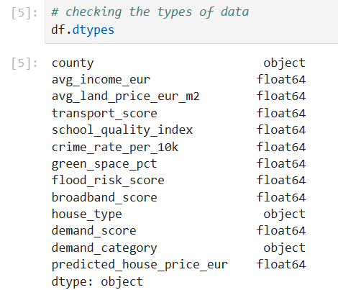

Types of data

DATA PREPARATION

Characterisation of the data set (48)
The number of observations or Rows are 2080.
The number of attributes in Columns are 13. Which of the following are:

Exploratory Data Analysis
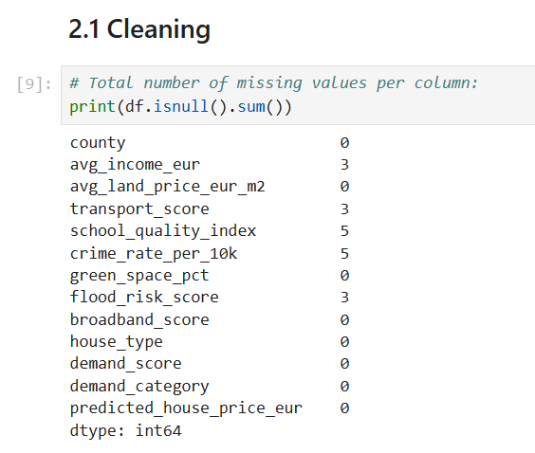

Number of missing values per column

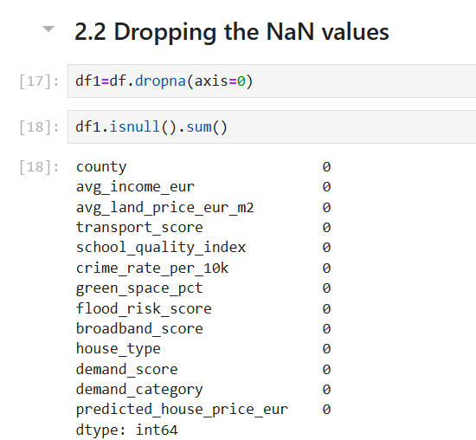

Dropping the NaN values

Originally we had 2080 rows; after dropping missing values, we have 2062 rows.

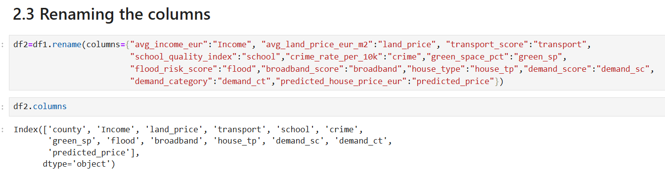

Renaming the columns

PLot differents features (scatter)

Ploting a histogram
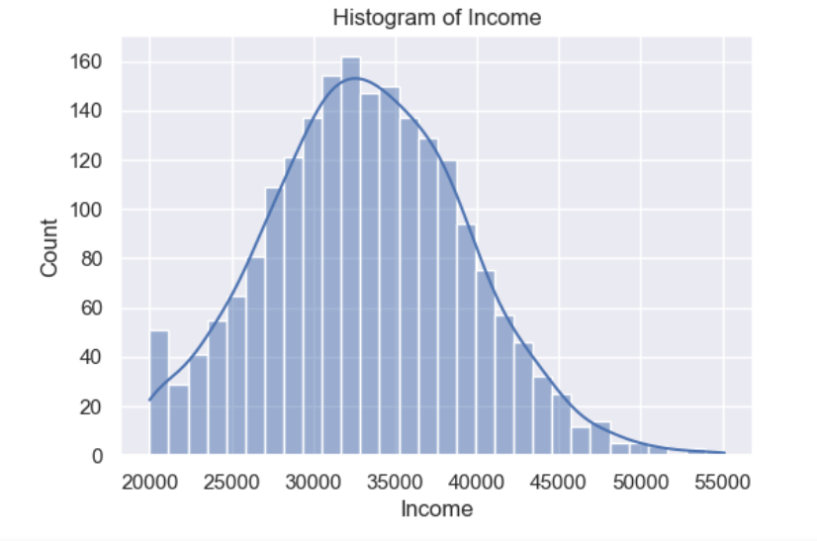 | 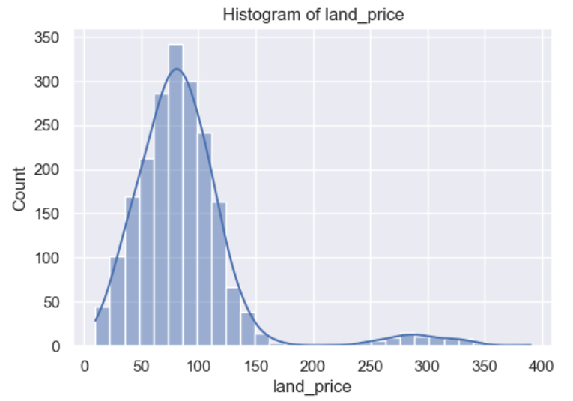
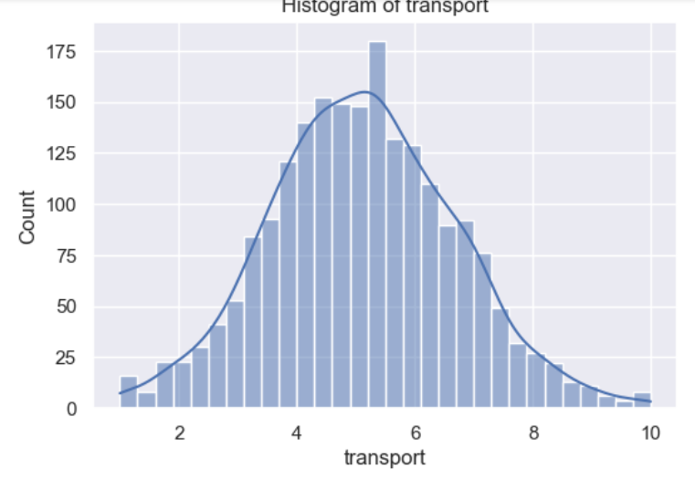 | 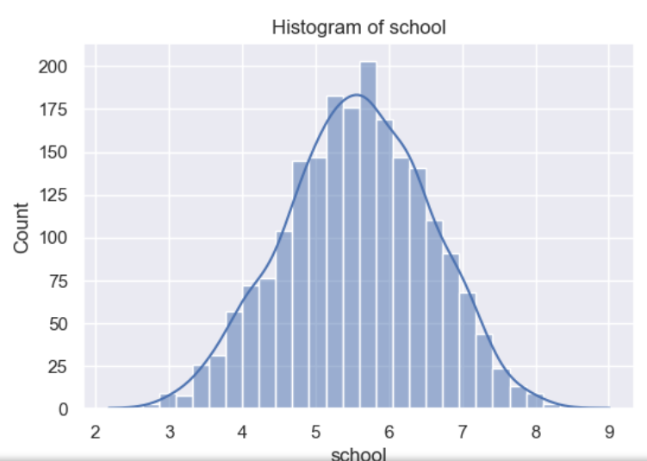
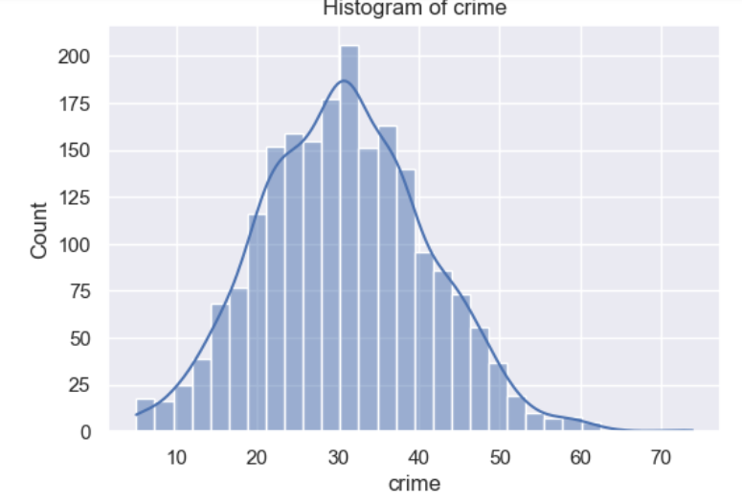 | 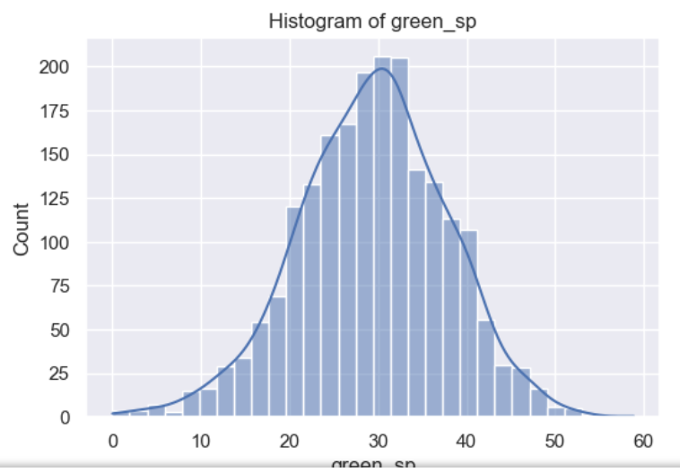
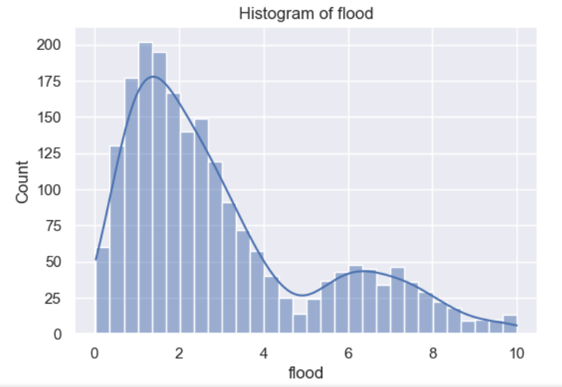 | 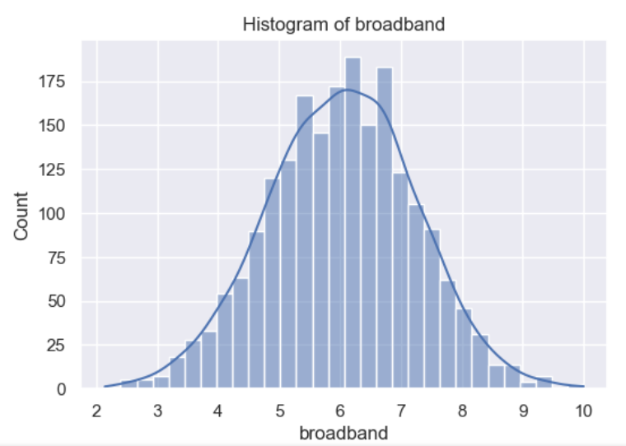
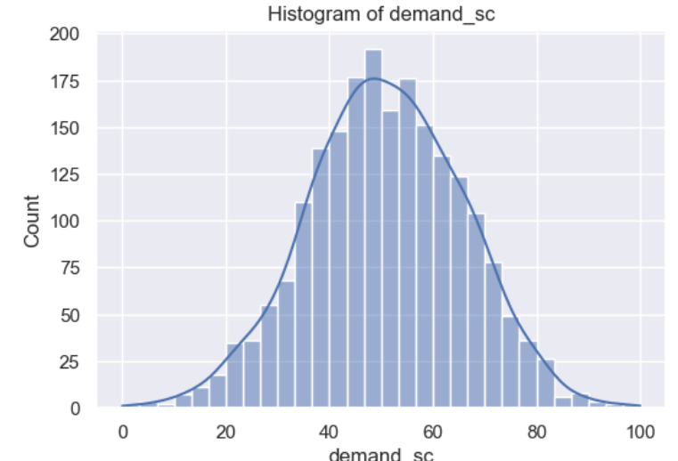 | 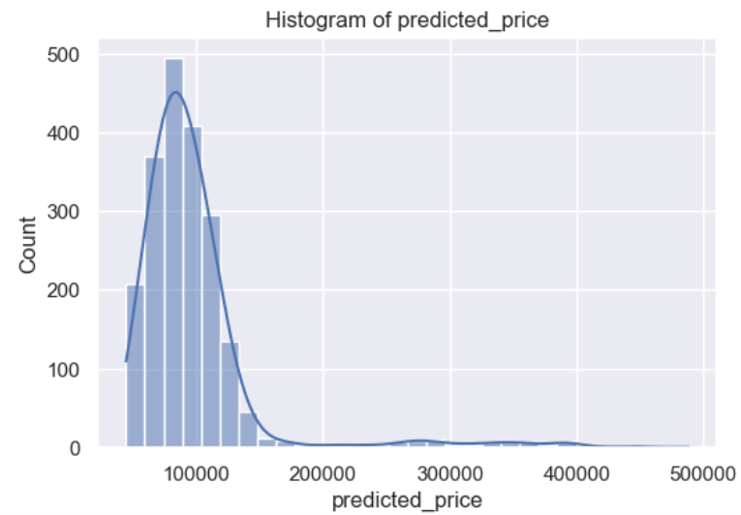

Plotting a histogram

The Figure 5, show the histograms of most of the explanatory variables show reasonably normal distributions, centred around average values, such as in green spaces, most areas have moderate levels of crime, in contrast, the abnormal distributions are Predicted_price, which has a strongly right-skewed distribution with a large concentration of prices in low-middle ranges and a long tail of high prices; likewise, flood risk, Average land price, also has an distribution skewed to the left.

Detecting Outliers
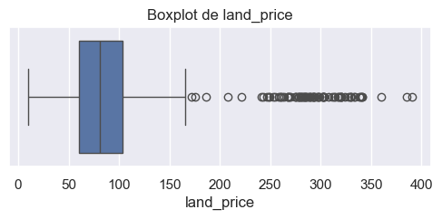 | 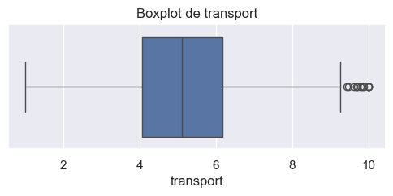
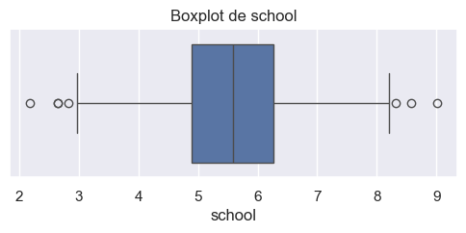 | 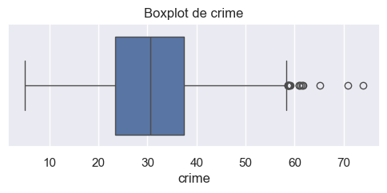
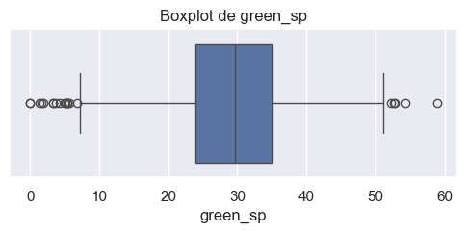 | 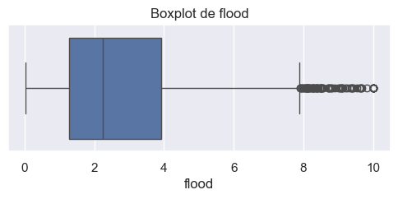
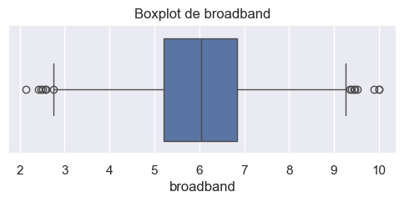 | 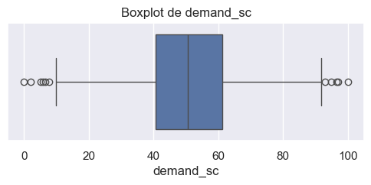
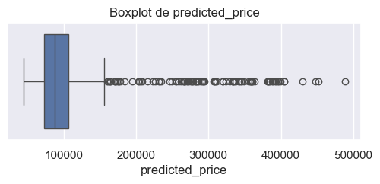

Detecting outliers
The outlier charts in Figure 6 also show that there are more outliers in Predicted_price, flood risk, and Average land price, just as the histograms had already shown.

APPLY ENCODING, SCALING AND FEATURE ENGINEERING

Encoding Categorical Data

OneHotEncoding
We use OneHot Encoder for Housing demand category and Type of House as well, we have to many variables for County, and this is why we decided to use Label Encoder.
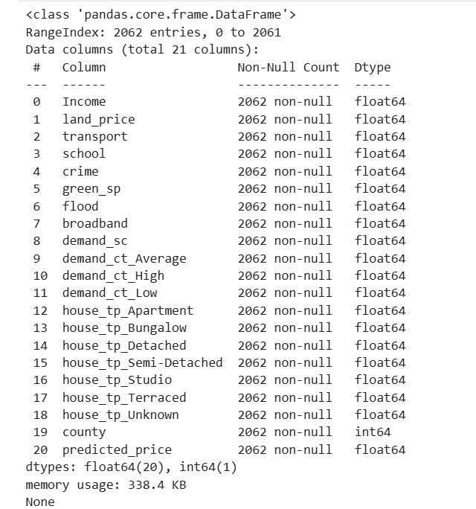

OneHot Encoder

Scaling of the Values

PCA (Principal Component Analysis) (54)
Principal Component Analysis (PCA) was used, a technique that transforms the original variables into a new set of components that explain most of the system's variation using the fewest possible dimensions.

PCA allowed us to identify combinations of variables that capture significant patterns in price demand. The results revealed two particularly relevant principal components:

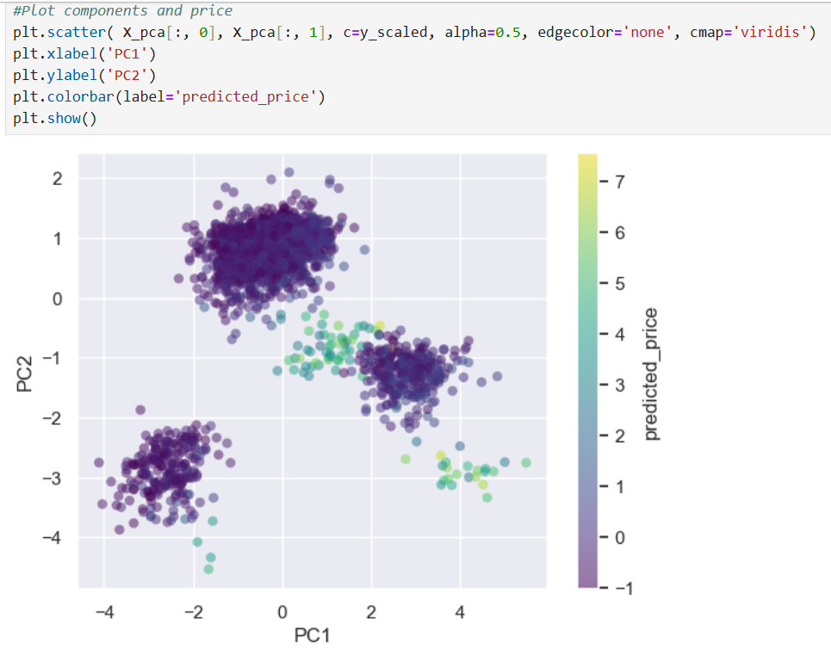
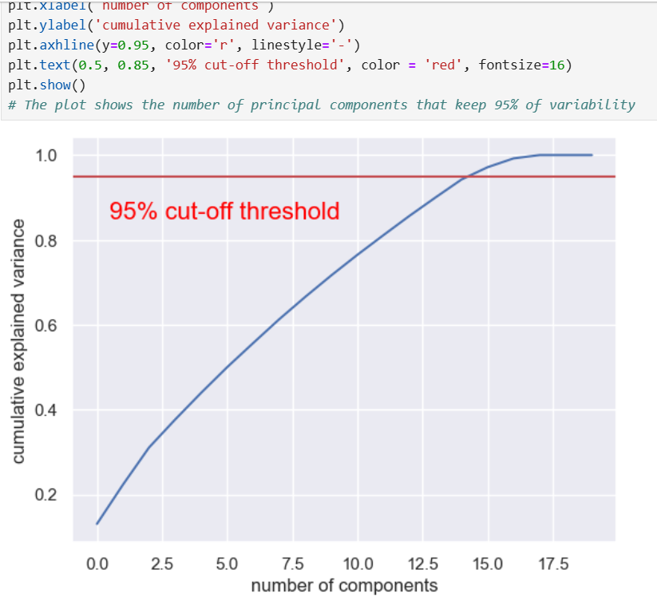

Linear Discriminant Analysis (LDA)
LDA is a supervised method used for classification. It is a regression problem, so we can not use LDA

PREDICTION MODELS

Feature selection (with random forest) (71)
Random forests is a supervised learning algorithm. It can be used both for classification and regression. It is the most flexible and easy to use algorithm. (-McKinney, 2010) We used supervised learning because the dataset contains property price information
With the high correlation between numerical columns with Random Forest, we obtained 8 principal features, land price is around 77.13% in these 8 features, the rest are shown in the figure 8:
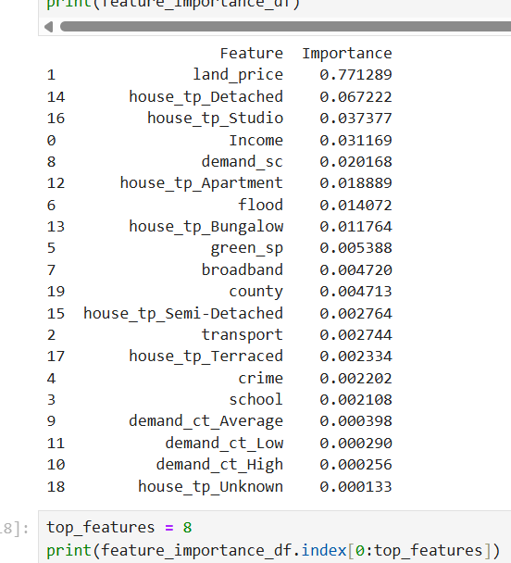

Importance of features

Machine learning algorithms (196)
In this study, various Machine Learning (ML) models were used to predict house prices and understand the relevance of variables such as socio-economic, infrastructure, and environmental factors. Random Forest (RF), Linear Regression (LR), Neural Networks (NN), Support Vector machine for Regression (SVR), and K-Nearest Neighbors (KNN) offer standard and comprehensive approaches for the analysis.
The efficiency of the ML model is evaluated using three common metrics in the literature, Mean Squared Error (MSE), Root MSE (RMSE), and R-squared ($R^{2}$)
The results tables contain two columns, one for training values of all metrics and the other for the testing values of all metrics. The implementation uses 10 Cross-Validation (10CV) for the training of the algorithm and selects the best of the 10 executions to evaluate the testing set.
The algorithms were implemented using Jupiter notebook 7.3.2 and the sklearn 1.6.1 library on a computer with AMD Ryzen 5 5500U with Radeon Graphics, 8,00 GB, 64 bits of procesador.
Every algorithm considers a set of configurations and two splits. The implementation contemplates a grid search to find the hyperparameters that maximize the efficiency of the algorithms, and 70-30% and 80-20% splits that are commonly used in the literature.

Linear regression (122)
Linear Regression (LR) is an algorithm that maps data points with the most optimized linear functions. It can be used to predict new data points as a baseline algorithm (lower bound) to estimate the efficiency of the other algorithms.
The results show that MSE, RMSE, and $R^{2}$ values are 0.1356, 0.3682 and 0.8668 for the training stage, and 0.1515, 0.3892 and 0.8368 for the testing stage with the 80-20 split, respectively. The value for the metrics with respect to the 70-30 split are 0.1316, 0.3627 and 0.8612 for the training stage, and 0.1546, 0.3932 and 0.8621 for the testing stage. The differences of the three metrics with respect to the splits are between 0.0036 and 0.02780, which no represents a significant difference.

Support Vector Regression (228)
Support Vector Regression (SVR) defines a region around the function with a tolerance, where the points within the region are considered correct predictions.
Table 1 presents the configurations of SVR to find the best prediction model using 10CV. Common hyperparameters for SVR are the type of kernel (kernels), the degree of the polynomial kernel function (degrees), the number of iterations (max_iters), and the epsilon value (epsilons). A total of 200 (8 x 5 x 5) configurations of hyperparameters are evaluated per split.

Hyperparameters for SVR.
The results of SVR with 80-20 split show that five configurations obtained the best efficiency for the six values, three metrics for both training and testing stages. The SVR algorithm with 500 iterations, radial basis function (rbf) kernel, and 0.2-1.0 values of epsilons provides MSE values of 0.0343 and 0.0838, RMSE values of 0.1853 and 0.2895, and $R^{2}$ values of 0.9662 and 0.9097 for training and testing stages, respectively.
The results of SVR with 70-30 show a similar situation to the 80-20 split, five configurations obtained the best efficiency for the six values, three metrics for both training and testing stages. The SVR algorithm with 400 iterations, rbf kernel, and all the values of epsilons provides MSE values of 0.0373 and 0.954, RMSE values of 0.1931 and 0.3089, and $R^{2}$ values of 0.9607 and 0.9149 for training and testing stages, respectively.

Random Forest (490)
Random forests is a supervised learning algorithm. It can be used both for classification and regression. It is the most flexible and easy-to-use algorithm. It creates decision trees on randomly selected data samples, gets predictions from each tree, and selects the best solution by means of voting. It provides a pretty good indicator of the feature importance.
Random Forest (RF) creates several Decision Trees (DTs) as a single model to generate the prediction. A DT is a non-linear alternative to LR that divides or partitions the space into more manageable regions. RF is an ensemble learning algorithm that estimates the output using the mean output values of the DTs in the RF, which tends to reduce the individual trees’ tendency to overfit the data.
RF is a recommended model because it is robust to noise and outliers, works well with many variables, and allows for identifying the importance of features easily. Table 2 presents the configurations of RF to find the best prediction model using 10CV. Common hyperparameters for RF are the number of DTs in the forest (estimators), the maximum depth of the tree (depth), and the minimum number of samples required to split an internal node (split). A total of 125 (5 x 5 x 5) configurations of hyper parameters are evaluated per split.

Hyperparameters for RF.
In general, the average values of MSE, RMSE, and $R^{2}$ for all the configurations are 0.0524, 0.2204, and 0.9485 in the case of the training and 0.0734, 0.2692, and 0.9210 in the case of the testing with a split of 80-20, respectively. Similarly, for the 70-30 split, the average values of MSE, RMSE, and $R^{2}$ for all the configurations are 0.0190, 0.1380, and 0.9799, and 0.0467, 0.2160, and 0.9584 for the training and testing phases.
The results of RF with 80-20 show that four configurations obtained the best efficiency for the three metrics in the training stage. The RF algorithm with 400 iterations, 10 samples required to split an internal node, and from 20-50 maximum depth of the tree provides 0.0179 of MSE value, 0.1337 of RMSE value, and 0.9824 of $R^{2}$ value. RF with 300 iterations, 10 samples required to split an internal node, and 20-50 maximum depth of the tree provides very close values of MSE, RMSE, and $R^{2}$ to the training stage, but better for the testing stage, 0.0523, 0.2287, and 0.9436, respectively.
The results of RF with 70-30 show that four configurations obtained the best efficiency for the six metrics in the training and testing stages. The RF algorithm with 500 iterations, 10 samples required to split an internal node, and 20-50 maximum depth of the tree provides 0.0190 of MSE value, 0.1380 of RMSE value, and 0.9799 of $R^{2}$ value for the training stage and 0.0467, 0.2160, and 0.9584 for the testing stage, respectively.

Neural Networks (669)
Neural Networks (NNs) simulates the interconnected neurons of the human brain, which consists of a network structure with independent layers and an arbitrary number of neurons. The three types of layers provide different functionalities: The input layer receives the external signals, the hidden layers compute the input information, and the output layer provides the output.
NN is a recommended model because it learns complex patterns, handles non-linear relationships, and is robust to noisy data. Table 3 presents the configurations of NN to find the best prediction model using 10CV. Common hyperparameters for NN are the number of epochs, the number of Hidden Layers (HLs) and their neurons per layer, activation function and learning rate. A total of 405 (135 + 135 + 135) configurations of hyper parameters are evaluated per split.

Hyperparameters for NN.
The results of NN with 80-20 and 1HL show that three configurations obtained the best efficiency for the three metrics in the training stage. The NN algorithm with 250 neurons, relu activation function, 0.01 learning rate, and 250-750 epochs provides 0.0072 of MSE value, 0.0849 of RMSE value, and 0.9925 of $R^{2}$ value. NN with 100 neurons, logistic activation function, 0.05 learning rate, and 500-750 epochs generates better values for the testing stage, 0.0413, 0.2032, and 0.9641, respectively.
The results of NN with 70-30 and 1HL show that three configurations obtained the best efficiency for the three metrics in the training stage. The NN algorithm with 200 neurons, relu activation function, 0.1 learning rate, and 250-750 epochs provides 0.0076 of MSE value, 0.0871 of RMSE value, and 0. 9918of $R^{2}$ value. NN with 200 neurons, tanh activation function, 0.05 learning rate, and 250-750 epochs provides close values of MSE, RMSE, and $R^{2}$ to the training stage, but better for the testing stage 0388, 0.1969, and 0.9672, respectively.
The results of NN with 80-20 and 1HL-2HL show that three configurations obtained the best efficiency for the three metrics in the training stage. The NN algorithm with 250-125 neurons, relu activation function, 0.05 learning rate, and 250-750 epochs provides 0.0023 of MSE value, 0.0478 of RMSE value, and 0.9976 of $R^{2}$ value. NN with 250,125 neurons, relu activation function, 0.1 learning rate, and 250-750 epochs provides very close values of MSE, RMSE, and $R^{2}$ to the training stage, but better for the testing stage, 0.0350, 0.1870, and 0.9696, respectively.
The results of NN with 70-30 and 1HL-2HL show that three configurations provided the best efficiency for the six metrics, in both training and testing stages. The NN algorithm with 250-125 neurons, relu activation function, 0.1 learning rate, and 250-750 epochs provides 0.0026 of MSE value, 0.0510 of RMSE value, and 0.9972 of $R^{2}$ value for the training stage and 0.0335 of MSE value, 0.1830 of RMSE value, and 0.9717 of $R^{2}$ value for the testing stage.
The results of NN with 80-20 and 1HL-2HL-3HL show that two configurations obtained the best efficiency for the three metrics in the training stage. The NN algorithm with 125-250-125 neurons, relu activation function, 0.1 learning rate, and 500-750 epochs provides 0.0015 of MSE value, 0.0385 of RMSE value, and 0.9985 of $R^{2}$ value. NN with 100-200-100 neurons, tanh activation function, 0.1 learning rate, and 250 epochs provides better vales for the testing stage, 0.0345, 0.1857, and 0.9700, respectively.
The results of NN with 70-30 and 1HL-2HL-3HL show that two configurations obtained the best efficiency for the three metrics in the training stage. The NN algorithm with 125-250-125 neurons, relu activation function, 0.1 learning rate, and 500-750 epochs provides 0.0015 of MSE value, 0.0385 of RMSE value, and 0.9985 of $R^{2}$ value. NN with 100-200-100 neurons, tanh activation function, 0.1 learning rate, and 250 epochs provides better values for the testing stage 0.0088, 0.0939, and 0.9908, respectively.

K-Nearest Neighbors (KNN) (124)
The results of KNN with 80-20 shows one configuration with the best efficiency for the three metrics in the training stage. The KNN algorithm with N equal to1 provides 0.0086 of MSE value, 0.0926 of RMSE value, and 0.9916 of $R^{2}$ value. KNN with N equal to 4 generates better values for the testing stage, 0.0569, 0.2385, and 0.939, respectively.
The results of KNN with 80-20 are like the 80-20 split, one configuration obtained the best efficiency for the three metrics in the training stage. The KNN algorithm with N equal to1 provides 0.0052 of MSE value, 0.0720 of RMSE value, and 0.9945 of $R^{2}$ value. KNN with N equal to 4 generates better values for the testing stage, 0.0545, 0.2335, and 0.9514, respectively.

Results comparison (328)
In terms of model performance with a split of 80-20, NN with two HLs (NN-2) provides the best values during the training phase and NN-3 presents the highest, MSE, RMSE, and R² values during the testing phase according to Table 4. The difference in performance with respect to $R^{2}$ is 0.0061 with NN3, and 0.1301 with LR for the training set and 0.0004 with NN-2 and 0.1332 with LR, the second best model and the lower bound model for the testing set.

Best strategies for $R^{2}$ with 80-20 split and the testing set.

In terms of model performance with a split of 70-30, NN with two HLs (NN-2) provides the best values during the training and testing phases according to Table 5. The difference in performance with respect to $R^{2}$ is 0.0064 with NN3, and 0.136 with LR for the training set, and 0.0017 with NN-2 and 0.1096 with LR, the second-best model and the lower bound model for the testing set.

Best strategies for $R^{2}$ with 70-30 split and the testing set.
The comparison between split shows that NN-2 with split of 70-30 generates a better $R^{2}$ value than NN-3 with a 80-20 split considering the testing data set, but the difference is very low, 0.0017.

Conclusions (308)
Four algorithms were implemented to solve the problem: linear regression, support vector machines, random forests, and neural networks. Linear regression was used as the baseline model, allowing for the evaluation of the relative performance of the more complex models.

The problem was formulated as a prediction (regression) task, since housing prices are a continuous numerical variable. To improve the performance and interpretability of the models, a feature selection process based on random forests was applied, reducing the original dataset to eight relevant variables. Furthermore, hyperparameter fitting was performed using GridSearchCV, employing cross-validation to ensure optimal configurations and avoid overfitting.

The results show that neural network models outperform traditional approaches, such as linear regression, suggesting the presence of non-linear relationships between the explanatory variables and housing prices. In particular, the neural network with two hidden layers (NN-2) showed the best overall performance, especially in the testing phase, for both the 80–20 and 70–30 split.

The comparison between data partitions showed that the 70–30 split with NN-2 produced the highest R² value in the test set. However, the difference compared to the best model under the 80–20 split is marginal (0.0017), demonstrating the robustness and stability of the proposed approach, regardless of the partitioning scheme used. In contrast, linear regression consistently presented the lowest R² values, acting as a lower bound on achievable performance.

Identifying key features using random forest techniques helped improve the model's interpretability and highlight the factors with the greatest impact on price fluctuations, such as land price, distance, house type, education level, income, and demand.

Finally, the study's findings offer valuable information for public policy formulation and urban planning by allowing researchers to understand which variables most strongly influence housing prices and demand. This type of analysis can support decision-making aimed at improving housing affordability and designing more efficient urban development strategies.

Bibliography (132)
Geerts, M.; vanden Broucke, S.; De Weerdt, J., 2023. A Survey of Methods and Input Data Types for House Price Prediction. ISPRS Int. J. Geo-Inf. [Online]
Available at: https://doi.org/10.3390/ijgi12050200
[Accessed 28 12 2025].
Margot Geerts,Seppe vanden Broucke, Jochen De Weerdt, 2023. ISPRS International Journal of Geo-Information. [Online]
Available at: https://www.mdpi.com/2220-9964/12/5/200?trk=public_post_main-feed-card-text
[Accessed 31 12 2025].
-McKinney, W., 2010. Data Structures for Statistical Computing in Python.. s.l.:Proceedings of the 9th Python in Science Conference.
Pedregosa, F., Varoquaux, G., Gramfort, A., Michel, V., Thirion, B., Grisel, O. & Duchesnay, E. , 2011. Scikit-learn: Machine learning in Python.. Journal of Machine Learning Research, Volume 12, pp. Journal of Machine Learning Research,2825-2830.
Quang Truong, Minh Nguyen, Hy Dang, Bo Mei,, 2020. ousing Price Prediction via Improved Machine Learning Techniques,. [Online]
Available at: https://doi.org/10.1016/j.procs.2020.06.111.
[Accessed 30 12 2025].

GitHub repository

https://github.com/CCT-Dublin/integrated-ca2-dp-stda-and-ml-2025653-droid

Use of Artificial Intelligence (160)

Before starting this course, I didn't use artificial intelligence (AI). I did see my friends using it to answer general questions, such as steps for completing procedures in Dublin, or similar things.

From my point of view, AI is a tool that, if used properly, can help you resolve doubts, clarify questions, and help you find reference pages. But as its name suggests, AI is a machine that doesn't answer these questions based on algorithms.

In class, I had some problems with the codes, and in my first assignment, I didn't know how to use them. Later, I was taught how to ask questions correctly to fix these codes. In my particular case, I suffer from dyslexia and tend to make mistakes, including omissions and letter substitutions. In this case, I must admit that it was very useful for me to continue progressing with my assignments.

I use AI to improve my writing, as well as to correct my writing errors.

