CCT College Dublin

Assessment Cover Page

Module Title: | Algorithms & Constructs  Software Development Fundamentals
Assessment Title: | System Modelling & Build
Lecturer Name: | Ken Healy / Taufique Ahmed
Student Full Name: | Guoqin Chen
Student Number: | 2025755
Assessment Due Date: | Saturday 23rd May 2026 at 11.59pm
Date of Submission: | 23rd May 2026

Declaration

By submitting this assessment, I confirm that I have read the CCT policy on Academic Misconduct and understand the implications of submitting work that is not my own or does not appropriately reference material taken from a third party or other source. I declare it to be my own work and that all material from third parties has been appropriately referenced. I further confirm that this work has not previously been submitted for assessment by myself or someone else in CCT College Dublin or any other higher education institution.

CA2 Report

1. System Overview
This project is a command-line Java prototype for modelling an organisation. The selected organisation style is a bank with employees working across departments such as IT Development, Finance, HR, Marketing, Sales, Accounting, Operations, Customer Service and Technical Support.
The system reads employee records from Applicants_Form.txt, stores the records in memory, allows records to be sorted and searched, accepts new employee input, and builds an employee hierarchy using a binary tree. The application uses the package name CA_2 and is implemented as a NetBeans Maven Java project.

2. Functional Requirements
- The system shall read employee data from a text file named Applicants_Form.txt.
This is required so the program can start with a realistic list of organisation records.
- The system shall display a console menu using enum-based menu options.
This is required to keep the user interface structured and easy to maintain.
- The system shall sort employee names alphabetically and display the first 20 names.
This is required by the Algorithms and Constructs sorting task.
- The system shall allow users to search for an employee by name and display relevant details.
This is required so the user can retrieve Manager Type / Role and Department information.
- The system shall allow a user to add a new employee record with a valid name, manager type and department.
This is required so the program can accept new input and update its in-memory records.
- The system shall build and display an employee hierarchy using level-order binary tree insertion.
This is required by the binary tree assessment task.
- The system shall display the binary tree height and total node count.
This is required to demonstrate that the tree structure has been created correctly.

3. Non-Functional Requirements
- The system shall run as a command-line program only.
This follows the assignment restriction that GUI tools such as JavaFX or Swing are not allowed.
- The system shall use clear class names, method names and package structure.
This improves readability and supports the code quality requirement.
- The system shall validate user menu, manager type and department choices.
This prevents invalid input from corrupting the program state.
- The system shall use recursive custom algorithms for sorting and searching.
This is necessary to meet the Algorithms and Constructs requirements.
- The system shall be maintainable through separate classes for Employee, Manager, Department and BinaryTree.
This keeps responsibilities separated and makes the design easier to explain in Q&A.
- The system shall load and run in NetBeans as a Maven Java project.
This is required because the assignment asks for a NetBeans Maven Java project.

4. Use Cases

Use Case 1: Load Employee Records
Primary actor: User
Goal: Load employee records from a text file.
Main flow:
- The program starts.
- The system asks the user to enter a filename.
- The user presses Enter to use the default file.
- The system reads Applicants_Form.txt.
- The system confirms that the file was read successfully and displays the number of records loaded.
Alternative flow:
- If the file cannot be found, the system displays an error message and starts with an empty list.

Use Case 2: Sort Employees
Primary actor: User
Goal: Display the first 20 employee names in alphabetical order.
Main flow:
- The user selects SORT from the menu.
- The system applies recursive merge sort to a copy of the employee list.
- The system displays the first 20 sorted names.
Alternative flow:
- If no records are available, the system displays No records available to sort.

Use Case 3: Search Employee
Primary actor: User
Goal: Search for an employee and view their details.
Main flow:
- The user selects SEARCH.
- The system sorts the employee list.
- The user enters a full employee name.
- The system applies recursive binary search.
- The system displays the employee name, role, department, email and company.
Alternative flow:
- If the search field is blank, the system rejects the input.
- If the employee is not found, the system displays a not found message.

Use Case 4: Add Employee
Primary actor: User
Goal: Add a new employee record.
Main flow:
- The user selects ADD RECORDS.
- The user chooses Add Employee.
- The user enters the employee name.
- The user selects a valid manager type.
- The user selects a valid department.
- The system adds the new employee to memory.
- The system displays all newly added records.
Alternative flow:
- If the name is blank, the system rejects the record.
- If the manager type or department choice is invalid, the system asks again.

Use Case 5: Create Employee Hierarchy
Primary actor: User
Goal: Build and display an employee hierarchy using a binary tree.
Main flow:
- The user selects Create Binary Tree.
- The system creates a new binary tree.
- The system inserts employee records using level-order insertion.
- The system displays the hierarchy using level-order traversal.
- The system displays tree height and total node count.
Alternative flow:
- If no records are available, the system displays No records available to build a tree.

5. Use Case Diagram
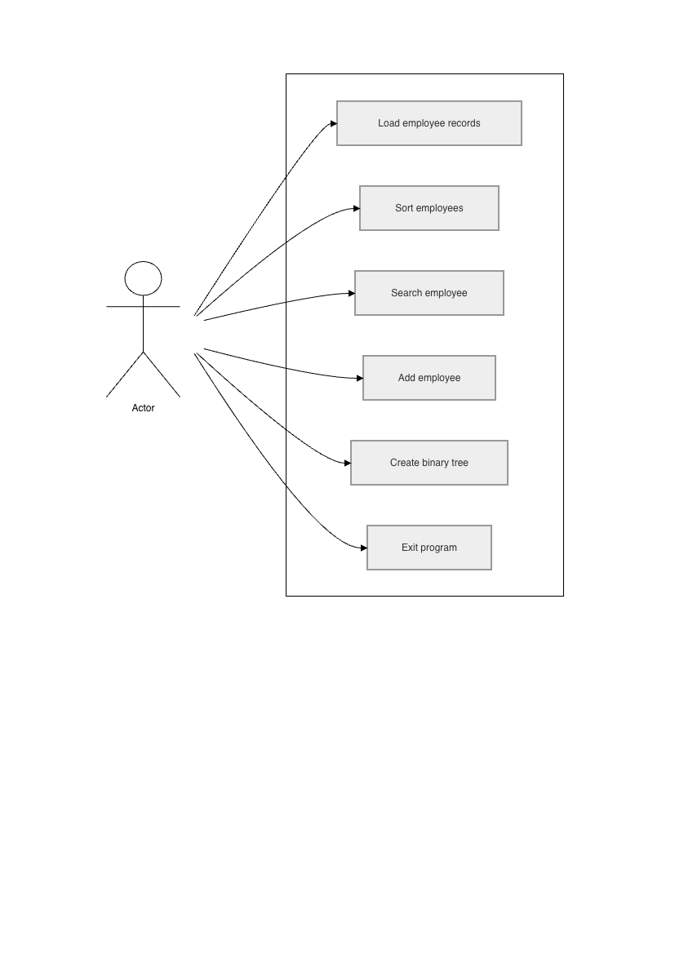

6. UML Model 1: Class Diagram
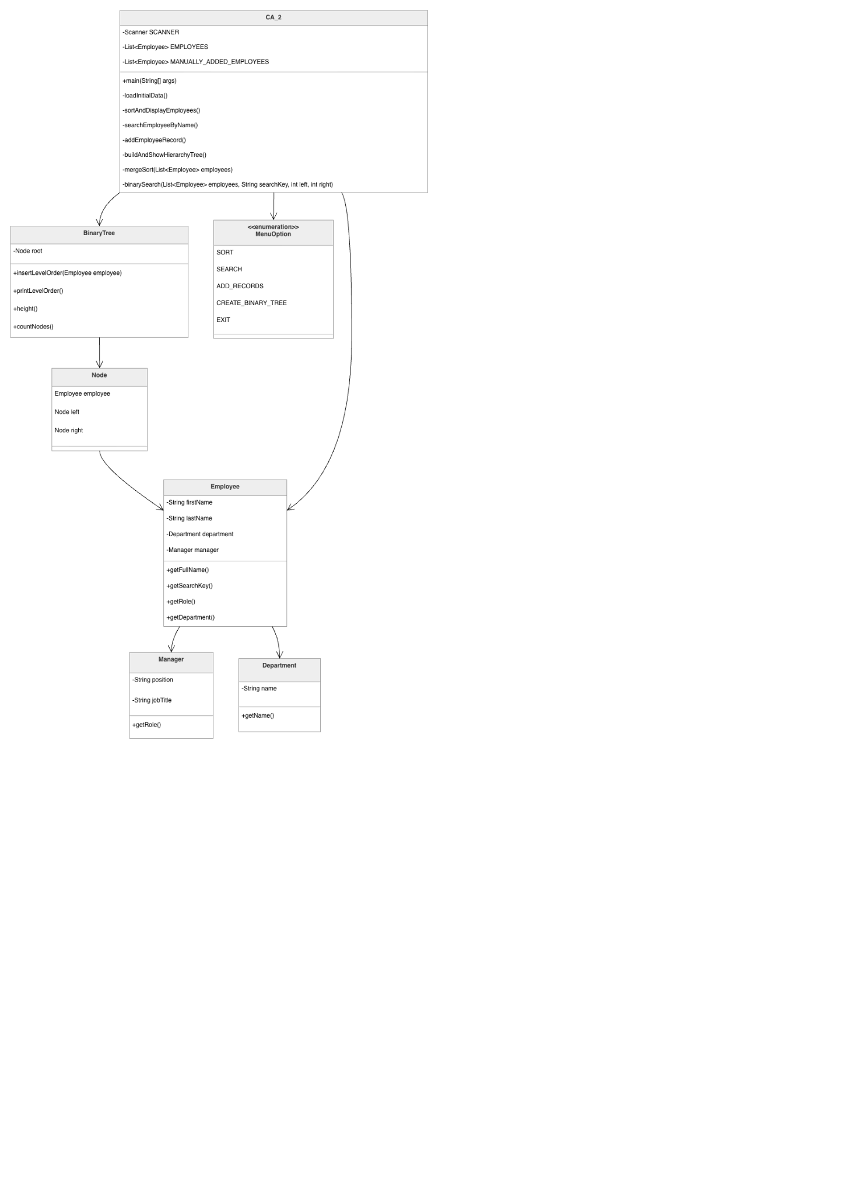

7. UML Model 2: Activity Diagram
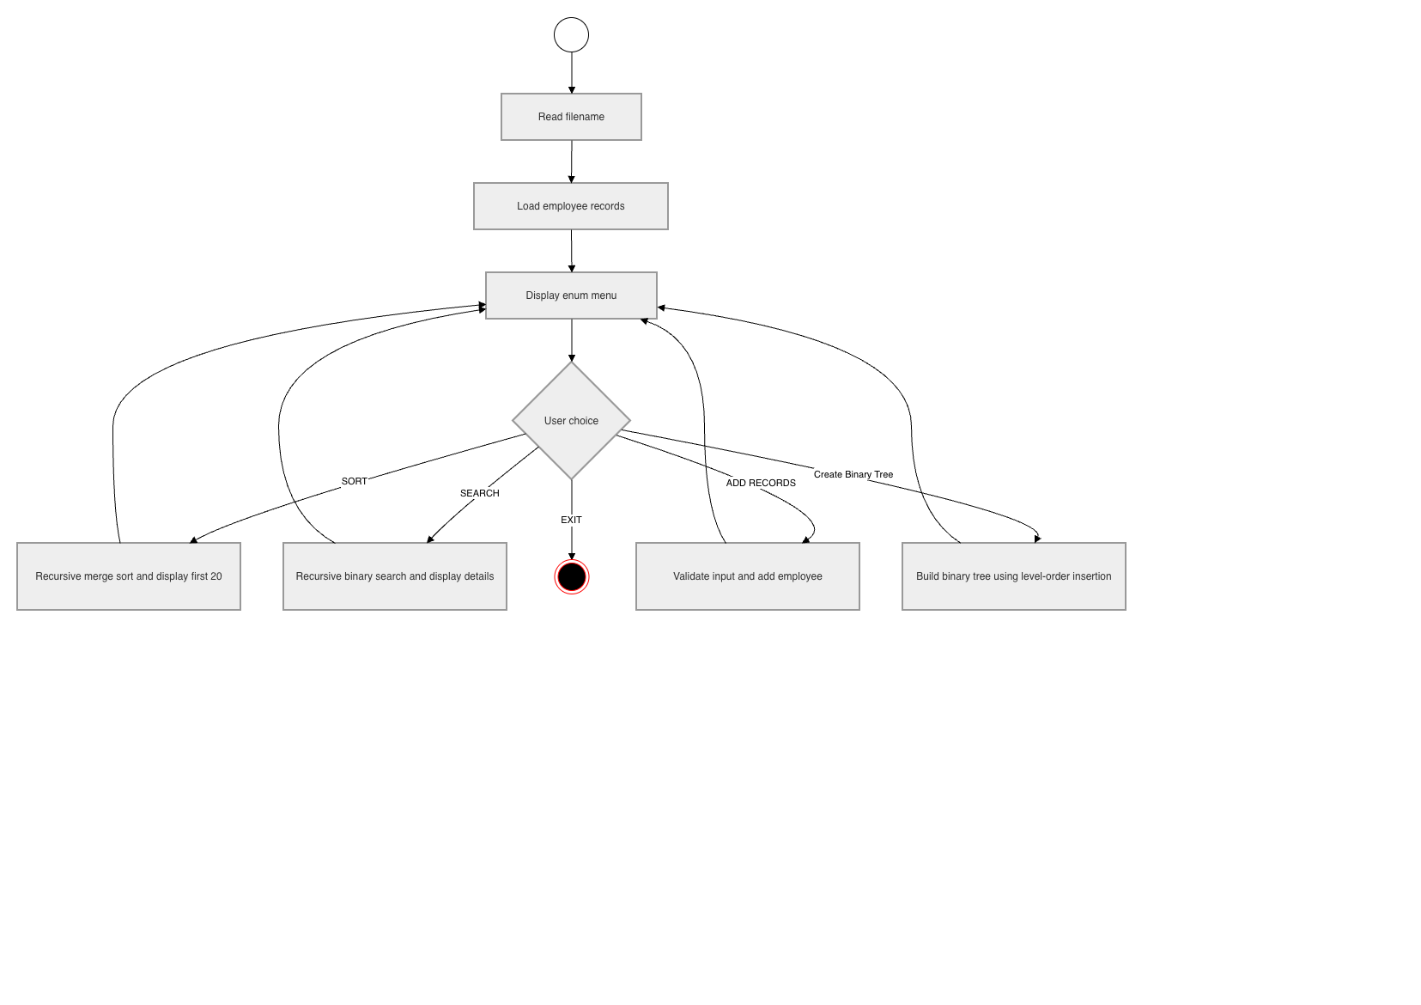

8. User Stories and Acceptance Criteria

User Story 1: Load Records
As a user, I want to load employee records from a file so that I can work with existing organisation data.
Acceptance criteria:
- The system loads Applicants_Form.txt when I press Enter at the filename prompt.
- The system displays the number of records loaded.
- The system handles a missing file without crashing.

User Story 2: Sort Records
As a user, I want to sort employees alphabetically so that I can view the organisation list in a readable order.
Acceptance criteria:
- The system sorts employees by full name.
- The system displays only the first 20 names.
- The system uses a recursive sorting algorithm.

User Story 3: Search Records
As a user, I want to search for an employee by name so that I can find their department and role quickly.
Acceptance criteria:
- The system accepts a full name as search input.
- The system returns role and department information when a match is found.
- The system displays a clear message when no match exists.

User Story 4: Add Employee
As a user, I want to add a new employee so that the organisation data can be updated during runtime.
Acceptance criteria:
- The system requires a non-empty name.
- The system only accepts valid manager type and department choices.
- The system displays the newly added record after insertion.

User Story 5: Generate Hierarchy
As a user, I want to generate an employee hierarchy so that I can see the organisation represented as a tree.
Acceptance criteria:
- The system inserts records into a binary tree using level-order insertion.
- The system displays the hierarchy by level.
- The system displays tree height and total node count.

9. Unit Tests

Test 1: Default File Loading
Purpose: Confirm that the program reads Applicants_Form.txt when the user presses Enter.
Test data:
- Input: blank filename
- Expected result: File read successfully: Applicants_Form.txt and Records loaded: 46

Test 2: Employee Search
Purpose: Confirm that recursive binary search can find an existing employee.
Test data:
- Input: Emma Brown
- Expected result: employee found with role Marketing Specialist and department Marketing

Test 3: Binary Tree Count After Adding Record
Purpose: Confirm that the binary tree includes both loaded and manually added employees.
Test data:
- Loaded records: 46
- Added record: Tina Chen
- Expected result: Total node count: 47

10. Algorithms and Constructs Explanation

Sorting Algorithm Choice
I selected recursive merge sort for sorting the employee list. This was the best fit because the assignment required a recursive sorting algorithm and the program works with a list of employee records loaded from a file. Merge sort is reliable for this situation because its performance remains consistent even when the input file is randomly ordered. A simple algorithm such as bubble sort or insertion sort would be easier to write, but it would be less suitable if the employee file became larger because those approaches compare and swap many more records. Merge sort also works cleanly with Java List<Employee> data because the list can be divided into smaller lists recursively and then merged back in alphabetical order using each employee's full name as the search key. For this prototype, merge sort gives a clear balance between assessment requirements, readability and dependable behaviour.

Searching Algorithm Choice
I selected recursive binary search for finding an employee by name. This was the best fit because the employee list is sorted before searching, which allows the search space to be cut in half on each recursive call. Compared with a linear search, binary search is more efficient and demonstrates a stronger algorithmic choice for a sorted list. A linear search would still work, but it would check records one by one and would not take advantage of the sorted data. Recursive binary search also matches the assignment requirement for a recursive searching algorithm and is easy to explain during Q&A because each call searches either the left half or the right half of the sorted employee list. The search returns relevant information including the employee's role and department.

11. Manual Test Evidence
The program was tested in NetBeans using Maven. The successful run showed:
- BUILD SUCCESS
- File read successfully: Applicants_Form.txt
- Records loaded: 46
- Sorting displayed the first 20 names alphabetically.
- Searching for Emma Brown returned the correct role and department.
- Adding Tina Chen as Head Manager in Finance succeeded.
- Binary tree output showed Tree height: 6 and Total node count: 47.

12. Conclusion
The completed prototype meets the core Algorithms and Constructs requirements. It uses enum-based menus, validates user input, reads employee data from a file, sorts and searches records using recursive algorithms, accepts new employee records, and builds a binary tree hierarchy using level-order insertion. The design also includes separate Employee, Manager, Department, BinaryTree and Node classes, making the structure clear enough to explain and extend in a future version.

13. GitHub Repository:
https://github.com/2025755-coder/CA_2

