Heart Disease Risk Prediction: End-to-End MLOps Pipeline
MLOps Assignment 1 — Final Report
Student Name | KATBA ANKIT CHIMANBHAI
BITS ID | 2025AE05229
Course | AIMLCZG523 — Machine Learning Operations (MLOps)
Assignment | Assignment 1
Dataset | UCI Heart Disease — Cleveland subset
Code Repository | https://github.com/2025AE05229/mlops-a1
CI/CD Workflow | https://github.com/2025AE05229/mlops-a1/actions/workflows/ci.yml
Screenshots | https://github.com/2025AE05229/mlops-a1/tree/main/screenshots
Live API (public) | https://heart-disease-api.1s0uu8ax973i.us-south.codeengine.appdomain.cloud  Username: admin  Password: ce340a68-2574-4e18-928b-f65a4d14a817
Pipeline Video | Walkthrough recording (SharePoint); also in the repository as video-recording.mp4

Table of Contents
1. Setup & Installation Instructions 2
2. Dataset Overview & EDA 2
3. Feature Engineering & Modelling Choices 5
4. Experiment Tracking Summary 7
5. Model Packaging & Reproducibility 8
6. CI/CD Pipeline 8
7. Containerisation 10
8. Architecture Diagram 11
9. Deployment Workflow & Screenshots 12
10. Monitoring & Logging 13
Appendix A. Additional Evidence Screenshots 14

1. Setup & Installation Instructions
All commands are run from the repository root. The project targets Python 3.11 and was developed on macOS; the same steps work on Linux, and on Windows with the alternative activation command shown.

1.1 Prerequisites
- Python 3.11 or above
- Git
- Docker or Podman (container build and run)
- kubectl and kind (optional — local Kubernetes deployment)

1.2 Clone & Environment Bootstrap
git clone https://github.com/2025AE05229/mlops-a1.git
cd mlops-a1
python3.12 -m venv .venv
source .venv/bin/activate # macOS / Linux
# .venv\Scripts\activate # Windows
pip install -r requirements.txt

All 13 packages in requirements.txt are pinned to exact versions. A leaner requirements-serve.txt (runtime dependencies only) is used inside the Docker image.

1.3 Run the Full ML Pipeline
# 1. Download the dataset from UCI (falls back to the bundled copy in data/raw/)
python -m src.ml_pipeline.tasks.download_data
# 2. Clean and preprocess -> data/processed/heart_disease_cleaned.csv
python -m src.ml_pipeline.tasks.preprocess
# 3. Generate EDA figures -> reports/figures/
python -m src.ml_pipeline.tasks.eda
# 4. Tune (GridSearchCV, 5-fold), evaluate and log both models to MLflow
python -m src.ml_pipeline.tasks.evaluate
# 5. Register the champion model in the MLflow Model Registry
python -m src.ml_pipeline.tasks.register_model
# Or the CI-equivalent single entry point (steps 2, 4, 5 + champion.txt)
python src/ml_pipeline/ci_train.py

1.4 Run Tests and Linting
flake8 src/ tests/
python -m pytest # 20 tests; JUnit report -> reports/junit.xml

1.5 Serve Locally via Docker
docker build -t heart-disease-api:local .
docker run --rm -p 8080:8080 \
-e API_USERNAME=<user> -e API_PASSWORD=<password> heart-disease-api:local
# Smoke test
curl http://localhost:8080/health

podman can be substituted for docker unchanged. docker compose up --build is also supported (it requires API_PASSWORD to be set in the shell or in a git-ignored .env file).

1.6 View the MLflow Experiment Tracking UI
mlflow ui --backend-store-uri sqlite:///mlflow.db
# Open http://localhost:5000

2. Dataset Overview & EDA

2.1 Dataset
The UCI Heart Disease — Cleveland subset is a standard benchmark for heart-disease prediction (source: https://archive.ics.uci.edu/dataset/45/heart+disease). The raw file processed.cleveland.data contains 303 patient records described by 13 clinical features and one multiclass target (0 = no disease, 1–4 = disease grade). It is fetched by src/ml_pipeline/tasks/download_data.py, which falls back to the copy stored in data/raw/ when the download is unavailable. Table 1 lists the features.
Table 1 — Feature descriptions.
Feature | Type | Description
age | Numerical | Age in years
sex | Categorical | 1 = male, 0 = female
cp | Categorical | Chest-pain type (1–4)
trestbps | Numerical | Resting blood pressure (mm Hg)
chol | Numerical | Serum cholesterol (mg/dl)
fbs | Categorical | Fasting blood sugar > 120 mg/dl (1 = true)
restecg | Categorical | Resting ECG results (0–2)
thalach | Numerical | Maximum heart rate achieved
exang | Categorical | Exercise-induced angina (1 = yes)
oldpeak | Numerical | ST depression induced by exercise
slope | Categorical | Slope of the peak exercise ST segment (1–3)
ca | Categorical | Number of major vessels coloured by fluoroscopy (0–3)
thal | Categorical | Thalassemia (3 = normal, 6 = fixed defect, 7 = reversible defect)
target | Binary | 0 = no disease, 1 = disease present (after binarisation)

2.2 Data Quality & Preprocessing
- Missing values: the raw file encodes them as ?. Six rows were affected (ca: 4 values, thal: 2 values). They were imputed with the median for numerical columns and the mode for categorical columns.
- Target binarisation: grade 0 → 0 (no disease), grades 1–4 → 1 (disease present). The raw distribution (0: 164, 1: 55, 2: 36, 3: 35, 4: 13) becomes 164 negative / 139 positive.
- Types: all discrete columns were cast to int. The cleaned file data/processed/heart_disease_cleaned.csv has 303 rows × 14 columns.
Imputation is applied to the full dataset before the train/test split. Because only 6 of 303 records are affected, the effect on the held-out evaluation is negligible.

2.3 Exploratory Data Analysis
All EDA outputs are generated by src/ml_pipeline/tasks/eda.py and saved as 300-dpi PNG files in reports/figures/: class balance, numerical distributions, categorical relationships and the correlation heatmap. Table 2 summarises the numerical features.
Table 2 — Descriptive statistics for numerical features (N = 303).
Feature | Mean | Std | Min | Median | Max
age | 54.44 | 9.04 | 29 | 56 | 77
trestbps | 131.69 | 17.60 | 94 | 130 | 200
chol | 246.69 | 51.78 | 126 | 241 | 564
thalach | 149.61 | 22.88 | 71 | 153 | 202
oldpeak | 1.04 | 1.16 | 0.0 | 0.8 | 6.2

Class balance: the dataset is nearly balanced — 164 negative (54.1 %) and 139 positive (45.9 %) records (Figure 1) — so accuracy is a reasonable headline metric alongside ROC-AUC.
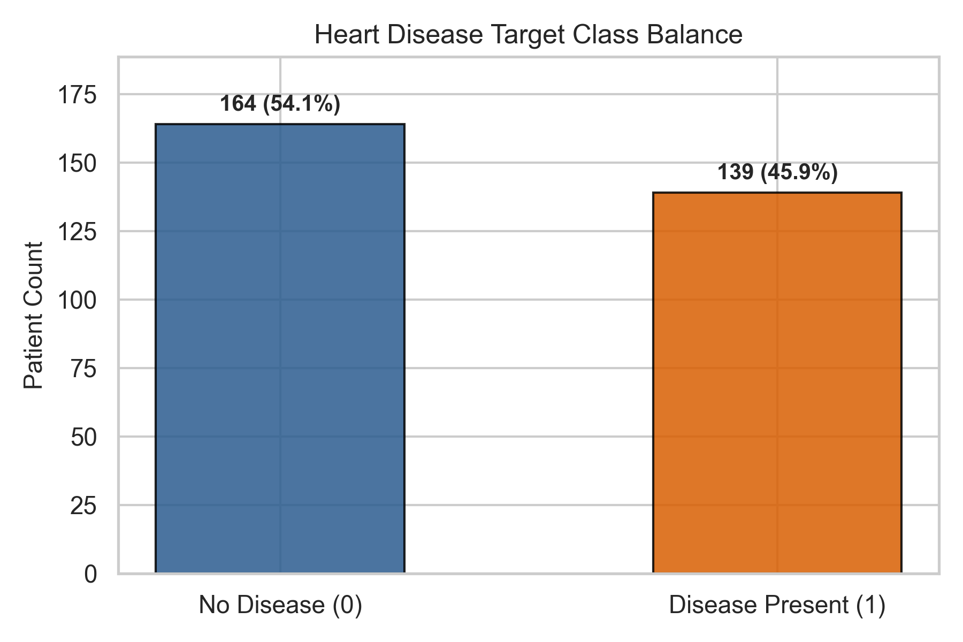
Figure 1 — Target class balance (164 no disease vs 139 disease; N = 303). [View Full Image ↗]
Figure 2 compares the distribution of every numerical feature between the two classes; the categorical features are shown in Figure 21 (Appendix A).
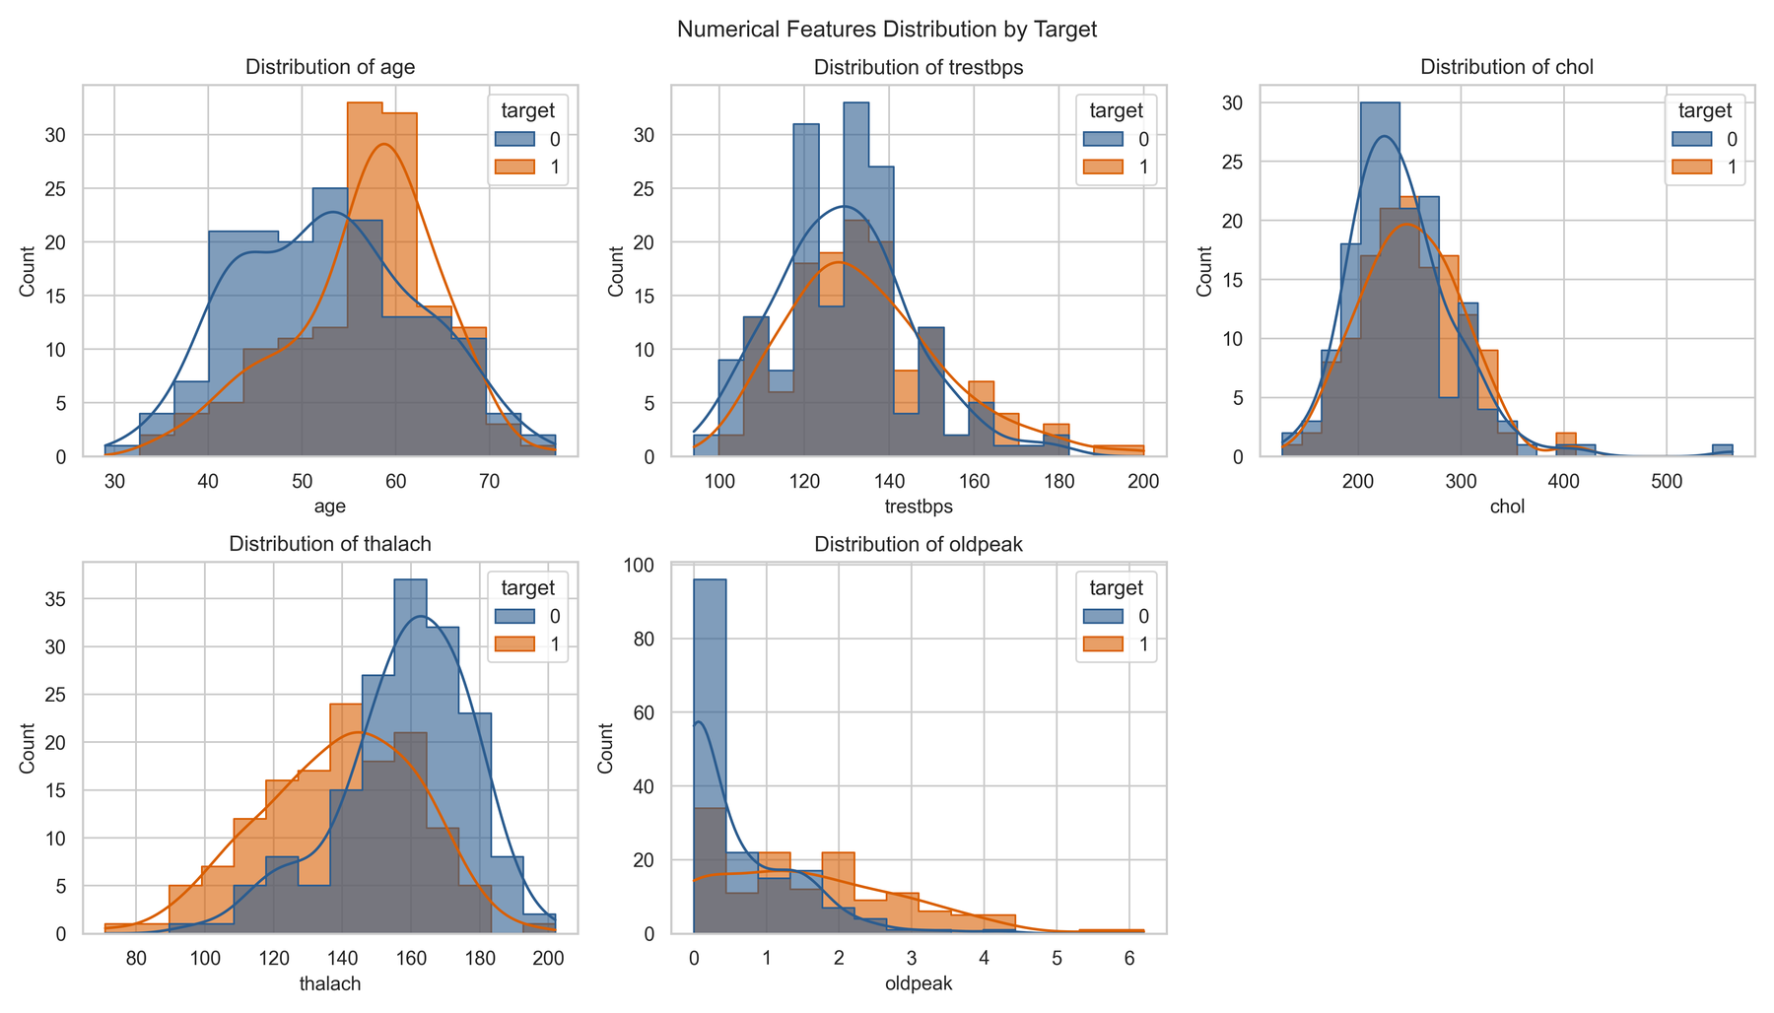
Figure 2 — Distribution of the numerical features by target class. [View Full Image ↗]

2.4 Feature Correlation with Target
Table 3 lists the Pearson correlation of each feature with the binary target (for a binary target this equals the point-biserial correlation), sorted by absolute strength. thal (0.522), ca (0.460), exang (0.432) and oldpeak (0.425) are the strongest predictors. thalach is inversely correlated (−0.417): a higher maximum heart rate is associated with lower disease risk. Cholesterol (0.085) and fasting blood sugar (0.025) are only weakly related to the target. The full 14 × 14 matrix is shown in Figure 3.
Table 3 — Correlation of each feature with the binary target.
Feature | Correlation (r) | Direction
thal | 0.522 | Positive
ca | 0.460 | Positive
exang | 0.432 | Positive
oldpeak | 0.425 | Positive
thalach | −0.417 | Negative
cp | 0.414 | Positive
slope | 0.339 | Positive
sex | 0.277 | Positive
age | 0.223 | Positive
restecg | 0.169 | Weak positive
trestbps | 0.151 | Weak positive
chol | 0.085 | Weak positive
fbs | 0.025 | Negligible

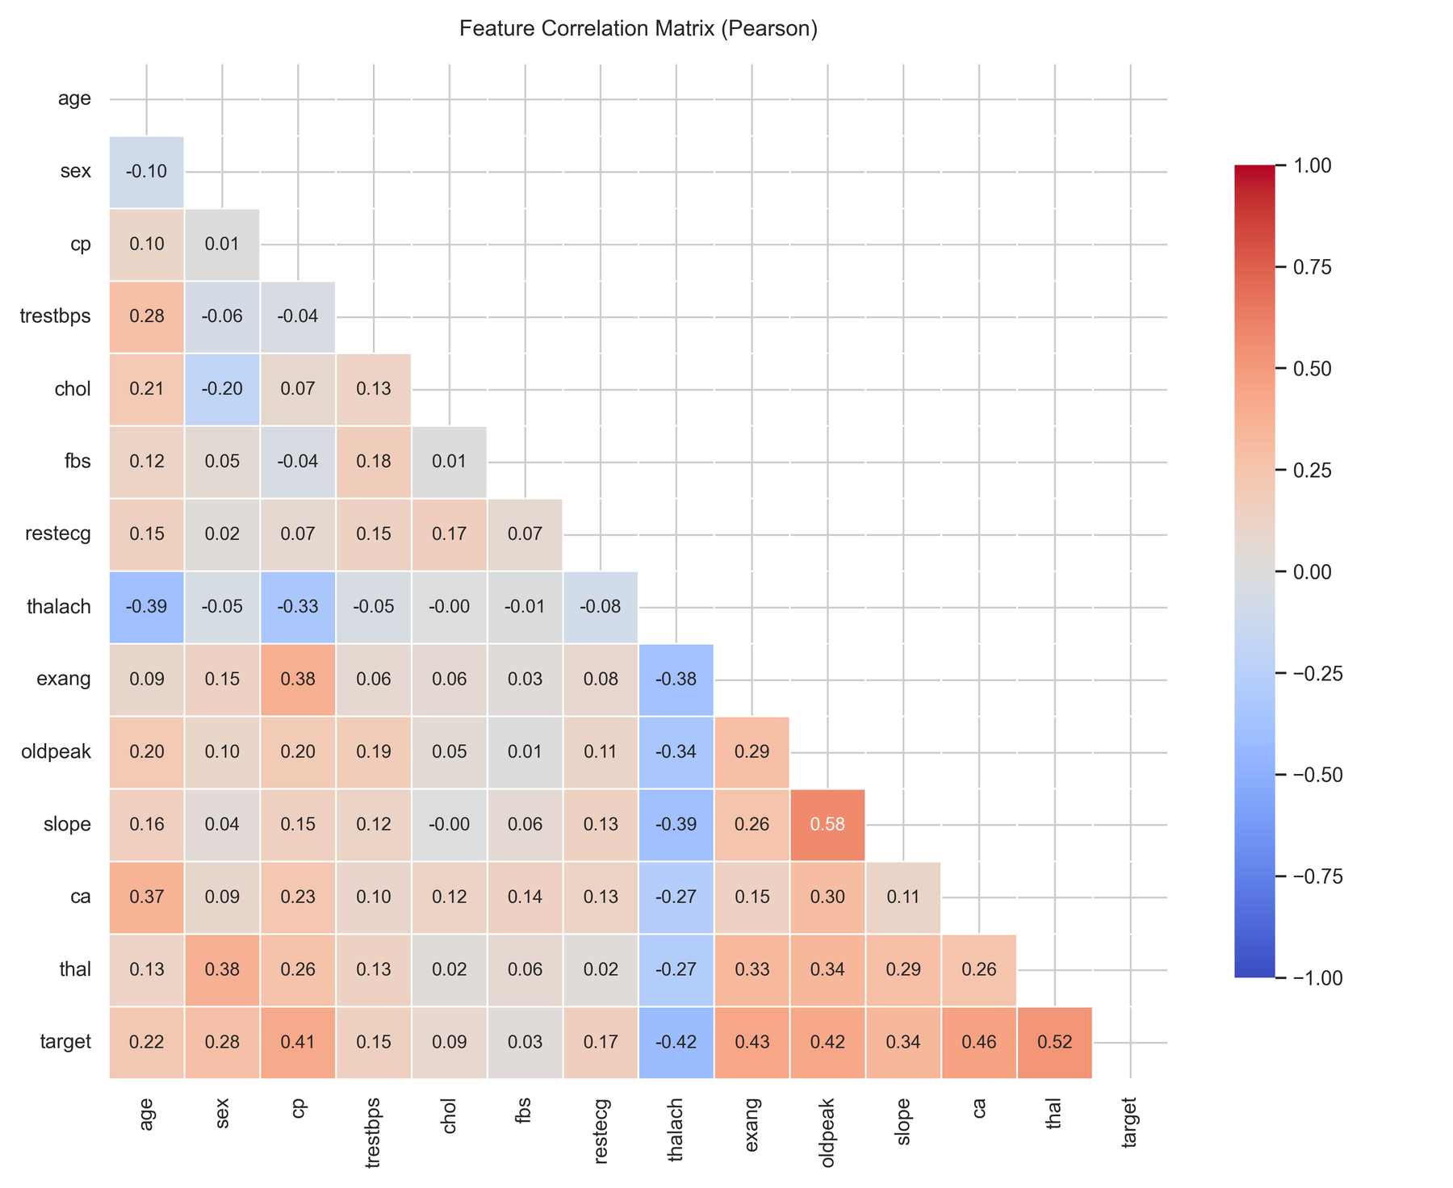
Figure 3 — Pearson correlation matrix of the 13 features and the target. [View Full Image ↗]

3. Feature Engineering & Modelling Choices

3.1 Feature Engineering
All 13 features are retained: with so few variables, each of clear clinical relevance, no feature selection or dimensionality reduction was applied. Preprocessing differs by feature type and is implemented as a Scikit-Learn ColumnTransformer (src/ml_pipeline/tasks/build_features.py):
- Numerical pipeline (age, trestbps, chol, thalach, oldpeak): StandardScaler — zero mean, unit variance. Needed so that Logistic Regression is not dominated by large-scale features such as chol.
- Categorical pipeline (sex, cp, fbs, restecg, exang, slope, ca, thal): OneHotEncoder(handle_unknown="ignore") — expands each integer-coded category into binary columns so the model does not treat codes as ordered numeric values.
The ColumnTransformer and the classifier are combined in a single end-to-end Scikit-Learn Pipeline, so the scaler and encoder are fitted only on the training portion of each cross-validation fold, which prevents data leakage. The data is split 80 % / 20 % (stratified, random_state=42): N = 242 for training and tuning, N = 61 held out for the final test.

3.2 Candidate Models
Logistic Regression is the primary candidate: it is interpretable, produces well-calibrated probabilities and gives a strong regularised linear baseline once features are scaled.
Random Forest is the non-linear ensemble alternative: it captures feature interactions, is robust to outliers and exposes feature importances, which helps clinical explainability.

3.3 Hyperparameter Tuning
Tuning uses GridSearchCV with Stratified 5-Fold cross-validation on the training split, optimising roc_auc (n_jobs=-1, refit=True). The Logistic Regression grid has 8 combinations (40 fits) and the Random Forest grid 24 combinations (120 fits). Fixed settings: random_state=42 for both models and max_iter=1000 for Logistic Regression.
Table 4 — Hyperparameter search spaces and selected values.
Model | Parameter | Search values | Best value
Logistic Regression | C | [0.01, 0.1, 1.0, 10.0] | 1.0
Logistic Regression | solver | [lbfgs, liblinear] | lbfgs
Random Forest | n_estimators | [50, 100, 200] | 100
Random Forest | max_depth | [3, 5, 8, None] | 8
Random Forest | min_samples_split | [2, 5] | 5

3.4 Evaluation Metrics
Both tuned pipelines were evaluated with 5-fold stratified cross-validation on the training split (Table 5) and once on the 61-patient hold-out test set (Table 6). Values are taken from reports/model_evaluation.json.
Table 5 — Cross-validation results (5-fold, mean ± std).
Model | ROC-AUC | Accuracy | Precision | Recall | F1
Logistic Regression ✓ | 0.9025 ± 0.0144 | 0.8471 ± 0.0100 | 0.8768 ± 0.0542 | 0.7834 ± 0.0459 | 0.8245 ± 0.0069
Random Forest | 0.9021 ± 0.0217 | 0.8223 ± 0.0106 | 0.8282 ± 0.0498 | 0.7830 ± 0.0741 | 0.8004 ± 0.0211

Table 6 — Hold-out test-set results (N = 61).
Model | ROC-AUC | Accuracy | Precision | Recall | F1
Logistic Regression ✓ | 0.9665 | 0.8852 | 0.8387 | 0.9286 | 0.8814
Random Forest | 0.9502 | 0.8852 | 0.8387 | 0.9286 | 0.8814

The two models make identical predictions on the test set — both produce the same confusion matrix (TN = 28, FP = 5, FN = 2, TP = 26; see Figure 22 and Figure 23 in Appendix A) — and differ only in their predicted probabilities, hence in ROC-AUC. Figure 4 compares the metrics and Figure 5 and Figure 6 show the ROC curves.
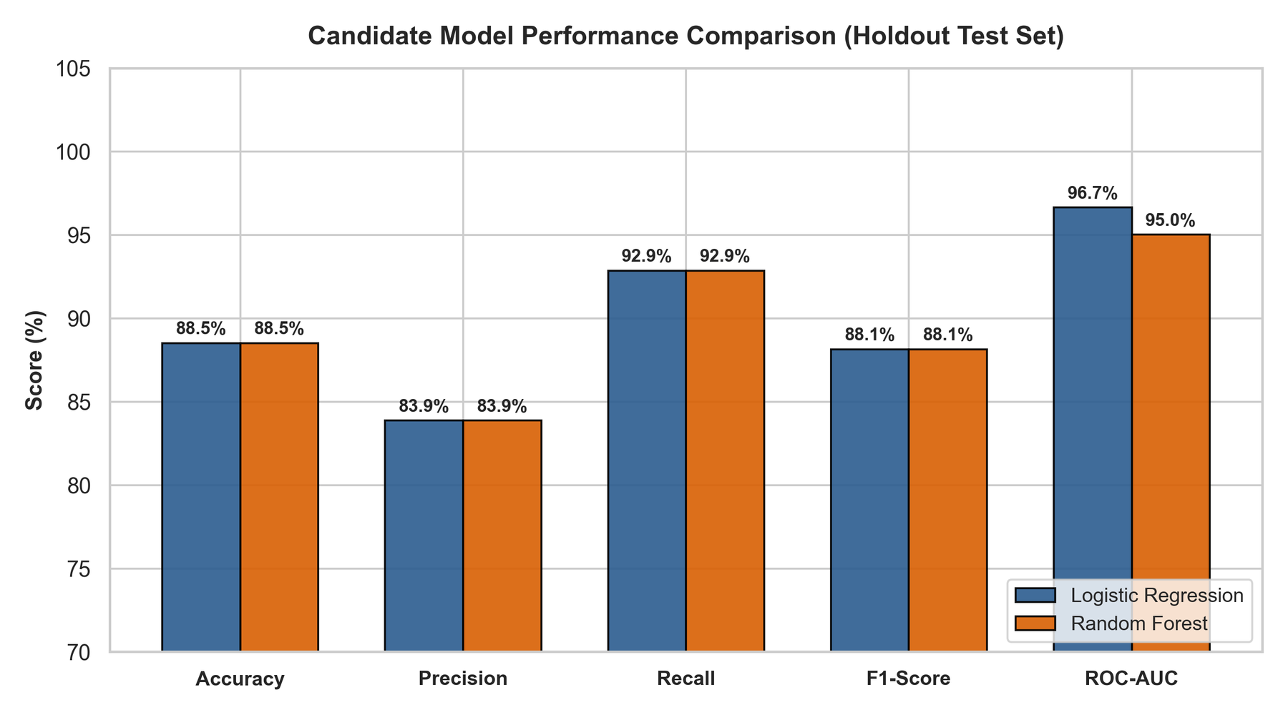
Figure 4 — Hold-out test-set metric comparison of the two candidate models. [View Full Image ↗]
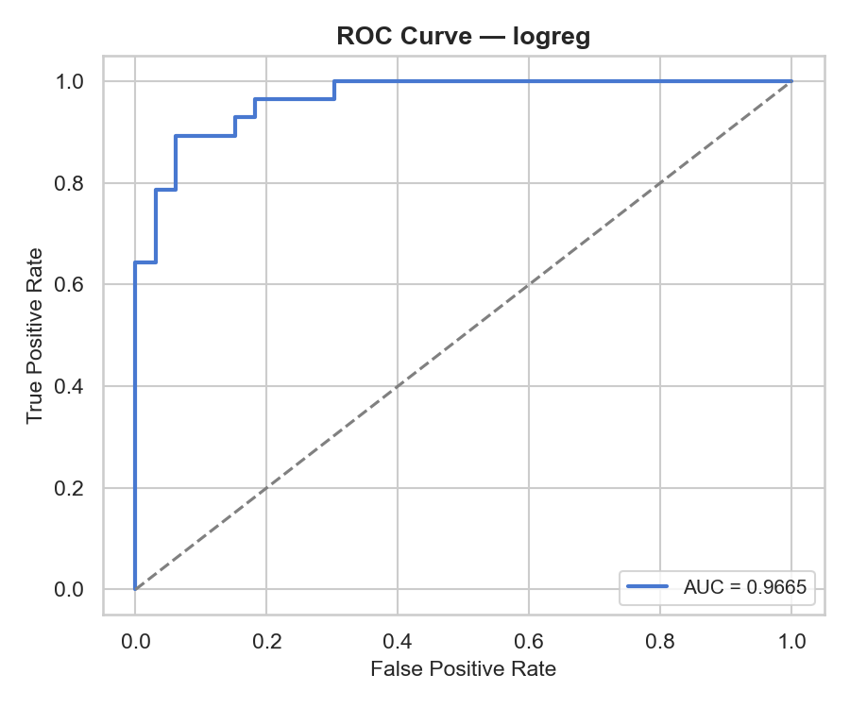  Figure 5 — ROC curve — Logistic Regression (test AUC 0.9665). [View Full Image ↗] | 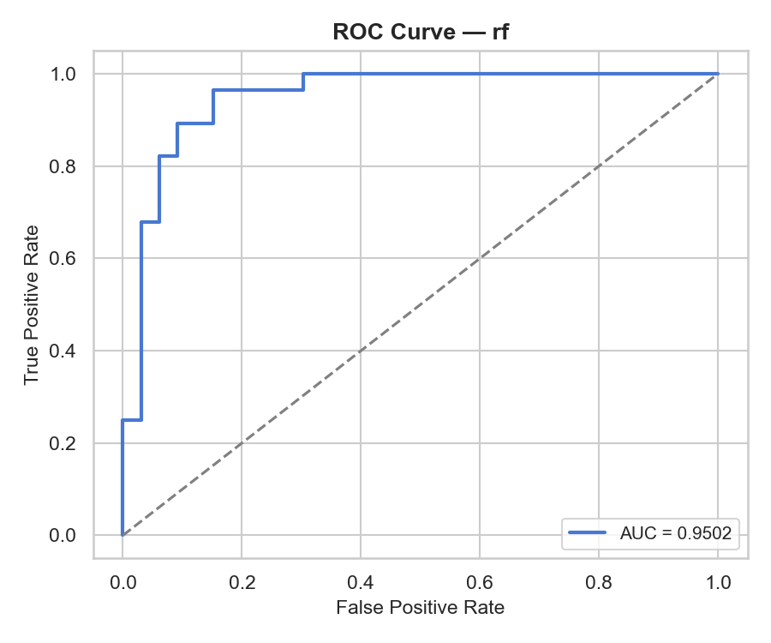  Figure 6 — ROC curve — Random Forest (test AUC 0.9502). [View Full Image ↗]

3.5 Model Selection Decision
Logistic Regression was selected as the champion. Because the two models tie on test accuracy, precision, recall and F1, the decision rests on the remaining evidence:
1. Higher ROC-AUC — 0.9665 vs 0.9502 on the test set, and marginally higher cross-validated ROC-AUC (0.9025 vs 0.9021) with lower fold-to-fold variance (± 0.0144 vs ± 0.0217).
2. Higher cross-validated accuracy — 84.71 % vs 82.23 %, again with similar variance.
3. Simplicity and interpretability — coefficients are directly interpretable as log-odds, the serialised pipeline is 4 KB (vs 553 KB for the forest) and inference cost is negligible, which suits a small containerised microservice.
Recall is the clinically important metric (a missed disease case is the costly error); it is equal for both models at 92.86 % (26 of 28 diseased patients detected). With only 61 test patients, one prediction changes accuracy by about 1.6 percentage points, so test-set differences should be read as indicative; the cross-validation figures are the more reliable guide.

4. Experiment Tracking Summary

4.1 Tracking Backend
MLflow 3.16.1 is used for all experiment tracking, backed by a local SQLite store (mlflow.db). Runs are logged to the experiment heart-disease-classification; the tracking URI is set to sqlite:///mlflow.db at the start of every training run. Figure 24 shows the experiments in the UI.

4.2 What is Logged
mlflow.sklearn.autolog is enabled with max_tuning_runs=0, which keeps all GridSearch artefacts on the parent run instead of spawning one child run per candidate. For every model run it captures:
- Parameters: the best hyperparameter combination found by GridSearchCV.
- Metrics: the best cross-validated ROC-AUC.
- Model artefact: the fitted Scikit-Learn Pipeline (preprocessing + classifier) with a model signature.
- CV results table: full cross-validation scores for every candidate.
- Dataset inputs: the train and test DataFrames, logged with mlflow.log_input.
After fitting, the evaluation module resumes the same run and additionally logs:
- Metrics: test-set accuracy, precision, recall, F1 and ROC-AUC, plus cv_<metric>_mean/std.
- Plots: a ROC-curve PNG and a confusion-matrix PNG for each model.
- Summary artefacts: the model-comparison chart and model_evaluation.json, attached to the last (rf) run.
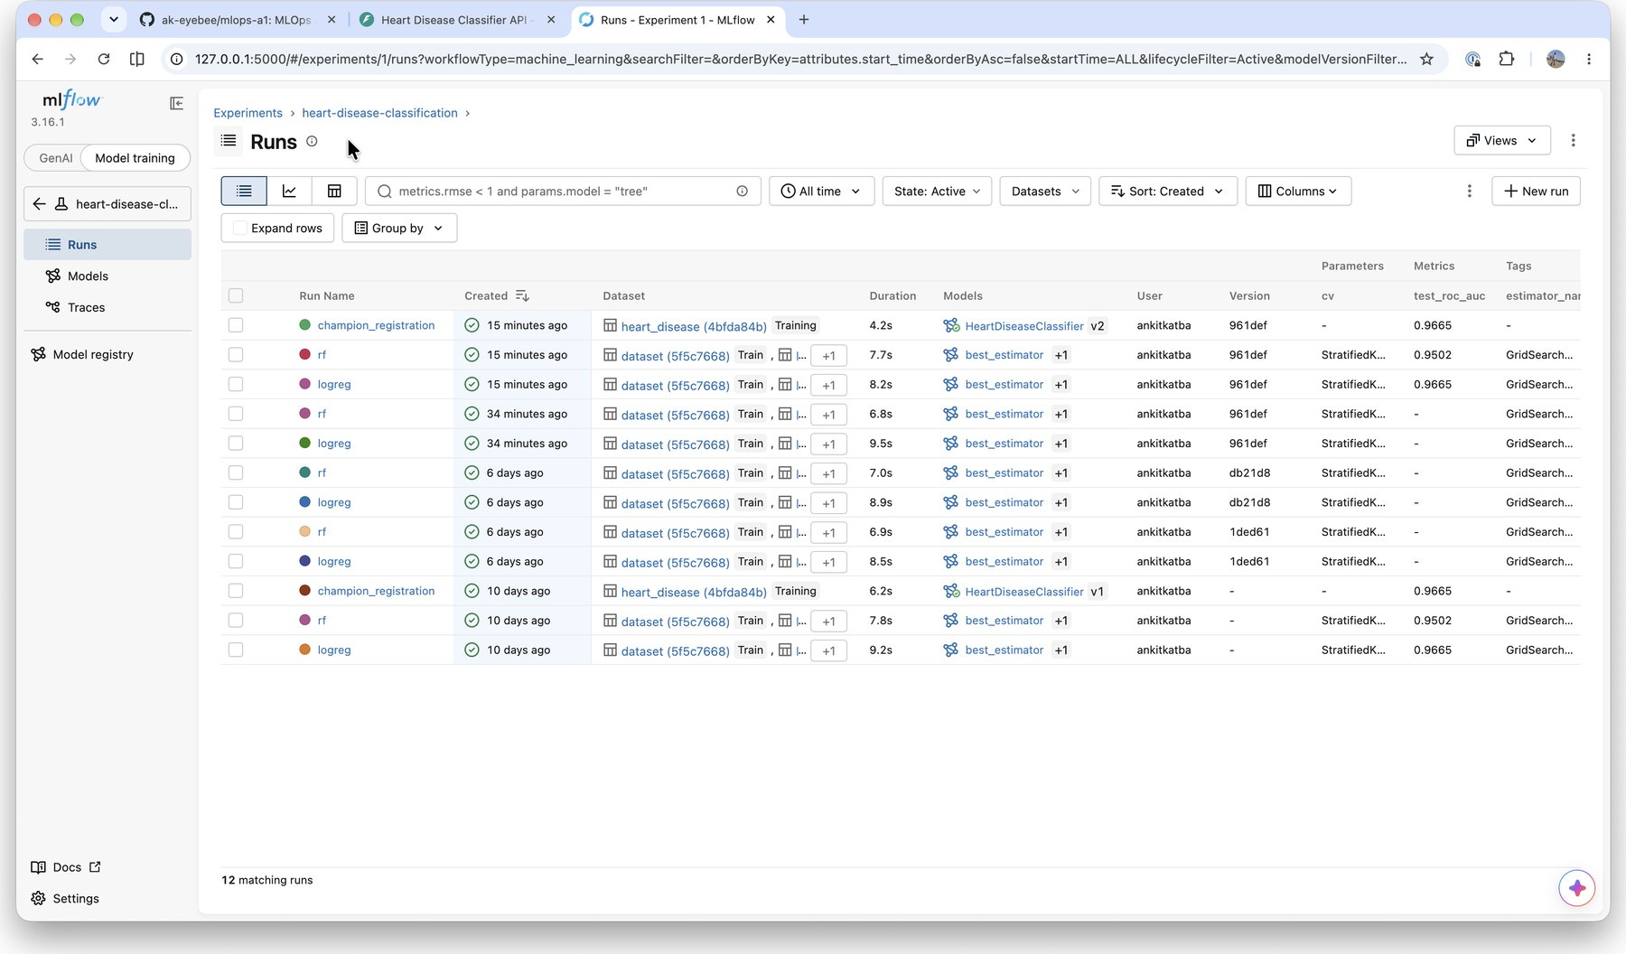
Figure 7 — MLflow Runs view: logreg, rf and champion_registration runs with test ROC-AUC, dataset inputs and registered-model links. [View Full Image ↗]

4.3 MLflow Model Registry
After evaluation, register_model.py reads reports/model_evaluation.json, selects the model with the highest cross-validated ROC-AUC, and logs that pipeline (with an inferred input/output signature) in a champion_registration run. It is registered as a new version of the HeartDiseaseClassifier model; Figure 8 shows Version 1 and Version 2, the latter created by a later re-run, and Figure 26 shows the 13-column input signature of Version 2. The winning model type is also written to models/champion.txt so the serving API can resolve it at start-up without querying MLflow.
Table 7 — MLflow runs in the heart-disease-classification experiment.
Run name | Best CV ROC-AUC | Test ROC-AUC | Key artefacts / content
logreg | 0.9025 | 0.9665 | Pipeline model, CV results, ROC PNG, confusion-matrix PNG, datasets
rf | 0.9021 | 0.9502 | Pipeline model, CV results, ROC PNG, confusion-matrix PNG, comparison chart, JSON report
champion_registration | 0.9025 | 0.9665 | Registered HeartDiseaseClassifier pipeline with signature; tag champion_model_type

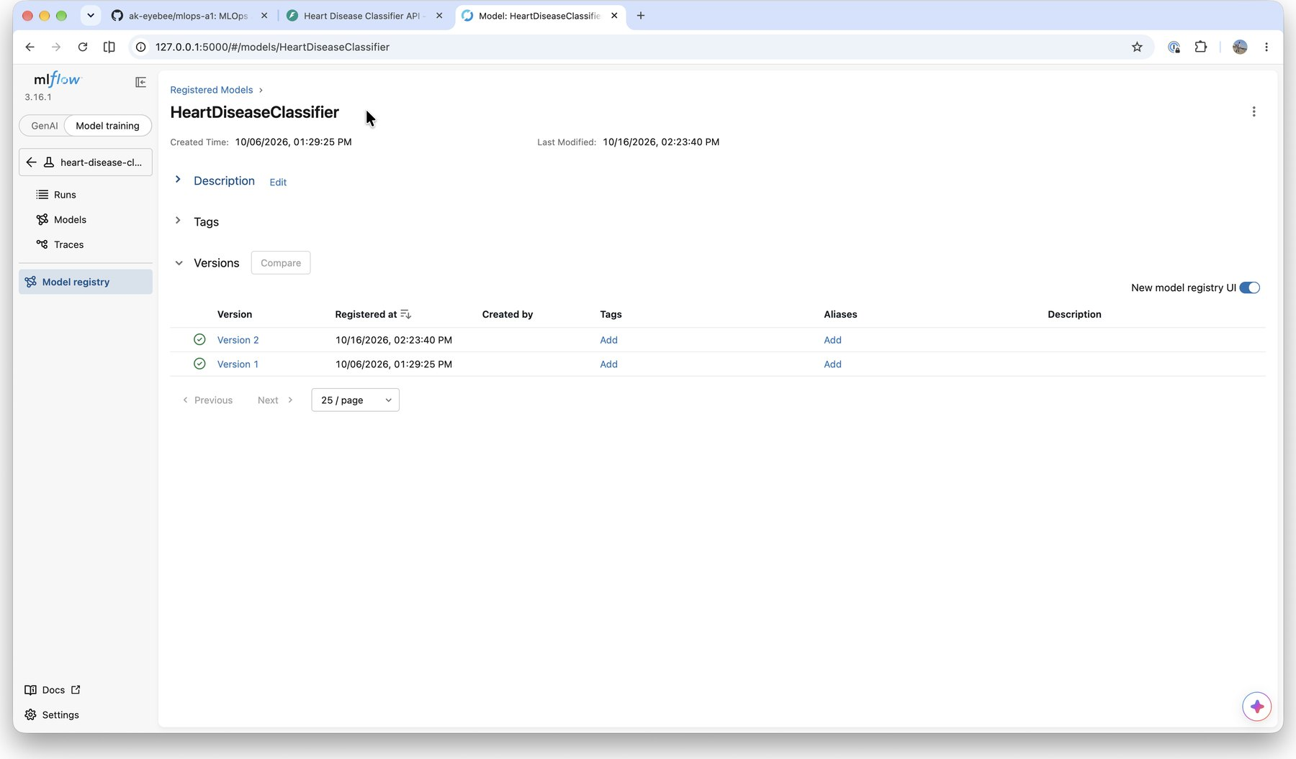
Figure 8 — MLflow Model Registry: HeartDiseaseClassifier, Version 1 and Version 2. [View Full Image ↗]
Note: The CI pipeline uploads the mlruns/ artifact store as the workflow artefact mlflow-run-<sha> (30-day retention); run metadata lives in mlflow.db.

5. Model Packaging & Reproducibility

5.1 Serialisation Format
Both trained models are saved as Joblib files (models/logreg_model.joblib, models/rf_model.joblib). Each file contains a full end-to-end Scikit-Learn Pipeline:
Pipeline
├── preprocessor (ColumnTransformer)
│ ├── num → StandardScaler (age, trestbps, chol, thalach, oldpeak)
│ └── cat → OneHotEncoder (sex, cp, fbs, restecg, exang, slope, ca, thal)
└── classifier (LogisticRegression / RandomForestClassifier)

Calling pipeline.predict(raw_df) on a new raw DataFrame applies exactly the scaling and encoding fitted during training — no separate scaler file and no manual feature transformation are needed at inference time. The champion is additionally registered in the MLflow Model Registry (Section 4.3).

5.2 Active Model Resolution
The serving API resolves the active model at start-up using the following priority chain:
1. MODEL_PATH environment variable — explicit override.
2. models/champion.txt — written by ci_train.py after every training run; contains logreg or rf.
3. Hard-coded fallback: logreg.
ci_train.py chooses the champion by highest cross-validated ROC-AUC; this criteria select Logistic Regression for the current data.

5.3 Dependency Pinning
requirements.txt pins its 13 direct dependencies to exact versions (==), so the environment can be recreated from a clean Python 3.12 installation. A separate requirements-serve.txt is used in the Docker image; it contains only the runtime packages (NumPy, pandas, scikit-learn, FastAPI, uvicorn, Pydantic and prometheus-fastapi-instrumentator) and excludes training, testing and plotting libraries to keep the image small.

5.4 Reproducibility Guide
REPRODUCIBILITY.md in the repository root documents:
- Step-by-step environment setup and pipeline re-run commands.
- How to recreate the MLflow experiment from scratch.
- How to load a registered model with mlflow.sklearn.load_model.
- How to re-run the test suite.
Randomness is fixed throughout (random_state=42 for the train/test split, cross-validation folds and both models), so retraining on the same data reproduces the reported metrics.

6. CI/CD Pipeline

6.1 Technology
GitHub Actions (.github/workflows/ci.yml, workflow name MLOps CI Pipeline) is the CI/CD engine. It triggers on every push and pull request to main and runs on ubuntu-latest runners with Python 3.11. Each job caches pip downloads keyed on the hash of requirements.txt.

6.2 Pipeline Jobs
The workflow has three jobs. lint and test run in parallel; train declares needs: [lint, test], so it starts only when both succeed and a code or test error stops the pipeline before training (Figure 10, Figure 11).
Table 8 — CI/CD pipeline jobs.
Job | Tool | Scope | Gate
lint | flake8 | src/ and tests/ (setup.cfg: max line length 120) | train cannot run if lint fails
test | pytest | 20 unit tests across data, model and API layers; uploads junit.xml | train cannot run if tests fail
train | ci_train.py | Full pipeline: preprocess → tune → evaluate → register; uploads models and MLflow data | —

6.3 Uploaded Artifacts
Three GitHub Actions artifacts are uploaded with 30-day retention:
- test-results-<sha> — JUnit XML (reports/junit.xml); uploaded even when tests fail (if: always()), so failing runs still carry logs.
- trained-models-<sha> — Joblib model files (models/).
- mlflow-run-<sha> — MLflow artifact store (mlruns/).

6.4 Unit Tests
The test suite (tests/, configured in setup.cfg) contains 20 tests in three modules. pytest writes a JUnit report to reports/junit.xml on every run.
Table 9 — Unit-test modules.
Module | Tests | What is verified
test_data_pipeline.py | 4 | Data acquisition, raw-data loading, cleaning (imputation, binary target, integer types), EDA figure generation
test_model_pipeline.py | 4 | Preprocessor, pipeline build and training, prediction shape and probability range, metric evaluation, MLflow run logging during tuning
test_api.py | 12 | /health; valid /predict payload; 422 for a missing field; 401 (with WWW-Authenticate) for missing or wrong credentials on /predict and /metrics; authenticated /metrics

6.5 Pipeline Run History & Failure Evidence
Figure 9 shows the run history of the workflow. Run #8 ("added authentication on api endpoints") demonstrates the fail-fast behaviour: both the lint job and the unit-test job failed, so the Model Training job was skipped and only the test-results artefact was uploaded (Figure 11). The pytest log (Figure 12) shows 2 failed, 9 passed: after authentication was added, two API tests still expected the unauthenticated behaviour (401 != 422 and 401 != 200) and the step exited with code 1. The follow-up commit "fix lint and unit-tests on auth code" produced the green run #10 (Figure 10) with all three artefacts.
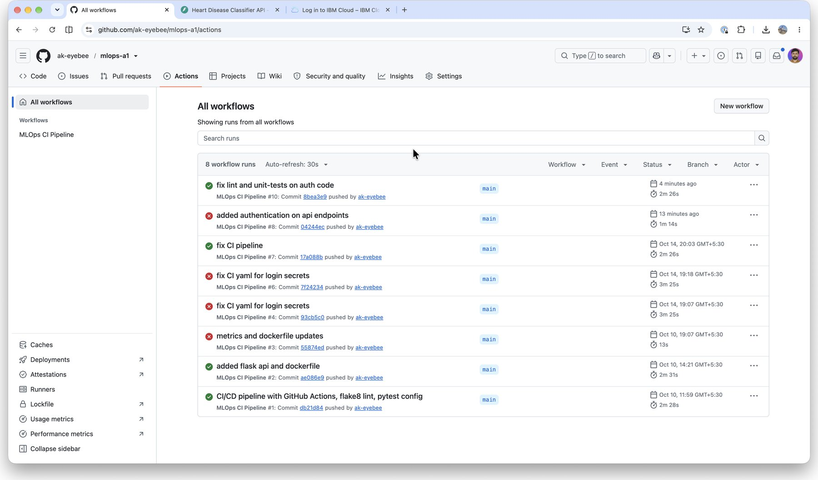
Figure 9 — GitHub Actions run history of MLOps CI Pipeline (green = passed, red = failed). [View Full Image ↗]
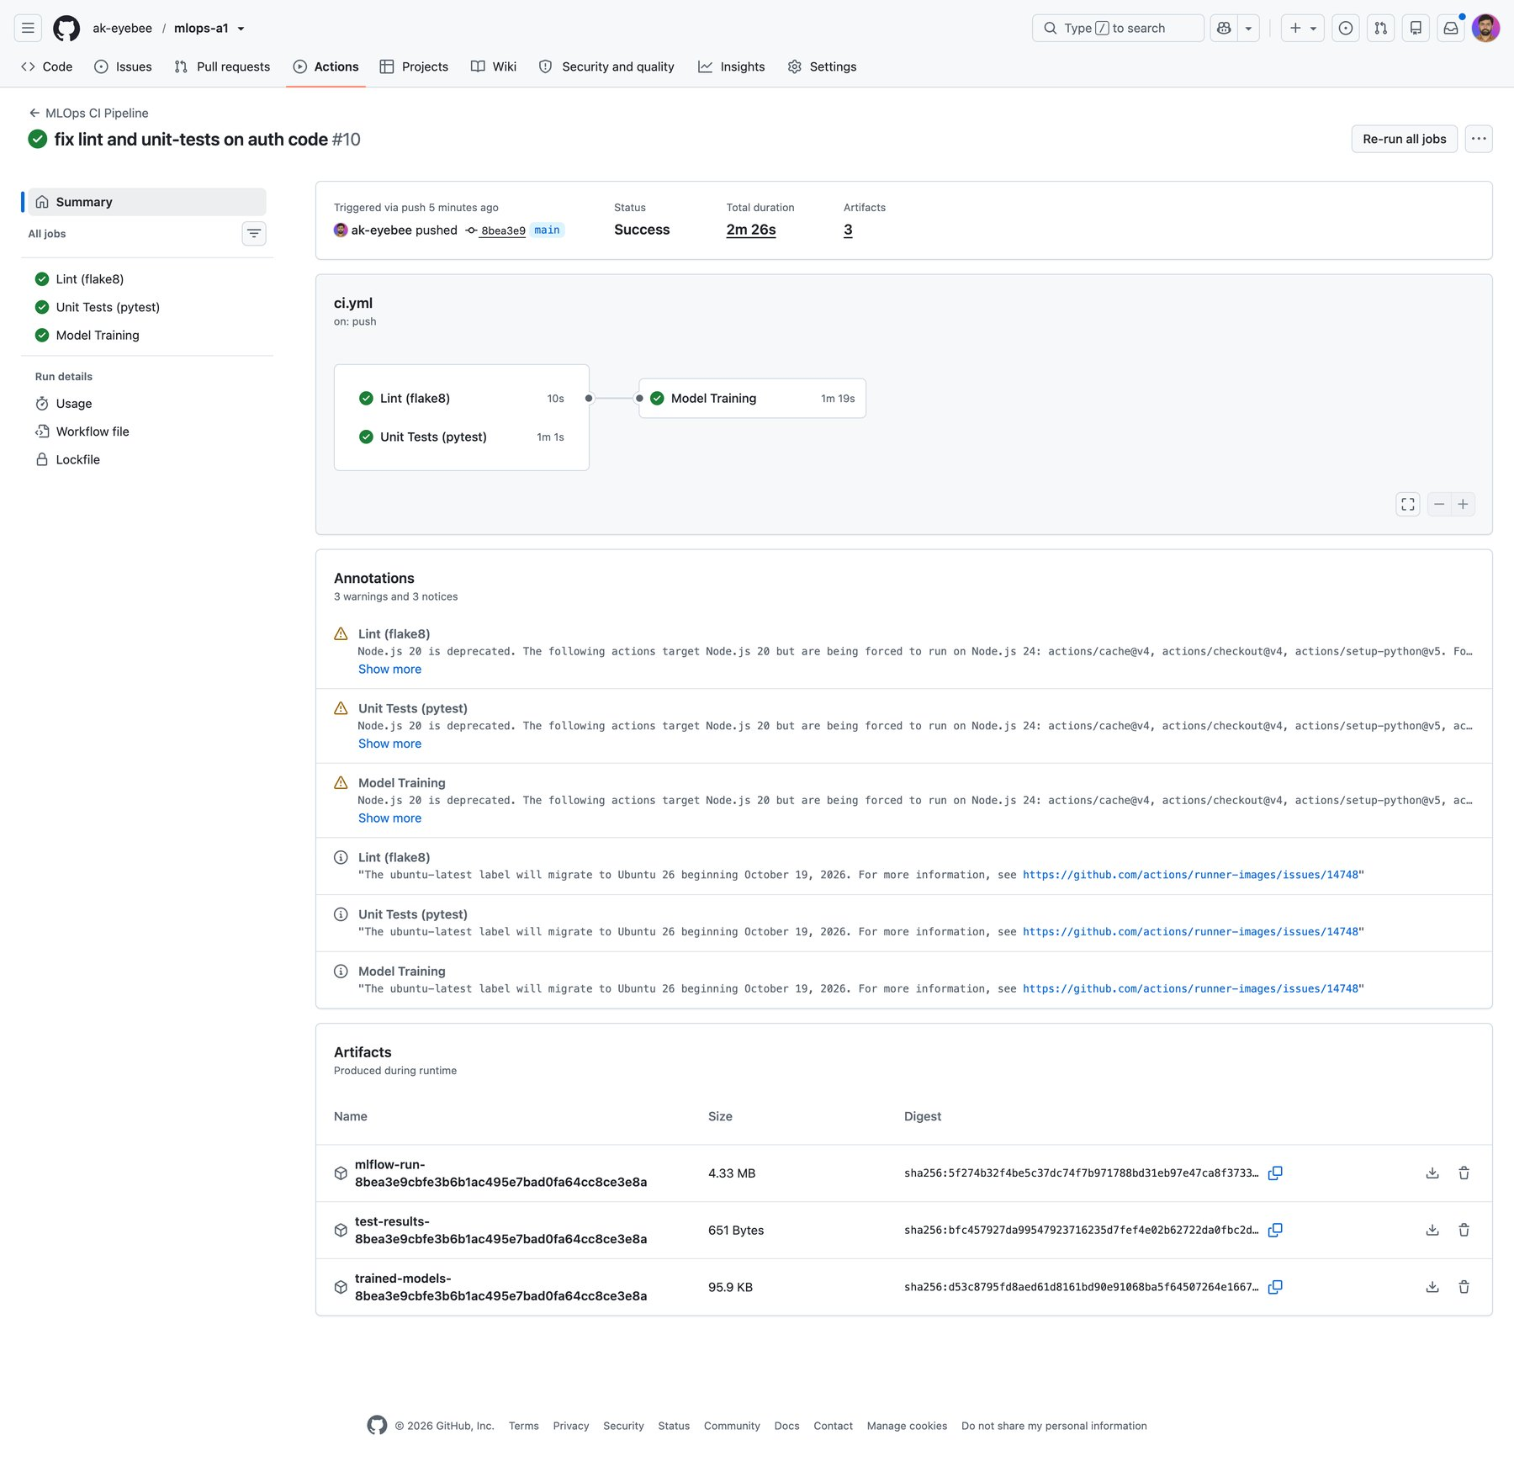  Figure 10 — Run #10 (success): lint and unit tests in parallel, then Model Training; three artefacts. [View Full Image ↗] | 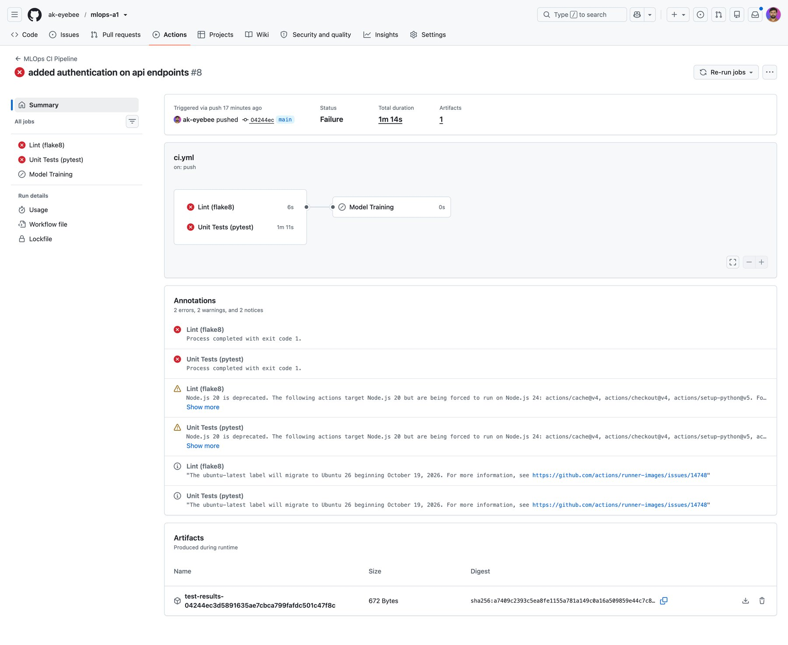  Figure 11 — Run #8 (failure): lint and unit-test jobs failed; Model Training skipped. [View Full Image ↗]

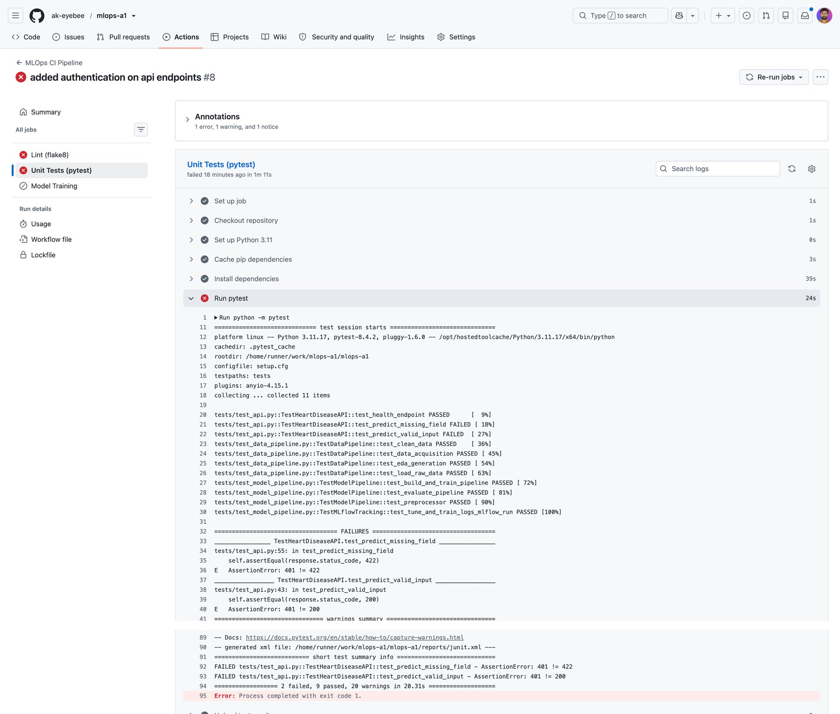
Figure 12 — Run #8 pytest log: two failed API tests (2 failed, 9 passed), step exits with code 1. [View Full Image ↗]

7. Containerisation

7.1 Docker Image
The Dockerfile builds a lean production image from python:3.12-slim (linux/amd64 platform target). The build:
1. Copies and installs requirements-serve.txt (no MLflow, plotting or test packages).
2. Copies the application source (src/) and the pre-trained model artefacts (models/).
3. Sets PORT=8080, exposes port 8080 and starts uvicorn through sh -c so that ${PORT} is expanded at run time, allowing IBM Code Engine to inject its own port.

7.2 API Design
The serving application is a FastAPI app in src/api/app.py. It exposes the endpoints in Table 10; request and response bodies are validated by Pydantic models.
Table 10 — API endpoints.
Endpoint | Method | Auth | Description
/health | GET | None | Liveness probe; returns {"status":"ok","model":"logreg"}
/predict | POST | HTTP Basic | Accepts a 13-feature JSON body; returns {"prediction": 0|1, "confidence": <float>} (probability of disease)
/metrics | GET | HTTP Basic | Prometheus-format metrics (request counts, latency histograms)
/docs | GET | None | Auto-generated Swagger UI (OpenAPI schema at /openapi.json)

7.3 Authentication
HTTP Basic authentication is enforced on /predict and /metrics and compares credentials with secrets.compare_digest to prevent timing attacks. Credentials come from the API_USERNAME and API_PASSWORD environment variables: in Kubernetes they are injected from a Secret, in Code Engine from the application's environment variables.

7.4 Sample Request
curl -u <user>:<password> -X POST http://localhost:8080/predict \
-H "Content-Type: application/json" \
-d '{"age":63,"sex":1,"cp":1,"trestbps":145,"chol":233,"fbs":1,"restecg":2,
"thalach":150,"exang":0,"oldpeak":2.3,"slope":3,"ca":0,"thal":6}'
# Response: {"prediction": 0, "confidence": 0.1655}

confidence is the model's probability for class 1 (disease present). A higher-risk patient (57 years, oldpeak 0.6, exang 1, thalach 112, …) returns {"prediction": 1, "confidence": 0.888} on the live deployment (Figure 17).

7.5 Container Build & Run Evidence
The image builds from a clean checkout and runs locally. Figure 13 shows the container serving requests, with one structured JSON log line per request, and Figure 14 shows a successful POST /predict through the Swagger UI (HTTP 200 with prediction and confidence). The build log, image list, /health and /metrics calls are in Appendix A (Figure 27 – Figure 30). The image targets linux/amd64, so on an Apple-Silicon host Docker prints a platform warning and runs it under emulation.
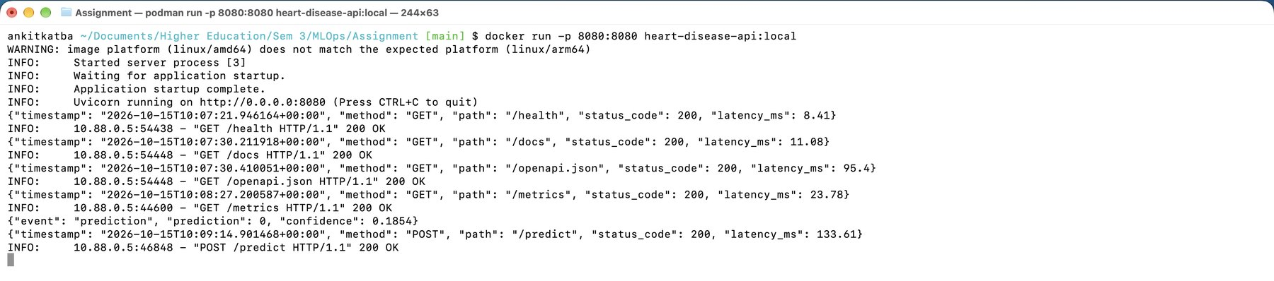
Figure 13 — Local container started with docker run; JSON request logs for /health, /docs, /metrics and /predict. [View Full Image ↗]
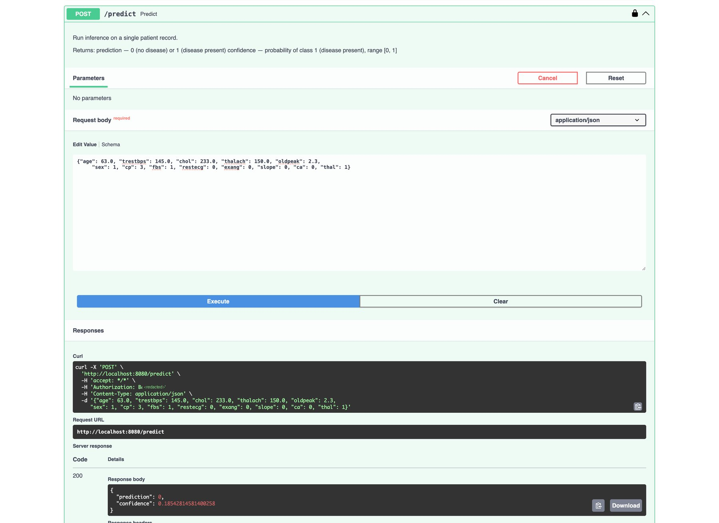
Figure 14 — Swagger UI POST /predict on the local container: HTTP 200 with prediction and confidence (Authorization header redacted). [View Full Image ↗]

8. Architecture Diagram
Figure 15 shows the end-to-end system, from developer commit to production monitoring. A push to main triggers GitHub Actions (lint → test → train). The ML pipeline (data → features → tuning → MLflow tracking → joblib pipeline + champion.txt) is packaged into a FastAPI Docker image, which is deployed to IBM Code Engine (public HTTPS) and to a local kind cluster behind Contour. Clients call /health, /predict and /metrics; request logs go to stdout and Prometheus metrics feed a Grafana Cloud dashboard.
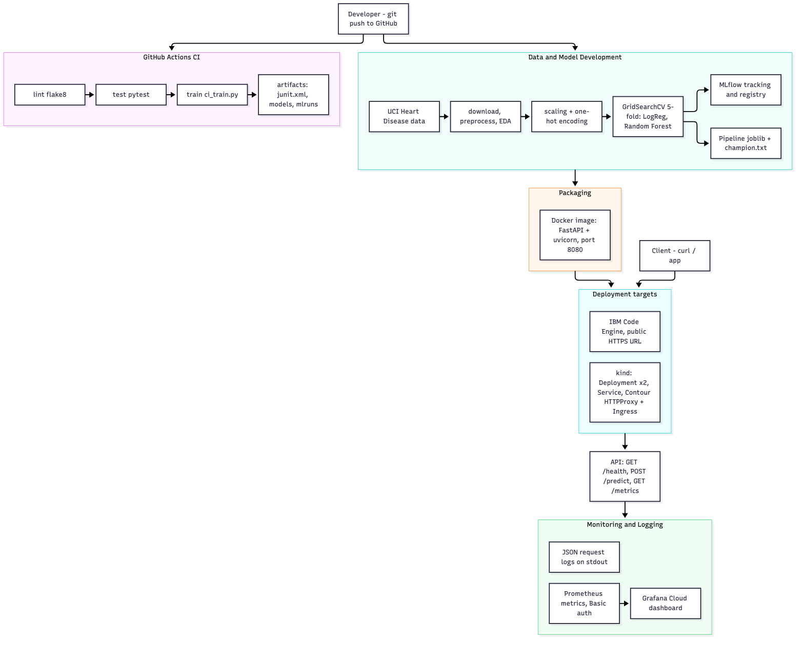
Figure 15 — End-to-end MLOps system architecture. [View Full Image ↗]

9. Deployment Workflow & Screenshots

9.1 Overview
The trained model is served through two deployment targets: a fully public cloud deployment on IBM Code Engine, and a local Kubernetes cluster created with kind and exposed through the Contour ingress controller.

9.2 IBM Code Engine (Public Cloud)
1. The Docker image is built locally and pushed to IBM Container Registry (icr.io).
2. A Code Engine application heart-disease-api is created from the image with port 8080 and the API_USERNAME / API_PASSWORD environment variables.
3. Code Engine provides a public HTTPS URL automatically: heart-disease-api.1s0uu8ax973i.us-south.codeengine.appdomain.cloud.
4. /health is open; /predict and /metrics require HTTP Basic authentication.
The application runs with 1 vCPU / 4 GB per instance, autoscaling between 0 and 1 instance, a target concurrency of 100 and a 300-second request timeout; revision heart-disease-api-00004 receives 100 % of the traffic (Figure 16, Figure 31). The live endpoint was verified with the Swagger UI (Figure 32) and a direct prediction request (Figure 17).
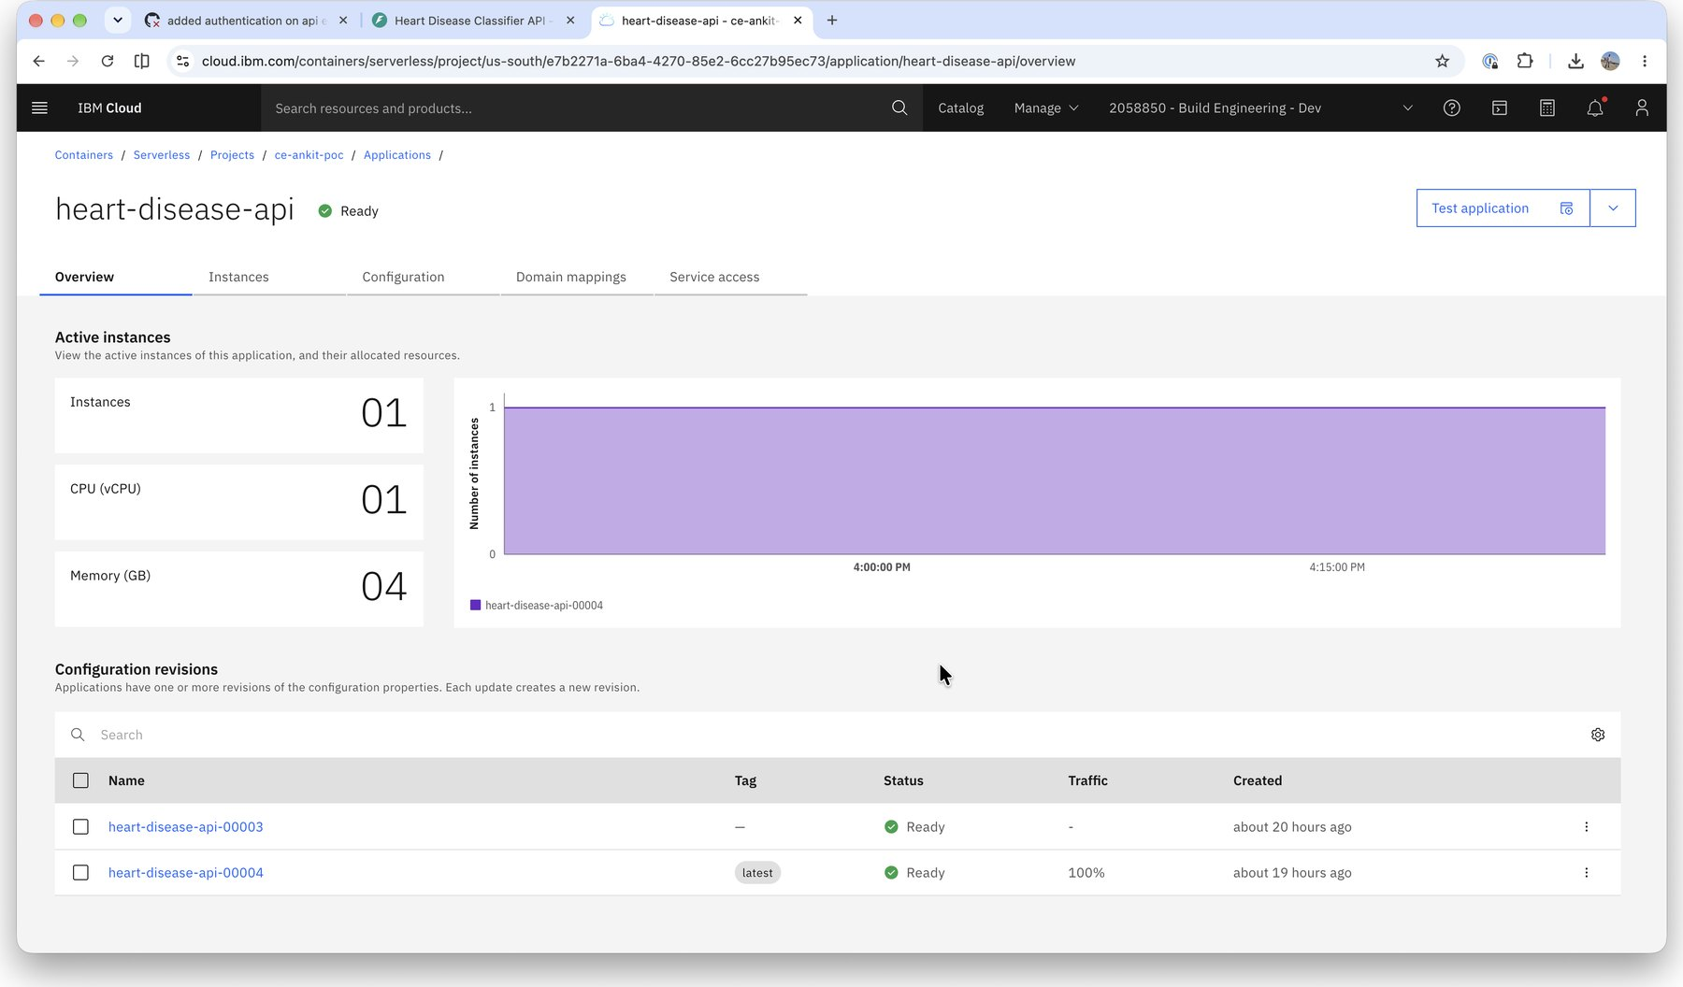
Figure 16 — IBM Code Engine application heart-disease-api — Ready; revision 00004 serves 100 % of traffic. [View Full Image ↗]

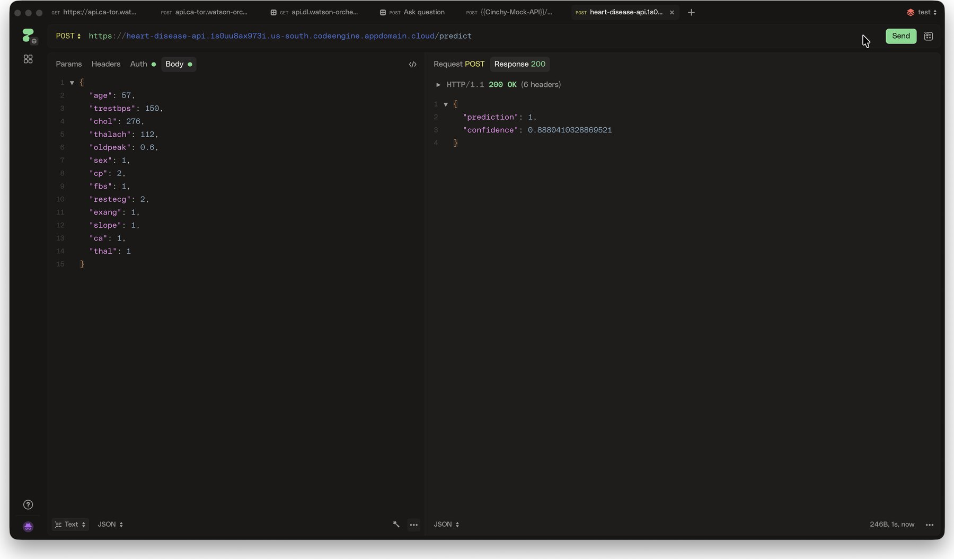
Figure 17 — Live POST /predict on the public Code Engine URL: HTTP 200, prediction 1, confidence 0.888. [View Full Image ↗]

9.3 Kubernetes — kind + Contour (Local)
The deployment/ directory contains a Kustomize-managed set of manifests (Table 11). They create the heart-disease namespace, a 2-replica Deployment with probes and resource limits, a ClusterIP Service, a Secret for the credentials and two ways of exposing the service externally: a Contour HTTPProxy and a standard Ingress.
Table 11 — Kubernetes manifests (deployment/).
File | Resource | Key settings
namespace.yaml | Namespace | heart-disease
deployment.yaml | Deployment | 2 replicas; RollingUpdate (maxSurge 1, maxUnavailable 0); startup, readiness and liveness probes on /health; CPU 100m–500m; memory 256Mi–512Mi
service.yaml | ClusterIP Service | Port 80 → container port 8080
secret.yaml | Secret | API_USERNAME, API_PASSWORD injected as environment variables
httpproxy.yaml | Contour HTTPProxy | Routes heart-disease.localtest.me to the Service
ingress.yaml | Ingress | Standard Kubernetes Ingress for heart-disease-ingress.localtest.me
kustomization.yaml | Kustomize root | Single-command apply: kubectl apply -k deployment/

9.4 Deployment Commands
# Build the image
podman build -t heart-disease-api:local .
# Load it into the kind cluster
podman save -o /tmp/heart-disease-api.tar localhost/heart-disease-api:local
kind load image-archive /tmp/heart-disease-api.tar --name heart-disease-mlops
# Apply the manifests
kubectl apply -k deployment/
kubectl -n heart-disease rollout status deployment/heart-disease-api
# Access via port-forward
kubectl -n heart-disease port-forward svc/heart-disease-api 8080:80
# Or via the Contour route (kind maps node port 80 -> host port 9090)
curl http://heart-disease.localtest.me:9090/health

Figure 18 and Figure 19 show the Deployment with 2/2 pods available and the two running pods. The Service, Ingress, Secret and cluster overview are in Appendix A (Figure 33 – Figure 36).[View Full Image ↗]
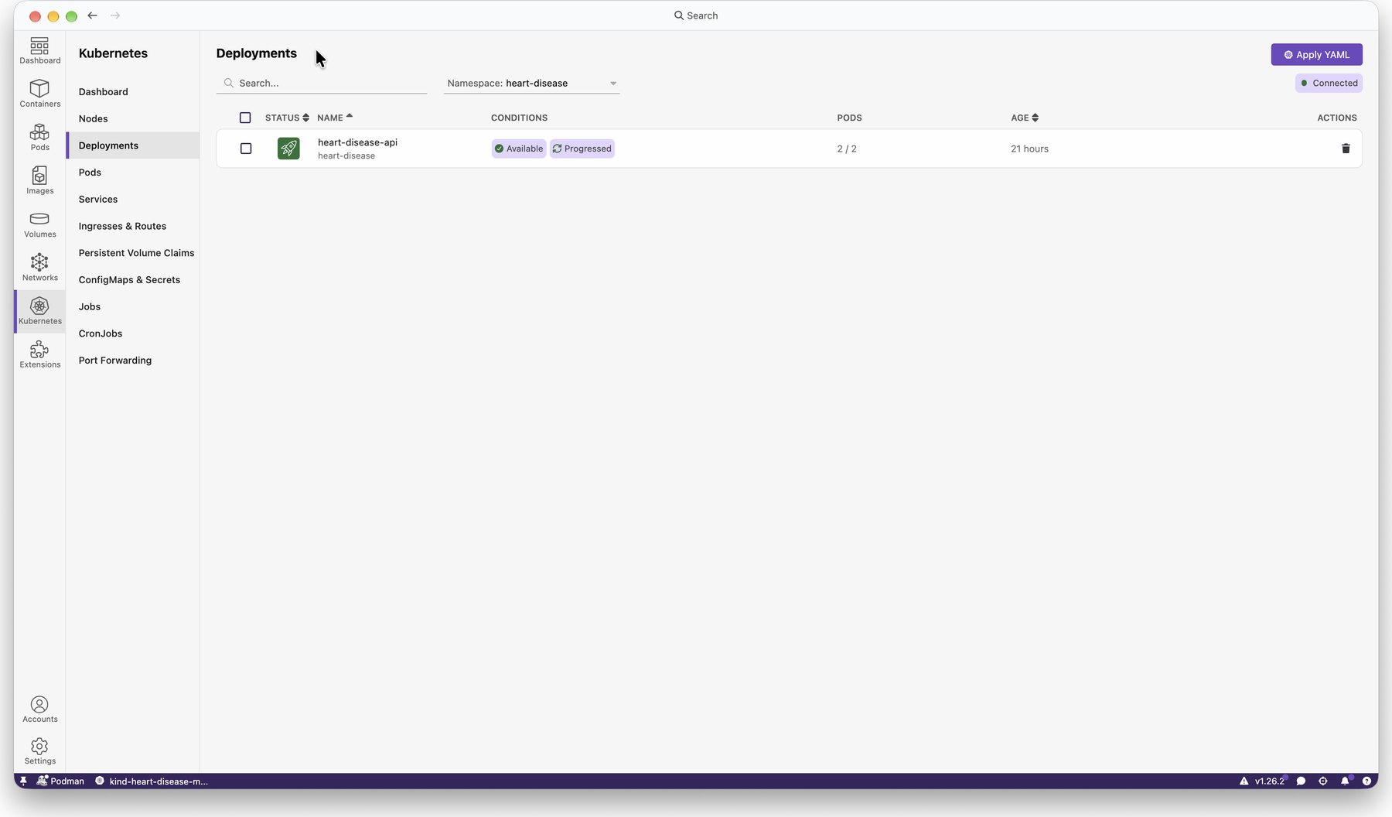  Figure 18 — Deployment heart-disease-api: 2/2 pods available. [View Full Image ↗] | 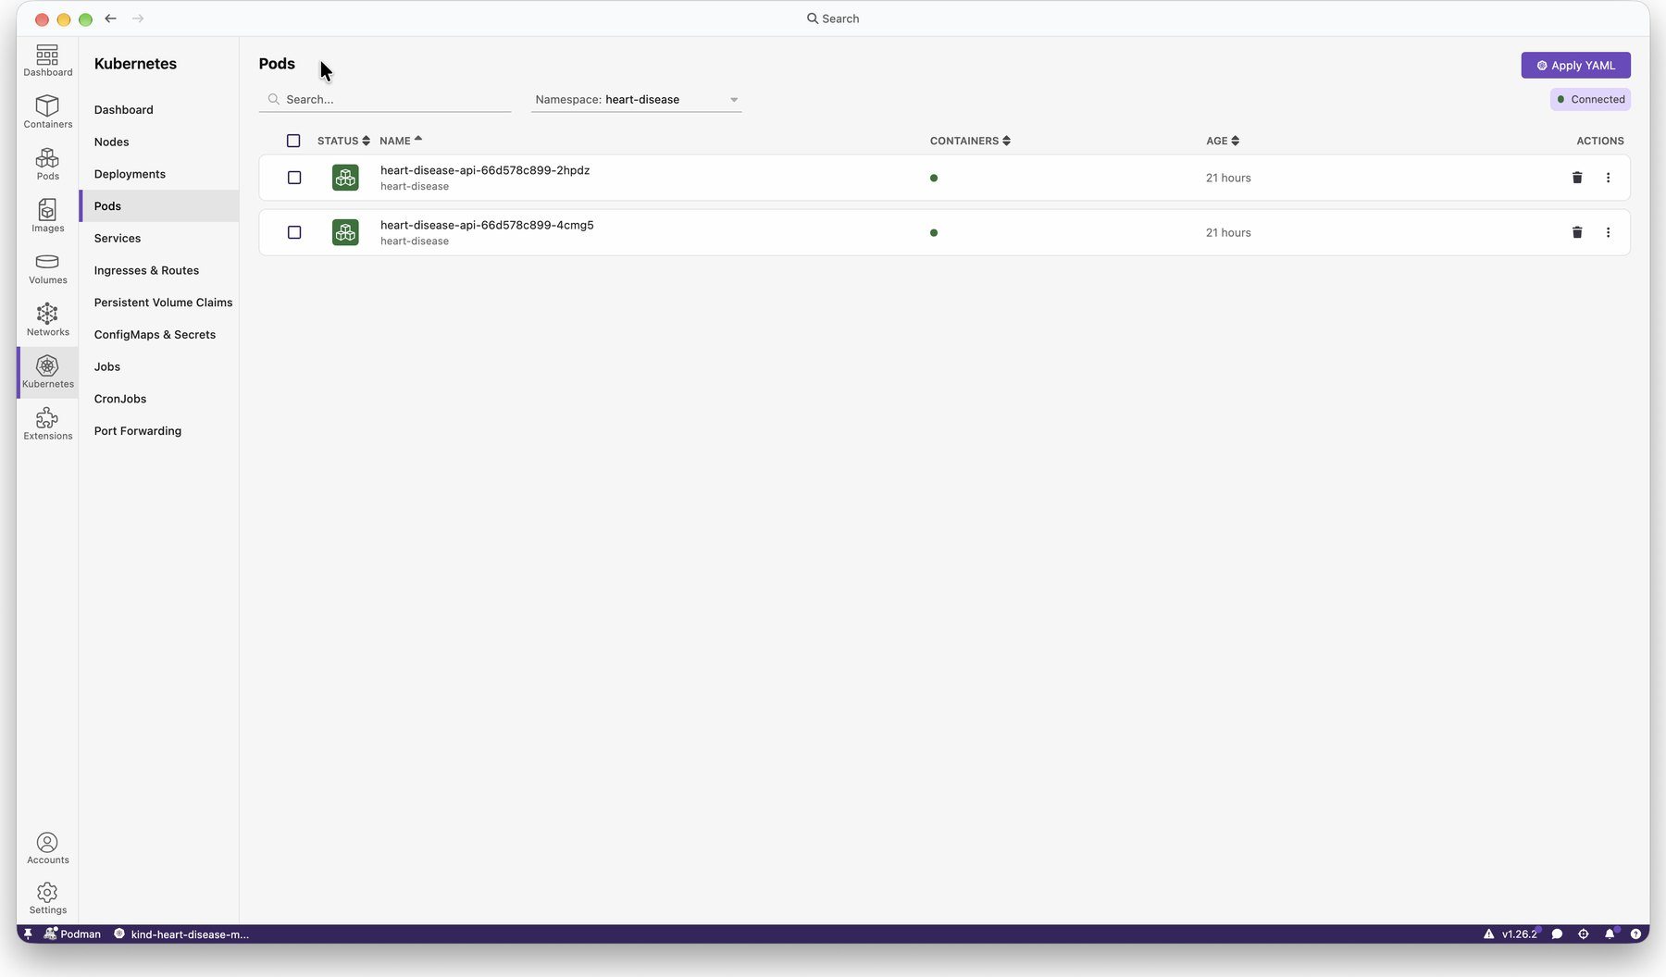  Figure 19 — Two running pods in namespace heart-disease. [View Full Image ↗]

10. Monitoring & Logging

10.1 Structured Request Logging
An ASGI middleware in src/api/app.py intercepts every HTTP request and emits one JSON line to stdout. Prediction events are additionally logged with the returned class and confidence (sample taken from Figure 13):
{"timestamp": "2026-10-15T10:07:30.211918+00:00", "method": "GET", "path": "/docs",
"status_code": 200, "latency_ms": 11.08}
{"event": "prediction", "prediction": 0, "confidence": 0.1854}

In Code Engine, stdout is collected by IBM Cloud Logs (Figure 37); in Kubernetes it is captured by the container runtime and can be read with kubectl logs.

10.2 Prometheus Metrics
prometheus-fastapi-instrumentator instruments all FastAPI routes. The /metrics endpoint (protected by HTTP Basic authentication so traffic data is not publicly exposed) returns the standard Prometheus text format (Figure 38). Key metrics:
- http_requests_total — counter by method, handler and status code.
- http_request_duration_seconds — latency histogram per handler and method.
- Default Python process and garbage-collector metrics.

10.3 Grafana Cloud Dashboard
A Grafana Cloud Metrics Endpoint integration scrapes the live API's /metrics endpoint every minute with Basic authentication (Figure 39). The Heart Disease API Dashboard (Figure 20) shows the success rate, requests per second, total requests, traffic by HTTP status and method, 95th-percentile latency, a latency heatmap, p50/p90/p99 latency and the 5xx error rate (no 5xx responses were recorded). scripts/populate_grafana.py generates synthetic /predict traffic — a mix of high- and low-risk patient payloads with jittered timing — so the dashboard shows a meaningful time series.
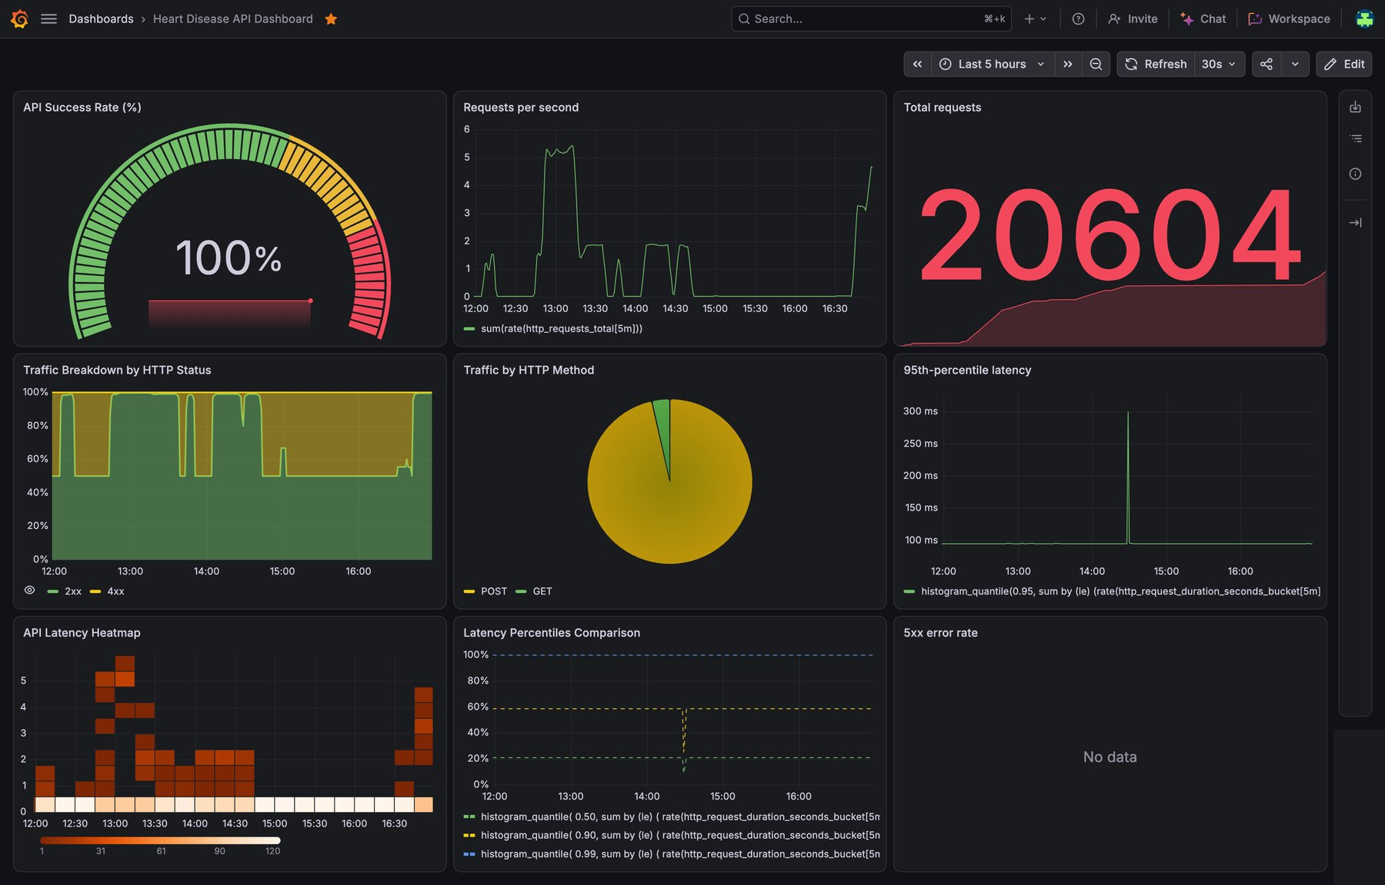
Figure 20 — Grafana Cloud dashboard "Heart Disease API Dashboard" (20,604 total requests; 100 % success rate). [View Full Image ↗]

Appendix A. Additional Evidence Screenshots
Supporting figures referenced from the sections above.

A.1 EDA and model evaluation
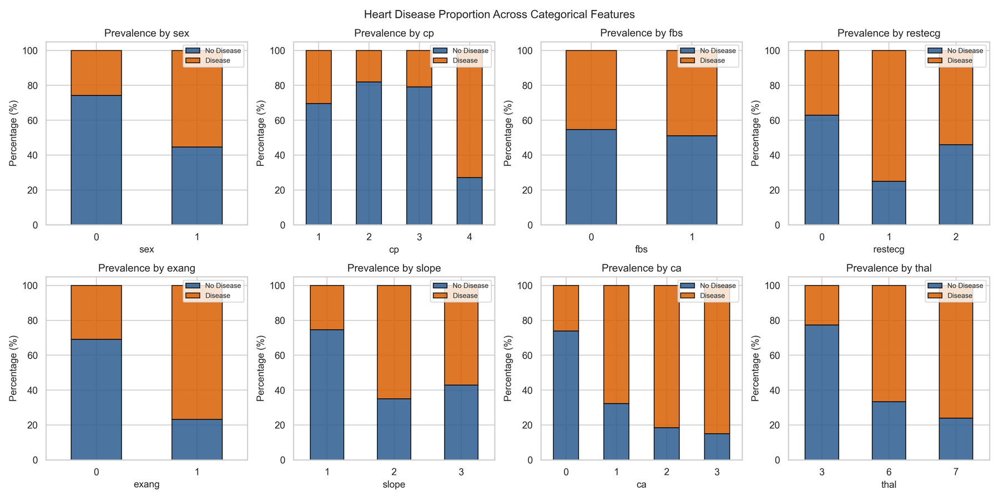
Figure 21 — Disease prevalence across the categorical features. [View Full Image ↗]
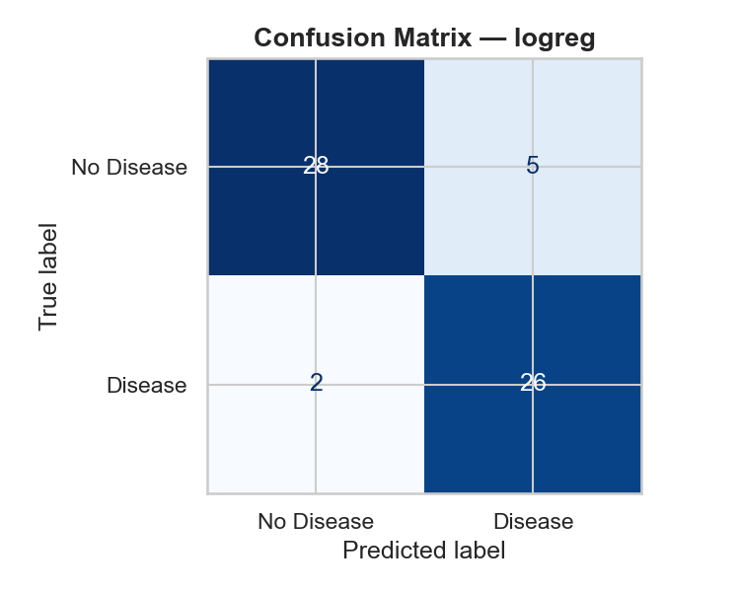  Figure 22 — Confusion matrix — Logistic Regression (test set). [View Full Image ↗] | 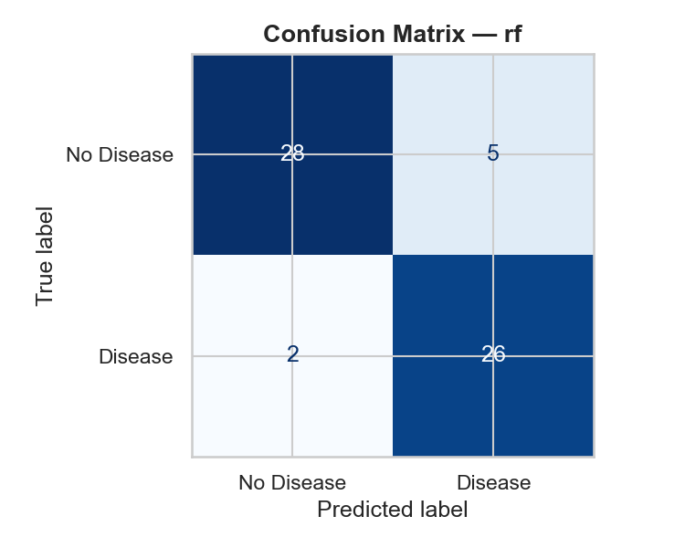  Figure 23 — Confusion matrix — Random Forest (test set). [View Full Image ↗]

A.2 Experiment tracking
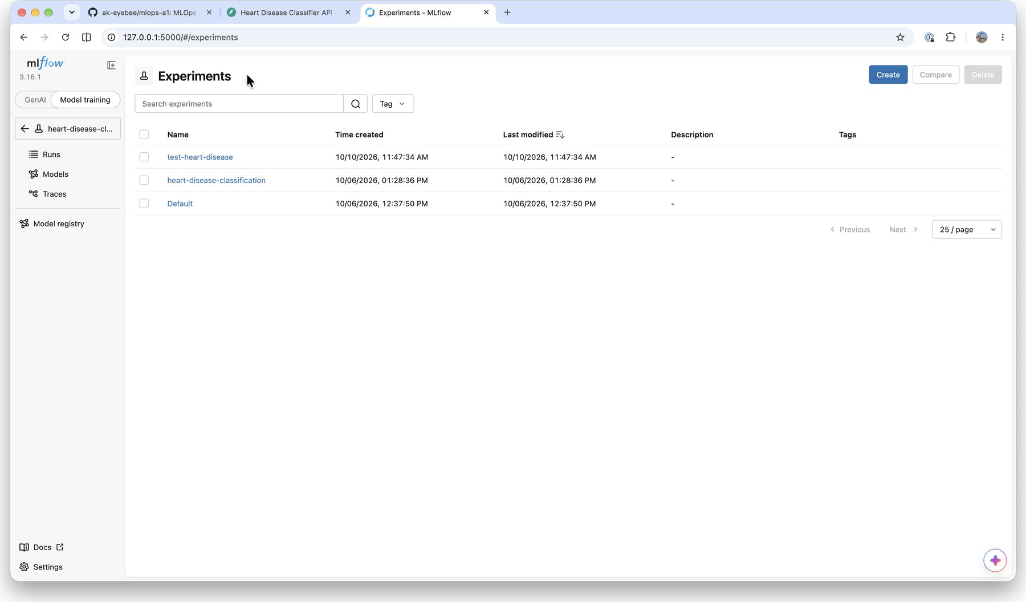  Figure 24 — MLflow Experiments list: heart-disease-classification and test-heart-disease (created by the unit tests). [View Full Image ↗] | 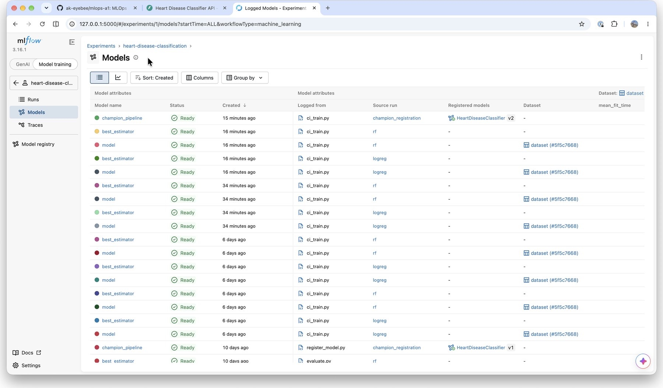  Figure 25 — Logged models of the experiment: per-run model and best_estimator, and the registered champion_pipeline. [View Full Image ↗]

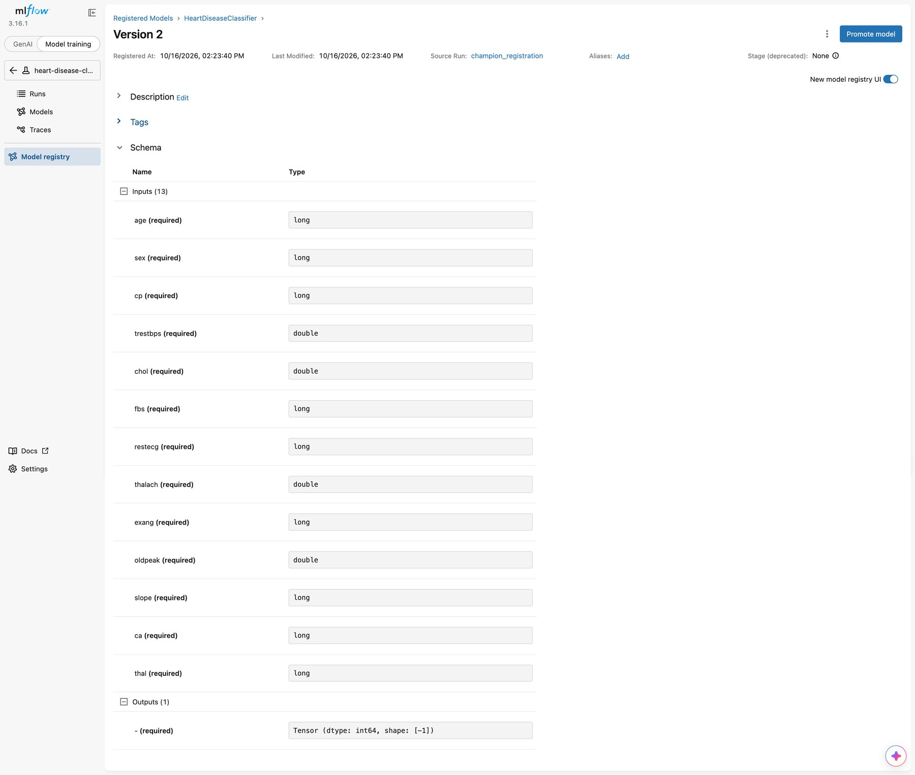
Figure 26 — Registered model Version 2: input/output signature (13 inputs, 1 output). [View Full Image ↗]

A.3 Container and API
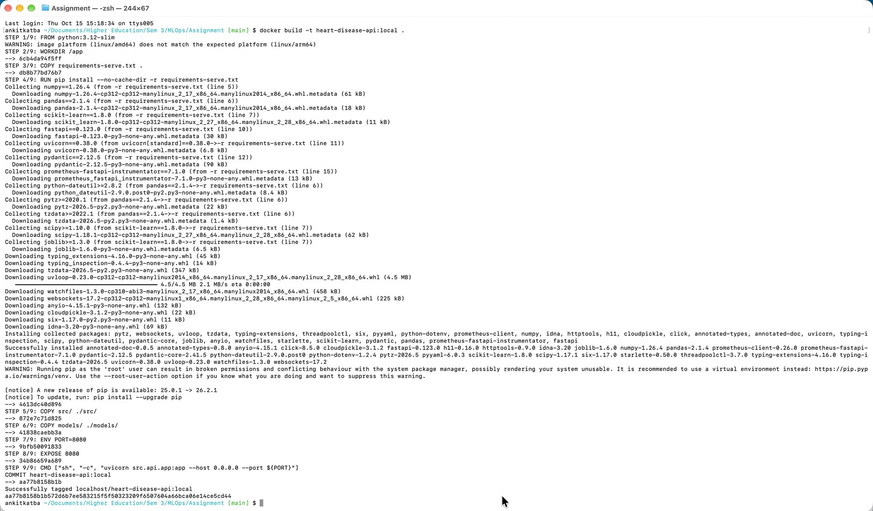  Figure 27 — docker build -t heart-disease-api:local . completing successfully. [View Full Image ↗] | 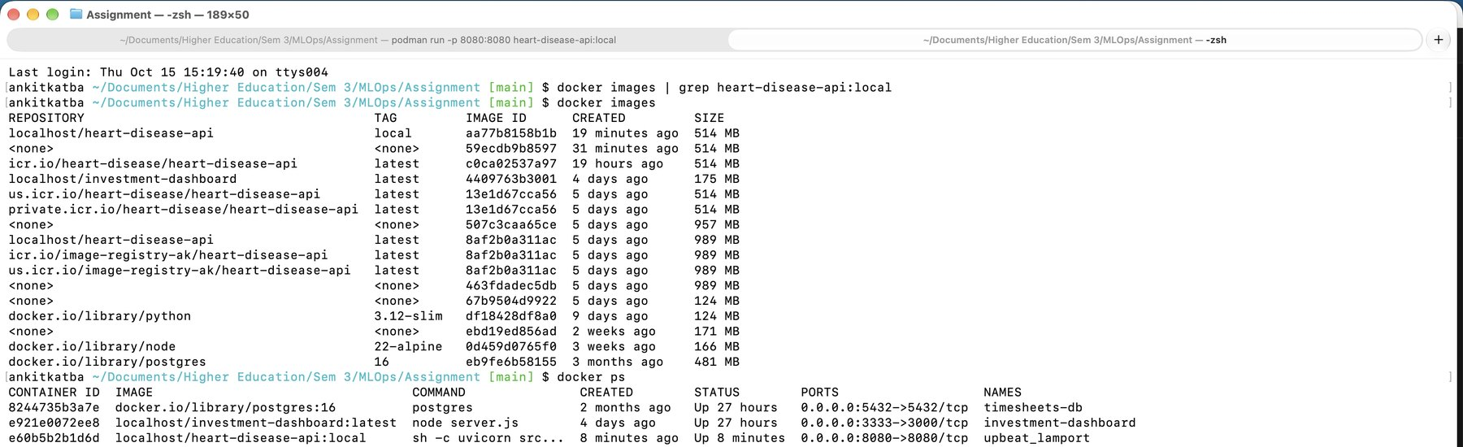  Figure 28 — docker images and docker ps: the 514 MB image and the running container on port 8080. [View Full Image ↗]

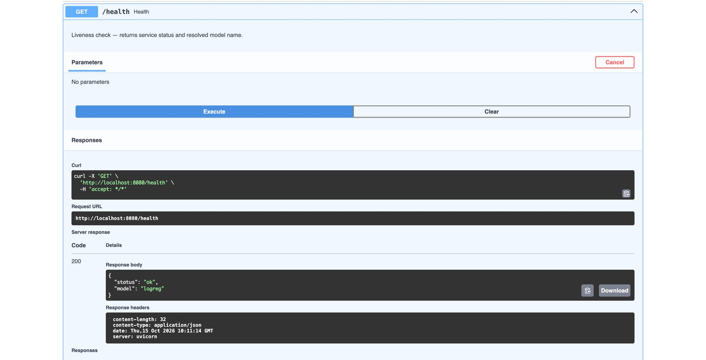  Figure 29 — Swagger UI GET /health on the local container (HTTP 200). [View Full Image ↗] | 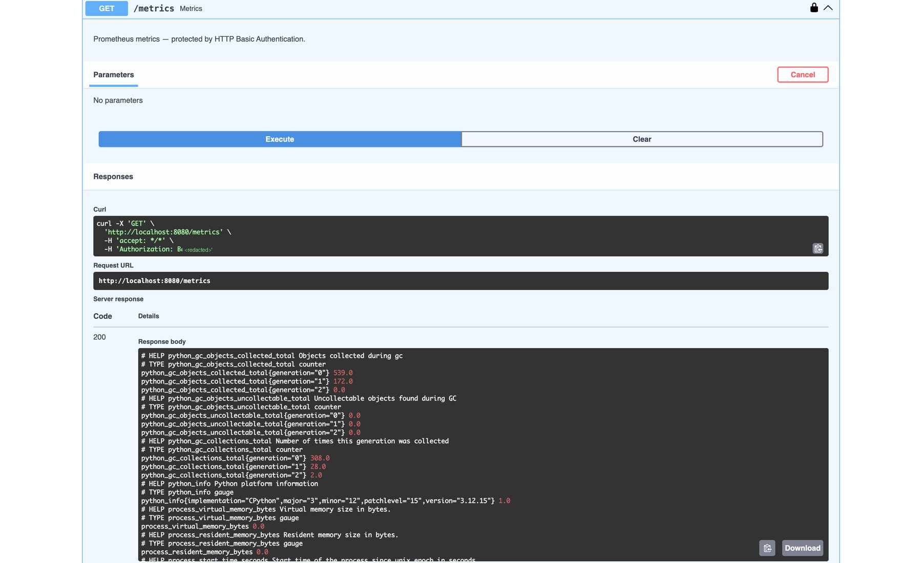  Figure 30 — Swagger UI GET /metrics (Basic auth, header redacted): Prometheus text output. [View Full Image ↗]

A.4 Cloud deployment
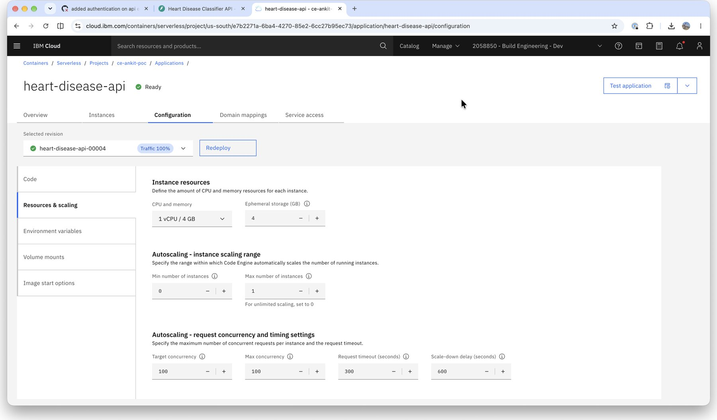  Figure 31 — Code Engine configuration: 1 vCPU / 4 GB, 0–1 instances, concurrency 100, 300 s timeout. [View Full Image ↗] | 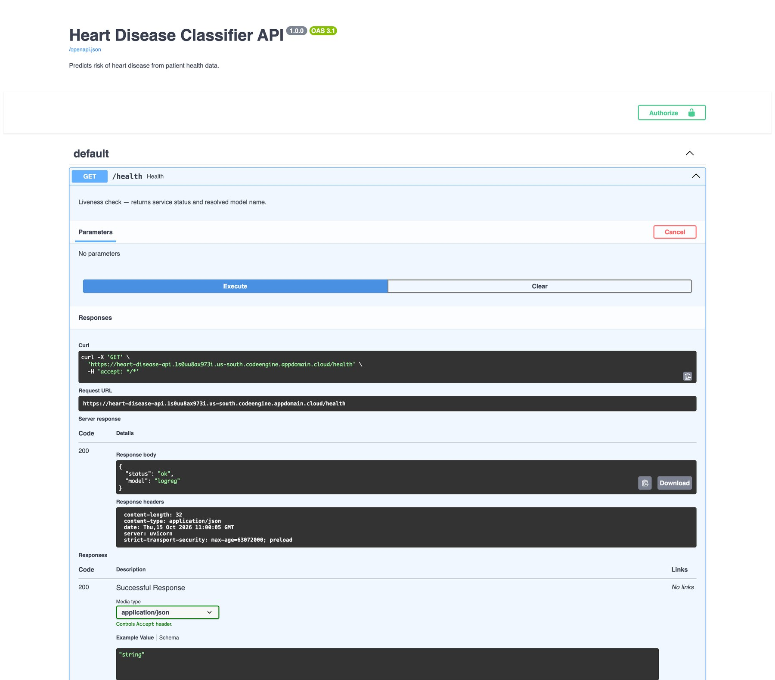  Figure 32 — Swagger UI on the public URL: GET /health returns {"status":"ok","model":"logreg"}. [View Full Image ↗]

A.5 Local Kubernetes
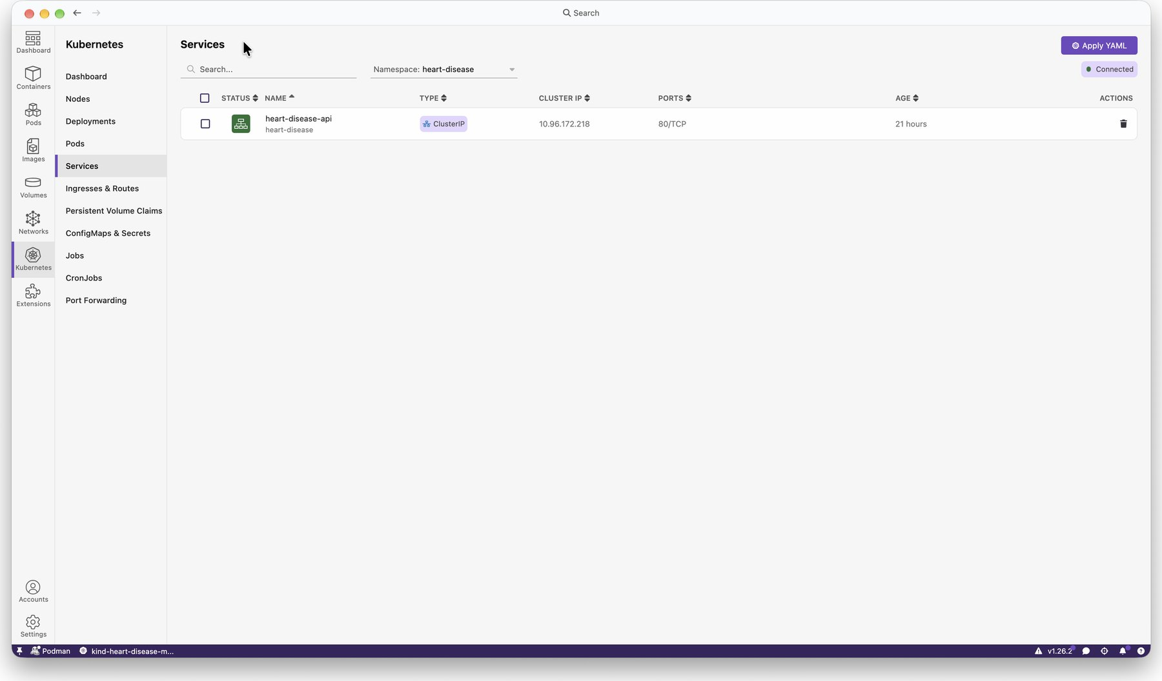  Figure 33 — ClusterIP Service heart-disease-api (80/TCP). [View Full Image ↗] | 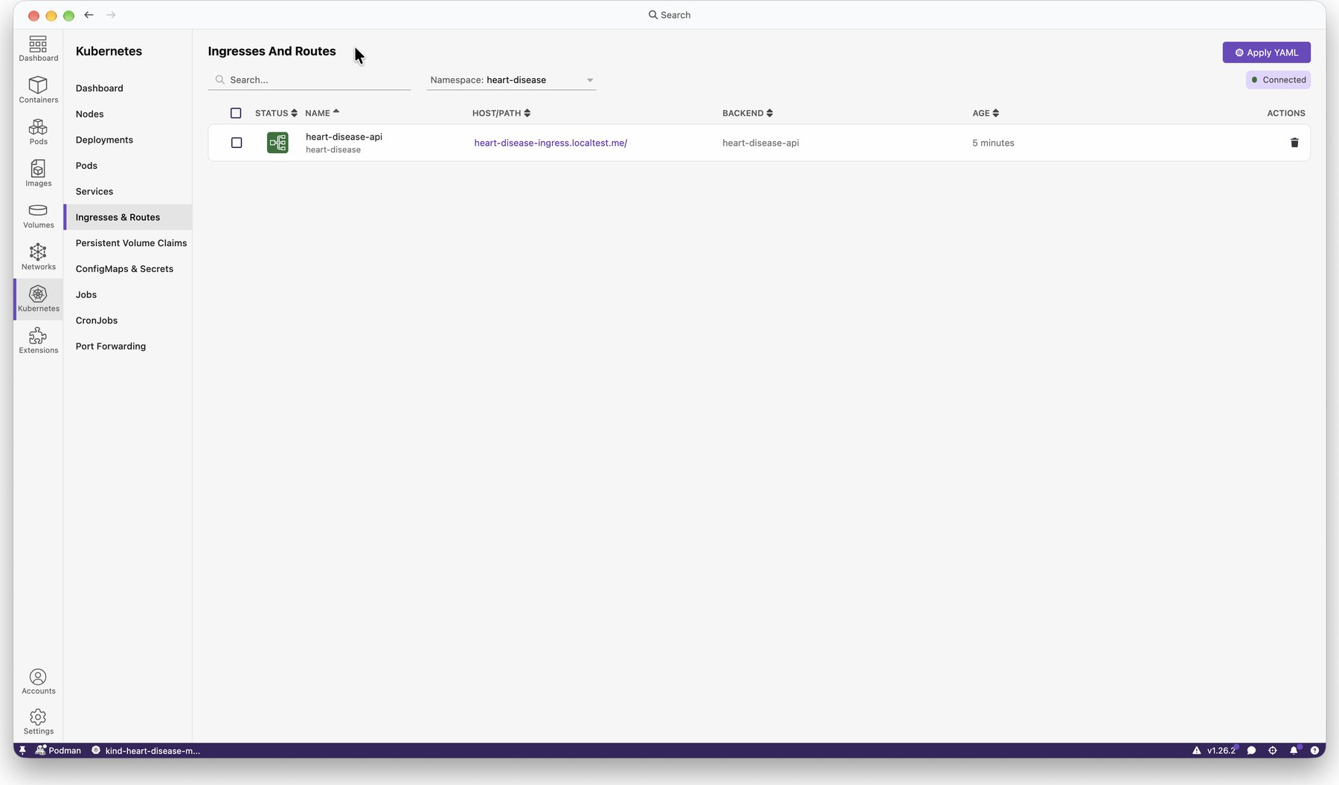  Figure 34 — Ingress for heart-disease-ingress.localtest.me. [View Full Image ↗]

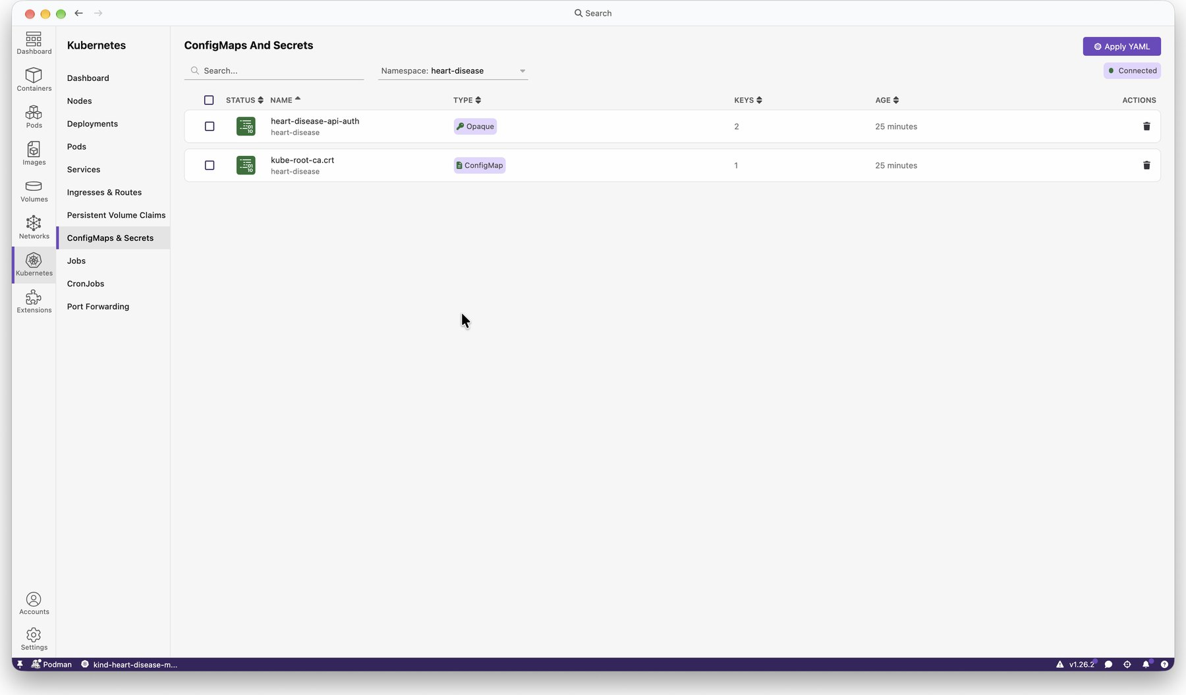  Figure 35 — Secret heart-disease-api-auth (Opaque, 2 keys). [View Full Image ↗] | 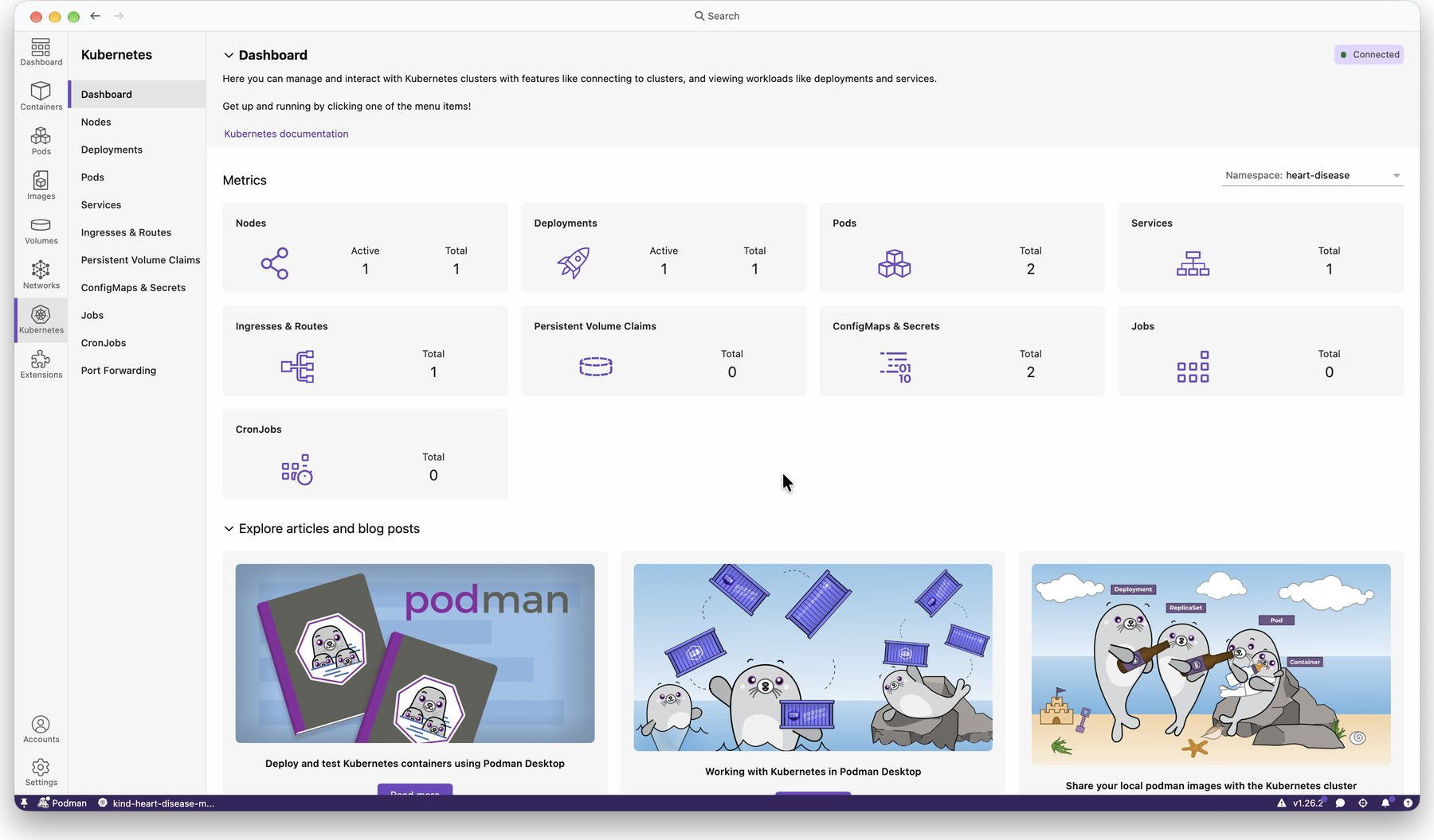  Figure 36 — Cluster overview: 1 node, 1 deployment, 2 pods, 1 service, 1 ingress. [View Full Image ↗]

A.6 Monitoring and logging
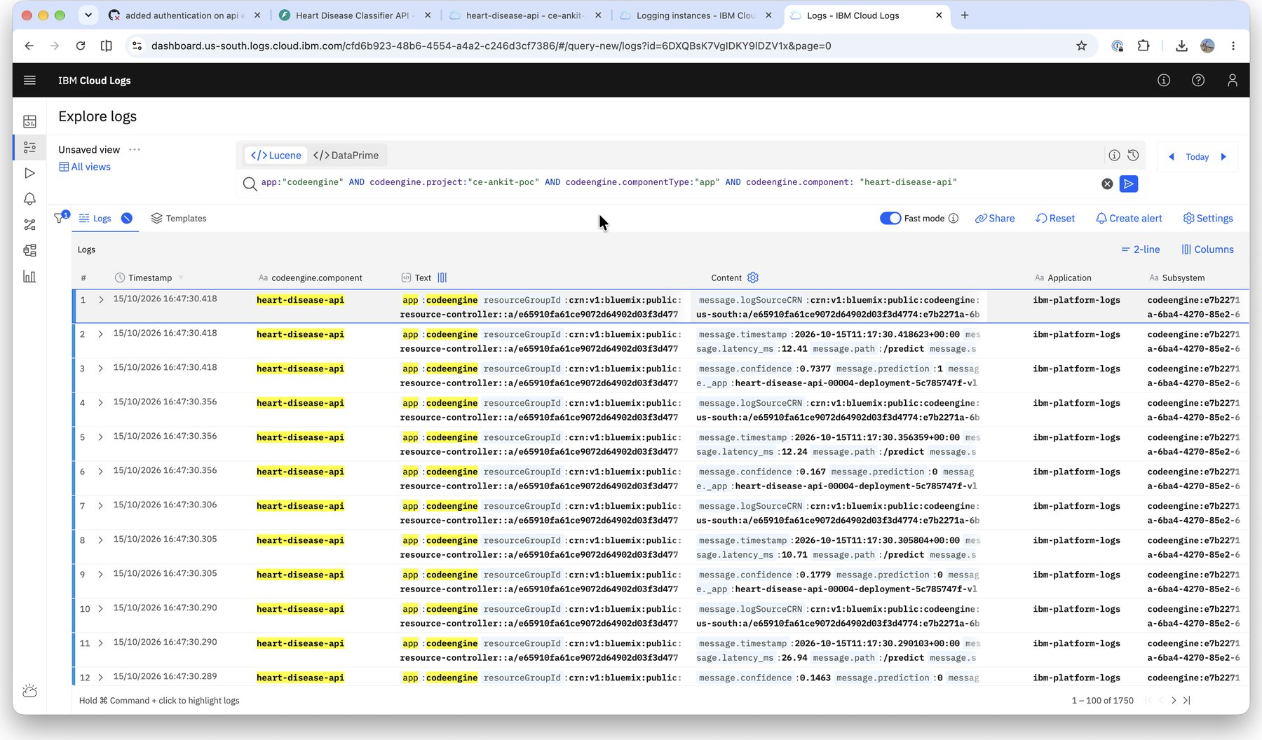  Figure 37 — IBM Cloud Logs: JSON request and prediction log lines from the Code Engine application. [View Full Image ↗] | 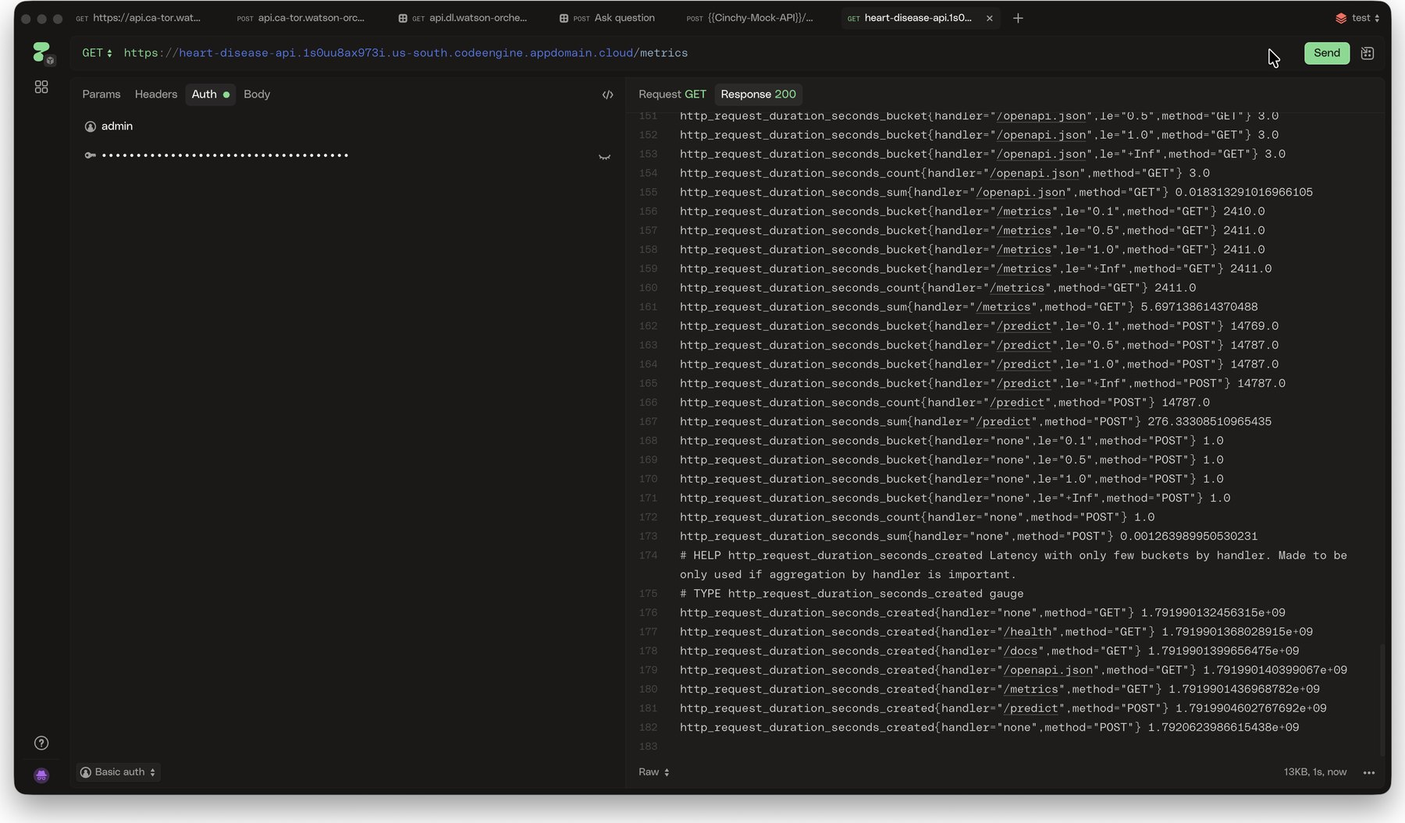  Figure 38 — Live GET /metrics response (HTTP 200, Basic auth) with per-handler latency histograms. [View Full Image ↗]

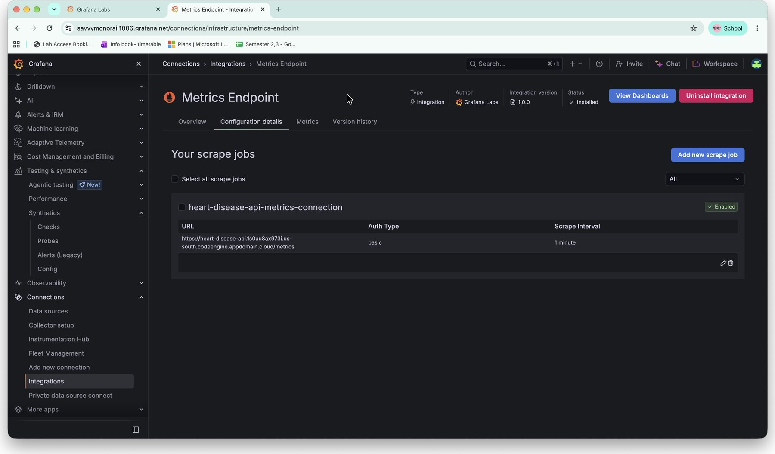
Figure 39 — Grafana Cloud Metrics Endpoint integration: scrape job for the live /metrics URL (Basic auth, 1-minute interval). [View Full Image ↗]

— End of Report —

