Project Report: End-to-End MLOps Solution for Heart Disease Classification
Student Name: Patel Zeel Dharmendrakumar
BITS ID: 2025AE05289
Course: AIMLZG523 MLOps
Repository: https://github.com/2025AE05289/MLOps-assignment-1
Recorded Video: Assignment-1-video
Executive Summary
This report documents the design, development, experiment tracking, continuous integration, containerization, cloud deployment, and real-time observability of a production-grade Machine Learning Operations (MLOps) solution. Built using the UCI Heart Disease Dataset, the solution automates the full machine learning lifecycle from raw data acquisition to a resilient, autoscaling cloud inference service on Azure Kubernetes Service (AKS).

1. Setup and Installation Guide

1.1 Prerequisites
- Python 3.11 or above
- Git
- Docker or Podman (container build and run)
- Kubectl
- Make
1.2 Local Pipeline Execution
# 1. Clone the repository
git clone https://github.com/2025AE05289/MLOps-assignment-1.git
cd MLOps-assignment-1
# 2. Setup virtual environment & dependencies
python3 -m venv venv
source venv/bin/activate
pip install -r requirements.txt
# 3. Run complete pipeline (data -> eda -> train -> lint -> test)
make pipeline
# 4. Start local services
make serve # Runs FastAPI server on http://localhost:8000
make monitoring # Runs Prometheus (9090) and Grafana (3000) stack
make mlflow # Runs MLflow UI on http://localhost:5001
2. Data Acquisition & Exploratory Data Analysis (EDA)
2.1 Dataset Description
The pipeline uses the UCI Heart Disease Dataset (Cleveland database, UCIMLRepo ID: 45) comprising 303 patient records and 14 clinical features:
Feature | Description | Type | Values / Clinical Units
age | Patient age | Numerical | 29 – 77 years
sex | Biological sex | Categorical | 1 = Male, 0 = Female
cp | Chest pain type | Categorical | 1: Typical Angina, 2: Atypical, 3: Non-anginal, 4: Asymptomatic
trestbps | Resting blood pressure | Numerical | 94 – 200 mm Hg
chol | Serum cholesterol | Numerical | 126 – 564 mg/dl
fbs | Fasting blood sugar > 120 mg/dl | Categorical | 1 = True, 0 = False
restecg | Resting ECG results | Categorical | 0: Normal, 1: ST-T wave abnormality, 2: LV hypertrophy
thalach | Maximum heart rate achieved | Numerical | 71 – 202 bpm
exang | Exercise-induced angina | Categorical | 1 = Yes, 0 = No
oldpeak | ST depression induced by exercise | Numerical | 0.0 – 6.2 mm
slope | Slope of peak exercise ST segment | Categorical | 1: Upsloping, 2: Flat, 3: Downsloping
ca | Number of major vessels colored by fluoroscopy | Categorical | 0 – 3
thal | Thallium heart rate stress test | Categorical | 3: Normal, 6: Fixed defect, 7: Reversible defect
num | Target diagnosis of heart disease | Target | 0 (No Disease) to 4 (Severe Disease)
3.2 Data Preprocessing & Cleaning Pipeline
Implemented in `src/data_preprocessing.py`:
- Automated Acquisition: Script `data/download_data.py` fetches directly from the UCI repository using ucimlrepo (with HTTP fallback to the raw Cleveland repository) and saves the raw CSV to data/raw/heart_disease.csv.
- Missing Value Imputation:
- ca contained 4 missing values (1.3%).
- thal contained 2 missing values (0.7%).
- Because missingness is <2\% and features are discrete categories, values were imputed using their statistical mode (ca_mode = 0.0, thal_mode = 3.0), avoiding sample loss.
- Target Binarization:
- Original target num ranges from 0 (absence) to 1, 2, 3, 4 (stages of disease).
- Following clinical standards and assignment requirements, the target was binarized:
- Class 0 (No Disease): num == 0 (164 samples, 54.1%)
- Class 1 (Disease Present): num > 0 (139 samples, 45.9%)
- Class Balance: The dataset is balanced (54.1% vs 45.9%), eliminating the need for synthetic oversampling (e.g., SMOTE) while motivating stratified sampling for cross-validation splits.
3.3 Exploratory Data Analysis & Clinical Insights
Implemented in `src/eda.py`, generating 6 publication-quality figures saved to output/figures/:
- Target Distribution : Confirms balanced binary classes (164 healthy vs 139 diseased).
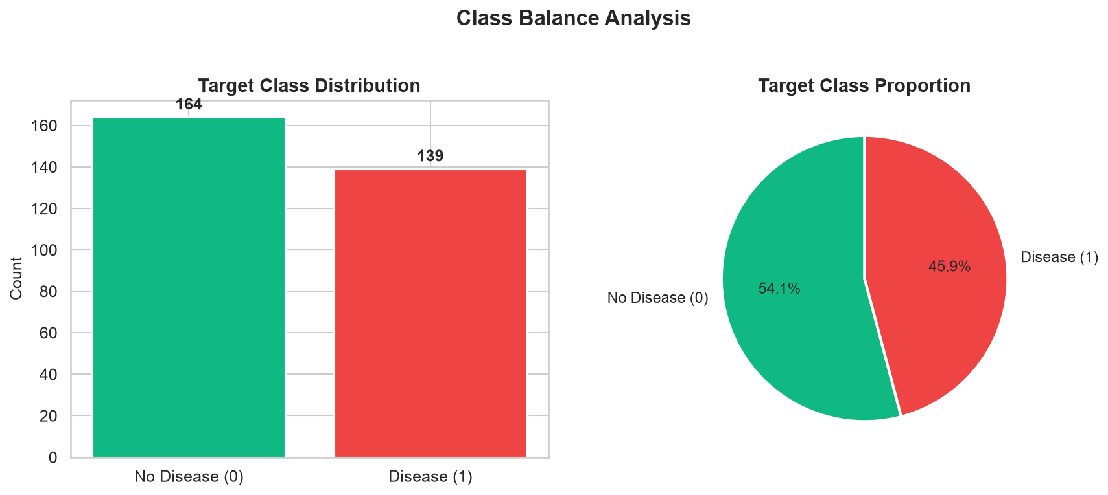
- Numerical Histograms: Highlights near-Gaussian distributions for age, trestbps, and chol, with right-skewed oldpeak and left-skewed thalach.
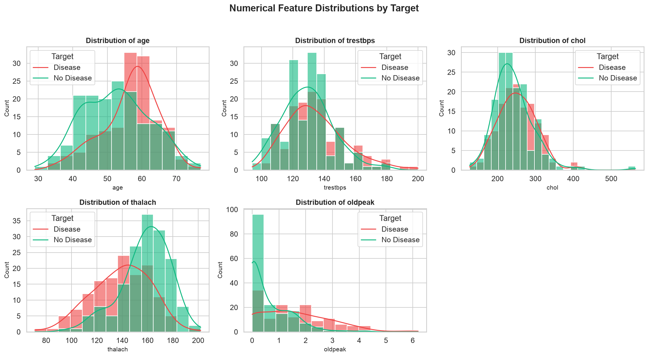
- Correlation Heatmap (`03_correlation_heatmap.png`): Shows strong positive correlation between heart disease and oldpeak (r = +0.42), ca (r = +0.46), and thal (r = +0.52), and strong negative correlation with thalach (r = -0.42).
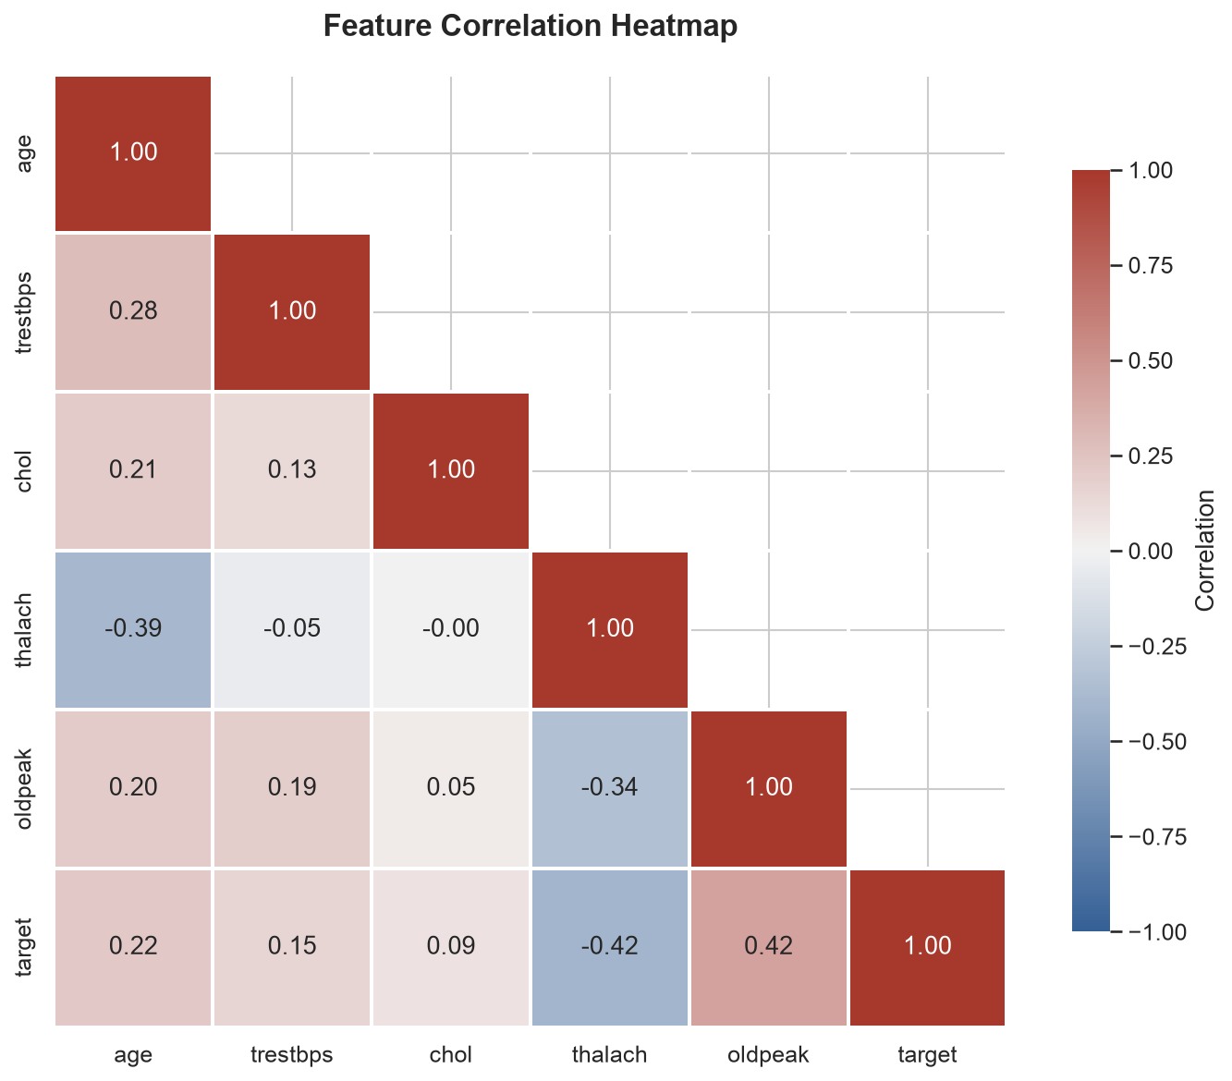
- Boxplots by Target (`04_boxplots_by_target.png`): Confirms patients with heart disease have significantly lower maximum heart rate (thalach) and higher exercise ST depression (oldpeak).
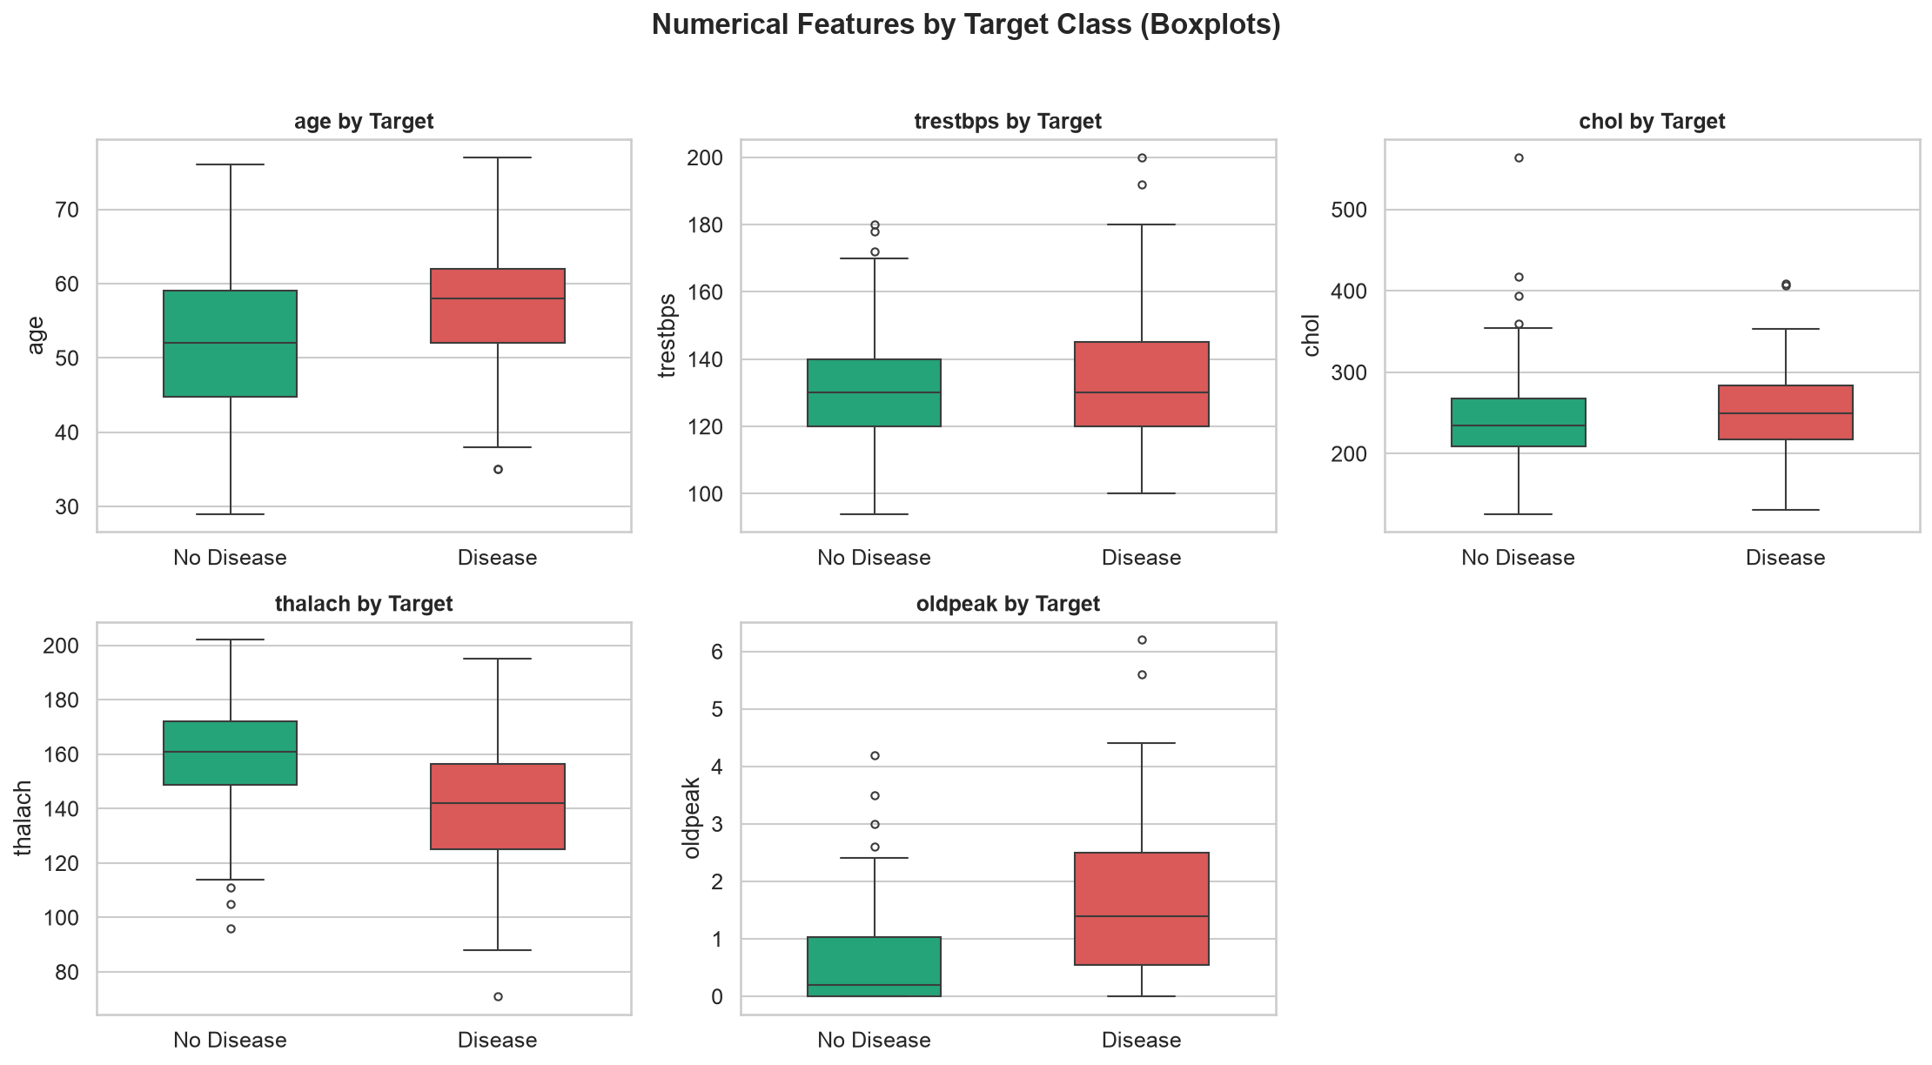
- Categorical Distributions: Reveals that asymptomatic chest pain (cp=4) and exercise-induced angina (exang=1) are primary risk indicators.
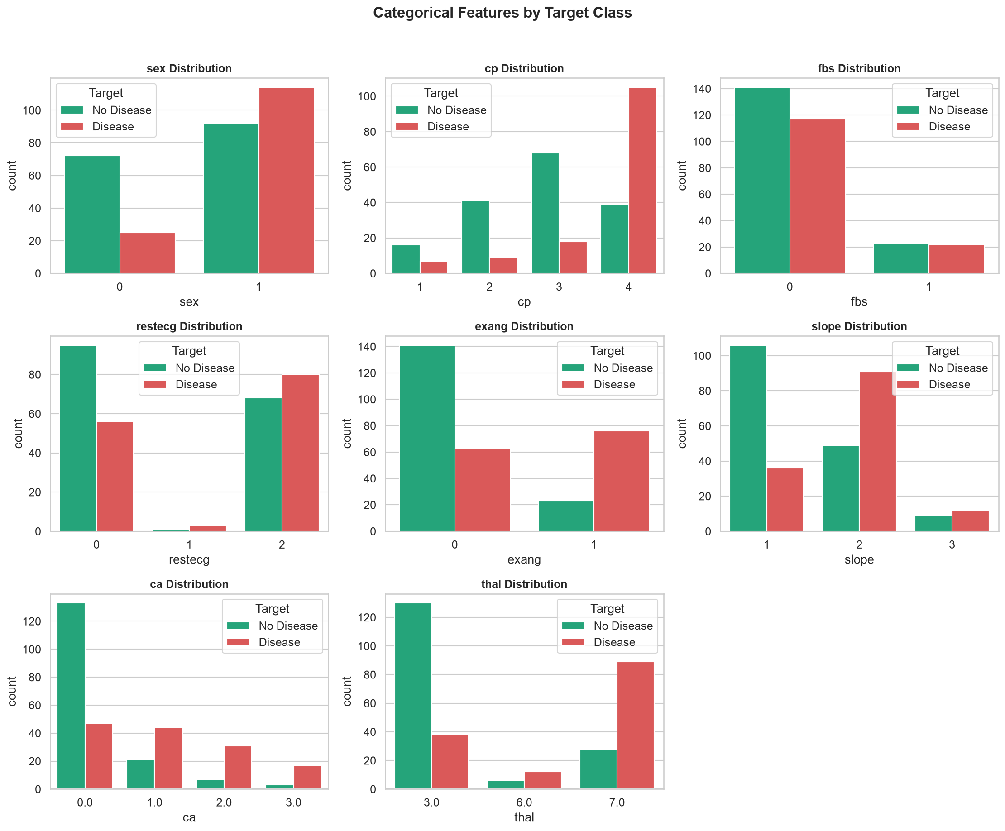
- Pairplot Matrix: Demonstrates multi-dimensional separation between patient cohorts along combinations of thalach, oldpeak, and age.
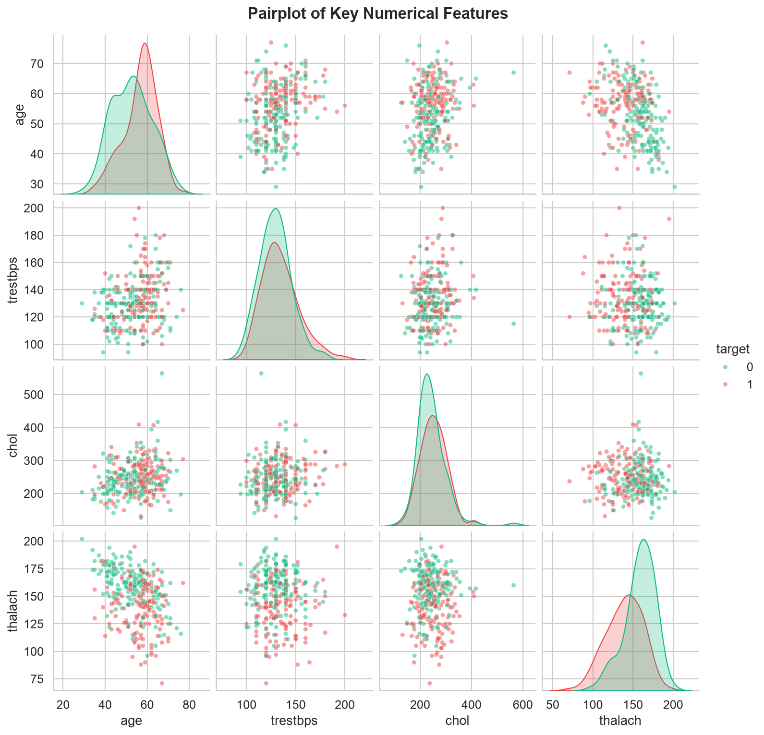
4. Feature Engineering & Model Selection
4.1 Feature Engineering Architecture
Implemented in `src/feature_engineering.py`:
- Numerical Sub-Pipeline: Median imputation followed by StandardScaler() applied to all 5 continuous variables (age, trestbps, chol, thalach, oldpeak) to zero-center features and scale variance to 1.
- Categorical Sub-Pipeline: Mode imputation followed by OneHotEncoder(drop='first', handle_unknown='ignore', sparse_output=False) applied to all 8 discrete features (sex, cp, fbs, restecg, exang, slope, ca, thal), generating 20 encoded binary columns.
- Pipeline Integration: Assembled into a Scikit-Learn ColumnTransformer. The transformer is fitted strictly on X_{train} and applied to X_{test}, preventing train-test data leakage.
4.2 Model Exploration & Selection
Two classification algorithms were trained in `src/train.py`:
- Logistic Regression (Linear Benchmark):
- Hyperparameters: C=1.0, solver='lbfgs', penalty='l2', max_iter=1000, random_state=42.
- Rationale: High interpretability, well-calibrated confidence probabilities, convex optimization, and robustness against overfitting on smaller clinical cohorts (N=303).
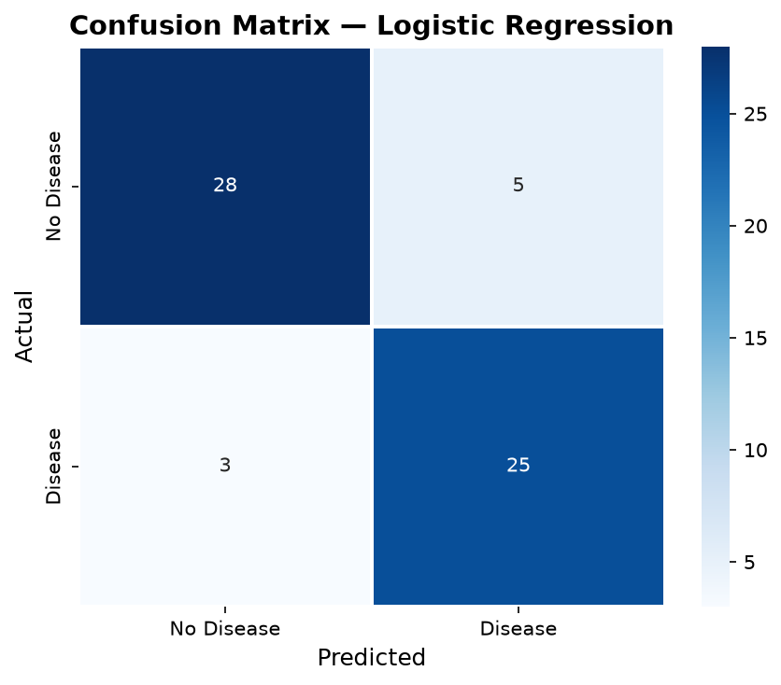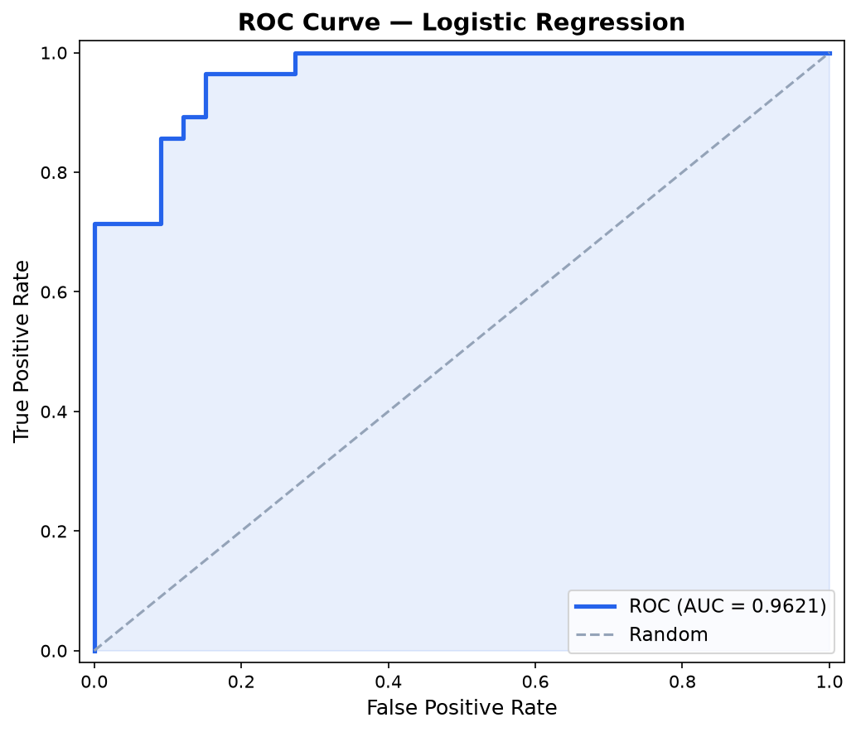
- Random Forest Classifier (Ensemble Benchmark):
- Hyperparameters: n_estimators=100, criterion='gini', max_depth=None, random_state=42.
- Rationale: Non-parametric tree ensemble capable of capturing non-linear interactions without manual feature interaction engineering.
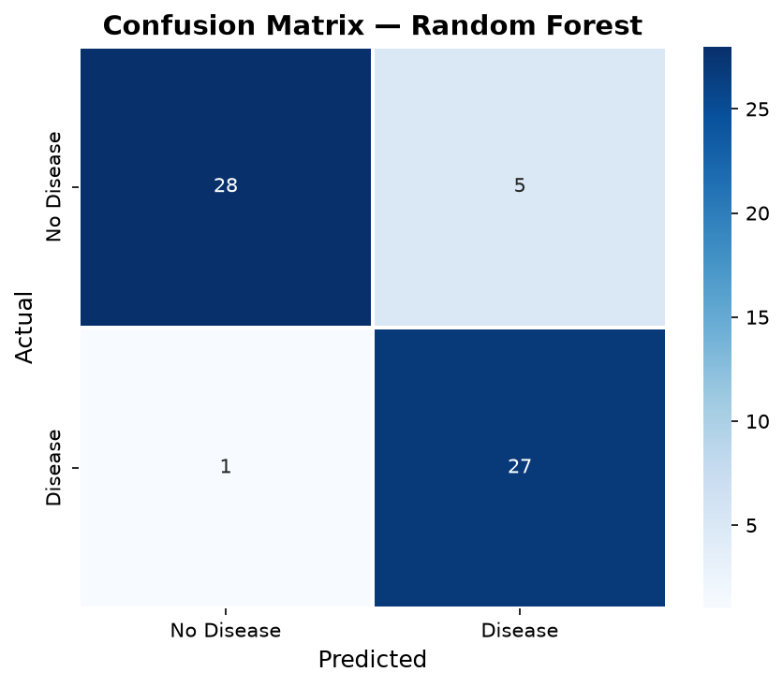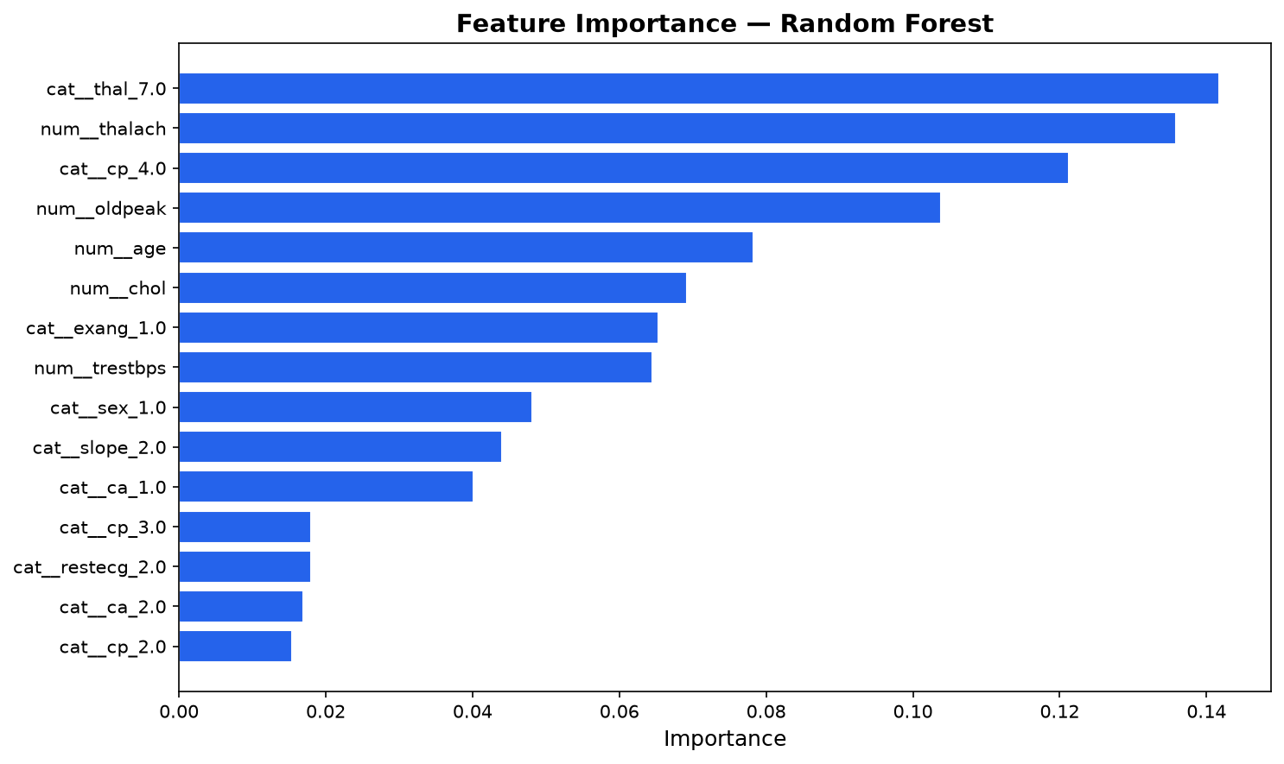
4.3 Validation Protocol & Comparative Results
Evaluated using 5-Fold Stratified Cross-Validation on the training partition (N=242) and final validation on a held-out test partition (N=61, 20% stratified):
Evaluation Metric | Logistic Regression (5-Fold CV) | Logistic Regression (Test Set) | Random Forest (5-Fold CV) | Random Forest (Test Set)
Accuracy | 0.8429 ± 0.0168 | 0.8689 | 0.8016 ± 0.0215 | 0.9016
Precision | 0.8658 ± 0.0680 | 0.8333 | 0.8045 ± 0.0435 | 0.8438
Recall (Sensitivity) | 0.7921 ± 0.0751 | 0.8929 | 0.7561 ± 0.0633 | 0.9643
F1-Score | 0.8214 ± 0.0215 | 0.8621 | 0.7767 ± 0.0284 | 0.9000
ROC-AUC | 0.9018 ± 0.0172 | 0.9621 | 0.8828 ± 0.0251 | 0.9481

4.4 Champion Model Selection
Logistic Regression was selected as the Champion Model for production serving:
- Superior Generalization & Discrimination: Higher Cross-Validation ROC-AUC (0.9018 vs 0.8828) and Test ROC-AUC (0.9621 vs 0.9481).
- Cross-Validation Stability: Lower variance across folds (Accuracy variance ±0.0168 vs ±0.0215).
- Clinical Interpretability: Naturally calibrated confidence scores, essential for medical decision support and threshold tuning.
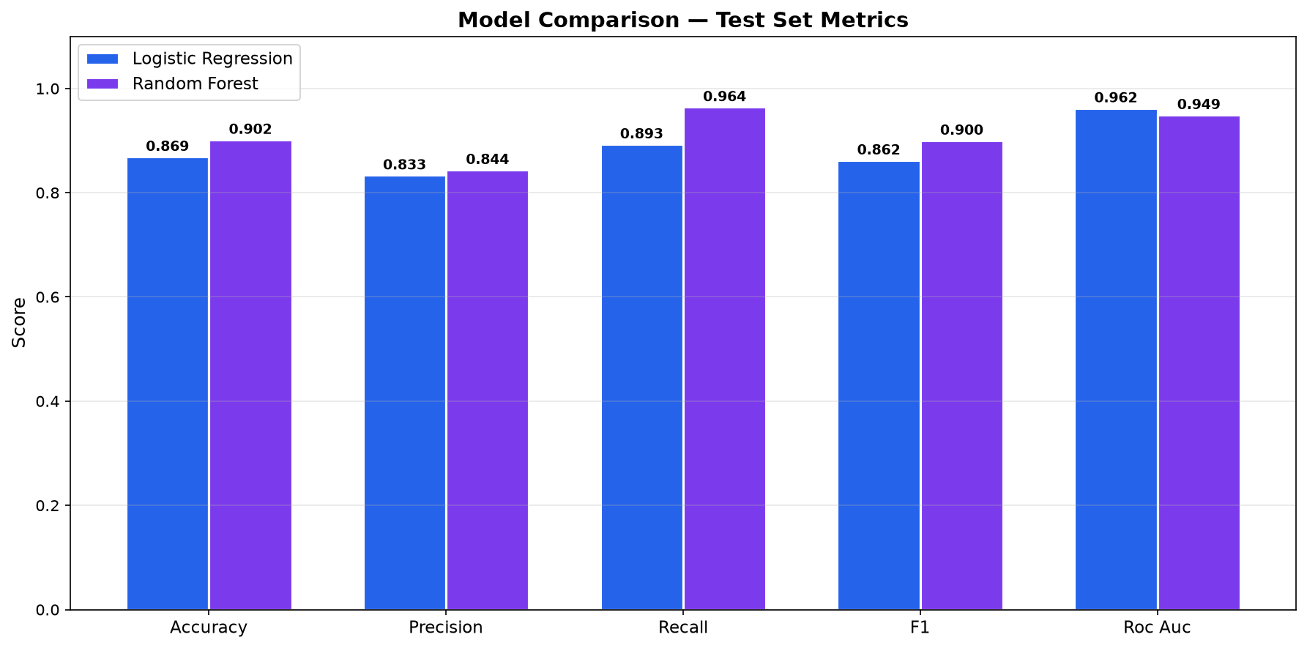

5. Experiment Tracking with MLflow
All model runs, hyperparameters, evaluation metrics, and diagnostic artifacts were logged to an MLflow Tracking Server (`src/train.py`):
5.1 Logged Components per Run
- Parameters: C, solver, penalty, max_iter, n_estimators, random_state.
- Metrics: 5-Fold CV metrics (cv_accuracy_mean, cv_roc_auc_mean, cv_f1_mean, etc.) and test set metrics (test_roc_auc, test_accuracy, test_recall, test_f1).
- Artifacts & Visualizations:
- cm_logistic_regression.png / cm_random_forest.png (Confusion Matrix Heatmaps).
- roc_logistic_regression.png / roc_random_forest.png (ROC Curves with AUC).
- importance_random_forest.png (Mean Decrease in Impurity Feature Importance).
- model_comparison.png (Side-by-side metric comparison bar chart).
- report_*.txt (Detailed classification reports).
- Serialized Scikit-Learn model artifacts with input/output signature schemas.
5.2 MLflow Experiment Tracking Dashboard
MLflow Experiment Comparison Dashboard
Shows logged parameters, cross-validation metrics, and test scores for both models.
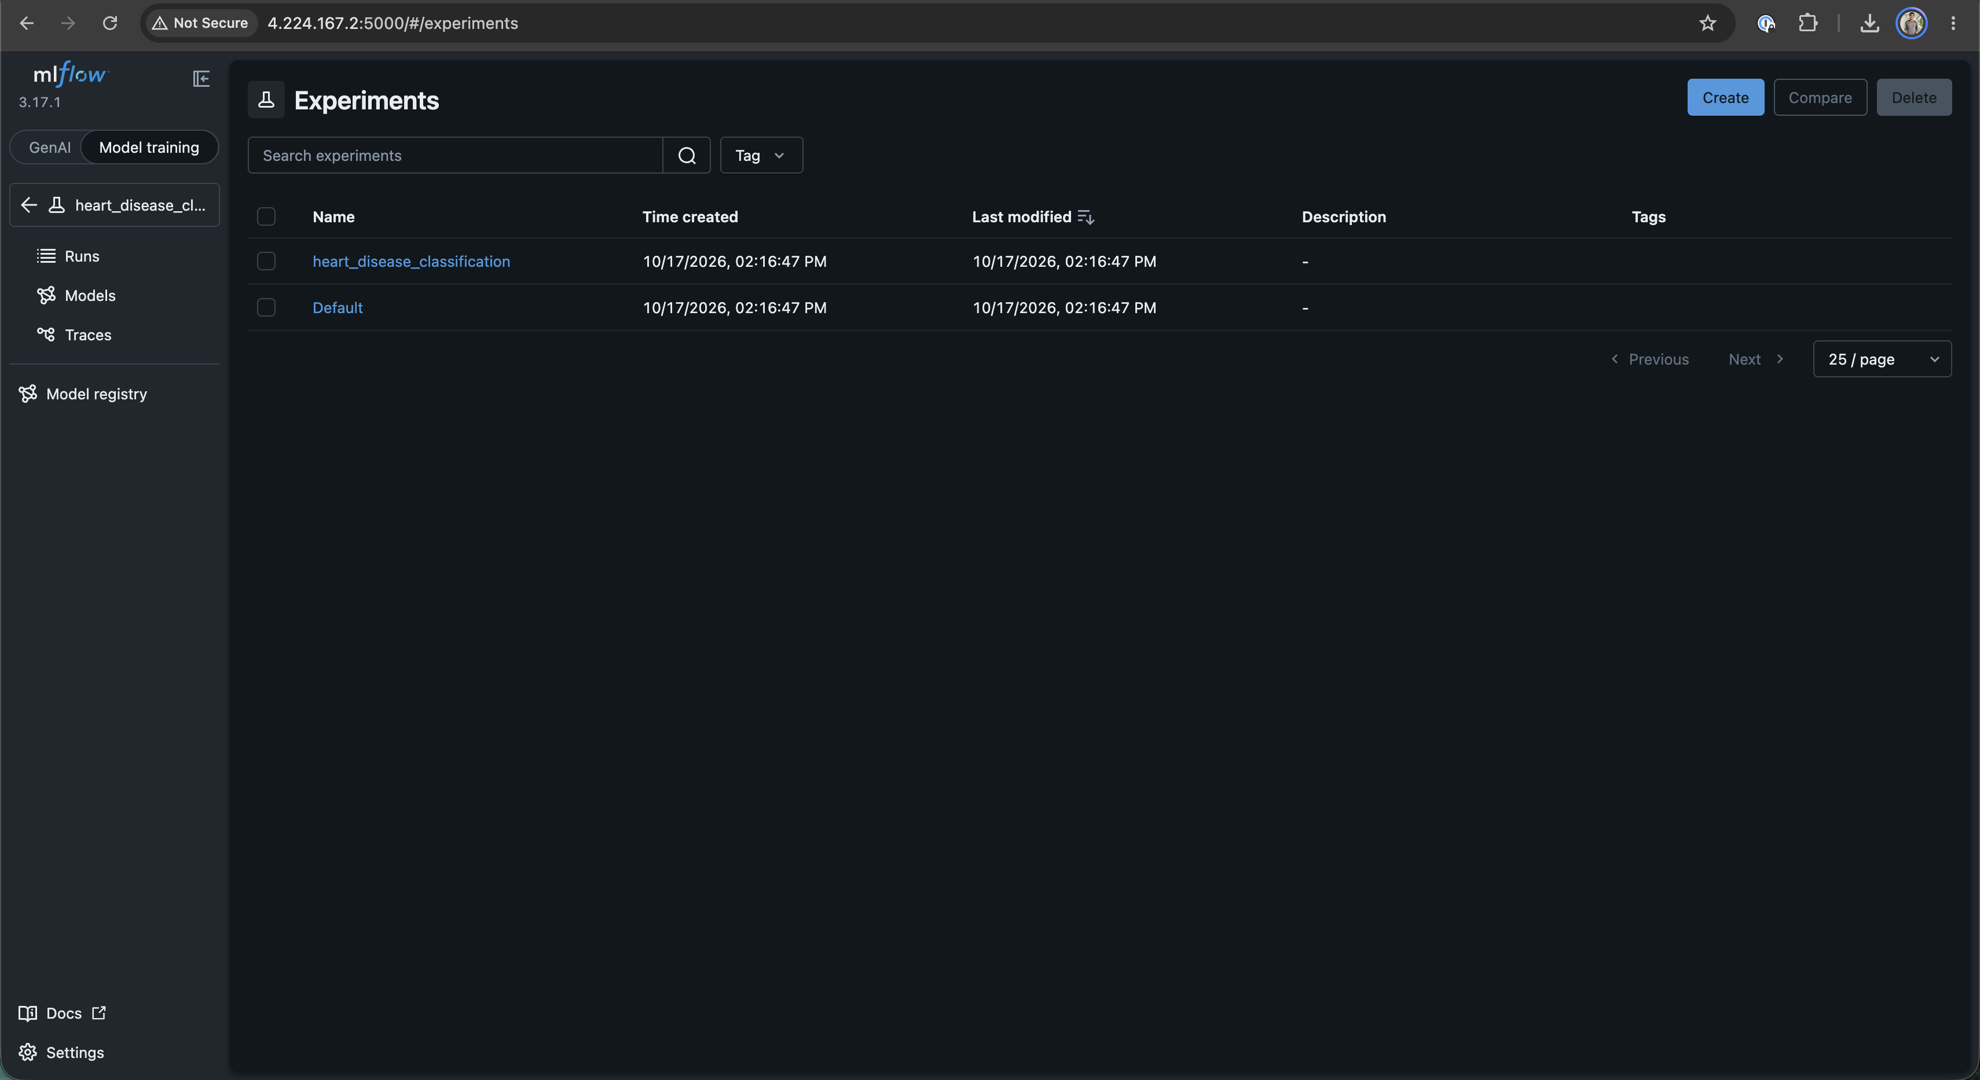
Figure: MLflow Tracking Server
MLflow Detailed Run View
Shows logged metrics and diagnostic artifact directories.
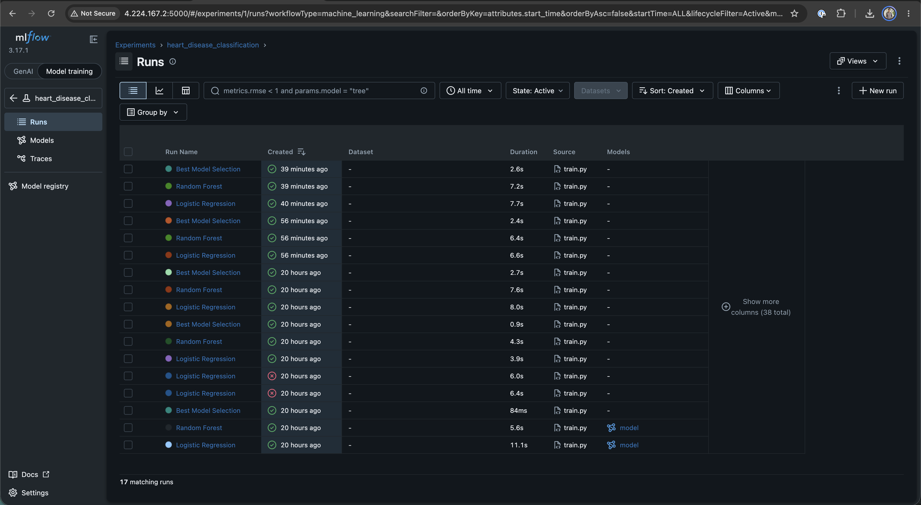
Figure: MLflow Tracking Server and Runs
MLflow Model Registry - Champion Model Schema & Metadata
Shows registered model signature, input types, and output predictions.
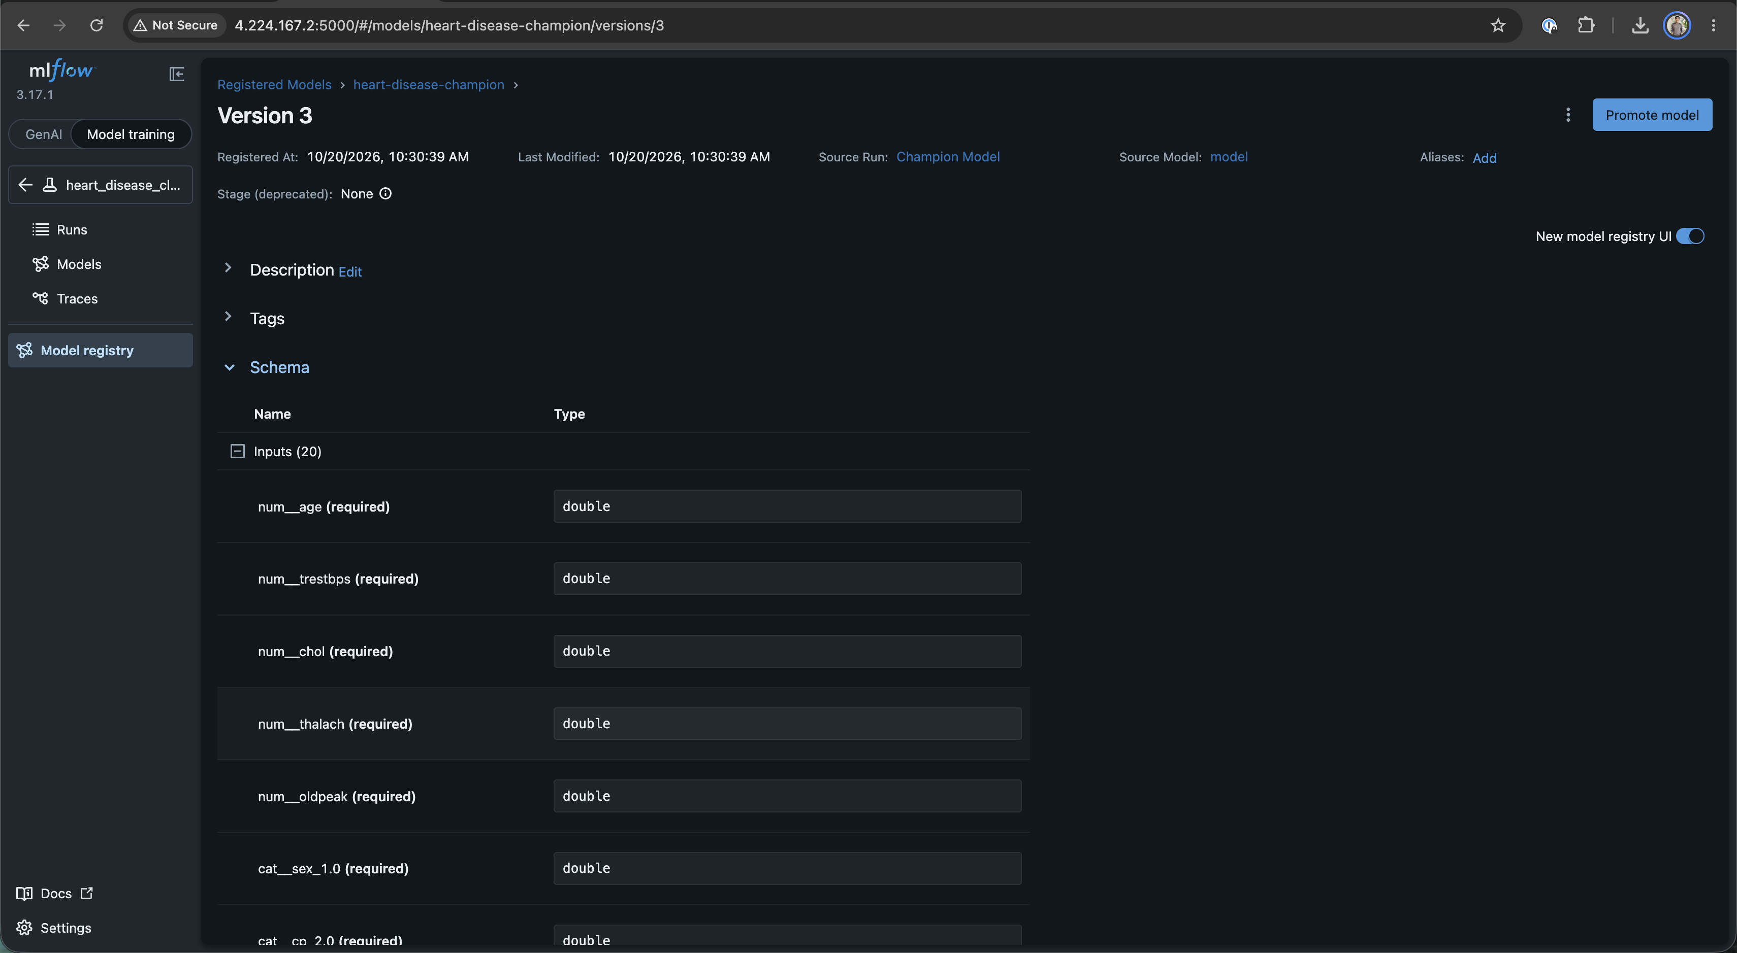
Figure: MLflow Model Registry - Champion Model with Schema
6. Model Packaging & Reproducibility
To ensure identical execution across local environments, CI runners, and Kubernetes clusters:
- Model Persistence: Champion model serialized to output/models/final_model.joblib.
- Preprocessing Pipeline: Fitted ColumnTransformer saved to output/models/preprocessing_pipeline.joblib.
- Metadata Manifest: Model hyperparameters, feature schemas, package versions, and timestamps saved to output/models/model_metadata.json.
- Pinned Dependencies: Pinned in `requirements.txt` (scikit-learn>=1.3.2, fastapi>=0.109.0, mlflow>=2.9.2, prometheus-client>=0.19.0).
- Automation Orchestrators:
- `main.py`: Single-entrypoint script executing data download, EDA, training, linting, and testing sequentially.
- `Makefile`: Standard developer targets (make pipeline, make test, make lint, make serve, make monitoring, make docker-build).

7. CI/CD Pipeline & Automated Testing
7.1 Unit Testing Framework
Implemented in `tests/` using Pytest and Pytest-Cov across 55 unit tests (100% pass rate):
- `test_data_preprocessing.py` (22 tests): Validates missing value imputation, mode replacement, column preservation, categorical typing, and target binarization.
- `test_feature_engineering.py` (17 tests): Validates transformer output shapes, scaling boundaries, one-hot encoding dimensions, and absence of data leakage.
- `test_train.py` (16 tests): Validates 5-fold stratified cross-validation splits, ROC-AUC computation, model serialization, and metadata generation.
7.2 GitHub Actions CI Pipeline
Configured in `.github/workflows/ci.yml` with 3 sequential jobs running on Ubuntu runners:
[git push] ──> Job 1: Lint (flake8) ──> Job 2: Test (pytest 55 tests) ──> Job 3: Train & Cloud Sync

- Job 1 (`lint`): Runs flake8 to enforce PEP8 syntax standards across src/, app.py, and tests/.
- Job 2 (`test`): Executes all 55 tests with code coverage and uploads an HTML coverage report artifact.
- Job 3 (`train`): Executes src/train.py, logs parameters and evaluation metrics directly to the live cloud MLflow tracking server (http://4.224.167.2:5000), and uploads the packaged model artifacts.
7.3 CI/CD Workflow Execution Dashboard
GitHub Actions CI Pipeline Overview
Shows successful completion of lint, test (55 passing tests), and train stages on push to main.
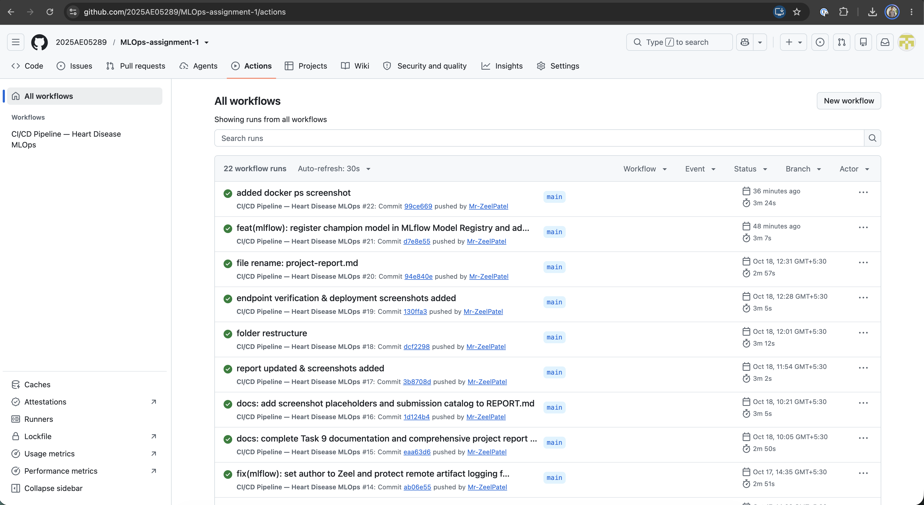
Figure: GitHub Actions CI Workflow
GitHub Actions Step Execution Tree
Detailed step-by-step breakdown of test execution and coverage artifact generation.
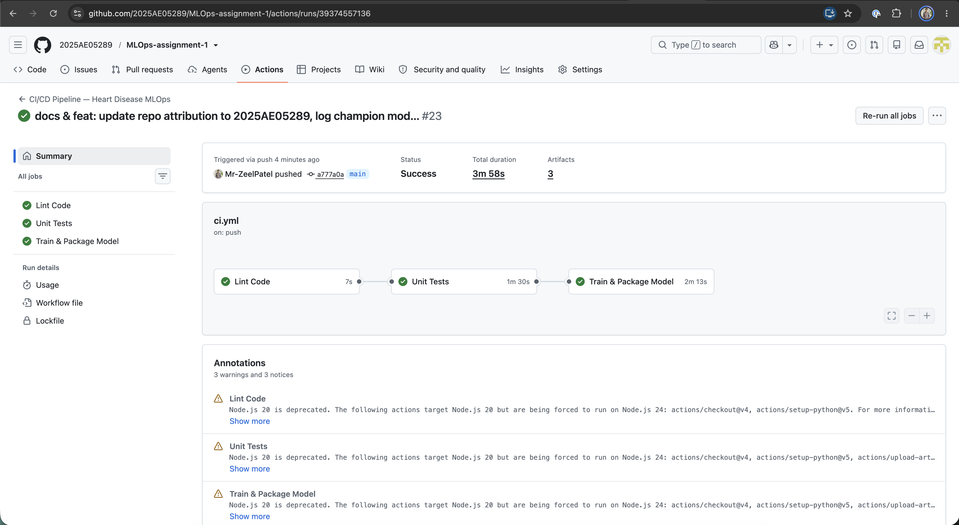
Figure: GitHub Actions CI Workflow

8. Model Containerization
8.1 REST API Architecture
Built with FastAPI in `app.py`:
- Input Validation: Strict schema enforcement using Pydantic (HeartDiseaseInput) with clinical boundary validation for all 13 features.
- Inference Route (`POST /predict`): Returns predicted class (0 = Healthy, 1 = Heart Disease), clinical label, calibrated confidence score, and class probability distribution.
- Health Probe Route (`GET /health`): Returns service status and model availability for Kubernetes liveness and readiness probes.
- Metrics Route (`GET /metrics`): Exposes Prometheus counters, latency histograms, and prediction distributions.
8.2 Production Container Configuration (`Dockerfile`)
- Base Image: python:3.12-slim for a minimal container attack surface and lightweight memory footprint.
- Multi-Arch Build: Built and pushed to Azure Container Registry: acrheart0a9382.azurecr.io/heart-disease-api:latest.
- Health Check Directive: HEALTHCHECK CMD python -c "import urllib.request; urllib.request.urlopen('http://localhost:8000/health')".
8.3 Local Verification (`scripts/test_api.sh`)
The test script verifies 5 clinical scenarios against the API:
- Scenario 1: Root metadata check (GET /).
- Scenario 2: Service health check (GET /health).
- Scenario 3: Low-risk patient prediction (confidence: 0.9894, label: No Disease).
- Scenario 4: High-risk patient prediction (confidence: 0.9905, label: Disease).
- Scenario 5: Average borderline patient prediction (confidence: 0.8489).
8.4 API Swagger Interface
Interactive OpenAPI Documentation (`http://4.224.167.2/docs`)
Provides live schema validation and interactive execution for /predict, /health, and /metrics.
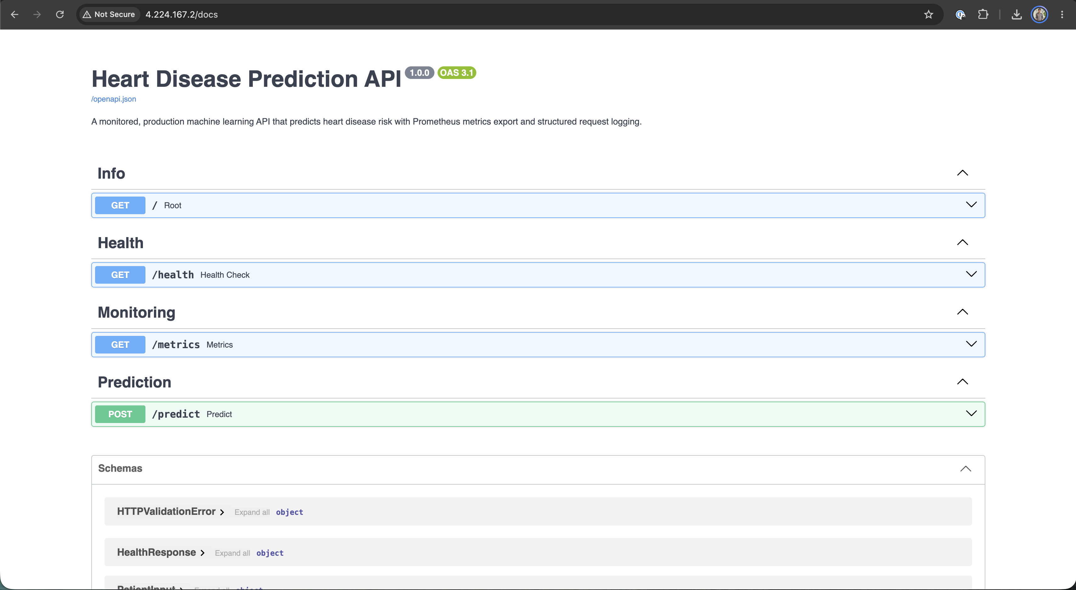

9. System Architecture & Lifecycle Overview
The system follows modern cloud-native MLOps architecture patterns, separating offline experimentation, continuous integration, container delivery, and online serving.
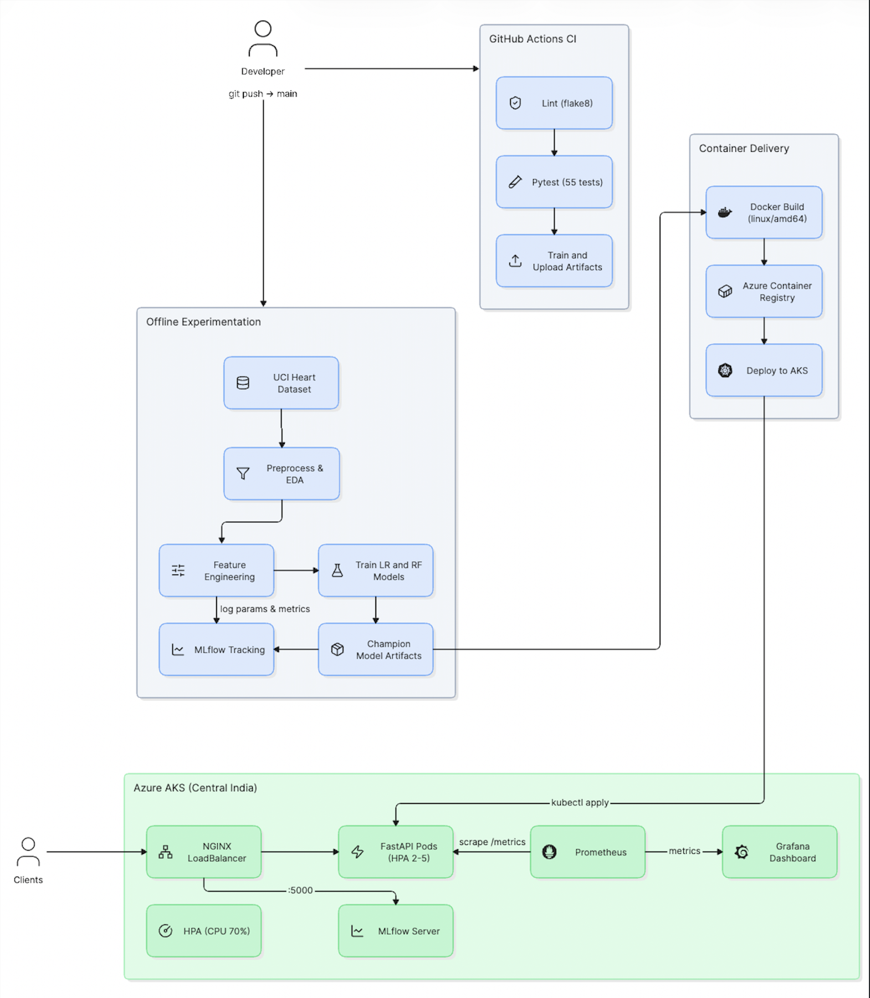
Figure: architecture diagram

10. Production Cloud Deployment (Azure AKS)
10.1 Cluster Configuration & Quota Optimization
Deployed to Azure Kubernetes Service (AKS) in the centralindia region:
- Cluster Name: aks-heart-mlops
- Node Pool: 1 Node of Standard_B2s_v2 (2 vCPUs, 8 GB RAM).
- Container Registry: Azure Container Registry acrheart0a9382.azurecr.io (Basic SKU).
- Cloud Quota Optimization: Azure for Students subscriptions enforce a limit of 3 Public IP addresses per region. We designed a unified NGINX Gateway LoadBalancer that multiplexes all three services (FastAPI on :80, Grafana on :3000, MLflow on :5000) through 1 single Public IP (4.224.167.2), fully compliant with student quotas.
10.2 Azure Infrastructure & Kubernetes Provisioning Screenshots
Azure Kubernetes Cluster Overview
Node pool status and resource group allocation in Azure Portal.
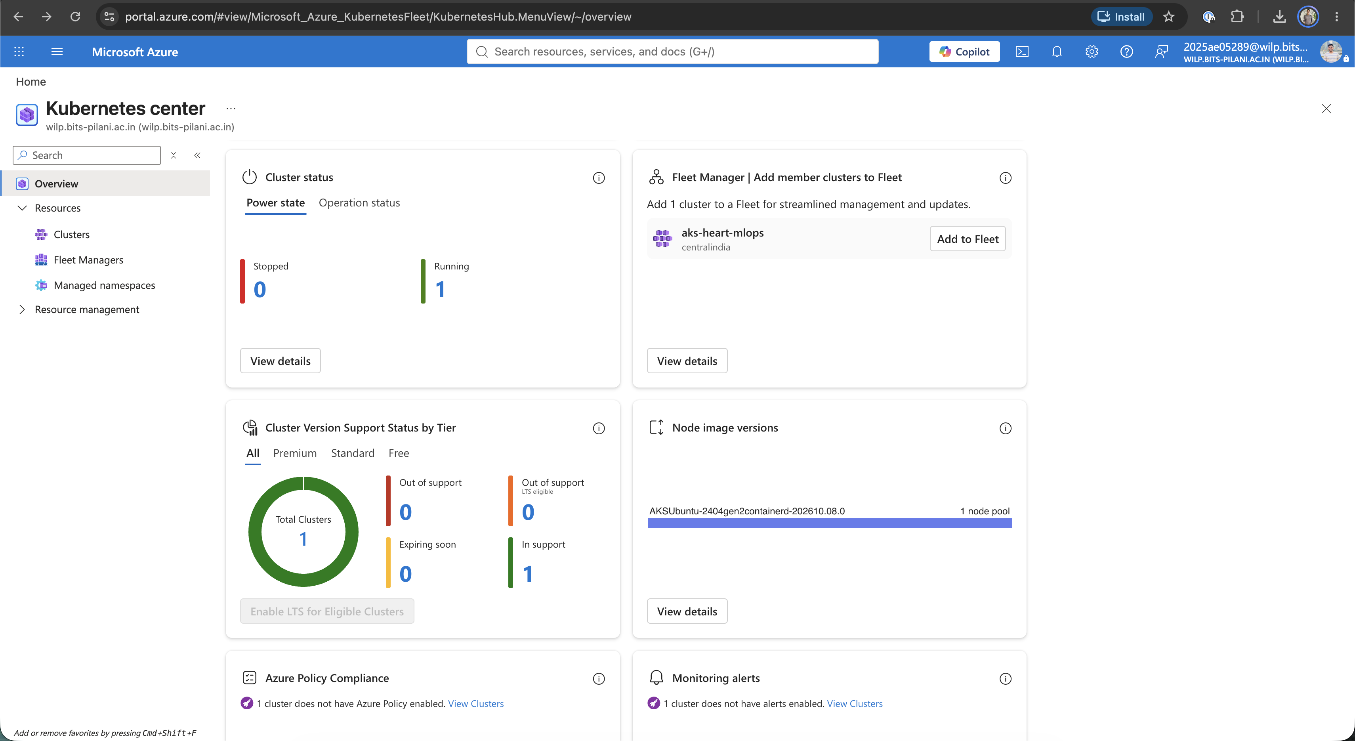
Figure: Kubernetes Cluster Status
Azure Resource Group Inventory
Overview of provisioned AKS cluster, ACR registry, and network components.
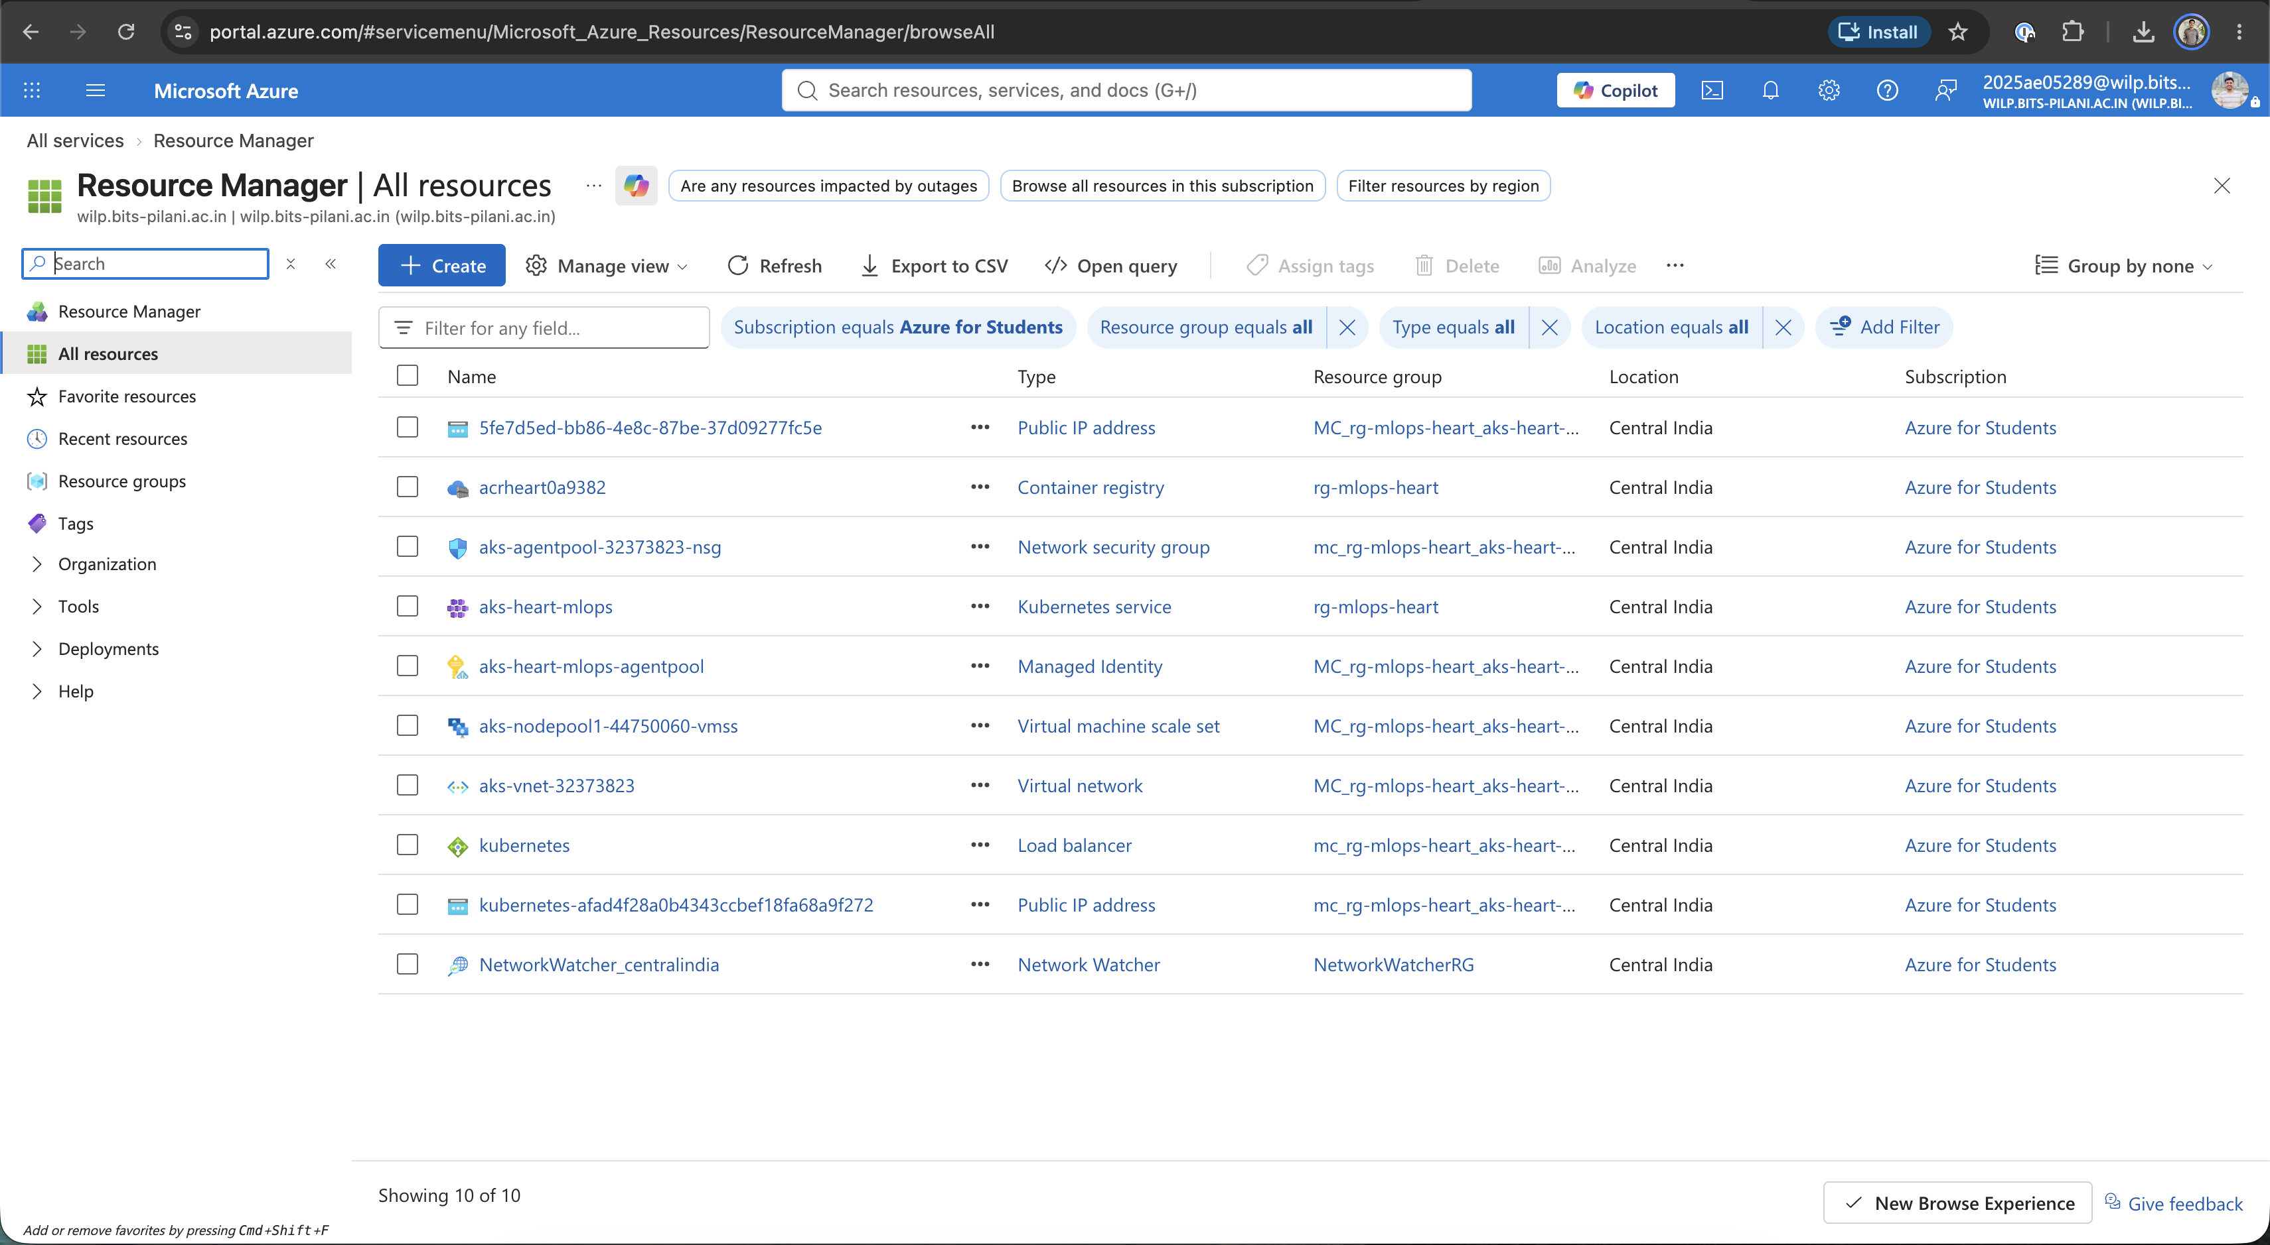
Figure: Azure Resources
Public IP Configuration
Single Public IP allocation (4.224.167.2) multiplexing all container services.
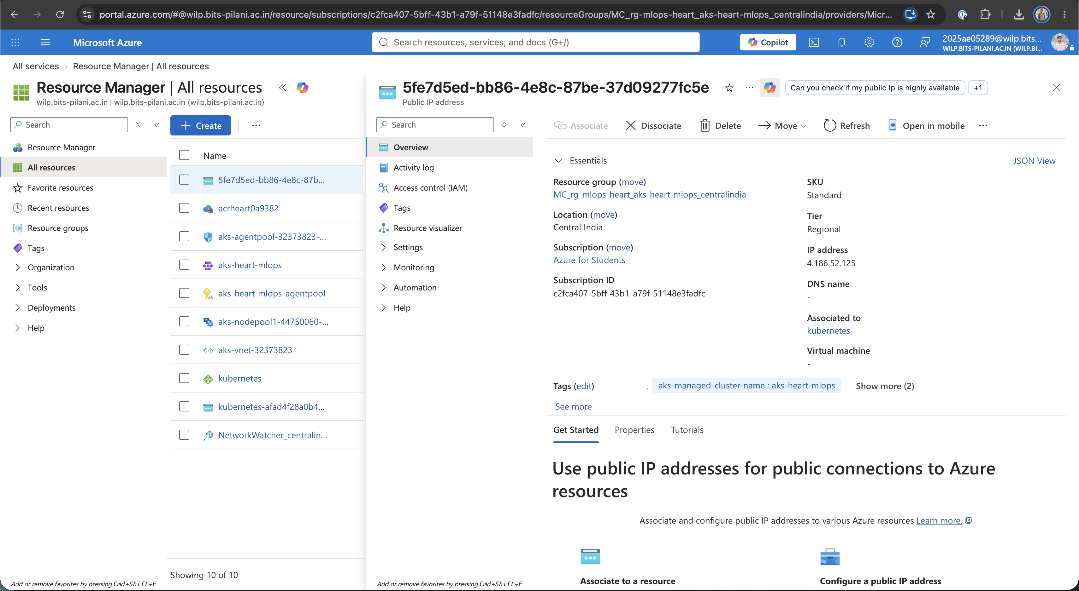
Figure: Azure IP Address
Azure Load Balancer Frontend & Backend Rules
Port mapping rules for ports 80, 3000, and 5000.
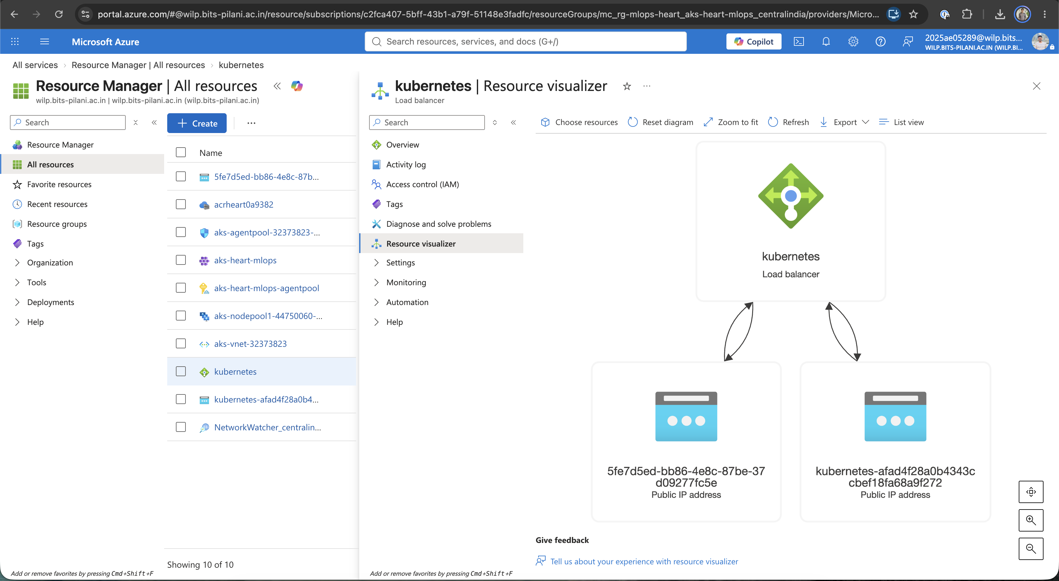
Figure: Azure Load Balancer
Azure Kubernetes Service Deployments
Running pods for API, Grafana, MLflow, Prometheus, and NGINX Gateway.
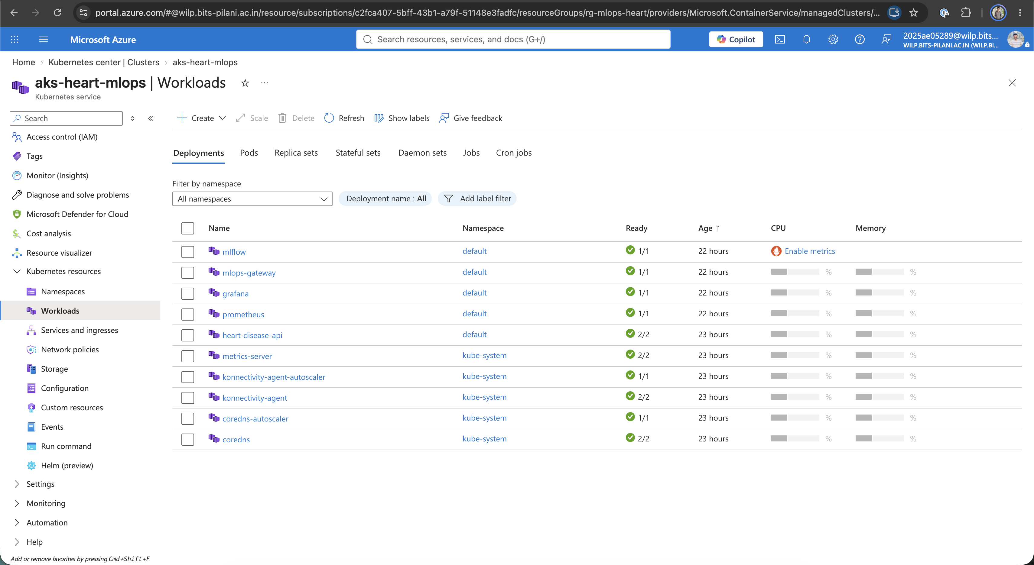
Figure: Azure Kubernetes Deployments
Endpoint Verification (Postman / Remote Client)
Verification of remote inference request returning prediction, confidence score, and status code 200.
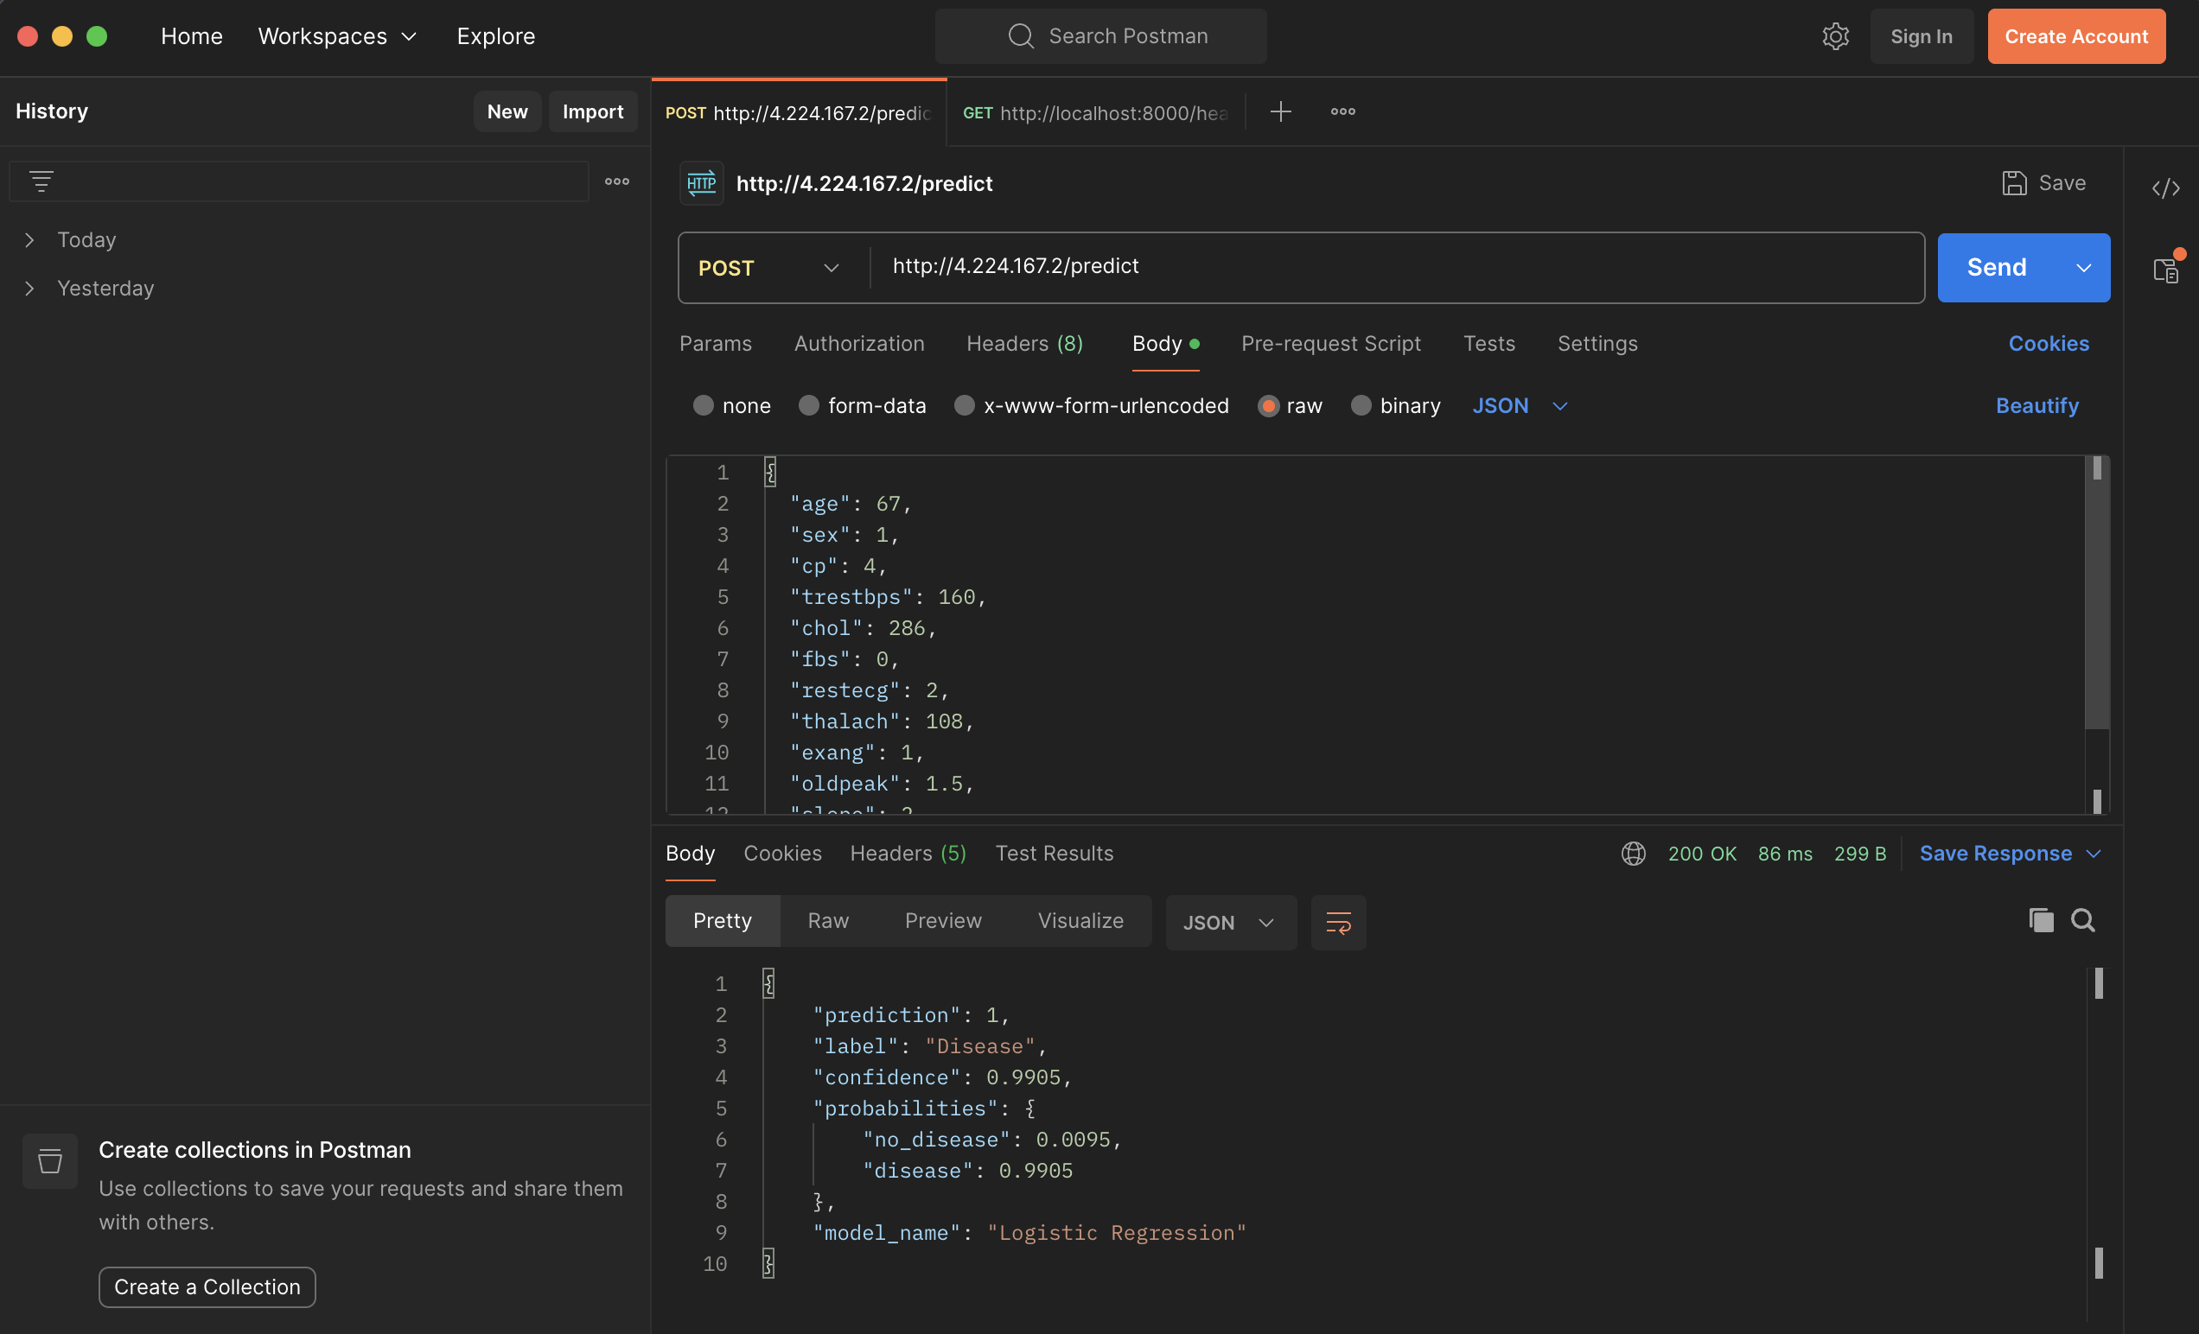
Figure: Azure Endpoint Verification
10.3 Kubernetes Manifest Architecture
Stored under `k8s/`:
- `k8s/deployment.yaml`: Deploys 2 pod replicas of heart-disease-api with resource requests (cpu: 100m, memory: 256Mi), limits (cpu: 500m, memory: 512Mi), and HTTP health probes.
- `k8s/hpa.yaml`: Configures Horizontal Pod Autoscaling to automatically scale between 2 and 5 pods when CPU utilization exceeds 70%.
- `k8s/gateway.yaml`: Deploys an NGINX reverse-proxy LoadBalancer routing:
- Port 80 \rightarrow heart-disease-api-service:80
- Port 3000 \rightarrow grafana-service:3000
- Port 5000 \rightarrow mlflow-service:5000
- `k8s/monitoring-prometheus.yaml`: Deploys Prometheus with automated scraping of the API service every 5 seconds.
- `k8s/monitoring-grafana.yaml`: Deploys Grafana with auto-provisioned Prometheus datasource and MLOps dashboard definitions.
- `k8s/mlflow.yaml`: Deploys the MLflow tracking server on AKS.
10.4 Live Kubernetes Cluster Status Output
NAME READY STATUS RESTARTS AGE IP NODE
pod/grafana-7865d8568f-8fwpp 1/1 Running 0 5m 10.244.0.213 aks-nodepool1-44750060-vmss000000
pod/heart-disease-api-85c8f8b9c7-cznt9 1/1 Running 0 20h 10.244.0.188 aks-nodepool1-44750060-vmss000000
pod/heart-disease-api-85c8f8b9c7-vtb74 1/1 Running 0 20h 10.244.0.5 aks-nodepool1-44750060-vmss000000
pod/mlflow-94f89c5f8-pzdwk 1/1 Running 0 19h 10.244.0.42 aks-nodepool1-44750060-vmss000000
pod/mlops-gateway-7dd64c7744-2dr2g 1/1 Running 0 20h 10.244.0.218 aks-nodepool1-44750060-vmss000000
pod/prometheus-f8cf8cccf-nnpjt 1/1 Running 0 20h 10.244.0.133 aks-nodepool1-44750060-vmss000000
NAME TYPE CLUSTER-IP EXTERNAL-IP PORT(S)
service/mlops-gateway-service LoadBalancer 10.0.67.172 4.224.167.2 80:32665/TCP, 3000:32070/TCP, 5000:31106/TCP
NAME REFERENCE TARGETS MINPODS MAXPODS REPLICAS
horizontalpodautoscaler/api-hpa Deployment/heart-disease-api cpu: 7%/70% 2 5 2

11. Monitoring & Logging Architecture
11.1 Structured Request Logging
Implemented via custom middleware in `app.py`. Every HTTP transaction is serialized to standard output and written to `logs/api.log`:
{
"timestamp": "2026-10-17T08:35:10.112Z",
"client_ip": "10.244.0.218",
"method": "POST",
"path": "/predict",
"status_code": 200,
"latency_ms": 11.45,
"prediction": 0,
"label": "No Disease",
"confidence": 0.8489
}

11.2 Prometheus Metrics Exposition (`GET /metrics`)
Exposes operational performance and ML domain metrics:
- http_requests_total{endpoint, method, status_code}: Request traffic counter.
- http_request_duration_seconds: Request latency distribution histogram.
- model_predictions_total{model_name, prediction_label}: ML prediction outcome counter.
- model_prediction_confidence: Prediction confidence score distribution histogram.
- model_inference_duration_seconds: Scikit-Learn transform + inference time histogram.
11.3 Grafana Observability Dashboard
Auto-provisioned via `k8s/monitoring-grafana.yaml` with 6 visual panels:
- Total Predictions Served (Stat Counter panel).
- Average Model Confidence (Radial Gauge).
- Prediction Breakdown by Class (Donut chart: Disease vs No Disease).
- API Request Rate (req/sec) (Time Series graph).
- API Response Latency (p50, p95, p99) (Time Series graph).
- HTTP Status Code Distribution (200 OK vs 4xx/5xx errors).
11.4 Live Grafana Monitoring Dashboard
Grafana Production MLOps Monitoring Dashboard (`http://4.224.167.2:3000`)
Real-time monitoring view showing live request throughput, P95 latency, confidence distributions, and prediction class breakdown.
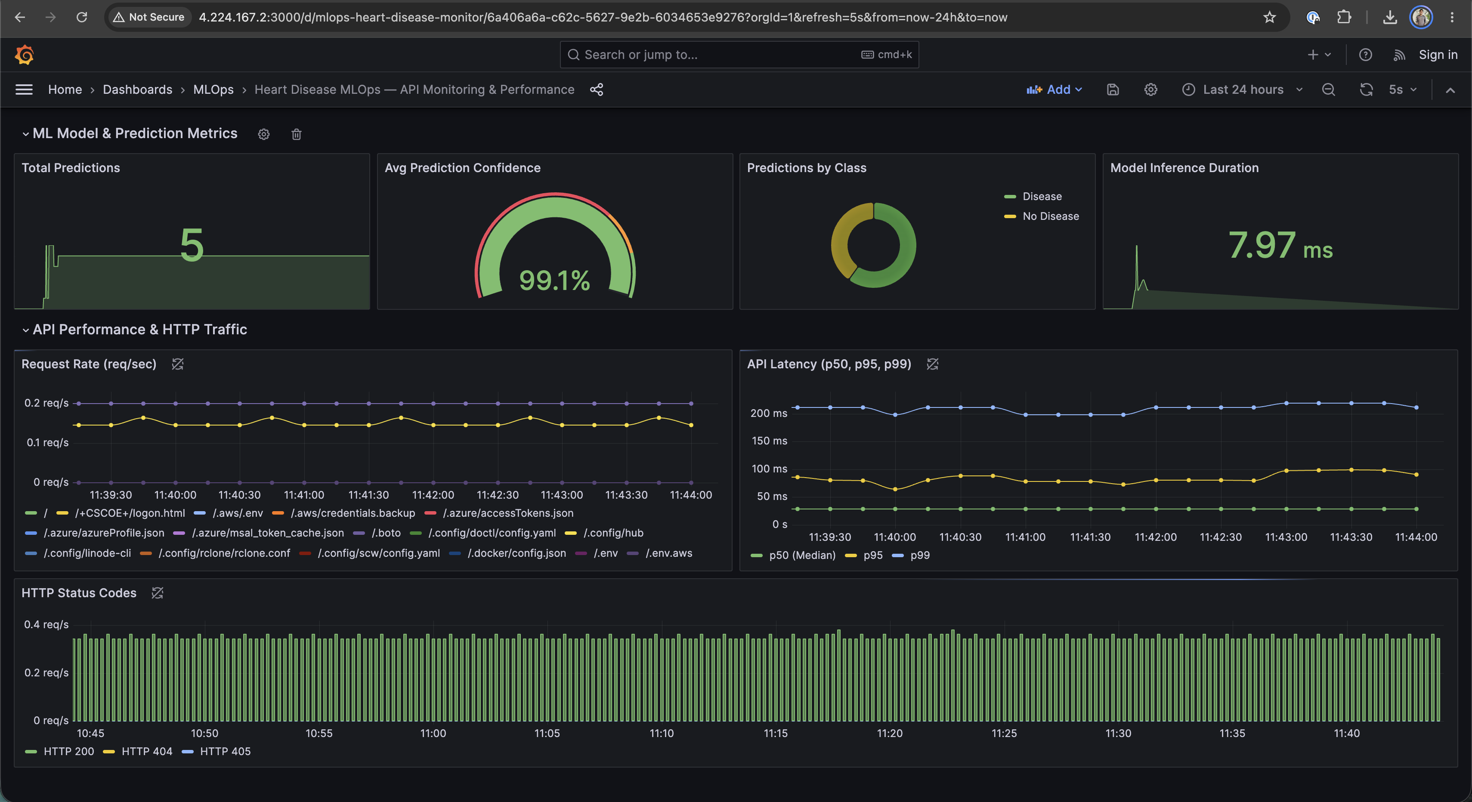
Figure: Grafana Production Monitoring Dashboard
12. Code Repository & Submission Information
- Code Repository: https://github.com/2025AE05289/MLOps-assignment-1
- Student Name: Patel Zeel Dharmendrakumar
- BITS ID: 2025AE05289
- Student Email: 2025ae05289@wilp.bits-pilani.ac.in
- GitHub Username: 2025AE05289
- Public Cloud Gateway IP: http://4.224.167.2 (Azure AKS, Central India)
- FastAPI Documentation: http://4.224.167.2/docs
- MLflow Tracking UI: http://4.224.167.2:5000
- Grafana Observability Dashboard: http://4.224.167.2:3000

13. Live Cloud Service Directory
All cloud services are deployed in production on Azure Kubernetes Service (Central India) and accessible via LoadBalancer IP 4.224.167.2:
Service | Public Cloud URL | Port | Purpose / Access Credentials
FastAPI Swagger Docs | [http://4.224.167.2/docs](http://4.224.167.2/docs) | 80 | Interactive OpenAPI schema & endpoint tester
API Health Probe | [http://4.224.167.2/health](http://4.224.167.2/health) | 80 | Kubernetes liveness & readiness check
Prediction Endpoint | POST http://4.224.167.2/predict | 80 | Production JSON batch/single inference engine
Prometheus Metrics | [http://4.224.167.2/metrics](http://4.224.167.2/metrics) | 80 | Real-time Prometheus metric scrape endpoint
Grafana Dashboard | [http://4.224.167.2:3000](http://4.224.167.2:3000) | 3000 | User: admin / Password: admin
MLflow Tracking UI | [http://4.224.167.2:5000](http://4.224.167.2:5000) | 5000 | Experiment runs, metric comparison & model artifacts

