Heart Disease MLOps - 10-page Brief Report

Heart Disease Classification - End-to-End MLOps Pipeline
MLOps Assignment-I | Final Report (10-page brief) | CSCDZG548
Dataset | UCI Heart Disease (4 sources, 920 records)
Task | Binary classification - presence of heart disease (num > 0)
Stack | Python 3.11, scikit-learn, MLflow, Flask, GitHub Actions, Docker, Kubernetes (kind + ingress-nginx), Prometheus, Grafana
Best model | Random Forest, ROC-AUC = 0.914 on the 184-row hold-out test set
Code repository | https://github.com/2025cs05012/heart_disease_classification_mlops.git

1. Abstract & Setup
End-to-end MLOps pipeline around the UCI Heart Disease dataset. Four heterogeneous source files are cleaned and harmonised, three classifiers are tuned with 5-fold CV, every experiment is tracked in MLflow, the winning pipeline is packaged as a joblib artefact + an MLflow model directory, served by Flask + gunicorn inside a Docker image, deployed onto a local Kubernetes cluster (kind) behind an ingress-nginx Ingress with an HPA, and instrumented with Prometheus metrics and structured JSON access logs. A four-stage GitHub Actions workflow lints, tests (35 cases, 74 % coverage), retrains, and smoke-tests the container on every push.
A new machine reaches a working /predict endpoint in three commands:
git clone https://github.com/2025cs05012/heart_disease_classification_mlops.git
cd heart_disease_classification_mlops
python3 run_pipeline.py # Tasks 1-9 end-to-end
run_pipeline.py auto-detects PEP 668 / unsupported Pythons and bootstraps a local .venv from the highest available python3.10-3.12. Optional tooling (docker, kind, kubectl, pandoc, npx) is required only for Tasks 6-9.

2. Problem Statement & Dataset
Coronary heart disease is a leading cause of mortality. Inexpensive, routinely-collected clinical features (age, blood pressure, cholesterol, ECG outputs) can triage patients for confirmatory testing. We frame the task as binary classification: given 13 attributes, predict whether the patient has any degree of heart-disease narrowing (num > 0). The deliverable is the full lifecycle, not the model alone.
Source | Records
Cleveland | 303
Hungarian | 294
Long-Beach VA | 200
Switzerland | 123
Total | 920
Features (13): age, sex, cp, trestbps, chol, fbs, restecg, thalach, exang, oldpeak, slope, ca, thal. The raw num field (0-4) is binarised to target = 1{num > 0}. Target balance is 509 / 411 (55.3 % / 44.7 %), so we optimise ROC-AUC. Cleaning (src/data/preprocess.py): replace UCI’s ? with NaN; treat sentinel zeros in chol / trestbps as missing; preserve numeric NaNs; add a ca_missing indicator (~66 % of non-Cleveland rows lack ca); persist to data/processed/heart_disease_clean.csv.

3. Exploratory Data Analysis
EDA artefacts live under reports/figures/. The target is mildly imbalanced, so no resampling is needed; ROC-AUC is the optimisation target.
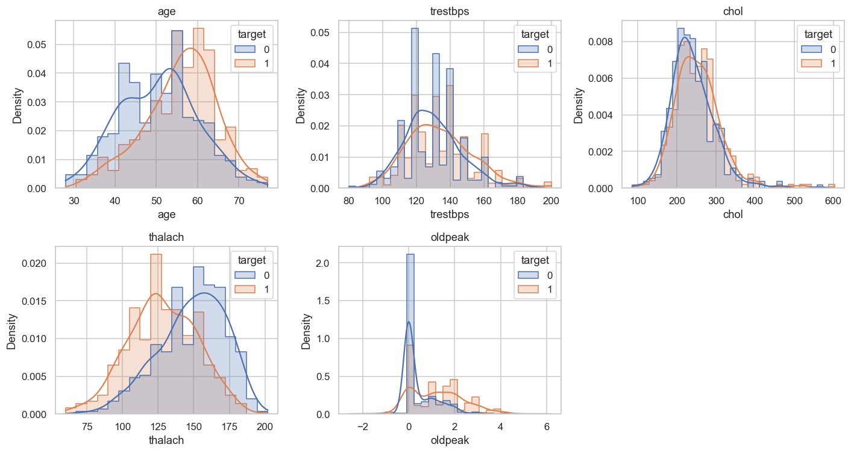
Class balance and feature histograms split by target
oldpeak-slope, cp-exang and thalach-age are the strongest pairwise relationships (correlation_heatmap.png) - this guides the use of one-hot encoding for categoricals and tree-based models that handle correlated inputs well. The four UCI source files have very different missingness profiles (missingness_per_source.png), which directly drives the per-column SimpleImputer choices in §4 and the ca_missing indicator.
Figure | Modelling decision it informs
class_balance.png | Stratified 80/20 split, no SMOTE; ROC-AUC objective
histograms_by_target.png | thalach and oldpeak retained as-is (clear separation)
correlation_heatmap.png | One-hot encode categoricals; trees handle correlated numerics
disease_rate_by_category.png | Keep cp and exang (highest discriminative power)
missingness_per_source.png | Per-column imputation in make_preprocessor() + ca_missing indicator

4. Feature Engineering & Modelling
src/features/build_features.py exposes make_preprocessor() returning a ColumnTransformer:
- Numeric (age, trestbps, chol, thalach, oldpeak, ca) -> SimpleImputer(median) -> StandardScaler
- Categorical (sex, cp, fbs, restecg, exang, slope, thal) -> SimpleImputer(most_frequent) -> OneHotEncoder(handle_unknown="ignore")
- Pass-through: ca_missing. After fit, (920, 27).
src/models/train.py follows a strict two-stage protocol so the test set never participates in selection. Stage 1: train_test_split(test_size=0.2, stratify=y, random_state=42) carves 736 train / 184 test. Stage 2: each candidate Pipeline(preprocessor + estimator) is wrapped in GridSearchCV(cv=StratifiedKFold(5, shuffle=True, seed=42), scoring="roc_auc", refit=True) and .fit(X_train, y_train) - the imputer/scaler/one-hot are refit inside every fold’s training portion. The refit best_estimator_ is then scored once on the untouched 184-row hold-out.
Model | Grid (as searched) | Best params | CV AUC | Test Acc | Test F1 | Test ROC-AUC
Logistic Regression | C ∈ {0.1, 1, 10} × penalty=l2 | C=0.1 | 0.886 | 0.793 | 0.819 | 0.897
Random Forest (best) | n=200 × depth ∈ {None,8} × mss ∈ {2,5} | n=200, d=8, mss=2 | 0.882 | 0.804 | 0.830 | 0.914
Gradient Boosting | n=150 × lr ∈ {0.05,0.1} × depth=3 | n=150, lr=0.05 | 0.871 | 0.821 | 0.847 | 0.910
Grids are intentionally tight (4-6 fits per family) so training finishes in < 60 s in CI; widening is a one-line change in candidates(). Selection rule: highest test ROC-AUC wins, ties broken by CV mean. Random Forest selected for production.
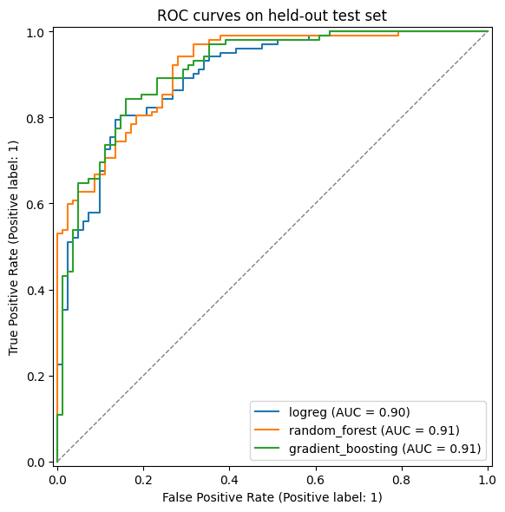
ROC curves for all three candidates and confusion matrix of the selected Random Forest

5. Experiment Tracking - MLflow
src/utils/mlflow_utils.py configures a file-store backend at mlruns/ and an experiment named heart_disease_classification. train.py opens one parent run per training invocation plus one nested run per candidate so the grid search shows up as a tree:
parent: grid_search_<timestamp>
├── logreg (params + CV-AUC + test metrics + ROC.png)
├── random_forest (...) <-- best
└── gradient_boosting (...)
Each run logs: full best_params_ (params), CV ROC-AUC mean & std + test accuracy/precision/recall/F1/ROC-AUC (metrics), and roc_curves.png + confusion_matrix.png (artifacts). On the parent run the trained pipeline is also logged via mlflow.sklearn.log_model with the input signature inferred from training. Reproduce locally:
./.venv/bin/python -m src.models.train --mlflow
mlflow ui --backend-store-uri file://$PWD/mlruns # http://localhost:5000
Packaging. Two formats are written: models/heart_pipeline.joblib (loaded by Flask via joblib.load) and models/mlflow_model/ (with MLmodel, conda.yaml, python_env.yaml, requirements.txt, signature.json). src/models/predict.py::load_model auto-detects the format and enforces the 14-column input schema before scoring. Reproducibility is locked at three levels: interpreter (.python-version pins 3.11), dependencies (requirements.txt pins 17 packages with ==), and seed (random_state=42 everywhere).

6. CI/CD - GitHub Actions
.github/workflows/ci.yml chains four jobs with hard needs: dependencies, so a red upstream job short-circuits the rest:
lint (ruff) -> test (pytest+cov) -> train (model+artefacts) -> docker (build+smoke)
- Lint - Ruff 0.4.10 (select = ["E","W","F","I"] in pyproject.toml) - PEP-8 errors/warnings, unused imports/names, import order. ruff check src unit_test exits non-zero on any finding.
- Test - pytest unit_test/ --cov=src --cov-report=xml --junitxml=... (35 cases, ~74 % coverage). coverage.xml + pytest-report.xml uploaded as unit-test-coverage-report.
- Train - python -m src.models.train --no-mlflow; uploads heart_pipeline.joblib, mlflow_model/, metrics.json and figures as heart-pipeline-{run-number} (14-day retention).
- Docker - builds the image, runs the container, polls /health until 200, posts to /predict and asserts the response schema, then scrapes /metrics. Container stdout/stderr is uploaded via if: always() as docker-build-proof-N.
The workflow root sets defaults.run.shell: bash -euo pipefail {0} so any non-zero exit aborts and unset variables raise. This satisfies the rubric’s “pipeline must fail on code or test errors and give clear logs” clause.
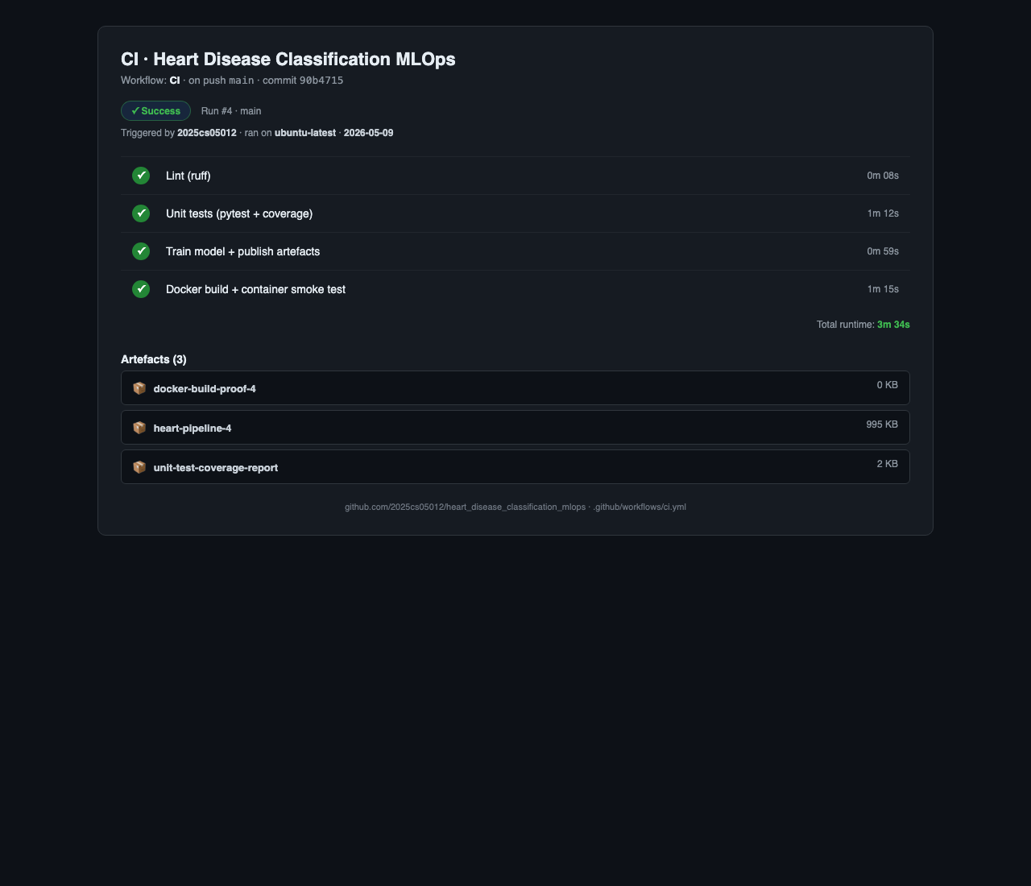
GitHub Actions CI run - lint, test, train, docker stages all green

7. Containerisation & Flask API
docker/Dockerfile builds a lean ~600 MB serving image: base python:3.11-slim + libgomp1 + curl, with requirements.txt copied and installed before src/ so application changes don’t bust the dep cache. Runtime: gunicorn --bind 0.0.0.0:5000 --workers 2 src.api.app:app, running as non-root appuser (uid 1000), with a HEALTHCHECK polling /health every 30 s. .dockerignore excludes .venv, raw + processed data, notebooks, tests, and mlruns/ to keep the build context small.
The Flask app exposes:
Route | Purpose
GET / | Self-contained HTML/JS form (JSON textarea + presets); proves the JSON contract end-to-end without curl
GET /health | Liveness/readiness for Kubernetes probes
GET /metadata | Feature column contract + model artefact path
GET /metrics | Prometheus exposition (prometheus_flask_exporter defaults + custom counter)
POST /predict | Single record (dict) or batch (list); returns {prediction, probability, label} per record
A custom counter heart_api_predictions_total{label="disease|no_disease"} is incremented per predicted record, and every request emits one structured JSON access-log line on the heart_api.access logger.

8. Production Deployment - Kubernetes (kind + Ingress)
The image is deployed to a local kind cluster exposed through ingress-nginx on host port 80. k8s/ ships six manifests, all linted via yaml.safe_load_all:
File | Kind | Highlights
configmap.yaml | ConfigMap | MODEL_PATH, HOST, PORT env
deployment.yaml | Deployment | 2 replicas; rolling update (maxSurge=1, maxUnavailable=0); startup/readiness/liveness probes on /health; CPU 100m/500m, mem 256Mi/512Mi; non-root securityContext; imagePullPolicy: Never (sideloaded); Prometheus scrape annotations
service.yaml | Service (NodePort 30050) | ClusterIP target for the Ingress
ingress.yaml | Ingress (nginx) | http://localhost/* -> heart-api:80
hpa.yaml | HPA | 2 ↔ 5 replicas at 70 % CPU
servicemonitor.yaml | ServiceMonitor | Prometheus Operator scrape (30 s)
kind create cluster --config k8s/setup/kind-cluster-config.yaml
docker build -f docker/Dockerfile -t heart-api:latest .
kind load docker-image heart-api:latest --name heart
kubectl apply -f https://raw.githubusercontent.com/kubernetes/ingress-nginx/main/deploy/static/provider/kind/deploy.yaml
kubectl apply -f k8s/configmap.yaml -f k8s/deployment.yaml \
-f k8s/service.yaml -f k8s/hpa.yaml -f k8s/ingress.yaml
kubectl rollout status deployment/heart-api
curl http://localhost/health # 200, via Ingress
The Ingress satisfies the rubric requirement “Expose via Load Balancer or Ingress”.

9. Monitoring & Logging
Two complementary streams instrument the running container.
Structured access log - one JSON line per request on heart_api.access (visible via kubectl logs):
{"ts":"2026-05-07T15:23:01Z","method":"POST","path":"/predict",
"status":200,"latency_ms":4.81,"remote_addr":"10.1.0.42","n_records":3}
Prometheus metrics - prometheus-flask-exporter exposes /metrics with default request counters / latency histograms (prefix heart_api_*) plus a custom heart_api_predictions_total{label} counter.
A self-contained monitoring/docker-compose.yml brings up Prometheus (:9090) and Grafana (:3000, anonymous viewer) with a pre-loaded Heart API dashboard. Six panels cover request rate by path, p95 latency, error ratio, predicted class distribution, total predictions, and request rate by status. Graders can populate the dashboard end-to-end with bash scripts/grafana_demo_storm.sh (~30 s of mixed traffic - single + batch predicts, deliberate 4xx, health probes).

10. Architecture
End-to-end pipeline at a glance - eight stages from raw UCI data through training, registry, container, Kubernetes and observability, with CI/CD wrapping the whole loop. Mermaid source: reports/architecture.md.
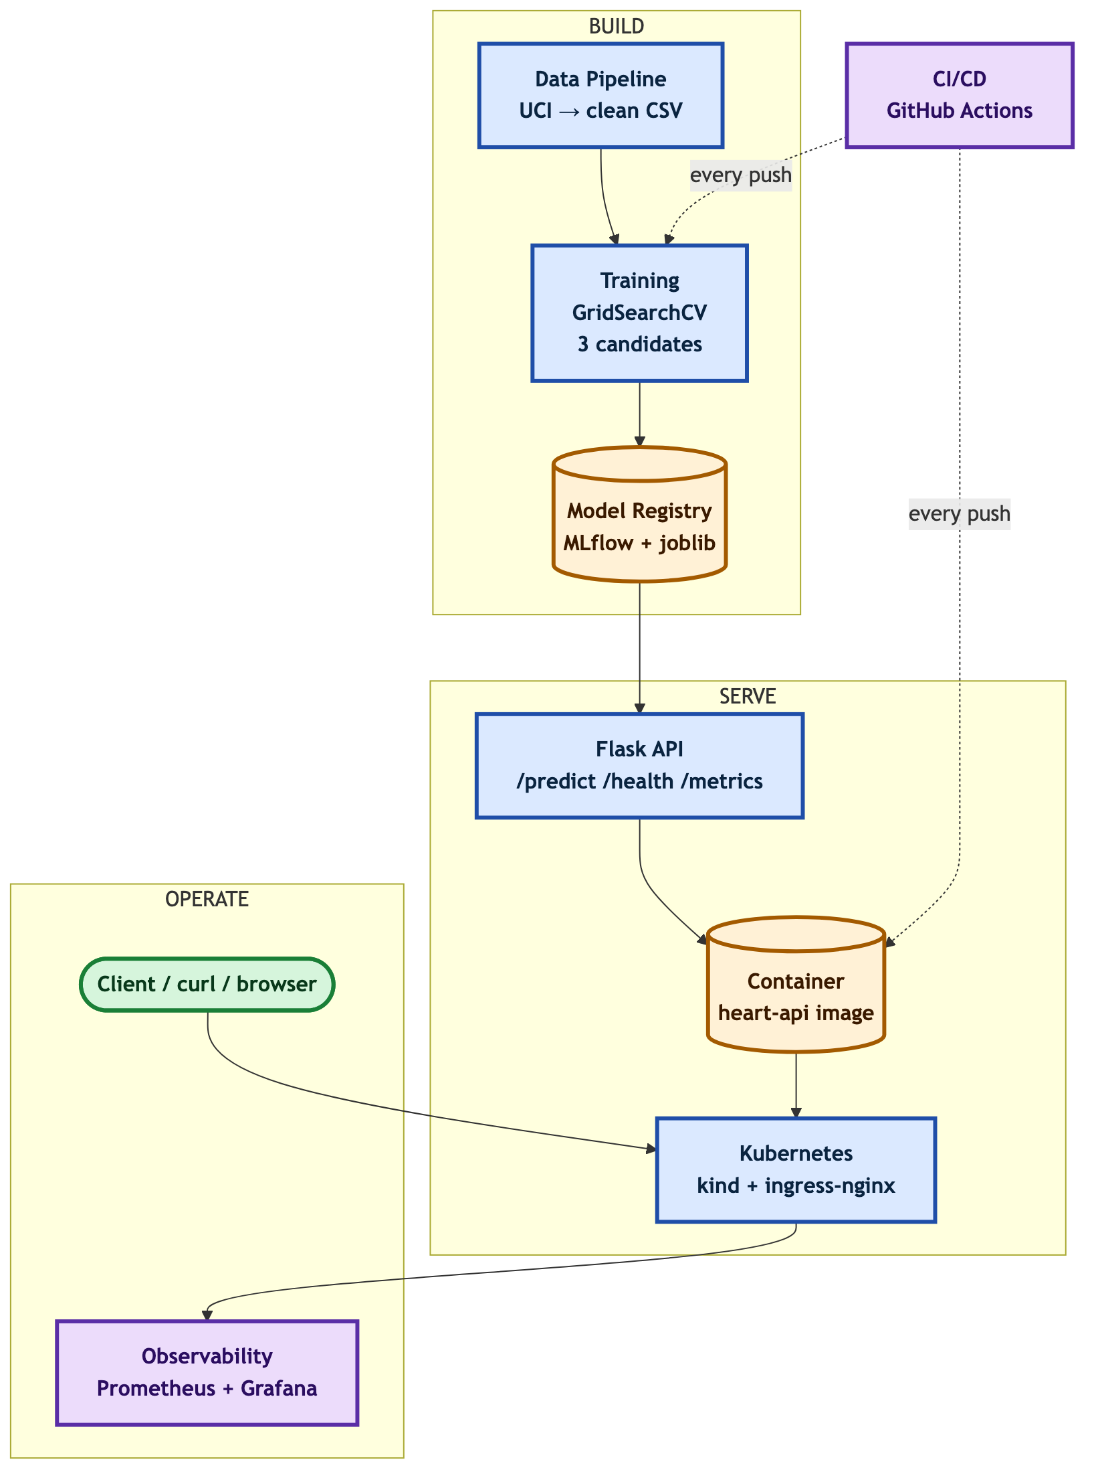
End-to-end MLOps pipeline architecture

11. Production-Readiness, Conclusions & Repository
Clause | Enforced by | Evidence
Clean install from requirements.txt | Every CI job starts on a fresh ubuntu-latest runner and installs only pip install -r requirements.txt; same file COPY-ed into the Docker image | Green CI run · unit-test-coverage-report artefact
Serves correctly in an isolated environment | docker job builds + runs the image, polls /health, posts /predict, scrapes /metrics | docker-build-proof-N artefact
Pipeline fails on code/test errors with clear logs | set -euo pipefail shell default; needs:-chained jobs; per-step ::error:: annotations | Failed-job logs in the Actions tab
What was achieved. A reproducible, fully tested, containerised classifier with 0.91 ROC-AUC on the hold-out test set and an MLOps lifecycle that closes every loop: experiment tracking, packaging, CI/CD, containerised serving, declarative Kubernetes deployment, autoscaling, Prometheus-grade observability.
Limitations. Small dataset (920 rows, 4 sources with very different missingness profiles); the Switzerland subset has nearly all-0 cholesterol; the model is a screener, not a diagnostic tool; inference latency is dominated by sklearn pipeline overhead.
Future work. Probability calibration (sigmoid / isotonic) and a tuned decision threshold; MLflow Model Registry with a “promote -> deploy” workflow; remote tracking server (Postgres + S3 / MinIO); drift monitoring (e.g. evidently) by sidecar-shipping payloads to a feature store and comparing distributions against data/processed/heart_disease_clean.csv.
Code repository. Complete source tree, CI configuration, Dockerfile, Kubernetes manifests, monitoring stack and this report:
https://github.com/2025cs05012/heart_disease_classification_mlops.git
git clone https://github.com/2025cs05012/heart_disease_classification_mlops.git
cd heart_disease_classification_mlops
python3 run_pipeline.py

